Project
  - Deadline: Tuesday 02/12/2024 @ 23:59
[Total Mark is 14]

Digital Logic Design
CC231
Name: Withheld for privacy

Description and Instructions
Project objective:
The objective of this project is to apply the concepts learned throughout the course, such as design, analyze and implement the combinational circuits. Also, analyze the sequential circuit.

Project Instructions:
- The project is a Group work with a minimum of 2 and a maximum of 3 People.
- Use https://circuitverse.org/ platform to simulate all project circuits. Make sure to add the Circuit Verse project link in both word and PDF files.
- Each group must submit/upload 2 files: project report in word document, and PDF file of the project report. One of the group members (i.e., group leader) should submit all the files on the blackboard.
- Marks will be given based on your submission and the quality of the content.
- You Should list and cite the resources and references include the required book.
- Your project must be original work. The project will be checked using a plagiarism tool. Any matching with an online project or another/previous student project will be given ZERO.
- Project Total Marks = 14.

Due date: 2nd December 2024 @11:59 PM

Question One
Learning Outcome(s): CLO1
Define the concepts, tools and techniques for the design of digital logic and integrated circuits.
CLO2
Develop basic skills of designing combinatorial and sequential logic circuits.

7 Marks
A math teacher asked you as a digital circuit designer to build an interactive tool that would allow elementary school students to have fun while learning the properties of numbers. The teacher described the tool to you in the following details:
- The tool has an input panel that allows the student to enter any number from 1 to 10.
- The tool has two lights: green & red.
- If the student enters an even number, the green light will turn on.
- If the student enters a prime number, the red light will turn on.
- Of course, green & red lights can turn on together, depending on the properties of the entered number.
Your task is to design and implement the underlying combinational circuit for this interactive tool. Answer the following questions:
- How many bits are required as inputs for this combinational logic circuit to represent the numbers from 1 to 10? Describe. [1 mark]
- How many outputs in this combinational logic circuit? Describe. [1 mark]
- Derive the truth table that defines the required relationship between inputs and outputs. [1 mark]
- Obtain the canonical algebraic expressions (i.e., sum of minterms) for each output as a function of the input variables. [1 mark]
- Obtain the simplified Boolean functions (using K-map) for each output as a function of the input variables. [1 mark]
- Draw the logical diagram of the combinational circuit. [1 mark]
- Verify your design by simulation using https://circuitverse.org/simulator (implement your circuit, attach a screenshot of the circuit design, and provide a link to your implementation). [1 mark]

Solution:

1. How many bits are required as inputs for this combinational logic circuit to represent the numbers from 1 to 10? Describe.
This circuit needs 4 bits for 4 inputs (A, B, C, D) because the decimal number 10 requires 4 bits to be represented in binary, as 2^4 = 16.

2. How many outputs in this combinational logic circuit? Describe.
The circuit has 2 outputs: a Green light output if the input is an even number, and a Red light output if the input is a prime number.

3. Derive the truth table that defines the required relationship between inputs and outputs.
Input Output
A | B | C | D | G | R
0 | 0 | 0 | 0 | 0 | 0
0 | 0 | 0 | 1 | 0 | 0
0 | 0 | 1 | 0 | 1 | 1
0 | 0 | 1 | 1 | 0 | 1
0 | 1 | 0 | 0 | 1 | 0
0 | 1 | 0 | 1 | 0 | 1
0 | 1 | 1 | 0 | 1 | 0
0 | 1 | 1 | 1 | 0 | 1
1 | 0 | 0 | 0 | 1 | 0
1 | 0 | 0 | 1 | 0 | 0
1 | 0 | 1 | 0 | 1 | 0
1 | 0 | 1 | 1 | 0 | 0
1 | 1 | 0 | 0 | 0 | 0
1 | 1 | 0 | 1 | 0 | 0
1 | 1 | 1 | 0 | 0 | 0
1 | 1 | 1 | 1 | 0 | 0

4. Obtain the canonical algebraic expressions (i.e., sum of minterms) for each output as a function of the input variables.

The output G, or Green Light, is activated for even input numbers (2, 4, 6, 8, 10)
Expression: G = m₂ + m₄ + m₆+ m₈ + m₁₀

The output R, or Red Light, is activated for prime input numbers (2, 3, 5, 7)
Expression: R = m₂ + m₃ + m₅+ m₇

- Obtain the simplified Boolean functions (using K-map) for each output as a function of the input variables.

 | 00 | 01 | 11 | 10
00 | 0 | 0 | 0 | 1
01 | 1 | 0 | 0 | 1
11 | 0 | 0 | 0 | 0
10 | 1 | 0 | 0 | 1

A’CD’
A’BD’

AB’D’

 | 00 | 01 | 11 | 10
00 | 0 | 0 | 1 | 1
01 | 0 | 1 | 1 | 0
11 | 0 | 0 | 0 | 0
10 | 0 | 0 | 0 | 0
G=A’CD’+A’BD’+AB’D’

A’B’C
A’BD

R=A’B’C + A’BD

- Draw the logical diagram of the combinational circuit.
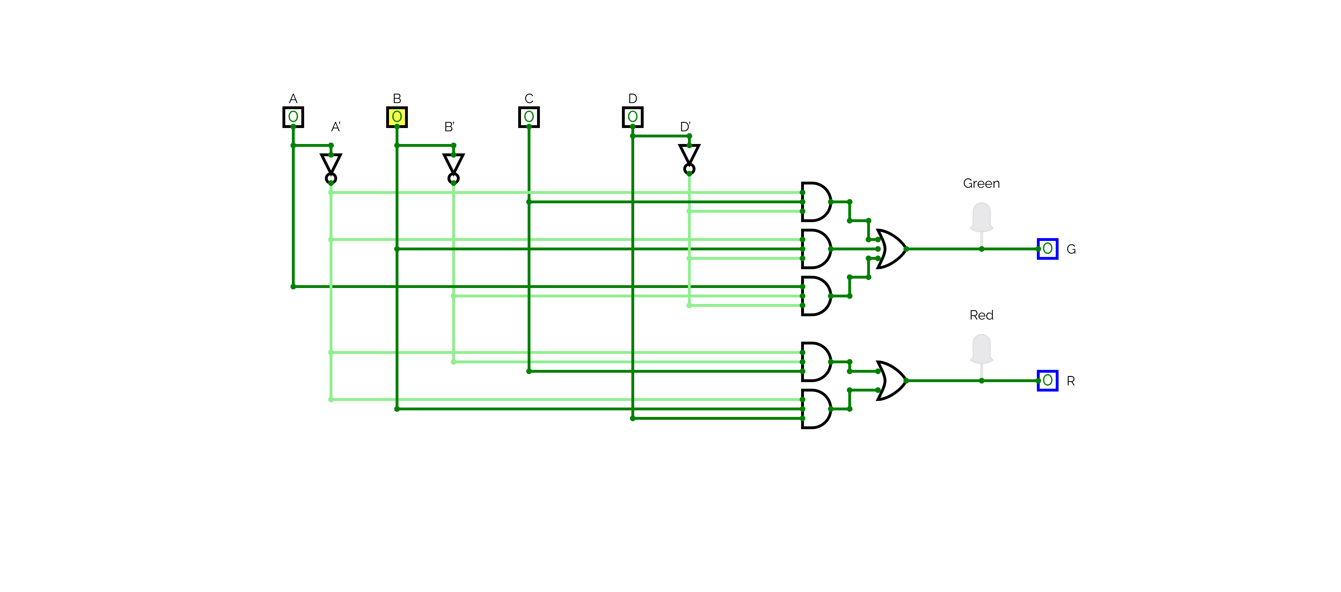

- Verify your design by simulation using https://circuitverse.org/simulator (implement your circuit, attach a screenshot of the circuit design, and provide a link to your implementation).
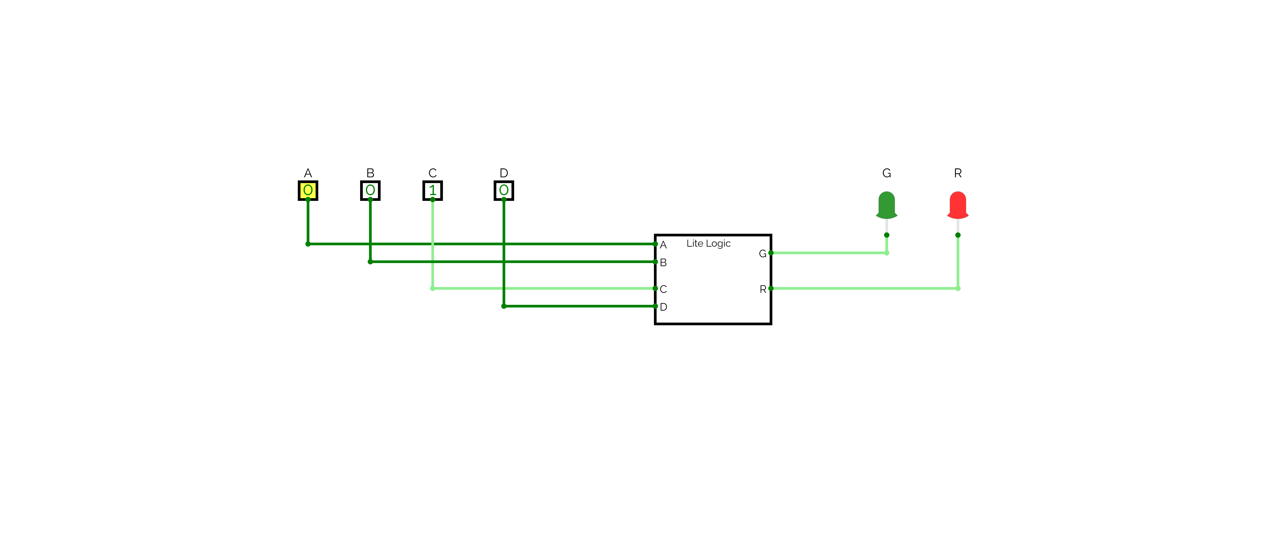
https://circuitverse.org/simulator/embed/math-tool-6e74c987-ef97-4bc4-9559-16bcf5bf898e
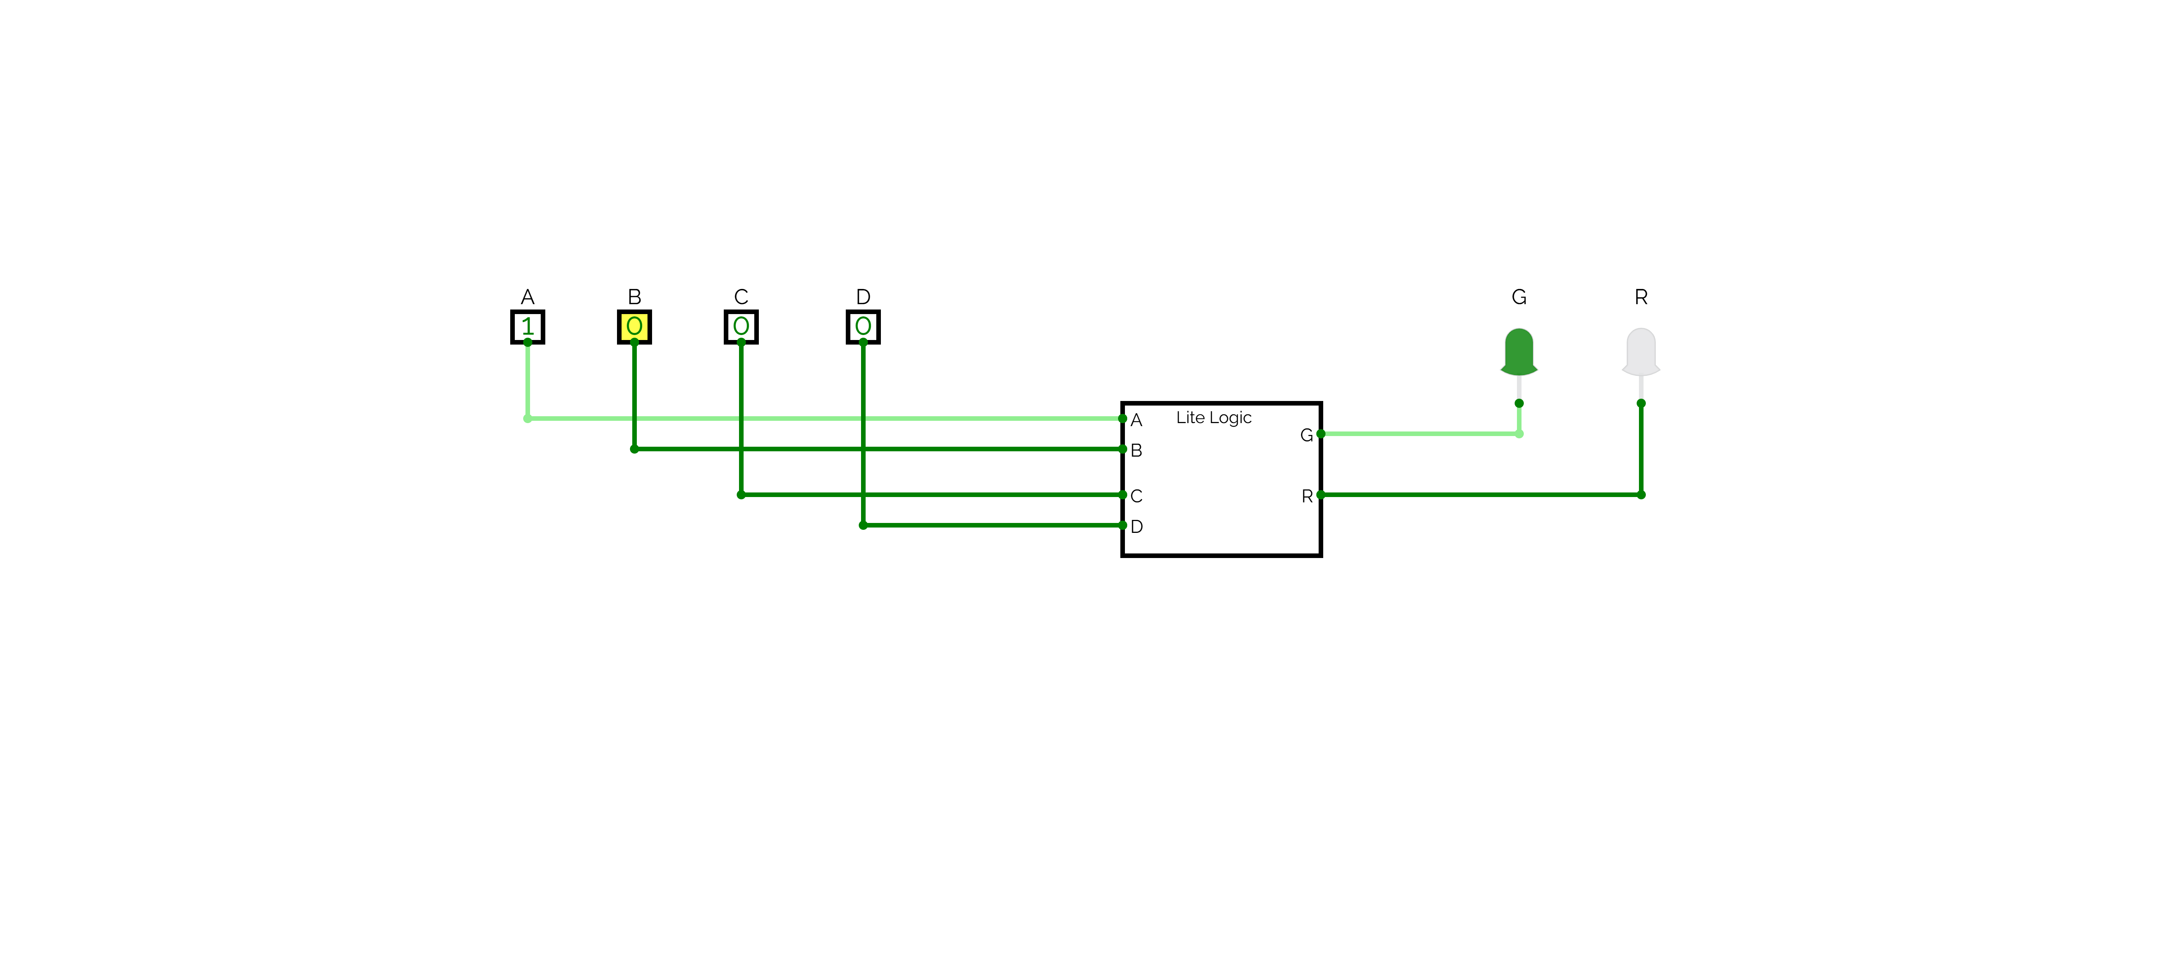

Question Two
4 Marks

Learning Outcome(s): CLO1
Define the concepts, tools and techniques for the design of digital logic and integrated circuits.

A sequential circuit includes two D flip-flops, U and V; with two inputs, a and b; and one output, c. The equations that characterized the next state and output are outlined below:
- U(t + 1) = ab' + aV
- V(t + 1) = aU + aV'
- c=U
(a) Draw the logic diagram of the circuit. [1 mark]
(b) List the state table for the sequential circuit. [1 mark]
(c) Draw the corresponding state diagram. [1 mark]
(d) Is this a Mealy machine or a Moore machine? and why? [1 mark]

- Draw the logic diagram of the circuit.
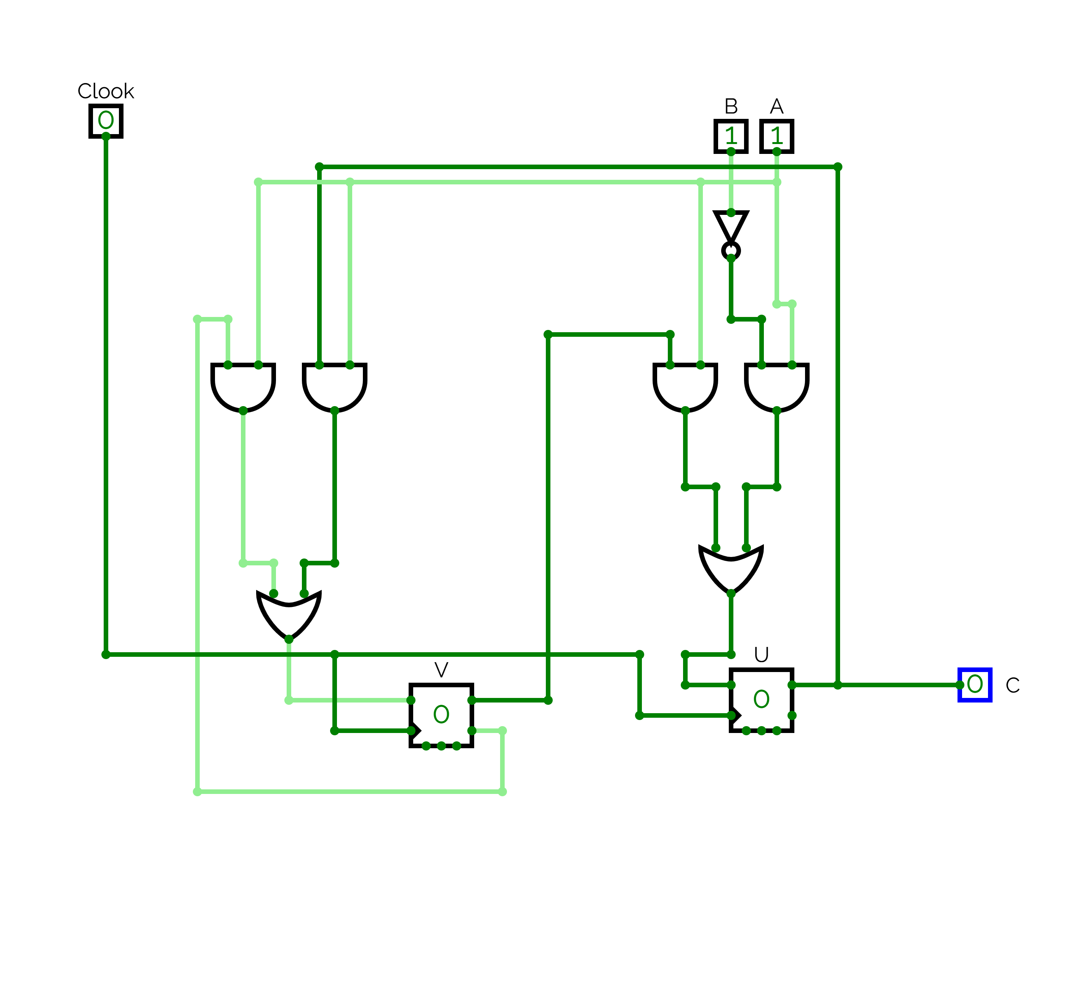

https://circuitverse.org/simulator/embed/project-1-dld-63e17ac5-7ba4-41fc-8dc0-44e0421e9d43

(b) List the state table for the sequential circuit.

 | Present State |  |  |  | Next State
 | U | V | a | b | U(t+1) | V(t+1) | C
0 | 0 | 0 | 0 | 0 | 0 | 0 | 0
1 | 0 | 0 | 0 | 1 | 0 | 0 | 0
2 | 0 | 0 | 1 | 0 | 1 | 1 | 0
3 | 0 | 0 | 1 | 1 | 0 | 1 | 0
4 | 0 | 1 | 0 | 0 | 0 | 0 | 0
5 | 0 | 1 | 0 | 1 | 0 | 0 | 0
6 | 0 | 1 | 1 | 0 | 1 | 0 | 0
7 | 0 | 1 | 1 | 1 | 1 | 0 | 0
8 | 1 | 0 | 0 | 0 | 0 | 0 | 1
9 | 1 | 0 | 0 | 1 | 0 | 0 | 1
10 | 1 | 0 | 1 | 0 | 1 | 1 | 1
11 | 1 | 0 | 1 | 1 | 0 | 1 | 1
12 | 1 | 1 | 0 | 0 | 0 | 0 | 1
13 | 1 | 1 | 0 | 1 | 0 | 0 | 1
14 | 1 | 1 | 1 | 0 | 1 | 1 | 1
15 | 1 | 1 | 1 | 1 | 1 | 1 | 1

(c) Draw the corresponding state diagram.

(d) Is this a Mealy machine or a Moore machine? and why?
This is a Moore machine because its output C depends solely on the state U, rather than the inputs a or b. In simpler terms, in a Moore machine, the output is a function of the state alone. On the other hand, in a Mealy machine, the output is influenced by both the current state and the input values.

Question Two
3 Marks

Learning Outcome(s): CLO4
Interpret combinational logic circuits, sequential logic circuits, register transfers, and memory and its related components as the building blocks for digital design.

Consider the following state diagram of a sequential circuit.
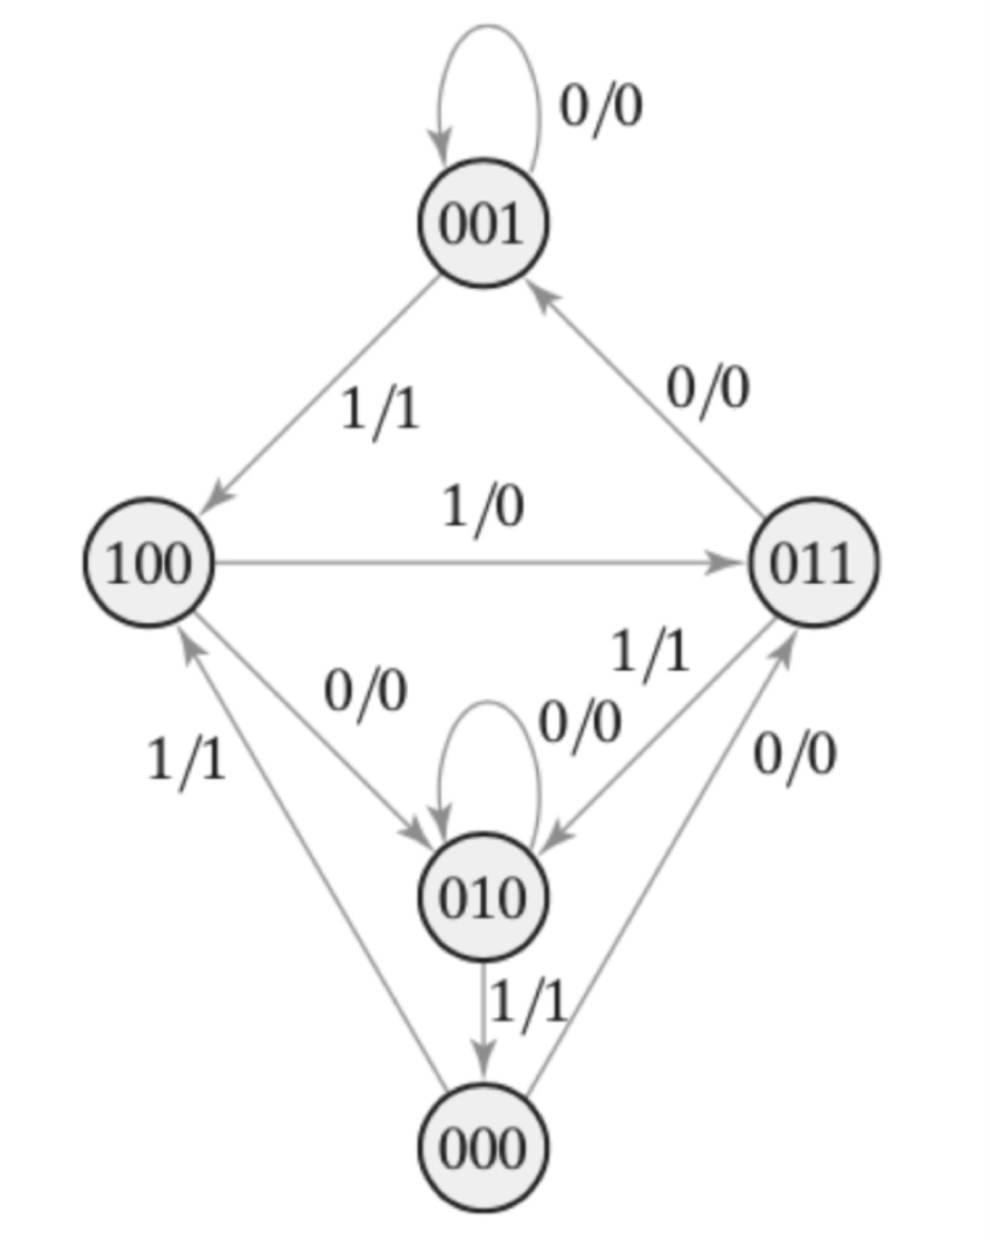
The circuit has three flip-flops A, B, C; one input x; and one output y. The circuit is to be designed by treating the unused states as don’t-care conditions. Analyze the circuit obtained from the design to determine the effect of the unused states. Use JK flip-flops in the design. [3 marks]

Solution:
Q (t) Q ( t = 1 ) | J k
0 0 | 0 X
0 1 | 1 X
1 0 | X 1
1 1 | X 0

Frist we use J = 0 and K = X in the excitation table for a JK flip-flop when the current state Q(t) = 0 and the next state Q(t+1) = 0 to keep the state unchanged.
 | Present State |  |  |  | Next State |  |  | Flip-Flops Inputs
 | A | B | C | X | A(t+1) | B(t+1) | C(t+1) | J_{A} | K_{A} | J_{B} | K_{B} | J_{C} | K_{C}
0 | 0 | 0 | 0 | 0 | 0 | 1 | 1 | 0 | X | 1 | X | 1 | X
1 | 0 | 0 | 0 | 1 | 1 | 0 | 0 | 1 | X | 0 | X | 0 | X
2 | 0 | 0 | 1 | 0 | 0 | 0 | 1 | 0 | X | 0 | X | X | 0
3 | 0 | 0 | 1 | 1 | 1 | 0 | 0 | 1 | X | 0 | X | X | 1
4 | 0 | 1 | 0 | 0 | 0 | 1 | 0 | 0 | X | X | 0 | 0 | X
5 | 0 | 1 | 0 | 1 | 0 | 0 | 0 | 0 | X | X | 1 | 0 | X
6 | 0 | 1 | 1 | 0 | 0 | 0 | 1 | 0 | X | X | 1 | X | 0
7 | 0 | 1 | 1 | 1 | 0 | 1 | 0 | 0 | X | X | 0 | X | 1
8 | 1 | 0 | 0 | 0 | 0 | 1 | 0 | X | 1 | 1 | X | 0 | X
9 | 1 | 0 | 0 | 1 | 0 | 1 | 1 | X | 1 | 1 | X | 1 | X
10 | 1 | 0 | 1 | 0 | X | X | X | X | X | X | X | X | X
11 | 1 | 0 | 1 | 1 | X | X | X | X | X | X | X | X | X
12 | 1 | 1 | 0 | 0 | X | X | X | X | X | X | X | X | X
13 | 1 | 1 | 0 | 1 | X | X | X | X | X | X | X | X | X
14 | 1 | 1 | 1 | 0 | X | X | X | X | X | X | X | X | X
15 | 1 | 1 | 1 | 1 | X | X | X | X | X | X | X | X | X
Next State the Table

 | 00 | 01 | 11 | 10
00 | 0 | 1 | 1 | 0
01 | 0 | 0 | 0 | 0
11 | X | X | X | X
10 | X | X | X | X

 | 00 | 01 | 11 | 10
00 | X | X | X | X
01 | X | X | X | X
11 | X | X | X | X
10 | 1 | 1 | X | X

 | 00 | 01 | 11 | 10
00 | 1 | 0 | 0 | 0
01 | X | X | X | X
11 | X | X | X | X
10 | 1 | 1 | X | X
 | 00 | 01 | 11 | 10
00 | X | X | X | X
01 | 0 | 1 | 0 | 1
11 | X | X | X | X
10 | X | X | X | X
K_{A} = 1
J_{A} = B’X
K_{B} = C’x + CX’
J_{B} = A + C’X’

 | 00 | 01 | 11 | 10
00 | 1 | 0 | X | X
01 | 0 | 0 | X | X
11 | X | X | X | X
10 | 0 | 1 | X | X

 | 00 | 01 | 11 | 10
00 | X | X | 1 | 0
01 | X | X | 1 | 0
11 | X | X | X | X
10 | X | X | X | X

K_{C} = X
J_{C} = AX + A’B’X’

Logic Diagram:
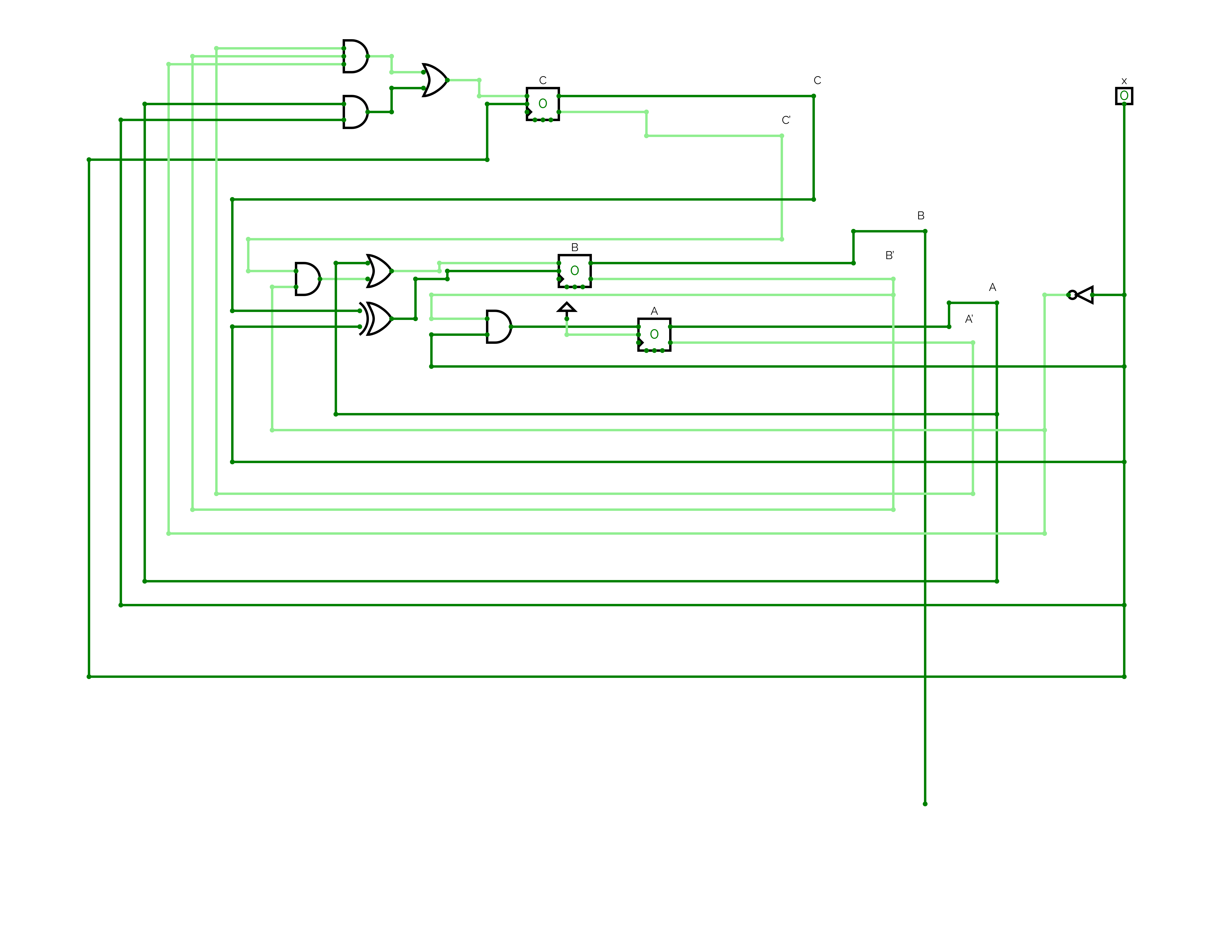

https://circuitverse.org/simulator/embed/project-dld-3-1f2459bd-c349-4a23-96db-f70d3c6c76b9

