Part 1 DFS Setup

1. Add an additional 10 GB drive to the FS01 and FS02 VMs.

NOTE: **** Perform further steps in Part 1 lab on the FS01 VM ****

2. Create a partition and format it as NTFS. Then, share out Drive E: as Catalog

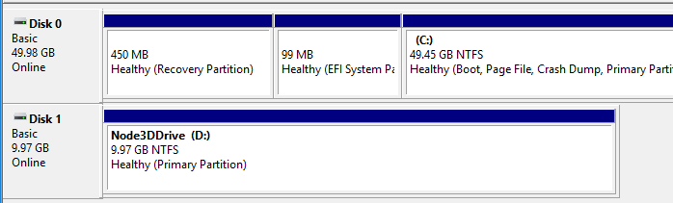

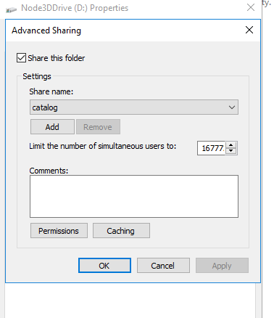

3. Add the DFS Namespace feature using Server Manager.

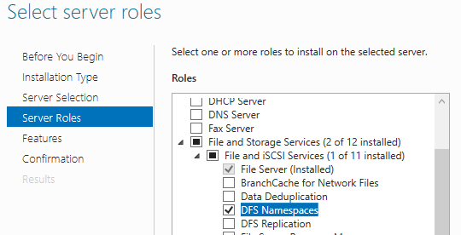

4. Create a new namespace

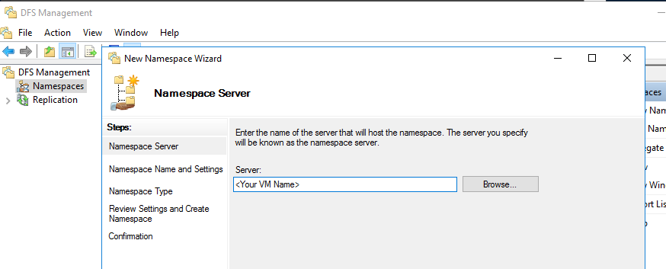

5. Choose the name for the namespace

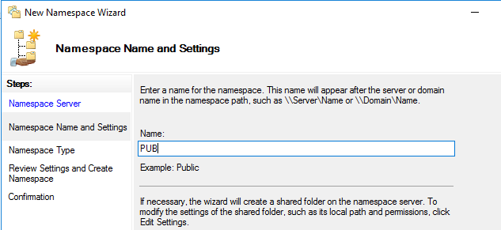

6. Select domain-based namespace

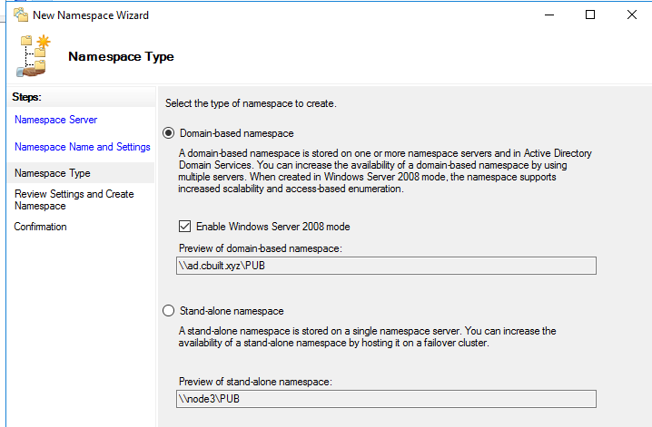

6. The namespace is created at this point.

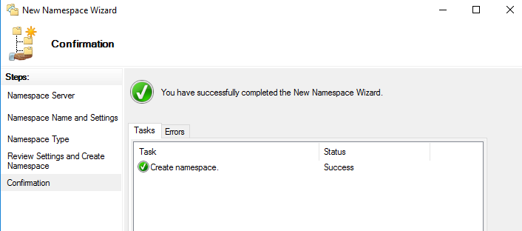

7. Examine the namespace and namespace server . NODE3 is used in this example, but should you see your own VM from Step 1 here.

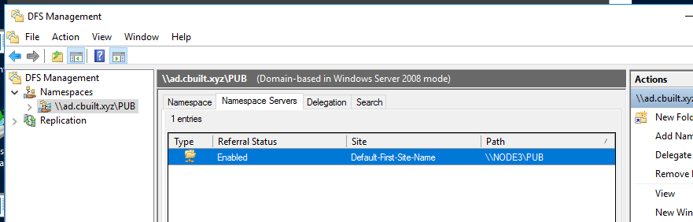

You should also see that there is a folder DFSRoots\PUB created on the C: drive of the VM.

8. In DFS GUI, add a new target folder using the name Catalog.

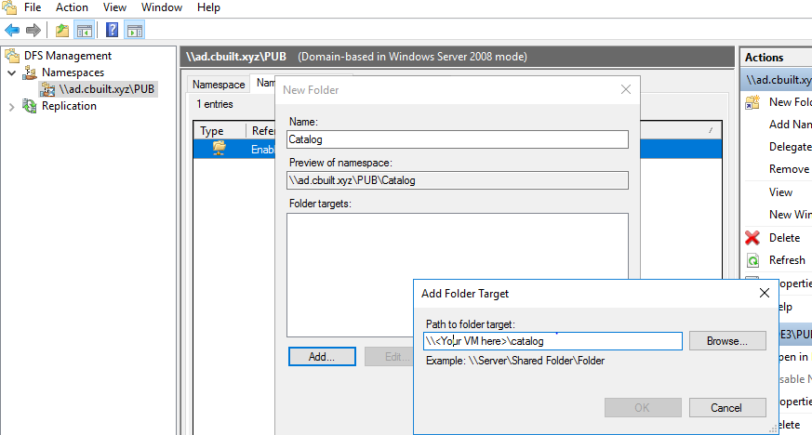

9. Make sure the Catalog namespace is created.

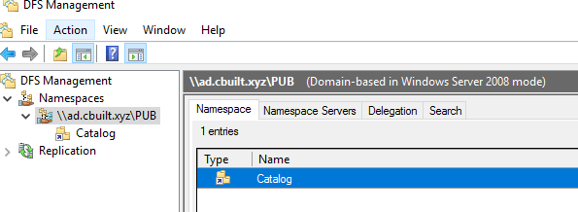

10. Now, let's test DFS namespace by copying a file into E:\ and access it from another Windows Explorer with \\DOMAINNETBIOSNAME\PUB\CATALOG . If you see the file, your DFS is working properly.

11. Download a zip file of images to to E:\ and unzip the pix.zip file to E:\pix.

D:\> invoke-webrequest -uri "<https://archive.org/compress/brooklynmuseum-o17617-mustard-seed-garden-a-chinese/formats=JPEG&file=/brooklynmuseum-o17617-mustard-seed-garden-a-chinese.zip>" -outfile pix.zip

You may choose any other files you'd like. This is just a test data.

Part 2 Setting up Azure File Share

1. Log in to the Azure portal and create a storage account.

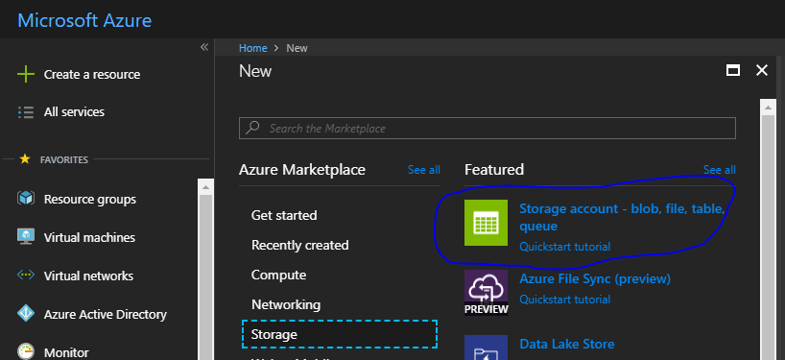

2. Enter the details for the storage account. Remember to select "***Canada Central***" as the location.

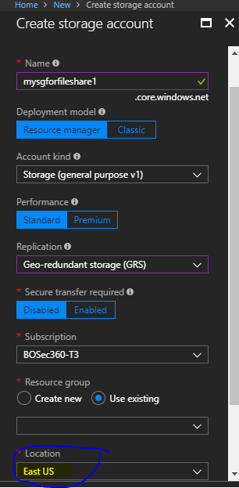

3. Locate the storage account and create a file share in it.

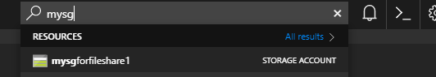

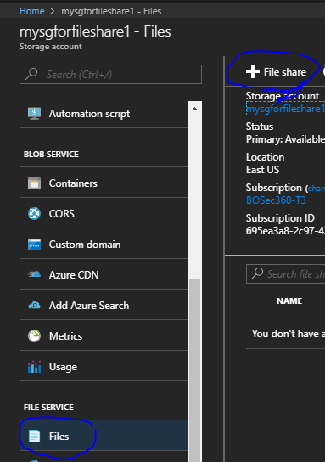

4. Enter a name for your file share and use 500 GB as quota.

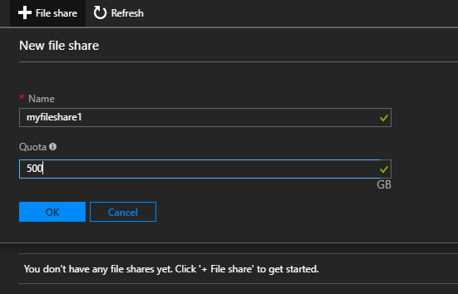

5. An empty file share is created at this point.

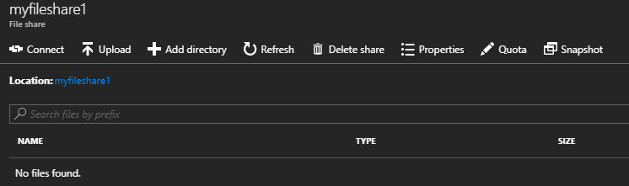

Part 3 Working with Azure File and Snapshot

1. Get your storage key, open a powershell window, and save it to a powershell variable

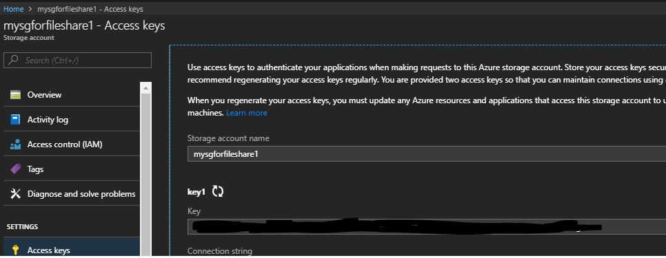

PS C:\>$key=<Your key from the portal>

NOTE: *** Perform the rest of the steps in this Part 3 lab on the FS01 VM***

2. Download a copy of azcopy to FS01, <http://aka.ms/downloadazcopy>

E:\>invoke-webrequest -uri "<http://aka.ms/downloadazcopy>" -outfile azcopy.msi

3. Upload files from e:\pix to Azure file

C:\Program Files (x86)\Microsoft SDKs\Azure\AzCopy>./AzCopy /Source:e:\pix /Dest:https://mysgforfileshare1.file.core.windows.net/myfileshare1 /DestKey:$key /Pattern:"brooklynmuseum-*vol1*"

How many files were copied? __________

4. In the same Powershell window, install the Azure Powershell Module.

PS C:\>Install-Module AzureRM

5. Display information of a file share and create a snapshot of it.

$ctx = New-AzureStorageContext -StorageAccountName mysgforfileshare1 -StorageAccountKey $key

PS C:\> $share=Get-AzureStorageShare -Context $ctx -Name myfileshare1yfileshare1

PS C:\> $share

PS C:\> $share.properties

PS C:\> $share.Snapshot()

6. List snapshots of a file share

PS C:\> Get-AzureStorageShare -context $ctx

File End Point: <https://mysgforfileshare1.file.core.windows.net/>

Name LastModified IsSnapshot SnapshotTime

---- ------------ ---------- ------------

myfileshare1 3/15/2018 8:39:38 PM +00:00 ***True*** 3/17/2018 10:54:31 PM +00:00

myfileshare1 3/15/2018 8:39:38 PM +00:00 False

7. List the contents of a snaphot

PS C:\> $snapshot = Get-AzureStorageShare -Context $ctx -Name myfileshare1 -SnapshotTime "3/17/2018 10:54:31 PM +00:00"

PS C:\> Get-AzureStorageFile -Share $snapshot

8. Download a file from the snapshot

PS C:\> $download='d:\'

PS C:\> $file="brooklynmuseum-o17617i008-05.583_vol1_8_PS2.jpg"

PS C:\> Get-AzureStorageFileContent -Share $snapshot -Path $file -Destination $download

PS C:\> dir d:\

8. Download entire contents of the snapshot

PS C:\> Get-AzureStorageFile -Share $snapshot | Get-AzureStorageFileContent -Destination $download

PS C:\> dir d:\

9 . Copy the command to map your file share from the portal to the FS01 server from the portal

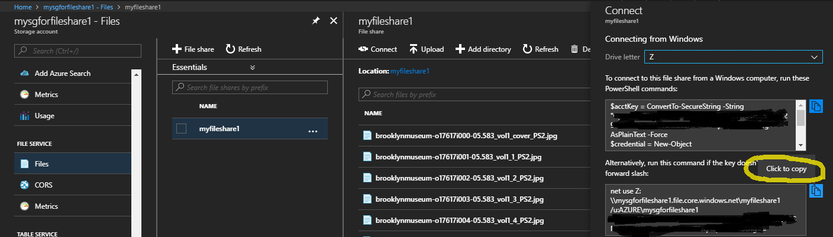

On the FS01 server, past the command into a Powershell window.

PS C:\> net use Z: \\mysgforfileshare1.file.core.windows.net\myfileshare1 /u:AZURE\mysgforfileshare1 <STORAGE ACCOUNT KEY>

Right click on Drive Z: and select "Restore previous versions". This allows for a restore directly from Azure File Snapshots.

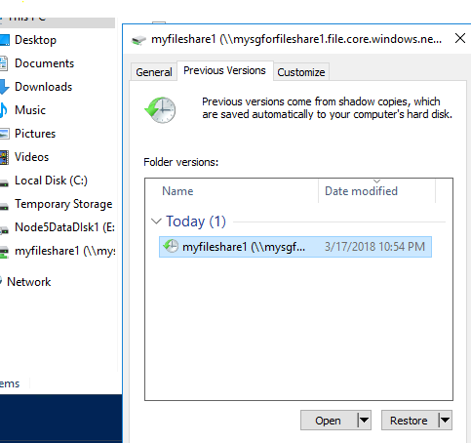

10. Create 300 more shapshots of the fileshare.

PS C:\> $loop=1..300

PS C:\> foreach ($i in $loop) { $snapshots.Snapshot() }

How many were created?_________________________

11. Delete all snapshots of the file share.

c:> $snapshots = Get-AzureStorageShare -context $ctx | where { ($_.IsSnapshot -eq$True) }

c:> foreach ($snap in $snapshots) {

Write-Host "Removing" $snap $snap.snapshottime

Remove-AzureStorageShare -Share $snap

}

12. Make sure all snaphosts have been deleted.

c:>$snapshots = Get-AzureStorageShare -context $ctx

c:>$snapshots

Part 4 Integrate Azure File Share with Active Directory

1. On ADDC, launch PowerShell for Active Directory.

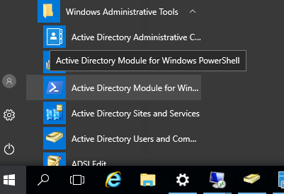

2. Add two users, Nick and Tim, to the domain.

PS C:\> New-ADUser -SamAccountName nick -Name "nick" -UserPrincipalName nick@<*FQDN*> -AccountPassword (ConvertTo-SecureString -AsPlainText "**Pass@word@zure1**" -Force) -Enabled $true -PasswordNeverExpires $true -Path 'CN=Users,DC=<*domain*>,DC=<d*omain extention*>' -server <*AD server name*>

PS C:\> New-ADUser -SamAccountName tim -Name "tim" -UserPrincipalName tim@<*FQDN*> -AccountPassword (ConvertTo-SecureString -AsPlainText "**Pass@word@zure1**" -Force) -Enabled $true -PasswordNeverExpires $true -Path 'CN=Users,DC=<*domain*>,DC=<d*omain extention*>' -server <*AD server name*>

3. Grant **Nick and Tim** the access to login through remote desktop on all computers.

- On ADDC, launch group policy editor and right click on "Local Users and Groups" then select New->Local Group to update the local "Remote Desktop Users" group.

- Make sure you type in "Remote Desktop Users" instead of selecting from the drop- down menu.

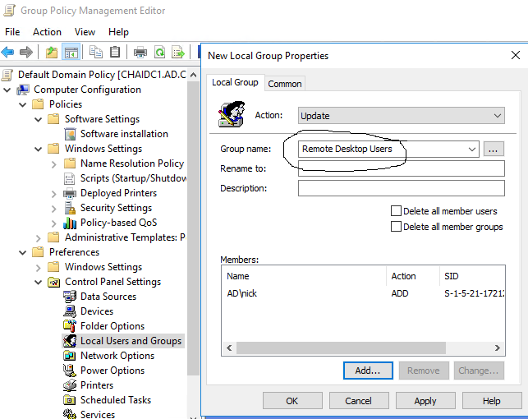

4. On FS01, grant Nick and Tim full-control right for E:\Pix

5. On FS01, create a text file with NotePad, type "Azure File Lab" in it, and save it to E:\pix\lab.txt.

Part 5 Set up Azure File Sync

1. In the Azure Portal, create a new storage sync service.

Click + Create a resource-> Storage-> and Azure File Sync(Preview)

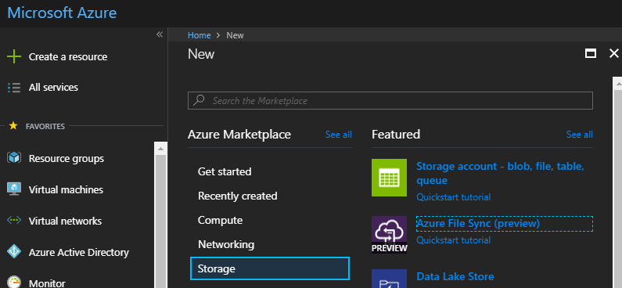

2. Name your Storage Sync Group with <YourInitial>StorageSync, select the existing resource group, and use Canada Central as the location

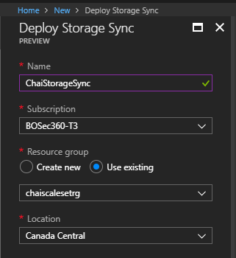

3. Add a sync group

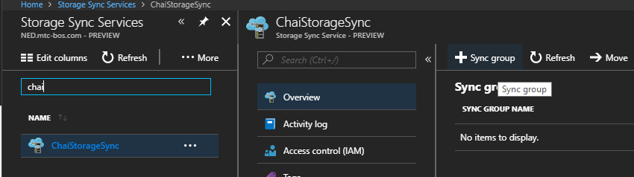

4. To create a sync group, enter sync group details and click Create button. Make sure to select "**myfileshare1**" for Azure File Share. If you dont see it, stop now and ask the facilitator.

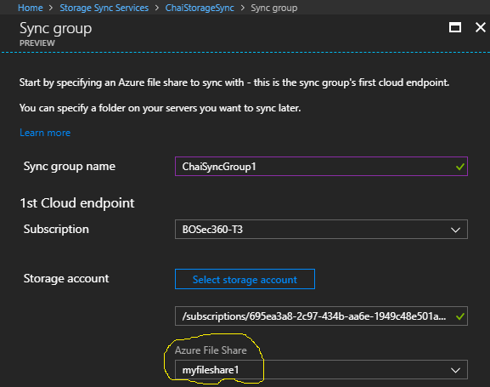

5. Download the Azure File Sync Agent from <https://www.microsoft.com/en-us/download/details.aspx?id=55988> and install it on FS01.

6. The installation process should automatically launch the server registration. When you get to this screen, make sure to select the your own correct resource group and sync group to complete the registration process.

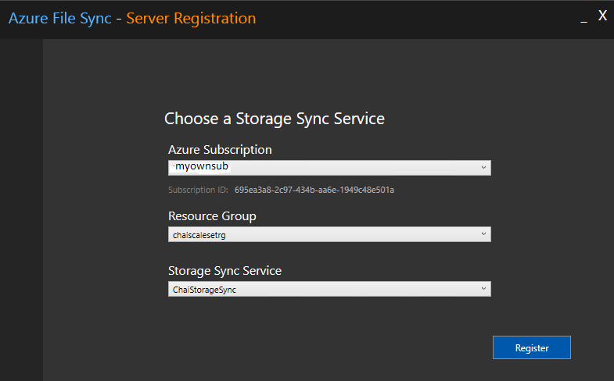

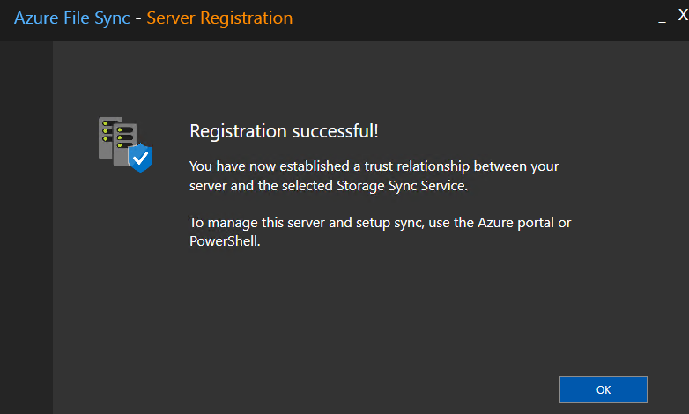

7. From the Azure Portal, add a server endpoint. USer E:\pix as path, enable cloud tiering, and specify 99% free space.

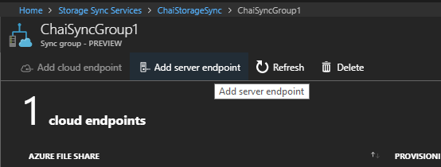

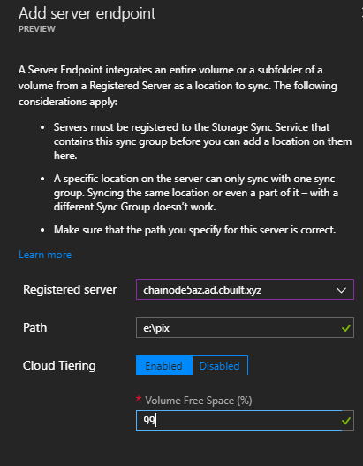

9. Throttle bandwidth of Sync Agent with Powershell.

PS C:\>Import-Module "C:\Program Files\Azure\StorageSyncAgent\StorageSync.Management.ServerCmdlets.dll"

PS C:\> get-command | findstr StorageSync

PS C:\>New-StorageSyncNetworkLimit -Day Monday, Tuesday, Wednesday, Thursday, Friday -StartHour 9 -EndHour 17 -LimitKbps 5000

Part 6 End User Experience

1. Log into Windows 10 and domain join to AD Forest

On the Win10 client, log on as ad\Nick and map a network drive.

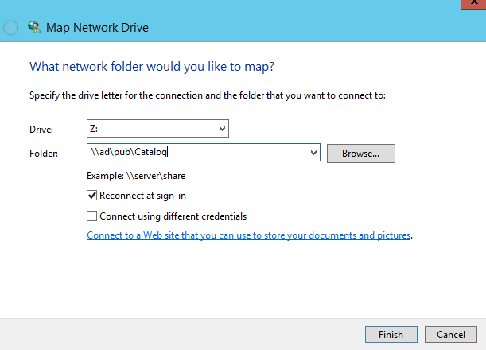

2. On Win10, examine the properties of the first file in z:\pix. The PLO attributes indicate that a file has been tiered by File Sync agent. The grayed-out icon of a file also offers a quick way to tell that the file is offline.

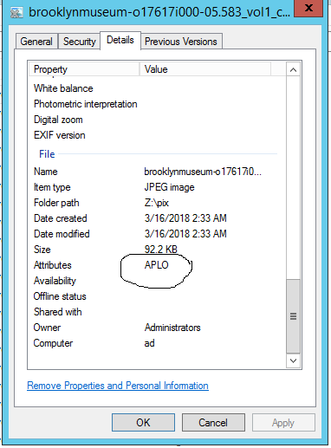

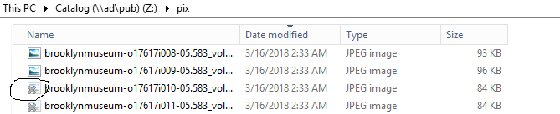

Do any of your files have APLO attribute? ______________________

Part 7 Seeding a new file server and adding DFS-N node

1. On FS02, log on as user with administrative right, NTFS format an available drive and assign E:\ as the drive letter.

2. Create a folder E:\pix

NOTE: *** If FS02 is on W12R2, you will need to download WMF 5.1 and install it before proceeding.

3. Download the File Sync Agent to FS02 , lauch the installation, and finish the server registration.

4. In the Azure Portal, add a FS02 as a new server endpoint in the sync group.

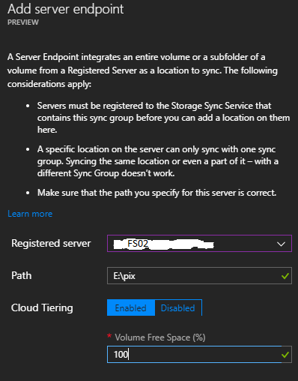

5. Your sync group should have two server endpoints at this point. The information to throttle the AFS agent network bandwith comsumption is at the end of Part 5.

6. on FS02, share E:\ drive as Catalog. It will be configure as a new folder target for DFS.

7. On FS01 (DFS nameserver), launch DFS Management MMC and click on Add folder target. Do not create a replication group.

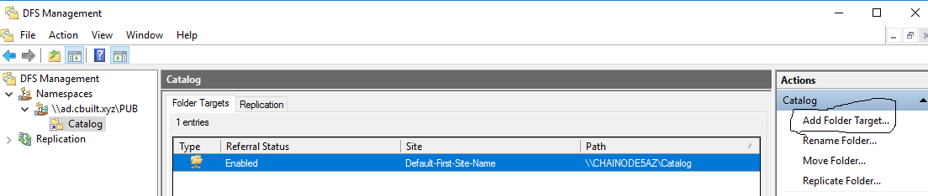

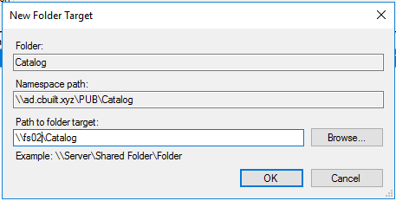

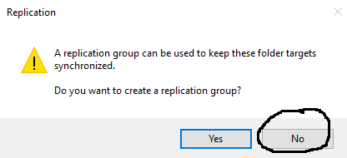

Note: **** Azure File Sync keeps contents of the target folders in sync.*****

8. Map Z: drive to \\ad\pub\catalog, and right click to show the Properties of the Pix folder.

- Click on the DFS tab, select \\FS02\Catalog and set it "Active". This forces DFS namespace \\ad\pub\catalog\ to use the FS02 target folder for lab purpose only.

NOTE: At this point the \\ad\pub\catalog DFS namespace on Win10 is active on FS01. FS02 is also using the same namespace but point it to itself. The contents of E:\pix on FS01 and FS02 are replicated by AFS.

Part 8 Backup of Azure File Share

1. In the Azure Portal Create a Backup and Site Recovery

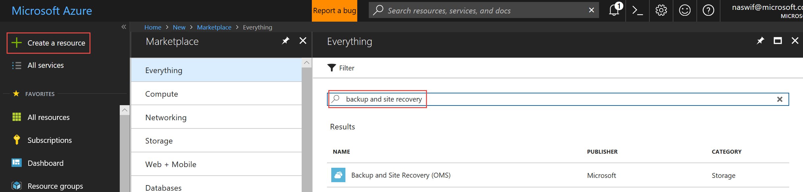

1. Enter configuration for the Backup and site recovery, be sure to create in Canada Central

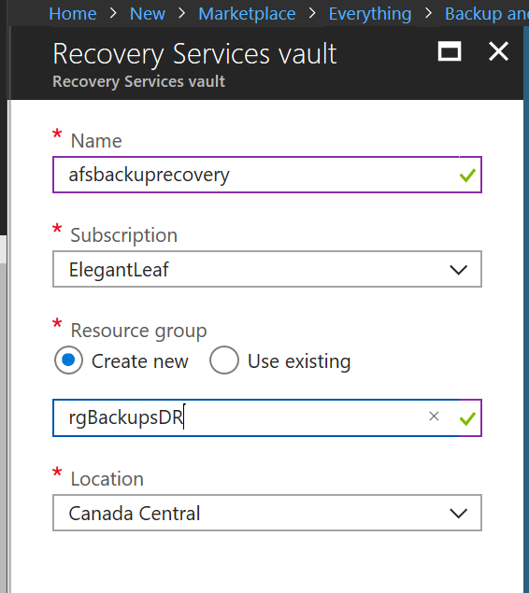

1. Configure the Backup and site recovery vault further – Getting started blade , choosing Azure and Azure Fileshare

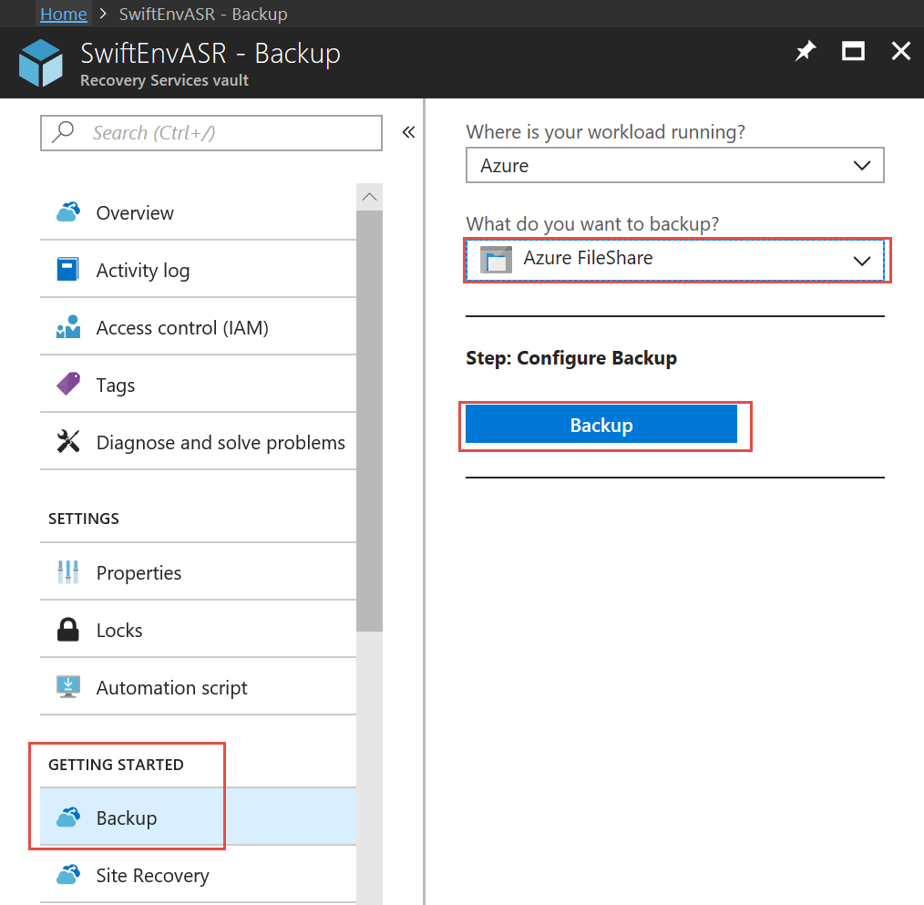

1. Choose the Storage Account created earlier to host Azure File Share

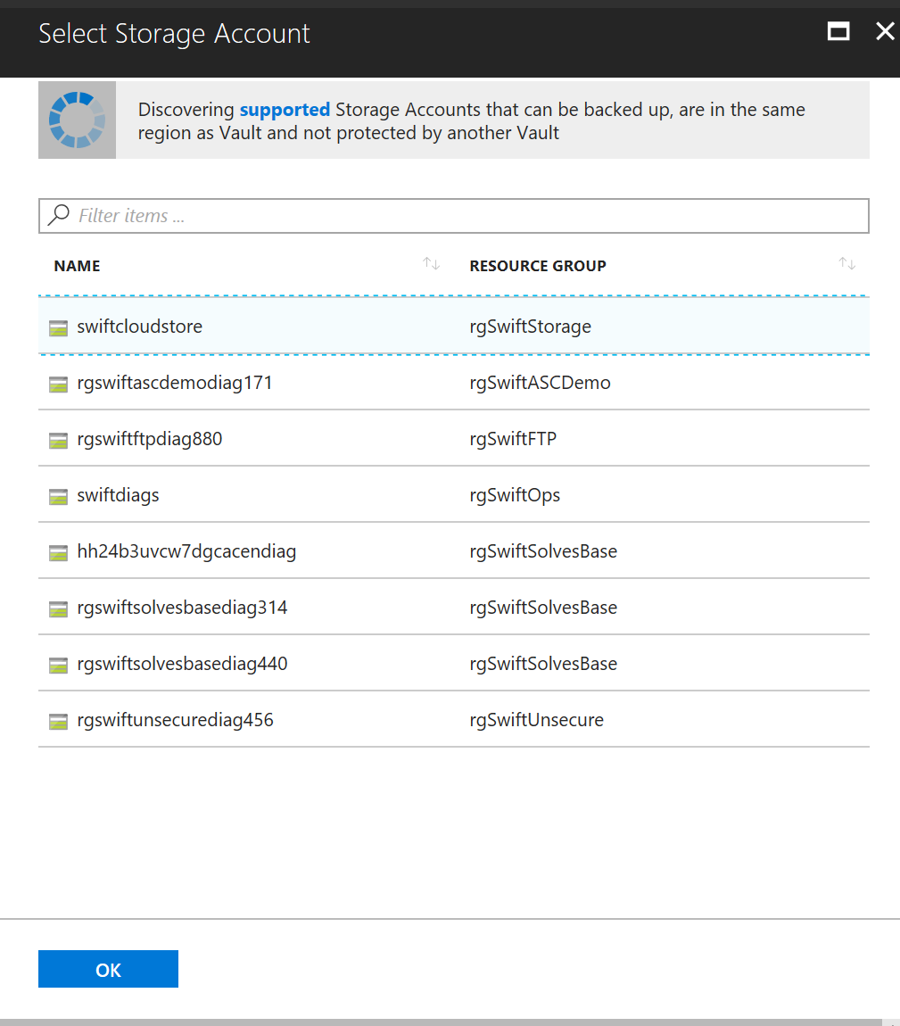

1. Select your Azure File Share
2. Choose the default Backup policy or create a daily backup policy with a 7 day retention,
3. Choose Backup items, Azure Storage (Azure Files)

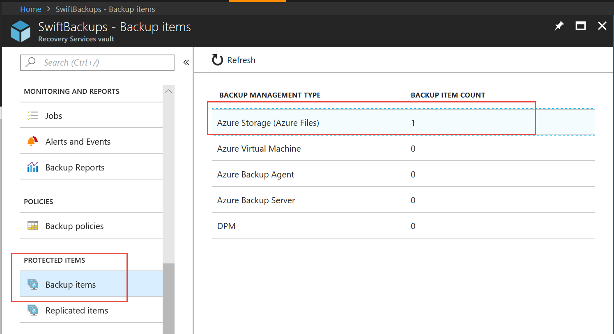

1. Choose the 3 little ellipses … net to the share and choose Backup Now

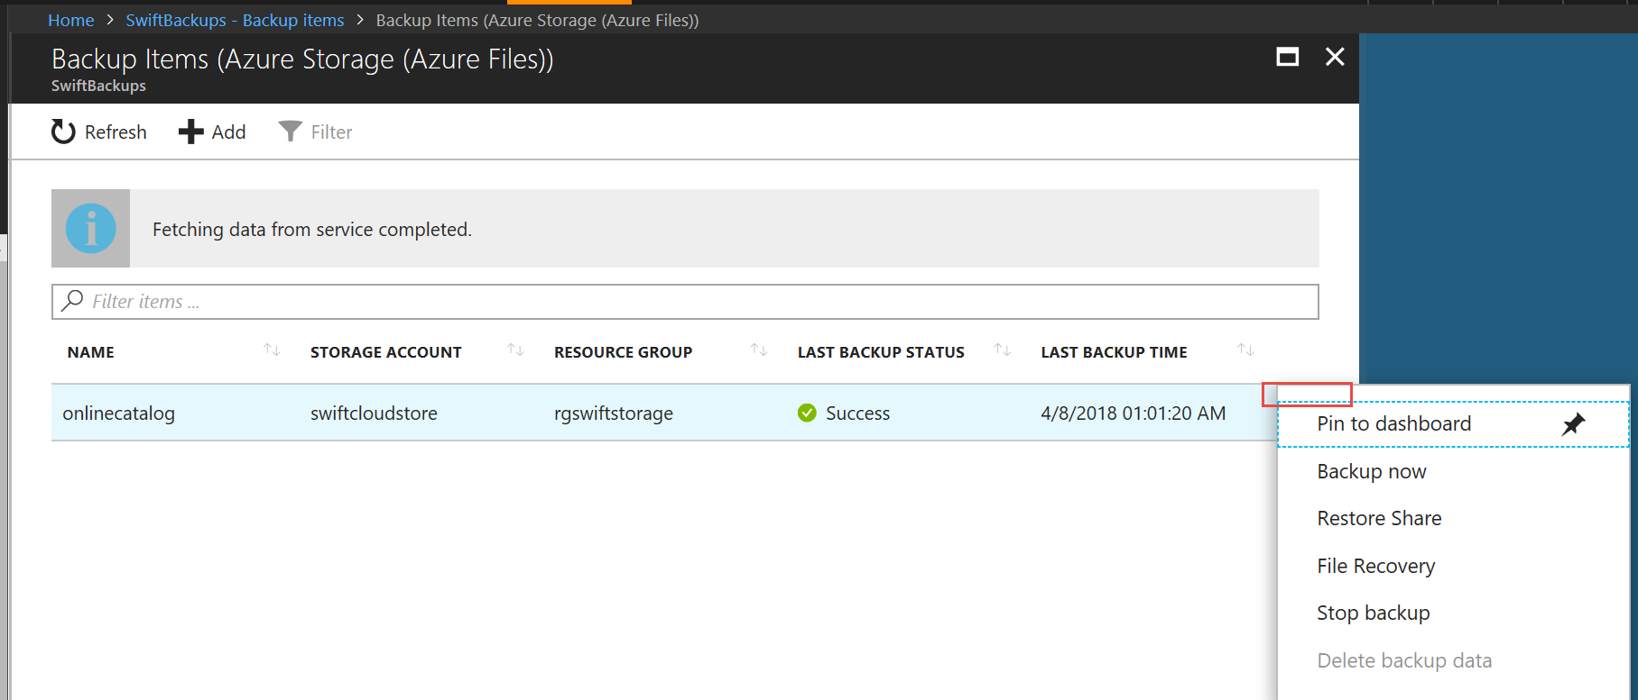

1. Once Backup is completed we test the following scenarios
   1. Modify a file on a file server, open image and paint on it and save, delete another file.
   2. Restore from Azure File Snapshots
   3. Restore from Azure Backup
   4. Restore from a file server – Previous Versions

Part 9 Operations

1. Install Log Analytics – in East US
2. Configure Log Analytics to install on both FS01 and FS02
3. [Download](https://aka.ms/dependencyagentwindows) and Install the Service Map agent on FS01 and FS02
4. Configure Log analytics: Settings – Data – Windows Event Logs: enter ***Microsoft-FileSync-Agent/Telemetry*** and add.

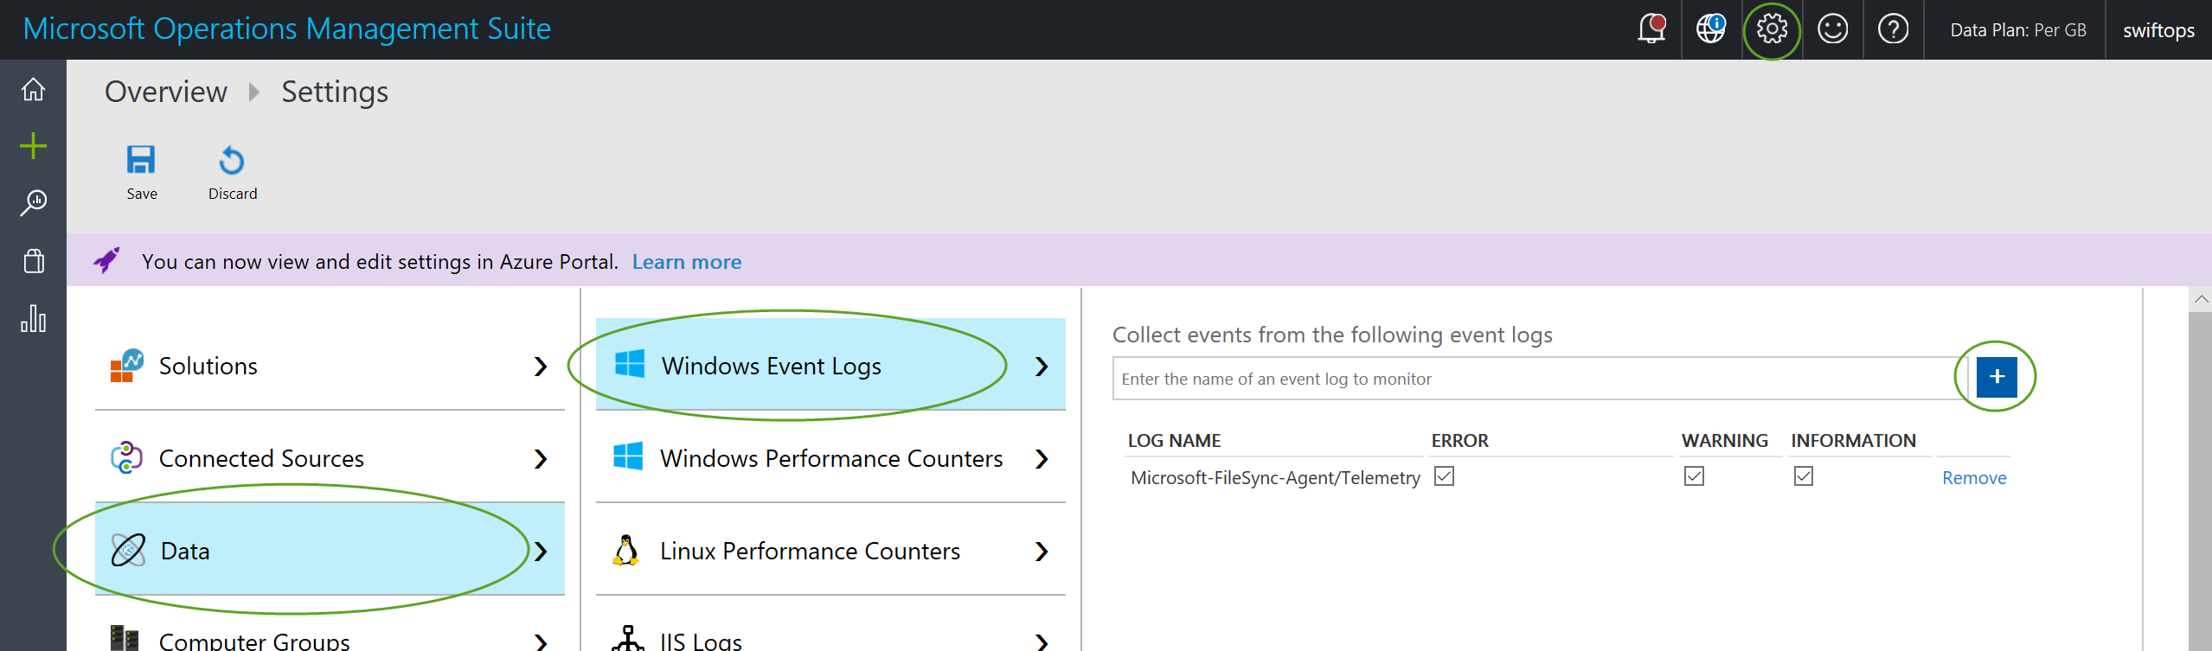

1. GoTo Log Search and create a Query:

search *

| where ( Type == "Event" )

| where ( EventID == 7006 )

| where ( RenderedDescription !has "Sync batch upload completed. Transferred 0 file" )

Save Query as AFS Jobs in a Category called AFS.

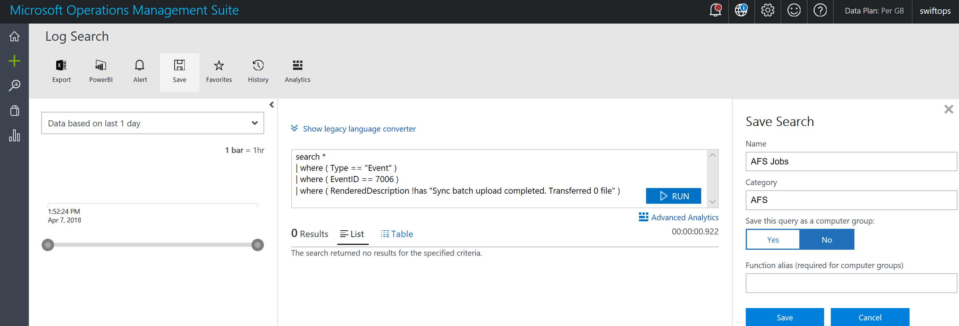

Part 10 Just in Time Access

1. Goto Azure Security Center – Pricing Tier – Standard 60 Day Free Trial
2. Goto Just in time VM Access blade, Recommended Tab and apply to VMs FS01,FS02,ADDC,Win10, review NSG security rules
3. Spin up Linux Cent-OS VM in Canada Central Request Just in Time VM Access – review NSG security rule

Part 11 Linux Azure Blob Fuse Adapter

1. Spin up Linux Cent-OS VM in Canada Central on Virtual Network
2. [Install](https://github.com/Azure/azure-storage-fuse/wiki/1.-Installation) bits
3. [Configure](https://github.com/Azure/azure-storage-fuse/wiki/2.-Configuring-and-Running)