**Business Problem**

In recent years, both City Hotel and Resort Hotel have experienced elevated cancellation rates. These cancellations have led to several challenges for each hotel, such as reduced revenue and suboptimal utilization of hotel rooms. As a result, the primary objective for both hotels is to decrease their cancellation rates. This reduction is essential to enhance revenue generation efficiency. Our role is to provide comprehensive business recommendations to tackle this issue effectively. This report focuses on the analysis of hotel booking cancellations, along with other factors unrelated to their core business, that impact annual revenue generation.

**Assumptions**

1. No significant unusual events occurred between 2015 and 2017 that would substantially impact the utilized data.
2. The provided information remains up-to-date and suitable for an efficient analysis of potential hotel strategies.
3. There are no unforeseen drawbacks to the implementation of any recommended techniques by the hotels.
4. The suggested solutions are not currently in use by the hotels.
5. The most influential factor affecting revenue generation is the occurrence of booking cancellations.
6. Cancellations lead to unoccupied rooms for the originally booked duration.
7. Customers typically make hotel reservations in the same year as their cancellations.

**Research Questions**

1. What are the variables that affect hotel reservation cancelations?
2. How can we make hotel reservations cancellations better?
3. How will the hotels be assisted in making pricing and promotional decisions?

**Hypothesis**

1. More cancellations occur when prices are higher.
2. When there is a longer waiting list, customers tend to cancel more frequently
3. Most clients are coming from offline travel agents to make their reservations.

**Analysis**

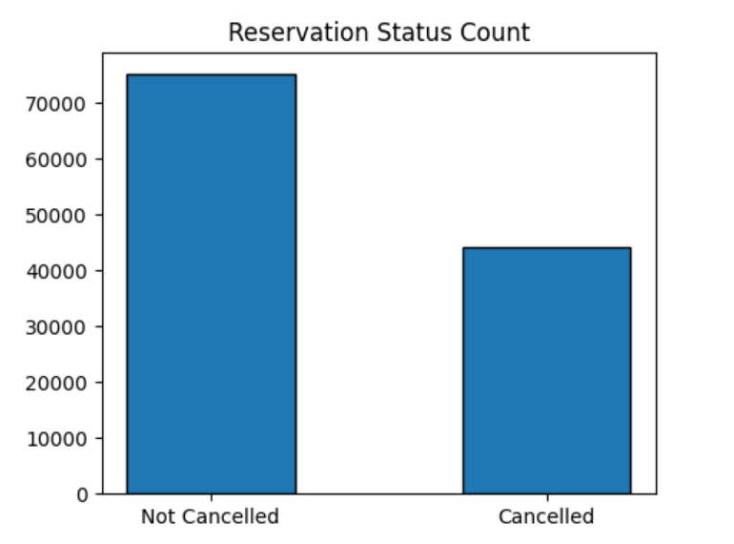

The initial bar graph depicts the overall reservation status for both canceled and non-canceled bookings. The graph notably illustrates a substantial count of reservations that have not been canceled. Nonetheless, it's essential to recognize that the percentage of canceled reservations stands at 37%. This percentage signifies a significant impact on the hotel's earnings, underscoring the importance of addressing the cancellation rate.

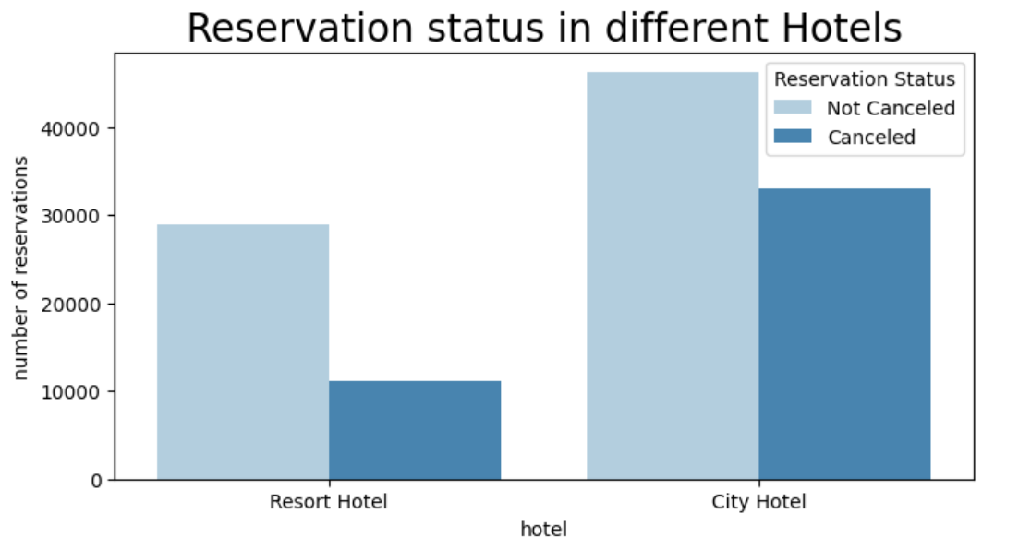

The second bar graph reveals a notable disparity between resort hotels and city hotels in terms of booking volumes. City hotels exhibit a higher number of bookings in comparison to resort hotels. This observation raises the possibility that resort hotels may be comparatively more expensive than their urban counterparts.

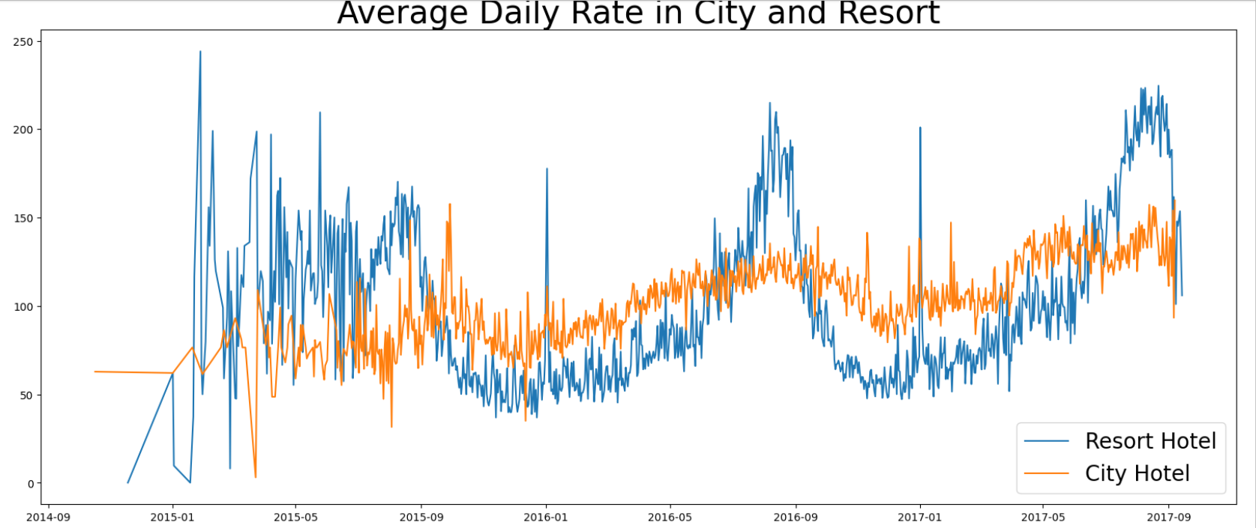

The provided line graph illustrates fluctuations in the average daily rate between city hotels and resort hotels. On specific days, the average daily rate for city hotels is lower than that of resort hotels, and on certain other days, it is even further reduced. Notably, weekends and holidays are likely to witness an increase in the average daily rate for resort hotels, suggesting a potential pattern of pricing adjustments.

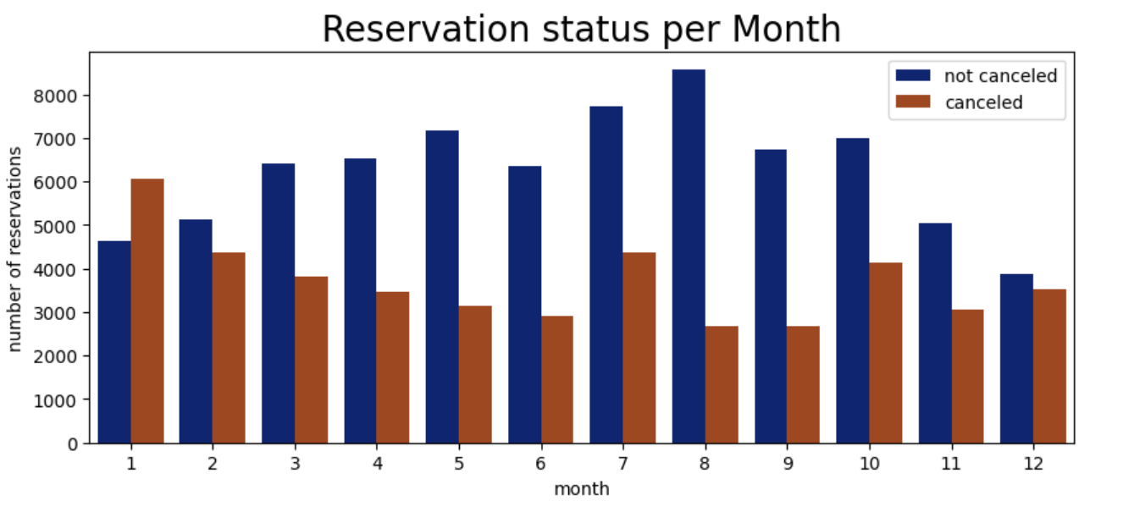

We have constructed a grouped bar graph to examine the months with the highest and lowest reservation counts based on their reservation status. It is evident from the graph that the highest count of non-canceled reservations occurs in the month of August, while January registers the highest count of canceled reservations.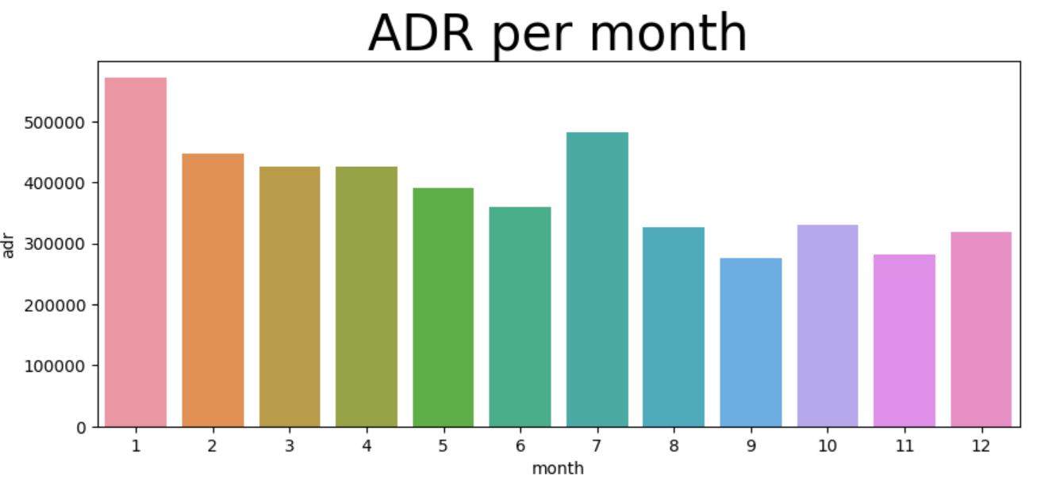  
Referring to the preceding graph that exclusively focuses on canceled reservation data, we have depicted the Average Daily Rate (ADR) on a monthly basis. The presented bar graph illustrates a clear trend: cancellations are most prevalent when accommodation prices are at their highest and are least frequent when prices are at their lowest. This observation suggests a direct correlation between the cost of accommodation and the occurrence of cancellations.

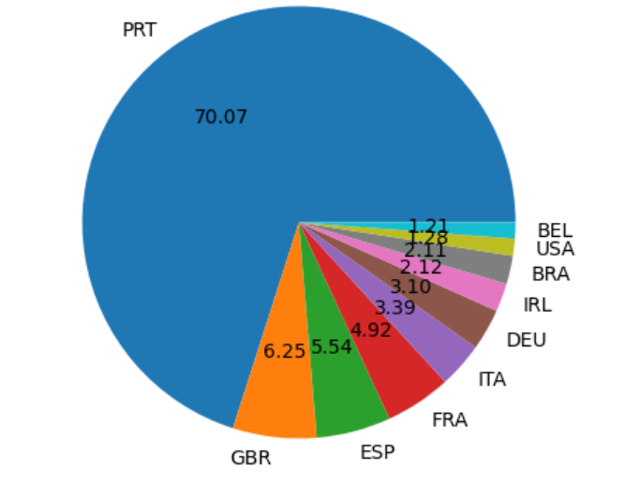

Moving on, let's examine which country holds the highest count of canceled reservations. The leading country in this regard is Portugal, as indicated in the pie chart above.

Now, let's explore the source of guests who are making hotel reservations and visiting. We'll examine whether these reservations originate from Direct bookings, Group bookings, Online channels, or Offline Travel Agents.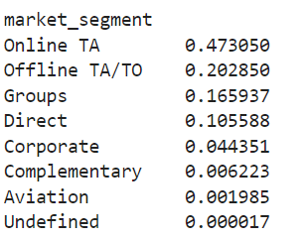  
Based on the analysis results, it can be observed that approximately 47% of the clients make their reservations through online travel agencies. Additionally, around 16% of clients come from group bookings. Interestingly, a mere 10% of clients choose to directly visit the hotels for making their reservations.

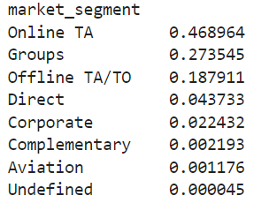

However, when considering only the cancelled reservations, it is approximately inferred that the Online Platform had the most cancellations (around 47%), while direct bookings had the least cancellations (approximately 4%).

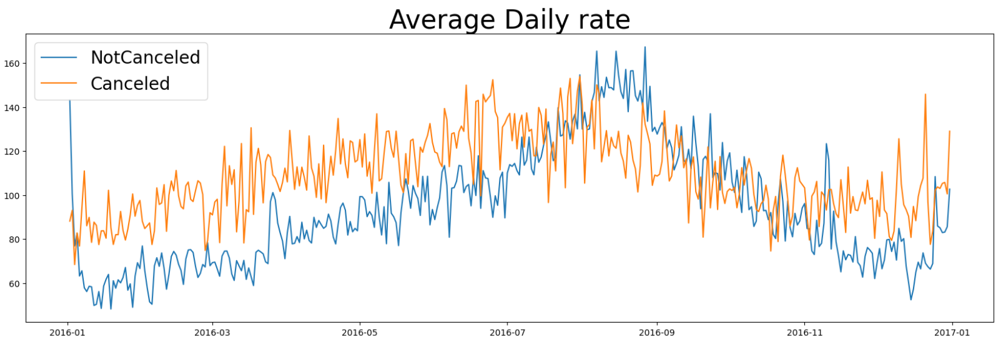

As observed in the graph, reservations tend to be canceled when the average daily rate is higher compared to cases where the reservation is not canceled. This observation strongly supports all the preceding analyses, indicating that higher prices are associated with a greater likelihood of cancellations.

**Suggestions**

1. Cancellation rates tend to increase alongside higher prices. To mitigate reservation cancellations, hotels could focus on refining their pricing strategies, exploring options to lower rates for specific locations, and potentially offering discounts to customers.
2. Given the higher ratio of cancellations for resort hotels compared to city hotels, it's recommended for hotels to consider offering reasonable room price discounts during weekends or holidays to incentivize bookings and reduce cancellations.
3. In January, hotels could consider launching targeted campaigns or marketing initiatives with attractive offers to boost revenue, especially given the higher cancellation rate during this month.
4. To decrease cancellation rates, hotels might consider enhancing the quality of services and accommodations in the Portugal location, aiming to provide an experience that aligns better with customer expectations.
5. Addressing the higher cancellation rate for Online Bookings, it's advisable for hotels to ensure that the information provided on online platforms is comprehensive and accurate. This can help manage customer expectations and prevent dissatisfaction stemming from discrepancies between expectations and actual services provided at the hotel.