1: What is wellbeing for you?
 | P1: Romwell Calma | P2: Katja Anneli Warwick Smith | P3: Dionne Sears | P4: Julie Melville | P6: Alicia Ishkhanian | P7: Nausheena Athar Hurzuk
Transcript | "For me, well being... it's the one inside of you, because once you feel like you're simply happy contented it will exude out your personality... it's a continuous cycle of being better." | "To me, well-being is really all about feeling reasonably content and able to cope with the stresses, whatever those stresses are... despite all of that, having the Happy Tuesdays and the happy Wednesdays." | "When I think of well-being from that clinical social work lens, its wholeness right it incorporates. All the pillars... being in a place where you are managing those different areas very happily, very contently in a place that feels. Safe for you." | "For me it's about balance, Wellness is about balance... it's also about my ability to participate in society in the roles that are important to me... not where someone else thinks I should be, but where I think I should be." | "For me, while being is not just an individual thing, it's also very holistic and very collective within the dynamics that we live in... the relationship within the family, within the society, the close circles and the friends, and how it all affects each other." | "If we consider their well-being, we need to be considered their physical, social and. Mental health." She notes that for the younger generation, these three perspectives are crucial.
Notes Summary | Balance; what's inside of you; a continuous cycle of being better. | Feeling of content and the ability to cope. | Wholeness; managing all things happily. Balance on where you are and how things should be. | The ability to participate in society in roles that are meaningful to the individual. It's about balance, but a balance that shifts based on personal priorities. | A holistic and dynamic concept; it's a spectrum of self-reflection and subjective balance. | It's about looking at things from a social, mental, and physical perspective. For youth, this holistic view is very im

2: When we describe someone as “well,” what do we mean?
 | P1: Romwell Calma | P2: Katja Anneli Warwick Smith | P3: Dionne Sears | P4: Julie Melville | P6: Alicia Ishkhanian | P7: Nausheena Athar Hurzuk
Transcript | "I should be satisfied. I'm well, that's the perception." He describes being grateful for having a stable job and healthy family compared to others in more difficult situations. | "The first question is how are you doing? How is the family? How have the kids been... It effectively goes through all those dimensions, and that's where you create this picture... is it well, or is it not well?" | "Wellness is really something you see externally, but that's truly a reflection of what's happening inside that individual... On the other side, if you physically see someone unwell... that's often also a reflection of what's happening internally." | "I have a friend... who I think I would describe her as well... but equally, I also know some of the background struggles that this person is going through... It's that balance of like... what is Wellness? How do you define it?" | "When I think of someone who is well... one of the first things that comes to mind is stability. And that includes financial and political and social stability... someone who's able to adapt, someone who's flexible and able to take it on." | "For me, you know, Wellness is like how strong you are internally and self-control... if you are internally strong, if you are like, you know emotionally strong. Then of course, you know the person can stand like strong in society."
Notes Summary | Being grateful and satisfied with one's own situation (stable job, healthy family) compared to others facing more hardship. | It's a common question that covers many different dimensions (family, job, health) to create a full picture. | Wellness is how a person presents externally, which is a direct reflection of what's happening internally (physically, mentally, socially). | Wellness is a complex concept. A person can be "well" and happy while also dealing with significant background struggles. It is not simply the absence of illness. | The ability to adapt to life's hardships. How strong you are internally. Having financial and social stability. | How strong you are internally and having self-control. Being emotionally strong allows a person to stand strong in society.

3: How can the 5 pillars contribute to improving your wellbeing?
 | P1: Romwell Calma | P2: Katja Anneli Warwick Smith | P3: Dionne Sears | P4: Julie Melville | P6: Alicia Ishkhanian | P7: Nausheena Athar Hurzuk
Transcript | "Spiritually... a person needs to have something that he or she believes in... that enables them to work towards better... which gives you motivation to just simply leave and be well." | "I really make a conscious effort to have a space when I am not talking. I am not thinking... that is the spiritual aspect... The social pillar is really my family network and without having the contact all the time I'd go bananas." | "The piece that I actually want to focus on is that intellectual pillar... this continuous learning that occurs... When I feel a sense of growth that also empowers me, that also helps me feel accomplished." | "I might seem like I'm that person who's always running... but like actually what it brings to me in all those other pillars is something I could never have... they're a Venn diagram, you know, and and somewhere in the middle, Wellness intersects." | "It is a really wanted direction and relationship between all the pillars and how it's all affecting each other... what is your current pillar that you could rely on that could affect the other ones?" | The pillars are basic teachings in Islam. Social: care begins with family. Physical: eating locally grown food and controlling portions. Intellectual: not judging others. Emotional: balance. Spiritual: brings calmness and compassion.
Notes Summary | The spiritual pillar gives a person beliefs that provide motivation and give value to life. | A person needs space to have their own beliefs. The social pillar (family network) is crucial for a sense of belonging and connectedness. | The intellectual pillar, driven by curiosity and continuous learning, leads to a sense of growth, accomplishment, and wisdom. | The physical pillar (e.g., sport) is connected to all other pillars, creating a community (social), providing emotional balance, and requiring a cognitive element (intellectual). They are not separate pillars but a "Venn diagram." | There is a multidirectional relationship between all the pillars; strengthening one can positively affect the others. | The social pillar begins with family and responsibility. The physical pillar is a priority (health, nutrition). The emotional pillar requires balance. The spiritual pillar fosters purification and
4: Are the HT pillars reflected in the healthcare services currently provided?
 | P1: Romwell Calma | P2: Katja Anneli Warwick Smith | P3: Dionne Sears | P4: Julie Melville | P6: Alicia Ishkhanian | P7: Nausheena Athar Hurzuk
Transcript | "I'm doing or applying all of these things, but at the back of my mind because I expect that it would be done also by others if the rule is reversed... giving back." | "From my perspective, it's not lack of knowledge... The pressures on the system, you have to balance the ethical values of what about the next caller? What if they're in acute crisis... Against have I given this person enough space to talk about it?" | "Part of our issue is actually integration. I think these pillars exist, but they may not be... well integrated within our systems... the psychosocial team that helps us be able to live." | "We are in a privileged position as healthcare providers seeking help, but we understand the system... How do we equalise that for everyone? The people without health literacy, without the knowledge, without the capacity." | "For the five pillars to be reflected in healthcare services, we have to 1st know whether these pillars are reflected in the caregivers themselves... if the caregiver is not able to take care of themselves, how will they be able to provide that space for others?" | "As a parent... getting an appointment within a time when we are sick is a task... Only the front desk... sometimes we don't get guided properly. That was only the drawback... with the physicians, our experiences are really very good."
Notes Summary | The pillars are in place, but there are lapses in utilization. As a provider, he applies them and hopes to receive the same care in return. | The pillars are included in standardized assessments, but the demand on the service vs. available resources forces a quick focus on only the presenting problem. | The system is fragmented and lacks integration. It does a good job with physical health, but the psychosocial aspects (how to live) are what's missing. Practitioners often don't know how to leverage each other's services. | Healthcare is delivered with a "very medical model." The pillars may be implemented for health-literate patients who can demand them, but not for everyone. The system needs to be equalized. | The pillars need to be reflected in the caregivers themselves first. Obstacles like time constraints and long waitlists hinder this process. | As a parent, she finds that while practitioners cover the pillars well, getting a timely appointment is a major issue, and the administrative/front-desk staff do not always guide patients properly.

5: Challenges, Opportunities, and Suggestions for Integrating HT Pillars
 | P1: Romwell Calma | P2: Katja Anneli Warwick Smith | P3: Dionne Sears | P4: Julie Melville | P6: Alicia Ishkhanian | P7: Nausheena Athar Hurzuk
Challenges | Access restrictions based on policies that limit who can access certain services. Scheduling appointments takes a huge amount of time and effort for minimum wage earners. | The biggest barrier is demand versus resources. The high volume of calls forces a quick, focused approach, preventing in-depth assessment across all pillars. | Ownership. Practitioners need to be empowered to speak up and have their feedback received well by other providers, not as a challenge to their authority. | Provider wellbeing. "Who cares for the carers?" Practitioners are under pressure from management and patients, and go home "empty," making it hard to deliver holistic care consistently. | Systemic challenges. The clients have often waited months for an appointment and come from a place of vulnerability, while the provider is coming from a place of power and has limited time. | A lack of reminder trainings or practical sessions for practitioners means the pillars become a "boring, routine practice" and are not actively applied.
Opportunities | There are opportunities for community activities for the elderly, including intergenerational programs with schools. | Conscious action. "Every unit or department has a certain level... of empowerment to take conscious actions about looking after each other." She describes her team's internal wellbeing channel as an example. | Interdisciplinary collaboration can enhance holistic care. The awareness of resources is key. | Health literacy. The fact that health-literate patients receive better care highlights an opportunity to empower all patients by improving their understanding of the system and their rights. | The fact that providers can control their own actions within their "one hour slot" is an opportunity to provide an empathetic and safe space, even if the system is flawed. | Continuous learning. She suggests that just as teachers get updated on new syllabuses, healthcare providers could have regular meetings or training on the five pillars.
Suggestions | Re-evaluate policies that restrict access to services for certain groups to ensure care is reachable for everyone, regardless of background or income. | Internal wellbeing initiatives. Create a focal point for wellbeing within each department and a dedicated channel (like Microsoft Teams) for mindfulness exercises, grounding techniques, and social support. | Empower providers to ask questions.  The provider should ask the patient, "Is there anything that I haven't done a very good job of explaining to you?" to shift the ownership of understanding onto the provider. | Care for the carers. The system needs to address provider burnout and wellbeing to ensure they have the capacity to care for patients holistically.
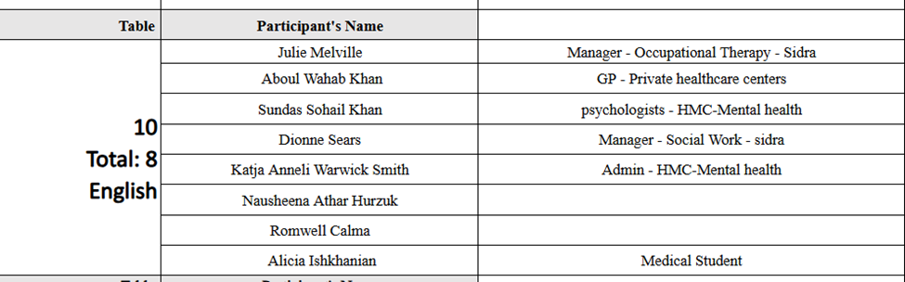
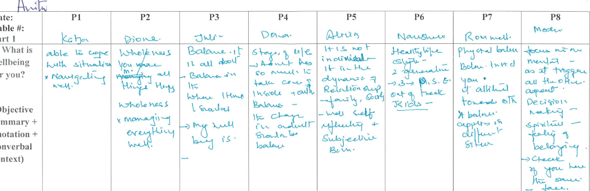
Here 2 names Khan and Aboul 1 are deleted from the summary and now they match

