

SIMPLE FILE / REVIEWER ORGANIZER SYSTEM

In Partial Fulfillment of the
Requirements for the Subject
Computer Programming 2
and Human Computer Interaction

Bacarrisas, Clint Jasper G.
Espinosa, Ryan Christian M.
Lagaolao, Junvic B.
Revilla, Alexander III
Surposa, Allyia Barillo
Viernes, Johnlloyd

April 7, 2026
Introduction
In the demanding academic landscape of institutions such as PHINMA Cagayan de Oro College, college students routinely face challenges including disorganized notes, difficulty in tracking study progress, and a lack of structured review methods. These obstacles contribute to diminished study efficiency and hindered academic performance, often stemming from fragmented management of digital and physical learning resources (Dunlosky et al., 2020). Such issues amplify cognitive demands during critical preparation periods, underscoring the need for innovative organizational tools.
The Reviewer Organizer System offers a practical, user-friendly solution through its centralized digital platform tailored for college students. By enabling seamless organization of review materials, real-time progress tracking, and structured review methodologies, Reviewer Organizer System enhances learning efficiency and academic outcomes. This intuitive system empowers users to optimize resource management, fostering improved retention and performance in a streamlined academic environment.

Statement of the Problem
In many academic and professional environments, the process of submitting, reviewing, and organizing documents remains fragmented. Without a dedicated system, users often rely on a mix of emails, messaging apps, and physical storage. This lack of a centralized platform leads to inefficiency, data redundancy, and a high risk of human error during the file evaluation process.
Specifically, this study seeks to address the following questions:
- Can users easily organize and manage their files using the Simple File / Reviewer Organizer System?
- Does the system help users categorize their notes using labels for better organization?
- How does the system contribute to better study habits and improved file management among users?
- What challenges might students encounter in using the system, and how can these be addressed to ensure user satisfaction and accessibility?

Objectives of the Study
General Objective:
This study aims to develop a Simple File / Reviewer Organizer System that promotes better organization, accessibility, and management of academic files and review materials among students.
Specific Objectives:
- To enable students to input their subjects and notes in real time, allowing them to save their reviewers easily.
- To organize and categorize each student's subjects and notes, making it easier for them to track their academic materials.
- To provide a summary of the total number of subjects and notes created, helping students to monitor their study progress.
- To implement a simple registration and log-in system, ensuring secure access to the user’s data.

Scope and Limitation
Scope:
This study focuses on the design and development of a Simple File / Reviewer Organizer System intended to improve how students manage their academic subjects and review notes. The system provides a centralized platform where users can input, organize, and access their subjects and notes efficiently. It includes core features that allow users to create subjects and store multiple notes within each subject, as well as a labeling mechanism to categorize notes for easier retrieval and organization. The system is limited to a console-based application developed in Java and does not include advanced features such as file uploading, cloud storage, or a graphical user interface.
Limitation:
Despite its usefulness, the system has certain limitations. It is primarily designed for students who want a simple way to organize their subjects and review notes, and may not be suitable for users who require more advanced features such as cloud storage, file attachments, or collaborative tools. Moreover, while the system helps in organizing academic materials, it does not guarantee improved academic performance, as effective studying still depends on the user’s effort and learning habits. Additionally, the system operates only through a text-based console in Java and does not include a graphical user interface (GUI), which may limit visual interaction and ease of use for some users. The system also does not store data permanently, meaning all saved subjects and notes will be lost once the program is closed. The system focuses on basic organization features and does not yet include advanced functionalities such as database storage or a graphical interface.

System Requirements
Hardware Requirements:
- Processor: Intel Core i3 or AMD equivalent (Currently using Intel N95 – meets the requirement)
- Memory (RAM): Minimum of 4GB (8GB recommended for smoother performance)
- Storage: At least 1GB of free disk space
- Display: 1366x768 resolution or higher
Software Requirements:
- Operating System: Windows 10 or 11, macOS, or Linux
- Programming Language: Java (JDK 8 or Higher)
- Text Editor/IDE: Visual Studio Code, IntelliJ IDEA, Eclipse, or NetBeans
- Java Runtime Environment (JRE): Required to run the system
- Console/Terminal: Required for running the text-based system interface

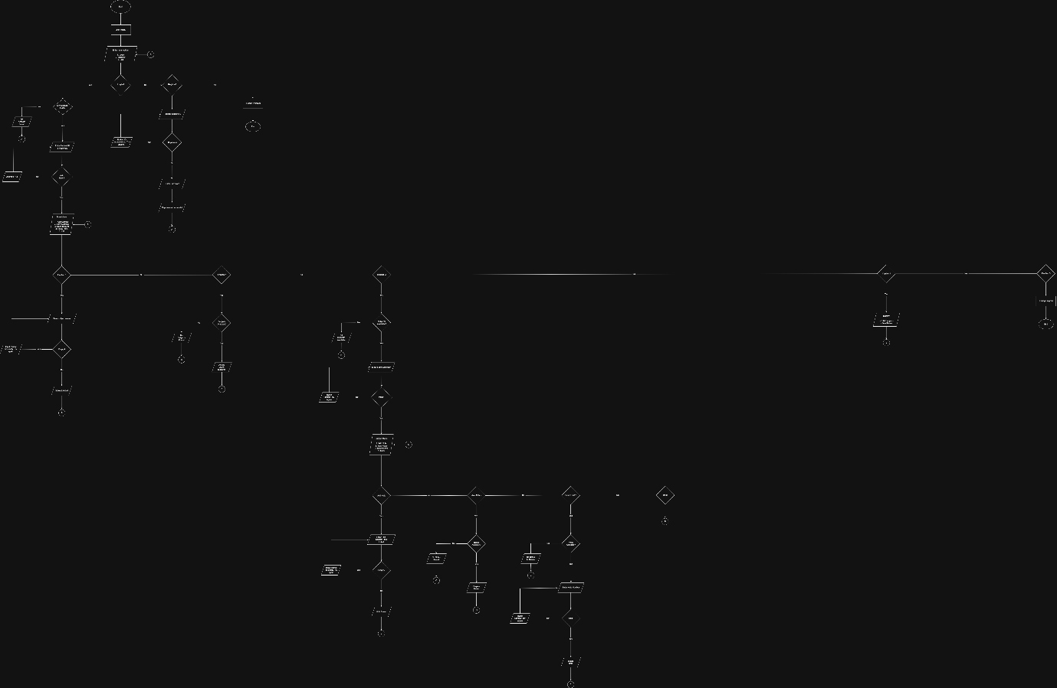
Flowchart

Test Scenarios & Outputs
S1: Log-In System Selection
Purpose: The user will select an option, either register or log in.
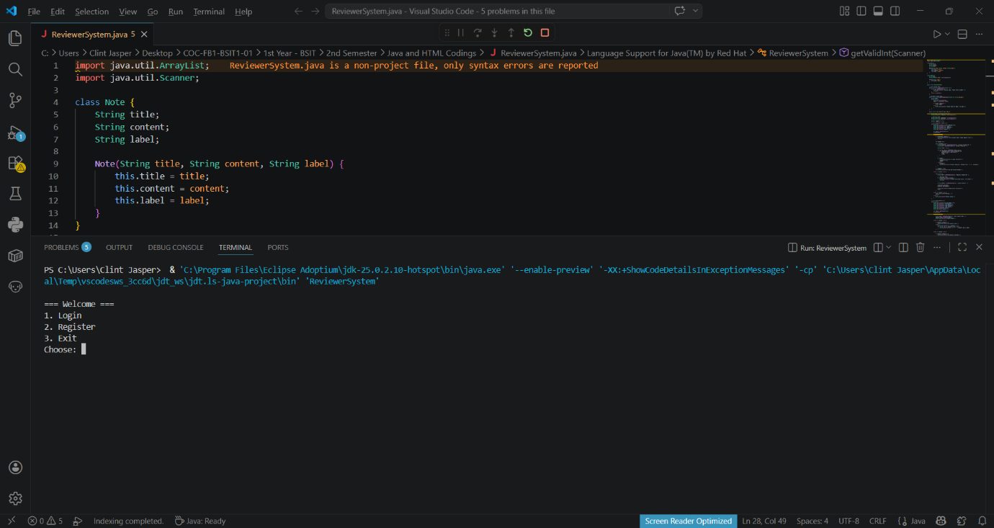

S2: Main Menu Selection
Purpose: The user will select an option after logging in.
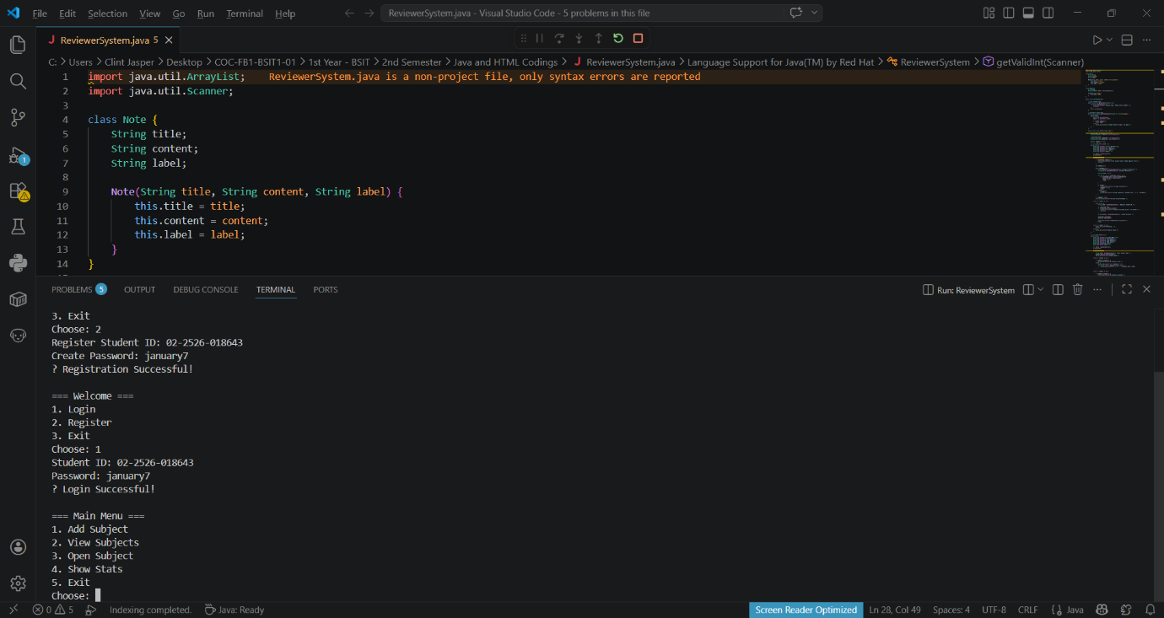

S3: Adding Subject
Purpose: To add a subject to your current account.
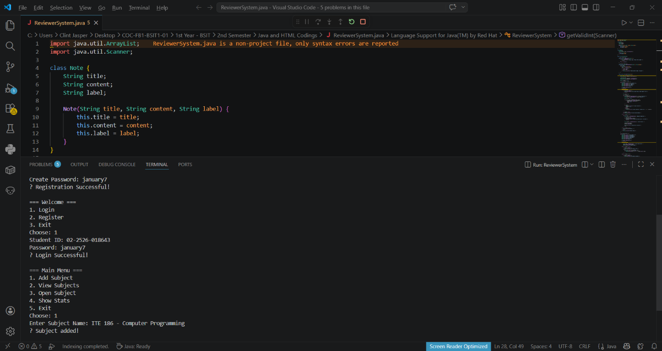

S4: View Subjects
Purpose: To view the subjects that you currently add.
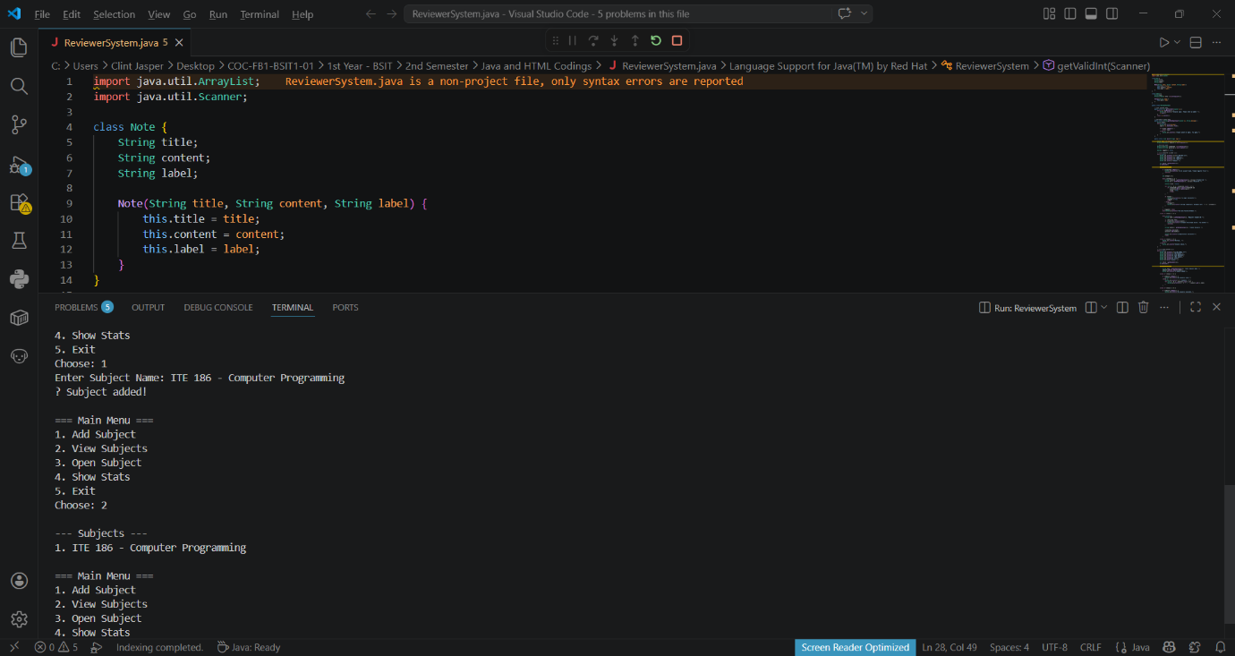

S5: Open Subjects
Purpose: To open a subject that you are currently added.
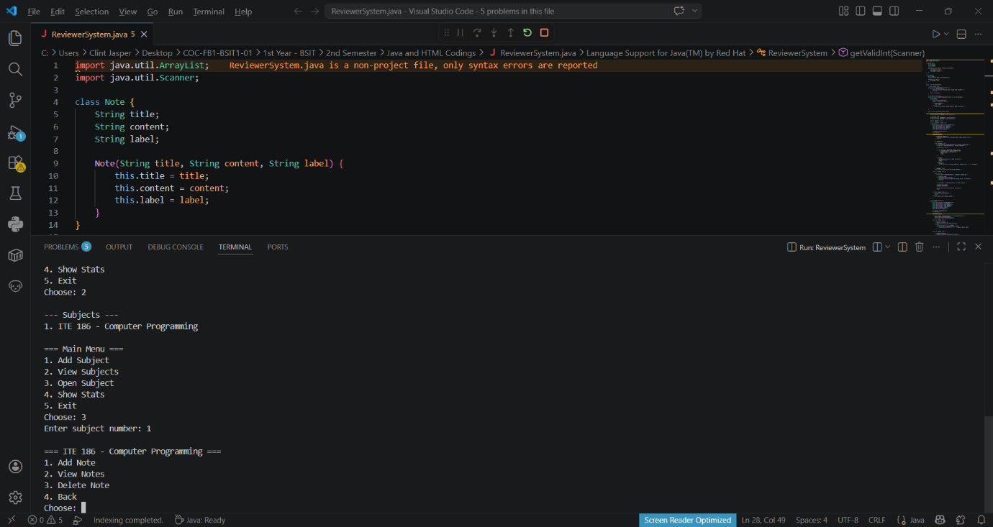

S6: Adding Notes
Purpose: The user can add a note, content, and a label to it.
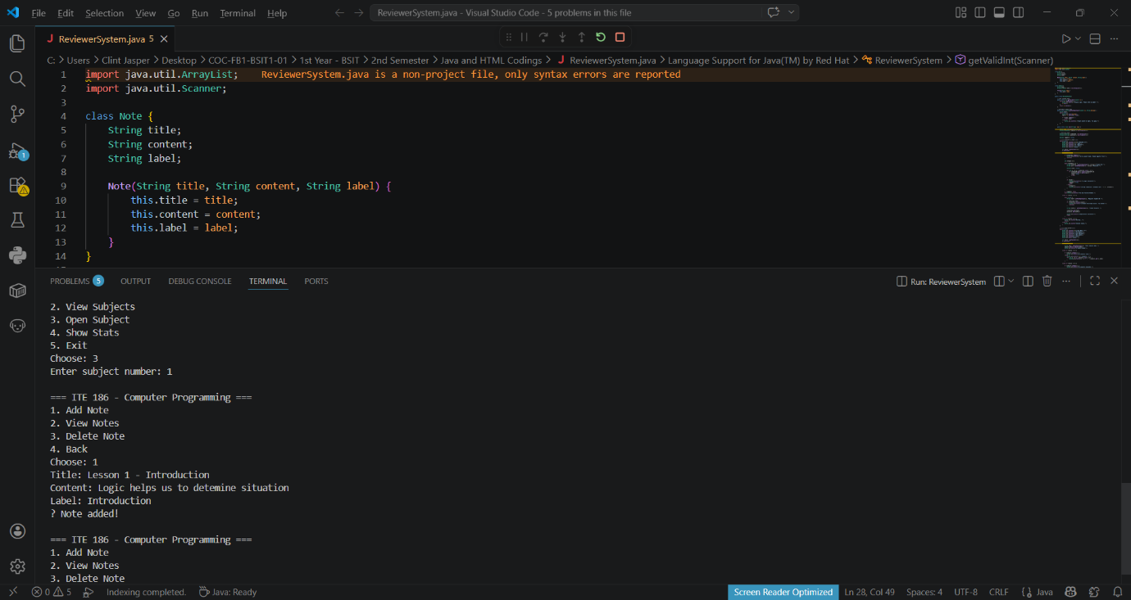

S7: View Notes
Purpose: To view your notes that you currently added on the specific subject.
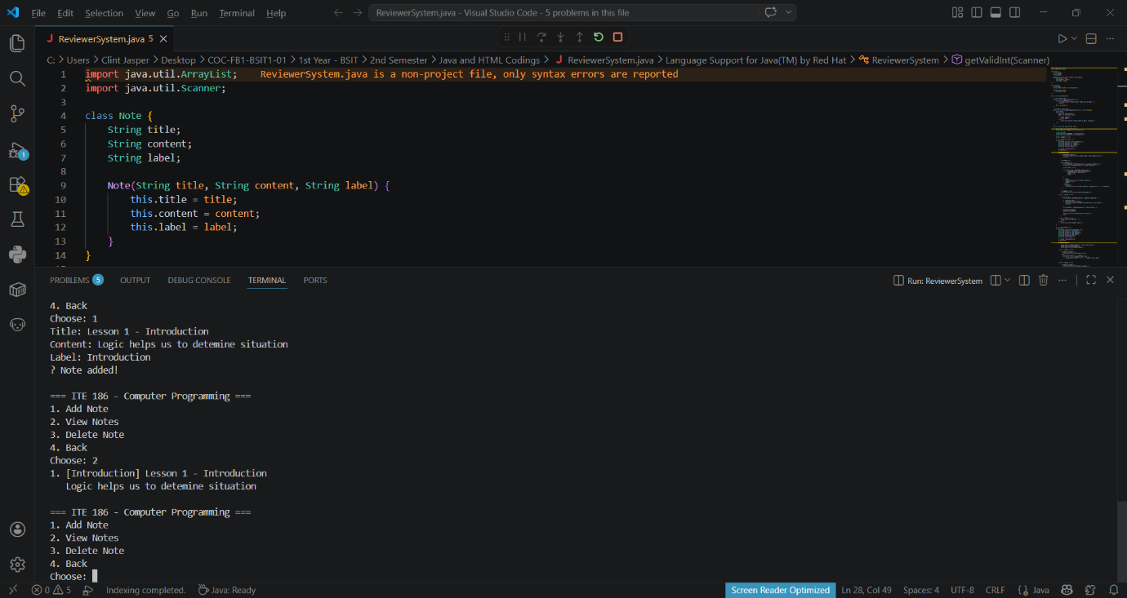

S8: Delete Notes
Purpose: The user can delete a note to a specific subject.
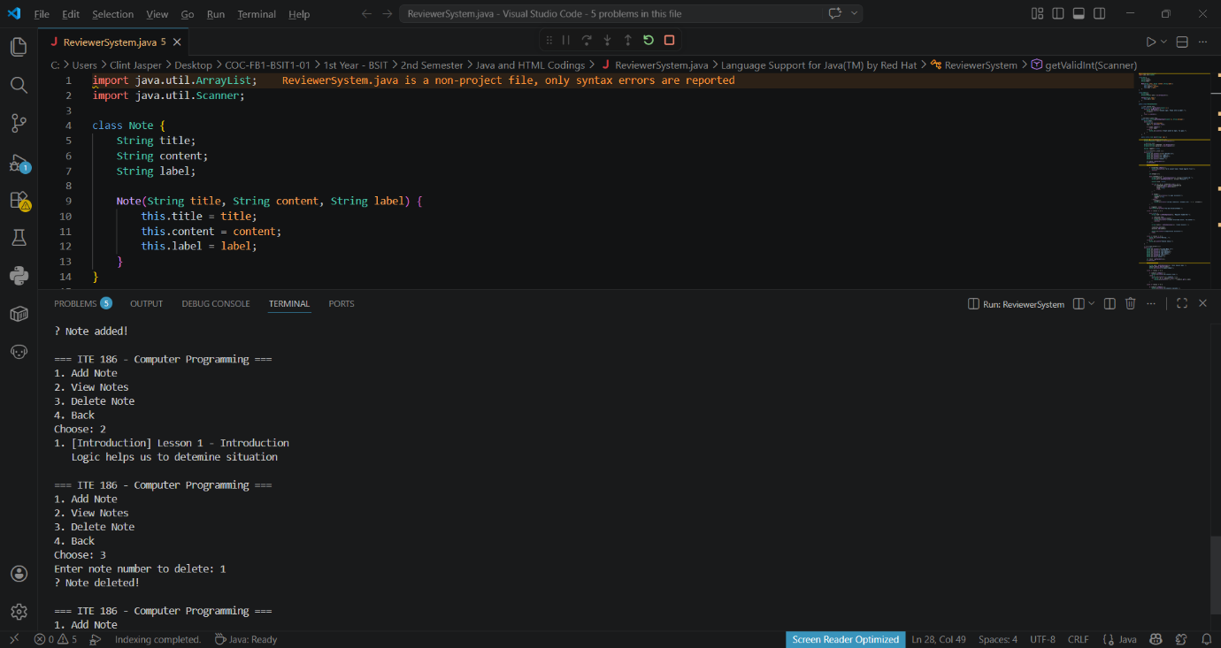

S9: Show Stats
Purpose: To show the status of current total subjects and notes that are added.
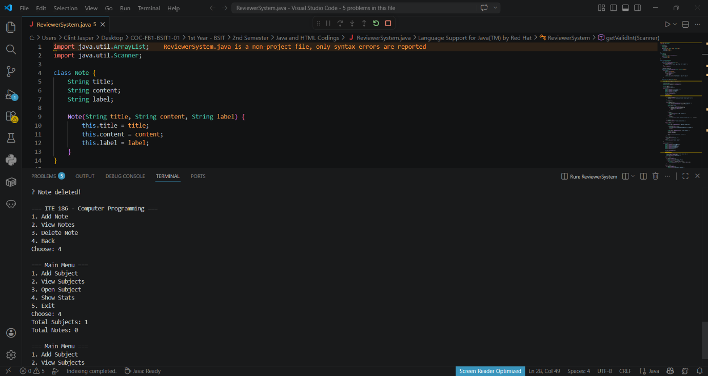

S10: Exit
Purpose: System exiting.
