Audio Features versus Artist Popularity in Predicting Track Popularity: A Study on the SpotGenTrack Dataset

Can Albayrak
Graduate School of Informatics
Middle East Technical University
Ankara, Turkiye
e216150@metu.edu.tr

Abstract—Over the years, numerous studies have examined song popularity and attempted to predict it prior to release. A major challenge in such studies has been the availability of large-scale, high-quality music datasets, as well as the definition and computation of appropriate popularity metrics. In this study, the SpotGenTrack Popularity Dataset is utilized to address these challenges and focus directly on the analysis of popularity. First, the relationship between artist popularity and track popularity is investigated through statistical analysis, which reveals a strong and statistically significant positive association. Then, a machine learning approach is employed to evaluate how well track-level audio features, together with artist popularity, can predict track popularity; a tuned Random Forest model significantly outperforms both a naive mean baseline and a linear model. Finally, the relative importance of audio features compared to artist-related factors is assessed through an interpretability analysis, which shows that artist popularity dominates the prediction, accounting for roughly three quarters of the model’s feature importance, whereas the audio features contribute little. The results indicate that, for high-level audio descriptors and the dataset’s popularity metric, track popularity is driven more by artist reputation than by intrinsic audio characteristics.
Keywords—Spotify dataset, audio features, popularity prediction, machine learning, data quality check, statistical analysis, feature importance

Introduction
Due to the digitalization of the world, online streaming platforms have experienced rapid growth. These platforms provide users with access to television shows, movies, documentaries, live sports events, and, most importantly for this study, music. The continuous expansion of streaming services such as Spotify has also encouraged other companies to invest in this domain, including YouTube Music and Apple Music. Consequently, these platforms increasingly utilize data-driven approaches, such as Music Information Retrieval (MIR), to enhance user experience and maximize profitability [1]. One of the prominent research topics in this field is the prediction of song popularity prior to release.
This study focuses on assessing the relationship between track popularity and both audio features and artist popularity. First, the existence of a statistically significant relationship between artist popularity and track popularity is examined. Subsequently, a machine learning model is employed to evaluate whether track-level audio features can be used to predict song popularity. The analysis is conducted using the SpotGenTrack Popularity Dataset introduced by D. Martin-Gutierrez, G. Hernandez Penaloza, A. Belmonte-Hernandez, and F. Alvarez Garcia [1].
Many studies have proposed different approaches to predicting song popularity. For example, D. Herremans, D. Martens, and K. Sörensen [2] investigated the prediction of song popularity based on audio characteristics. Their study focused on a specific genre, namely dance music, and developed a classification model to distinguish between “top 10” dance hits and lower-charting tracks. The authors utilized basic audio features such as duration, tempo, time signature, mode, key, loudness, danceability, and energy, as well as temporal features that capture how a song evolves over time.
D. Martin-Gutierrez, G. Hernandez Penaloza, A. Belmonte-Hernandez, and F. Alvarez Garcia [1] emphasize that while traditional approaches often rely on a single modality, recent studies demonstrate that multimodal methods (combining audio, lyrics, and metadata) are more effective in predicting song popularity. This study aligns with this perspective by utilizing a large-scale dataset that incorporates multiple types of information. In contrast, D. Herremans, D. Martens, and K. Sörensen [2] address the complexity of the problem by focusing on a single genre, thereby reducing variability within the dataset.
J. Fan and M. Casey [3] evaluate the effectiveness of hit song prediction models across two distinct markets, highlighting the influence of cultural differences on musical preferences. While the impact of cultural factors on song popularity is not explicitly addressed in this study, due to the use of a global popularity metric in the SpotGenTrack dataset, their work remains relevant. In particular, the authors employ audio features such as danceability, energy, duration, and tempo, which are also utilized in the present study.
N. Askin and M. Mauskapf [4], similarly to this study, examine the relationship between song popularity and artist-related characteristics. Their findings suggest that while an artist’s reputation is an important factor influencing a song’s success, the intrinsic qualities of the song itself play an even more significant role. In their analysis, the authors utilize audio features such as acousticness, danceability, energy, and tempo.
Furthermore, the study highlights the importance of “typicality” in determining a song’s success. The authors argue that a successful song should balance familiarity and novelty—being similar enough to existing songs to be recognizable, while also distinct enough to stand out. They quantify this concept by measuring the similarity of a song’s audio features and weighting this measure based on the distance between genres.
Building on this background, the study is guided by two explicit research questions, one statistical and one predictive:
RQ1 (statistical): Is artist popularity significantly associated with track popularity?
RQ2 (predictive): How well can track-level audio features, together with artist popularity, predict track popularity, and which of these factors—intrinsic audio characteristics or artist reputation—contributes most to the prediction?
Whether song popularity can be predicted has already been studied extensively; therefore prediction accuracy alone is not the aim of this work. Its contribution is twofold. First, rather than treating audio and artist information jointly, the study explicitly quantifies the relative importance of artist reputation versus intrinsic audio characteristics, using both model-based and permutation feature importance on a tuned non-linear model. Second, it introduces a systematic non-song filtering procedure for the SpotGenTrack dataset, which contains a non-trivial fraction of podcasts, spoken-word recordings, audiobooks, and silent or white-noise entries that would otherwise bias both the statistical test and the models. Together, these contributions clarify not only whether popularity is predictable from this data, but also why, and on what the prediction relies.

DATASET

Pre-processing of the Data
The SpotGenTrack Popularity Dataset consists of five separate datasets containing information on albums, artists, tracks, audio features, and lyrics. For the purposes of this study, the album, audio, and lyrics datasets are excluded, as they are not directly relevant to the research objectives.
The artists dataset contains 56,129 observations and 8 features, including artist popularity, number of followers, genre information, and unique identifiers. Additional fields such as track identifiers and metadata are also included.
The tracks dataset comprises 101,939 observations and 31 features. These features include a wide range of audio characteristics, such as acousticness, danceability, energy, instrumentalness, liveness, loudness, speechiness, tempo, and valence, as well as metadata fields such as album identifiers, track identifiers, and playlist information.
The “type” feature in both the artists and tracks datasets is found to be constant and therefore uninformative and is removed from further analysis. The followers feature is also excluded, as the artist_popularity variable provides a normalized measure of popularity on a scale from 1 to 100, as defined in the dataset [1].
The genres feature is not included in the analysis due to its high level of detail and the presence of substantial missing data. Approximately 41% of artists in the dataset were found to have no associated genre information, making this feature unsuitable for reliable analysis.
As a result, only the essential attributes (artist identifiers, artist popularity, and corresponding track identifiers) are retained to establish a consistent relationship between artists and tracks.
In the tracks dataset, several features are removed as they are not relevant to the objectives of this study. These include album_id, analysis_url, available_markets, country, disc_number, href, lyrics, playlist, preview_url, track_href, track_name_prev, track_number, uri, and type.
The remaining features in the tracks dataset can be grouped into several categories. These include identifiers such as artists_id, track_id, artist_name, and track_name, as well as metadata such as duration_ms and track_popularity. In addition, the dataset contains technical audio properties, including key, mode, tempo, time_signature, and loudness. Finally, perceptual audio features such as acousticness, danceability, energy, instrumentalness, liveness, speechiness, and valence are retained for analysis.
- Audio features descrıbed by spotıfy
Features | Description
Acousticness | A confidence measure ranging from 0.0 to 1.0 of whether the track is acoustic.
Danceability | A descriptor ranging from 0.0 to 1.0 of how suitable a track is for dancing.
Duration_ms | The total length of the track expressed in milliseconds.
Energy | A perceptual measure from 0.0 to 1.0 that represents the intensity and activity of a song.
Instrumentalness | A prediction between 0.0 and 1.0 of whether a track contains no vocals.
Key | The estimated overall musical key of the track.
Liveness | A feature ranging from 0.0 to 1.0 that detects the presence of an audience in the recording.
Loudness | The volume of a track measured in decibels.
Mode | An indicator of the modality (major or minor) of a track.
Track_popularity | A continuous value between 1 and 100 representing the current success of a song.
Speechiness | A measure ranging from 0.0 to 1.0 that detects the presence of spoken words within a track.
Tempo | The overall estimated speed of a track measured in beats per minute.
Time_signature | An estimated overall meter that specifies how many beats are contained in each musical bar.
Valence | A measure from 0.0 to 1.0 describing the musical positiveness.

Prior to merging, column names in both datasets are standardized for consistency. In the artists dataset, the columns id and name are renamed as artist_id and artist_name, respectively. Similarly, in the tracks dataset, the columns id, popularity, and name are renamed as track_id, track_popularity, and track_name.
Both datasets are then examined for missing values. No missing values are detected in the tracks dataset, while the artists dataset contains a single missing value in the artist_name field, which is considered negligible and does not impact the analysis. A uniqueness analysis is also conducted prior to merging. The track_id and artist_id fields are found to be unique within their respective datasets. However, artist_id is not unique within the tracks dataset, which is expected, as multiple tracks may belong to the same artist.
Furthermore, the artists_id field in the tracks dataset may contain multiple artist identifiers, reflecting collaborations between artists. To ensure a consistent one-to-one mapping prior to merging, a preprocessing step is applied. For tracks associated with multiple artists, the artist with the highest artist_popularity is selected to represent the track. This approach assumes that the most popular contributing artist has the strongest influence on the track’s overall popularity. Following these preprocessing steps, the datasets are prepared for merging.
To detect non-song entries, a subset of relevant features is selected and analyzed through descriptive statistics, histograms, and boxplots. The selected features include duration_ms, liveness, instrumentalness, speechiness, energy, danceability, and valence. These features provide insights into both the structural and perceptual characteristics of the tracks. The boxplot of duration_ms is presented below.
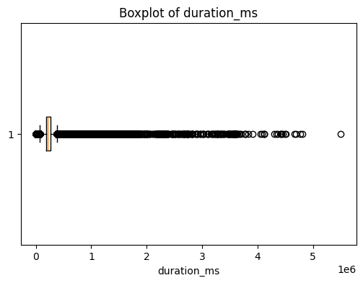
- Boxplot of duration_ms variable
As shown in the boxplot, the duration_ms variable exhibits a large number of outliers. This is primarily due to its highly skewed distribution, where the majority of tracks fall within a typical song length of approximately 2–5 minutes, while a subset of observations extends to significantly longer durations. These long-duration entries are likely to correspond to non-musical content such as podcasts or spoken-word recordings.
For further assessment, the ten tracks with the highest values of duration_ms, liveness, and speechiness are examined. In addition, the ten tracks with the lowest values of duration_ms, speechiness, instrumentalness, energy, danceability, and valence are also analyzed. These inspections provide qualitative insight into the nature of extreme observations. Furthermore, percentile analysis is conducted on these variables to support a more quantitative evaluation of their distributions.
These analyses indicate that the majority of tracks fall within a typical song duration range, while a small subset extends significantly beyond this range. Similarly, high speechiness values are associated with spoken content rather than music. Based on these observations, filtering criteria are applied by restricting track duration to the range of 1 to 10 minutes and excluding tracks with speechiness values greater than 0.7. In addition, a small number of observations exhibiting zero values across energy, instrumentalness, and speechiness are considered anomalous and removed. This preprocessing step ensures that the analysis focuses primarily on musical tracks while reducing noise introduced by non-song entries.

Data Profiling
Based on the research objectives, the analysis focuses on track_popularity as the target variable, along with artist_popularity and a set of audio features, including acousticness, danceability, energy, instrumentalness, liveness, speechiness, tempo, and valence. These features are selected as they capture both the perceptual and technical characteristics of musical tracks.
Descriptive statistics are computed for the selected numerical features to provide an overview of their distributions. These statistics include measures such as mean, standard deviation, minimum, maximum, and percentiles. The results are summarized in Table II.
- descrıptıve statıstıcs of some of the features
 | energy | danceability | valence
mean | 0.586479 | 0.586015 | 0.482813
std | 0.26017 | 0.177724 | 0.26169
min | 0.0 | 0.0 | 0.0
25% | 0.411 | 0.48 | 0.271
50% | 0.629 | 0.61 | 0.477
75% | 0.798 | 0.714 | 0.693
max | 1.0 | 0.989 | 0.993
skewness | -0.503321 | -0.62543 | -0.62543

The selected track-level features are examined to assess their distributions and variability. The analysis shows that these variables exhibit diverse distributional patterns, including approximately uniform, symmetric, and highly skewed distributions. Danceability and energy exhibits a standard normal distribution with a left skew. Valence is closer to uniform distribution.
The artist_popularity variable appears to follow a relatively symmetric distribution with no significant outliers. In contrast, the boxplot of track_popularity reveals the presence of outliers.
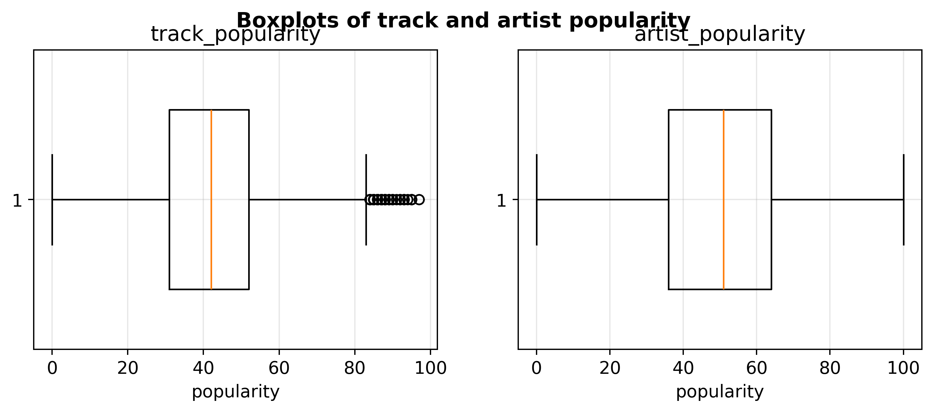
- Boxplots of track and artist popularity
This observation suggests that track popularity is not solely determined by artist popularity and may be influenced by additional factors, such as track-level audio characteristics. This supports the inclusion of multiple features in the subsequent analysis and modeling stages.

Naïve Baseline
As a baseline, a naive model is constructed by predicting the mean track popularity for all observations. This baseline represents the best constant prediction in the absence of feature information. The performance of the regression models is evaluated using Mean Absolute Error (MAE) and the coefficient of determination (R²). MAE provides an interpretable measure of the average prediction error, while R² evaluates how well the model explains the variability in the target variable. These two metrics complement each other by capturing both prediction accuracy and explanatory power.
The naive baseline model resulted in a Mean Absolute Error (MAE) of 12.654 and a Root Mean Squared Error (RMSE) of 15.695. The coefficient of determination (R²) is approximately zero, indicating that it does not explain any variability in the data. Therefore, any meaningful model should outperform this baseline in both MAE and R².

Methodology
This section describes the continuation of the analysis. Two complementary approaches are used: a hypothesis test addresses the statistical research question (RQ1), and a set of regression models with hyperparameter tuning and interpretability analysis addresses the predictive research question (RQ2).

Feature Selection and Generation
The candidate predictors are the audio features retained during pre-processing, which are acousticness, danceability, energy, instrumentalness, liveness, loudness, speechiness, tempo, and valence, together with artist_popularity. The discrete metadata fields key, mode, and time_signature are excluded, since they are categorical pitch and meter codes rather than perceptual descriptors and carry little information for a regression on a continuous target. The contribution of each predictor is first screened with a rank-based Spearman correlation against the target: artist_popularity is by far the strongest (ρ = 0.66), while every audio feature is weak (|ρ| ≤ 0.13, with loudness, instrumentalness, and danceability the largest). A model-based Random Forest importance screen produces the same ordering, with artist_popularity accounting for roughly 60% of the importance.
Redundancy among predictors is assessed with the Pearson correlation matrix in Fig. 3. Several audio features are strongly correlated. The results are as follows: energy and loudness (0.76), acousticness and energy (−0.73), acousticness and loudness (−0.58), and danceability and valence (0.52). They are forming a loudness-energy-acousticness cluster. This redundancy is noted but does not affect the tree-based model, which is robust to correlated inputs.
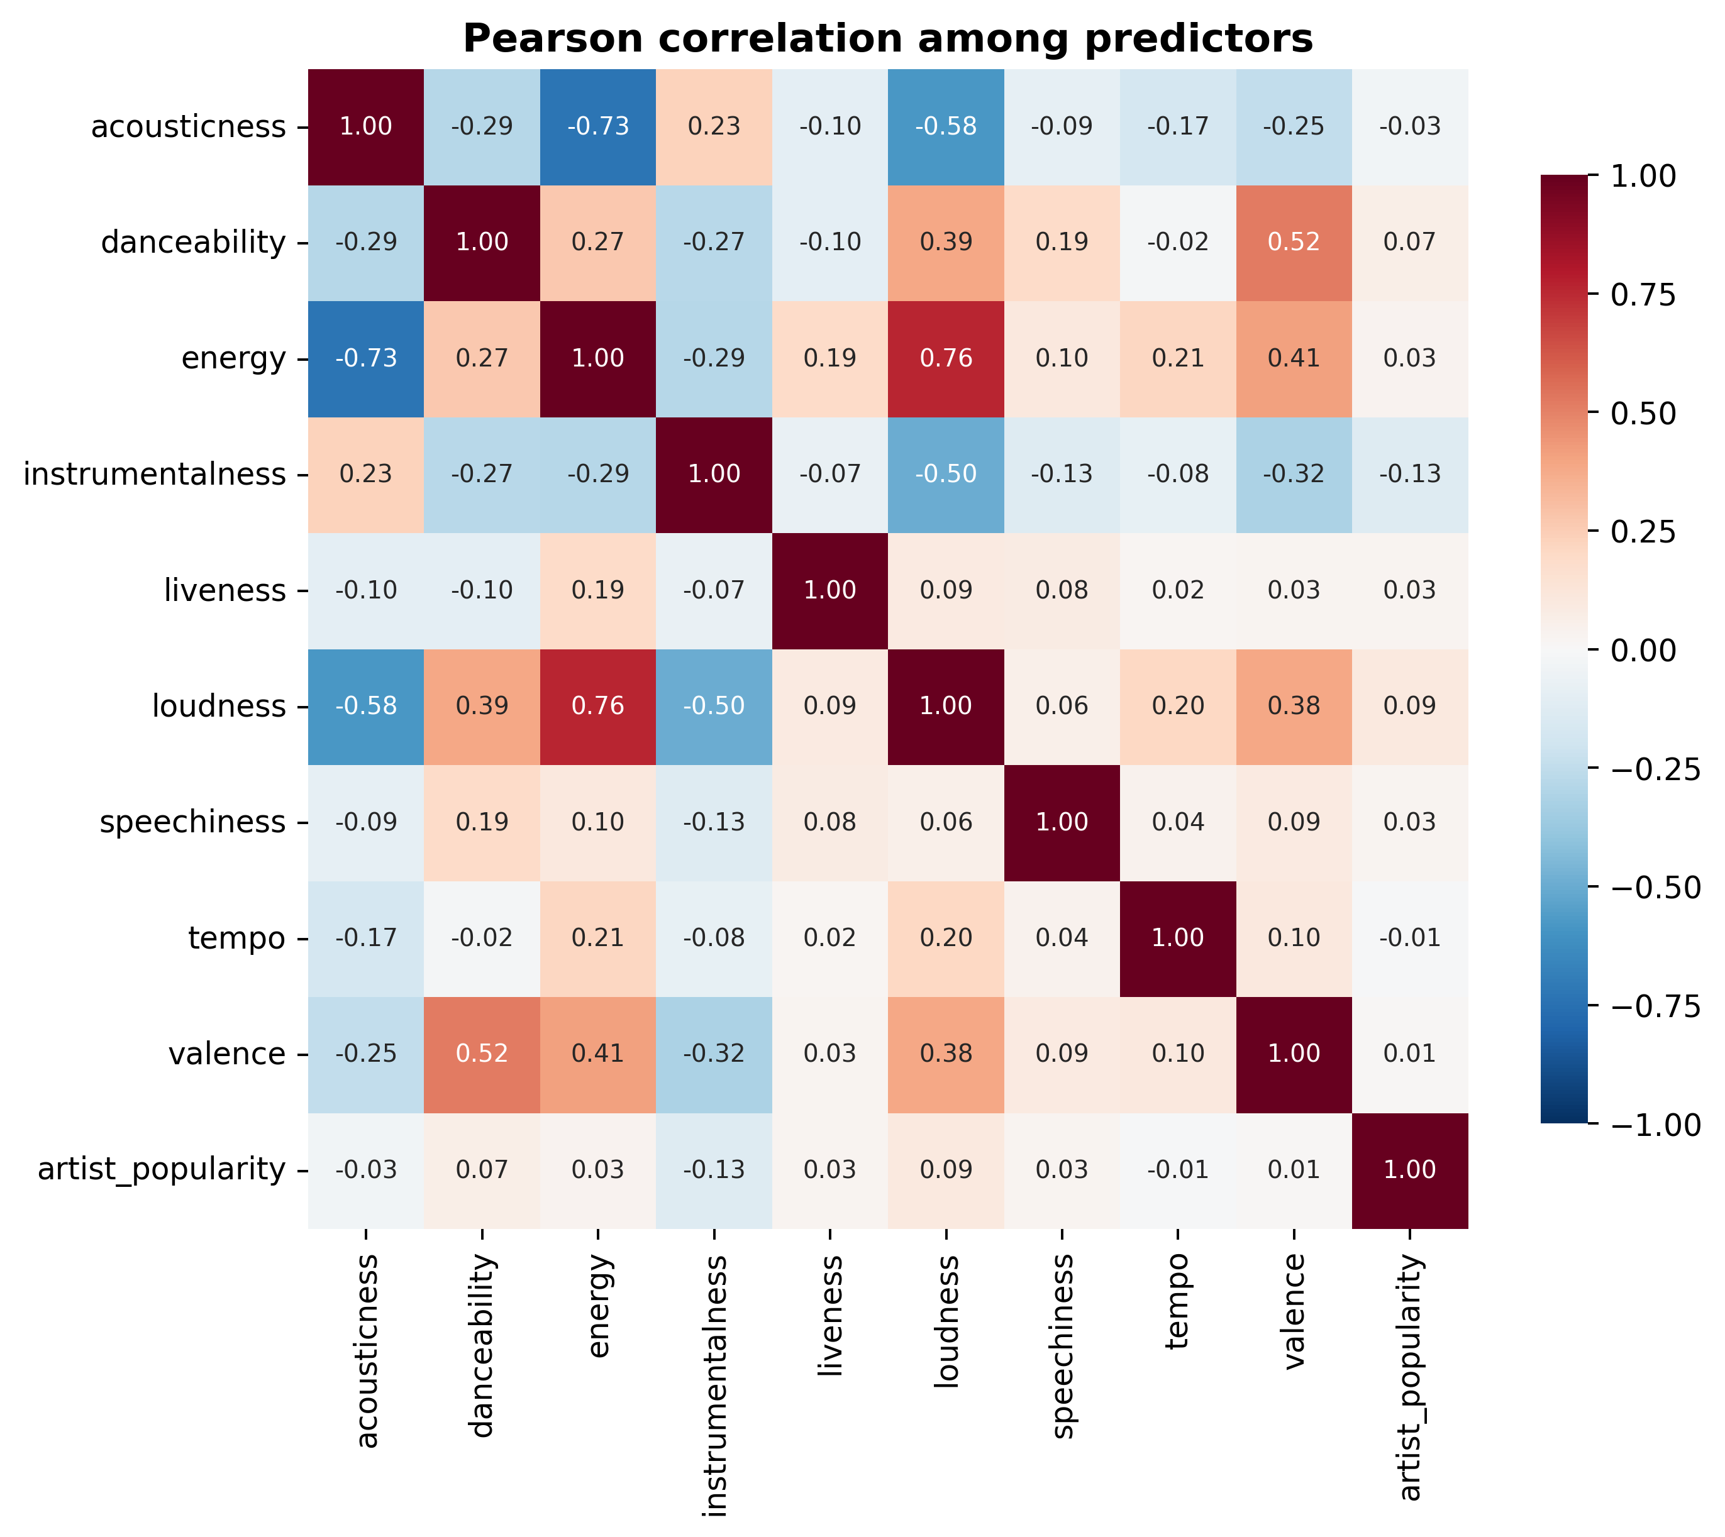
- Pearson correlation among the ten predictors.
Two new features are generated to test whether aggregated information adds value. log_duration is a log transform of the strongly right-skewed duration_ms, and mood_index is a standardized average of valence, energy, and danceability that summarizes an “upbeat/positive” character. Both correlate only weakly with the target (|ρ| ≈ 0.05–0.06), and adding them to a Random Forest improves the test R² by only about 0.008. They are therefore not retained, and the ten original predictors are used. For the scale-sensitive linear models, the predictors, which range from tempo in BPM to loudness in dB to bounded [0,1] descriptors, are standardized with a z-score transform inside a pipeline; the tree-based model uses the raw features.

Hypothesis Testing
The statistical question is formalized as follows. The variables are artist_popularity (X) and track_popularity (Y), both continuous integer scores in [0,100]. The null hypothesis H₀ states that there is no association between them (population correlation equal to zero); the alternative H₁ states that the correlation is non-zero. The significance level is α = 0.05. Both variables are close to symmetric (skewness -0.18 and -0.07), so a Pearson correlation is appropriate; a Spearman rank correlation is reported alongside because it does not assume linearity and is robust to the bounded scale.

Predictive Models and Tuning
The predictive task is treated as regression on the continuous track_popularity. Three models are compared. The naive baseline introduced in Section II-C predicts the mean track popularity for every observation. A linear model (ordinary least squares) and a Random Forest regressor are then trained. The data are split into training (60%), validation (20%), and test (20%) sets: the training set fits the models, the validation set selects hyperparameters, and the test set is held out for final evaluation only.
Because ordinary least squares has no hyperparameters, a regularized Ridge variant is tuned over the regularization strength α ∈ {0.01, 0.1, 1, 10, 100, 1000} to test whether shrinkage helps. For the Random Forest, the parameters that control complexity and overfitting such as the number of trees, maximum depth, minimum samples to split a node, and minimum samples per leaf are tuned over a grid of configurations fitted on the training set and ranked by validation mean absolute error. The selected configuration uses 120 trees, a maximum depth of 16, a minimum of 10 samples to split, and 10 samples per leaf.

Evaluation
Model performance is measured with the mean absolute error (MAE), the root mean squared error (RMSE), and the coefficient of determination (R²), the same metrics introduced for the naive baseline in Section II-C. To test whether differences between models are statistically significant, the per-track absolute errors on the same held-out test observations are compared with a Wilcoxon signed-rank test (which makes no normality assumption) and a paired t-test. Finally, impurity-based and permutation feature importance are computed for the best model to interpret which predictors drive its decisions.

Results

Artist Popularity and Track Popularity (RQ1)
The correlation between artist_popularity and track_popularity is strong and highly significant. The Pearson coefficient is r = 0.683 and the Spearman coefficient ρ = 0.665, both with p < 0.001, far below the 0.05 threshold, so the null hypothesis of no association is rejected. A simple linear fit gives a slope of about 0.55, meaning that a one-point increase in artist popularity is associated, on average, with roughly a half-point increase in track popularity. Fig. 4 shows the relationship as a density plot with the fitted trend. The wide vertical spread at any given artist-popularity value confirms that artist popularity, while clearly informative, does not fully determine track popularity.
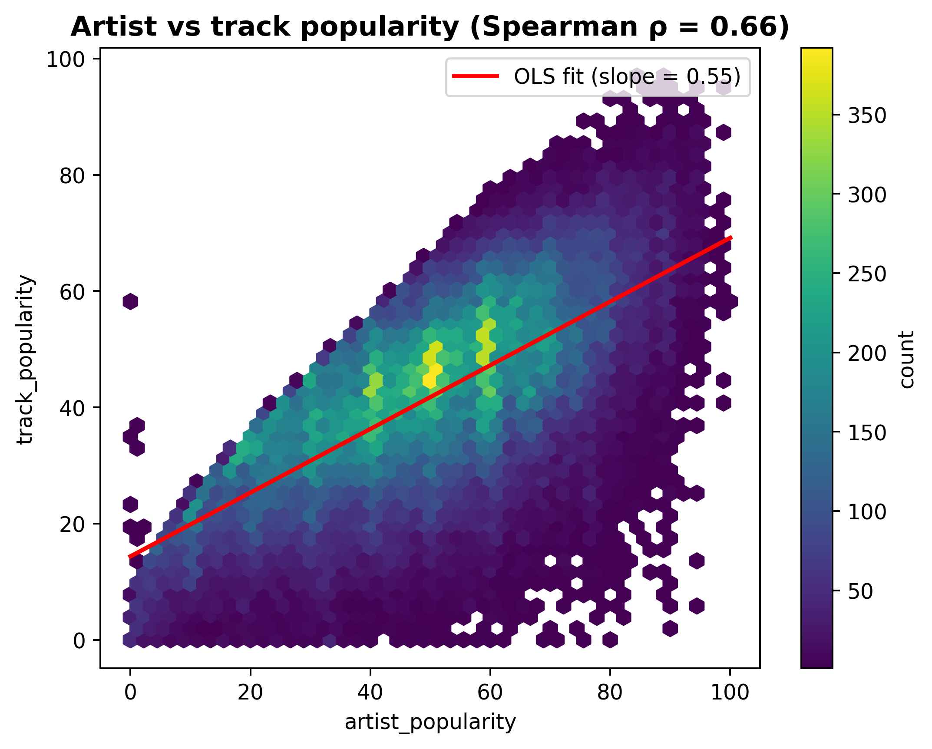
- Density of track popularity against artist popularity, with the ordinary-least-squares trend line.

Model Comparison (RQ2)
Table III reports the performance of all models on the held-out test set. Both trained models clearly outperform the naive baseline. The tuned Random Forest is the best model, with an MAE of 8.49 and an R² of 0.52, followed by the untuned Random Forest and the linear models. Regularization makes no difference: the tuned Ridge model is identical to ordinary least squares, which is expected because the number of observations greatly exceeds the number of predictors.
- Test-set performance of all models
Model | MAE | RMSE | R²
Naive (mean) | 12.567 | 15.585 | 0.000
Linear regression (OLS) | 8.912 | 11.266 | 0.477
Ridge (tuned) | 8.912 | 11.266 | 0.477
Random Forest (untuned) | 8.561 | 10.894 | 0.511
Random Forest (tuned) | 8.491 | 10.794 | 0.520
The paired error comparisons in Table IV confirm that these differences are statistically significant. The tuned Random Forest reduces the absolute error relative to both the naive baseline and the linear model with extremely small p-values, and even its improvement over the untuned Random Forest is significant, showing that tuning provides a small but real gain. In contrast, the Ridge model and ordinary least squares are statistically indistinguishable (p = 0.53), confirming that regularization is unnecessary here.
- Paired tests on test-set absolute errors
Comparison | Wilcoxon p | Significant
RF (tuned) vs. Naive | < 0.001 | Yes
RF (tuned) vs. Linear | < 0.001 | Yes
Linear vs. Naive | < 0.001 | Yes
RF (tuned) vs. RF (untuned) | 1.4 × 10⁻⁷ | Yes
Ridge vs. OLS | 0.53 | No

Feature Importance (RQ2)
The interpretability analysis gives a clear and one-sided answer to the second part of RQ2. In the impurity-based importance of the tuned Random Forest, artist_popularity accounts for about 75% of the total, while the nine audio features together account for only 25%; among the audio features, loudness, speechiness, and instrumentalness are the strongest but each contributes only a few percent. The permutation importance on the test set, shown in Fig. 5, is even more pronounced: shuffling artist_popularity reduces the test R² by about 0.94, whereas shuffling any individual audio feature barely changes it. In other words, almost all of the model’s predictive power comes from artist reputation rather than from the measurable sonic properties of the tracks.
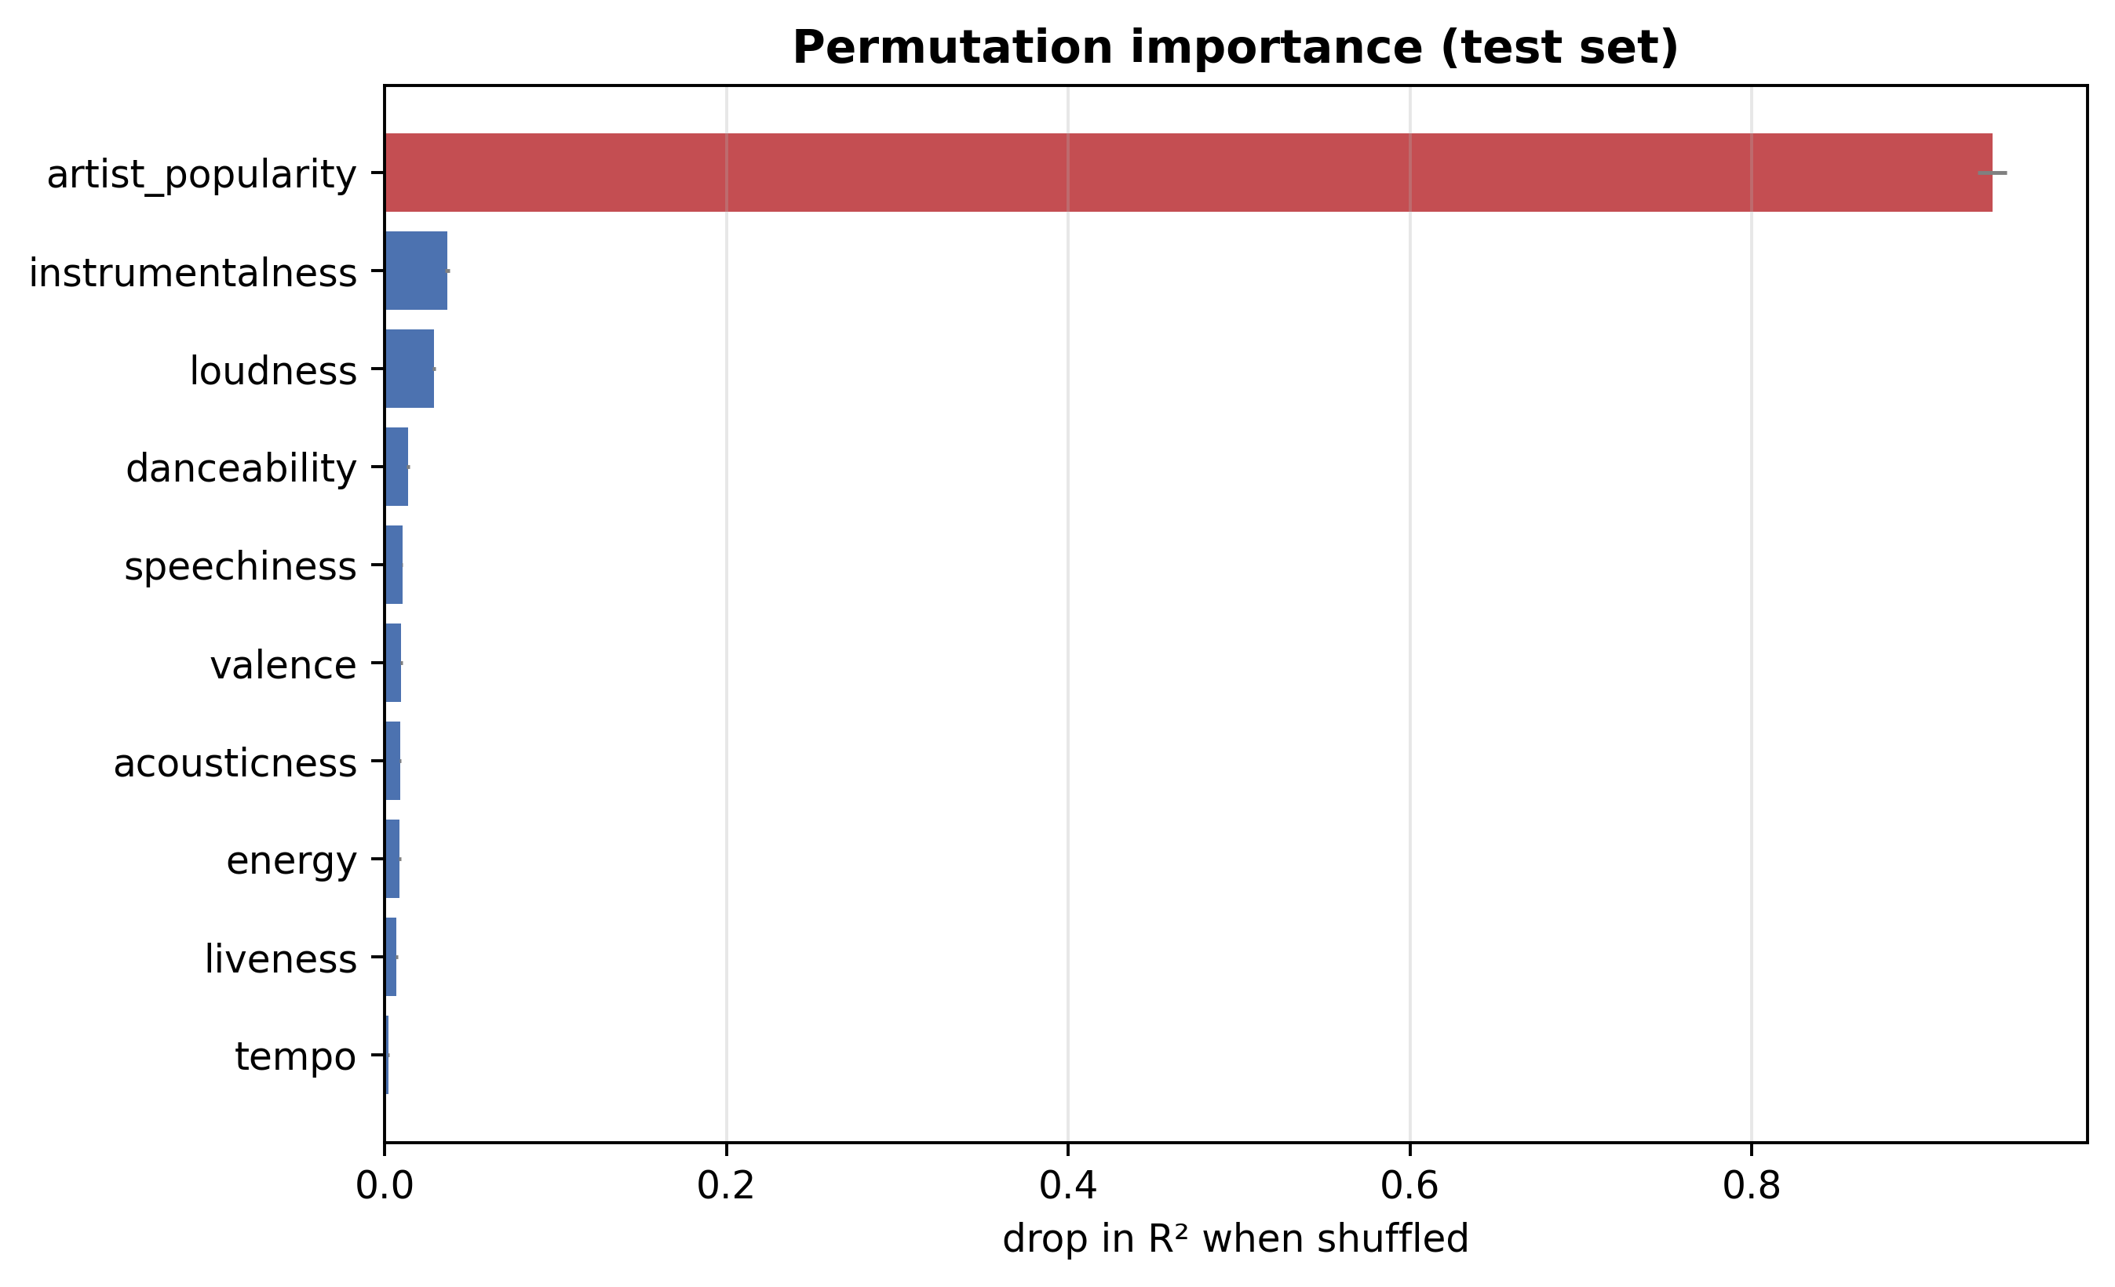
- Permutation importance on the test set. Shuffling artist popularity removes nearly all predictive power.

Discussion
The results give a consistent and somewhat one-sided picture. Artist popularity is by far the strongest signal: it alone reaches a correlation of about 0.66 with track popularity, accounts for roughly three quarters of the Random Forest’s importance, and explains almost all of its permutation importance. The nine audio features, individually and combined into an engineered mood index, add little predictive value once artist popularity is present.
For music information retrieval and recommender systems, this suggests that popularity is driven more by who releases a track, together with the exposure, playlist placement, and marketing that accompany a well-known artist, than by the intrinsic sonic characteristics of the track. This partly agrees with Askin and Mauskapf [4], who also find artist familiarity to be important, but it diverges from their conclusion that intrinsic song qualities matter more: in this dataset the audio features add only marginal value on top of artist reputation. A likely explanation is that the high-level descriptors are coarser than the micro-level acoustic and typicality features engineered by Askin and Mauskapf, and that the dataset’s popularity score is itself shaped by exposure that correlates with artist popularity.
A practical implication is that audio-only hit-prediction systems built on high-level features are likely to be limited, and that combining artist-level signals with richer content features like lyrics, low-level spectral descriptors, or an explicit typicality measure is a more promising direction for improving predictions and for understanding what makes a track succeed.

Conclusion and Future Work
Both research questions were answered. For the statistical question (RQ1), the Pearson (r ≈ 0.68) and Spearman (ρ ≈ 0.66) correlations were positive and highly significant (p < 0.001), so the null hypothesis of no association between artist popularity and track popularity is rejected. For the predictive question (RQ2), both regression models clearly beat the naive baseline: the tuned Random Forest reaching R² ≈ 0.52 and MAE ≈ 8.5 against the baseline’s R² ≈ 0 and MAE ≈ 12.6. Paired tests confirm that the Random Forest’s improvement over both the baseline and the linear model is statistically significant. The interpretability analysis shows that this predictive power comes overwhelmingly from artist popularity rather than from the audio features.
The main strengths of the approach are the large cleaned dataset of about 95,000 tracks, the combination of artist-level and track-level features, a careful non-song filtering step, and the comparison of tuned models against a baseline with statistical testing of the differences. The main limitations are the use of the dataset’s predefined popularity score as ground truth, since it is itself shaped by exposure and is not a pure measure of musical quality; the exclusion of genre because of missing values; the heuristic thresholds used to remove non-song entries; and the fact that popularity also depends on external factors such as marketing, playlist placement, social-media trends, and release timing which are not present in the data.
Future work could add cleaned metadata such as release date, genre, or playlist information, incorporate lyrics-based or low-level audio features, engineer a typicality or optimal-differentiation feature in the spirit of Askin and Mauskapf [4], test more expressive models, and examine how the balance between artist and audio factors varies across genres, markets, and time periods.

References
- D. Martin-Gutierrez, G. Hernandez Penaloza, A. Belmonte-Hernandez, and F. Alvarez Garcia, “A Multimodal End-to-End Deep Learning Architecture for Music Popularity Prediction,” IEEE Access, vol. 8, pp. 39361–39374, 2020, doi: https://doi.org/10.1109/access.2020.2976033.
- D. Herremans, D. Martens, and K. Sörensen, “Dance Hit Song Prediction,” Journal of New Music Research, vol. 43, no. 3, pp. 291–302, Jul. 2014, doi: https://doi.org/10.1080/09298215.2014.881888.
- J. Fan and M. Casey, “Study of Chinese and UK Hit Songs Prediction,” 2013.
- [4] N. Askin and M. Mauskapf, “What Makes Popular Culture Popular? Product Features and Optimal Differentiation in Music,” American Sociological Review, vol. 82, no. 5, pp. 910–944, Sep. 2017, doi: https://doi.org/10.1177/0003122417728662.

