Introduction to Data Informatics Term Project

Can Albayrak
Graduate School of Informatics
Middle East Technical University
Ankara, Turkiye
e216150@metu.edu.tr

Abstract—Over the years, numerous studies have examined song popularity and attempted to predict it prior to release. A major challenge in such studies has been the availability of large-scale, high-quality music datasets, as well as the definition and computation of appropriate popularity metrics. In this study, the SpotGenTrack Popularity Dataset is utilized to address these challenges and focus directly on the analysis of popularity. First, the relationship between artist popularity and track popularity is investigated through statistical analysis. Then, a machine learning approach is employed to evaluate how well track-level audio features, together with artist popularity, can predict song popularity. In addition, the study assesses the relative importance of audio features compared to artist-related factors in explaining popularity.
Keywords—Spotify dataset, audio features, popularity prediction, machine learning, data quality check, statistical analysis, feature importance

Introduction
Due to the digitalization of the world, online streaming platforms have experienced rapid growth. These platforms provide users with access to television shows, movies, documentaries, live sports events, and, most importantly for this study, music. The continuous expansion of streaming services such as Spotify has also encouraged other companies to invest in this domain, including YouTube Music and Apple Music. Consequently, these platforms increasingly utilize data-driven approaches, such as Music Information Retrieval (MIR), to enhance user experience and maximize profitability [1]. One of the prominent research topics in this field is the prediction of song popularity prior to release.
This study focuses on assessing the relationship between track popularity and both audio features and artist popularity. First, the existence of a statistically significant relationship between artist popularity and track popularity is examined. Subsequently, a machine learning model is employed to evaluate whether track-level audio features can be used to predict song popularity. The analysis is conducted using the SpotGenTrack Popularity Dataset introduced by D. Martin-Gutierrez, G. Hernandez Penaloza, A. Belmonte-Hernandez, and F. Alvarez Garcia [1].
Many studies have proposed different approaches to predicting song popularity. For example, D. Herremans, D. Martens, and K. Sörensen [2] investigated the prediction of song popularity based on audio characteristics. Their study focused on a specific genre, namely dance music, and developed a classification model to distinguish between “top 10” dance hits and lower-charting tracks. The authors utilized basic audio features such as duration, tempo, time signature, mode, key, loudness, danceability, and energy, as well as temporal features that capture how a song evolves over time.
D. Martin-Gutierrez, G. Hernandez Penaloza, A. Belmonte-Hernandez, and F. Alvarez Garcia [1] emphasize that while traditional approaches often rely on a single modality, recent studies demonstrate that multimodal methods (combining audio, lyrics, and metadata) are more effective in predicting song popularity. This study aligns with this perspective by utilizing a large-scale dataset that incorporates multiple types of information. In contrast, D. Herremans, D. Martens, and K. Sörensen [2] address the complexity of the problem by focusing on a single genre, thereby reducing variability within the dataset.
J. Fan and M. Casey [3] evaluate the effectiveness of hit song prediction models across two distinct markets, highlighting the influence of cultural differences on musical preferences. While the impact of cultural factors on song popularity is not explicitly addressed in this study, due to the use of a global popularity metric in the SpotGenTrack dataset, their work remains relevant. In particular, the authors employ audio features such as danceability, energy, duration, and tempo, which are also utilized in the present study.
N. Askin and M. Mauskapf [4], similarly to this study, examine the relationship between song popularity and artist-related characteristics. Their findings suggest that while an artist’s reputation is an important factor influencing a song’s success, the intrinsic qualities of the song itself play an even more significant role. In their analysis, the authors utilize audio features such as acousticness, danceability, energy, and tempo.
Furthermore, the study highlights the importance of “typicality” in determining a song’s success. The authors argue that a successful song should balance familiarity and novelty—being similar enough to existing songs to be recognizable, while also distinct enough to stand out. They quantify this concept by measuring the similarity of a song’s audio features and weighting this measure based on the distance between genres.

DATASET

Pre-processing of the Data
The SpotGenTrack Popularity Dataset consists of five separate datasets containing information on albums, artists, tracks, audio features, and lyrics. For the purposes of this study, the album, audio, and lyrics datasets are excluded, as they are not directly relevant to the research objectives.
The artists dataset contains 56,129 observations and 8 features, including artist popularity, number of followers, genre information, and unique identifiers. Additional fields such as track identifiers and metadata are also included.
The tracks dataset comprises 101,939 observations and 31 features. These features include a wide range of audio characteristics, such as acousticness, danceability, energy, instrumentalness, liveness, loudness, speechiness, tempo, and valence, as well as metadata fields such as album identifiers, track identifiers, and playlist information.
The “type” feature in both the artists and tracks datasets is found to be constant and therefore uninformative and is removed from further analysis. The followers feature is also excluded, as the artist_popularity variable provides a normalized measure of popularity on a scale from 1 to 100, as defined in the dataset [1].
The genres feature is not included in the analysis due to its high level of detail and the presence of substantial missing data. Approximately 41% of artists in the dataset were found to have no associated genre information, making this feature unsuitable for reliable analysis.
As a result, only the essential attributes (artist identifiers, artist popularity, and corresponding track identifiers) are retained to establish a consistent relationship between artists and tracks.
In the tracks dataset, several features are removed as they are not relevant to the objectives of this study. These include album_id, analysis_url, available_markets, country, disc_number, href, lyrics, playlist, preview_url, track_href, track_name_prev, track_number, uri, and type.
The remaining features in the tracks dataset can be grouped into several categories. These include identifiers such as artists_id, track_id, artist_name, and track_name, as well as metadata such as duration_ms and track_popularity. In addition, the dataset contains technical audio properties, including key, mode, tempo, time_signature, and loudness. Finally, perceptual audio features such as acousticness, danceability, energy, instrumentalness, liveness, speechiness, and valence are retained for analysis.
- Audio features descrıbed by spotıfy
Features | Description
Acousticness | A confidence measure ranging from 0.0 to 1.0 of whether the track is acoustic.
Danceability | A descriptor ranging from 0.0 to 1.0 of how suitable a track is for dancing.
Duration_ms | The total length of the track expressed in milliseconds.
Energy | A perceptual measure from 0.0 to 1.0 that represents the intensity and activity of a song.
Instrumentalness | A prediction between 0.0 and 1.0 of whether a track contains no vocals.
Key | The estimated overall musical key of the track.
Liveness | A feature ranging from 0.0 to 1.0 that detects the presence of an audience in the recording.
Loudness | The volume of a track measured in decibels.
Mode | An indicator of the modality (major or minor) of a track.
Track_popularity | A continuous value between 1 and 100 representing the current success of a song.
Speechiness | A measure ranging from 0.0 to 1.0 that detects the presence of spoken words within a track.
Tempo | The overall estimated speed of a track measured in beats per minute.
Time_signature | An estimated overall meter that specifies how many beats are contained in each musical bar.
Valence | A measure from 0.0 to 1.0 describing the musical positiveness.

Prior to merging, column names in both datasets are standardized for consistency. In the artists dataset, the columns id and name are renamed as artist_id and artist_name, respectively. Similarly, in the tracks dataset, the columns id, popularity, and name are renamed as track_id, track_popularity, and track_name.
Both datasets are then examined for missing values. No missing values are detected in the tracks dataset, while the artists dataset contains a single missing value in the artist_name field, which is considered negligible and does not impact the analysis. A uniqueness analysis is also conducted prior to merging. The track_id and artist_id fields are found to be unique within their respective datasets. However, artist_id is not unique within the tracks dataset, which is expected, as multiple tracks may belong to the same artist.
Furthermore, the artists_id field in the tracks dataset may contain multiple artist identifiers, reflecting collaborations between artists. To ensure a consistent one-to-one mapping prior to merging, a preprocessing step is applied. For tracks associated with multiple artists, the artist with the highest artist_popularity is selected to represent the track. This approach assumes that the most popular contributing artist has the strongest influence on the track’s overall popularity. Following these preprocessing steps, the datasets are prepared for merging.
To detect non-song entries, a subset of relevant features is selected and analyzed through descriptive statistics, histograms, and boxplots. The selected features include duration_ms, liveness, instrumentalness, speechiness, energy, danceability, and valence. These features provide insights into both the structural and perceptual characteristics of the tracks. The boxplot of duration_ms is presented below.
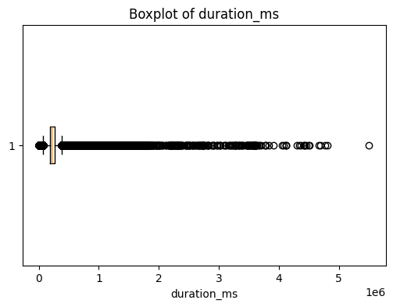
- Boxplot of duration_ms variable
As shown in the boxplot, the duration_ms variable exhibits a large number of outliers. This is primarily due to its highly skewed distribution, where the majority of tracks fall within a typical song length of approximately 2–5 minutes, while a subset of observations extends to significantly longer durations. These long-duration entries are likely to correspond to non-musical content such as podcasts or spoken-word recordings.
For further assessment, the ten tracks with the highest values of duration_ms, liveness, and speechiness are examined. In addition, the ten tracks with the lowest values of duration_ms, speechiness, instrumentalness, energy, danceability, and valence are also analyzed. These inspections provide qualitative insight into the nature of extreme observations. Furthermore, percentile analysis is conducted on these variables to support a more quantitative evaluation of their distributions.
These analyses indicate that the majority of tracks fall within a typical song duration range, while a small subset extends significantly beyond this range. Similarly, high speechiness values are associated with spoken content rather than music. Based on these observations, filtering criteria are applied by restricting track duration to the range of 1 to 10 minutes and excluding tracks with speechiness values greater than 0.7. In addition, a small number of observations exhibiting zero values across energy, instrumentalness, and speechiness are considered anomalous and removed. This preprocessing step ensures that the analysis focuses primarily on musical tracks while reducing noise introduced by non-song entries.

Data Profiling
Based on the research objectives, the analysis focuses on track_popularity as the target variable, along with artist_popularity and a set of audio features, including acousticness, danceability, energy, instrumentalness, liveness, speechiness, tempo, and valence. These features are selected as they capture both the perceptual and technical characteristics of musical tracks.
Descriptive statistics are computed for the selected numerical features to provide an overview of their distributions. These statistics include measures such as mean, standard deviation, minimum, maximum, and percentiles. The results are summarized in Table II.
- descrıptıve statıstıcs of some of the features
 | energy | danceability | valence
mean | 0.586479 | 0.586015 | 0.482813
std | 0.26017 | 0.177724 | 0.26169
min | 0.0 | 0.0 | 0.0
25% | 0.411 | 0.48 | 0.271
50% | 0.629 | 0.61 | 0.477
75% | 0.798 | 0.714 | 0.693
max | 1.0 | 0.989 | 0.993
skewness | -0.503321 | -0.62543 | -0.62543

The selected track-level features are examined to assess their distributions and variability. The analysis shows that these variables exhibit diverse distributional patterns, including approximately uniform, symmetric, and highly skewed distributions. Danceability and energy exhibits a standard normal distribution with a left skew. Valence is closer to uniform distribution.
The artist_popularity variable appears to follow a relatively symmetric distribution with no significant outliers. In contrast, the boxplot of track_popularity reveals the presence of outliers.
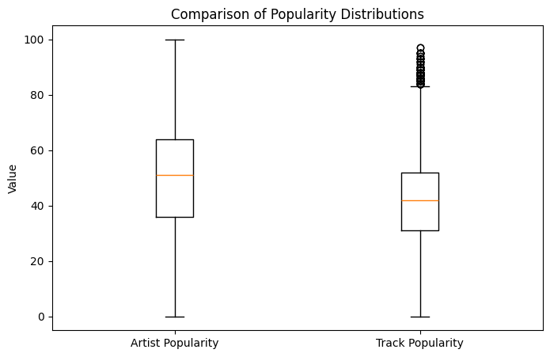
- Boxplots of track and artist popularity
This observation suggests that track popularity is not solely determined by artist popularity and may be influenced by additional factors, such as track-level audio characteristics. This supports the inclusion of multiple features in the subsequent analysis and modeling stages.

Naïve Baseline
As a baseline, a naive model is constructed by predicting the mean track popularity for all observations. This baseline represents the best constant prediction in the absence of feature information. The performance of the regression models is evaluated using Mean Absolute Error (MAE) and the coefficient of determination (R²). MAE provides an interpretable measure of the average prediction error, while R² evaluates how well the model explains the variability in the target variable. These two metrics complement each other by capturing both prediction accuracy and explanatory power.
The naive baseline model resulted in a Mean Absolute Error (MAE) of 12.654 and a Root Mean Squared Error (RMSE) of 15.695. The coefficient of determination (R²) is approximately zero, indicating that it does not explain any variability in the data. Therefore, any meaningful model should outperform this baseline in both MAE and R².

References
- D. Martin-Gutierrez, G. Hernandez Penaloza, A. Belmonte-Hernandez, and F. Alvarez Garcia, “A Multimodal End-to-End Deep Learning Architecture for Music Popularity Prediction,” IEEE Access, vol. 8, pp. 39361–39374, 2020, doi: https://doi.org/10.1109/access.2020.2976033.
- D. Herremans, D. Martens, and K. Sörensen, “Dance Hit Song Prediction,” Journal of New Music Research, vol. 43, no. 3, pp. 291–302, Jul. 2014, doi: https://doi.org/10.1080/09298215.2014.881888.
- J. Fan and M. Casey, “Study of Chinese and UK Hit Songs Prediction,” 2013.
- [4] N. Askin and M. Mauskapf, “What Makes Popular Culture Popular? Product Features and Optimal Differentiation in Music,” American Sociological Review, vol. 82, no. 5, pp. 910–944, Sep. 2017, doi: https://doi.org/10.1177/0003122417728662.

