**Farmers Markets Development**

**In the United States**

*An analysis on the regional distribution, product popularity and specialties,*

*payment method growth opportunities, and outreach development*

By: Albert Chen

Date: 26 Feb 2020

**Table of Contents**

1. Introduction 3

1.1. Farmers Market Promotion Program (FMPP) 3

1.2. Objective 3

2. Regional Distribution and Activity 4

2.1. State Distribution 4

2.2. Regional Activity 5

3. Popular and Specialty Products 7

3.1. Regional Goods Distribution 7

3.2. Product Popularity per Region 8

4. Payment Methods Acceptance 10

4.1. Supplemented Payment Methods 10

4.2. Payment Methods Distribution 11

5. Outreach Growth 12

6. Conclusion 14

**Table of Figures**

Figure 1: Map of the United States of America showing count of farmers markets per state. 4

Figure 2: Map of the United State of America showing count of farmers markets per 100k people per state population . 5

Figure 3: Distribution of farmers markets per region and division of the United States. 6

Figure 4: Relationship between active months of farmers markets split by region . 7

Figure 5: Density of total goods available at a given farmers market by region . 8

Figure 6: Comparing the top 10 most popular products by region . 9

Figure 7: Highlighting the products with the largest regional difference in availability and popularity . 9

Figure 8: Comparing total farmers markets accepting each payment types. 11

Figure 9: Time series graph showing farmers market payment types acceptance from 2011-2019 . 12

Figure 10: Comparing usage of various media platforms by farmers markets , . 13

Figure 11: Time series of percent of farmers markets using specific media platforms from 2009-2019 , . 14

# Introduction

Farmers markets are gatherings held by farmers to attract consumers to purchase their goods directly rather than through a supermarket or any third-party vendors. This creates a healthy relationship between producer and consumer which allows for increased confidence when purchasing items. These markets can carry a variety of goods from vegetables to homemade baked items which generally vary by region.

While cutting the middleman can provide increased profits for the farmers, there are also other federally funded programs that promote farmer market financial viability. These promotions extend to under privileged members of society who would normally could not afford or are not incentivized to pursue this route. Farmers markets are a healthy food source which is growing support through various programs and outreach.

## Farmers Market Promotion Program (FMPP)

A large federal push by the United States Department of Agriculture (USDA) to support farmer market development is the Farmers Market Promotion Program (FMPP). This program aims to “increase domestic consumption of, and access to, locally and regionally produced agricultural products” [1]. This is achieved from funding or assisting domestic markets and roadside stand with the goal of providing technical knowledge and personal connections.

From 2008 – 2016, the Program has awarded 879 grants for over $58 million since the 2008 Farm Bill which supported this program [2]. This investment into domestic farmers markets has increased sales to $1.4 billion in 2012 which is double from sales in 1992 2. This growth supported by the grants has been focused on both planning and implementation services along with greater acceptance to payments to increase revenue.

As an example, in 2010 The Highland Center in Virginia, received funding to develop a new marking plan to optimize sales and to implement a website to highlight specific vendors and products. This resulted in 155% increase in average sales for markets in the Center and 38% increase in vendor sales over two years 2. There are multiple similar stories which reflect the positive impact of these grants.

Overall, the support of the USDA in locally sourced products has greatly shaped the development of the farmers market industry in the United States.

## Objective

This report details the profile and growth of the farmers market industry through (1) regional distribution and activity, (2) popular and specialty products, (3) payment method diversity, and (4) outreach growth. The data is sourced from the United States Department of Agriculture in the National Farmers Market Directory [3]

# Regional Distribution and Activity

From the National Farmers Market Directory, 8791 farmers markets were listed from various regions and goods distributed. This range of farmers markets gave a general idea of the spread of farmers markets domestically given state and regions.

## State Distribution

When observing the distribution of farmers markets across states, it’s clear that areas of greater population and states with histories of progressive ideas generally contain greater amount of farmers markets. As seen in Figure 1, the states with the highest count of farmers markets is California and New York. This figure also shows that there is a greater amount of farmers markets along the coast and the Midwest region most likely due to fertile lands and greater population which would increase demand of locally sourced foods.

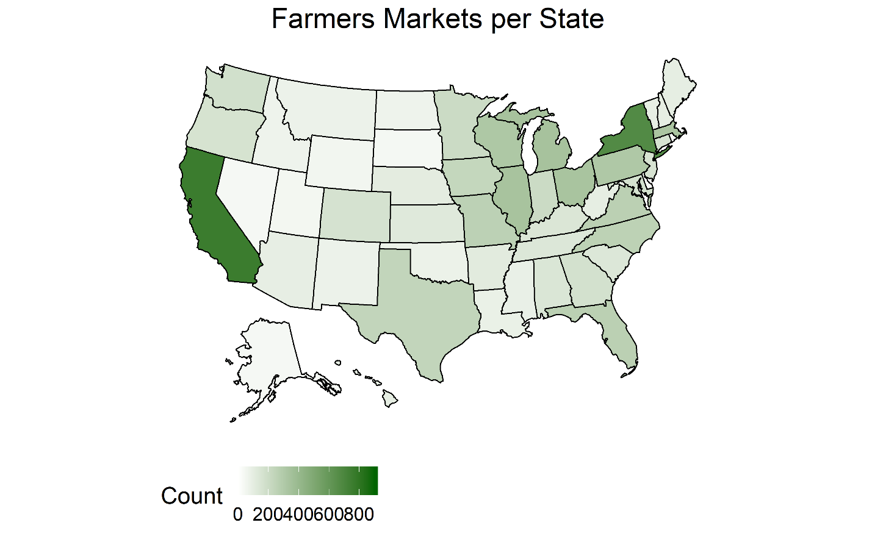

Figure 1: Map of the United States of America showing count of farmers markets per state.

This distribution does not factor into account the population per state as noted that California and New York are top states in population [4]. In Figure 2 the population is accounted for in each state. This new distribution shows a more even split between states with northeast, specifically Vermont, and some Central states showing higher count of farmers markets per population. Overall, this distribution shows that farmer markets are generally a function of the demand of the population.

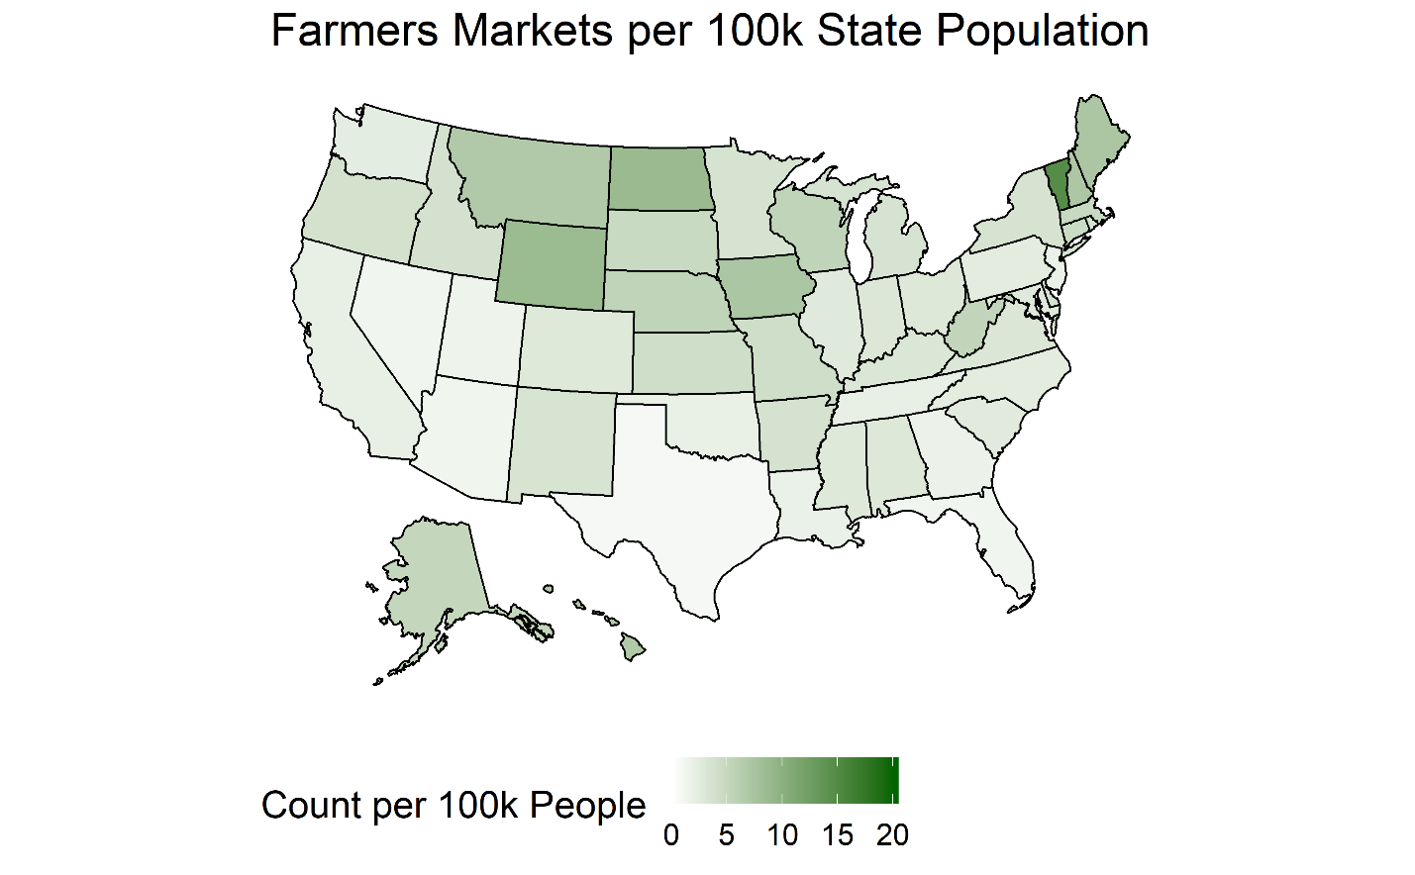

Figure 2: Map of the United State of America showing count of farmers markets per 100k people per state population 4.

## Regional Activity

To simplify future analysis of regional differences, each state is placed into a region which is split into a division [5]. The breakdown of farmers markets per region and division can be seen in Figure 3 below. Each region will be used for further analysis rather than division. It can be noted that the Midwest and Southern regions contain the most farmers markets overall. While the South contains the majority of the population of 120,000 people compared to the Midwest (67,000) they contain a similar amount of farmers markets 4. Furthermore, while the West contains (75,000) people, they contain less markets compared to the Northeast (56,000) 4.

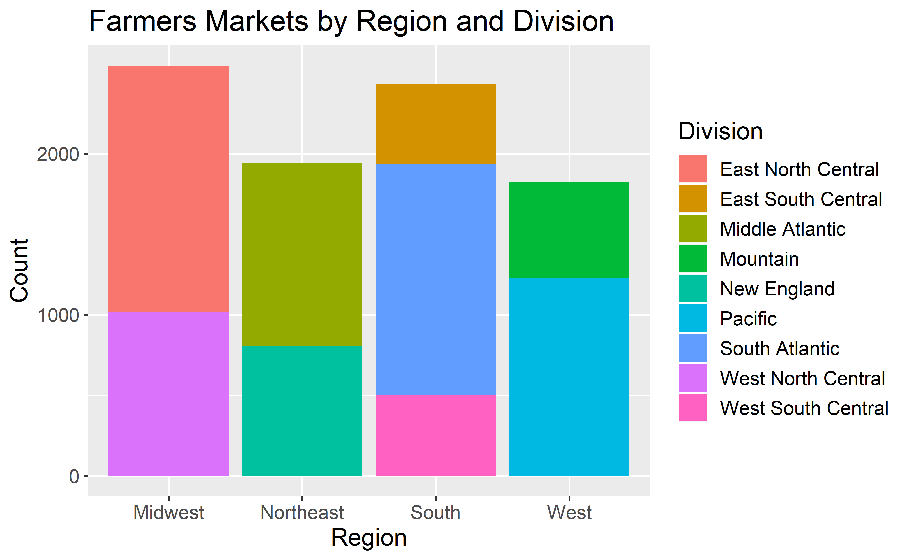

Figure 3: Distribution of farmers markets per region and division of the United States.

To expand on the regional difference between farmers markets, the active seasons of each famer market was analyzed to produce Figure 4 to show how many markets are open during each month of the year [6]. It can be observed that each region has a relatively even number of markets open during the summer between June and October. However, as the seasons progress to winter, only a subset of markets stays open.

It’s clear that the south and west have more markets that stay open year round most likely due to regional climate differences. The difference is most prominent during December to March in which most Midwest and Northeast markets are closed.

The availability of these markets throughout the year can influence consumer’s dependence and regulate how many regulars the market obtains. Therefore, while it may not be possible to overcome natural regional differences, knowing the active months of farmers markets can allow targeted initiatives based on seasons and regions.

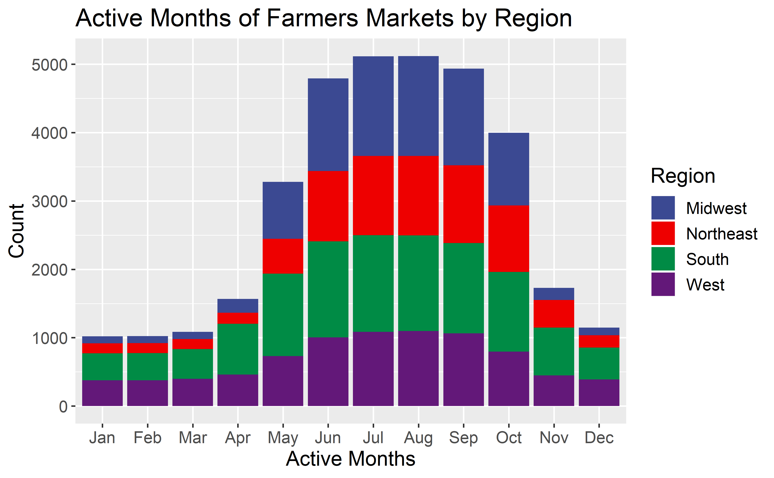

Figure : Relationship between active months of farmers markets split by region 6.

# Popular and Specialty Products

In the National Farmers Market Directory, it lists if the market carries a subset of common products search for each farmers market such as vegetables, baked goods, meats, etc. To observe differences in regional specialties the total goods available for each product, and the most popular products for each region were summarized in Figure 6.

## Regional Goods Distribution

In Figure 5, the total types of goods in each farmers market was compared by each region. Out of a total possible 29 products, it’s observed that for each region, there is an average range of 10 – 15 types of product are typical available at a market across all regions. Furthermore, there is a skew towards farmers markets having more specialized selection given the left leaning density plot. Especially within the Northeast, there seems to be a greater trend compared to other regions of having <5 products in a given market.

This trend may be due to a decrease in variety of product, or an indication of smaller markets within the northeast compared to other regions. When shopping for specific items, it’s valuable to have both large and small selections for the mastery in a specialized market vs the wide berth of products in a diverse market.

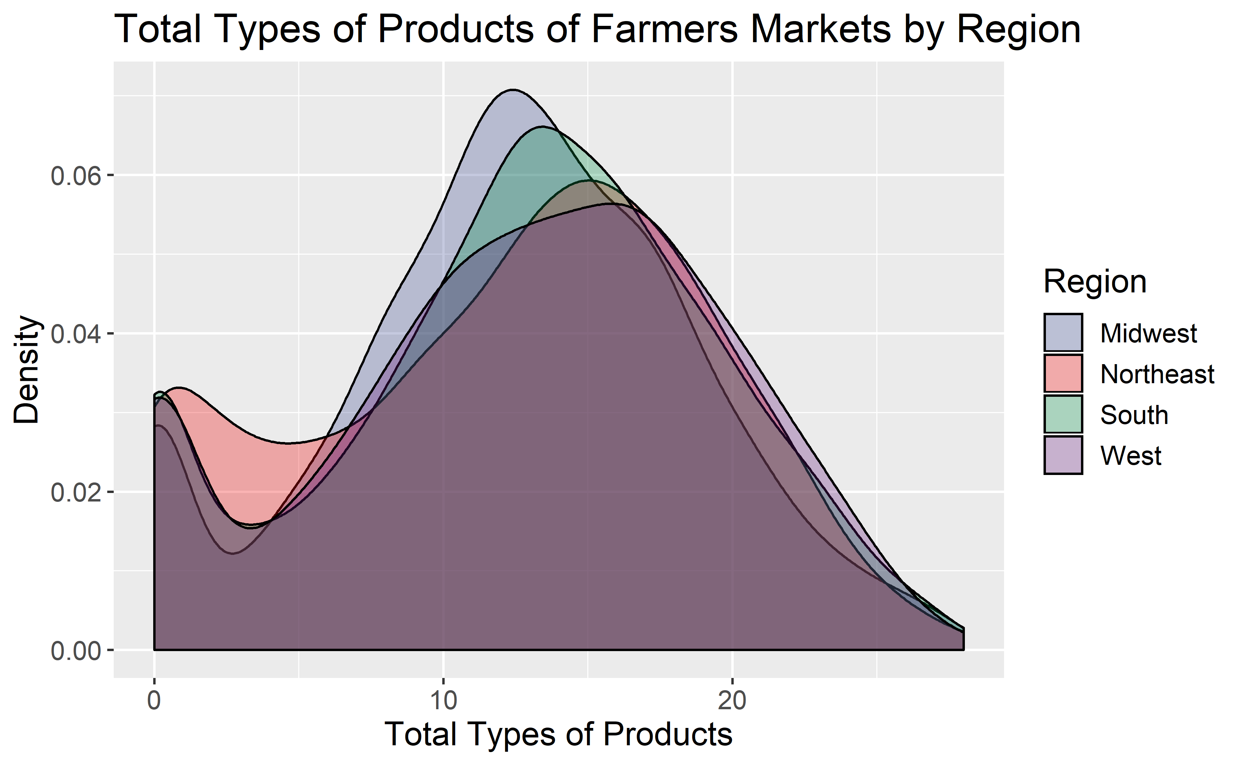

Figure 5: Density of total goods available at a given farmers market by region [7].

## Product Popularity per Region

Given the diversity of each region, Figure 6 shows what are the most popular items in each region. To determine the popularity of each item per region, the amount of farmers markets that offered the products vs the total farmers markets per region were calculated. This meant that multiple common products such as vegetables, eggs, flowers, fruits, etc. overlapped since they are popular items in all regions.

Therefore, rather than observing the most popular products per region, Figure 7 displays products that have a large difference in popularity between regions. The products listed have a region which has an 8% difference between its popularity and the average popularity across regions [8].

This shows reasonable differences such as maple being more popular in the Northeast, and lack of seafood in the Midwest. However, there’s also interesting products such as nuts, tree and wine. This graph better shows regional specialties and regionally unpopular items rather than common items across all farmers markets.

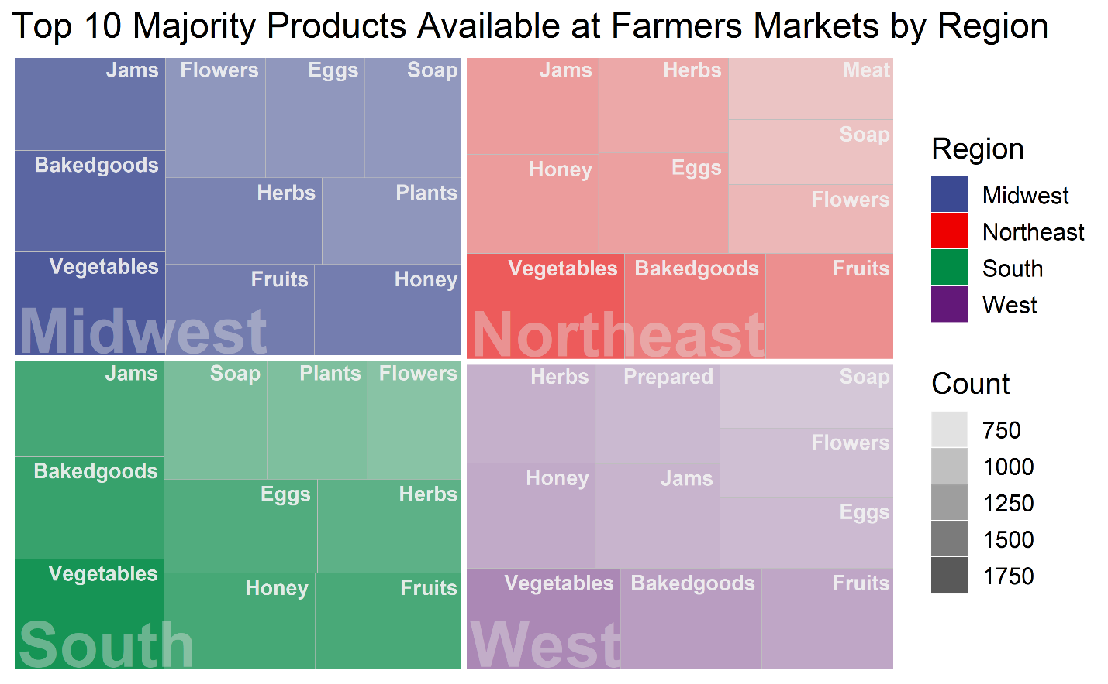

Figure 6: Comparing the top 10 most popular products by region 8.

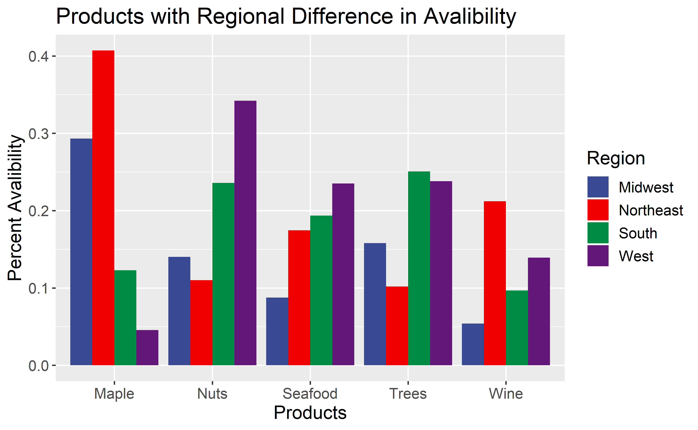

Figure 7: Highlighting the products with the largest regional difference in availability and popularity 8.

# Payment Methods Acceptance

The safest form of payment for farmers markets is to pay in cash which is domestically accepted in all markets. In the recent years, credit the also making headway into most. However, cash is still the assured form of payment. In this section, the development of payment methods to promote growth of the farmers market industry is explored.

## Supplemented Payment Methods

Other payment methods supported by the federal government, all aim to support lower income citizens to allow them to eat healthy and support local farmers. This means there are general restrictions across the board. Such as only certain products such as fruits and vegetables, meat, dairy, etc. can only be bought. While beer, wine, liquor, cigarettes, vitamins, hot foods, etc. will not be supported even if available at a farmers market.

* **Seniors Farmers' Market Nutrition Program (SFMNP)**

This program was started to make locally sourced foods available for low-income seniors and to increase consumer growth for farmers markets. Since the 2014 Farm Bill, $21 million annually (decreased to $19 million in 2017) is used to support those who apply [9]. Only markets which are authorized by the State agency can accept that redeem these coupons used, so it limits the amount of markets which are officially allowed to accept this form or payment.

* **Supplemental Nutrition Assistance Program (SNAP)**

To get SNAP benefits, a family or individual must be below a certain poverty limit as well but looks to support eating healthy even though it may be financially difficult. A single person household would have a maximum monthly allotment of $194 [10]. The main goal is to teach people to cook and eat healthy especially since 2/3 of SNAP benefits go to households with children [11].

Furthermore, its observed that “SNAP benefits lifted at least 4.7 million people out of poverty in 2014” 11. This program is highly supported and has only been growing. Since 2008, the number of farmers, stand, and markets accepting SNAP has grown eight-fold to +6,000 [12].

* **Women, Infants, and Children (WIC) (Cash Value Voucher (CVV))**

The WIC aims to support woman, infants and children with supplemental foods specifically for low income pregnant woman and children up to five. This program was established in 1992 and in “2017, over 1.7 million WIC participants received FMNP benefits.” [13]. Furthermore, it’s noted that in 2017, 3,300 farmer markets support WIC payments. Similar to the other programs, it supports woman and children’s healthy growth with a payment method to purchase local beneficial goods.

## Payment Methods Distribution

From Figure 8, it’s clear that credit is the most widely accepted form of currency accepted by most farmers markets beside cash. The difference between each other government supported method requires time to implement and verify compared to simply using credit. Therefore, it is understandable that some markets are unable to or are uninterested in perusing accepting a supplemental form of payment.

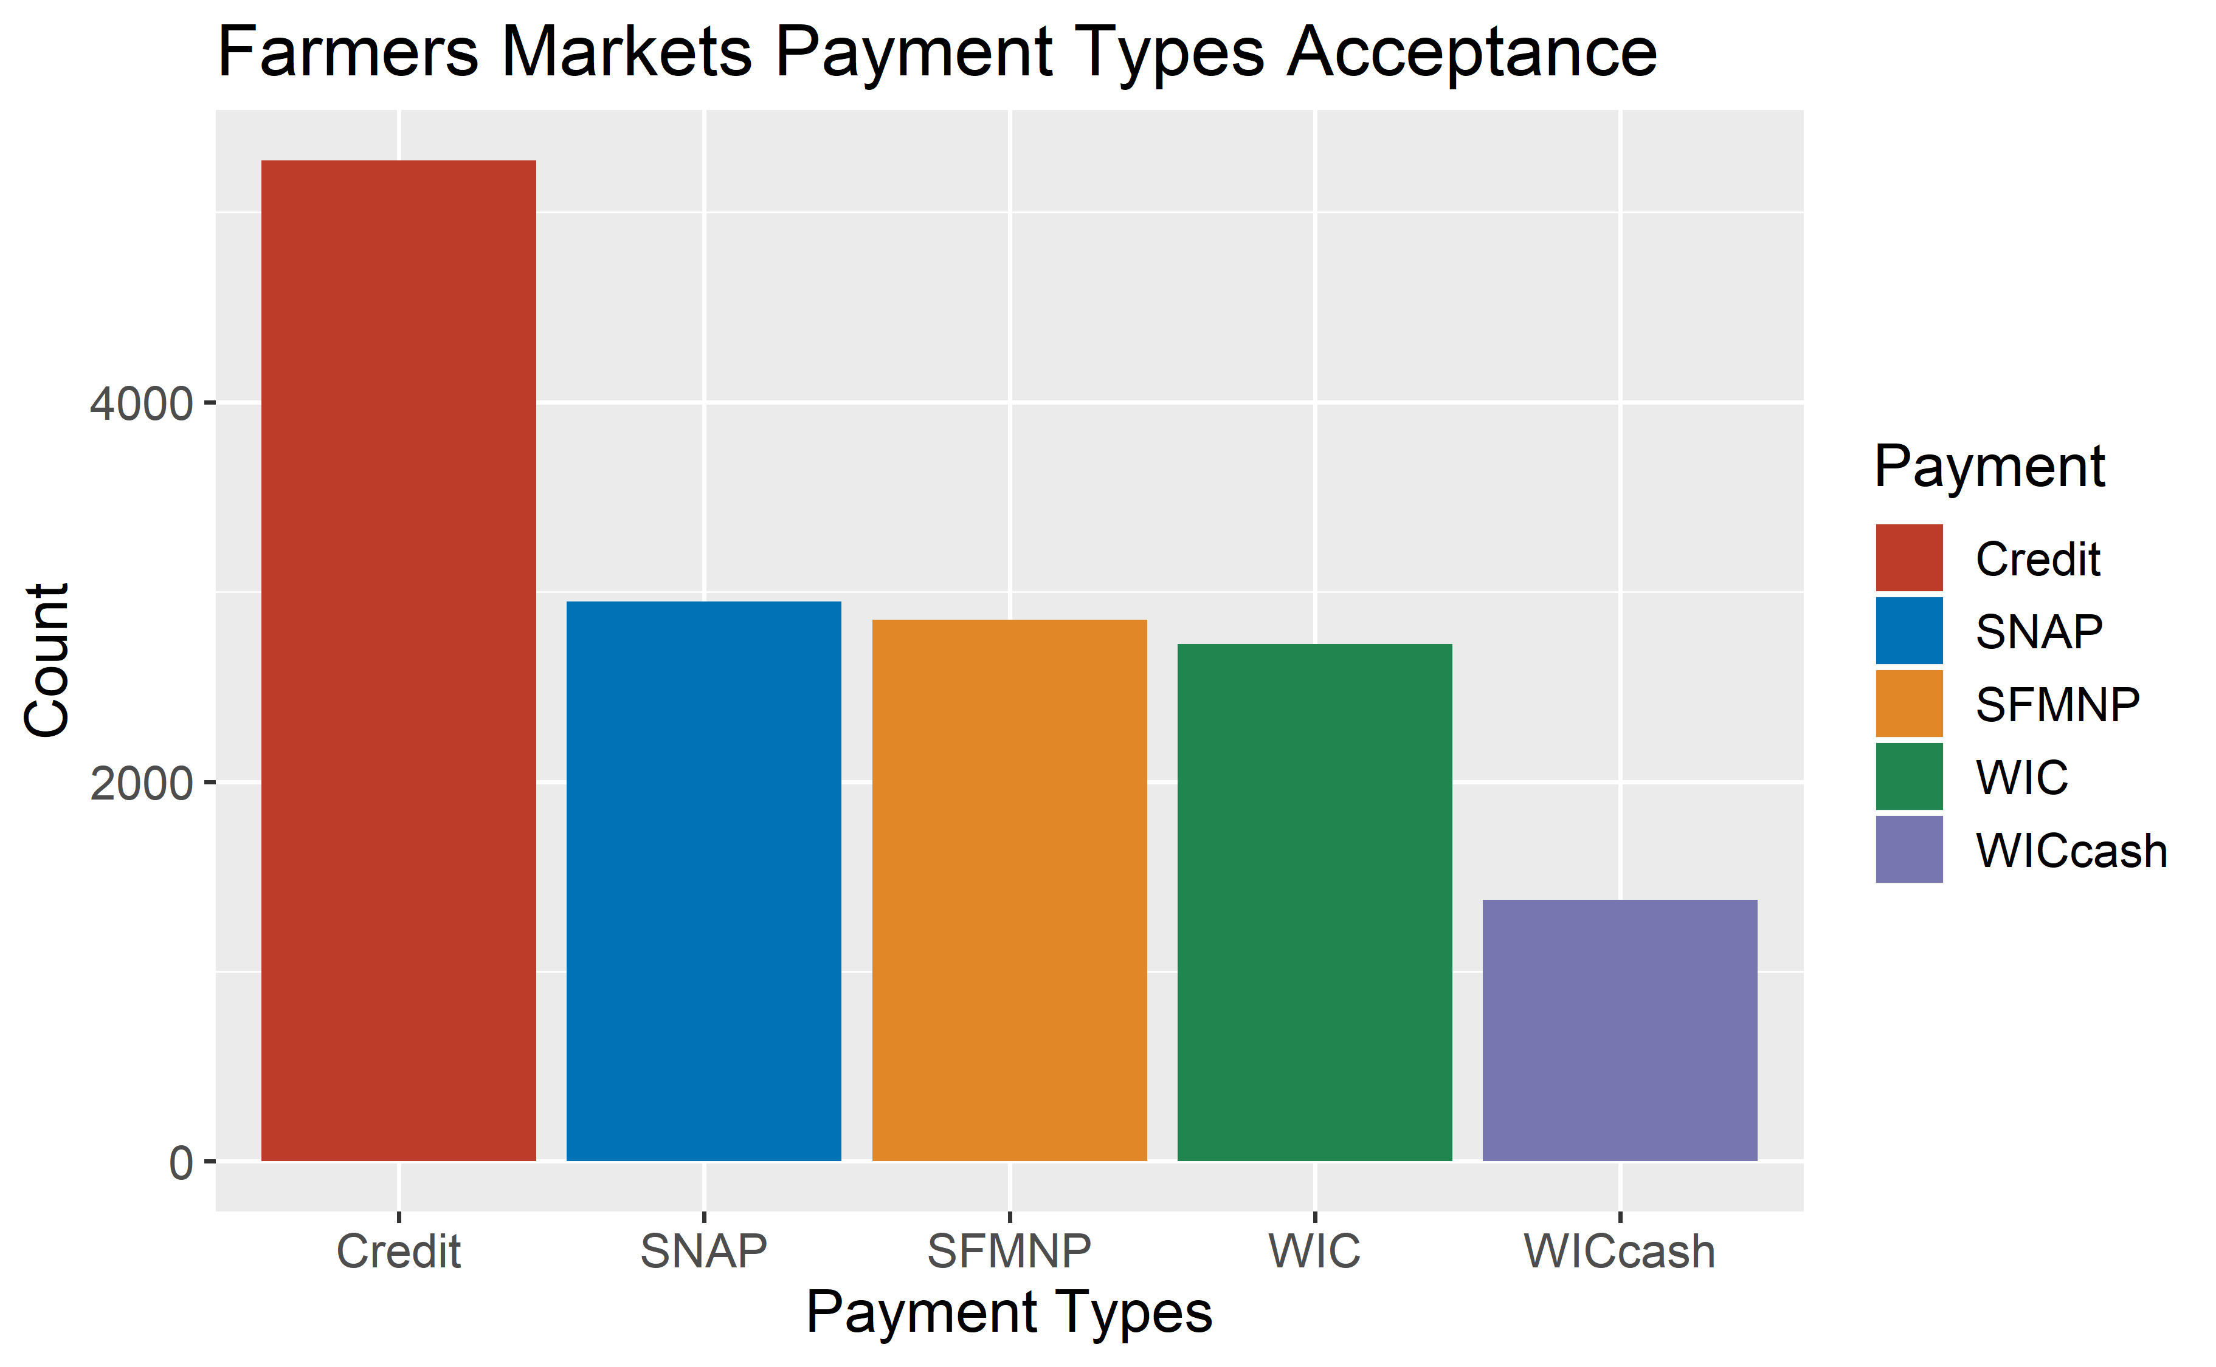

Figure : Comparing total farmers markets accepting each payment types.

Rather than seeing the raw values of farmers markets that accepted each form of payment, the variation of payment types observed over each year was mapped in Figure 9 [14]. This graph displays the growth of each payment type and shows a positive trend for the future of these government supported programs. Furthermore, for all markets from 2015 onwards accept credit form of payment which provides the consumer with a convenient payment method.

For supplemental payment methods such as SNAP, there is a general increase in acceptance overtime, especially around 2014 due to the funding in the 2014 Farm Bill which increased funding for these types of programs 13,9,12.

Overall, increased percentage of famers markets that accept more types of payments should increase profits of farmers markets and also provide a healthy source of food for lower income people that are illegible for these programs.

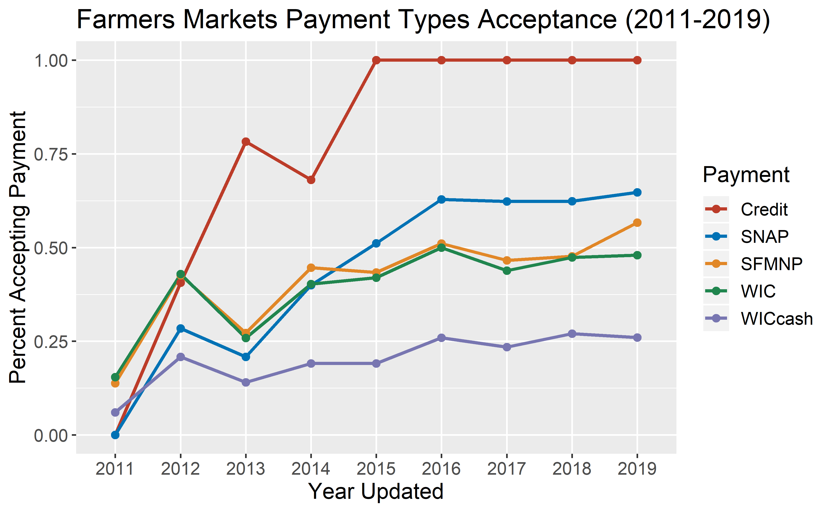

Figure : Time series graph showing farmers market payment types acceptance from 2011-2019 14 [15].

# Outreach Growth

With support from FMPP, these companies grow through multiple route, whether it be planning technical advantages or renovations on physical markets. Another important aspect is the exposure of the market to local communities to display highlight vendors or specialty products. In the recent years, social media is the most effective route to building up a loyal community and maintaining contact directly with consumers.

When reporting farmers market data to the National Farmers Markets Directory, various social media platforms can be included such as Facebook and Twitter. In Figure 10 its observed that farmers markets prefer website and Facebooks groups over other platforms like Twitter and YouTube. Facebook especially can be beneficial since there are inherent synergies with discussion boards, ability to see profiles of actual consumers, and notification system for special events.

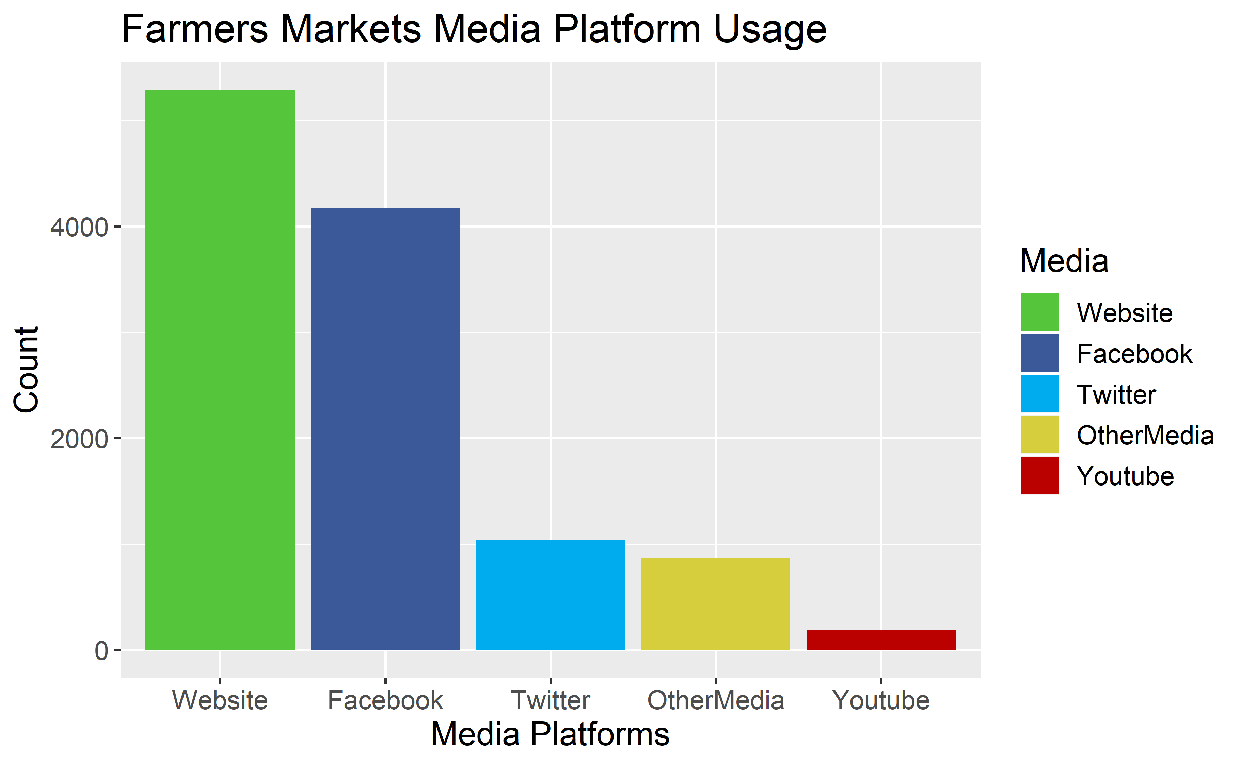

Figure : Comparing usage of various media platforms by farmers markets 14, [16].

Furthermore, the development of farmers markets usage of social media has recently grown throughout the years. As seen in Figure 11, Facebook and website implementation has skyrocketed in the past ten years and a steady adoption of twitter and other medias (ex: Instagram) has grown as well. YouTube has minimal growth most likely due to the large time investment needed for video creation. Comparatively, usage of Facebook and Websites can be simple and are common practice.

This connection with the community is important to an industry which thrives and survives off of local consumers. Therefore, it’s promising to see these types of media adopted by farmers markets in recent years.

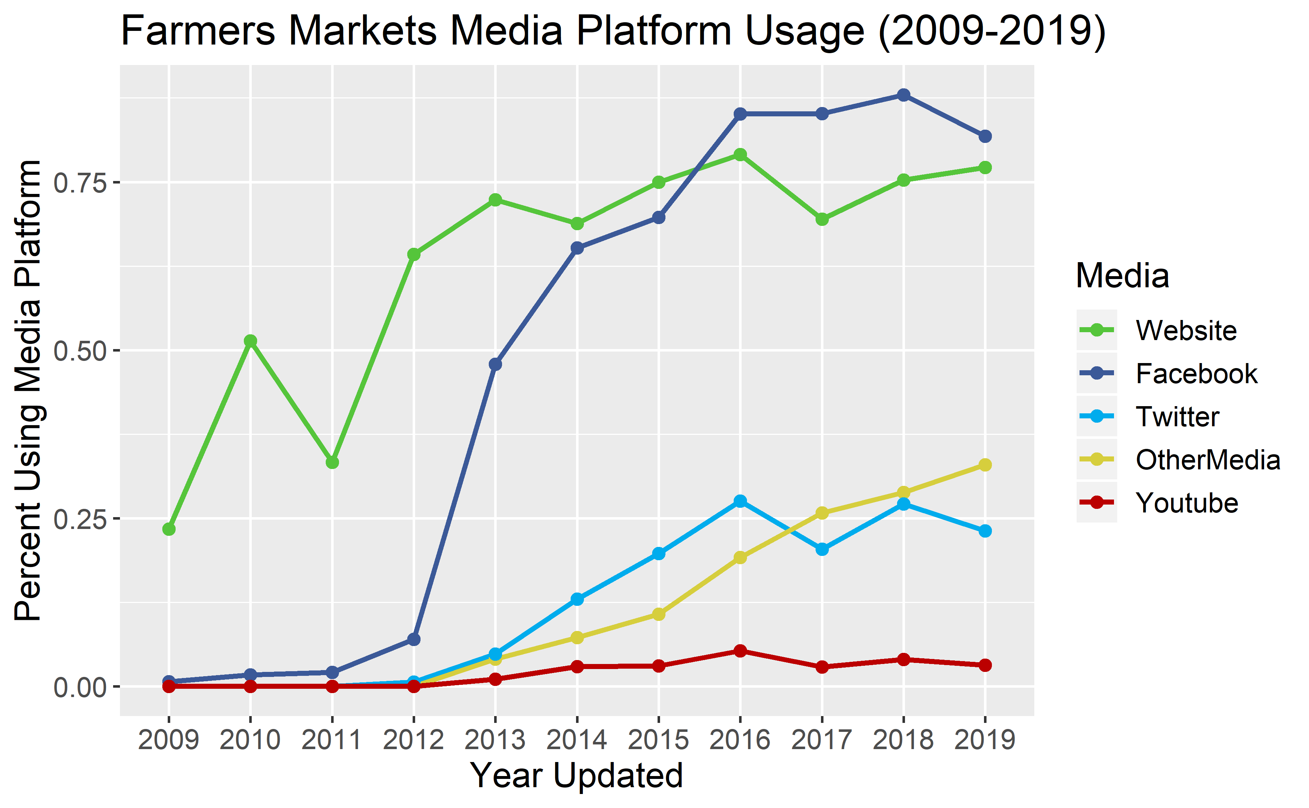

Figure : Time series of percent of farmers markets using specific media platforms from 2009-2019 14, 16.

# Conclusion

Farmers markets are spread across the United States and generally carry similar goods that a normal consumer can grow to expect. However, there are select regional or even market specific specialties which make each one different. There are also regional differences in availability of the market throughout the year.

The famers market industry has grown in initiative and development due to federal support that has allowed technical and financial advances. Farmers markets have increased usage of supplemental payment methods from programs such as SNAP and WIC. Furthermore, there is increased outreach to local communities through social media channels like Facebook and Twitter. These two developments should allow the industry to gain and maintain new consumers.

Overall, with the support of the federal government, and advances in social and community outreach, the farmer market industry is poised to grow.

1. Agricultural Marketing Service, ‘Farmers Market Promotion Program’, *United States Department of Agriculture*, <https://www.ams.usda.gov/services/grants/fmpp>, (accessed 25 February 2020)
2. Agricultural Marketing Service, ‘Farmers Market Promotion Program 2016 Highlights’, *United States Department of Agriculture*, <https://www.ams.usda.gov/sites/default/files/media/FMPP2016Highlights.pdf> (accessed 25 February 2020)
3. Agricultural Marketing Service, ‘National Famers Market Directory’, *United States Department of Agriculture*, <https://www.ams.usda.gov/local-food-directories/farmersmarkets>, (accessed 25 February 2020)
4. ‘State Population Totals: 2010-2019’, *United States Census Bureau*, <https://www.census.gov/data/datasets/time-series/demo/popest/2010s-state-total.html>, (accessed 25 February 2020)
5. Omer Shacham, ‘USA States to region’, *Kaggle*, <https://www.kaggle.com/omer2040/usa-states-to-region> , (accessed 25 February 2020)
6. Assumption: Only ‘Season 1’ from the National Farmers Markets Directory was observed – seasons 2/3/4 were infrequent and held minimal information.
7. Assumption: Removed markets that had not been updated since 2009 and 2010 since disproportional amount of farmers markets had zero total products, so it’s most likely that products weren’t tracked at that time.
8. Assumption: Popularity per region is calculated by total markets in region having the product divided by the total markets in the given region.
9. ‘Seniors Farmers’ Market Nutrition Program’, *United States Department of Agriculture*, <https://fns-prod.azureedge.net/sites/default/files/sfmnp/SFMNPFactSheet.pdf>, (accessed 25 February 2020)
10. ‘SNAP Eligibility’, *United States Department of Agriculture*, <https://www.fns.usda.gov/snap/recipient/eligibility>, (accessed 25 February 2020)
11. White House, ‘FACT SHEET: White House Report Highlights New Research on SNAP’s Effectiveness and the Importance of Adequate Food Assistance’, *United States Department of Agriculture*, <https://www.fns.usda.gov/pressrelease/2015/wh-120815>, (accessed 25 February 2020)
12. White House, ‘SNAP Benefit Redemptions through Farmers and Farmers Markets Show Sharp Increase’, *United States Department of Agriculture*, <https://www.fns.usda.gov/pressrelease/2015/fns-0007-15>, (accessed 25 February 2020)
13. WIC Farmers' Market Nutrition Program, *United States Department of Agriculture*, <https://fns-prod.azureedge.net/sites/default/files/fmnp/WICFMNPFactSheet.pdf>, (accessed 25 February 2020)
14. Assumption: In the raw data from National Farmers Market Directory, the year extracted was derived from the year the entry was last updated. Therefore, the year does not indicate the year of market opening or year a specific aspect was updated. However, as an overall trend, the year can be indicative of future developments and trends.
15. Assumption: Total payment methods in 2009 and 2010 were both zero – indicating payment acceptance was not documented, or no farmers market accepted any of these payments.
16. Assumption: If a website, Facebook, etc. link was not associated with the farmers market it was assumed that they were not associated with the platform