# Introduction

Farmers markets are gatherings held by farmers to attract consumers to purchase their goods directly rather than through a supermarket or any third-party vendors. This creates a healthy relationship between producer and consumer which allows for increased confidence when purchasing items. These markets can carry a variety of goods from vegetables to homemade baked items which generally vary by region.

While cutting the middleman can provide increased profits for the farmers, there are also other federally funded programs that promote farmer market financial viability. These promotions extend to under privileged members of society who would normally could not afford or are not incentivized to pursue this route. Farmers markets are a healthy food source which is growing support through various programs and outreach.

## Farmers Market Promotion Program (FMPP)

A large federal push by the United States Department of Agriculture (USDA) to support farmer market development is the Farmers Market Promotion Program (FMPP). This program aims to “increase domestic consumption of, and access to, locally and regionally produced agricultural products” [1]. This is achieved from funding or assisting domestic markets and roadside stand with the goal of providing technical knowledge and personal connections.

From 2008 – 2016, the Program has awarded 879 grants for over $58 million since the 2008 Farm Bill which supported this program [2]. This investment into domestic farmers markets has increased sales to $1.4 billion in 2012 which is double from sales in 1992. This growth supported by the grants have been either to support both planning and implementation services along with greater acceptance payments to increase revenue.

As an example, in 2010 The Highland Center in Virginia, received funding to develop a new marking plan to optimize sales and to implement a website to highlight specific vendors and products. This resulted in 155% increase in average sales for markets in the Center and 38% increase in vendor sales over two years 2. There are multiple similar stories which reflect the positive impact of these grants.

Overall, the support of the USDA in locally sourced products has greatly shaped the development of the farmers market industry in the United States.

## Objective

This report details the profile and growth of the farmers market industry through (1) regional distribution and products, (2) payment method diversity, and (3) availability and outreach. The data is sourced from the United States Department of Agriculture in the National Farmers Market Directory [3]

# Location and Spread of Farmers Markets

From the National Farmers Market Directory, 8791 farmers markets were listed from various regions and goods distributed. This range of farmers markets gave a general idea of the spread of farmers markets domestically given state and regions.

## State Distribution

When observing the distribution of farmers markets across states, it’s clear that areas of greater population and states with histories of progressive ideas generally contain greater amount of farmers markets. As seen in Figure 1, the states with the highest count of farmers markets is California and New York. This figure also shows that there is a greater amount of farmers markets along the coast and the Midwest region most likely due to fertile lands and greater population which would increase demand of locally sourced foods.

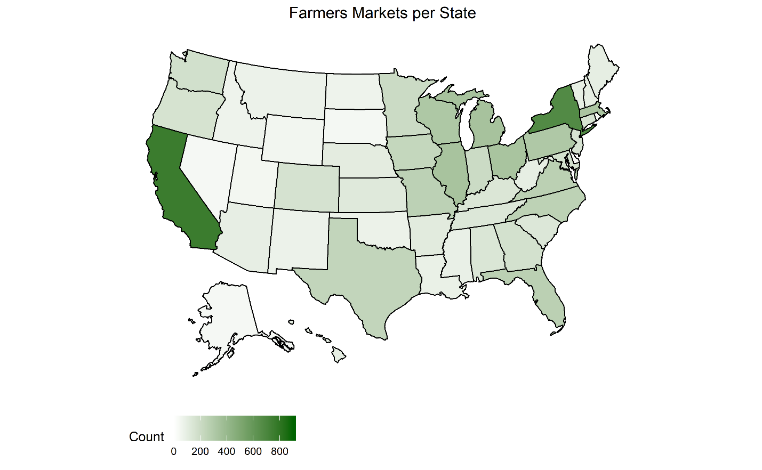

Figure 1: Count of Farmers Markets per State in the United States of America

This distribution does not factor into account the population per state as noted that California and New York are the top states in population [4]. In Figure 2 the population is accounted for in each state. This new distribution shows a more even split between states with northeast, specifically Vermont, and some Central states showing higher count of farmers markets per population. Overall, this distribution shows that farmer markets are generally a function of the demand of the population.

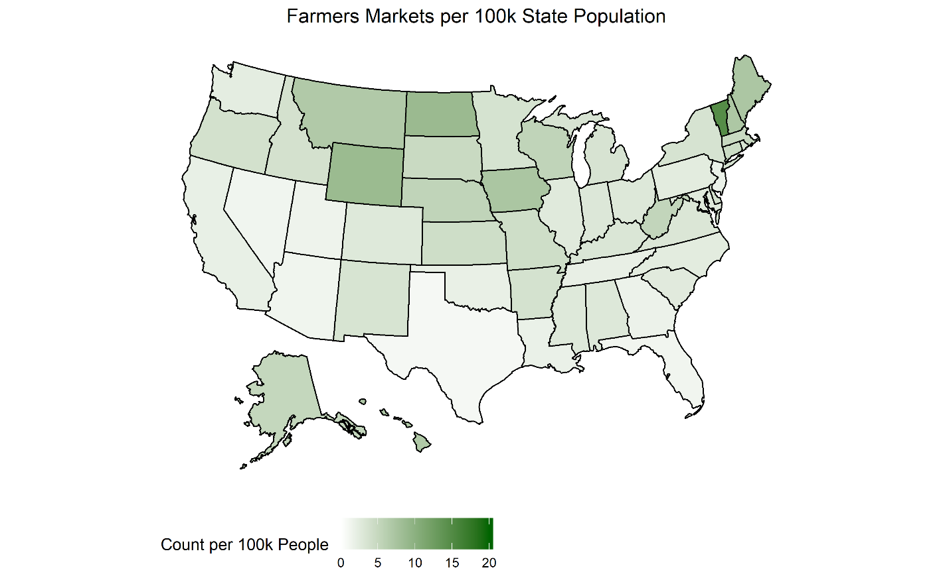

Figure 2: Count of Farmers Markets per 100k People per State Population 4

To simplify future analysis of regional differences, each state is placed into a region which is split into a division [5]. The breakdown of farmers markets per region and division can be seen in XXXXX below. Each region will be used for further analysis rather than division. It can be noted that the Midwest and Southern regions contain the most farmers markets overall. While the South contains the majority of the population of 120,000 people compared to the Midwest (67,000) they contain the same amount of farmers markets 4. Furthermore, while the West contains (75,000) people, they contain less markets compared to the Northeast (56,000) 4.

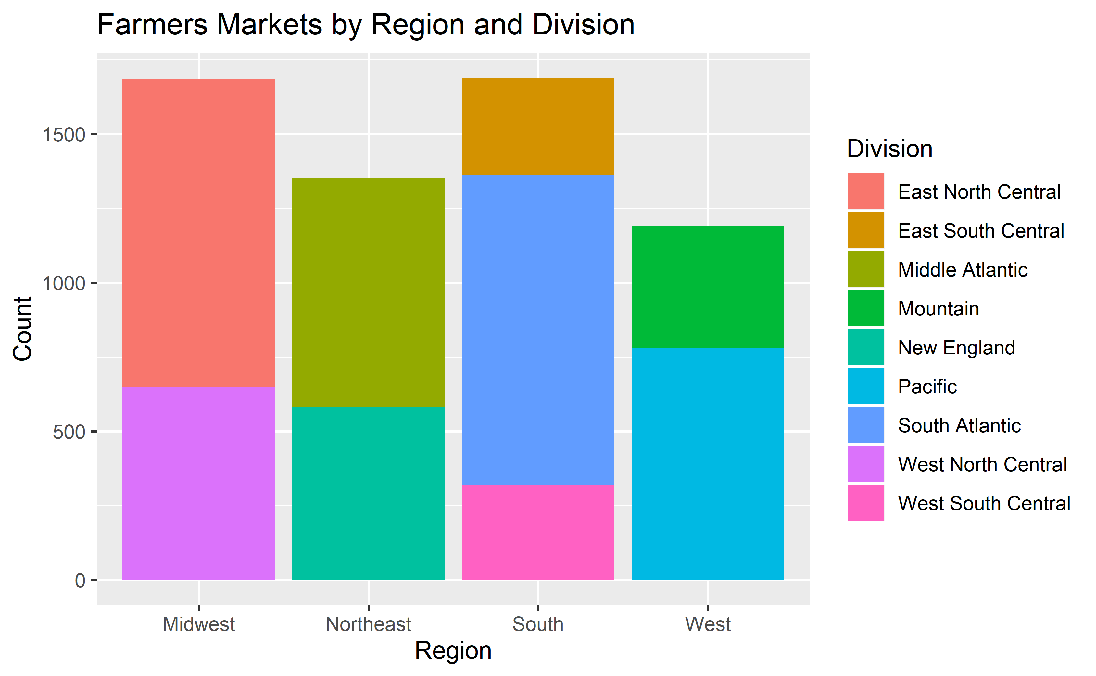

Figure 3: Farmers Markets per Region and Division

## Regional Goods Distribution

In the National Farmers Market Directory, it lists if the market carries a subset of common products search for each farmers market such as vegetables, baked goods, meats, etc. To observe differences in regional specialties the total goods available for each product, and the most popular products for each region were summarized in XXXX and XXXX.

In XXXXXX, the total types of goods in each farmers market was compared by each region. Out of a total possible 29 products, it’s observed that for each region, there is an average range of 10 – 15 types of product across all regions. Furthermore, there is a skew towards farmers markets having more specialized selection given the left leaning density plot. Especially within the Northeast, there seems to be a greater trend compared to other regions of having <5 products in a given market.

This trend may be due to a decrease in variety of product, or an indication of smaller markets within the northeast compared to other regions. When shopping for specific items, it’s valuable to have both large and small selections for the mastery in a specialized market vs the wide berth of products in a diverse market.

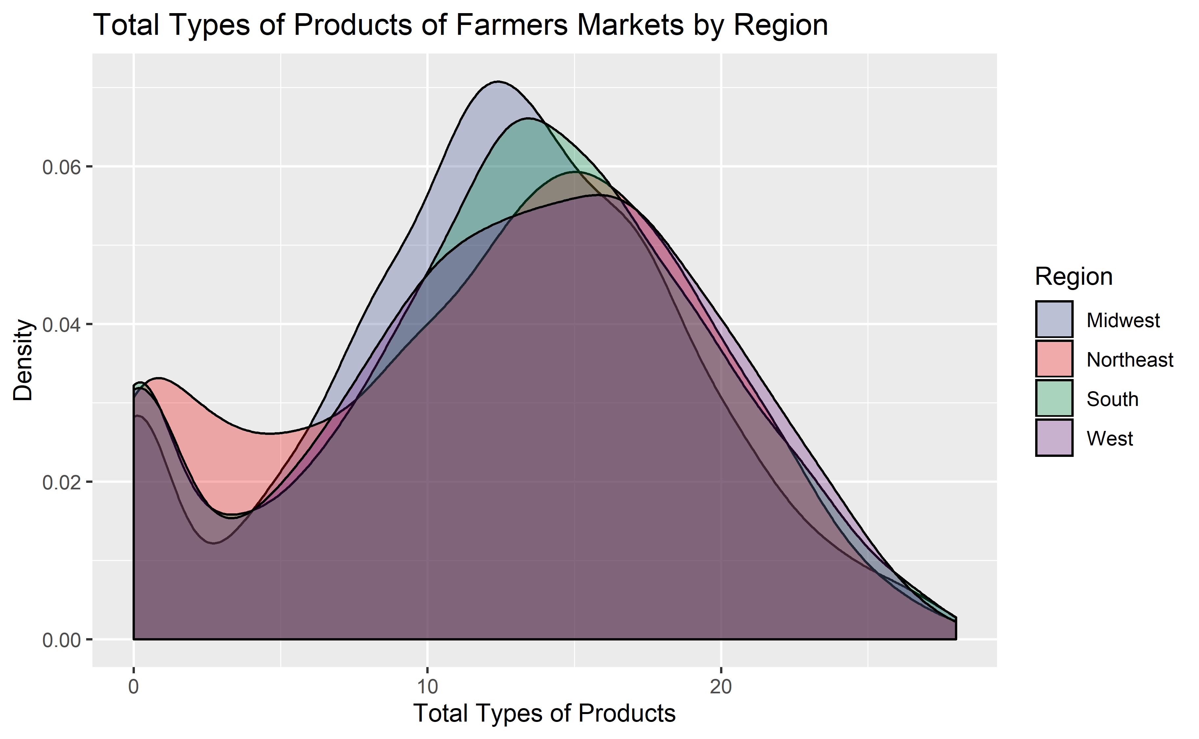

Figure 4: Total Goods Available at a Given Farmers Market by Region [6]

Given the diversity of each region, XXXXXX shows what are the most popular items in each region. To determine the popularity of each item per region, the amount of farmers markets that offered the products vs the total farmers markets per region were calculated. This meant that multiple common products overlap such as vegetables, eggs, flowers, fruits, etc. overlapped since they are popular items in all regions.

Therefore, rather than observing the most popular products per region, XXXXX displays products that have a large difference in popularity between regions. The products listed have a region which has an 8% difference between its popularity and the average popularity across regions.

This shows reasonable and initiative difference such as maple greatly more popular in the northeast, and lack of seafood in the Midwest. However, there’s also interesting products such as nuts, tree and wine. This graph better shows regional specialties rather than popular items.

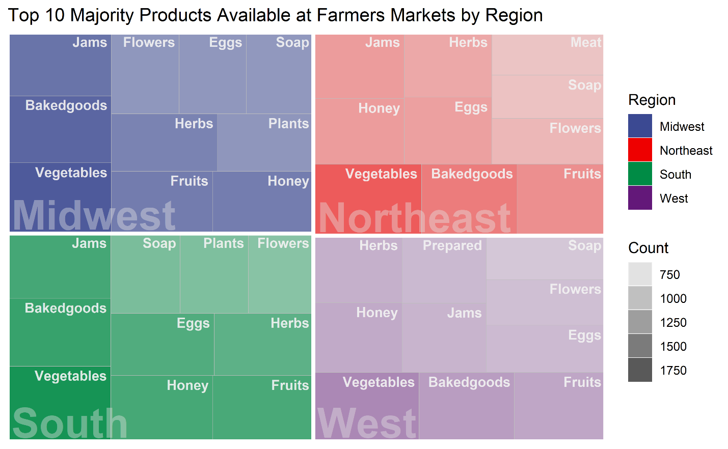

Figure 5: Top 10 Popular Products by Region

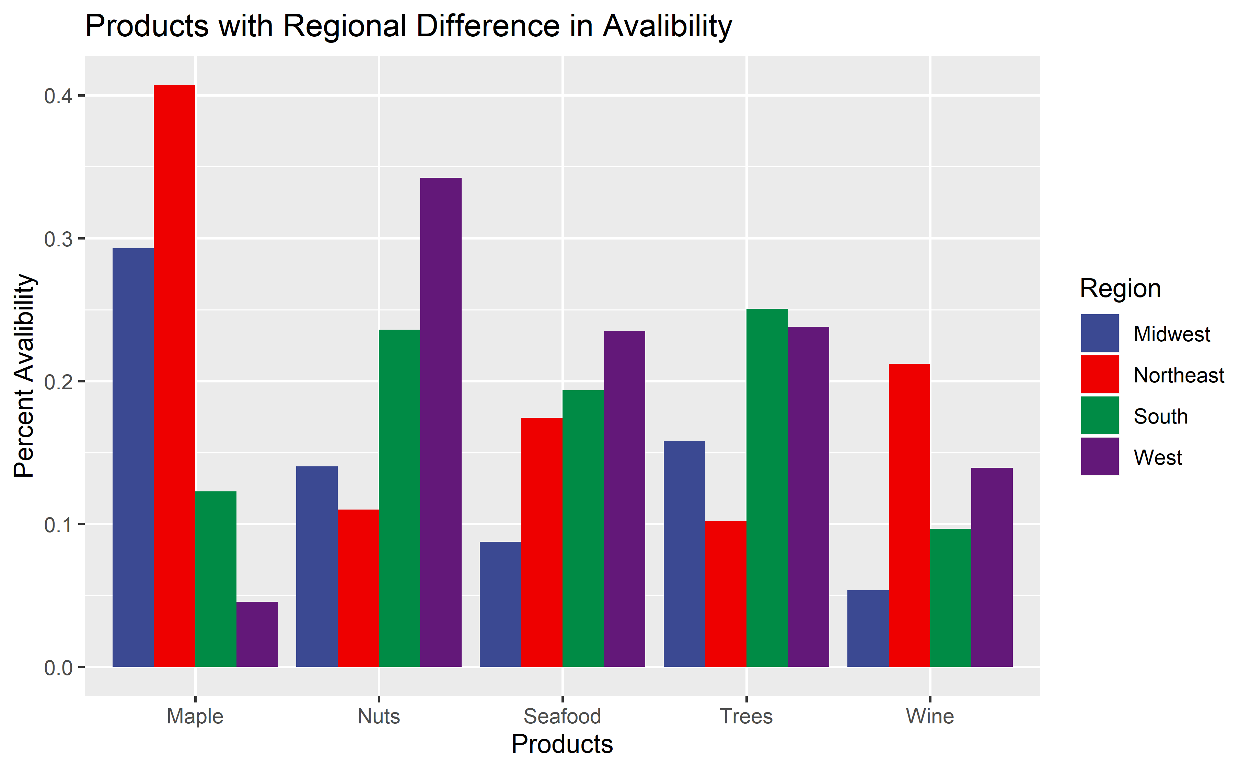

Figure 6: Products with regional difference in availability and popularity

# Payment Methods Accepted

The safest form of payment for farmers markets is to pay in cash which is domestically accepted in all markets. In the recent years, credit the also making headway into most. However, cash is still the assured form of payment. In this section, the development of payment methods to promote growth of the farmers market industry is explored.

## Supplemented Payment Methods

Other payment methods supported by the federal government, all aim to support lower income citizens to allow them to eat healthy and support local farmers. This means there are general restrictions across the board. Such as only certain products such as fruits and vegetables, meat, dairy, etc. can only be bought. While beer, wine, liquor, cigarettes, vitamins, hot foods, etc. will not be supported even if available at a farmers market.

* **Seniors Farmers' Market Nutrition Program (SFMNP)**

This program was started to make locally sourced foods available for low-income seniors and to increase consumer growth for farmers markets. Since the 2014 Farm Bill, $21 million annually (decreased to $19 million in 2017) is used to support those who apply [7]. Only markets which are authorized by the State agency can accept that redeem these coupons used, so it limits the amount of markets which are officially allowed to accept this form or payment.

* **Supplemental Nutrition Assistance Program (SNAP)**

To get SNAP benefits, a family or individual must be below a certain poverty limit as well but looks to support eating healthy even though it may be financially difficult. A single person household would have a maximum monthly allotment of $194 [8]. The main goal is to teach people to cook and eat healthy especially since 2/3 of SNAP benefits go to households with children [9].

Furthermore, its observed that “SNAP benefits lifted at least 4.7 million people out of poverty in 2014” 9. This program is highly supported and has only been growing. Since 2008, the number of farmers, stand, and markets accepting SNAP has grown eight-fold to +6,000 [10].

* **Women, Infants, and Children (WIC) (Cash Value Voucher (CVV))**

The WIC aims to support woman, infants and children with supplemental foods specifically for low income pregnant woman and children up to five. This program was established in 1992 and in “2017, over 1.7 million WIC participants received FMNP benefits.”[11]. Furthermore, it’s noted that in 2017, 3,300 farmer markets support WIC payments. Similar to the other programs, it supports woman and children’s healthy growth with a payment method to purchase local beneficial goods.

## Payment Methods Distribution

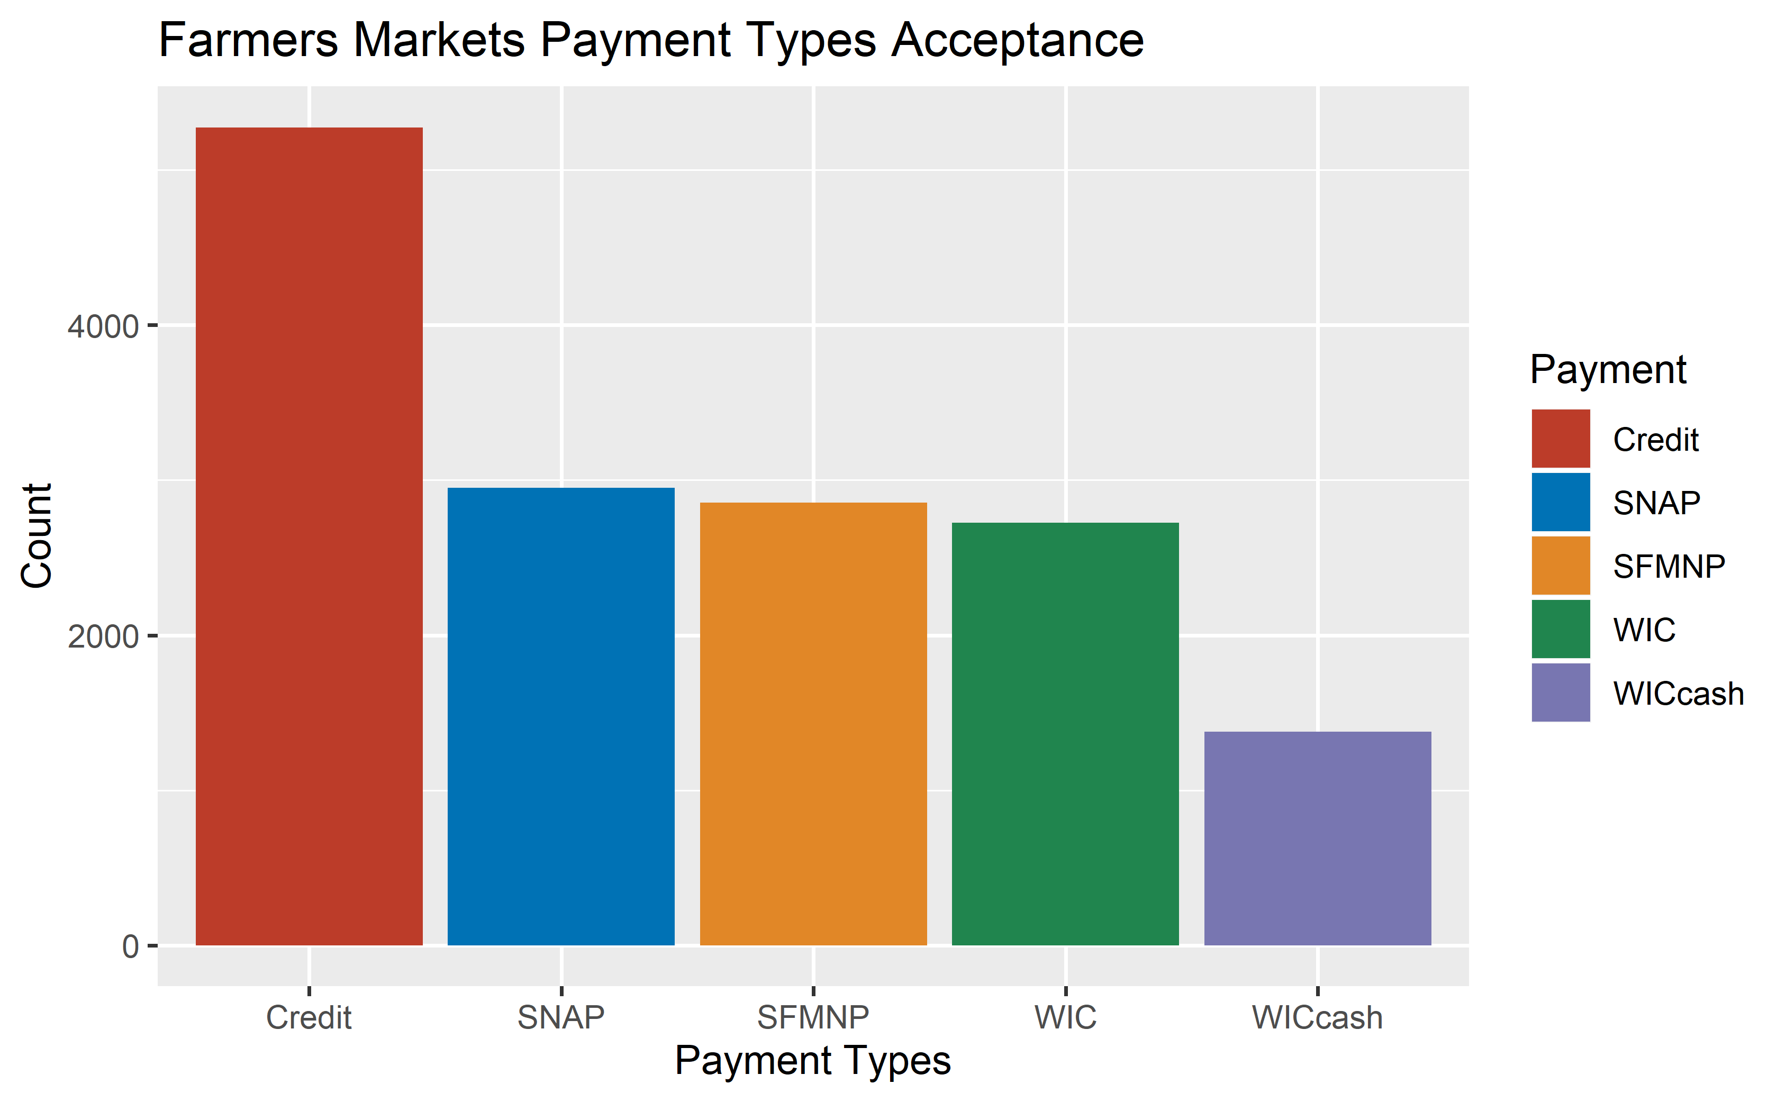

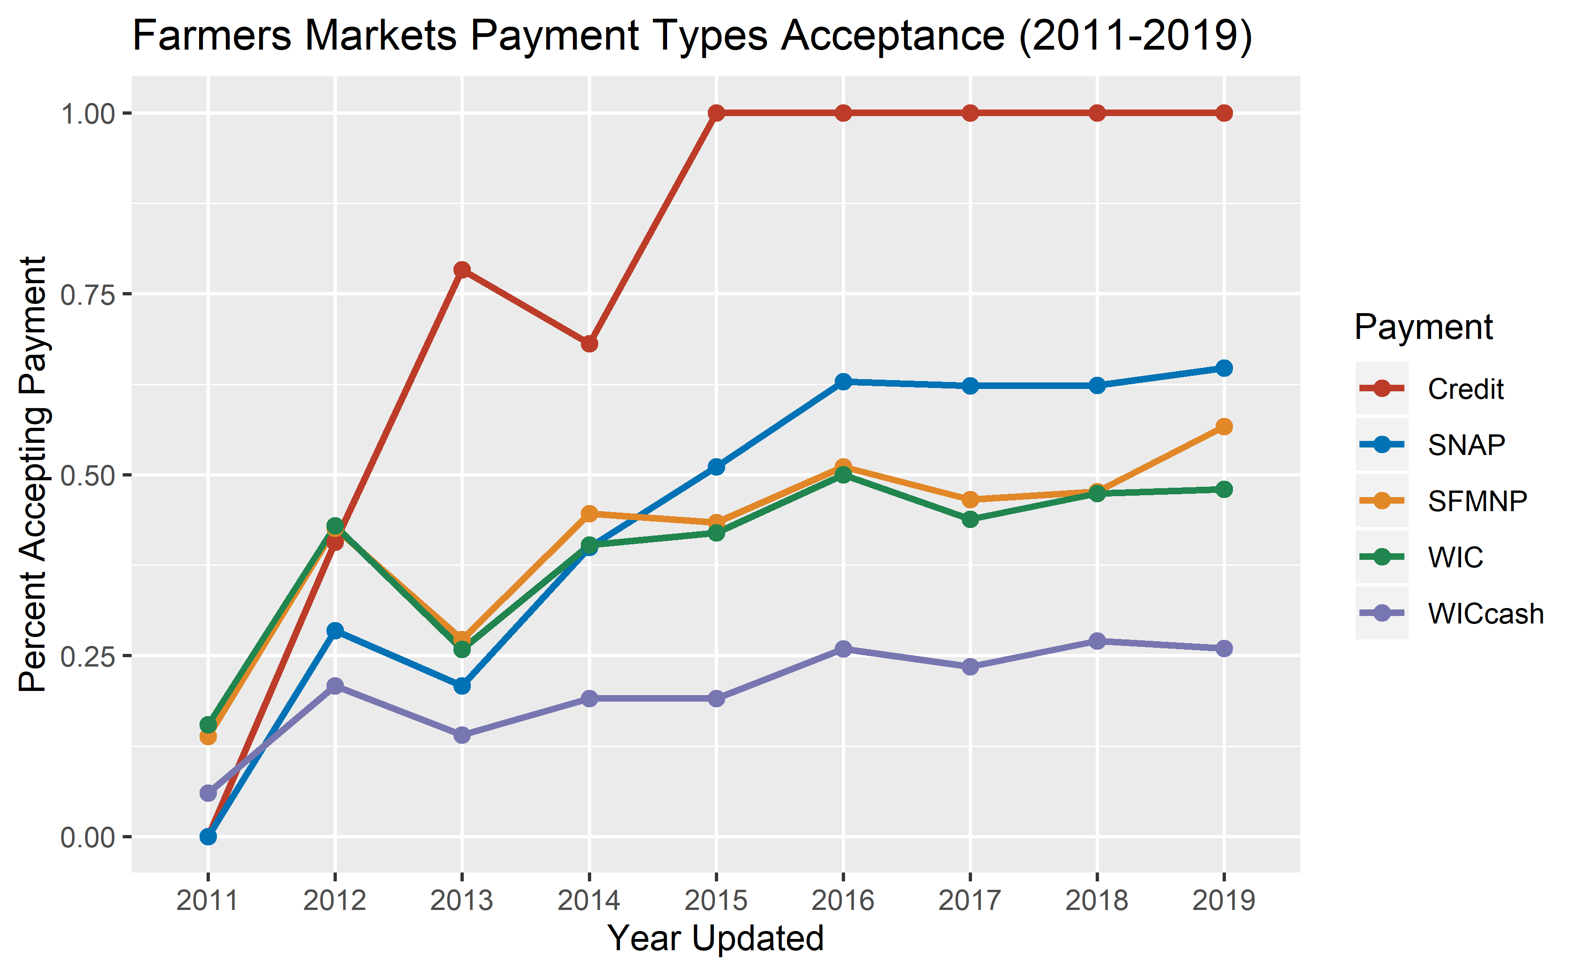

# Outreach and Availability

## Active Seasons

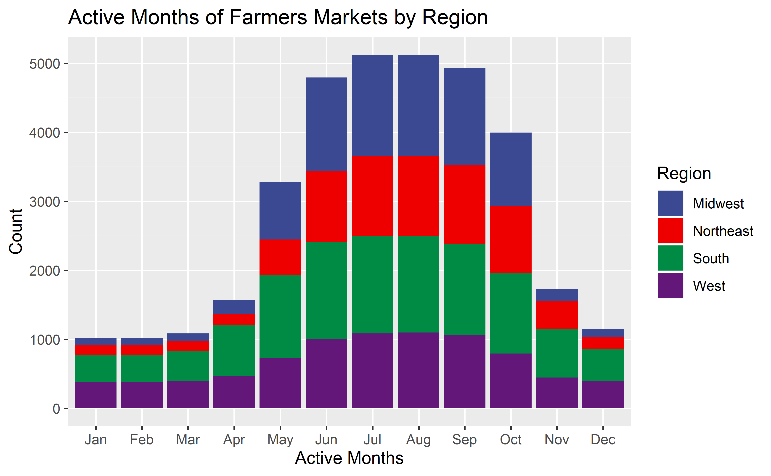

## Social Media Presence

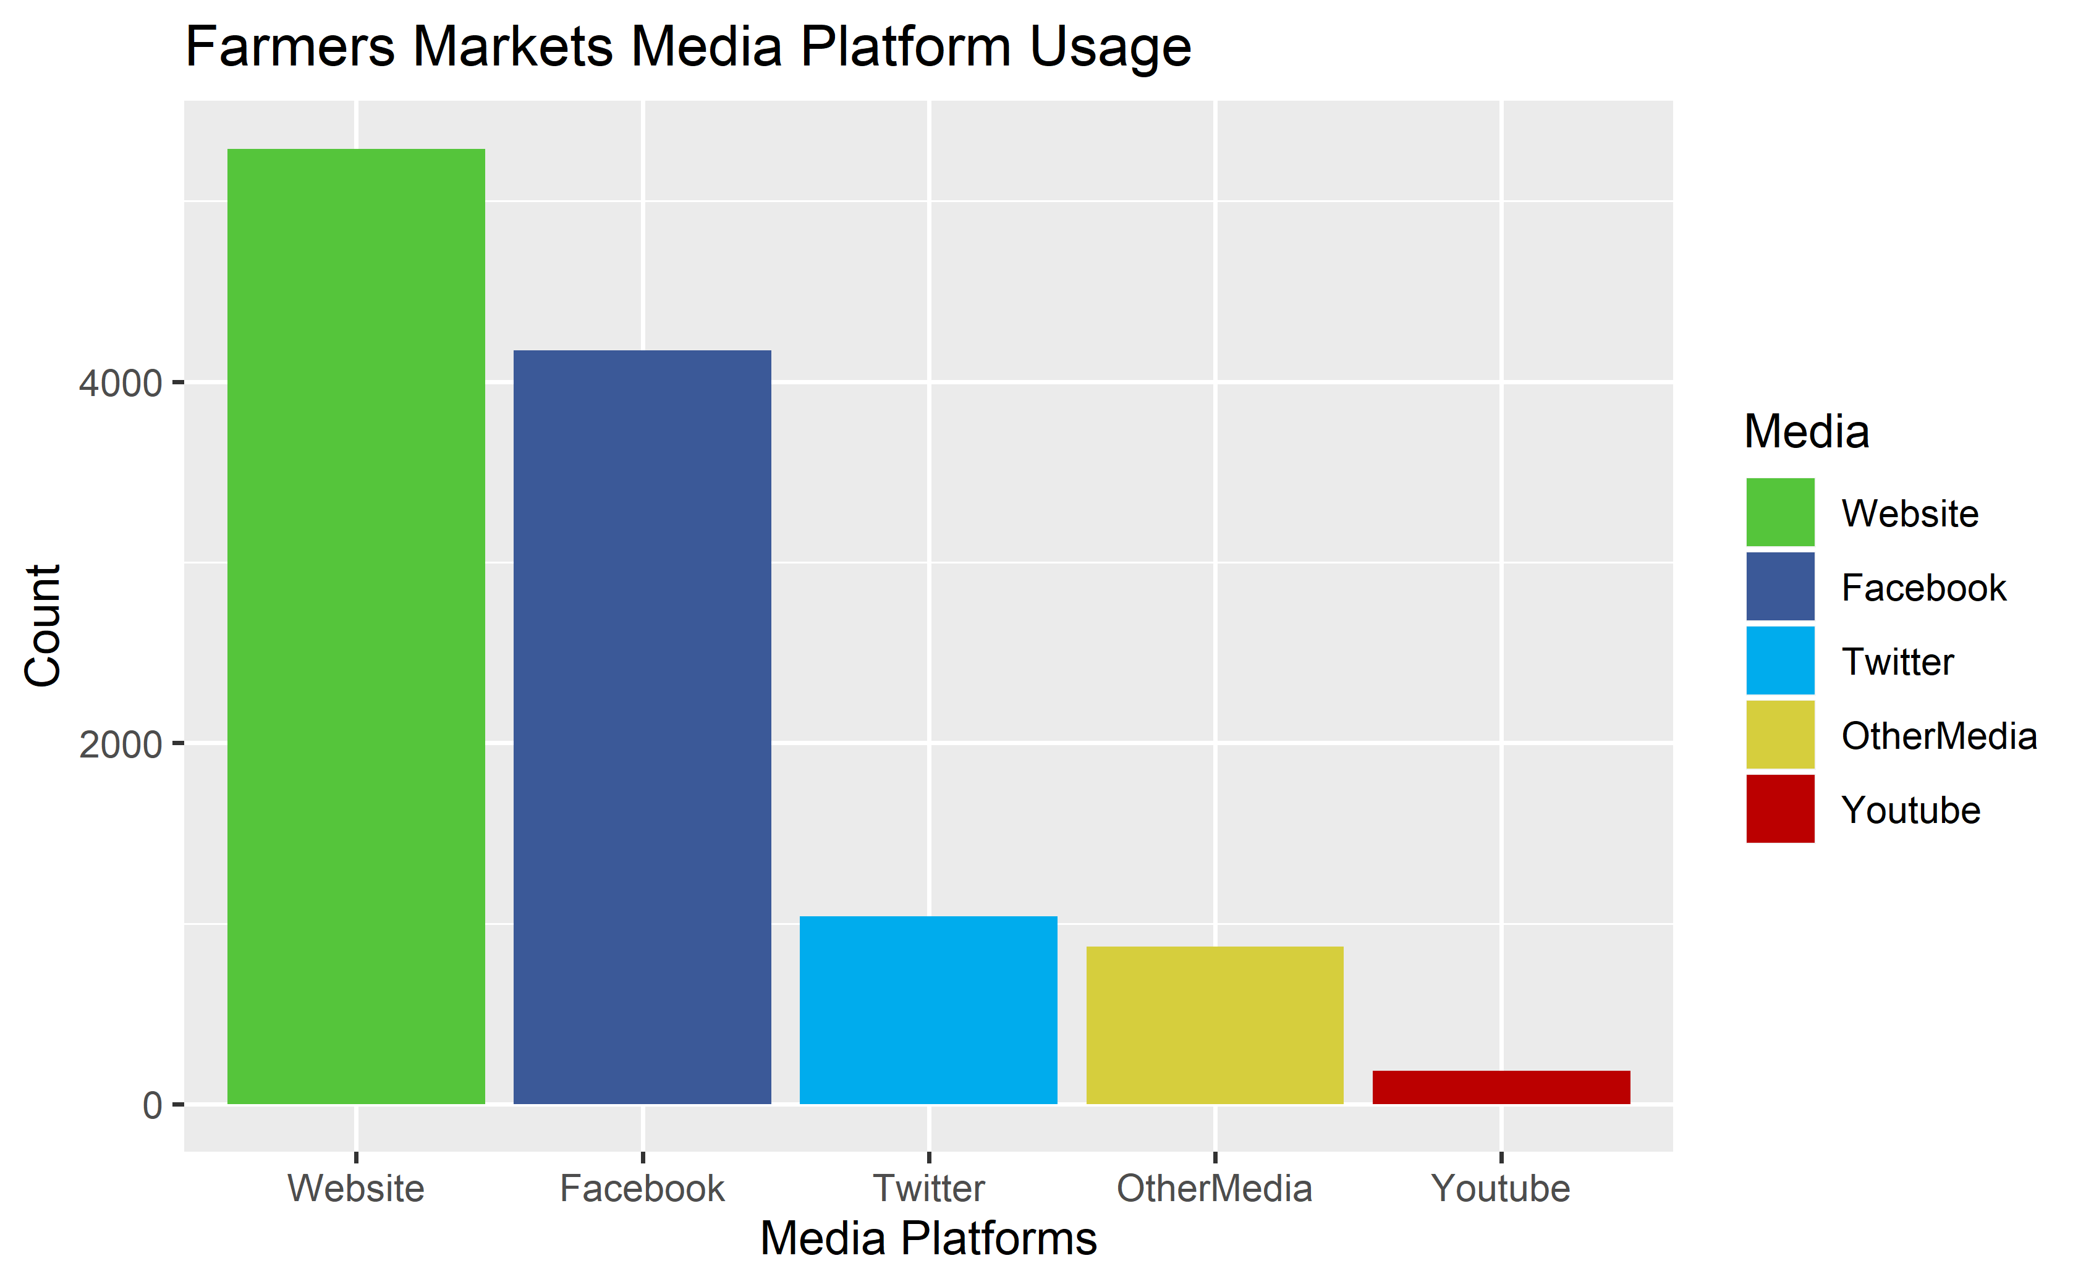

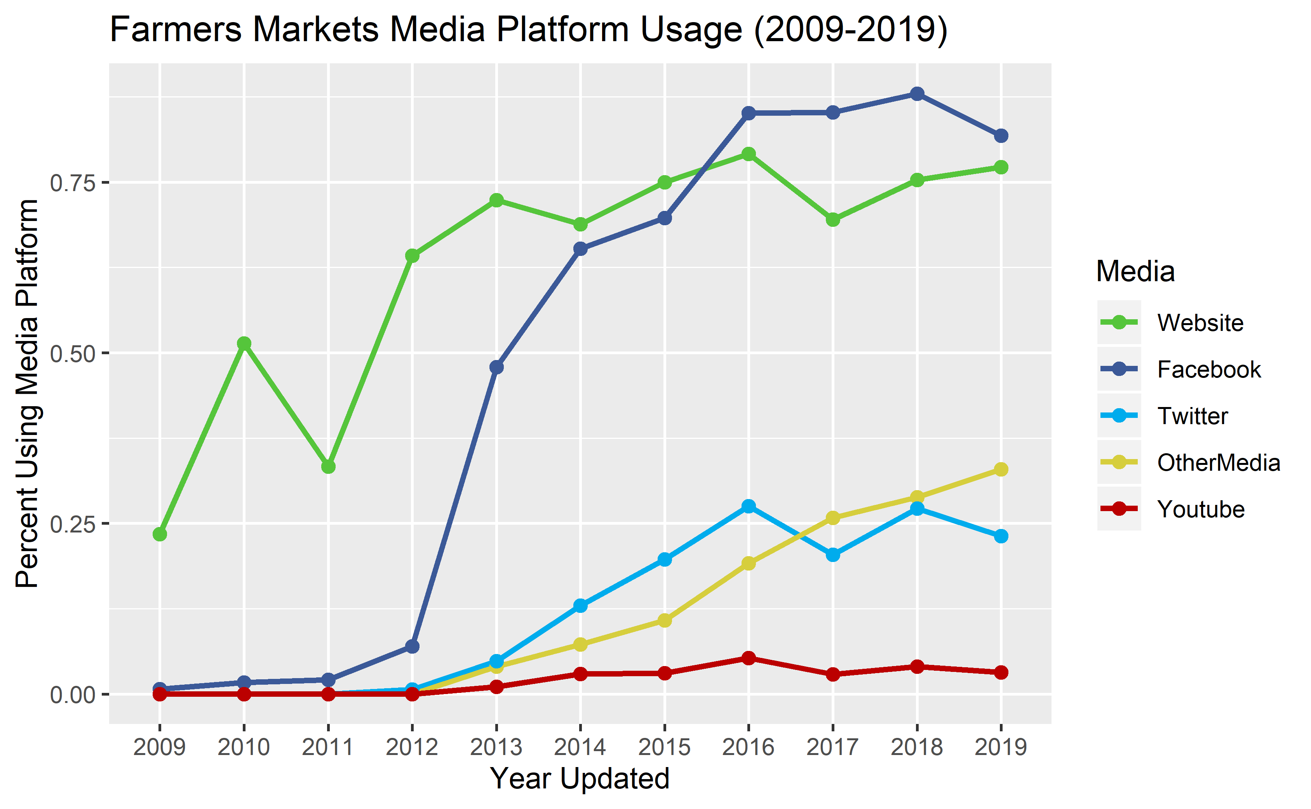

1. Agricultural Marketing Service, ‘Farmers Market Promotion Program’, *United States Department of Agriculture*, <https://www.ams.usda.gov/services/grants/fmpp>, (accessed 25 February 2020)
2. Agricultural Marketing Service, ‘Farmers Market Promotion Program 2016 Highlights’, *United States Department of Agriculture*, <https://www.ams.usda.gov/sites/default/files/media/FMPP2016Highlights.pdf> (accessed 25 February 2020)
3. Agricultural Marketing Service, ‘National Famers Market Directory’, *United States Department of Agriculture*, <https://www.ams.usda.gov/local-food-directories/farmersmarkets>, (accessed 25 February 2020)
4. ‘State Population Totals: 2010-2019’, *United States Census Bureau*, <https://www.census.gov/data/datasets/time-series/demo/popest/2010s-state-total.html>, (accessed 25 February 2020)
5. Omer Shacham, ‘USA States to region’, *Kaggle*, <https://www.kaggle.com/omer2040/usa-states-to-region> , (accessed 25 February 2020)
6. Removed markets that had not been updated since 2009 and 2010 since disproportional amount had zero total products, so it most likely wasn’t tracked at that time.
7. ‘Seniors Farmers’ Market Nutrition Program’, *United States Department of Agriculture*, <https://fns-prod.azureedge.net/sites/default/files/sfmnp/SFMNPFactSheet.pdf>, (accessed 25 February 2020)
8. ‘SNAP Eligibility’, *United States Department of Agriculture*, <https://www.fns.usda.gov/snap/recipient/eligibility>, (accessed 25 February 2020)
9. White House, ‘FACT SHEET: White House Report Highlights New Research on SNAP’s Effectiveness and the Importance of Adequate Food Assistance’, *United States Department of Agriculture*, <https://www.fns.usda.gov/pressrelease/2015/wh-120815>, (accessed 25 February 2020)
10. White House, ‘SNAP Benefit Redemptions through Farmers and Farmers Markets Show Sharp Increase’, *United States Department of Agriculture*, <https://www.fns.usda.gov/pressrelease/2015/fns-0007-15>, (accessed 25 February 2020)
11. WIC Farmers' Market Nutrition Program, *United States Department of Agriculture*, <https://fns-prod.azureedge.net/sites/default/files/fmnp/WICFMNPFactSheet.pdf>, (accessed 25 February 2020)