ABSTRACT

We built a genome‑resolved catalogue of the gut microbiome of the common brushtail possum (Trichosurus vulpecula), looking at the plasticity of the community and how it changes with temperature and the availability of a native apex predator, the Tasmanian devil (Sarcophilus harrisii). Using a dereplicated set of metagenome‑assembled genomes (MAGs) and genome‑inferred functional traits (GIFT), we quantify α/β‑diversity, composition and community functions across different environmental factors, focusing on thermal and predator gradients. Hierarchical modelling of species communities (HMSC) further identified genome-level associations with devil density, temperature,their interactions as well as landscape diversity.

1 | Introduction
New Version 1.1
The associations between complex organisms and their microbiomes shape host phenotype, fitness, and, presumably, even evolutionary potential (Henry et al., 2021). One of the most widely studied associations in this topic is the gut microbiome and its connection to the animal host (Zilber-Rosenberg & Rosenberg, 2008; Esser et al., 2018). Across taxa, gut microbiome flexibility can shift mean host traits, alter phenotypic variance, and act as a fast-responding layer of plasticity that helps to adjust to environmental change (Alberdi et al., 2016a; Aizpurua et al., 2021) by modifying nutritional capability, behaviour (Flint et al., 2012; Jumpertz et al., 2011), detoxification (Kohl & Dearing, 2016) and energy metabolism (Chevalier et al., 2015). This microbiome-mediated flexibility may be particularly important in systems where environmental conditions change rapidly, enhancing short-term acclimation and potentially shaping longer-term adaptive responses(Alberdi et al., 2016a).
The multiple drivers that shape the gut microbiome can be grouped into direct and indirect factors. Diet and host genomics directly influence the taxa that can reside in an animal gut by determining the nutrient source and physicochemical conditions in the gut(X. Wu et al., 2022; Ortega-Reyes et al., 2025). In addition, gut microbiomes are often associated with other factors that likely influence their composition indirectly, such as environmental temperature by modifying host physiology, habitat by modifying access to diet or interactions with other species by exerting behavioral changes(Fontaine et al., 2018; J. Li et al., 2022). While associations with abiotic factors like temperature has been thoroughly studied (Tajima et al., 2007; Fontaine et al., 2018; Koziol et al., 2023c), biotic interactions across species remain comparatively underexplored (Brown, 1998; Creel et al., 2005; Cunningham, Johnson, et al., 2019). Competition for resources or predation can lead to behavioural changes that could end up associated with different microbiota signatures.
The level of insight achieved from studying associations between gut microbiomes and factors shaping them depends on the methodological strategy employed to profile microbial communities. Most studies on gut microbiomes rely on 16S rRNA gene amplicon sequencing, which provides cost-effective taxonomic profiles but only indirect and often low-resolution inferences about function (Matchado et al., 2024). By contrast, genome-resolved metagenomics reconstructs metagenome-assembled genomes (MAGs) and their gene repertoires, directly linking microbial lineages to their functional potential at the genome scale (Mirete et al., 2025). Distilling these annotations to genome-inferred functional traits (GIFTs) allows microbiome variation to be described not only as changes in taxa but also in functional capabilities, including degradation and biosynthesis of ecologically relevant compounds (Koziol et al., 2023c). Combined with hierarchical modelling of species communities (HMSC) (Aizpurua et al., 2024), such genome-resolved data enable quantification of how both MAG occurrences and functional trait distributions respond to correlated environmental factors, and the identification of functional microbiome features associated with specific ecological conditions.
In this study, we combined genome-resolved metagenomics with ecological modelling to examine the taxonomic and functional properties of the gut microbiota of common brushtail possums (Trichosurus vulpecula) associated with a range of ecological variables. T. vulpecula are generalist, largely folivorous marsupials inhabiting Australia, Tasmania and New Zealand, where they experience landscapes of broad variety in ambient temperature and habitat type that shape their physiology and diet. In Tasmania, the behaviour of these animals is also largely shaped by the density of their main native predator, the Tasmanian devil (Sarcophilus harrisii).
We hypothesised that the gut microbiome of T. vulpecula would vary across space, exhibiting functional signatures associated with multiple direct and indirect factors. We predicted that the presence of Tasmanian devils would be a major driver, with possums inhabiting high‐devil‐density landscapes harbouring gut communities and GIFT profiles indicative of shifts in dietary niche, fibre degradation capacity, and the potential to detoxify plant secondary metabolites as well as modulate energy- and stress-related metabolic pathways compared to individuals in devil-free areas. To address this, we analysed faecal samples of 73 wild brushtail possums collected across Tasmania and mainland Australia using metagenomic assembly and binning. The reconstructed genomes were taxonomically and functionally annotated, and gene annotations distilled into genome-inferred functional traits (GIFTs) to associate functional microbiome features with ecological predictors. In doing so, we identified the main microbiome attributes associated with various ecological factors, and discussed the implications of these potential links for T. vulpecula’s ecology and conservation.

2 | Materials and Methods

2.1 | Study system and sampling

We studied common brushtail possums (Trichosurus vulpecula) mainly from Tasmania, with a smaller portion from southwest australia. Faecal material was collected non-invasively from free-ranging individuals across multiple localities spanning a broad range of habitat types and climatic conditions.

Sample collection and preservation followed the standard guidelines of the Earth Hologenome Initiative (EHI) (Pietroni et al., 2024b). For each individual, a fresh faecal pellet was placed into an EHI sampling tube prefilled with 1 mL DNA/RNA Shield (Zymo Research), targeting a ~1:10 sample-to-buffer ratio (≈100 mg faeces). Tubes were inverted to homogenise the sample and buffer and stored cool in the field before being frozen at −20°C or below within 2 weeks of collection. Each specimen was assigned a unique identifier, and associated metadata (geographic coordinates, date, habitat category and sex) were entered into a central metadata table. Field negatives (collection tubes opened briefly at each site and processed alongside biological samples) accompanied each sampling day and were carried through laboratory and bioinformatic workflows. One sample that did not meet quality criteria based on DNA yield and sequencing performance was removed prior to downstream analysis. All animal procedures complied with institutional animal ethics approvals and relevant permits.

2.2 | DNA extraction

DNA extractions were performed in the molecular laboratories of the Globe Institute, University of Copenhagen (Denmark), following unidirectional workflows to minimise contamination risk and the EHI laboratory guidelines for wildlife material. Approximately 100mg of faecal material from each tube was subsampled for DNA extraction.

Samples were first mechanically disrupted by bead beating on a Tissuelyser (Qiagen) with Lysing Matrix E (MP Biomedicals), and DNA was then isolated using silica-coated magnetic beads and solid-phase reversible immobilisation chemistry, as described in Bolt Botnen et al. (2023). Extracts were eluted in 50 µL of elution buffer and stored at −20°C until further processing.

DNA concentration was measured using a Qubit 3 Fluorometer (Thermo Fisher Scientific) with the dsDNA HS Assay Kit. Where necessary, extracts were cleaned with SPRI beads (AMPure XP, Beckman Coulter) at a 1:1.4 DNA:bead ratio and re-eluted in 50 µL of elution buffer. DNA was then sheared to an average fragment length of ~400 bp using a Covaris M220 ultrasonicator (Covaris) with 50 µL DNA in a microTUBE-50, using the following settings: peak power 30, duty factor 20, 50 cycles per burst, 60 s treatment time.

2.3 | Library preparation and sequencing

DNA extracts were measured with a Qubit, then diluted to about 100 nanograms in 16 microliters for library construction. Libraries were prepared with the BEST ligation based protocol (Carøe et al., 2017). For each reaction, the end repair master mix contained 2 microliters T4 DNA ligase buffer, 1 microliter reaction enhancer, 0.5 microliters T4 PNK, 0.2 microliters T4 polymerase, and 0.2 microliters dNTP at 25 millimolar. A volume of 3.9 microliters of this mix was added to each sample, followed by incubation at 20 degrees Celsius for 30 minutes and then 65 degrees Celsius for 30 minutes.

The ligation master mix per reaction contained 3 microliters PEG 4000 at 50 percent, 0.5 microliters T4 DNA ligase buffer, and 0.5 microliters T4 DNA ligase. To each sample, 1 microliter adapter at 50 micromolar was added, then 4 microliters of the ligation master mix. Samples were incubated at 20 degrees Celsius for 30 minutes and then 65 degrees Celsius for 10 minutes.

The fill in master mix contained, per reaction, 3 microliters nuclease free water, 1 microliter Isothermal buffer, 0.2 microliters dNTP at 25 millimolar, and 0.8 microliters Bst 2.0 polymerase. A volume of 5 microliters of this mix was added to each sample and incubated at 65 degrees Celsius for 15 minutes and then 80 degrees Celsius for 15 minutes. Each library was diluted one to two with molecular grade water. Cleanup used the AMPure purification protocol with SPRI beads at a ratio of one to one point four, and DNA was eluted in 30 microliters of elution buffer.

For quantification by qPCR, one to one hundred dilutions of each library were prepared. A qPCR master mix was made with 11.8 microliters nuclease free water, 2.5 microliters ten times buffer, 2.5 microliters MgCl2 at 25 millimolar, 0.5 microliters BSA, 0.5 microliters SYBR, 0.2 microliters dNTP at 25 millimolar, 0.5 microliters forward primer BGI F at 10 micromolar, and 0.5 microliters TaqGold, per reaction. Each reaction contained 10 microliters of diluted DNA, 1 microliter reverse primer BGI R at 10 micromolar, and 19 microliters master mix. The qPCR program was 95 degrees Celsius for 10 minutes; then 30 cycles of 95 degrees Celsius for 20 seconds, 60 degrees Celsius for 30 seconds, and 72 degrees Celsius for 40 seconds; followed by 72 degrees Celsius for 7 minutes and a final hold at 4 degrees Celsius. The cycle threshold determined the number of cycles for indexing.

For indexing, a master mix was prepared with 12.3 microliters nuclease free water, 2.5 microliters ten times buffer, 2.5 microliters MgCl2 at 25 millimolar, 0.5 microliters BSA, 0.2 microliters dNTP at 25 millimolar, and 0.5 microliters TaqGold, per reaction. Each reaction contained 10 microliters undiluted DNA, 1 microliter of each indexed primer BGI R and BGI F at 10 micromolar, and 19 microliters master mix. The PCR program was 95 degrees Celsius for 10 minutes, then seven to eleven cycles of 95 degrees Celsius for 20 seconds, 60 degrees Celsius for 30 seconds, and 72 degrees Celsius for 40 seconds, followed by 72 degrees Celsius for 7 minutes and a hold at 4 degrees Celsius.

Libraries were cleaned with beads at a ratio of one to one point four, eluted in 30 microliters of elution buffer, quantified on the Qubit, and two to three microliters were taken for fragment analysis (Mak et al., 2017).

2.4 | Bioinformatics

2.4.1 | Read processing and host removal

All bioinformatic processing followed the Earth Hologenome Initiative (EHI) snakemake-based pipeline for genome-resolved metagenomics (Mölder et al., 2021). Paired-end reads were trimmed and quality checked with fastp version 0.20.1(Chen et al., 2018). Settings enabled trimming of poly G runs and poly X runs, set the maximum number of ambiguous bases to five, required a minimum Phred quality of twenty, and enforced a minimum read length of thirty five bases. Processed reads were mapped to the host reference of possum assembly mTriVul1.pri. Mapping and file handling used Bowtie2(Langmead & Salzberg, 2012) and samtools(Li et al., 2009) with default parameters. Contigs shorter than one thousand five hundred bases were removed. Reads from each sample were then mapped to the corresponding co assembly with Bowtie2. The resulting BAM files were passed to the binning module in MetaWRAP(Uritskiy et al., 2018). Co assembled contigs were binned with CONCOCT(Alneberg et al., 2014), MaxBin2(Wu et al., 2015), and MetaBAT2(Kang et al., 2019). Bins were refined with the MetaWRAP bin refinement module using a minimum CheckM(Parks et al., 2015) completeness of seventy percent and a maximum CheckM contamination of ten percent.

Dereplication used dRep with an average nucleotide identity (ANI) threshold of 98% (Olm et al., 2017). First, primary clusters were created at greater than ninety percent average nucleotide identity using MASH(Ondov et al., 2016). Second, secondary clusters were defined at greater than ninety eight percent average nucleotide identity using ANImf(Kurtz et al., 2004). Non host, quality controlled reads were then mapped to the dereplicated catalogue of metagenome assembled genomes as described above. The resulting BAM files were profiled with CoverM (Aroney et al., 2025) to produce the final sample by genome count table. Taxonomic annotation of the dereplicated genomes was performed with GTDB tk(Chaumeil et al., 2019), which uses pplacer(Matsen et al., 2010), prodigal(Hyatt et al., 2010), HMMER3(Eddy, 2011), (Jain et al., 2018)FastANI, and FastTree(Price et al., 2010). Functional annotation used the DRAM pipeline(Shaffer et al., 2020), which searches predicted proteins against several databases (Rawlings et al., 2009; Suzek et al., 2014; Kanehisa et al., 2016; El-Gebali et al., 2018) using MMseqs2(Steinegger & Söding, 2017).

Finally, gene annotations were summarised into Genome Inferred Functional Traits with the distillR package(https://github.com/anttonalberdi/distillR). This approach uses a curated set of more than three hundred metabolic pathways and calculates standardised values based on KEGG identifiers and Enzyme Commission identifiers. Values range from zero to one, where zero indicates that none of the genes for a pathway are present and one indicates that all required genes are present. For a step that requires two specific identifiers, the step is considered complete when both are detected, half complete when only one is detected, and empty when neither is detected.

2.5 | Statistics

2.5.1 | Alpha and beta diversity

Alpha and beta diversity were quantified within the Hill numbers framework(Alberdi & Gilbert, 2019b). For alpha diversity, we computed four metrics per sample. Richness at order zero(q=0)counts genomes only. Neutral diversity at order one(q=1) weights genomes by relative representation and equals the exponential of the Shannon index, also known as Shannon diversity. Phylogenetic diversity at order one(q=1) incorporates the pruned genome tree. Functional diversity at order one(q=1) and uses a Gower distance built from Genome Inferred Functional Traits.

For beta diversity, we computed Hill-based dissimilarities that mirror the four alpha metrics. We checked multivariate dispersion and then ran permutational multivariate analysis of variance with adonis2 with nine hundred and ninety-nine permutations. Where relevant, we performed pairwise tests. Ordinations used non-metric multidimensional scaling for visualisation.

2.5.2 | Differential abundance

To identify genomes and higher ranks that differ between groups, we applied ANCOMBC with the structural zero framework. We reported results for individual genomes and after aggregation to phylum, family, and genus. Sensitivity analyses were run with and without a random effect. Where multiple comparisons were present, we applied the Benjamini and Hochberg correction.

2.5.3 | Functional community tests

Community-level functional differences were summarised with multivariate community indices and evaluated with Wilcoxon tests on Genome Inferred Functional Traits. We report results for elements, specific functions, and broader domains. Multiple testing was controlled with Benjamini and Hochberg correction.

2.6 | Environmental covariates

Landscape descriptors were derived from the sample coordinates and geographic layers. We computed land cover percentages within buffers around each sample to get continuous, comparable variables for further testing. To evaluate climatic context, we derived metrics for each sample locality, including mean annual temperature and precipitation. Predator availability was encoded from Tasmanian devil Sarcophilus harrisii presence based on devil density data (cunningham). We tested relationships between environmental alpha diversity of land cover and microbiome beta diversity with adonis2, and we visualised associations between environmental Hill metrics, temperature metrics, predator availability, and microbiome ordination axes.

2.7 | Microbial fraction benchmarking

We compared the estimated microbial fraction per sample obtained from a single copy gene approach with the fraction of reads recovered by the metagenome assembled genome catalogue to quantify capture efficiency at genome resolution.

2.8 | HMSC
Hierarchical modelling of species communities (HMSC) was applied genom-by-genome to 576 MAGs detected in all 55 Tasmanian samples. Fixed effects comprised of Tasmanian devil density, mean annual temperature, landcover heterogeneity, precipitation, vegetation density and human population density. Sample-specific effects were weight, development stage and sex. Random effects comprised site and individual animal. Genome-level association classes were assigned from posterior support(threshold 0.9). Functional responses of GIFT elements were contrasted between positive and negative.

2.9 | Reproducibility

All data harmonisation steps are documented in the project webbook. This includes loading of sample metadata, count tables, coverage matrices, genome phylogeny and functional trait tables, coverage thresholding at zero point three, read length normalisation at one hundred and fifty base pairs, and the creation of analysis objects. The code for plotting and testing, including colour schemes for taxonomy and model formulas, is recorded with the corresponding outputs. Data and code will be deposited in public repositories upon acceptance, and the webbook serves as an executable record of the workflow.

3 | Results

3.1 | A catalogue of brushtail‑associated microbial genomes

The assembly and binning of 352.3 Gb (4.89 ± 1.41 Gb/sample) of metagenomic data yielded 1,817 non-redundant MAGs spanning 13 bacterial and 2 archaeal phyla (Fig. 1). Read partitioning revealed that 70.9 ± 8.6% of reads mapped to microbial MAGs, 19.3 ± 6.0% remained unmapped, 7.3 ± 3.4% were classified as low-quality, and 2.5 ± 8.4% mapped to the host genome. Average CheckM quality of MAGs was 79.4 ± 16.8% completeness and 2.79 ± 2.58% contamination. One sample (EHI01340) was excluded for insufficient MAG reads.

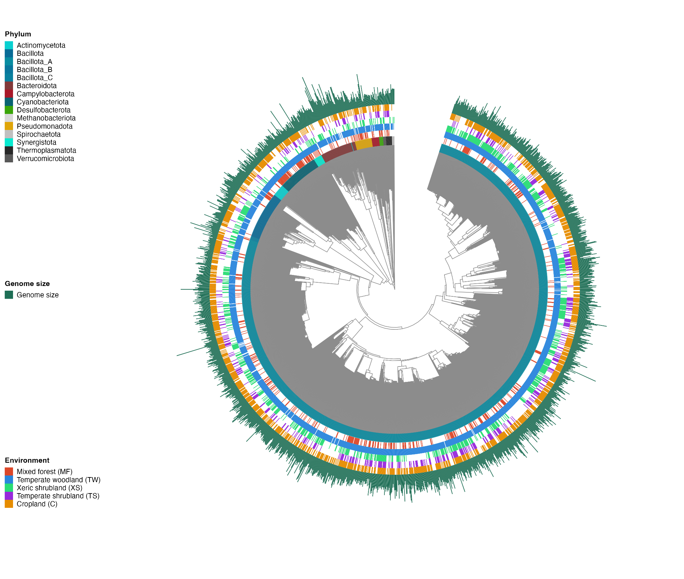
Figure 1: Catalog of brushtail-associated microbial genomes. a) Reference metagenome-assembled genome(MAG) catalog from 72 samples. Outer rings indicate MAG detection in different environmental clusters and genome size.
The gut communities were clearly dominated by Bacillota_A (60.7% ± 17.8%), with Bacteroidota (15.3% ± 12.8%) and Bacillota (10.7% ± 15.1%) as the next most abundant phyla, while all remaining groups each contributed on average less than 3% of the community (Fig. 2). At the family level, the microbiome was dominated by Lachnospiraceae (28.2% ± 10.0%), followed by Bacteroidaceae (10.7% ± 11.1%), Oscillospiraceae (11.2% ± 8.2%), Borkfalkiaceae (7.4% ± 5.3%) and CAG-288 (8.6% ± 15.3%). The most abundant genera were Prevotella (9.1% ± 10.5%), Enterosoma (8.6% ± 15.3%), Coproplasma (6.8% ± 5.0%), RGIG6307 (5.3% ± 4.8%) and Onthomonas (4.4% ± 3.2%).

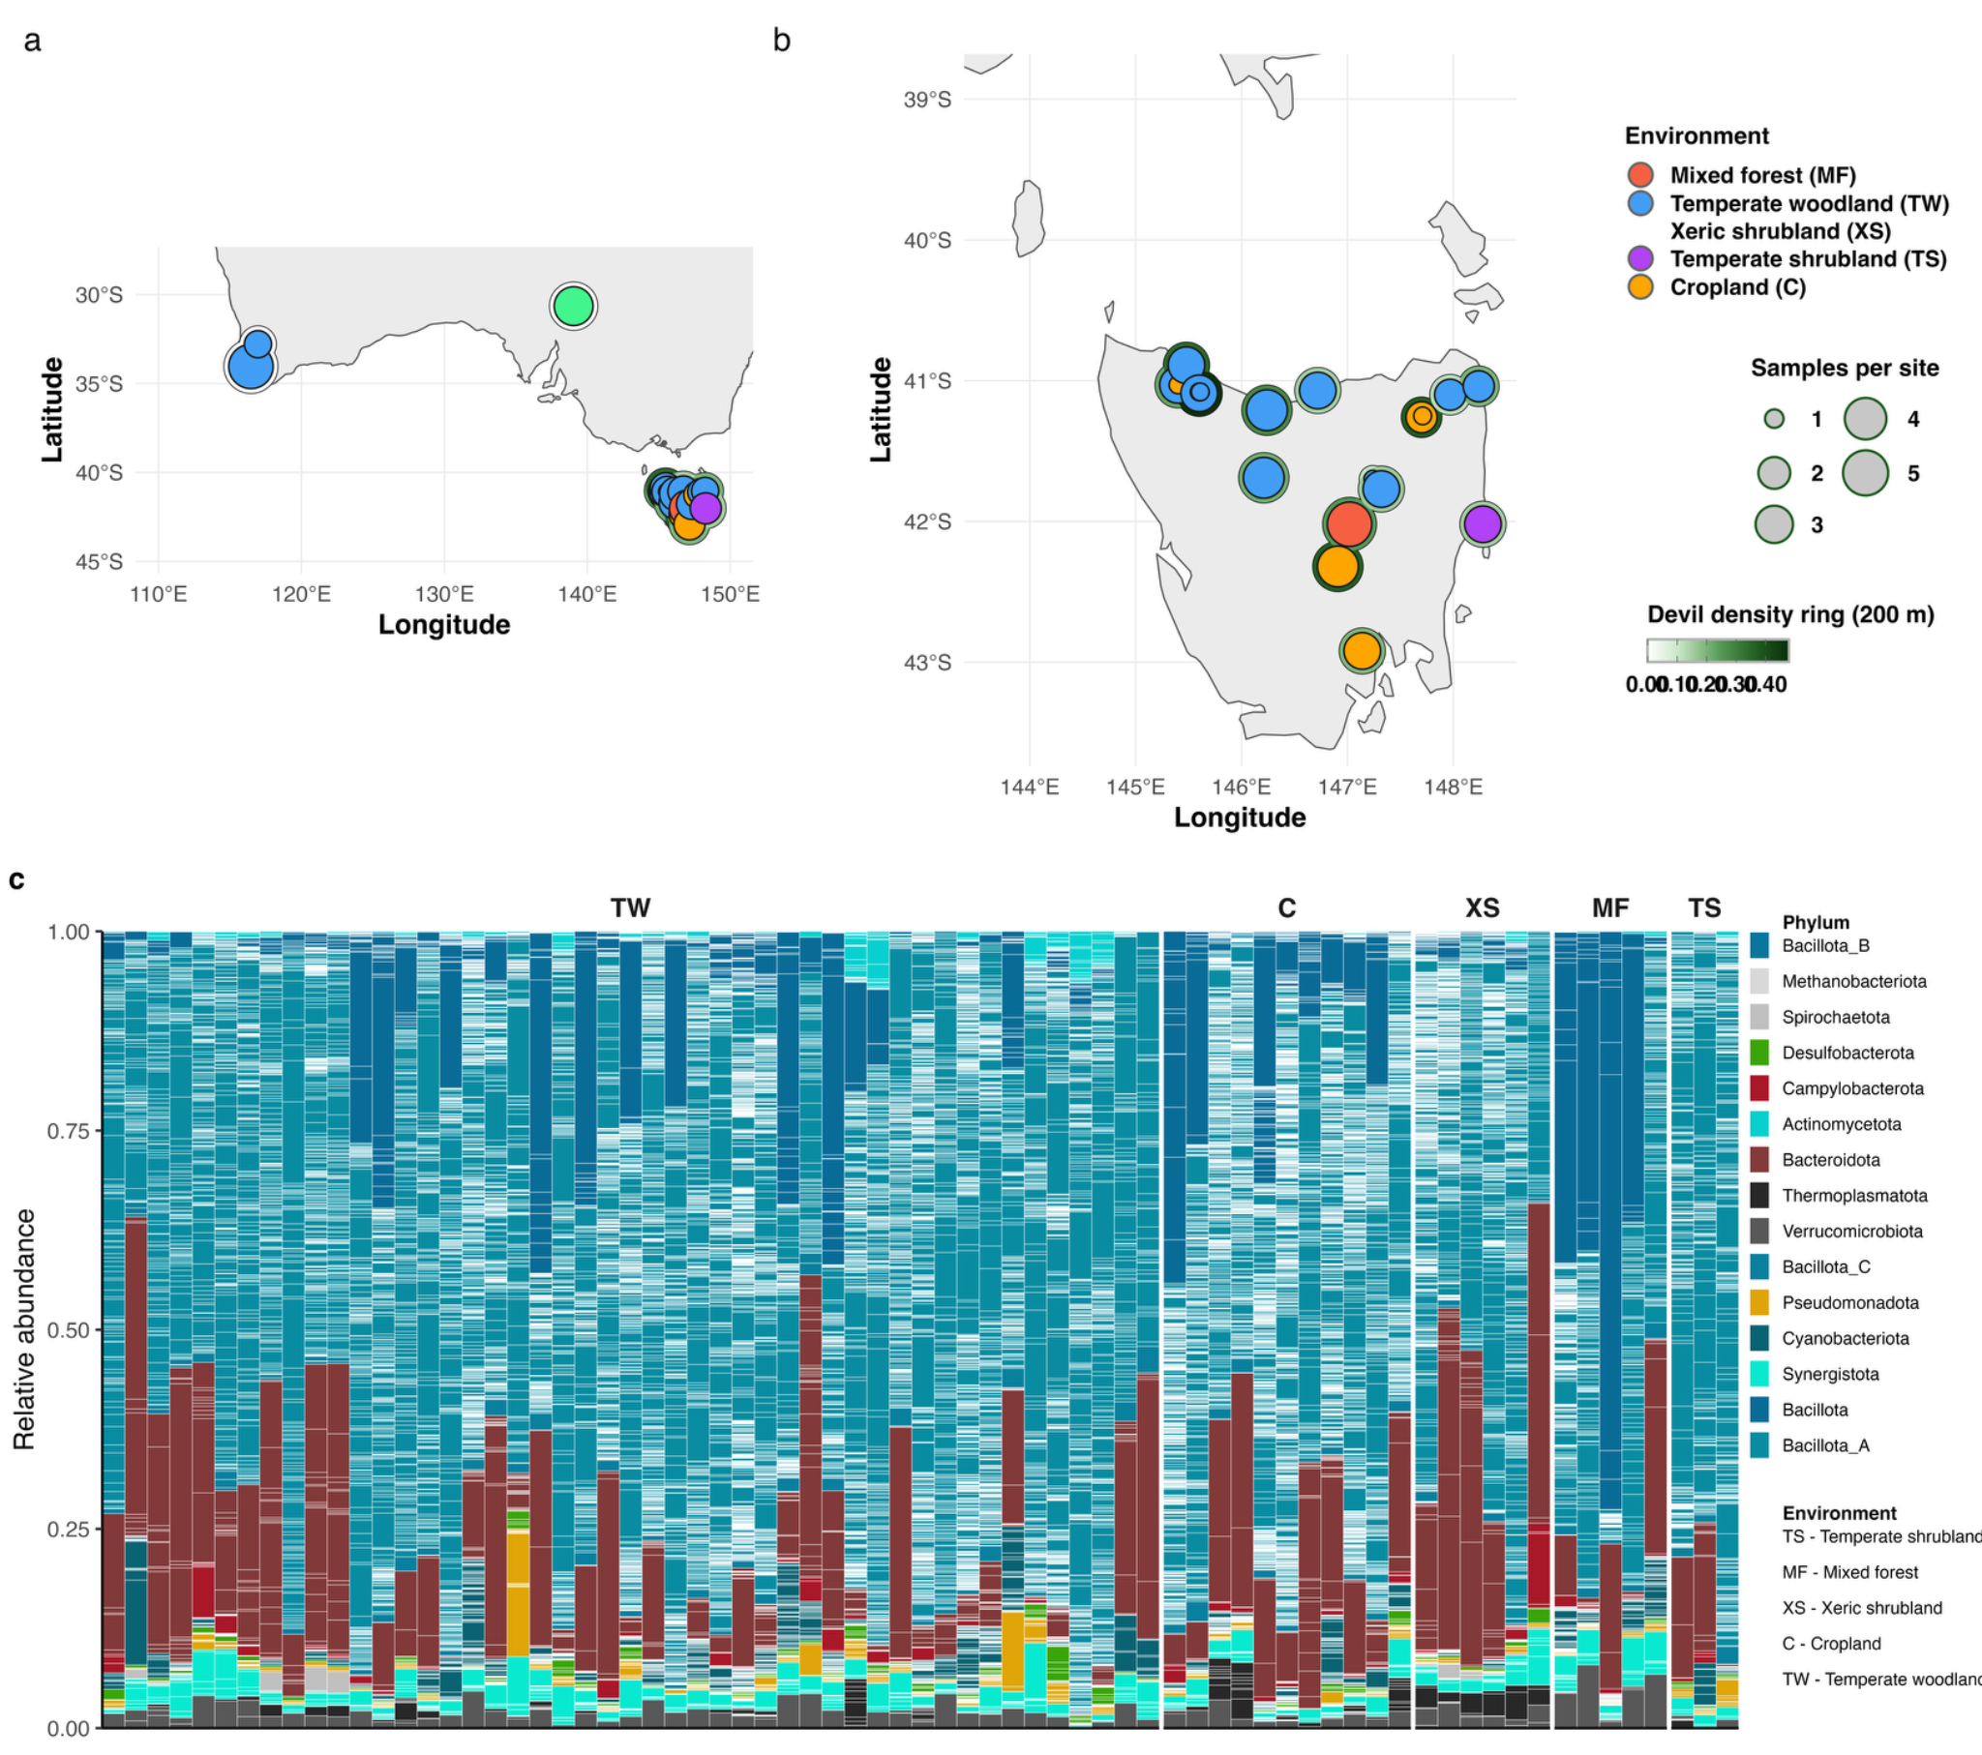
Figure 2: Study context and taxonomic composition. a)Map of sample locations in Australia and Tasmania. Left, full sample set; right, Tasmanian samples; dot size indicates sample number clustered into 4 environments; Green ring intensity indicates devil density. b) MAG-level taxonomic composition tile plot, colored by phylum

3.2 | Microbiota across environmental contexts

Across all samples, possum gut microbiomes harboured on average 307 ± 138 MAGs, with abundance-weighted diversity of 115 ± 69, phylogenetic diversity of 7.4 ± 1.4, and functional diversity of 1.44± 0.05. Linear mixed-effects models with broad environment as a fixed effect and region as a random intercept indicated significant environment effects on richness (F₄,₅₂ = 2.74, p = 0.038) and phylogenetic diversity (F₄,₅₂ = 3.77, p = 0.009), but not on abundance-weighted diversity (F₄,₅₂ = 1.48, p = 0.22) or functional diversity (F₄,₅₂ = 0.38, p = 0.82; Fig. 3). PERMANOVA showed that broad environment significantly structured richness-based (R² = 0.135, p = 0.001), abundance-weighted (R² = 0.150, p = 0.001), and phylogenetic β-diversity (R² = 0.183, p = 0.001), but not functional β-diversity (R² = 0.005, p = 0.755; Fig. X) of microbial communities. Island additionally structured taxonomic β-diversity (R² = 0.13-015, p = 0.001) without corresponding effect on α-diversity. Compositional turnover therefore occurred primarily in taxonomic and phylogenetic space, with functional potential largely conserved across environments. Land-cover heterogeneity was a weak predictor of taxonomic β-diversity (R² = 0.027–0.045) and unrelated to functional turnover. NMDS ordinations mirrored these patterns, with environmental groups partially separating for richness, neutral and phylogenetic distances, including clear separation of an Australian outgroup, but showing substantial overlap in the functional space (Figure 3).

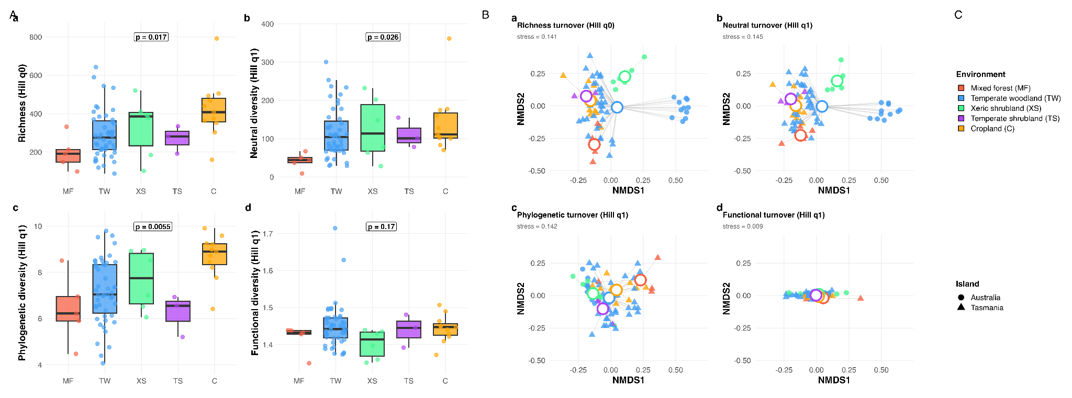
Fig3: α and β-diversity across broad environments. A) showing MAG richness, neutral diversity, phylogenetic diversity and functional diversity, with individual samples as points and boxes summarising habitat-level distributions b) NMDS ordination of gut microbiome β-diversity, points representing individuals. Coloured by broad environmental context and shaped by region.

3.3 | Metabolic capacitys and differences in MAGs connected to predictors

Across predictors, most genomes were neutral and only subsets responded positively or negatively: devil density (130 positive, 105 negative, 341 neutral), temperature (139 positive, 134 negative, 303 neutral) and landscape diversity (133 positive, 109 negative, 334 neutral). The devil × temperature interaction was estimable (119 positive, 102 negative, 355 neutral), although geographic confounding limits inference about synergistic effects; 207 genomes showed congruent devil and temperature responses.

To place this genome-level HMSC associations in phylogenetic and functional context we visualised a stratified subset of responsive MAGs (120 GENOMES) on a pruned phylogeny with linked annotation heatmap(fig4). Most responsive lineages fall within Bacillota_A and related Firmicus clades, with smaller cotnributions from Bacteroidota, Cyanobacteriota and other phyla. Adjacent HMSC strips display scaled posterior beta coefficients, showing ecological associaotns are phylogenetically structured but not phyllum-unfiorm. Closely related genomes often share similar response signs, yet sister lineagas can diverge in direction. At the function-family level biosynthetic and degredatitv categories form the dominant axes of variation among genomes.
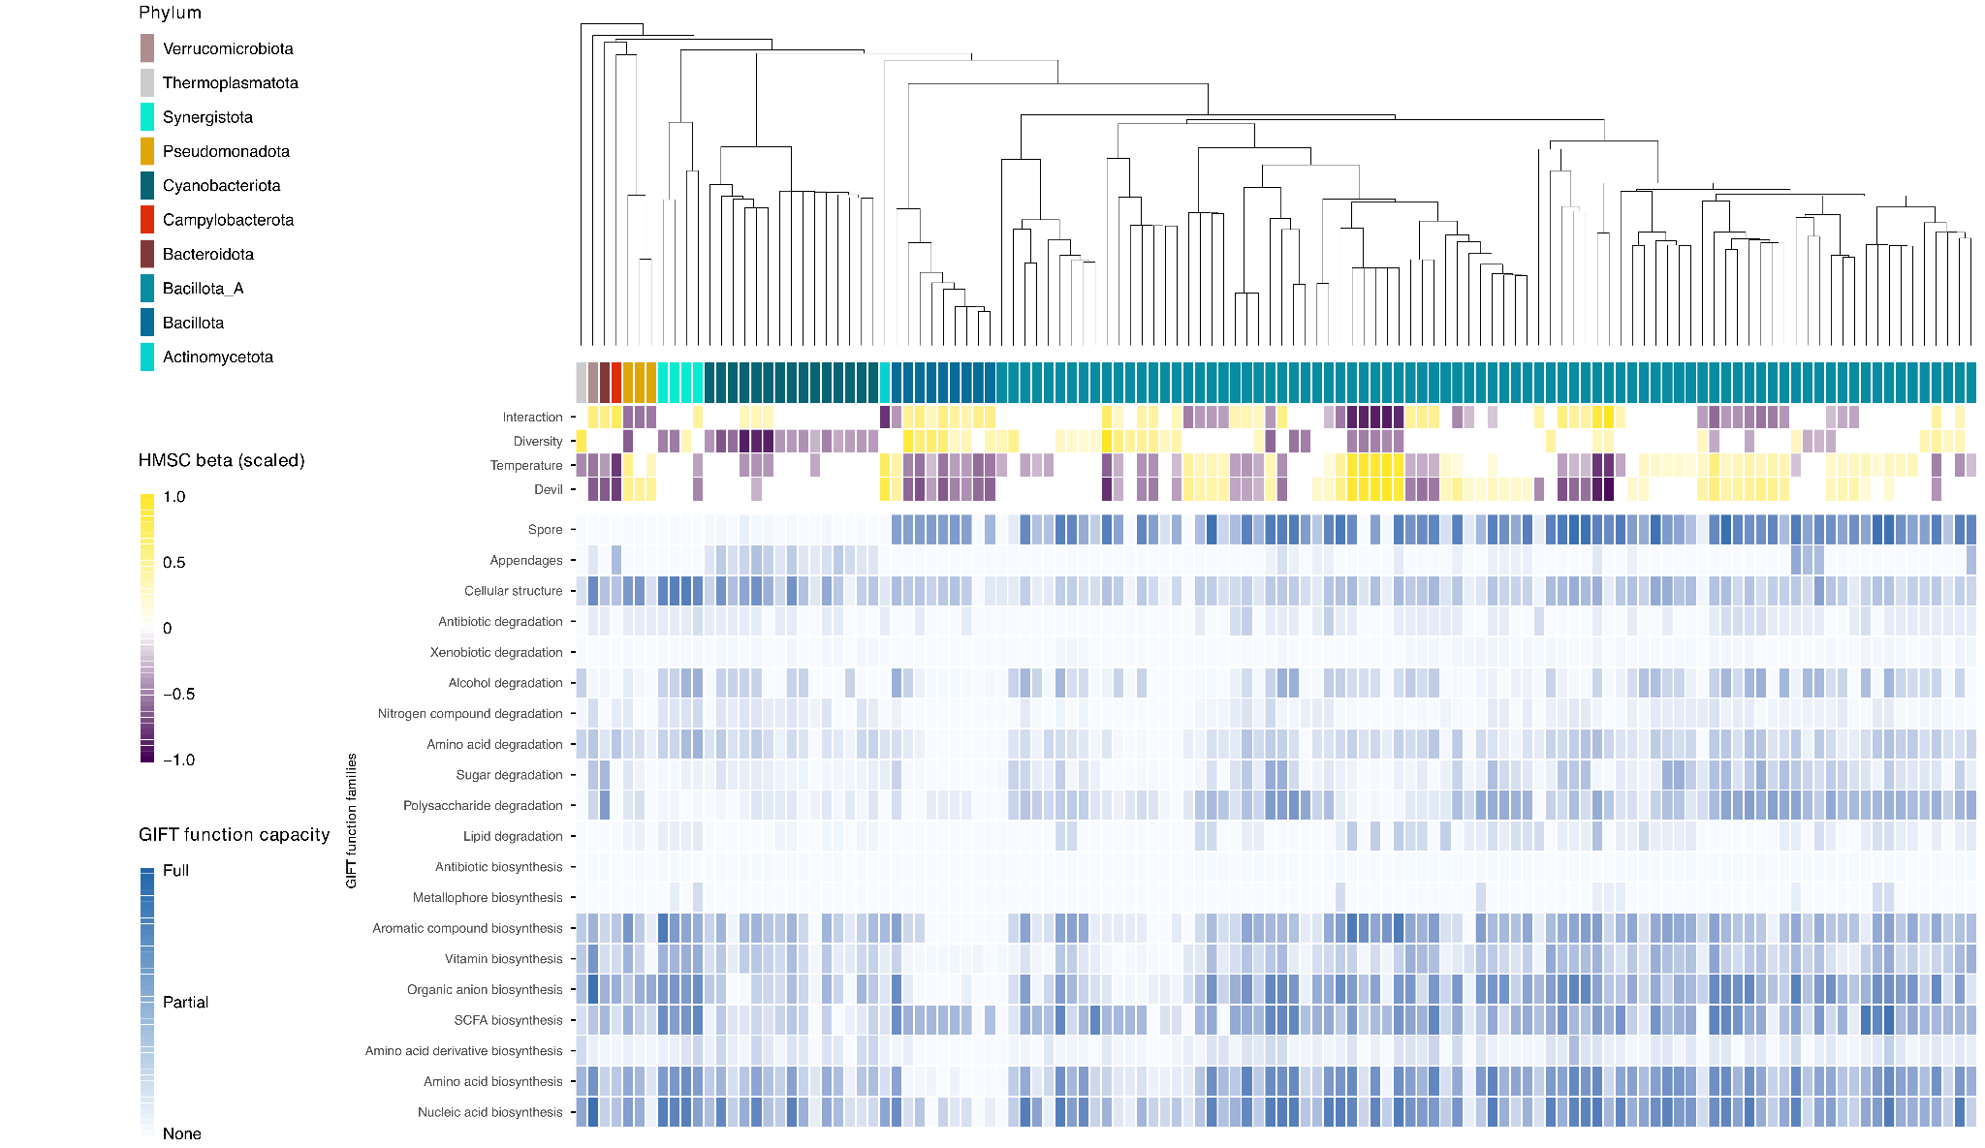
fig4) Phylogenetic tree and heatmap of reconstructed genomes, highlighting significant association to a given variable(devil density;temperature;landscape diversity; devil x temperature interaction) and capacity to perform metabolic functions in a given group. Fine grade visualization of metabolic capacities can be found in the supplementary.

Devil‐associated shifts in the possum gut microbiome
The final HMSC model showed a balanced pattern of partial association rather tahn community-wide enrichment. Devil positiv genomes where concentrated within Bacillota_A core families, especially Lachnospiraceae (n=55) and Oscillospiraceae (n=46). Devil-negative genomes included CVag-508 (n =19), CAG-274 and CAG-465 among other linages, indicating reweighting within dominant pyhlum rather than wholesale turnover.
Using the HMSC-derived posterior estimates, we then contrasted the functional potential of MAGs that increased versus decreased with devil density. Genomes positively associated with higher devil densities were consistently enriched in biosynthetic traits, including multiple elements of amino acid biosynthesis (B02), nucleic acid biosynthesis (B01), vitamin biosynthesis (B07), organic anion biosynthesis (B06) and aromatic compound biosynthesis (B08). High devil-density microbiomes also showed an enhanced capacity for the degradation of complex nutrients, with higher representation of polysaccharide degradation (D02), amino acid degradation (D05) and nitrogen compound degradation (D06), as well as antibiotic degradation (D09). Functional volcano contrasts identified 60 FDR-significant GIFT elements(FDR < 0.05) enriched among devilpositiv(n=52) and devil-negativ(n=8) genomes(Fig.5a), consistent with a broader metabolic repertoire under high devil density, including amino acid and vitamin biosynthesiss and polysachharide, amino acid and xenobiotic degredation pathways.
In contrast, only a few functional groups were relatively enriched among genomes negatively associated with devil density. These included cellular structural traits (S01) and alcohol degradation (D07), which were more prevalent in microbiomes from low devil-density areas. Overall, while most bacterial lineages and functions remain shared across the gradient, our results reveal a clear shift towards metabolically versatile, vitamin- and amino-acid–producing communities in possums occupying landscapes with higher Tasmanian devil densities.
Temperature‐associated shifts in the possum gut microbiome
HMSC revealed widespread but heterogeneous responses to environmental temperature. Warm-associated MAGs belonged predominantly to Bacillota_A (128 of 139; 92%), in particular Lachnospiraccae (n=76) and Oscillospiraceae(n = 36). Cooler-associated genomes were more taxonomically diverse, concentrated in Cyanobacteriota (RUG14156 and Gastranaerophilaceae), Thermoplasmatota (Methanomethylophilaceae), Bacteroidota (Rikenellaceae) and Pseudomonadota (Burkholderiaceae_A), indicating taxonomic narrowing towards Firmicus dominated communities at warmer sites.
Functional modelling identified 61 FDR-significant GIFT elements differing between temperature-positiv(n=55) and temperature-negativ(n=6) genomes. Temperature-positive genomes were enriched in biosynthetic and degradative traits(fig5b).

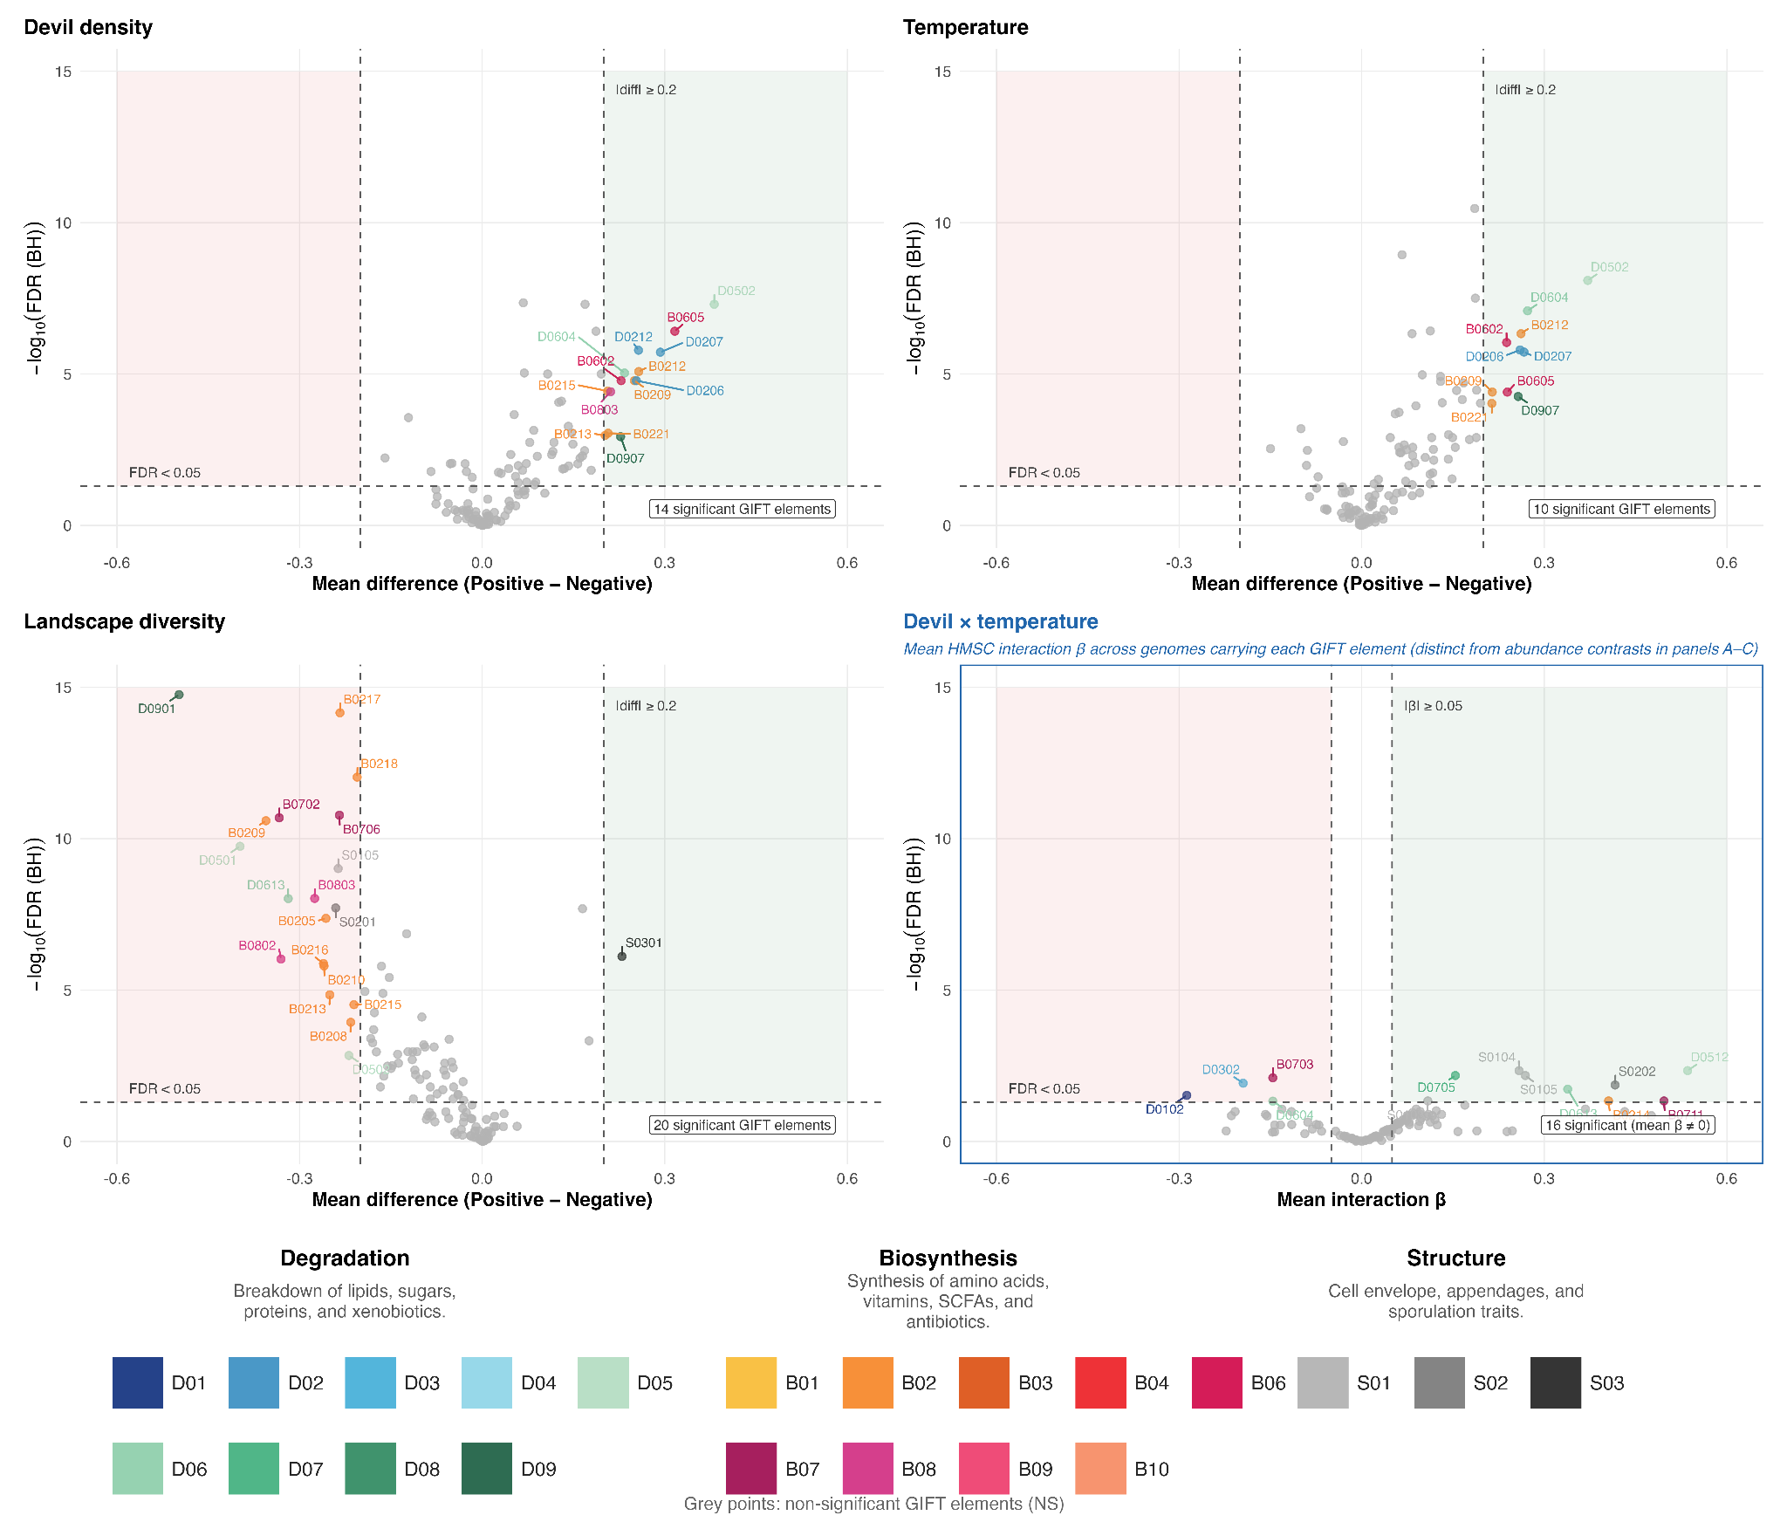

Fig. 5. HMSC functional associations across four predictors. Four-panel volcano plots show GIFT-level functional contrasts for devil density (A), temperature (B), landscape diversity (C) and devil × temperature interaction (D), ordered left to right, top to bottom. Panels A–C compare mean GIFT abundance between genomes classified as positively versus negatively associated with each predictor; panel D shows mean genome-level HMSC interaction β across genomes carrying each GIFT element (one-sample test vs zero). Points are coloured by GIFT category and dashed lines indicate FDR = 0.05 and effect-size thresholds.

3.4.3 Interaction-associated shifts in the microbiome
The fitted devil × temperature interaction term identified genome-specific responses that were not reducible to the main effects alone: 119 genomes (21%) carried a positive interaction coefficient, 102 (18%) a negative coefficient and 355 (62%) were neutral. Unlike panels A–C (Fig. 5), the interaction functional volcano (Fig. 5D) does not contrast mean GIFT abundance between interaction-positive and interaction-negative genomes. Interaction-positive MAGs largely overlapped devil-negative MAGs, so an abundance contrast would largely recapitulate the devil-density panel; instead, for each GIFT element we tested whether genomes carrying that trait show a mean HMSC interaction β significantly different from zero (FDR < 0.05, |β| ≥ 0.05). This identified 16 FDR-significant GIFT elements (Fig. 5D; 12 with positive and four with negative mean interaction β). Positive mean β was enriched for nitrogen-compound degradation (e.g. D0608, D0601, D0607, D0613), amino-acid degradation (D0512), vitamin biosynthesis (B0711), appendage traits (S0202) and cellular-structure traits (S0104, S0105), whereas negative mean β reflected higher capacity for lipid degradation (D0102), sugar degradation (D0302) and, in a smaller subset, vitamin biosynthesis (B0703) and nitrogen-compound degradation (D0604). Interpretation remains cautious because devil density and temperature co-vary geographically within Tasmania.

3.4.4 Diversity-associated shifts in the microbiome
Landscape diversity showed a parallel magnitude of genome-level response (133 positive, 109 negative). Diversity-positive genomes were dominated by Bacillota_A (n = 108), including CAG-508 (n = 36), Lachnospiraceae (n = 32) and Borkfalkiaceae (n = 24). Volcano contrasts identified 69 FDR-significant GIFT elements (FDR < 0.05; Fig. 5C), with a strongly asymmetric distribution: only three elements were enriched among diversity-positive genomes, spore formation (S0301), acetate biosynthesis (B0401) and cellular structure (S0104), whereas 66 elements showed higher capacity in diversity-negative genomes, spanning amino-acid, aromatic and vitamin biosynthesis and multiple degradation pathways including antibiotic (D09) and amino-acid (D05) degradation. Higher landscape diversity was thus associated with genome subsets carrying somewhat leaner biosynthetic and degradative pathway completeness.

4 | Discussion

Our metagenomic dataset provides insight into the taxonomic and functional diversity of brushtail-possum associated microbiomes across different environmental cluster and vairability as well as under varying intensity of two selection pressures. A major empirical contribution is a genome-resolved catalogue of 1,817 metagenome-assembled genomes (MAGs) that captures a substantial fraction of microbial biomass in faecal metagenomes and links lineage identity to functional potential more directly than amplicon profiling. Most genomes lacked species-level resolution, underscoring how much marsupial gut diversity remains uncharacterised.
The gut microbiome of possums was predominantly composed of Bacillota_A with Bacteroidota and Bacillota as the next most abundant phyla. On family level Lachnospiraceae and Oscillospiraceae were the constantly biggest lineages(Fig X, Supplementary. Sankey Plot). They are central to plant polysaccharide fermentation and short-chain fatty acid production. Given the folivorous baseline diet and chemical recalcitrance of Eucalyptus foliage, this dominance is biologically coherent and suggests a non-negotiable functional core for fibre and plant secondary metabolite processing.
The mean MAGs per sample increase with more open environment clusters with cropland and xeric shrubland having the highest MAG count, indicating a higer diversity of microbiota in “non tree areas” which might derive from reliance on a more diverse diet.

Hierarchical modelling of species communities (HMSC) show that the common brushtail possum (Trichosurus vulpecula) gut microbiome is taxonomically responsive yet functionally robust at community scale. Environmental gradients, island context and habitat jointly restructure lineage composition, especially within Bacillota_A, presumably because it is the most abundant taxa. Genome-level inference reveals parallel devil- and temperature-associated compensation that is directionally consistent with, but does not necessarily confirm, compounded physiological stress when predation recovery and warming coincide.

4.1. Metagenomic Plasticity and Functional Redundancy
One finding of this study is a marked decoupling of taxonomic structure from functional capacity in the Trichosurus vulpecula gut microbiome. Although community composition and phylogenetic breadth shifted significantly across habitats, islands and geographic regions, aggregate functional potential remained homeostatic. This pattern is consistent with high levels of functional redundancy, whereby phylogenetically diverse lineages occupy overlapping metabolic niches. Such redundancy may confer ecological insurance, providing a stable biochemical output for the host despite taxonomic turnover driven by environmental filtering or dispersal limitation. This metagenomic plasticity likely functions as a dynamic axis of phenotypic plasticity, enabling the holobiont to track environmental variation on ecological timescales that are inaccessible to the host genome alone.
4.3. Predation Landscapes and Nutritional Compensation
Predation pressure from the Tasmanian devil (Sarcophilus harrisii) was associated with significant restructuring of microbiome function. Higher devil density was associated with High-risk landscapes correlated with enrichment of biosynthetic pathways for vitamins, amino acids, and essential cofactors. This metagenomic signature may reflect a compensatory mechanism whereby the microbiome synthesises essential nutrients when predator-induced behavioural constraints limit host access to diverse, high-quality dietary sources. Upregulation of xenobiotic and plant secondary metabolite (PSM) degradation pathways in high-risk areas further suggests that predation pressure may drive greater reliance on chemically defended arboreal foliage. These patterns are correlative but align with landscape-of-fear theory(Cunningham, Johnson, et al., 2019).
4.3. Thermal Gradients
The shift toward Bacillota_A at higher temperatures is consistent with diet-induced thermogenesis logic: as possums may reduce protein intake in the heat to limit internal overheating, the microbiome may pivot toward Firmicutes lineages efficient at carbohydrate fermentation. A broad spore-formation signal was weak (one marginal S-element), so transmission-survival hypotheses remain plausible but are not strongly supported here. Independent devil and temperature associations raise the concern that compounding constraints in landscapes where both pressures coincide may exceed what community-level redundancy alone can buffer.
4.4. Synergistic Stress and Conservation Implications
The independent functional shifts associated with predation and thermal stress raise the possibility of a physiological trap in which both pressures coincide. Under such conditions, predator-induced movement restriction may prevent access to thermal refugia and water sources, while concurrent heat stress suppresses the host's intrinsic hepatic detoxification capacity. The microbiome's role as a modular physiological buffer may therefore become particularly critical under compound stressors.
Both main effects showed strong genome-level associations directionally consistent with compensatory logic. Among 207 genomes with non-neutral responses to both devil density and temperature, all were directionally congruent (112 devil-positive and temperature-positive; 95 devil-negative and temperature-negative; no discordant pairs), indicating parallel filtering of a shared stress-responsive core within Bacillota_A rather than independent turnover along orthogonal axes. Positive mean β was enriched for nitrogen-compound degradation, amino-acid degradation and vitamin biosynthesis, whereas negative mean β reflected lipid and sugar degradation. This suggests…

4.5. Broader Applicability Across Taxa and Systems
Although the present findings are grounded in a single species of marsupial host, the functional principles they reveal are likely not system-specific. The demonstration that microbiome-mediated functional homeostasis can be maintained despite extensive taxonomic turnover establishes a scalable framework applicable to other generalist vertebrates navigating rapid environmental perturbation. Analogous decouplings of taxonomic and functional structure have been reported in systems ranging from marine fish to soil-dwelling mammals, suggesting that functional redundancy may represent a conserved property of microbial communities in association with host , especially in the case of generalist species.
The nature of the stressors characterised in the deeper study, thermal gradients, predation-induced behavioural restriction, and dietary compression, are not unique to T. vulpecula or to Australian ecosystems, but reflect pressures increasingly common across vertebrate taxa under anthropogenic change. If biotic and abiotic stressors intensify together, persistence may depend on whether populations carry microbiome configurations capable of buffering and mediating compiled pressures. This positions the metagenome as a universal axis of phenotypic plasticity that complements, and in the fast changing environmental contexts of today may exceed, the adaptive capacity encoded by the host genome.
4.7. Limitations and Future Directions
Although this study employs genome-resolved metagenomics to provide a high-resolution view of microbial functional potential, climate layers and predator density models represent coarse proxies for individual host experience. The cross-sectional design precludes inference regarding the rate of microbiome reconfiguration or seasonal turnover dynamics. Future research should integrate plant DNA metabarcoding to link behavioural shifts directly to dietary chemistry, and employ longitudinal or experimental designs to establish causal pathways for microbiome-mediated physiological buffering. Experimental validation should precede consideration of management interventions such as probiotics or bioaugmentation to stabilise endangered populations.

References
Aizpurua, O., Botnen, A. B., Eisenhofer, R., Odriozola, I., Santos-Bay, L., Bjørnsen, M. B., Gilbert, M., & Alberdi, A. (2024). Functional insights into the effect of feralisation on the gut microbiota of cats worldwide. Cold Spring Harbor Laboratory. https://doi.org/10.1101/2024.09.04.611329
Aizpurua, O., Nyholm, L., Morris, E., Chaverri, G., Montalvo, L. G. H., Flores-Martinez, J. J., Lin, A., Razgour, O., Gilbert, M. T. P., & Alberdi, A. (2021). The role of the gut microbiota in the dietary niche expansion of fishing bats. Springer Science and Business Media LLC. https://doi.org/10.21203/rs.3.rs-230175/v1
Alberdi, A., Aizpurua, O., Bohmann, K., Zepeda-Mendoza, M. L., & Gilbert, M. T. P. (2016). Do vertebrate gut metagenomes confer rapid ecological adaptation? Trends in Ecology &amp; Evolution, 31(9), 689–699. https://doi.org/10.1016/j.tree.2016.06.008
Alberdi, A., Andersen, S. B., Limborg, M. T., Dunn, R. R., & Gilbert, M. T. P. (2021). Disentangling host–microbiota complexity through hologenomics. Nature Reviews Genetics, 23(5), 281–297. https://doi.org/10.1038/s41576-021-00421-0
Alberdi, A., & Gilbert, M. T. P. (2019). A guide to the application of Hill numbers to DNA‐based diversity analyses. Molecular Ecology Resources, 19(4), 804–817. https://doi.org/10.1111/1755-0998.13014
Alberdi, A., Razgour, O., Aizpurua, O., Novella-Fernandez, R., Aihartza, J., Budinski, I., Garin, I., Ibáñez, C., Izagirre, E., Rebelo, H., Russo, D., Vlaschenko, A., Zhelyazkova, V., Zrnčić, V., & Gilbert, M. T. P. (2020). DNA metabarcoding and spatial modelling link diet diversification with distribution homogeneity in European bats. Nature Communications, 11(1). https://doi.org/10.1038/s41467-020-14961-2
Alneberg, J., Bjarnason, B. S., de Bruijn, I., Schirmer, M., Quick, J., Ijaz, U. Z., Lahti, L., Loman, N. J., Andersson, A. F., & Quince, C. (2014). Binning metagenomic contigs by coverage and composition. Nature Methods, 11(11), 1144–1146. https://doi.org/10.1038/nmeth.3103
Andersen, G. E., Johnson, C. N., Barmuta, L. A., & Jones, M. E. (2017). Dietary partitioning of Australia’s two marsupial hypercarnivores, the Tasmanian devil and the spotted-tailed quoll, across their shared distributional range. PLOS ONE, 12(11), e0188529. https://doi.org/10.1371/journal.pone.0188529
anttonalberdi. (n.d.-a). GitHub - Anttonalberdi/distillR: R package for distilling functional annotations of bacterial genomes and metagenomes. GitHub. Retrieved October 30, 2025, from https://github.com/anttonalberdi/distillR
anttonalberdi. (n.d.-b). GitHub - Anttonalberdi/hilldiv2: Repository of hilldiv2. GitHub. Retrieved October 30, 2025, from https://github.com/anttonalberdi/Hilldiv2
Aroney, S. T. N., Newell, R. J. P., Nissen, J. N., Camargo, A. P., Tyson, G. W., & Woodcroft, B. J. (2025). CoverM: Read alignment statistics for metagenomics. Bioinformatics, 41(4). https://doi.org/10.1093/bioinformatics/btaf147
Beale, P. K., Connors, P. K., Dearing, M. D., Moore, B. D., Krockenberger, A. K., Foley, W. J., & Marsh, K. J. (2022). Warmer ambient temperatures depress detoxification and food intake by marsupial folivores. Frontiers in Ecology and Evolution, 10. https://doi.org/10.3389/fevo.2022.888550
Bestion, E., Jacob, S., Zinger, L., Di Gesu, L., Richard, M., White, J., & Cote, J. (2017). Climate warming reduces gut microbiota diversity in a vertebrate ectotherm. Nature Ecology &amp; Evolution, 1(6). https://doi.org/10.1038/s41559-017-0161
Bideguren, G., Razgour, O., & Alberdi, A. (2023). Quantitative synthesis of microbe-driven acclimation and adaptation in wild vertebrates. Springer Science and Business Media LLC. https://doi.org/10.21203/rs.3.rs-3577507/v1
Blyton, M. D. J., Pascoe, J., Hynes, E., Soo, R. M., Hugenholtz, P., & Moore, B. D. (2023). The koala gut microbiome is largely unaffected by host translocation but rather influences host diet. Frontiers in Microbiology, 14. https://doi.org/10.3389/fmicb.2023.1085090
Bolt Botnen, A., Bjørnsen, M. B., Alberdi, A., Gilbert, M. T. P., & Aizpurua, O. (2023). A simplified protocol for DNA extraction from FTA cards for faecal microbiome studies. Heliyon, 9(1), e12861. https://doi.org/10.1016/j.heliyon.2023.e12861
Bosch, T. C. G., & Miller, D. J. (2016). The holobiont imperative: Perspectives from early emerging animals. Springer.
Brown, J. S. (1998). The ecology of fear: Optimal foraging, game theory, and trophic interactions. IFAC Proceedings Volumes, 31(29), 31. https://doi.org/10.1016/s1474-6670(17)38332-5
Cahana, I., & Iraqi, F. A. (2020). Impact of host genetics on gut microbiome: Take‐home lessons from human and mouse studies. Animal Models and Experimental Medicine, 3(3), 229–236. https://doi.org/10.1002/ame2.12134
Carøe, C., Gopalakrishnan, S., Vinner, L., Mak, S. S. T., Sinding, M. H. S., Samaniego, J. A., Wales, N., Sicheritz‐Pontén, T., & Gilbert, M. T. P. (2017). Single‐tube library preparation for degraded DNA. Methods in Ecology and Evolution, 9(2), 410–419. https://doi.org/10.1111/2041-210x.12871
Chao, A., Chiu, C., Villéger, S., Sun, I., Thorn, S., Lin, Y., Chiang, J., & Sherwin, W. B. (2019). An attribute‐diversity approach to functional diversity, functional beta diversity, and related (dis)similarity measures. Ecological Monographs, 89(2). https://doi.org/10.1002/ecm.1343
Chao, A., Chiu, C.-H., & Jost, L. (2014). Unifying species diversity, phylogenetic diversity, functional diversity, and related similarity and differentiation measures through hill numbers. Annual Review of Ecology, Evolution, and Systematics, 45(1), 297–324. https://doi.org/10.1146/annurev-ecolsys-120213-091540
Chaumeil, P.-A., Mussig, A. J., Hugenholtz, P., & Parks, D. H. (2019). GTDB-Tk: A toolkit to classify genomes with the Genome Taxonomy Database. Bioinformatics, 36(6), 1925–1927. https://doi.org/10.1093/bioinformatics/btz848
Chen, S., Zhou, Y., Chen, Y., & Gu, J. (2018). fastp: An ultra-fast all-in-one FASTQ preprocessor. Bioinformatics, 34(17), i884–i890. https://doi.org/10.1093/bioinformatics/bty560
Chevalier, C., Stojanović, O., Colin, D. J., Suarez-Zamorano, N., Tarallo, V., Veyrat-Durebex, C., Rigo, D., Fabbiano, S., Stevanović, A., Hagemann, S., Montet, X., Seimbille, Y., Zamboni, N., Hapfelmeier, S., & Trajkovski, M. (2015). Gut microbiota orchestrates energy homeostasis during cold. Cell, 163(6), 1360–1374. https://doi.org/10.1016/j.cell.2015.11.004
Chong, R., Cheng, Y., Hogg, C. J., & Belov, K. (2020a). Marsupial gut microbiome. Frontiers in Microbiology, 11. https://doi.org/10.3389/fmicb.2020.01058
Chong, R., Cheng, Y., Hogg, C. J., & Belov, K. (2020b). Marsupial gut microbiome. Frontiers in Microbiology, 11. https://doi.org/10.3389/fmicb.2020.01058
Creel, S., Winnie, J., Jr., Maxwell, B., Hamlin, K., & Creel, M. (2005). ELK ALTER HABITAT SELECTION AS AN ANTIPREDATOR RESPONSE TO WOLVES. Ecology, 86(12), 3387–3397. https://doi.org/10.1890/05-0032
Cunningham, C. X., Comte, S., McCallum, H., Hamilton, D. G., Hamede, R., Storfer, A., Hollings, T., Ruiz‐Aravena, M., Kerlin, D. H., Brook, B. W., Hocking, G., & Jones, M. E. (2021). Quantifying 25 years of disease‐caused declines in Tasmanian devil populations: Host density drives spatial pathogen spread. Ecology Letters, 24(5), 958–969. https://doi.org/10.1111/ele.13703
Cunningham, C. X., Johnson, C. N., Barmuta, L. A., Hollings, T., Woehler, E. J., & Jones, M. E. (2018). Top carnivore decline has cascading effects on scavengers and carrion persistence. Proceedings of the Royal Society B: Biological Sciences, 285(1892). https://doi.org/10.1098/rspb.2018.1582
Cunningham, C. X., Johnson, C. N., Hollings, T., Kreger, K., & Jones, M. E. (2019). Trophic rewilding establishes a landscape of fear: Tasmanian devil introduction increases risk‐sensitive foraging in a key prey species. Ecography, 42(12), 2053–2059. https://doi.org/10.1111/ecog.04635
Cunningham, C. X., Johnson, C. N., & Jones, M. E. (2020). A native apex predator limits an invasive mesopredator and protects native prey: Tasmanian devils protecting bandicoots from cats. Ecology Letters, 23(4), 711–721. https://doi.org/10.1111/ele.13473
Cunningham, C. X., Scoleri, V., Johnson, C. N., Barmuta, L. A., & Jones, M. E. (2019). Temporal partitioning of activity: Rising and falling top‐predator abundance triggers community‐wide shifts in diel activity. Ecography, 42(12), 2157–2168. https://doi.org/10.1111/ecog.04485
Eddy, S. R. (2011). Accelerated profile HMM searches. PLoS Computational Biology, 7(10), e1002195. https://doi.org/10.1371/journal.pcbi.1002195
Eisenhofer, R., Alberdi, A., & Woodcroft, B. J. (2024a). Large-scale estimation of bacterial and archaeal DNA prevalence in metagenomes reveals biome-specific patterns. Cold Spring Harbor Laboratory. https://doi.org/10.1101/2024.05.16.594470
Eisenhofer, R., Alberdi, A., & Woodcroft, B. J. (2024b). Quantifying microbial DNA in metagenomes improves microbial trait estimation. ISME Communications, 4(1). https://doi.org/10.1093/ismeco/ycae111
El-Gebali, S., Mistry, J., Bateman, A., Eddy, S. R., Luciani, A., Potter, S. C., Qureshi, M., Richardson, L. J., Salazar, G. A., Smart, A., Sonnhammer, E. L. L., Hirsh, L., Paladin, L., Piovesan, D., Tosatto, S. C. E., & Finn, R. D. (2018). The Pfam protein families database in 2019. Nucleic Acids Research, 47(D1), D427–D432. https://doi.org/10.1093/nar/gky995
Esser, D., Lange, J., Marinos, G., Sieber, M., Best, L., Prasse, D., Bathia, J., Rühlemann, M. C., Boersch, K., Jaspers, C., & Sommer, F. (2018). Functions of the microbiota for the physiology of animal metaorganisms. Journal of Innate Immunity, 11(5), 393–404. https://doi.org/10.1159/000495115
Flint, H. J., Scott, K. P., Louis, P., & Duncan, S. H. (2012). The role of the gut microbiota in nutrition and health. Nature Reviews Gastroenterology &amp; Hepatology, 9(10), 577–589. https://doi.org/10.1038/nrgastro.2012.156
Fontaine, S. S., & Kohl, K. D. (2023). The microbiome buffers tadpole hosts from heat stress: A hologenomic approach to understand host–microbe interactions under warming. Journal of Experimental Biology, 226(1). https://doi.org/10.1242/jeb.245191
Fontaine, S. S., Mineo, P. M., & Kohl, K. D. (2021). Experimental depletion of gut microbiota diversity reduces host thermal tolerance and fitness under heat stress in a vertebrate ectotherm. Cold Spring Harbor Laboratory. https://doi.org/10.1101/2021.06.04.447101
Fontaine, S. S., Novarro, A. J., & Kohl, K. D. (2018). Environmental temperature alters the digestive performance and gut microbiota of a terrestrial amphibian. Journal of Experimental Biology. https://doi.org/10.1242/jeb.187559
Handelsman, J. (2005). Metagenomics: Application of genomics to uncultured microorganisms. Microbiology and Molecular Biology Reviews, 69(1), 195–195. https://doi.org/10.1128/mmbr.69.1.195.2005
Henry, L. P., Bruijning, M., Forsberg, S. K. G., & Ayroles, J. F. (2021). The microbiome extends host evolutionary potential. Nature Communications, 12(1). https://doi.org/10.1038/s41467-021-25315-x
Hernández, M., Langa, J., Aizpurua, O., Navarro-Noya, Y. E., & Alberdi, A. (2025). Contrasting recovery of metagenome‑assembled genomes and derived bacterial communities and functional profiles from lizard fecal and cloacal samples. Animal Microbiome, 7(1). https://doi.org/10.1186/s42523-025-00381-4
Hill, M. O. (1973). Diversity and evenness: A unifying notation and its consequences. Ecology, 54(2), 427–432. https://doi.org/10.2307/1934352
Hollings, T., Jones, M., Mooney, N., & McCallum, H. (2016). Disease‐induced decline of an apex predator drives invasive dominated states and threatens biodiversity. Ecology, 97(2), 394–405. https://doi.org/10.1890/15-0204.1
Hollings, T., McCallum, H., Kreger, K., Mooney, N., & Jones, M. (2015). Relaxation of risk-sensitive behaviour of prey following disease-induced decline of an apex predator, the Tasmanian devil. Proceedings of the Royal Society B: Biological Sciences, 282(1810), 20150124. https://doi.org/10.1098/rspb.2015.0124
Hyatt, D., Chen, G.-L., LoCascio, P. F., Land, M. L., Larimer, F. W., & Hauser, L. J. (2010). Prodigal: Prokaryotic gene recognition and translation initiation site identification. BMC Bioinformatics, 11(1). https://doi.org/10.1186/1471-2105-11-119
Jain, C., Rodriguez-R, L. M., Phillippy, A. M., Konstantinidis, K. T., & Aluru, S. (2018). High throughput ANI analysis of 90K prokaryotic genomes reveals clear species boundaries. Nature Communications, 9(1). https://doi.org/10.1038/s41467-018-07641-9
Jumpertz, R., Le, D. S., Turnbaugh, P. J., Trinidad, C., Bogardus, C., Gordon, J. I., & Krakoff, J. (2011). Energy-balance studies reveal associations between gut microbes, caloric load, and nutrient absorption in humans. The American Journal of Clinical Nutrition, 94(1), 58–65. https://doi.org/10.3945/ajcn.110.010132
Kanehisa, M., Furumichi, M., Tanabe, M., Sato, Y., & Morishima, K. (2016). KEGG: New perspectives on genomes, pathways, diseases and drugs. Nucleic Acids Research, 45(D1), D353–D361. https://doi.org/10.1093/nar/gkw1092
Kang, D., Li, F., Kirton, E. S., Thomas, A., Egan, R. S., An, H., & Wang, Z. (2019). MetaBAT 2: An adaptive binning algorithm for robust and efficient genome reconstruction from metagenome assemblies. PeerJ. https://doi.org/10.7287/peerj.preprints.27522v1
Kohl, K. D., & Dearing, M. D. (2016). The woodrat gut microbiota as an experimental system for understanding microbial metabolism of dietary toxins. Frontiers in Microbiology, 7. https://doi.org/10.3389/fmicb.2016.01165
Kohl, K. D., Weiss, R. B., Cox, J., Dale, C., & Denise Dearing, M. (2014). Gut microbes of mammalian herbivores facilitate intake of plant toxins. Ecology Letters, 17(10), 1238–1246. https://doi.org/10.1111/ele.12329
Kolodny, O., & Schulenburg, H. (2020). Microbiome-mediated plasticity directs host evolution along several distinct time scales. Philosophical Transactions of the Royal Society B: Biological Sciences, 375(1808), 20190589. https://doi.org/10.1098/rstb.2019.0589
Koziol, A., Odriozola, I., Leonard, A., Eisenhofer, R., San José, C., Aizpurua, O., & Alberdi, A. (2023a). Mammals show distinct functional gut microbiome dynamics to identical series of environmental stressors. mBio, 14(5). https://doi.org/10.1128/mbio.01606-23
Koziol, A., Odriozola, I., Leonard, A., Eisenhofer, R., San José, C., Aizpurua, O., & Alberdi, A. (2023b). Mammals show distinct functional gut microbiome dynamics to identical series of environmental stressors. mBio, 14(5). https://doi.org/10.1128/mbio.01606-23
Koziol, A., Odriozola, I., Leonard, A., Eisenhofer, R., San José, C., Aizpurua, O., & Alberdi, A. (2023c). Mammals show distinct functional gut microbiome dynamics to identical series of environmental stressors. mBio, 14(5). https://doi.org/10.1128/mbio.01606-23
Kurtz, S., Phillippy, A., Delcher, A. L., Smoot, M., Shumway, M., Antonescu, C., & Salzberg, S. L. (2004). Versatile and open software for comparing large genomes. Genome Biology, 5(2). https://doi.org/10.1186/gb-2004-5-2-r12
Langmead, B., & Salzberg, S. L. (2012). Fast gapped-read alignment with Bowtie 2. Nature Methods, 9(4), 357–359. https://doi.org/10.1038/nmeth.1923
Li, H., Handsaker, B., Wysoker, A., Fennell, T., Ruan, J., Homer, N., Marth, G., Abecasis, G., & Durbin, R. (2009). The Sequence Alignment/Map format and SAMtools. Bioinformatics, 25(16), 2078–2079. https://doi.org/10.1093/bioinformatics/btp352
Li, J., Bates, K. A., Hoang, K. L., Hector, T. E., Knowles, S. C. L., & King, K. C. (2022). Experimental temperatures shape host microbiome diversity and composition. Global Change Biology, 29(1), 41–56. https://doi.org/10.1111/gcb.16429
Mak, S. S. T., Gopalakrishnan, S., Carøe, C., Geng, C., Liu, S., Sinding, M.-H. S., Kuderna, L. F. K., Zhang, W., Fu, S., Vieira, F. G., Germonpré, M., Bocherens, H., Fedorov, S., Petersen, B., Sicheritz-Pontén, T., Marques-Bonet, T., Zhang, G., Jiang, H., & Gilbert, M. T. P. (2017). Comparative performance of the BGISEQ-500 vs Illumina HiSeq2500 sequencing platforms for palaeogenomic sequencing. GigaScience, 6(8). https://doi.org/10.1093/gigascience/gix049
Marsh, K. J., Yin, B., Singh, I. P., Saraf, I., Choudhary, A., Au, J., Tucker, D. J., & Foley, W. J. (2015). From leaf metabolome to in vivo testing: Identifying antifeedant compounds for ecological studies of marsupial diets. Journal of Chemical Ecology, 41(6), 513–519. https://doi.org/10.1007/s10886-015-0589-3
Matchado, M. S., Rühlemann, M., Reitmeier, S., Kacprowski, T., Frost, F., Haller, D., Baumbach, J., & List, M. (2024a). On the limits of 16S rRNA gene-based metagenome prediction and functional profiling. Microbial Genomics, 10(2). https://doi.org/10.1099/mgen.0.001203
Matchado, M. S., Rühlemann, M., Reitmeier, S., Kacprowski, T., Frost, F., Haller, D., Baumbach, J., & List, M. (2024b). On the limits of 16S rRNA gene-based metagenome prediction and functional profiling. Microbial Genomics, 10(2). https://doi.org/10.1099/mgen.0.001203
Matsen, F. A., Kodner, R. B., & Armbrust, E. V. (2010). pplacer: Linear time maximum-likelihood and Bayesian phylogenetic placement of sequences onto a fixed reference tree. BMC Bioinformatics, 11(1). https://doi.org/10.1186/1471-2105-11-538
Mirete, S., Sánchez-Costa, M., Díaz-Rullo, J., González de Figueras, C., Martínez-Rodríguez, P., & González-Pastor, J. E. (2025). Metagenome-Assembled genomes (mags): Advances, challenges, and ecological insights. Microorganisms, 13(5), 985. https://doi.org/10.3390/microorganisms13050985
Mölder, F., Jablonski, K. P., Letcher, B., Hall, M. B., Tomkins-Tinch, C. H., Sochat, V., Forster, J., Lee, S., Twardziok, S. O., Kanitz, A., Wilm, A., Holtgrewe, M., Rahmann, S., Nahnsen, S., & Köster, J. (2021). Sustainable data analysis with Snakemake. F1000Research, 10, 33. https://doi.org/10.12688/f1000research.29032.2
Molloy, S. W., Davis, R. A., & Van Etten, E. J. B. (2016). An evaluation and comparison of spatial modelling applications for the management of biodiversity: A case study on the fragmented landscapes of south-western Australia. Pacific Conservation Biology, 22(4), 338–349. https://doi.org/10.1071/pc16006
Molloy, S. W., Davis, R. A., & van Etten, E. J. B. (2016). Incorporating Field Studies into Species Distribution and Climate Change Modelling: A Case Study of the Koomal Trichosurus vulpecula hypoleucus (Phalangeridae). PLOS ONE, 11(4), e0154161. https://doi.org/10.1371/journal.pone.0154161
Nurk, S., Meleshko, D., Korobeynikov, A., & Pevzner, P. A. (2017). metaSPAdes: A new versatile metagenomic assembler. Genome Research, 27(5), 824–834. https://doi.org/10.1101/gr.213959.116
Odriozola, I., Rasmussen, J. A., Gilbert, M. T. P., Limborg, M. T., & Alberdi, A. (2024). A practical introduction to holo-omics. Cell Reports Methods, 4(7), 100820. https://doi.org/10.1016/j.crmeth.2024.100820
Olm, M. R., Brown, C. T., Brooks, B., & Banfield, J. F. (2017). dRep: A tool for fast and accurate genomic comparisons that enables improved genome recovery from metagenomes through de-replication. The ISME Journal, 11(12), 2864–2868. https://doi.org/10.1038/ismej.2017.126
Ondov, B. D., Treangen, T. J., Melsted, P., Mallonee, A. B., Bergman, N. H., Koren, S., & Phillippy, A. M. (2016). Mash: Fast genome and metagenome distance estimation using MinHash. Genome Biology, 17(1). https://doi.org/10.1186/s13059-016-0997-x
Ortega-Reyes, D., Takeuchi, T., Ogata, Y., Iwami, T., Suda, W., Kubota, T., Kubota, N., Kadowaki, T., Tomizuka, K., Ohno, H., Horikoshi, M., & Terao, C. (2025). Interplay between host genetics and gut microbiome composition in the Japanese population. Frontiers in Microbiomes, 4. https://doi.org/10.3389/frmbi.2025.1635907
Parks, D. H., Imelfort, M., Skennerton, C. T., Hugenholtz, P., & Tyson, G. W. (2015). CheckM: Assessing the quality of microbial genomes recovered from isolates, single cells, and metagenomes. PeerJ. https://doi.org/10.7287/peerj.preprints.554v2
Pavoine, S. (2020). adiv: An r package to analyse biodiversity in ecology. Methods in Ecology and Evolution, 11(9), 1106–1112. https://doi.org/10.1111/2041-210x.13430
Pfam database: Creating protein families. (n.d.). https://doi.org/10.6019/tol.pfam_fams-t.2018.00001.1
Pickett, K. N., Hik, D. S., Newsome, A. E., & Pech, R. P. (2005). The influence of predation risk on foraging behaviour of brushtail possums in Australian woodlands. Wildlife Research, 32(2), 121. https://doi.org/10.1071/wr03098
Pietroni, C., Gaun, N., Leonard, A., Lauritsen, J., Martin‐Bideguren, G., Odriozola, I., Aizpurua, O., Alberdi, A., & Eisenhofer, R. (2024a). Hologenomic data generation and analysis in wild vertebrates. Methods in Ecology and Evolution, 16(1), 97–107. https://doi.org/10.1111/2041-210x.14456
Pietroni, C., Gaun, N., Leonard, A., Lauritsen, J., Martin‐Bideguren, G., Odriozola, I., Aizpurua, O., Alberdi, A., & Eisenhofer, R. (2024b). Hologenomic data generation and analysis in wild vertebrates. Methods in Ecology and Evolution, 16(1), 97–107. https://doi.org/10.1111/2041-210x.14456
Price, M. N., Dehal, P. S., & Arkin, A. P. (2010). FastTree 2 – approximately maximum-likelihood trees for large alignments. PLoS ONE, 5(3), e9490. https://doi.org/10.1371/journal.pone.0009490
Rawlings, N. D., Barrett, A. J., & Bateman, A. (2009). MEROPS: The peptidase database. Nucleic Acids Research, 38(suppl_1), D227–D233. https://doi.org/10.1093/nar/gkp971
Reese, A. T., & Dunn, R. R. (2018). Drivers of microbiome biodiversity: A review of general rules, feces, and ignorance. mBio, 9(4). https://doi.org/10.1128/mbio.01294-18
Richter, M., & Rosselló-Móra, R. (2009). Shifting the genomic gold standard for the prokaryotic species definition. Proceedings of the National Academy of Sciences, 106(45), 19126–19131. https://doi.org/10.1073/pnas.0906412106
Scoleri, V. P., Ingram, J., Johnson, C. N., & Jones, M. E. (2023). Top predator restricts the niche breadth of prey: Effects of assisted colonization of Tasmanian devils on a widespread omnivorous prey. Proceedings of the Royal Society B: Biological Sciences, 290(1995). https://doi.org/10.1098/rspb.2022.2113
Shaffer, M., Borton, M. A., McGivern, B. B., Zayed, A. A., La Rosa, S. L., Solden, L. M., Liu, P., Narrowe, A. B., Rodríguez-Ramos, J., Bolduc, B., Gazitúa, M. C., Daly, R. A., Smith, G. J., Vik, D. R., Pope, P. B., Sullivan, M. B., Roux, S., & Wrighton, K. C. (2020). DRAM for distilling microbial metabolism to automate the curation of microbiome function. Nucleic Acids Research, 48(16), 8883–8900. https://doi.org/10.1093/nar/gkaa621
Stapley, J., Foley, W. J., Cunningham, R., & Eschler, B. (2000). How well can common brushtail possums regulate their intake of Eucalyptus toxins? Journal of Comparative Physiology B: Biochemical, Systemic, and Environmental Physiology, 170(3), 211–218. https://doi.org/10.1007/s003600050277
Steinegger, M., & Söding, J. (2017). MMseqs2 enables sensitive protein sequence searching for the analysis of massive data sets. Nature Biotechnology, 35(11), 1026–1028. https://doi.org/10.1038/nbt.3988
Suzek, B. E., Wang, Y., Huang, H., McGarvey, P. B., & Wu, C. H. (2014). UniRef clusters: A comprehensive and scalable alternative for improving sequence similarity searches. Bioinformatics, 31(6), 926–932. https://doi.org/10.1093/bioinformatics/btu739
Tajima, K., Nonaka, I., Higuchi, K., Takusari, N., Kurihara, M., Takenaka, A., Mitsumori, M., Kajikawa, H., & Aminov, R. I. (2007). Influence of high temperature and humidity on rumen bacterial diversity in Holstein heifers. Anaerobe, 13(2), 57–64. https://doi.org/10.1016/j.anaerobe.2006.12.001
Uritskiy, G. V., DiRuggiero, J., & Taylor, J. (2018). MetaWRAP—a flexible pipeline for genome-resolved metagenomic data analysis. Microbiome, 6(1). https://doi.org/10.1186/s40168-018-0541-1
Vannier, N., Mony, C., Bittebière, A.-K., & Vandenkoornhuyse, P. (2015). Epigenetic mechanisms and microbiota as a toolbox for plant phenotypic adjustment to environment. Frontiers in Plant Science, 6. https://doi.org/10.3389/fpls.2015.01159
Voolstra, C. R., & Ziegler, M. (2020). Adapting with microbial help: Microbiome flexibility facilitates rapid responses to environmental change. BioEssays, 42(7). https://doi.org/10.1002/bies.202000004
Wu, X., Wei, Q., Wang, X., Shang, Y., & Zhang, H. (2022). Evolutionary and dietary relationships of wild mammals based on the gut microbiome. Gene, 808, 145999. https://doi.org/10.1016/j.gene.2021.145999
Wu, Y.-W., Simmons, B. A., & Singer, S. W. (2015). MaxBin 2.0: An automated binning algorithm to recover genomes from multiple metagenomic datasets. Bioinformatics, 32(4), 605–607. https://doi.org/10.1093/bioinformatics/btv638
wwood. (n.d.). GitHub - Wwood/CoverM: Read alignment statistics for metagenomics. GitHub. Retrieved October 30, 2025, from https://github.com/wwood/CoverM
Youngentob, K. N., Lindenmayer, D. B., Marsh, K. J., Krockenberger, A. K., & Foley, W. J. (2021). Food intake: An overlooked driver of climate change casualties? Trends in Ecology &amp; Evolution, 36(8), 676–678. https://doi.org/10.1016/j.tree.2021.04.003
Zilber-Rosenberg, I., & Rosenberg, E. (2008). Role of microorganisms in the evolution of animals and plants: The hologenome theory of evolution. FEMS Microbiology Reviews, 32(5), 723–735. https://doi.org/10.1111/j.1574-6976.2008.00123.x

