12-09 Lecture: Navy Engagement Strategy and Technology Integration

Date Time: 2025-12-09 19:41:02
Location: [Insert Location] : [Insert Location]
Instructor: [Insert Name] : Jared, Admiral Conn
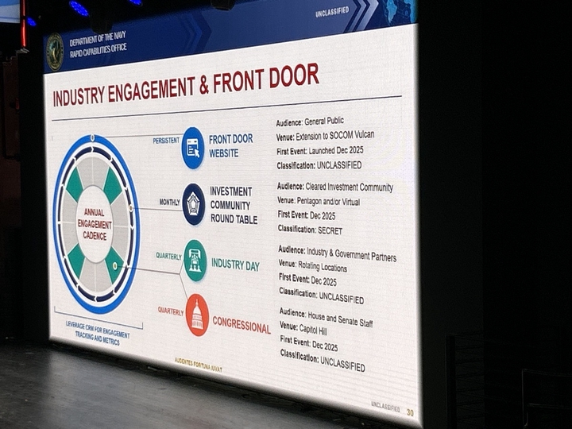
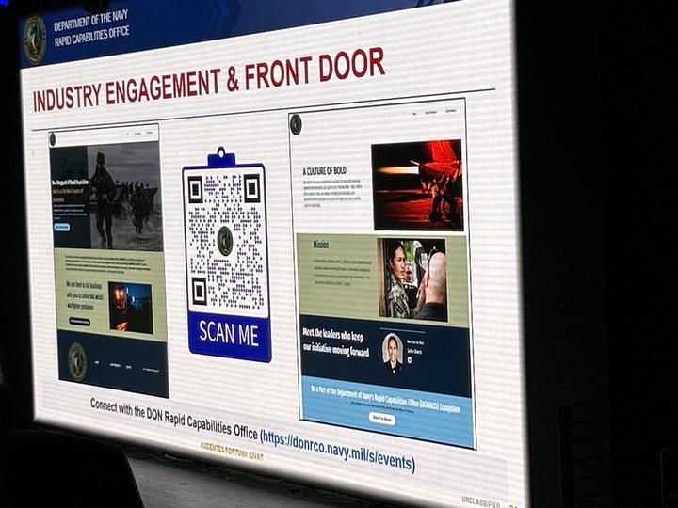
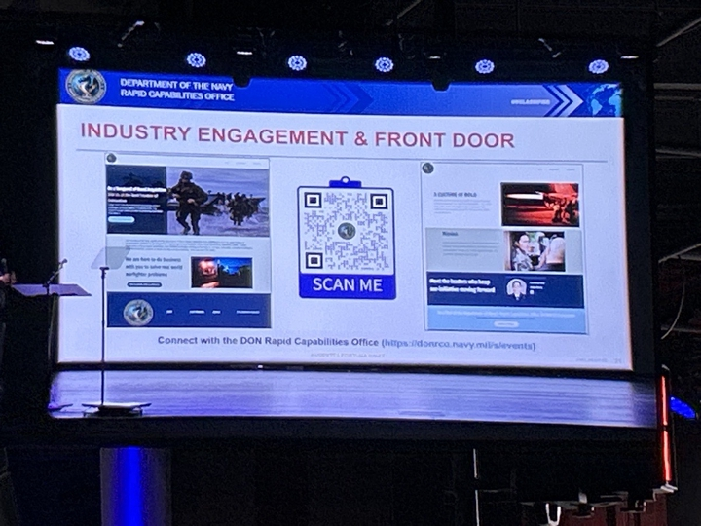

Summary
This lecture presents the Navy’s new engagement strategy to rapidly harvest and integrate technology from industry partners. Speakers Jared and Admiral Conn describe the creation of a “front door” for industry, centered on a new webpage and the Vulcan platform for submitting technology proposals. The strategy emphasizes persistent engagement through monthly meetings with the investment community and quarterly events in various locations. The lecture also introduces the Portfolio Acquisition Executive for Robotics and Autonomous Systems (PAE RAS), a new organizational structure designed to accelerate acquisition by tightening the linkage between operators, industry, and program offices. Key upcoming DON RCO events and locations are announced, and the importance of detailed technology submissions for effective evaluation is underscored.

Key Points

1. Engagement and Technology Harvesting Strategy
- Core Objectives
  - The strategy has three main goals:
    - Engage with government partners, including internal Navy stakeholders, OSD, and other agencies.
    - Provide a “front door” presence for industry.
    - Harvest the best technology at speed through persistent engagement with industry.
- Persistent Engagement Model
  - **Monthly:**Engagements with the investment community will occur monthly; some may be classified.
  - **Quarterly:**Events like the current one will be held quarterly in different locations outside D.C., bringing engagement to where industry operates.
  - **Congressional:**Quarterly congressional engagements are included; Admiral Conn has completed the first round.
  - **Customer Relations:**A customer relationship management system will track activities and report progress to leadership.
- Upcoming DON RCO Events
  - **January 22:**New York City.
  - **February:**California (location TBC, possibly Silicon Valley).
  - **March:**Austin, Texas.
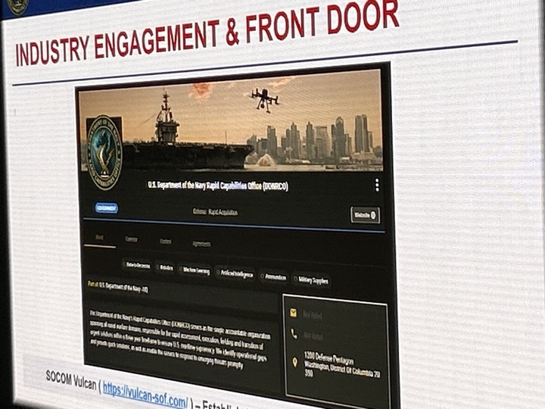
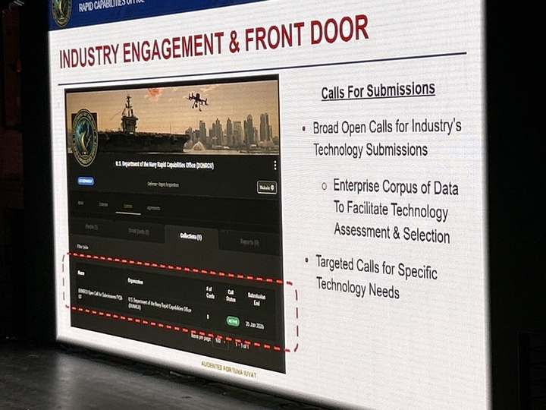

2. The “Front Door” - Web Presence and Vulcan Platform
- Webpage and Vulcan Integration
  - A new, searchable webpage serves as the primary entry point.
  - The site officially went live the morning of the lecture (December 9, 2025), after being soft-launched for a few days.
  - It is acknowledged the site is not polished initially; it will be iterated daily with improved content.
  - The webpage’s key function is directing users to the Vulcan website.
- Vulcan Website for Technology Submissions
  - Vulcan is SOCOM’s platform for harvesting technology proposals from industry and government, fostering competition to select the “best athlete.”
  - The site will be actively staffed to ensure responsiveness and engagement with submitters.
  - It will host calls for information and RFIs for proposals.
- Types of Submission Calls
  - **Broad/Open Calls:**General calls for industry to submit technology. The first broad call is active and will close around end of January 2026; these will be continuous.
  - **Targeted Calls:**Specific, urgent needs or leadership-driven ideas; can be posted within minutes.
- Importance of Detailed Submissions
  - Detailed proposals are crucial for filtering potentially thousands of submissions.
  - Detail helps “filter out the chaff” and identify the best technologies to advance.
  - The process narrows large volumes (e.g., 1,000) to a small, manageable group (e.g., 10) for in-depth evaluation before presenting to the “bets board.”
- Data Corpus
  - The Vulcan site will create an enterprise-wide data corpus.
  - This data will be leveraged by the RCO and other Navy entities.
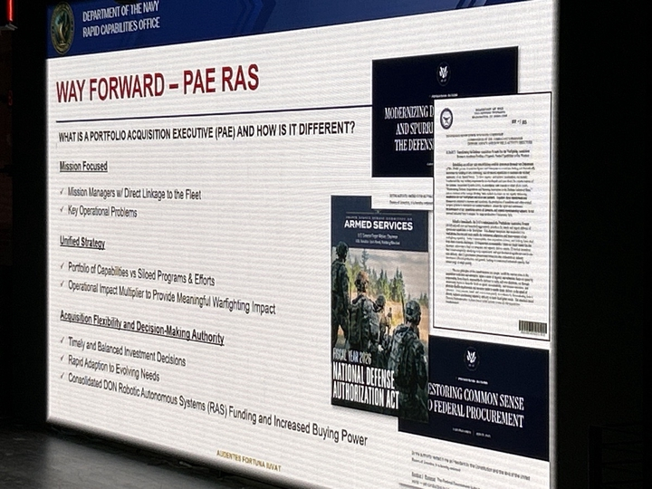
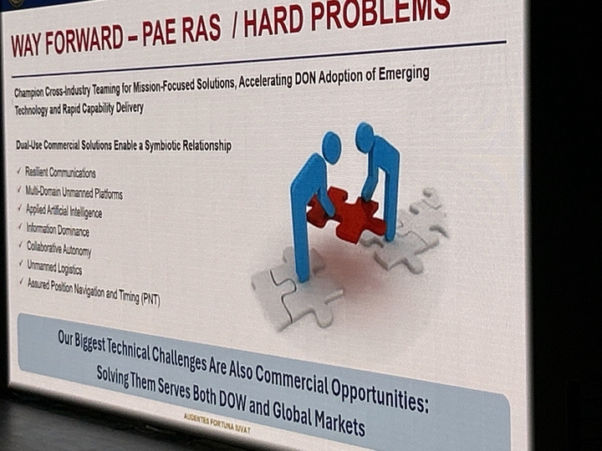

3. Portfolio Acquisition Executive for Robotics and Autonomous Systems (PAE RAS)
- Organizing Principle and Goal
  - The primary organizing principle for PAEs is speed.
  - The structure is designed to close the distance between operators, industry partners, and the acquisition program office.
- Structure and Focus
  - PAE RAS is organized around mission managers focused on combined missions, with platforms across all domains.
  - It was the first PAE stood up because robotics and autonomy are changing fastest and “rewriting the playbook on modern war.”
  - Goal for official sign-off of PAE RAS is Friday, December 12, 2025.
- Unifying a Fragmented System
  - Previously, over 200 separate programs were fragmented across 6 PEOs and 20 program offices, complicating industry engagement.
  - PAE RAS consolidates this into a “single belly button,” a unified entry point for autonomy and robotic systems.
- Acquisition and Industry Engagement
  - PAE RAS will adopt deliberate acquisition strategies, moving away from standard, “cookie-cutter” FAR-based contracting.
  - It will host its own industry days tailored to robotics and autonomous systems, with the first potentially combined with the RCO event in New York.

4. Logistics for Upcoming Classified Event
- Event Details
  - A classified event is scheduled for the next day (December 10, 2025) at the Office of Naval Research.
- Attendance Instructions
  - Approved registrants must attend only one of the two sessions, not the full day, due to space and safety constraints.

Questions
- [Insert Question/Confusion]
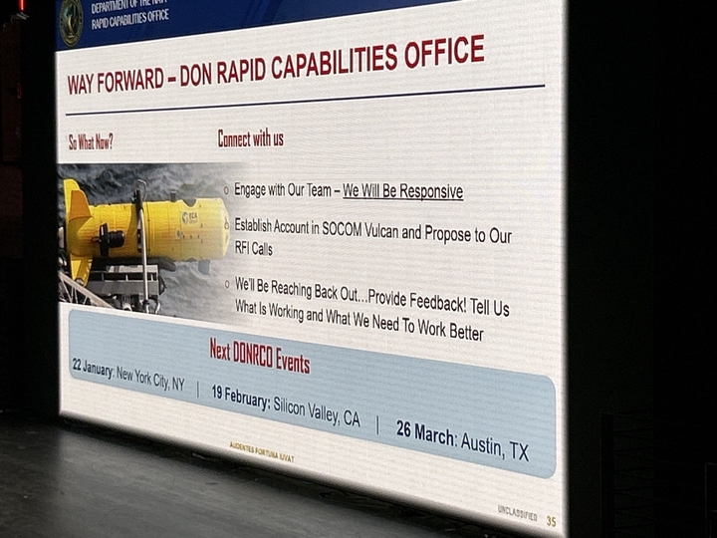

Action Items
[ ] 1. Industry partners: Create an account in the Vulcan system.
[ ] 2. Industry partners: Submit detailed “cool tech” proposals to the broad call on Vulcan.
[ ] 3. Approved attendees of the classified event: Confirm which of the two sessions you will attend; full-day attendance is not permitted.
[ ] 4. Interested parties: Monitor updates on upcoming DON RCO events in New York (Jan 22), California (Feb), and Austin (Mar).
[ ] 5. Robotics and autonomy sector: Watch for announcements regarding PAE RAS-specific industry days.

