Post Event Form
- Event Details:
Name of Event: | MCSS 2024 (MBSE Cyber Systems Symposium)
Date: | May 13-16, 2024
Location: | Dallas, TX
Albers POC: | Brendan McIntyre
Other Albers Attendees: | Noah Fergusion, Cliff Aldredge, Derek Miller, Matthew Daggett
Justification for Attending: | New MBSE pursuits, continuing customer relationships, sponsorship opportunity.

Attendee: Yes ☒ No ☐
Sponsor: Yes ☒ No ☐
Panelist: Yes ☐ No ☒

- Summary write-up:
The following write-up will be used for internal (Team Brief) and external (website/social media) release. Must be at least a paragraph long and include:
- The importance of our attendance and what was accomplished by attending
- Who did we meet with (customers/partners)
- If we sponsored, talk about how that increased our visibility
Importance of Attendance: MCSS is the premier US Based conference for MBSE. There are many opportunities for both networking with current and potential new clients, as well as a large number of technical sessions for our team to become smarter and stay aware of what “State of the Art” MBSE is.
Who did we meet with:
Sierra Nevada Corp. – Three primary POC’s are Danyel Fiet, Ryan Yourishin, and Chris J. Olsen. Danyel and Ryan both have interest in our software offerings. Chris is the Systems Engineering Hiring manage for the recently awarded SAOC program and has a need for small business partners. Huge opportunity – we have connected Chris with Edge to figure out how to make it happen.
LMCO – we met with several folks from several LMCO divisions. Vincent Cozza and John Howard work (I think) on the F-35 program and have interest in our software. We are waiting on them to reach out and have a plan if they do not. Matt Hayden works in a different unit (the name of which I did not capture) and has a need for MBSE Services. Same as above, waiting for him to reach out and have a plan if he does not. Lastly, a gentleman named Daniel who works for Lockheed’s internal training organization. He also had an interest in software. Vincent and John seem like the best leads – more to come with them.
BAE – we met Andrew Adams, Dustin Gerard, and Amanda (?) via an introduction from Risa Gorospe (she works on Johns Hopkins APL). They had interest in SEAM and SmartSync and we have been corresponding via email to set up an initial meeting.
Terma – Chuck Del Solar, he leads their MBSE and is in need of training and services. We referred chuck to Casey Medina with Studio SE for their training needs and Cliff either is or will be in touch with him regarding services.
Tangram Flex – Met a gentlemen named Joseph. We found out that we have a current proposal effort (I will have to defer to Cliff as I don’t know which one exactly) where we are already working with Tangram.
Leidos – Paul Calhoun. We have worked with Paul previously on the MUUV program and Paul has interest in getting other programs in Leidos to use SEAM. We have email correspondence out and are awaiting a reply.
GE – Tim Swanson and Katie Nowicki. GE is our strongest MBSE partnership, and we used the opportunity of them being in DFW to host them at our McKinney HQ. Great conversations surrounding current and future state of our program. They will continue to be a very strong partner to us moving forward.
Studio SE – Casey Medina, Marshall Lee, and Rae Lewark. We have a partnership with Studio SE in place and spent time with all three of them to have both strategic conversation as well as some good bull to strengthen the relationship.
Enola Technologies – David Fields. Their booth was directly across from ours. We have been in conversation with David to potentially become a development partner with Enola and used the opportunity to continue that conversation. We expect a meeting with David in the next month or so to discuss.
Sponsorship Increasing Visibility: The sponsorship greatly increased our visibility compared to being solely an attendee. Our booth gave us opportunities to interact with many people whom we may not have talked with, got out logo out on all conference signage, allowed us a slot in the conference “Demo theater” to present some of our solutions, and generally allows our company name to become more synonymous with MBSE. Mixing sponsorship with attendance allowed our team to create real, solid business leads as well as learn what current state of the art is in industry.
Marketing/CRM needs:
We will be more proactive next year in signing up for both attendance and sponsorship so that this conference makes it on the master list, which will allow for better pre- and mid-conference online posting and to ensure that our booth materials make it.
- Pictures:

See Next Page
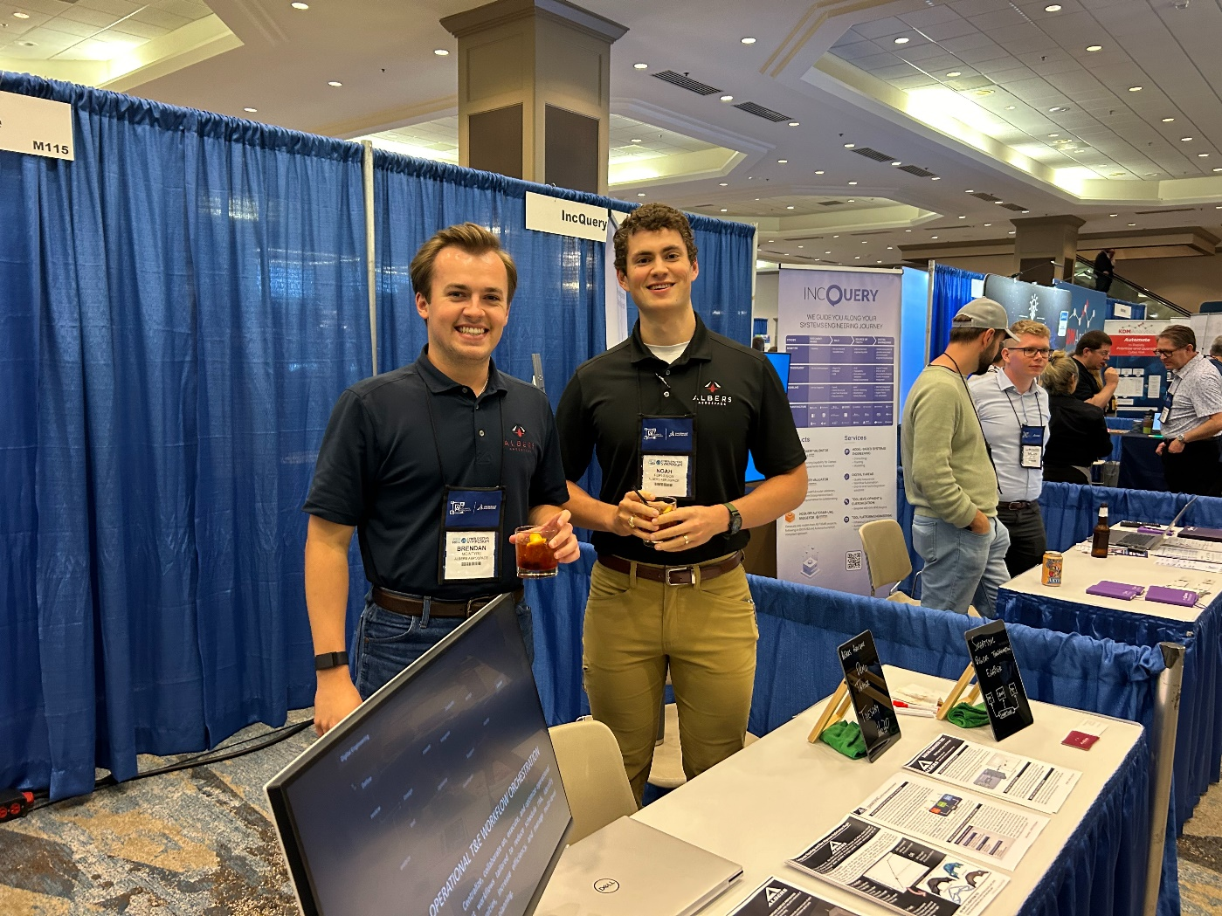
- Recommendations for next year:
- Should we return? If so, do we attend only, sponsor, exhibit? Why?
We should definitely return. If we only get one MBSE conference per year, this should be it. We should also sponsor if we can. As mentioned previously, there is no other us-based conference that I am aware of that shares the same opportunity of increasing brand awareness and increasing our engineer’s technical capacity than this one.

