


Technical Safety Concept Lane Assistance
Document Version: 1.0
Template Version 1.0, Released on 2017-06-21



Document history
Date | Version | Editor | Description
2017-10-18 | 1.0 | Albert Killer | First draft of technical safety concept

Table of Contents
Document history
Table of Contents
Purpose of the Technical Safety Concept
Inputs to the Technical Safety Concept
Functional Safety Requirements
Refined System Architecture from Functional Safety Concept
Functional overview of architecture elements
Technical Safety Concept
Technical Safety Requirements
Refinement of the System Architecture
Allocation of Technical Safety Requirements to Architecture Elements
Warning and Degradation Concept

Purpose of the Technical Safety Concept

The purpose of the technical safety concept is to refine the functional safety requirements established in the functional safety concept into technical safety requirements. This is a crucial step before developing reliabel hardware and software. As part of product development technical safety concept involves:

- Turning functional safety requirements into technical safety requirements
- Allocating technical safety requirements to the system architecture

As a subsequent step technical safety requirements will be considered within software and hardware implementation.

Inputs to the Technical Safety Concept

Functional Safety Requirements

ID | Functional Safety Requirement | ASIL | Fault Tolerant Time Interval | Safe State
Functional  Safety  Requirement  01-01 | The lane keeping item shall ensure that the lane departure oscillating torque amplitude is below Max_Torque_Amplitude | C | 50 ms | Lane Assistant functionality off
Functional  Safety  Requirement  01-02 | The lane keeping item shall ensure that the lane departure oscillating torque frequency is below Max_Torque_Frequency | C | 50 ms | Lane Assistant functionality off
Functional  Safety  Requirement  02-01 | The lane keeping item shall ensure that the lane keeping assistance torque is applied for only Max_Duration. | B | 500 ms | Lane Assistant functionality off

Refined System Architecture from Functional Safety Concept

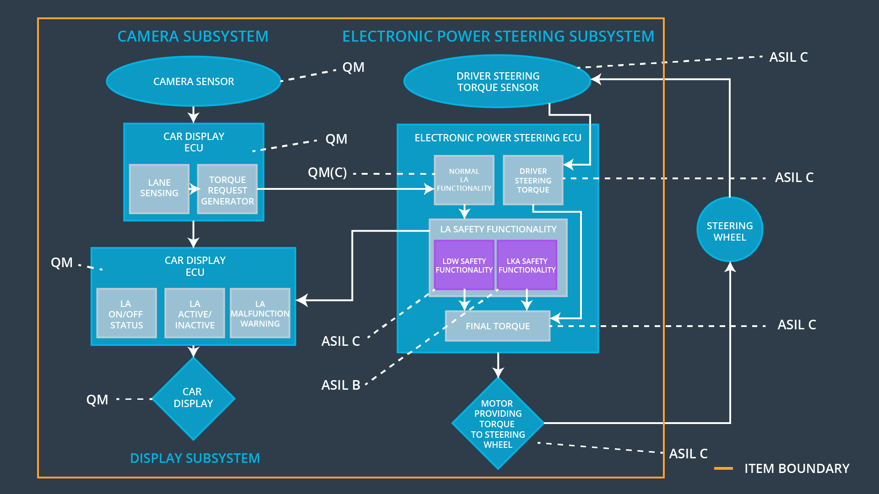

Functional overview of architecture elements

Element | Description
Camera Sensor | Provides camera images to the Camera Sensor ECU.
Camera Sensor ECU - Lane Sensing | Detects laneline positions from camera images.
Camera Sensor ECU - Torque request generator | Generates a torque request to the Electronic Power Steering ECU.
Car Display | Shows warning to driver.
Car Display ECU - Lane Assistance On/Off Status | Indicates if LA functionality is turned on.
Car Display ECU - Lane Assistant Active/Inactive | Indicates if LA functionality has properly detected lanes and is active at the moment.
Car Display ECU - Lane Assistance malfunction warning | Indicates fault malfunction of LA functionality.
Driver Steering Torque Sensor | Delivers steering torque intensity provided by driver to Electronic Power Steering ECU.
Electronic Power Steering (EPS) ECU - Driver Steering Torque | Processes input from Driver Steering Torque Sensor.
EPS ECU - Normal Lane Assistance Functionality | Receives torque request from Camera Sensor ECU and transfers it to Safety Lane Assistance Functionality.
EPS ECU - Lane Departure Warning Safety Functionality | Checks for malfunction of Lane Departure Warning and translates torque request into final torque output.
EPS ECU - Lane Keeping Assistant Safety Functionality | Checks for malfunction of Lane Keeping Assistant and transfers torque request to final torque output.
EPS ECU - Final Torque | Generates final torque from torque requests received from LDW and LKA safety.
Motor | Receives final torque calculated by Electronic Power Steering ECU and applies it to steering wheel.

Technical Safety Concept

Technical Safety Requirements

Lane Departure Warning (LDW) Requirements:

Functional Safety Requirement 01-01 with its associated system elements
(derived in the functional safety concept)
ID | Functional Safety Requirement | Electronic Power Steering ECU | Camera ECU | Car Display ECU
Functional  Safety  Requirement  01-01 | The lane keeping item shall ensure that the lane departure oscillating torque amplitude is below Max_Torque_Amplitude | X

Technical Safety Requirements related to Functional Safety Requirement 01-01 are:
ID | Technical Safety Requirement | ASIL | Fault Tolerant Time Interval | Architecture Allocation | Safe State
Technical  Safety  Requirement  01 | The LDW safety component shall ensure that the amplitude of ‘LDW_Torque_Request’ sent to the ‘Final electronic power steering Torque’ component is below ‘Max_Torque_Amplitude’. | C | 50 ms | LDW Safety | LDW_Activation_Status is zero
Technical  Safety  Requirement  02 | As soon as a failure is detected by the LDW function, it shall deactivate the LDW feature and the ‘LDW_Torque_Request’ shall e set to zero. | C | 50 ms | LDW Safety | LDW_Activation_Status is zero
Technical  Safety  Requirement  03 | As soons as the LDW function deactivates the LDW feature, the ‘LDW Safety’ software block shall send a signal to the car display ECU to turn on a warning light. | C | 50 ms | LDW Safety | LDW_Error_Status is zero
Technical  Safety  Requirement  04 | The validity and integrity of the data transmission for ‘LDW_Torque_Request’ signal shall be ensured. | C | 50 ms | Data Transmission Integrity Check | N/A
Technical  Safety  Requirement  05 | Memory test shall be conducted at start up of the EPS ECU to check for any faults in mermory. | A | ignition cycle | Memory Test | LDW_Activation_Status is zero

Functional Safety Requirement 01-2 with its associated system elements
(derived in the functional safety concept)
ID | Functional Safety Requirement | Electronic Power Steering ECU | Camera ECU | Car Display ECU
Functional  Safety  Requirement  01-02 | The lane keeping item shall ensure that the lane departure oscillating torque frequency is below Max_Torque_Frequency | X

Technical Safety Requirements related to Functional Safety Requirement 01-02 are:
ID | Technical Safety Requirement | ASIL | Fault Tolerant Time Interval | Architecture Allocation | Safe State
Technical  Safety  Requirement  01 | The LDW safety component shall ensure that the frequency of ‘LDW_Torque_Request’ sent to the ‘Final electronic power steering Torque’ component is below ‘Max_Torque_Frequency’. | C | 50 ms | LDW Safety | LDW_Activation_Status is zero
Technical  Safety  Requirement  02 | As soon as a failure is detected by the LDW function, it shall deactivate the LDW feature and the ‘LDW_Torque_Request’ shall e set to zero. | C | 50 ms | LDW Safety | LDW_Activation_Status is zero
Technical  Safety  Requirement  03 | As soons as the LDW function deactivates the LDW feature, the ‘LDW Safety’ software block shall send a signal to the car display ECU to turn on a warning light. | C | 50 ms | LDW Safety | LDW_Error_Status is zero
Technical  Safety  Requirement  04 | The validity and integrity of the data transmission for ‘LDW_Torque_Request’ signal shall be ensured. | C | 50 ms | Data Transmission Integrity Check | LDW_Activation_Status is zero
Technical  Safety  Requirement  05 | Memory test shall be conducted at start up of the EPS ECU to check for any faults in mermory. | A | ignition cycle | Memory Test | LDW_Activation_Status is zero

Lane Keeping Assistance (LKA) Requirements:

Functional Safety Requirement 02-1 with its associated system elements
(derived in the functional safety concept)
ID | Functional Safety Requirement | Electronic Power Steering ECU | Camera ECU | Car Display ECU
Functional  Safety  Requirement  02-01 | The lane keeping item shall ensure that the lane keeping assistance torque is applied for only Max_Duration | X

Technical Safety Requirements related to Functional Safety Requirement 02-01 are:
ID | Technical Safety Requirement | ASIL | Fault Tolerant Time Interval | Allocation to Architecture | Safe State
Technical  Safety  Requirement  01 | The LKA safety component shall ensure that ‘LKA_Torque_Request’ is sent to the ‘Final electronic power steering Torque’ component for only ‘Max_Duration’. | B | 500 ms | LKA Safety | LKA_Activation_Status is zero
Technical  Safety  Requirement  02 | As soon as a failure is detected by the LKA function, it shall deactivate the LKA feature and the ‘LKA_Torque_Request’ shall e set to zero. | B | 500 ms | LKA Safety | LKA_Activation_Status is zero
Technical  Safety  Requirement  03 | As soons as the LKA function deactivates the LKA feature, the ‘LKA Safety’ software block shall send a signal to the car display ECU to turn on a warning light. | B | 500 ms | LKA Safety | LKA_Error_Status is zero
Technical  Safety  Requirement  04 | The validity and integrity of the data transmission for ‘LKA_Torque_Request’ signal shall be ensured. | B | 500 ms | Data Transmission Integrity Check | LKA_Activation_Status is zero
Technical  Safety  Requirement  05 | Memory test shall be conducted at start up of the EPS ECU to check for any faults in mermory. | A | ignition cycle | Memory Test | LKA_Activation_Status is zero

Refinement of the System Architecture

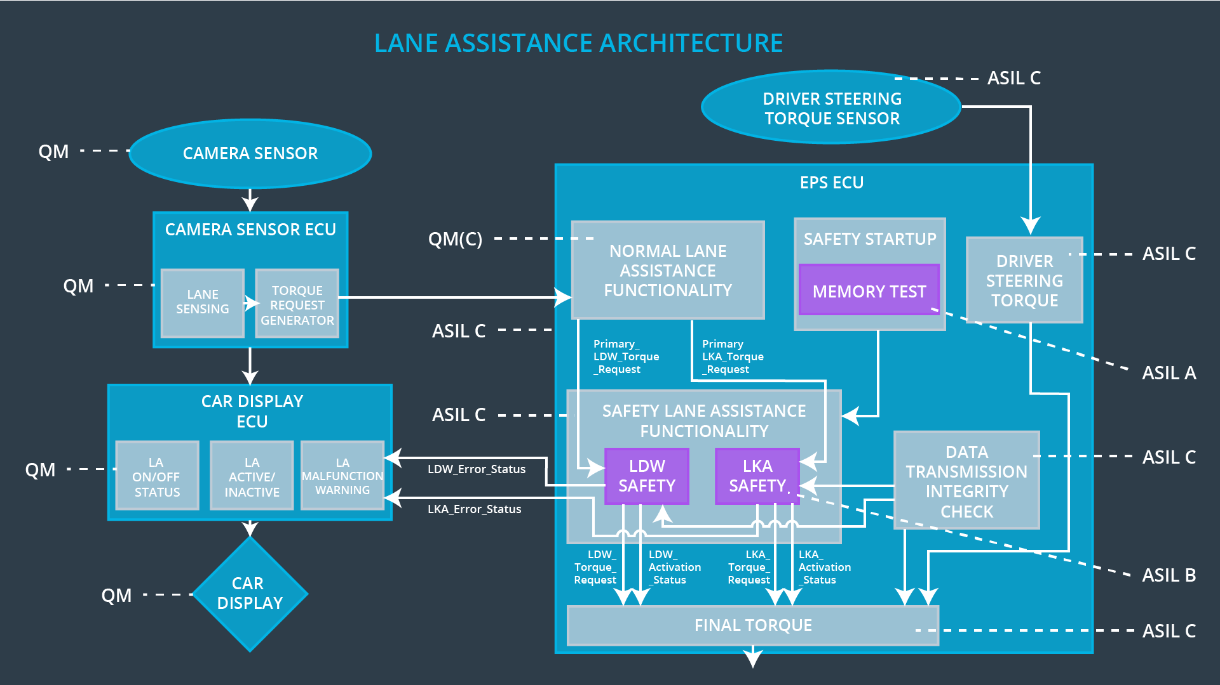

Allocation of Technical Safety Requirements to Architecture Elements

All technical safety requirements were allocated to the Electronic Power Steering ECU. For the exact allocation within EPS ECU compare the technical requirement tables above.

Warning and Degradation Concept

For any system malfunction, the lane assistance functions will be turned off and the driver will receive a warning light indication.

ID | Degradation Mode | Trigger for Degradation Mode | Safe State invoked? | Driver Warning
WDC-01 | Turn off Lane Assistant functionality | Malfunction_01 | Yes | Lane Assistant Malfunction Warning on Car Display
WDC-02 | Turn off Lane Assistant functionality | Malfunction_02 | Yes | Lane Assistant Malfunction Warning on Car Display
WDC-03 | Turn off Lane Assistant functionality | Malfunction_03 | Yes | Lane Assistant Malfunction Warning on Car Display
WDC-04 | Turn off Lane Assistant functionality | Malfunction_04 | Yes | Lane Assistant Malfunction Warning on Car Display
WDC-05 | Turn off Lane Assistant functionality | Malfunction_05 | Yes | Lane Assistant Malfunction Warning on Car Display

