FAKE SCREENSHOT DETECTOR
Implementation Walkthrough & Sample Run Documentation
A companion to the Review 2 presentation: how an upload actually becomes a verdict,
demonstrated end to end on a genuine authentic screenshot and a genuine fake one.
github.com/albert-matheww/fake-screenshot-detector

1. Purpose of This Document
This document explains what happens, computationally, between a user uploading an image and the tool returning a verdict — and demonstrates it with two real, captured runs of the live system: one on an authentic bank-statement screenshot, and one on the same statement with a fake-document-generator watermark injected into it. Every number, image, and JSON excerpt in Sections 5–7 is copied directly from an actual POST /analyze response; none of it is illustrative or invented.
A note on the sample images: no public dataset of labeled real/fake screenshots exists (see the project README and the accompanying literature review) — this is a documented, honest gap, not an oversight. The two sample images used here are procedurally generated by the project's own tools/synthesize_dataset.py, built specifically to fill that gap with real, on-disk, labeled training and demonstration material. They are clearly identified as such throughout — “real” and “fake” below refer to the authentic/tampered class, not to the images' real-world provenance.

2. System Overview
The system is two independently deployed services joined by one HTTP contract:
- A React frontend (drag-and-drop upload, ELA heatmap comparison, per-cue breakdown, JSON report download).
- A Flask backend exposing POST /analyze and GET /status, running the forensic pipeline and returning a verdict as JSON.
Images are processed entirely in memory. Nothing is written to disk at any point in the pipeline — only a SHA-256 hash of the upload is logged, for traceability without retaining the image itself. In Docker Compose, nginx serves the frontend and reverse-proxies /api/* to the Flask container; the two services can be built, scaled, and tested independently.

3. The Analysis Workflow, Step by Step
This is the exact sequence executed by forensic.analyze_image_bytes() for every uploaded image, in order:
- The client sends the image as multipart/form-data to POST /analyze.
- Flask validates the file extension and size (≤10 MB) and reads the bytes into memory — never to disk.
- A SHA-256 hash of the raw bytes is computed and logged for traceability.
- Cues that need the original, unresized file run first: quantization-table inspection, EXIF/metadata inspection, and one shared Tesseract OCR pass (the same OCR data feeds document-text, font-consistency, chrome-consistency, and amount-consistency, so Tesseract runs exactly once per request).
- The image is resized to a maximum dimension (1600px) for the remaining, more compute-intensive cues.
- Block-grid cues run on the resized copy: Error Level Analysis, JPEG Ghost, noise consistency, copy-move detection, and edge-sharpness consistency.
- All eleven cue scores are assembled into one feature vector.
- classify_content_type() buckets the image (financial_document / social_or_chat / photo / unknown) from its OCR text and shape, and resolves the threshold to use for this specific request.
- model_loader.predict_fake() computes the composite fake_score — the bundled RandomForest if it loaded successfully, otherwise a transparent weighted-average heuristic.
- A high-confidence override check runs on top of that score: if metadata_score, text_score, or arithmetic_score individually reaches 0.8, the verdict is forced to “fake” regardless of the composite score.
- The final verdict, override reason (if any), ELA heatmap (base64 PNG), full per-cue breakdown, and metadata are assembled into one JSON response and returned.
- The React frontend renders the verdict card, the original image next to its ELA heatmap, the per-cue meters, and offers the JSON report as a download.

4. The Eleven Forensic Cues
Seven cues come from classical photograph forensics; four are specific to rendered UI and were added and empirically calibrated this phase — two validated and scored, two implemented, tested, and found not yet reliable (and excluded from scoring for that reason, shown only for transparency).
Cue | What it measures | Status
Error Level Analysis | Recompression-error hotspots vs. local neighborhood | Scored
JPEG Ghost | Multi-quality recompression dip scan | Shown only
Quantization tables | Multiple compression generations | Scored (low weight)
EXIF / Metadata | Editing-tool tags, camera EXIF, GPS | Scored + override
Document text (OCR) | Generator watermarks, placeholder data | Scored + override
Noise consistency | Local noise-energy outliers | Scored
Copy-move detection | Offset-vector voting + compactness gate | Scored
Amount consistency | Contradictory totals in printed numbers | Scored + override
Chrome consistency | Duplicated status-bar clock reading | Scored (capped)
Font consistency | Anti-aliasing mismatch between regions | Shown only — not validated
Edge sharpness | Resampling/interpolation blur | Shown only — found unreliable

5. Sample Run 1 — Authentic Bank Statement
A single bank-statement screenshot render (Union Trust Bank, six transactions, no edits of any kind) submitted as-is.
Original image  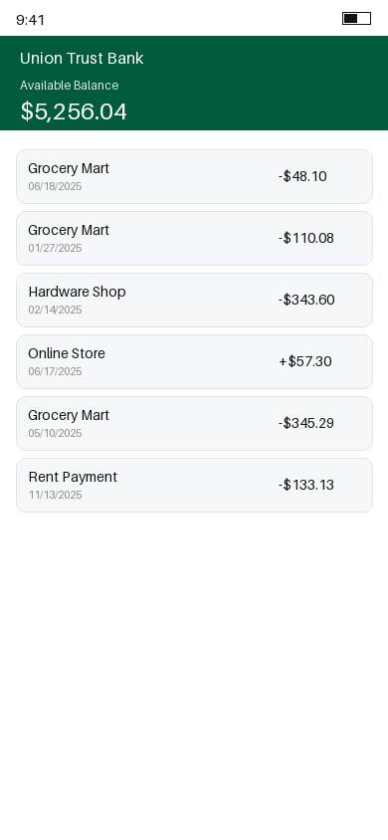 | ELA heatmap (as returned by the API)  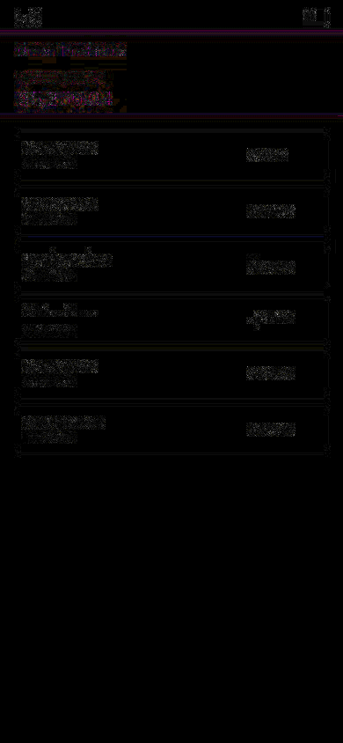
Result
- Detected content type: financial_document → effective threshold 0.55 (raised from the 0.5 default — see Section 4 of the presentation deck for why).
- Composite fake_score: 0.4413 — below the 0.55 threshold.
- No override cue fired.
Verdict: Likely Authentic

Full per-cue breakdown
Cue | Score
ELA | 0.8937
JPEG Ghost (not scored) | 1.0000
Quantization tables | 0.0000
Noise consistency | 0.8056
Copy-move detection | 0.3216
Metadata / EXIF | 0.0000
Document text (OCR) | 0.0000
Font consistency (not scored) | 0.0885
Edge sharpness (not scored) | 0.8409
Chrome consistency | 0.0000
Amount consistency | 0.0000
Reading this: ela_score (0.89), noise_score (0.81), and edge_score (0.84) are all elevated — but this is expected and not itself suspicious. This is a dense, text-heavy document; the README's own “Known limitations” section documents that these classical compression/noise cues are much weaker signals on flat, vector-rendered UI screenshots than on the natural photographs they were originally validated on, and are prone to firing on ordinary content complexity. What actually decides this verdict is that metadata_score, text_score, and arithmetic_score — the cues capable of reaching the 0.8 override bar — are all 0.0: nothing conclusive was found, so the composite score is trusted as-is, and it falls under threshold.

6. Sample Run 2 — Fake Bank Statement (Same Statement, Watermark Injected)
This is deliberately the same underlying statement as Sample Run 1 — identical bank name, identical balance, identical six transactions — with exactly one change: a small line of text reading “makereceipt” was added near the bottom of the image, simulating the real-world pattern of a fake-statement-generator watermark left on a document produced by an online statement-generator service. This isolates the tamper's effect from any incidental difference in content or image quality between the two samples.
Original image (note the faint watermark, bottom left)  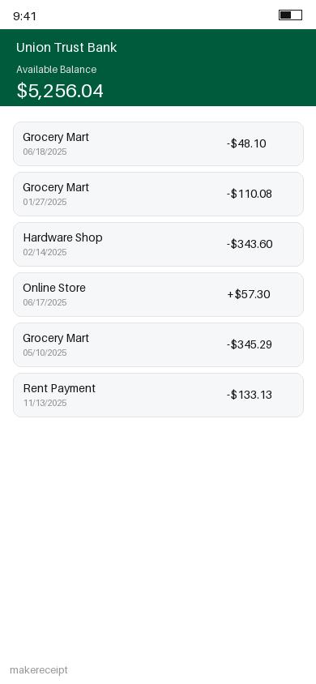 | ELA heatmap (as returned by the API)  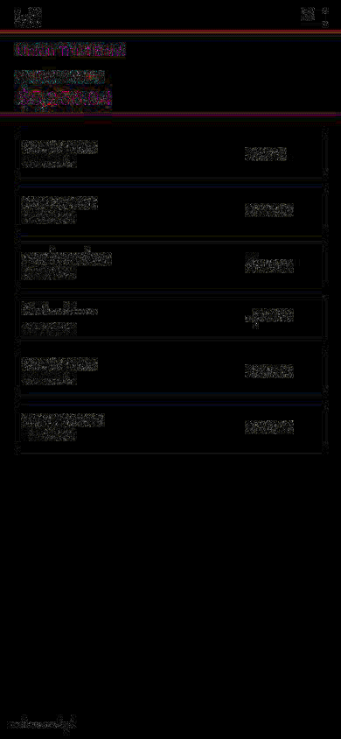
Result
- Detected content type: financial_document → effective threshold 0.55 (same as Sample 1).
- Composite fake_score: 0.3304 — actually lower than Sample 1's 0.4413, and further under the threshold. On the composite score alone, this image would be classified Likely Authentic — a false negative.
- The OCR-based document-text cue caught it: “Text contains a known fake-document-generator marker: ‘makereceipt’” → text_score = 0.9.
- 0.9 clears the 0.8 override bar → the high-confidence override forces is_fake = true, with override_reason = “text_score” reported explicitly in the response.
Verdict: Possible Fake (via override — not via the composite score)

Full per-cue breakdown
Cue | Score
ELA | 0.8974
JPEG Ghost (not scored) | 0.9289
Quantization tables | 0.0000
Noise consistency | 0.8045
Copy-move detection | 0.3266
Metadata / EXIF | 0.0000
Document text (OCR) | 0.9000
Font consistency (not scored) | 0.0000
Edge sharpness (not scored) | 0.8523
Chrome consistency | 0.0000
Amount consistency | 0.0000
Reading this: every pixel-level cue (ELA, noise, clone, edge-sharpness) is within a few thousandths of Sample 1's values — unsurprising, since a few dozen pixels of light-gray watermark text on an otherwise-unchanged 390×844 image barely perturbs global compression or noise statistics at all. The single highlighted row is the entire story: text_score jumps from 0.0 to 0.9 because the pipeline read what the document actually says, not just how its bytes were compressed — something none of the other ten cues can do. This is the exact scenario the override architecture exists for, reproduced directly rather than only described.

7. Side-by-Side Comparison
Highlighted rows moved by more than 0.05 between the two runs.
Cue | Authentic | Fake | Δ
ELA | 0.8937 | 0.8974 | +0.0037
JPEG Ghost (not scored) | 1.0000 | 0.9289 | -0.0711
Quantization tables | 0.0000 | 0.0000 | +0.0000
Noise consistency | 0.8056 | 0.8045 | -0.0011
Copy-move detection | 0.3216 | 0.3266 | +0.0050
Metadata / EXIF | 0.0000 | 0.0000 | +0.0000
Document text (OCR) | 0.0000 | 0.9000 | +0.9000
Font consistency (not scored) | 0.0885 | 0.0000 | -0.0885
Edge sharpness (not scored) | 0.8409 | 0.8523 | +0.0114
Chrome consistency | 0.0000 | 0.0000 | +0.0000
Amount consistency | 0.0000 | 0.0000 | +0.0000
Only one cue moved meaningfully. This is a deliberately narrow, high-precision tamper — real forgeries are often exactly this narrow (one added line of text, one changed digit), which is precisely why the pipeline fuses eleven independent cues rather than relying on any single one: a tamper invisible to compression analysis can still be conclusive to a cue that reads the document's actual content.

8. What This Demonstrates
- The multi-cue architecture matters in practice, not just in theory: this run is a concrete case where the composite pixel-based score alone would have produced a false negative, and a narrower, conclusive text-based signal caught what it missed.
- The high-confidence override is not a hypothetical safeguard — it changed the verdict on this exact pair of images, and the response reports why (override_reason), so the mechanism is never silent.
- Per-cue transparency is real, not marketing: every number shown above came directly from the JSON response, unedited.
- What this run does NOT demonstrate: real-world generalization. Both images are procedurally generated (see Section 1) — the same honest caveat that runs throughout this project's own README and presentation deck applies here too.

9. Reproducing This Run
With the stack running (docker compose up --build, or the backend alone via python app.py):
curl -X POST http://localhost:5050/analyze \
-F "image=@your_screenshot.jpg"
The two sample images used in this document can be regenerated deterministically from backend/tools/synthesize_dataset.py's render_bank() and apply_tamper() functions (tamper type 4, “watermark-inject”) — see that file's docstring for the full generator design.

