Testing author list with scholarpandoc

#### Jane Doe*,1,2,✉, John Q. Doe*,1, Peder Ås1, and Juan Pérez3,✉

* These authors contributed equally to this work.

1 Formatting Open Science Group  
2 Federation of Planets  
3 Acme Corporation

✉ Correspondence: [Jane Doe <[jane.doe@example.com](mailto:jane.doe@example.com)>](mailto:jane.doe@example.com), [Juan Pérez <[juan.perez@example.edu](mailto:juan.perez@example.edu)>](mailto:juan.perez@example.edu)

Federation of Planets

# Abstract

This is an example article. There is not much to see but filler text.

# Further reading

See the [pandoc manual](http://pandoc.org/MANUAL.html) for more information on pandoc.

$$E=mc^{2}$$

# Lorem Ipsum

Lorem ipsum dolor sit amet, consectetur adipiscing elit, sed do eiusmod tempor incididunt ut labore et dolore magna aliqua. Ut enim ad minim veniam, quis nostrud exercitation ullamco laboris nisi ut aliquip ex ea commodo consequat. Duis aute irure dolor in reprehenderit in voluptate velit esse cillum dolore eu fugiat nulla pariatur. Excepteur sint occaecat cupidatat non proident, sunt in culpa qui officia deserunt mollit anim id est laborum.



**Figure 1. SSA Logo!** here ios asdsdsdsnostrud exercitation ullamco laborinisi ut aliquip ex ea commodo consequat.Duis aute irure dolor in reprehenderit in voluptate velit esse cillum dolore eufugiat nulla pariatur. Excepteur sint occaecat cupidatat non proident, sunt inculpa qui officia deserunt mollit anim id est laborum.

## Dolor sit amet

Deserunt excepturi commodi sit qui velit quis. Delectus sit omnis culpa accusamus repellat iusto vel. Quod deserunt quasi nisi dolor. Quo eum id reiciendis dolor. Est qui illum et.

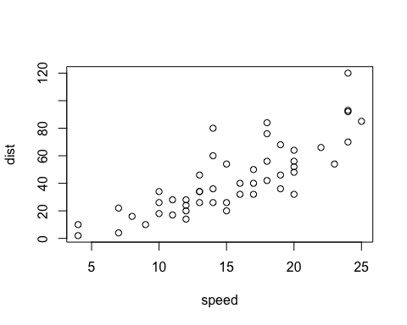

An amazing plot

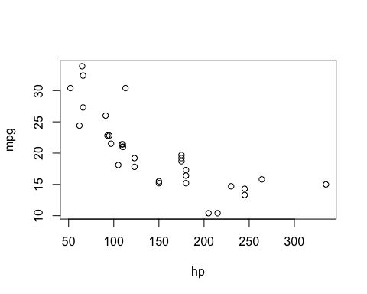

Another amazing plot

Quo dolore molestiae et laboriosam occaecati explicabo corrupti. Earum expedita ducimus quaerat est quam ut molestiae. Illum deleniti vel labore facilis et cum est. Est nemo est vel ad. Assumenda consequatur rerum officiis atque officia. Est nihil iste cumque ad qui.



**The new SSA logo**, which is actually a scatterplot, which is super neat!

Eaque sed sit totam enim. Et explicabo illum rerum aut. Aspernatur sit dolor animi tempora cum. Maxime in soluta aut. Explicabo id maiores voluptates aut voluptas id. Dolore sed labore voluptatem omnis doloribus mollitia aliquid cupiditate.

Table 1. A table of the first 10 rows of the mtcars data.

|  |  |  |  |  |  |  |  |  |
| --- | --- | --- | --- | --- | --- | --- | --- | --- |
|  | mpg | cyl | disp | hp | drat | wt | qsec | vs |
| Mazda RX4 | 21.0 | 6 | 160.0 | 110 | 3.90 | 2.620 | 16.46 | 0 |
| Mazda RX4 Wag | 21.0 | 6 | 160.0 | 110 | 3.90 | 2.875 | 17.02 | 0 |
| Datsun 710 | 22.8 | 4 | 108.0 | 93 | 3.85 | 2.320 | 18.61 | 1 |
| Hornet 4 Drive | 21.4 | 6 | 258.0 | 110 | 3.08 | 3.215 | 19.44 | 1 |
| Hornet Sportabout | 18.7 | 8 | 360.0 | 175 | 3.15 | 3.440 | 17.02 | 0 |
| Valiant | 18.1 | 6 | 225.0 | 105 | 2.76 | 3.460 | 20.22 | 1 |
| Duster 360 | 14.3 | 8 | 360.0 | 245 | 3.21 | 3.570 | 15.84 | 0 |
| Merc 240D | 24.4 | 4 | 146.7 | 62 | 3.69 | 3.190 | 20.00 | 1 |
| Merc 230 | 22.8 | 4 | 140.8 | 95 | 3.92 | 3.150 | 22.90 | 1 |
| Merc 280 | 19.2 | 6 | 167.6 | 123 | 3.92 | 3.440 | 18.30 | 1 |

# References

# header 1

## header 2

### header 3

#### header 4

##### header 5