**Appraisal of endolymphatic space 3D-MR-Imaging in view of different gadolinium-based** **contrast agent applications**

A. Berman1, V. Kirsch2-4, D. Keeser 1,5, U. Kumpf 1,5, S. Bense2,4, M. Dieterich2-4, 6, B. Ertl-Wagner1,6

1Department Radiology, 2 Department of Neurology, 3 Graduate School of Systemic Neuroscience, 4 German Center for Vertigo and Balance Disorders (IFBLMU), 5Department of Psychiatry, Ludwig-Maximilians University, Munich, 6 Munich Cluster for Systems Neurology (SyNergy), Munich, Germany

**Introduction:** The endolymphatic hydrops (EH) seems to occur in many different disorders of the vestibular system- yet little is known about its pathophysiological mechanism [1]. An important reason might be that until recently changes in the endolymphatic space could only be diagnosed indirectly through the loss of neuro-otologic functions, post mortem on the basis of histological sections of the inner ear or invasively via intratympanic injection gadolinium-based contrast medium (GBCM) in combination with magnetic resonance imaging (MRI). Intravenous contrast agent administration in combination with 3D-MR-Imaging, allow a less invasive in vivo appraisal of the endolymphatic space [2,3]. Aim of this study was to investigate the effect of different intravenous GBCM applications on endolymphatic space 3D-MR-Imaging.

**Methods:**   
Four healthy controls (two females, aged 30–36 years) were included in this study. Intravenous gadolinium-based contrast medium (GBCM) application was compared between Dotarem® (=D) vs. Gadovist® (=G) and single dose (=S) vs. Double dose (D). Intravenous gadolinium-based contrast medium (GBCM) was applied at three different time points (T1: after 3½ hours, T2: after 4 hours, T3 after 4½). Magnetic resonance (MR) cisternography with a T2- SPACE sequence was combined with a T2-FLAIR sequence for delimitation of inner ear fluid spaces. Machine learning and automated local thresholding segmentation algorithms were applied for three- dimensional (3D) reconstruction and volumetric quantification of endolymphatic hydrops. Appraisal of endolymphatic space 3D-MR-Imaging was estimated in view of signal-to-noise-ratio and distribution of signal intensity.

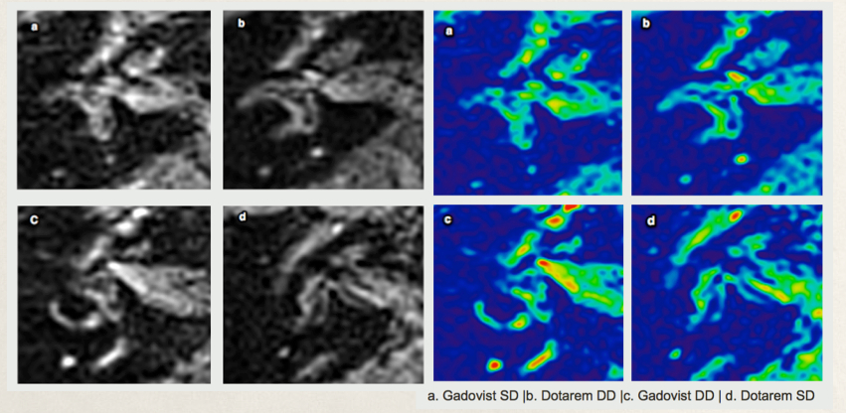

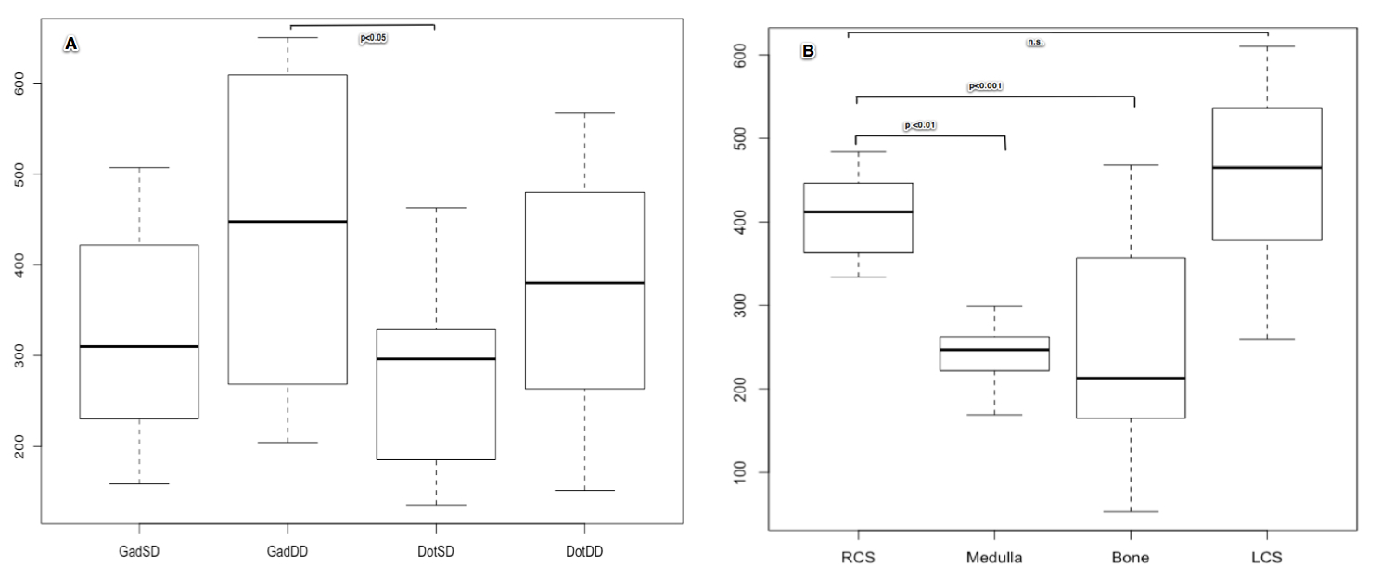

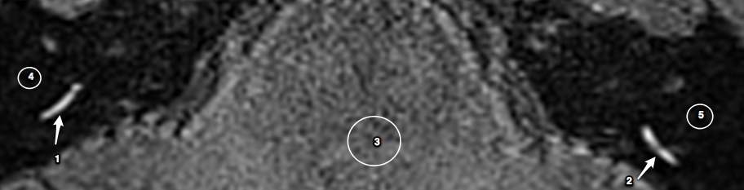

A 3D-FLAIR image at the level of the cochlear basal turns after IV Gadovist injection (IV-method) in a 30-year-old healthy woman. The IV gadolinium injection was administered 4 hours before MR imaging, and the cochlear basal turns has higher signal intensity than the Medulla oblongata p<0.01 and Temporal bone p<0.001 the gadoliniu is evenly distributed no significant difference between left and right cochlear basal turn.

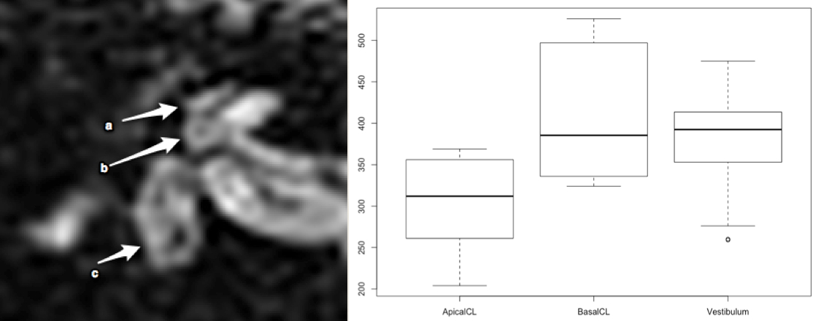

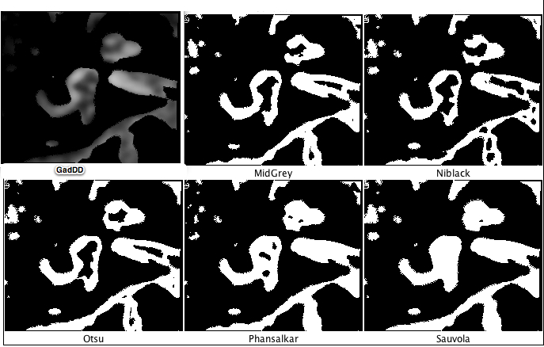

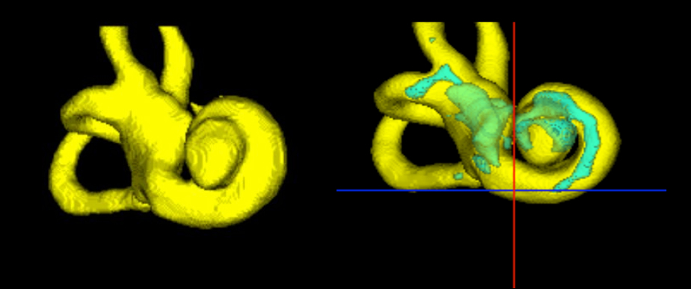

**Results:**   
Our analyses showed four major results: i) perilymph signal intensity signal-to-noise-ratio were significantly increased in the double dose intravenous gadolinium-based contrast medium (GBCM) applications (DG> DD> SG> SD), ii) in average intravenous GBCM showed best results 4 hours after application, iii) intravenous application showed a particularly homogenous signal distribution when compared to intrarympanal application and iv) 3D-Recontruction of the perilymphatic/endolymphatic space worked best in data with homogenous signal distribution and high signal-to-noise ratio.

**Discussion:**   
The data suggest clear methodical advantages when using intravenous double dose gadolinium-based contrast medium (GBCM) applications for endolymphatic space 3D-MR-Imaging, namely due to the combination of high signal-to-noise-ratio and homogeneity of signal intensity. This is in accordance with results of earlier studies [4]. However, to the best of our knowledge, this is the first study to supply a structured comparison of application method, type of contrast agent and dosage in view of 3D-MR-Imaging of endolymphatic space. This should prove important in the search for clinical correlates of the endolymphatic space 3D-Imaging.

**References:**

1. Strupp M, Dieterich M, Zwergal A, Brandt T (2015) Peripheral, central and functional vertigo syndromes. Nervenarzt 86(12):1573-87.
2. Gürkov R, Berman A., Dietrich O, Flatz W, Jerin C, Krause E, Keeser D, Ertl-Wagner B (2015) MR volumetric assessment of endolymphatic hydrops. Eur Radiol 25:585–595.
3. Tanigawa T, Tamaki T, Yamamuro O, et al (2011) Visualization of endolymphatic hydrops after administration of a standard dose of an intravenous gadolinium-based contrast agent. Acta Otolaryngol 131:596–601.
4. Iida T, Teranishi M, Yoshida T Otake H, Sone M, Kato M, Shimono M, Yamazaki M, Naganawa S, Nakashima T (2013) Magnetic resonance imaging of the inner ear after both intratympanic and intravenous gadolinium injections. Acta Otolaryngol 133:434–8.

Supported by the Bavarian Research Foundation (Bayerische Forschungsstiftung, Grant code AZ-1160-15), the Graduate School of Systemic Neuroscience (GSN), the German Foundation for Neurology (Deutsche Stiftung Neurologie) and the German Federal Ministry of Education and Research (German Center for Vertigo and Balance Disorders -IFBLMU, Grant code 01 EO 1401).