# CS 340 README Template

## About the Project/Project Title

The Grazioso Salvare Dashboard is a JupyterNotebooks dashboard for managing animals in MongoDB database. It provides an interactive way to navigate a CSV file with the possibility for preset filters, or alternative filters. It provides a dynamic pie chart of the currently selected animals in the dashboard, with the ability to select an animal to find them in a map

## Motivation

Traditional flat file or spreadsheet animal registries become unmanageable as the dataset grows. This project explores how a JupyterNotebook dashboard can be used to simplify finding the right animal(s) for a purpose.

## Getting Started

* Clone or download the repository.
* Load the project into JupyterNotebooks
* Change the database location to your database’s location.

## Installation

Required dependencies:

* Python 3.x
* MongoDB
* JupyterNotebooks
* AnimalShelter from crud

## Usage

### Code Example

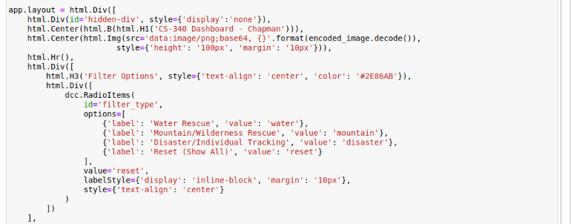

### Tests

Use Jupyter Notebooks to open the ipynb file, then run the first dashboard script

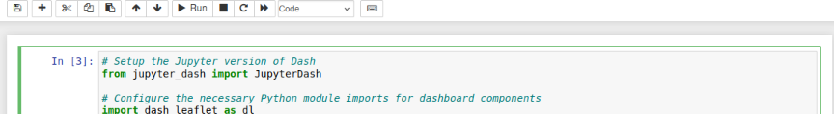

If valid, use the link to go to the dashboard in another tab

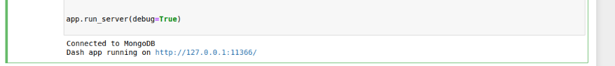

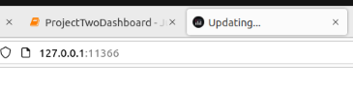

### Screenshots

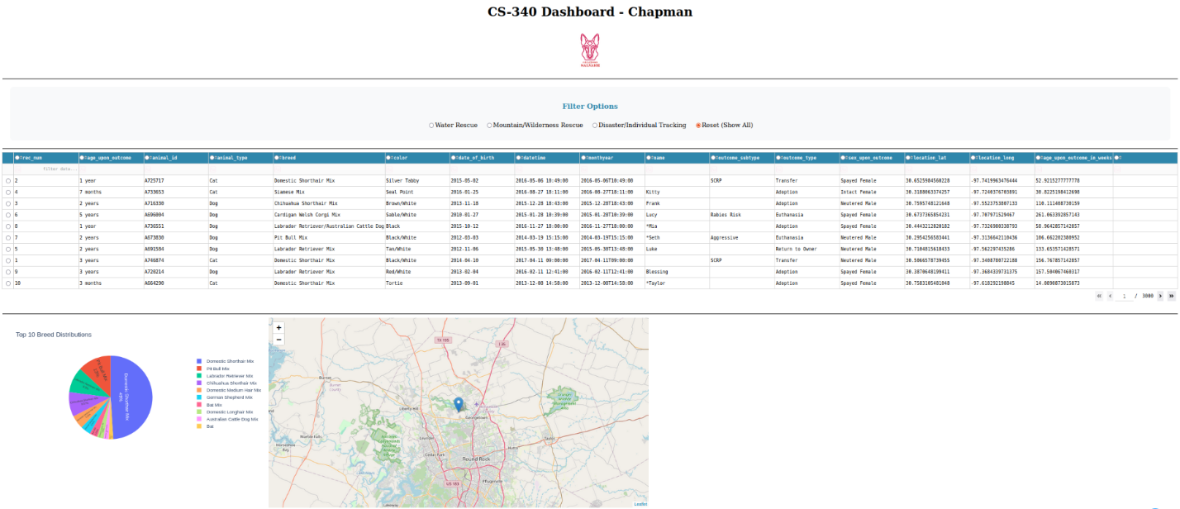

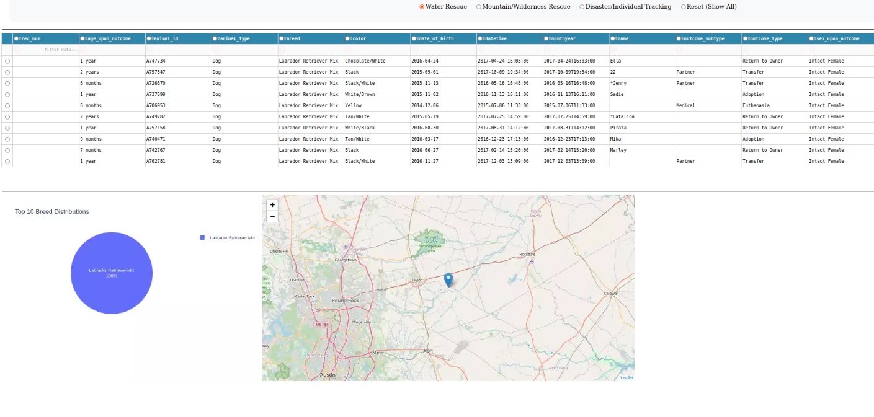

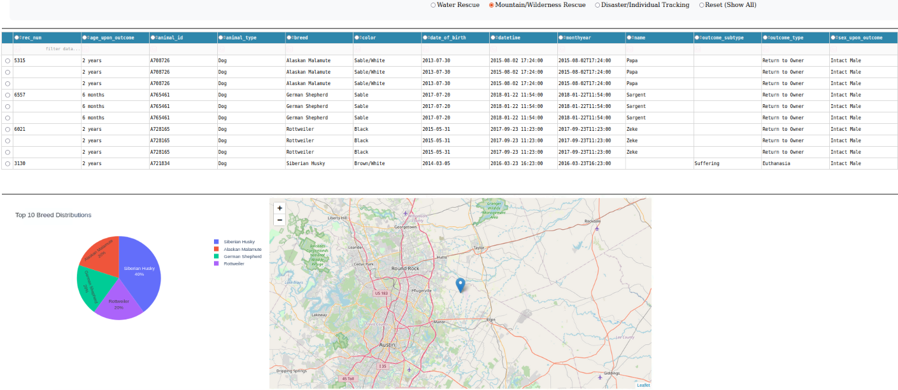

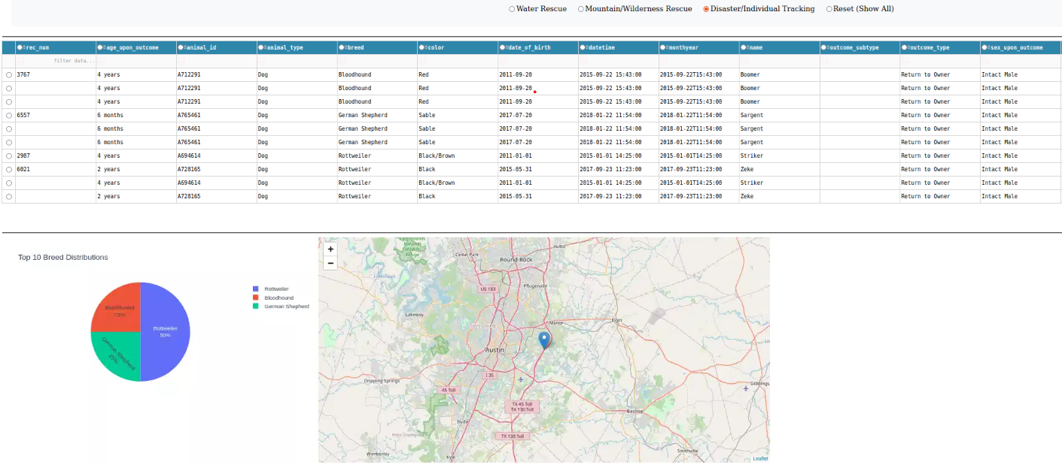

## Contact

Your name: Albert Chapman