Javascript assignment
Albert Abraham(3985)

1.Prompt for amount, interest rate and no. of years and calculate simple interest.

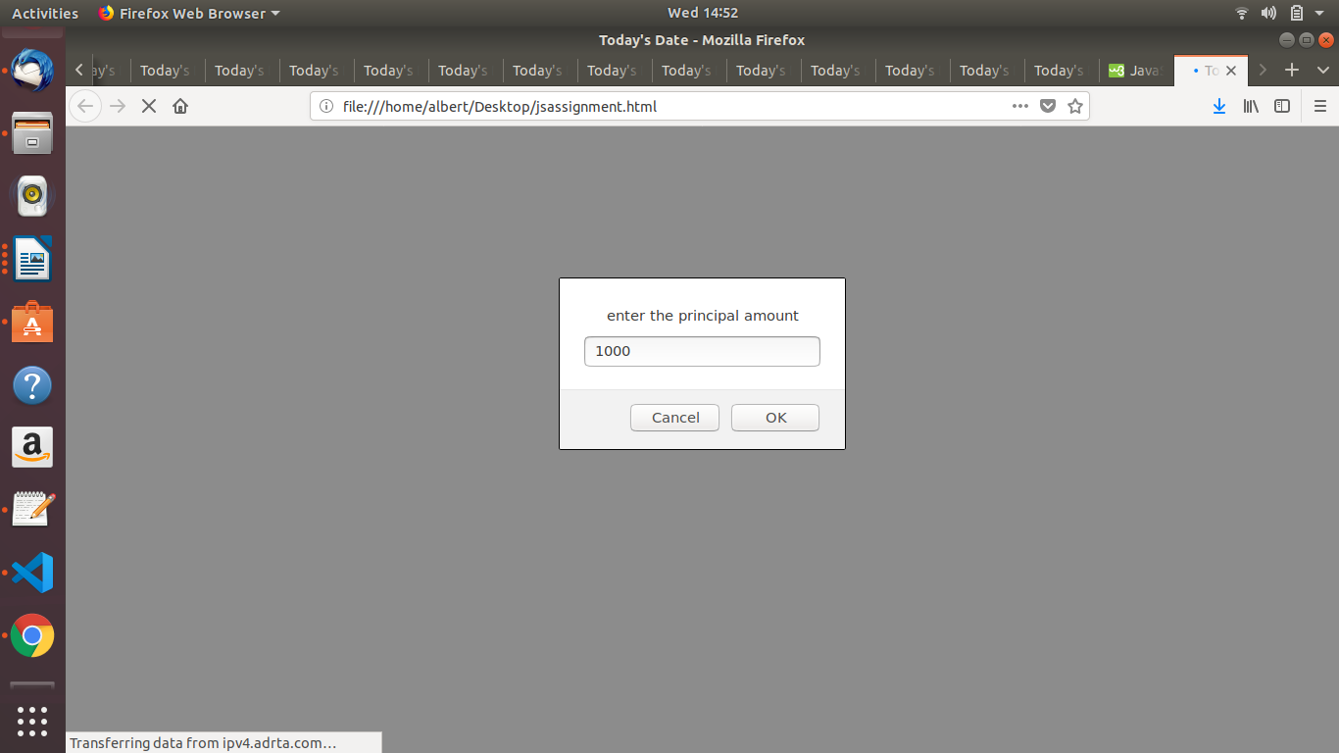
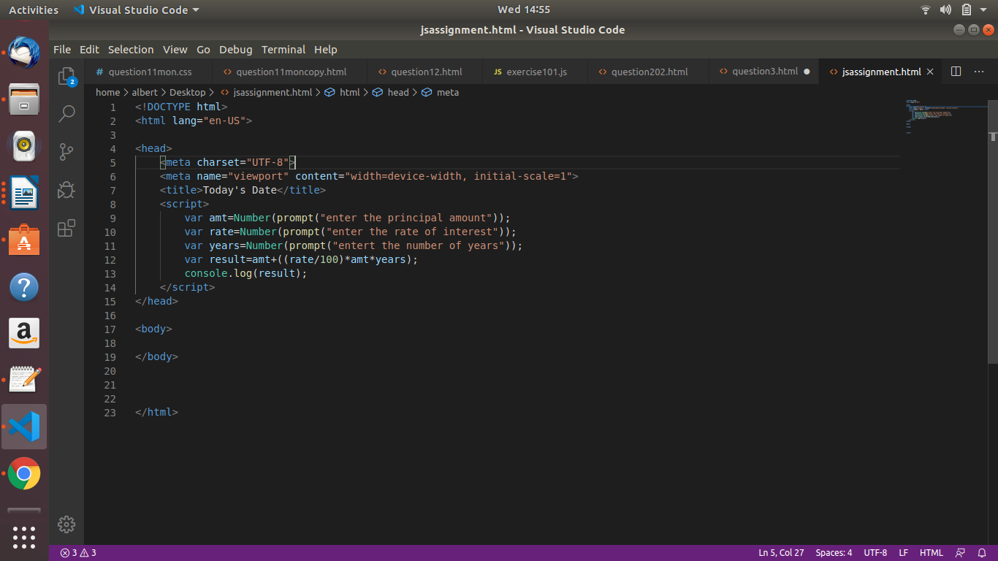

2.is palindrome string

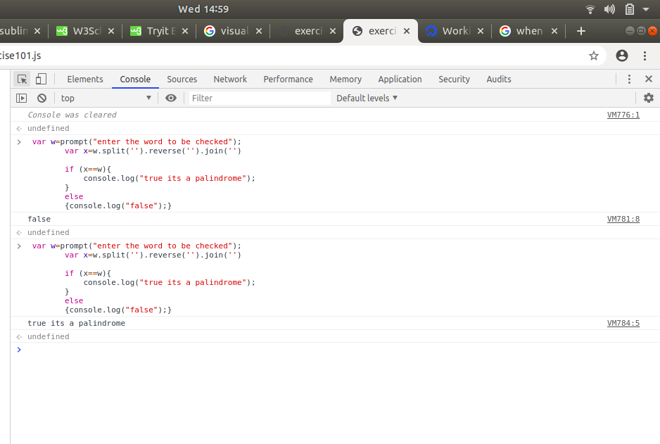
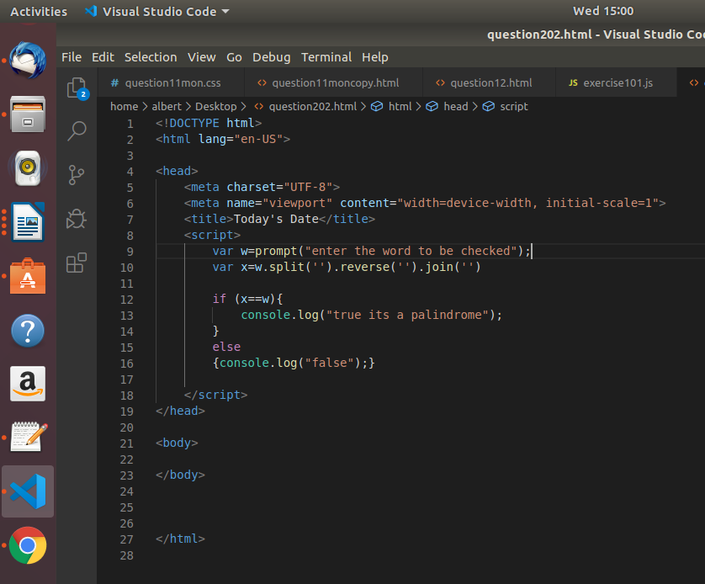

3.Area of circle

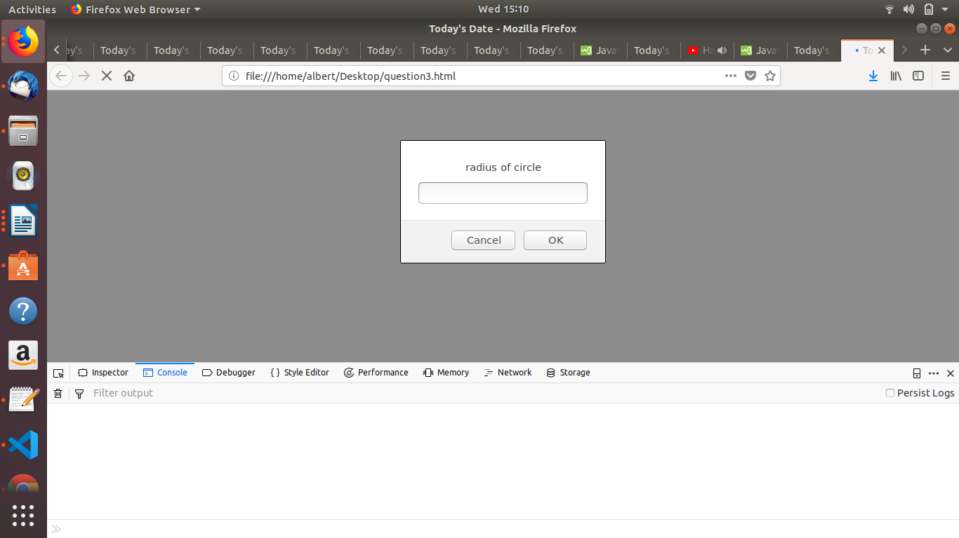

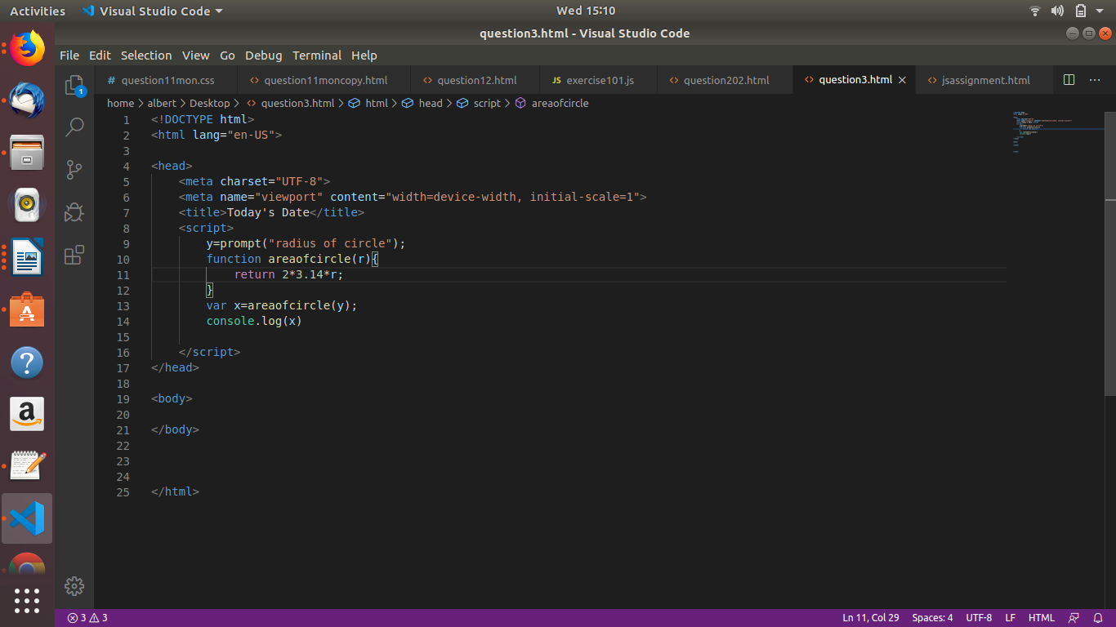

4.Copy information of one object to another and log it to console.

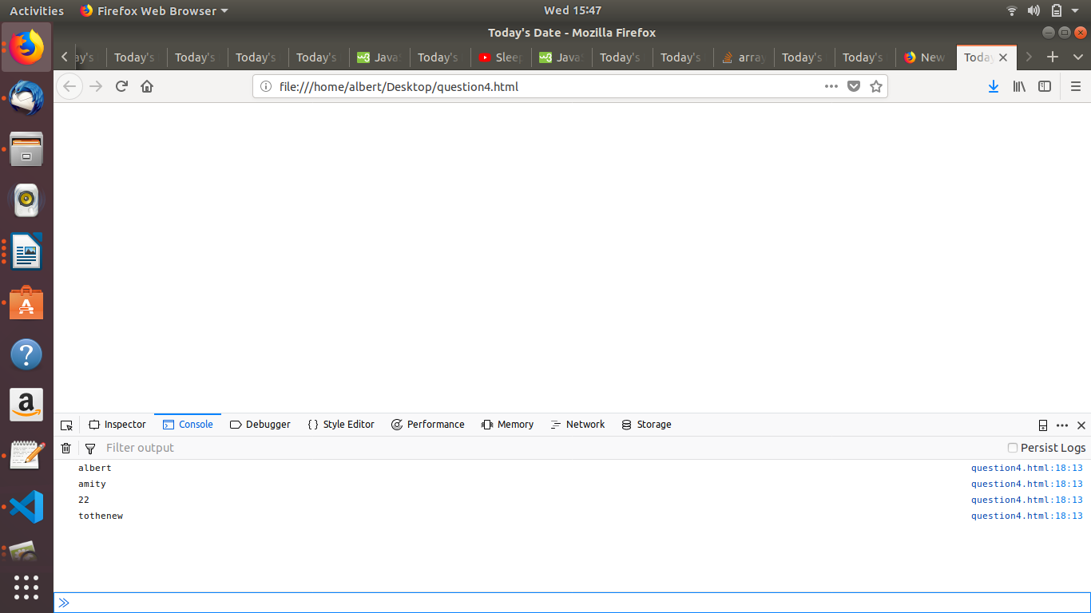

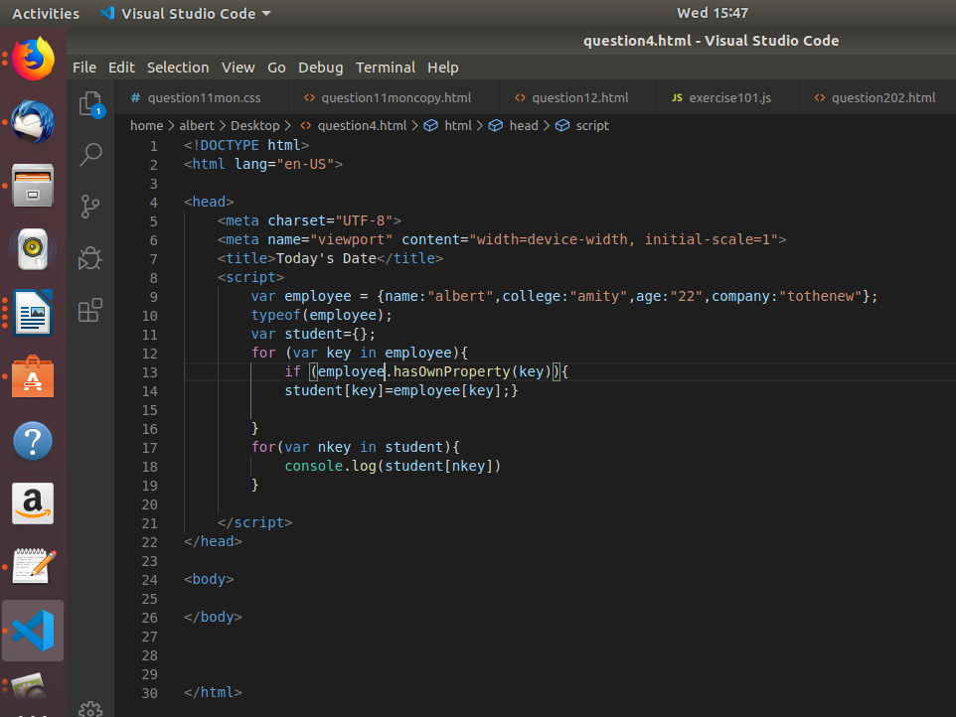

5.create a list of objects of Employee with info as follow :(i have also attached the html file for the code in the git branch)
- Name, age, salary ,DOB
- filter all employees with salary greater than 5000
- group employee on the basis of their age
- fetch employees with salary less than 1000 and age greater than 20. Then give them an increment 5 times their salary.

