TWITTER BOOTSTRAP ASSIGNMENT
ALBERT ABRAHAM(3985)
1.Make a webpage using twitter bootstrap for reportbug.
(the html and css page is attached and in the same branch on github)
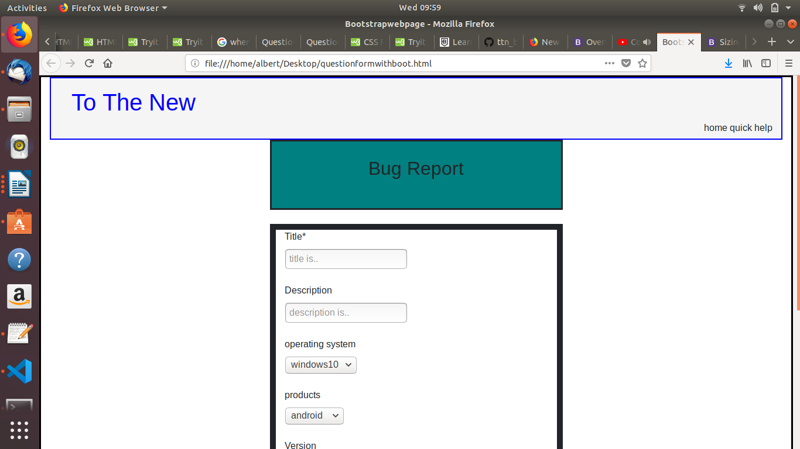

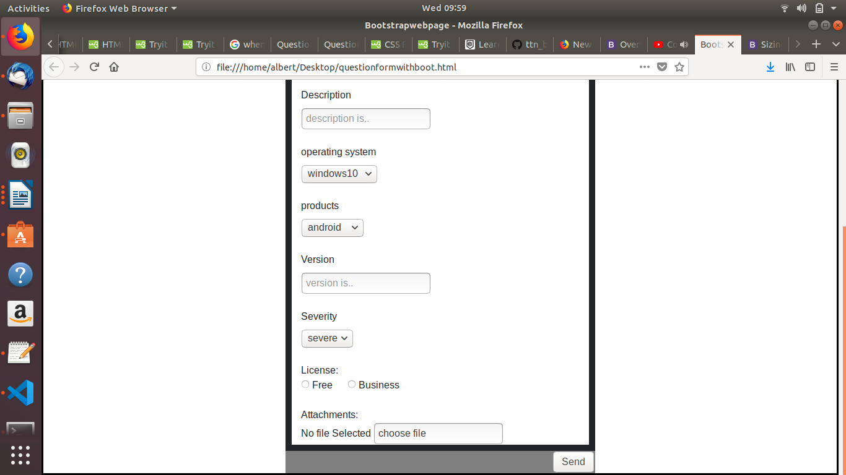

2.Create HTML for web-page.jpg
(the html and css page is attached and in the same branch on github)

