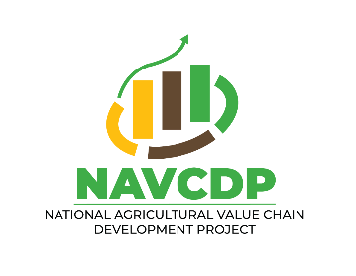



**National Project Coordination Unit (NPCU)**

**NATIONAL AGRICULTURAL VALUE CHAIN DEVELOPMENT PROJECT**

**(NAVCDP)**

**REPUBLIC OF KENYA**

# Call for Application: Ward Veterinary Surgeons and Veterinary Para Professionals for County FMD & PPR Vaccination Campaign through the E- Voucher System under the NAVCDP PrNAVCDP-LOGOoject

**Deadline: 27th August, 2025**

The County Governments in collaboration with National Agricultural Value Chain Development Project **(NAVCDP)** and the Directorate of Veterinary Services, invite qualified and licensed Veterinarians and Veterinary Para-professionals to apply to participate in the upcoming Foot and Mouth Disease (FMD) and Peste des Petits Ruminants (PPR) vaccination campaign. This initiative will be implemented through the e-voucher system, ensuring efficient service delivery and transparent compensation**.**

# Objectives of the Campaign

* To enhance livestock health and productivity across Kenya
* To prevent and control outbreaks of FMD and PPR
* To strengthen veterinary service delivery through digital platforms

# Who Should Apply

Licensed Veterinarians and Veterinary Para-professionals who;

* Are registered, retained and can practice with the Kenya Veterinary Board (KVB)
* Are familiar with digital tools and mobile -based service delivery
* Are available for deployment between September and November 2025

# Responsibilities

* Administer FMD and PPR vaccines to targeted livestock populations
* Record and report vaccination data via the e-voucher system
* Registration of animals through digital platform
* Engage with livestock owners and local stakeholders
* Ensure cold chain and vaccine integrity throughout the campaign period

# Renumeration

* VPPs Ksh.24 per head of cattle vaccinated and Kshs. 3 per sheep /goat vaccinated
* VSs Ksh.8 per head of cow vaccinated and Kshs. 1 per sheep/ goat vaccinated
* Target animals in cattle, sheep and goats

# E-Voucher System

Selected Veterinarians will be onboarded on to the e-voucher platform, which will;

* Facilitate service tracking and reporting
* Enable timely payments for services rendered
* Provide real-time data for monitoring and evaluation

# How to Apply

Interested candidates should submit;

* A cover letter expressing interest
* Updated CV with relevant experience
* Copy of updated KVB registration certificate
* A copy of professional certificate
* National ID and contact details
* All the above documents should be compiled as one PDF Document for ease of upload and download

Submit your application via the portal so as to reach us on or before 27th August 2025.