***W***

***orld***

Fernando Alberte García Vieites

05-01-2024

**Table of Contents**

Database Diagram…….…………………………………………………………………………………………………………………….. 3

Steps to create a SQL script and database diagram…………………….……………………………………… 5

Task 13 Solution.………………………………………………………………………………………………………………………………… 12

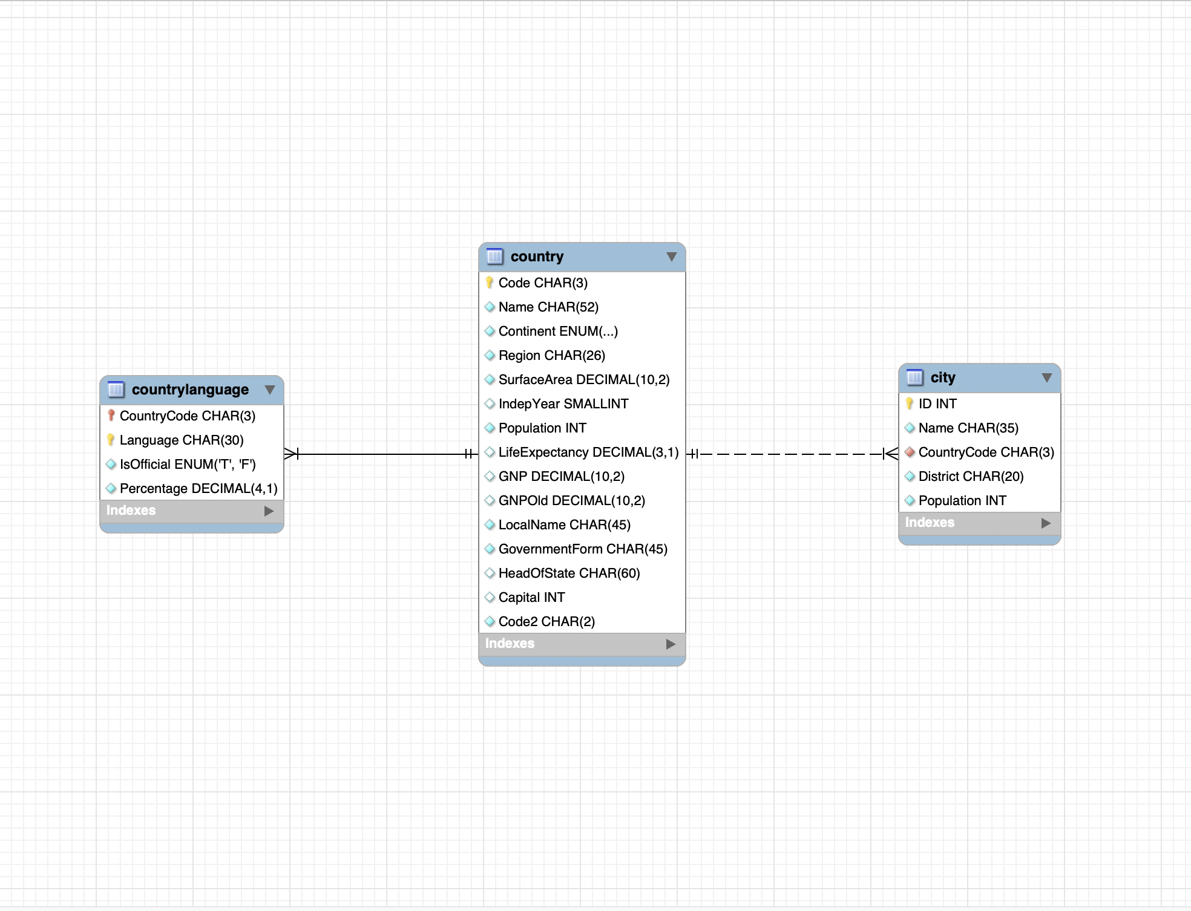**Database Diagram**

1. **country Table**
   * Primary Key: Code
   * Foreign Keys: There are no direct foreign keys in this table, but the Code field is used as a foreign key in other tables to establish a relationship with this one.
2. **city Table**
   * Primary Key: ID
   * Foreign Keys:
     + CountryCode: This foreign key refers to the Code field in the country table, establishing a relationship between a city and the country it belongs to.
3. **countrylanguage Table**
   * Primary Keys:
     + CountryCode
     + Language This table has a composite primary key, meaning the unique combination of CountryCode and Language uniquely identifies each row in the table.
   * Foreign Keys:
     + CountryCode: Similar to the city table, this foreign key refers to the Code field in the country table, linking the language to the corresponding country.

**Steps to create SQL script and Database Diagram**

* Open SQL script

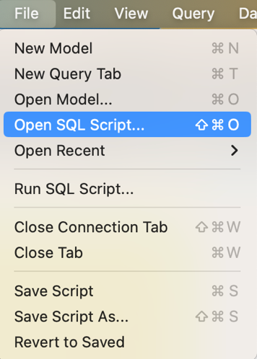

* Load SQL script

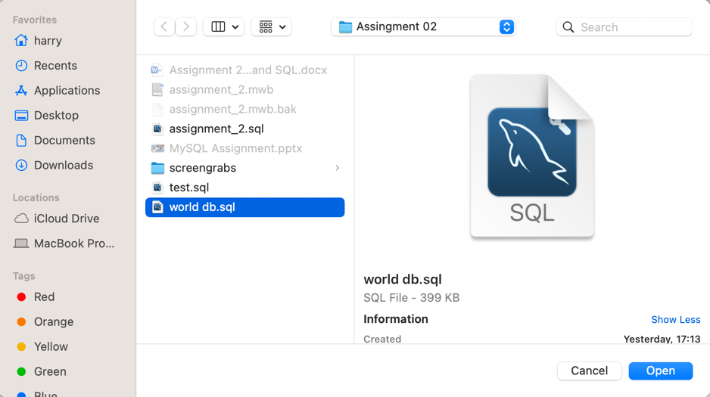

* Execute SQL script

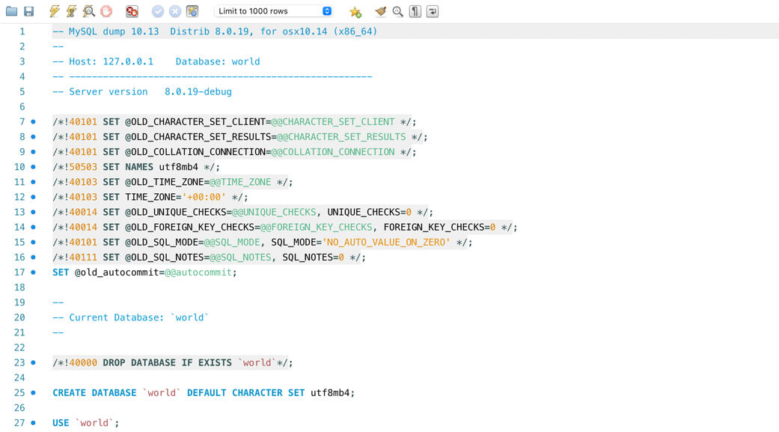

* Create new query tab

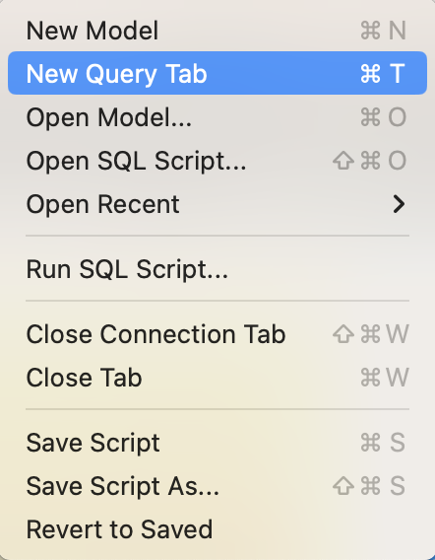

* Save SQL script

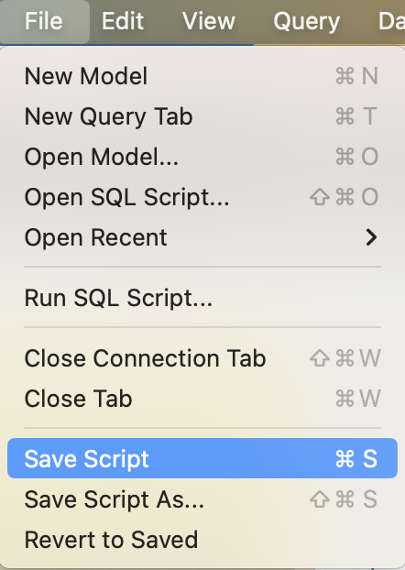

* Reverse Engineer to create a diagram

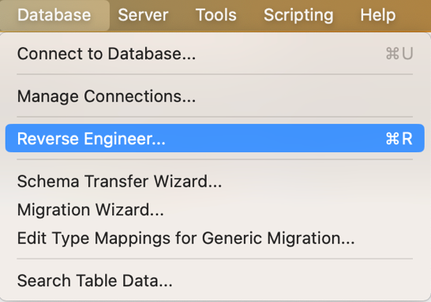

* Save SQL script



* Connections options ERR

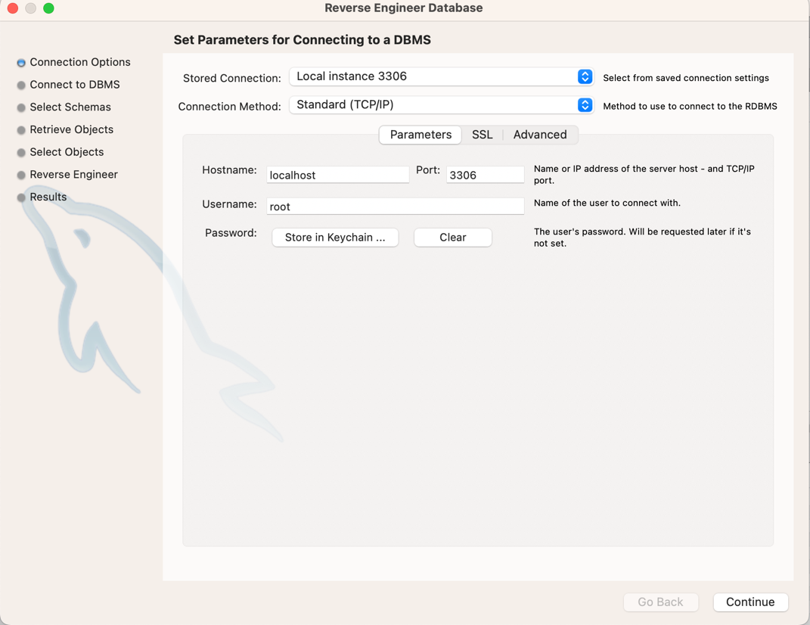

* Connect to DBMS

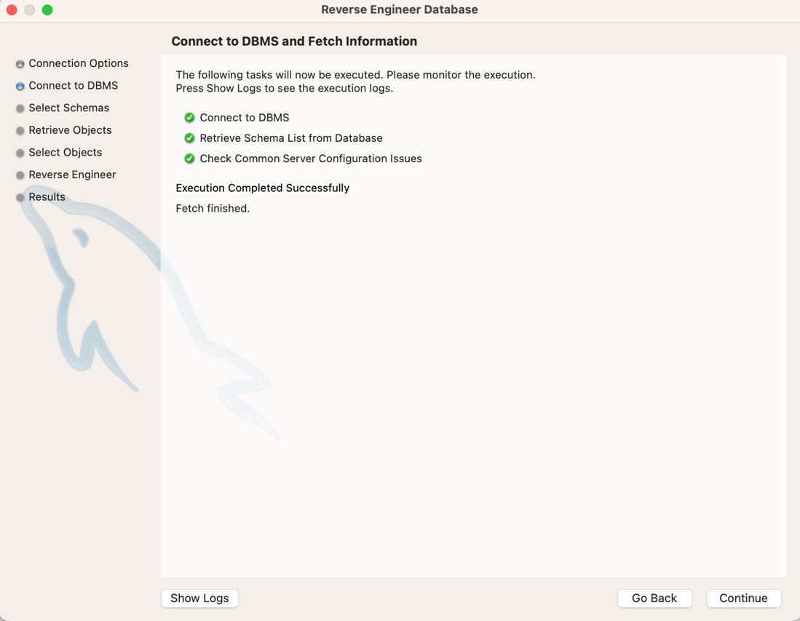

* Select Schemas

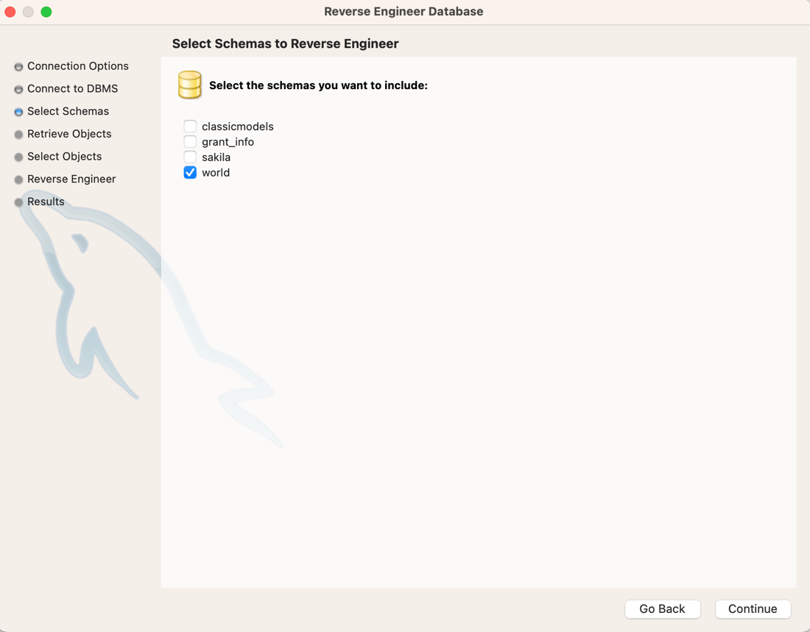

* Retrieve Objects

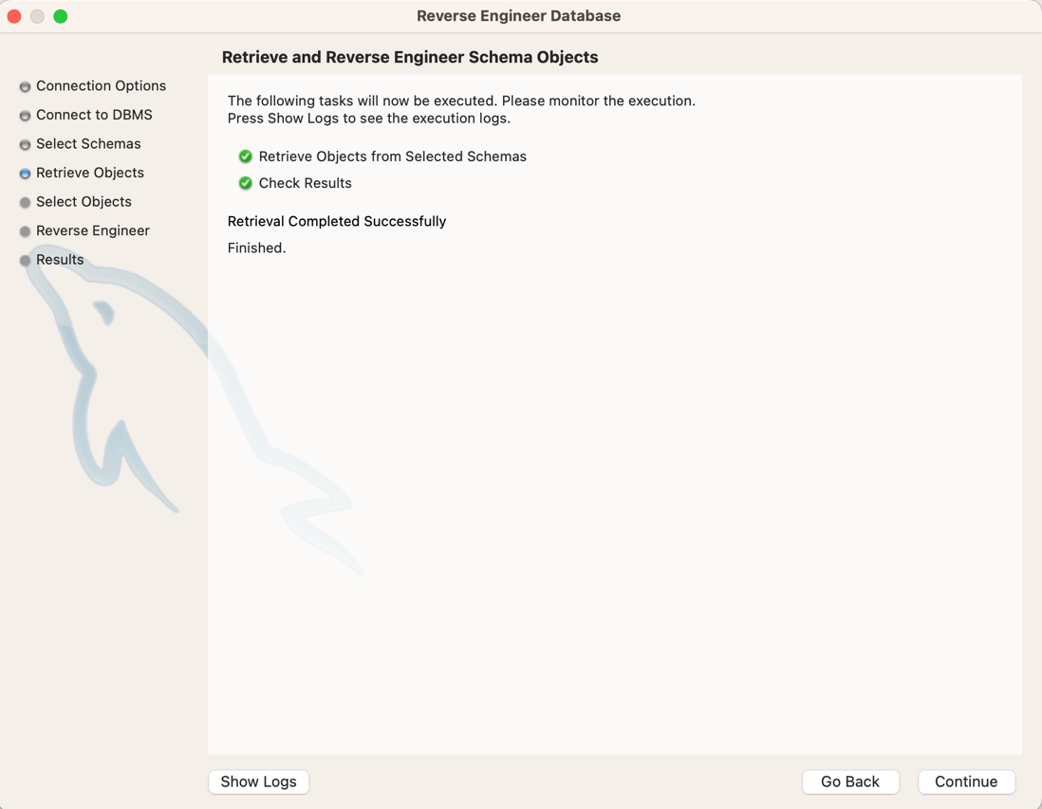

* Select Objects

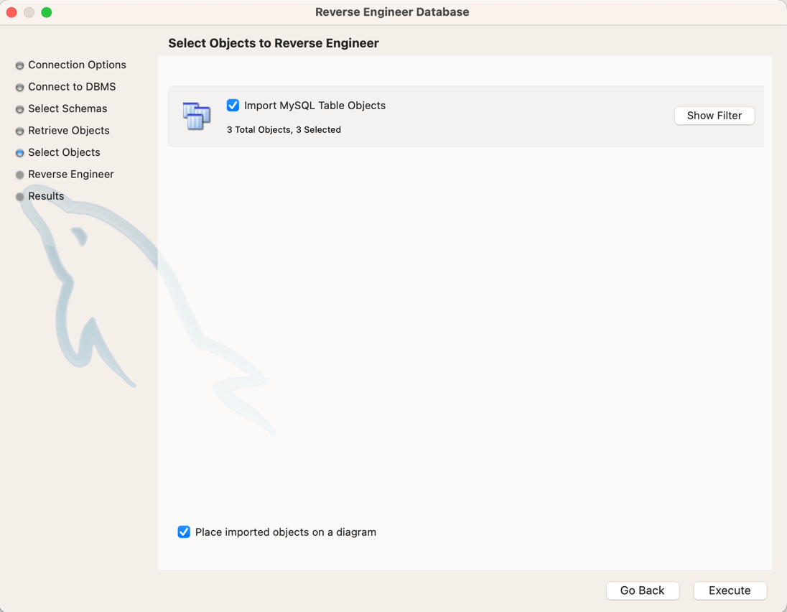

* Reverse Engineer

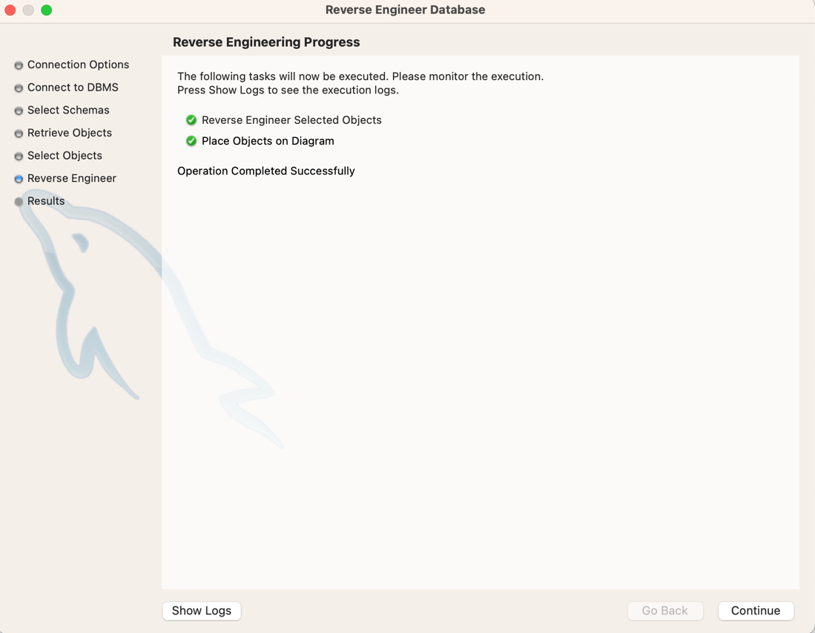

* Results

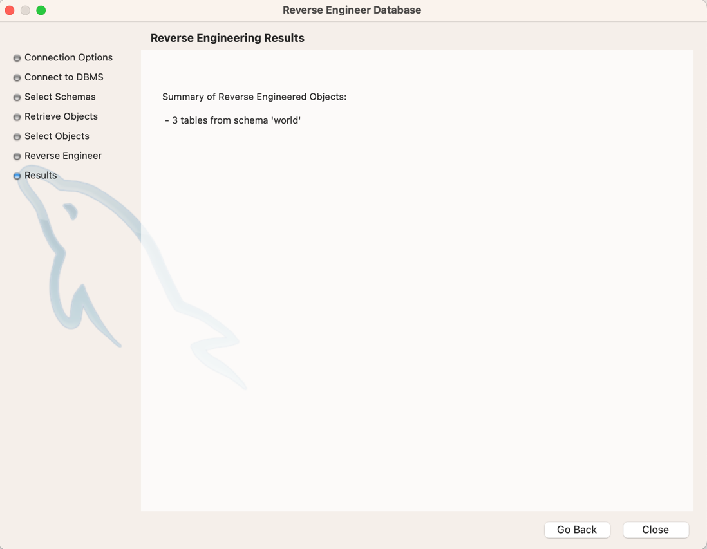

* Save model

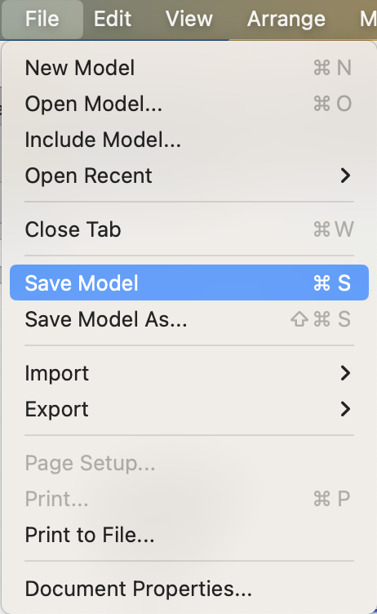

**Task 13**

* Identify the primary key in country table.

Code

* Identify the primary key in city table.

ID

* Identify the primary key in countrylanguage table.

Language, CountryCode

* Identify the foreign key in city table.

CountryCode

* Identify the foreign key in countrylanguage table.

CountryCode

In this specific task, I was uncertain about which foreign key corresponds to the **countrylanguage** table. When reviewing the properties of this table, I noticed that **CountryCode** is listed as a primary key. I assume this is because, in the **country** table, the key is named **Code**.

