Abstract

The constant fast growth in travel information make difficult to find and organize the information required by the Users because Users’s background regarding their computer literacy are very different.

Collections of Touristic Point of Interest are becoming more common in applications and are widely used to suggest touristic places based on the users needs. Paths data are generally available  as points and don’t provide semantic information. Adding domain-specific information is more needed. Semantic informations are essential to discover, reuse and integrate data collections derived from different sources. Apply an ontology design pattern or a good ontology creation method make the data robust, extensible and easy to manage. Consequently the data results interdisciplinary and multithematic allowing different perspectives of applications possible.

Has been widely discussed about the standardized of event, geo-location, actors or persons and this work proposes an high-level ontology strictly related with GeoSpatial Semantic Web, Events described in OWL and Touristic Actors. This paper has a special focus to define a class hierarchy and inference rules using OWL Description Logic. We present various experiments on spatial inference calculation based on Sardinian Cultural Touristic POI scenario.

1.Introduction

For decades the tourism experience-based value is object of a marketing process study and operators, such travel agents, hoteliers, manager of attractions, attempt to sell a service as much as experience.

Tour trips tend to appear like a working day, travellers have to spend a lot of time in preparation for stay, matching interests, find preliminary information, check on internet, book accommodation etc. For instance a travellers couple have different preferences compared to the preferences of a family with kids, maybe they are attracted by different opportunities.

The term trajectory is used in many different context. It can be defined as a path through the space where an object can moves over time. If we consider animal movement, trajectories are defined by a set of spread point indexed by a temporal position, while the path from an point to another is not defined. Geographic positions are limited by the definition provide by a device or technology, in other cases a geo-point can refer to an activity or where you can satisfy a goal.

Since 2007, at the advent of social networks (Foursquare, Facebook) and navigation platform ( Google Maps), trajectories are reached with more informations, like name of a visited place, called Point of Interest and the time spent visiting a POI. Holiday trips or daily trips are perceived and set out as trajectories. Web application or mobile application collects and analyze this data to activate a decisional process (shortest path for a city trip) or understand behavior choice or gain knowledge of the actors that traverse a way.

There are multiple ways to publish trajectories data, methods like Semantic Web or Linked Data allows us to share data, providing the possibility to access to the data by an unique identifier. Refer to a known object increase the possibility to be linked, related with other object and add semantic annotations. Semantic annotations are realized using vocabulary o high-level ontologies. In a Linked Data context, high-level ontologies are proposed as base for develop new ontologies and often tend to be too abstract and introduce a strong knowledge of them.

Ontology design pattern are flexible, reusable and manageable. To reach a satisfactory level of formalization could be useful combine pattern and high-level ontologies. For instance a tourism ontology ought to describe space and time. Are part of geographical concepts points, simple or complex shape and coordinates systems. Data are represented in a specific language into ontologies in the form of data properties, like well-known text (WKT).

As for spatial concepts, GeoSPARQL present properties to represent relations between domain geometries like those relate a centroide with a shape. GeoSPARQL formalize features related with their geometries and formalize relations each other.

W3C Time allow to represent instance, intervals or sequence and combining this three entities.

To fill the gap between travellers intentions, his aspectatives and POI offered by destinations is important to create an high-level ontology, maked by description of space, time and semantic. For instance: which aspect are to be considered to enrich trajectories? How are they related with each other? Examples are the goal of an activity, which needs must to be satisfied, the context where a moving object acts and his behaviour.

We believe there are much work to do for define ontological semantic trajectories. RoadOntology aims to integrate appropriately many aspects of the concept of semantic path. The proposed method is more generic then stop and moves models, is focused on representing different semantic aspects of trajectory and answer to queries more complex and add definition of activities or goals.

The remainder of this paper is structured as follow: Section 2 introduces some background works and related works supporting the understanding of the proposed ontology; Section 3 introduces the motivations through some questions; Section 4 debate the formalization of the pattern using OWL; Section 5 demonstrates the application of this pattern through the answers of questions write in section 3. We conclude by summarizing our results and pointing out directions for future work.

2. Related Work

A Trajectory consists of a line in the space described by a point or by a moving body, represented by a position {x,y} in a 2D space and a temporal point t. Overall points are represented as a triple {x,y,t} but whether a trajectory are described in a 3D space the representation turn to {x,y,z,t}, for instance a bullet trajectory.These conventional representations may be enriched with domain knowledges.

The first semantic trajectory model was introduced by [Spaccapietra et al. (2007)], objects are sequence of places (stop) which are connected by moves (position change of an object).

The aim of [A Model for Enriching Trajectories with Semantic Geographical Information (2007)] is to provide some basic definition about trajectory, subtrajectory, stop candidate and spatial features.

[Alvares, Luis Otavio, et al.(2007)] presents a formal model for trajectories with geographical information and an algorithm for the model implementation. Stops are important place where an actor stay for a minimum time.

According to definitions and characteristics of geometric entity, [The design and implementation of ontology and rules based knowledge base for transportation (2008)] divide them in three categories: point, lines and surfaces; relation exists between point-point, point-line, point-surface, line-surface, line-line, surface-surface.

A new approach as a means of compressing of trajectories with acceptable information loss is presented by [Semantic trajectory compression (2009)]. For [Ontology-based route planning for OpenStreetMap (2012)] activity covers a central role, developing an activity ontology, concepts refer to locations where a certain activity takes place. This ontology was developed like a task ontology: doesn’t provide a domain ontology but its main goal is to resolve a known task, in this case find a place.

[A Geo-Ontology Design Pattern for Semantic Trajectories(2013)] divide trajectories in fixes that require a temporal reference system. Moving objects can be described by other ontologies or vocabularies like FOAF or ONKI. This work offers a ontology design patter, exploitable by wide range of dataset and focus on resolve integration problems or data accessibility.

There are two major type of ontology design patterns: logical patterns and content patterns. Logical patterns deal with issues arising from the formal semantics of a knowledge representation languages. Content patterns often focus on domain knowledge and are used to model recurrent domain facts.

More recently [Bogorny et al. 2014] propose a new trajectory model, where it can be represented in different ways. For instance a trajectory can be understood as a sequence of stop and movements, sequence of transport means, activity to do during movements etc.

Model proposed in [CONSTAnT – A Conceptual Data Model for Semantic Trajectories of Moving Objects (2014)], consider semantic trajectories as semantic subtrajectories. Subtrajectories are expressed by object, transport means or decision makes analyzing object behaviors.

[Semantic Trajectories in Mobile Workforce Management Applications (2017)] analyze daily work tasks, by identifying: Actors, Workers, Customers, Schedules and TaskType. Schedule class describe which tasks must be performed by workers, start time, end time and the path from certain point to destination. Exist an activity taxonomy, leaf nodes are activities that can be performed by workers.

Foundation and Motivation

Creating an ontology design pattern is a difficult task. [Engineering Ontologies with Patterns – The eXtreme Design Methodology ] propose to create use cases with the aim of develop ontological model basic requirements. User stories can be made in different ways: illustrating the schema or inferencing entities described by ontology rules. So once the stories are sufficiently generalised, can be extracted some conditions that commonly may fall in three categories:

* Competency Questions (CQs)
* Contextual Statements (CS)
* Reasoning Requirements (RR).

CQs typically are queries on ontology in order to do a task [The Role of Competency Questions in Enterprise Engineering], but CS and RR sometimes are needed to specify axioms mentioned by CQs. We use Competency Questions, sequently we propose turistic scenarios which activity they desire to do. In order to answer these questions, an entity of ontology design pattern needs many relations, for instance in a spazio temporal conceptualisation of semantic trajectory, we are able to answer to this questions:

Question 1: “Show me the museum which are in these ways”

Spatio-temporal points are basic informations like things that have spatial positions (park, museum etc.) or spatial representation of places (sets of coordinates). First, to be able to create trajectories starting with specific spatial positions (Question 1), we need to divide data in segments or positions which are related by properties (hasNext, isNextOf, isDividedBy, hasSegment, isPointOf, hasPoint, hasEndFix, hasStartFix).

Question 2: “Show me the activity which i can satisfy my goal”

Question 3: “Show me the activity which i can do near to beach”

Second, build trajectories according to activities or according to fix in a certain area (Question 2), the schema introduce properties between destionation and activities (hasAttribute, isAttributeOf, hasGoal, isSatisfiedBy, characterize, isCharacterizedBy).

Question 4: “show the trajectories of a human which cross as much as possible museum”

Third, to build trajectories based on actors (Question 4), we need to describe the movement of an actor that traverse segments (isTraversedBy, hasActor).

Question 5: “show the life trajectories of this area”

Fourth, in order to answer to Question 5 we need to introduce an conceptualization of events (hasEvent, isEventOf, hasStartTime, hasEndTime, hasDuration).

|  |  |  |
| --- | --- | --- |
| Property Name | Type | Inverse |
| hasNext | Trajectory x Segment | isNextOf |
| hasSegment | Trajectory x Segment | isDividedBy |
| hasPoint | Segment x Point | isPointOf |
| hasStartFix | Segment x Fix | hasEndFix |
| hasAttribute | Segment x Activity x Point | isAttributeOf |
| hasGoal | Activity x Goal | isSatisfiedBy |
| characterize | Segment x Activity | isCharacterizedBy |
| hasActor | Trajectory x Actor | isTraversedBy |
| hasEvent | Event x Activity | isEventOf |
| hasStartTime | Event x FixedActivity | hasEndTime |
|  |  |  |

Figure 1 illustrate which properties can be used to create trajectories and to integrate knowledge for trip planning.

Trajectories are enriched by wide range of information and allow us to execute query more complicated. This pattern is general, such as to be enrich by informations from different levels, an example is add subtypes of the conceptualizetion proposed. Specifically this idea is discussed in the next section.

Owl Formalization

In this section, we present our spatio-temporal ontology. We discuss hierachy, ObjectProperty and DataProperty. The pattern is formalized in OWL (Web Ontology Language), using DL notation (Description Logic notation), some restriction have been included to promote inference of reasoner.

Activity. An activity is a phenomena able to satisfy needs or to achieve a goal. Using this definition, Destinations, Events and Goals may be infered. An Activity cannot exist if cannot exist a Goal associated to it.

$$AXIOM 1: Activity ⊑hasGoal.(some)Goal$$

Considered one of the main classes, affects the definition of other classes, i.e. Destination is characterized by at least one Activity. This class have a subclass: FixedActivity.

FixedActivity. An fixed activity is a phenomena able to satisfy needs or to achieve a goal, which is knowed the place, the start time, the end time and duration. This formalization is expressed by Axiom 2, force to have exactly time:Duration, exactly a time:TemporalEntity.

$$AXIOM 2: FixedActivity ⊑\left(hasDuration only Duration\right)$$

$$and \left(hasEnd some TemporalEntity\right)$$

$$and (hasBeginning some TemporalEntity)$$

Actor. An actor is who realize something, so he have a goal, he moves from A to B and follow a trajectory. An actor using a device can share his position to match POI that are in a certain distance. Actor is equivalent to foaf:Person.

foaf:Person. The Person class represents people. Something is a Person if it is a person. The Person class is a sub-class of the Agent class, since all people are considered 'agents' in FOAF.

Destination. A destination is where it is possible realize a goal, i.e. lungomare Poetto is a destination where an Actor can do jogging. The formalization presented in Axiom 3 describe a destination as POI, because is associated with a Point, where take place a Activity.

$$AXIOM 3:Destination ⊑ \left(hasPoint some Point\right)$$

$$and \left(isCharacterizedBy some Activity\right)$$

$$and (isCharacterizedBy min 1 Activity)$$

Fix. A fix is defined as a point, indicating a position of an moving object in a time istant. The position can be share by mobile devices through GPS. They not only shared spatio-temporal position, but can be analyzed as point with a semantic level, i.e. if in a certain moment Paolo is in on point, this point may be interpreted as “Paolo is at the bar” or “Paolo ish relaxing having a coffee”. Below its formalization:

$$AXIOM 4:Fix ⊑ \left( Point\right)$$

$$and \left(hasActor some Actor\right)$$

$$and \left(hasTime some TemporalEntity\right)$$

Goal. An goal is a objective, the reason of movement and can be related with the whole trajectory or a part of it. A goal represent the reason of a movement, may be met by at least one activity.

Segment. An segmenti is defined by one start point {xi,yi} and one end point {xj,yj}. This formalization is expressed in Axiom 5 and Axiom 6. Each segment is related with a minimum of two points, through hasStartPoint and hasEndPoint.

$$AXIOM 5:Segment ⊑ \left(hasStartPoint some Point\right)$$

$$and \left(hasEndPoint some Point\right)$$

$$and \left(hasStartPoint\min{1}Point\right)$$

$$and (hasEndPoint min 1 Point)$$

$$AXIOM 6:Segment ⊑(isSegmentOf some Trajectory)$$

An segment is a street, highway or road that connect two stops or else a road between two museums tooked by a turist visited in one day.

time:TemporalEntity. This entity allow to represent concepts of time as time instant and time intervals or any temporal entity that is associated with a temporal value expressed by time:inXSDDataTime or xsd:dateTime.

GeoSparql:Point. We reuse GeoSparql ontology that relate Geometries and Features using geo:hasGeometry. Geometries have RDF literal representation, geo:asWKT bind Geometries with wktLiteral.

Any geospatial entity declared in other ontologies can be subsumed by skos:Concept and geo:Feature to inherit geospatial properties and its location can be declared using the geo:Geometry subclasses. Each geo:Feature even are mathematical entity, it might seem appropriate to declare the mas subclasses of geo:Geometry in GeoSparql, all linked all linked via its hasGeometry property to the same geo:Feature (and to each other).

The proposed ontology not only add new knowledge levels to dataset, but may be queried using relations of incorpored ontologies. It is possible to build a trajectory without instantiate one; properties like hasNext or hasPrevious enable to sort segments by spatial data and instead when we want to get routes built by moves of actors, points may be filtered by temporal entities.

Application/ Instrumenting of ontology

Web sites, turistic agents or advertisers need to advertise attractions by creating itineraries, spread them widely using efficient marketing techniques. In recent years a lot has been studied on user recommendation and profiling techniques and new data capture techniques have been introduced to understand what a user is doing. In this section we apply our ontology in two real-world scenarios: in first scenario a tourist can get a guide of museums placed in the route from hotel to friend house; in the second scenario a tourist share is fixes with the aim to save his memories of a daily trip in a new city.

Turistic guide

Suppose the following situation: Marco is a tourist and stay in a hotel. It’s morning and he wants to visit museums in Cagliari. In the late morning he must meet Paolo at his home. They want to know the names of museums, a small description of its and their location. The above use case can be modeled by the SPARQL query:

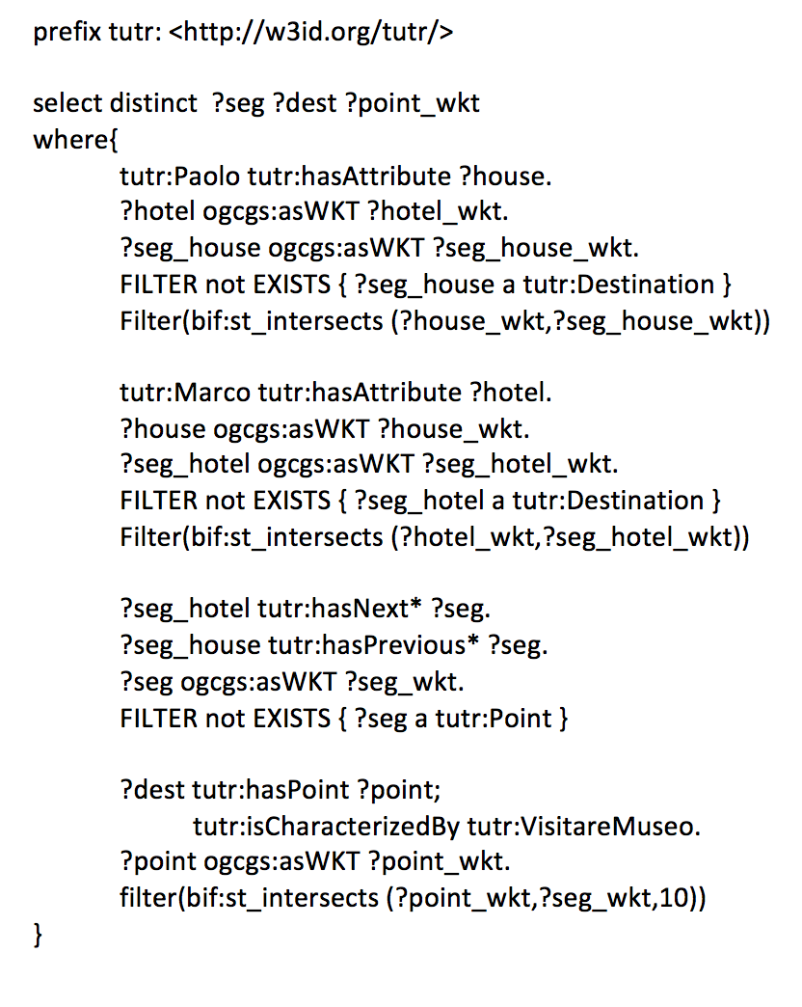

We seek to represent points of interest of various types (Monuments, Parks, Houses, Hotels, etc.). All that is required to link this ontology with GeoSPARQL, and thus give its classes a geospatial reference, is to make Point of Interest a subclass of geo:Feature.

For instance hotel and buildings are tutr:Point, equivalent to geo:Point, expressed by wktLiteral. With the filter functions, you can compare two geometries that are fetched from the triple store, or you can compare a geometry from the triple store and one that is explicitly stated in the query.

We extracted two representative segments and two point, where the start and the end of a trajectory are placed. The two segments must be traversed by Marco, so is usefull know if these segments are reached each other.

Turist has two objective: meet his friend and increase cultural knowledge. Each objective may be satisfy by a specific activity and each activity characterizes tutr:Destination entities.

Museum data are provided by OpenStreetMap, each of its entities are related with encyclopedic informations provided by DBpedia. DBpedia has 300k+ basic POIs, plus a jumble of other information about the places and associated entities. You can query it with a standard language but the data can be very sparse and queries can very easily bring back much more limited sets of results. We can find descriptions and comments that are related to the POI by arbitrary Properties.

Turistic memories

Travel trajectories have been studied and investigated by sociologist, anthropologists and for economic purposes by tourist agents. During any trip a tourist can change way he moves, for instance a tourist can start his trip walking but can take a bus to a destination. Using ontology design pattern proposed is posible to save environment temperature data, speed of travel, direction, timestamp and device like GPS.

|  |  |  |
| --- | --- | --- |
|  |  |  |
| MarcoTrajectory | a  tutr:hasSegment  tutr:hasPoint  tutr:hasAttribute | tutr:Trajectory,geo:MultiPoint;  tutr:segment1,tutr:segment2,tutr:segment3,…;  tutr:fix1, tutr:fix2, tutr:fix3, …;  MarcoGPSDevice; |
| Marco | a | foaf:Person,tutr:Actor,schema:Person; |
| Segment1 | a  tutr:hasPoint  tutr:isTraversedBy | tutr:Segment;  tutr:fix1;  Marco; |
| tutr:fix1 | a  tutr:hasActor  hasTime  asWKT | tutr:Fix;  Marco;  tutr:instantA;  POINT(9.116650074720383 39.222093095626086) |
| tutr:instantA | a | time:TemporalEntity; |
| Museo delle Cere Anatomiche di Clemente Susini | a  tutr:hasFix  tutr:isCharacterizedBy | tutr:Destination;  tutr:fix1  tutr:VisitareMuseo; |
| tutr:VisitareMuseo | a  tutr:hasGoal  tutr:hasGoal | tutr:Activity;  tutr:AumentareLivelloCulturale;  tutr:Relax; |

The actor of this trajectory is Marco classified as tutr:Actor. For reason of space in Table3 we present only one example of a trajectory. tutr:Trajetory is a ordered list of geographic segments. The segments are traversed by a Actor or Person. He send with device fixes with a location and time information. Each fix is related with a Destination where you can satifisy your goal doing an activity. Trajectories may be divided in several subtrajectories, which can be performed query like this: “show me museums which were visited between 2 and 3 p.m”, “show me means of transport which were used to arrive to Bonaria”

Conclusions