IS PROJECT MANAGEMENT 2

PROJECT REPORTING AND DOCUMENTATION

- PROGRESS REPORT

Project Objectives
To develop an web-based sales monitoring system for Loyal’s Printing Shop that automates the tracking of sales transactions in real-time, thereby enhancing operational efficiency.
    - To create a centralized monitoring of sales transactions.
    - To generate daily, monthly and yearly sales reports.
    - To provide sales derives inventory indicators
    - To implement a unified chatbox across multiple branches.
    - To evaluate the system using the ISO/IEC 25010 focusing on the following:
      - Performance efficiency.
      - Usability.
      - Reliability.

SYSTEM ANALYST TASK
As a System Analyst, I performed the following major tasks:

1. System Planning and Requirements Gathering
I and together with my team we initiated the project by conducting client interviews with Loyal’s printing services owner to understand their business operations, existing challenges, and desired outcomes.
Key identified problems included:
- Time-consuming and hassle of manual sales report by every branches
- Difficulty in providing the sales report
From these findings, I created the functional and non-functional requirements to guide system design and development.

2. System Design and Architecture
I created and design system diagrams such as:
- Use Case Diagram
- Data Flow Diagram (DFD)
- Entity-Relationship Diagram (ERD)
- System Flowchart
- Activity diagram

3. System Development Oversight
4.0 Design and Methodology
The primary objective of this project is to develop the Web-based Sales Monitoring System for Loyal’s Printing Services, which addresses the challenges of inefficient sales tracking and data management across multiple locations. This system aims to streamline operations by automating sales transaction tracking, generating real-time reports, and enhancing communication between branches through an integrated chatbox. A thorough understanding of the design and methodology employed in this system is crucial for its successful implementation.
In this chapter, we outline the methodologies utilized for planning, analysis, and development of the web-based Sales Monitoring System. Key components of this discussion include requirement analysis, system architecture diagrams, software development tools, the chosen model methodology for system development, testing strategies, as well as the responsibilities of the project team members. Additionally, we cover budget management strategies that ensure the project’s successful execution and adherence to timeline goals. This comprehensive approach provides insights into the structured process of designing and implementing an effective sales monitoring solution for Loyal’s Printing Shop.
4.1 Concept
This section encompasses diagrams and illustrations designed to enhance the comprehension of how the web-based Sales Monitoring System operates. These include a system architecture diagram, which presents a high-level overview of the interactions between various components of the system; a data flow diagram that visually represents how data is processed and transmitted throughout the system. Additionally, a Use Case Diagram will outline the various actions users can perform and their interactions with the system; an Activity Diagram will depict the flow of activities or processes within the system. Lastly, an Entity Relationship Diagram will illustrate the relationships between different entities within the database of the system, providing a clear foundation for understanding the underlying structure and data management processes involved in the system’s design.

4.2 System Development Oversight
Although I participated in coding and testing, my main role was to ensure that all development activities aligned with the system requirements and the ISO/IEC 25010 standards. I worked closely with the development team to:
- Review database schema design and table relationships.
- Ensure functional correctness and data integrity during user testing.
- Provide feedback on the user interface layout for better usability.
Technologies used included:
- PHP for back-end logic
- HTML, CSS, and JavaScript for front-end development
- MySQL (phpMyAdmin) for database management
- XAMPP for local server hosting
- VSCode as the primary development environment

TASKS ACCOMPLISHED
branch profile and content management
amin and staff User authentication system
Initial troubleshooting guide

PENDING TASK

Revision of Paper

System revision

CHALLENGES ENCOUNTERED
- The responsiveness and bug of the system
- Incorrect system responses

MY ASSIGNED PARTS

As the System Analyst responsible for the project, my role involves meticulous planning, coordination, and oversight of each phase outlined in the Gantt chart to ensure timely and successful system development. I will conduct comprehensive requirements gathering through stakeholder interviews and documentation review, followed by detailed system analysis to identify key functionalities and user needs. During the design phase, I will develop system architecture diagrams and use case models, continuously coordinating with developers and stakeholders to ensure alignment with project goals. Throughout the implementation stage, I will monitor progress according to the Gantt schedule, facilitate effective communication among team members, and perform quality assurance testing to detect and resolve any issues early. Additionally, I will manage project documentation and provide status updates to stakeholders, ensuring that all activities adhere to the planned timeline and scope, ultimately guiding the project towards successful deployment within the specified schedule.

- TECHNICAL DOCUMENTATION

The following are the technical elements worked on, organized by module. This includes overviews, screenshots, tables, and outputs.

OVERVIEW
As the System Analyst overseeing the project, my role aligns closely with the planned schedule outlined in the Gantt chart, ensuring each phase progresses smoothly and on time. I will lead the requirements analysis by collaborating with stakeholders to gather detailed functional and non-functional needs, translating these into comprehensive specifications. During the design phase, I will develop system architecture diagrams, including use case and activity diagrams, to visualize user interactions and system workflows, ensuring alignment with project objectives. Throughout implementation, I will monitor progress, coordinate tasks among developers using tools like VSCode within an agile framework, and facilitate iterative testing to identify and resolve issues early. I will also oversee the integration of core modules such as the SQL database schema, appointment management, troubleshooting, authentication, feedback, and notifications, ensuring they meet quality standards. Regular communication and documentation updates will be maintained to keep stakeholders informed, ensuring that the project adheres to the planned timeline for a successful deployment.

OVERVIEW | SCREENSHOTS | TABLES | OUTPUTS
SQL  Uses MySQL managed via phpMyAdmin for database design and query execution. Stores user info, appointments, troubleshooting entries and feedback. | 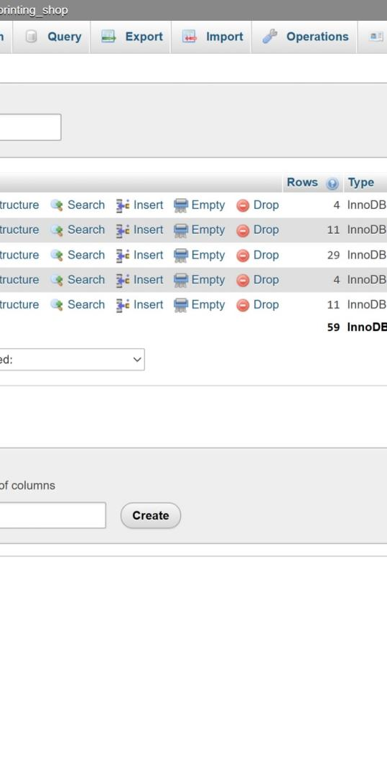
Auth Module  PHP sessions and MySQL for login/registration with validation and error handling. | 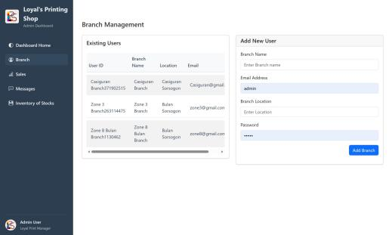  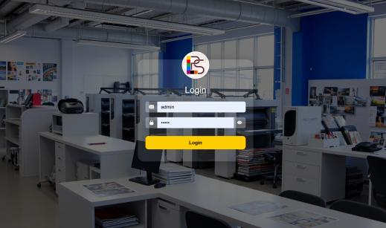 | Creating an account for staff  →  Input invalid info  →  Shows error message  →  Input valid info  →  Registered successfully  →  Pass  Login account  →  Input invalid info  →  Show error message  →  Pass  Input valid info  →  Logged in  →  Redirects to dashboard  →  Pass | Login in success  →  Redirects to Dashboard
Sales report submitting  PHP form for submitting | 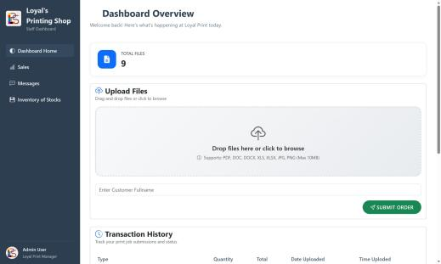

- EXECUTIVE SUMMARY

