SEND EMAIL
Code
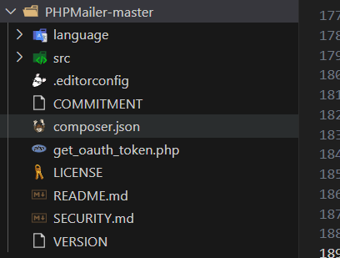

Pano ma co connect siya gamit ya maiimod sa kada sa pinka taas function.php
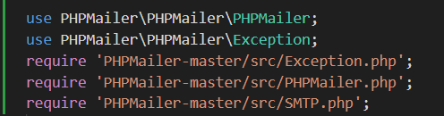

Sample code sa pag send
if (isset($_POST['send_verification'])) {
$email = $_POST['email'];

$check = $conn->prepare("SELECT * FROM `accounts` WHERE `email` = ?");
$check->bind_param("s", $email);
$check->execute();
$result = $check->get_result();

if ($result->num_rows > 0) {
$row = $result->fetch_assoc();
$fullname = htmlspecialchars($row['fullname']);
$user_id = htmlspecialchars($row['user_id']);

$verification_code = random_int(100000000, 999999999);
$subject = "Barangay PADRE DIAZ VERIFICATION CODE";
$message = "
<p>Dear $fullname,</p>
<h2 style='color:#2c7be5;letter-spacing:3px;'>$verification_code</h2>
<p>Best regards,</p>
<p><strong>Brgy. Padre Diaz Staff</strong></p>
";

$mail = new PHPMailer(true);
try {
$mail->isSMTP();
$mail->Host = 'smtp.gmail.com';
$mail->SMTPAuth = true;
$mail->Username = 'les.ballers2025@gmail.com';
$mail->Password = 'hzyi mwys xdsk npjv';
$mail->SMTPSecure = PHPMailer::ENCRYPTION_SMTPS;
$mail->Port = 465;

$mail->setFrom('les.ballers2025@gmail.com', 'Brgy. Padre Diaz Verification');
$mail->addAddress($email);
$mail->isHTML(true);
$mail->Subject = $subject;
$mail->Body = $message;

$mail->send();

$_SESSION['verification'] = $verification_code;
$_SESSION['user_id'] = $user_id;
$_SESSION['success'] = "Please check your email for the verification code.";
header("Location: verifi_password.php");
exit;
} catch (Exception $e) {
$_SESSION['error'] = "Error sending email: " . $mail->ErrorInfo;
header("Location: forgot_password.php");
exit;
}
} else {
$_SESSION['error'] = "User doesn't exist.";
header("Location: forgot_password.php");
exit;
}
}

Pano na connect an database
Maiimod an una is localhost para ma connect sa xampp an root is para makuha port address san xampp tapos kiyopal an name san database maiimod yun sa cofig.php
$conn = mysqli_connect("localhost","root","","kiyopal");
if(!$conn){
echo "not connected";
}

Alert notification
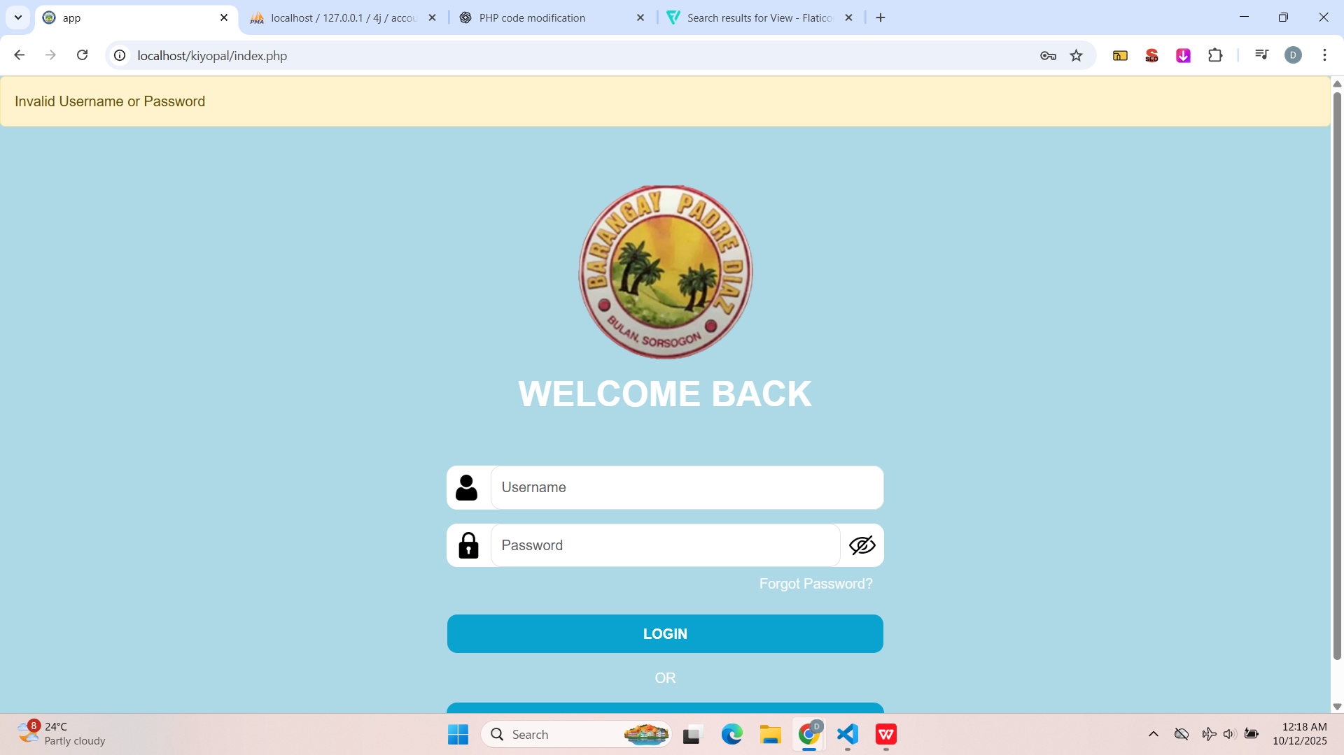
Code para mag luwas my iba iba na klase error, warning ,success ingagamit kapag halimabawa ang register ka ma save na yn magiging success na kay naka save
<!--alert-->

<?php
if (isset($_SESSION['error'])) {
$error = $_SESSION['error'];
unset($_SESSION['error']);
?>
<div class="alert alert-warning" role="alert">
<?php echo $error; ?>
</div>
<?php
}
?>

<?php
if (isset($_SESSION['success'])) {
$success = $_SESSION['success'];
unset($_SESSION['success']);
?>
<div class="alert alert-success" role="alert">
<?php echo $success; ?>
</div>
<?php
}
?>

