ICT ACADEMY OF KERALA
Summer Internship Report

Campus Care

Campus Issue Tracker



Albert Jaison
Sahrdaya College of Engineering and Technology
23 October 2026

EXECUTIVE SUMMARY
Campus Care is a MERN web application that lets students report campus issues and follow their resolution. It combines a React interface, an Express and Node.js API, Mongoose schemas, and a MongoDB database. Students can register, create reports, add comments, and view their own activity. Administrators can review all reports, assign teams, and update status and priority.
The application includes authenticated report management, scoped statistics, searching, filters, pagination, and responsive views. Fourteen local API integration tests passed, followed by hosted browser checks. Source: https://github.com/albertjaison18/campus-care. Live application: https://campus-care-h82p.onrender.com. The project is a demonstration and does not claim institutional adoption.

INTRODUCTION
A campus issue needs a clear description, an exact location, and visible progress. Campus Care explores a structured reporting workflow for maintenance, classroom, connectivity, sanitation, and safety-related requests. The project is prepared for the full stack development course context at ICT Academy of Kerala.
The application is a student project for Sahrdaya College of Engineering and Technology. It is not integrated with an existing college service. All seeded reports and demonstration identities are fictional, and no real campus incident data or operational improvement has been measured.

OBJECTIVES
The project objectives are to implement a complete browser-to-database flow and make the access rules understandable and testable. The technical focus includes React state and forms, HTTP APIs, MongoDB schema design, authentication, authorization, and reproducible verification.
- Provide a clear report-to-resolution workflow for students and administrators.
- Enforce authentication, report ownership, validation and controlled status transitions on the server.
- Verify the API and browser journey and prepare reproducible documentation for review.

SCOPE AND DELIVERABLES
The first release includes student registration and sign-in, report creation and viewing, Open-only editing and deletion, comments, embedded activity history, assignment to named campus teams, administrator status and priority controls, and owner-scoped statistics. Search, filters, sorting and pagination make reports manageable as the list grows.
Deliverables include the React frontend, Express API, MongoDB models, a software requirements specification, API notes, setup instructions, automated integration tests, hosted screenshots, and this report. A proposed completion target of 6 November 2026 supports planning only and is not an institution-confirmed deadline.
Email verification, password reset, uploads, institutional SSO, staff accounts, notifications and real-time push updates are excluded from this release. The application is not an emergency service.

METHODOLOGY
Development follows a sequence of requirements, data modelling, API implementation, UI construction, integration, verification, and publication. Each feature is tied to an observable acceptance criterion. Coding assistance was used to prepare implementation and documentation; the source and learning guide support student review and explanation.
React and TypeScript implement the client. Vite builds the production bundle and forwards local API requests. Express handles HTTP requests, Zod validates input, Mongoose defines the stored records, and MongoDB persists them. The production server serves the compiled frontend and API under one origin.
Authentication uses bcrypt password hashes and an eight-hour signed session in an HTTP-only cookie. Authorization loads the current database role and applies report ownership on the server. Validation, origin checks, rate limits, request size limits, safe errors, and optimistic concurrency protect the request flow.

PROJECT ACTIVITIES
Requirements and modelling: defined the student and administrator roles, documented the MVP, mapped the status transitions, and designed User, Issue and embedded Activity records. Assigned teams remain fixed labels rather than separate user accounts.
Backend development: implemented registration, login, logout, metadata, report CRUD, comments, administrator management, statistics and pagination. The server rejects client-supplied ownership or roles and returns 404 for another student's report.
Frontend development: built sign-in and registration screens, an overview dashboard, report lists, a reporting dialog, report details, management controls and help. Forms include validation and disabled submit states; data views distinguish loading, empty and failure states.
Integration: routed requests through one client API helper and verified the journey from a browser action to MongoDB and back. A local launcher downloads MongoDB once, persists demonstration data in an ignored folder, and generates local demonstration credentials outside source control.
Debugging and review: resolved an orphaned local database process, corrected a demonstration text encoding problem, added accessible names to compact navigation, and preserved the local session secret across development restarts.
Verification and publication: compiled the frontend, passed database-backed API tests, published the source on GitHub, configured a database-scoped Atlas user, deployed on Render Free, repeated the hosted browser journey, and captured its major views. Credentials remain outside source control.

RESULTS & FINDINGS
The final local API suite contains 14 passing integration tests. It verifies authentication, password handling, validation, database persistence, ownership isolation, comments, administrator workflows, search and pagination, deletion, origin checks, production cookies, and frontend fallback. Detailed cases are recorded in docs/TEST_RESULTS.md.
Hosted browser checks confirmed registration, report creation, comments, persistence after refresh, administrator sign-in, assignment, Open-to-In-progress-to-Resolved updates, filters, search empty states, and logout. Desktop and 390-pixel mobile layouts passed. Screenshots show fictional hosted demonstration data. Local checks also covered pagination.
The live health check returned 200, anonymous access returned 401, and the admin session used Secure, HttpOnly and SameSite=Lax cookies. Tested flows passed; long-term uptime, institutional effectiveness, concurrent performance and independent security certification remain unverified. Free hosting can pause idle instances.

CONCLUSION
Campus Care connects a practical reporting interface with a validated API and persisted MongoDB records. Its ownership checks and status history make the intended student and administrator responsibilities explicit. Local and hosted checks confirm the tested report-to-resolution workflow.
The repository, HTTPS application, external database, hosted checks and supporting documents are prepared. Student review, explanation practice, confirmation of the official deadline, and uploading to the assignment portal remain. Future work could add verified college membership, password recovery, attachments, staff accounts, notifications and activity archiving.

APPENDIX
Supporting project artifacts: docs/Campus_Care_SRS.docx, docs/API.md, docs/TEST_RESULTS.md, docs/LEARNING_GUIDE.md, docs/SUBMISSION_CHECKLIST.md, the root README, and server/test/api.test.js.
Repository: https://github.com/albertjaison18/campus-care. Live application: https://campus-care-h82p.onrender.com. Verified on 23 October 2026 using Render Free and MongoDB Atlas Free. The README contains setup instructions; docs/TEST_RESULTS.md distinguishes local tests from hosted checks. Administrator credentials are not included in the submission.
Figure 1 Sign in and registration entry point
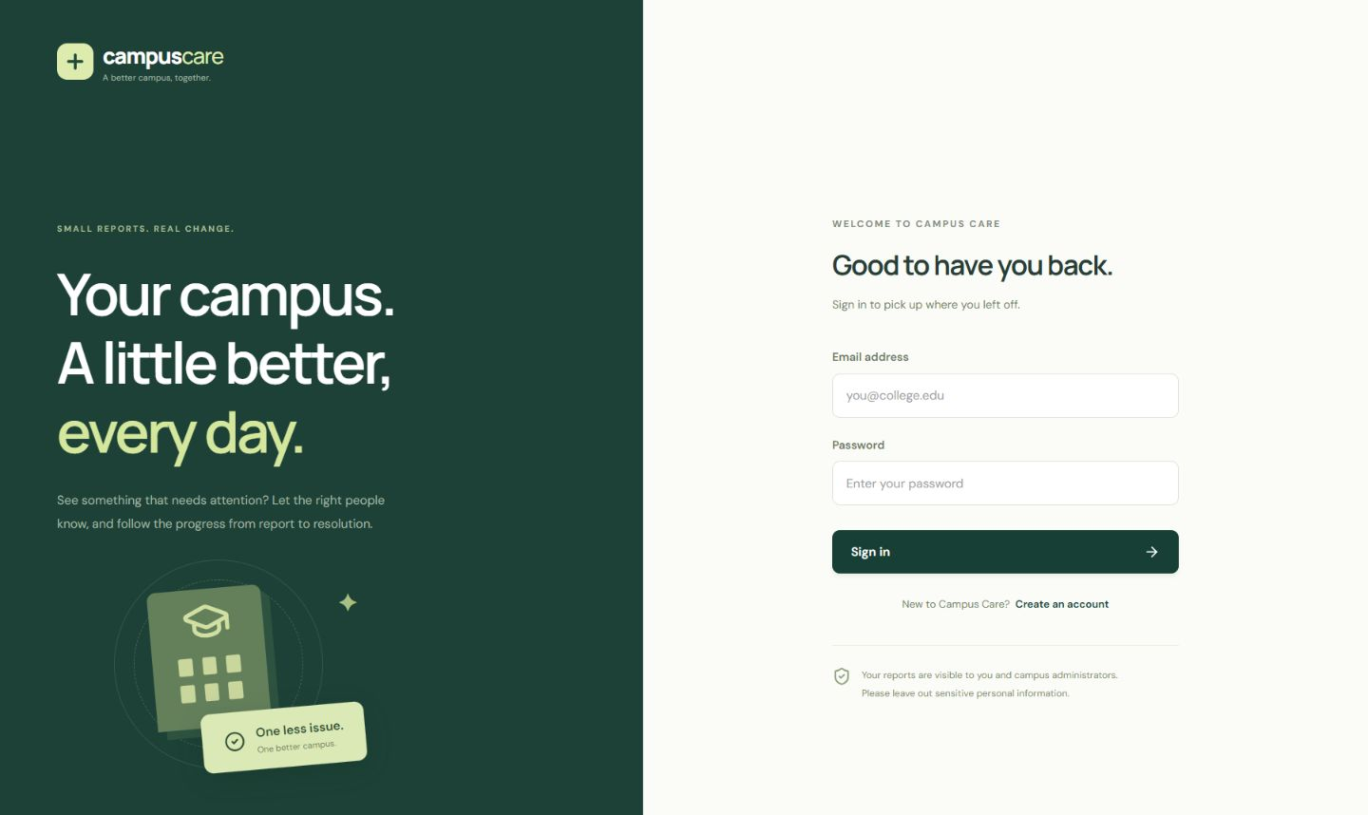
Figure 2 Administrator overview with fictional campus reports
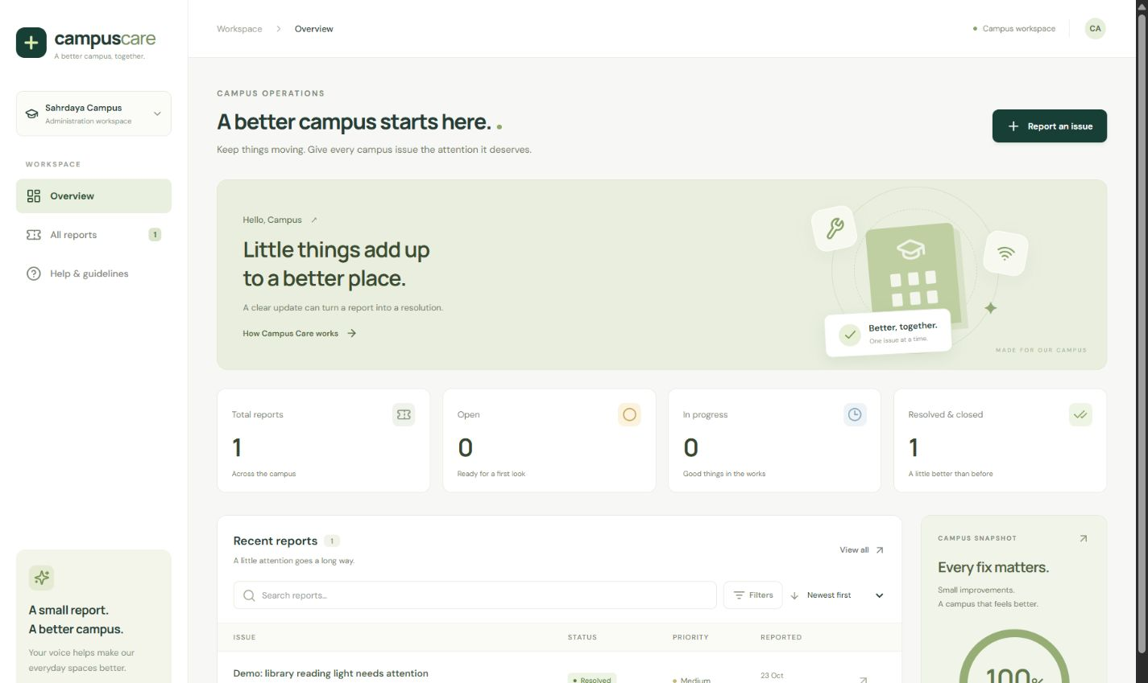
Figure 3 Structured campus issue reporting form
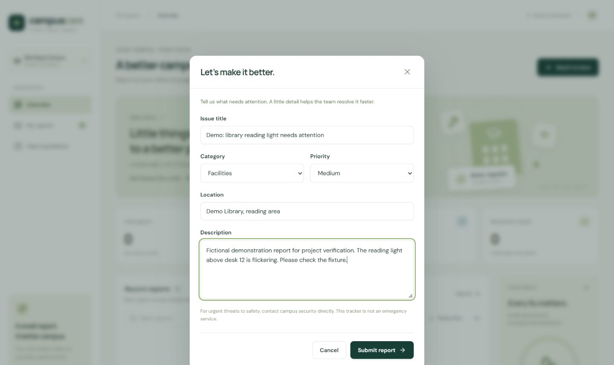
Figure 4 Resolved status and team assignment
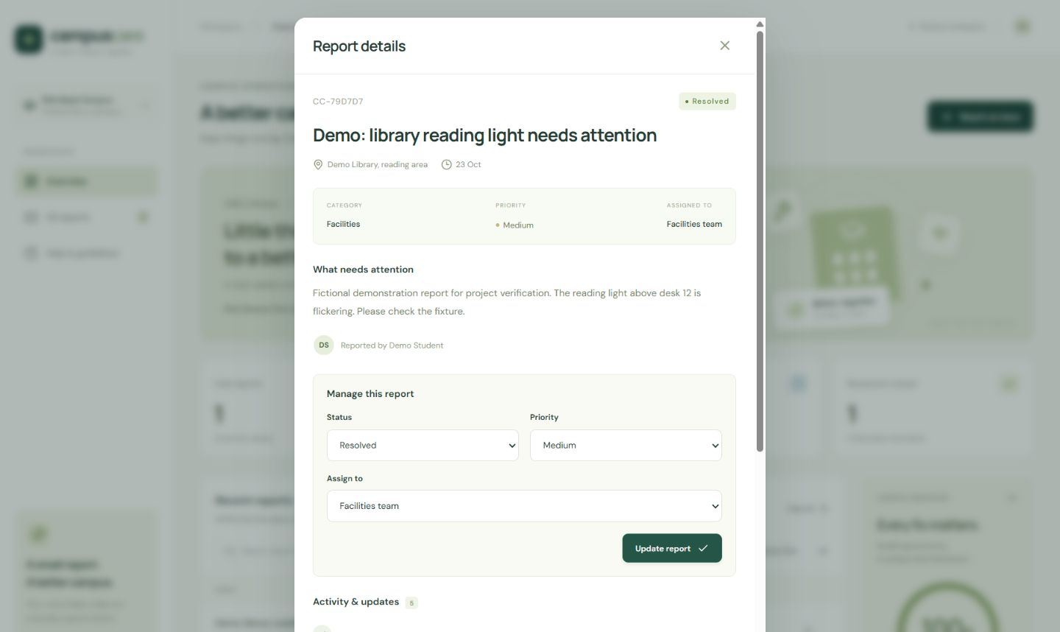
Figure 5 Report list at the 390 pixel mobile breakpoint
