SLIDE 1 — MODULE COVER

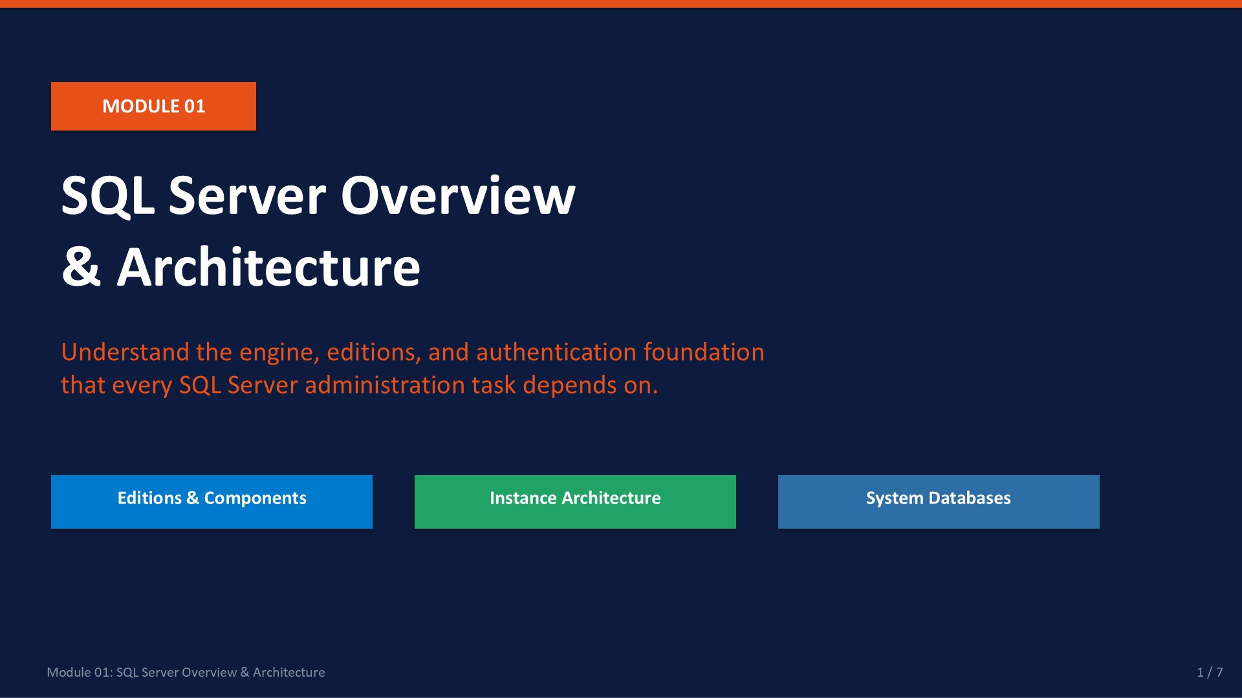
Slide 1 of 7

Module 01: SQL Server Overview & Architecture
Module | Day | Duration | Lab
01 | 1 — Morning | 90 minutes | Lab 01

This module provides the conceptual foundation for everything else in this course. Before you can install, configure, or maintain SQL Server, you need to understand what SQL Server actually is — how it is packaged, what its core components are, how it organises data internally, and how it identifies the users who connect to it.
You will work with SQL Server Management Studio (SSMS) throughout the course. This module introduces the tool, and Lab 01 gives you your first live connection to the NovaMart training instance.
ℹ | Training Environment  The labs use SQL Server 2022 Developer Edition. Developer Edition is feature-identical to Enterprise Edition and is free for non-production use — the ideal choice for a training lab.

What This Module Covers
- Editions & Components Which edition is right for a given workload; what gets installed.
- Instance Architecture The hierarchy: instance → database → object; default vs named instances.
- System Databases The four built-in databases and why each matters to a DBA.
- Authentication Modes Windows vs SQL Server Authentication — when to use each.
- SSMS Orientation Key areas of Management Studio used in every lab.

SLIDE 2 — LEARNING OBJECTIVES

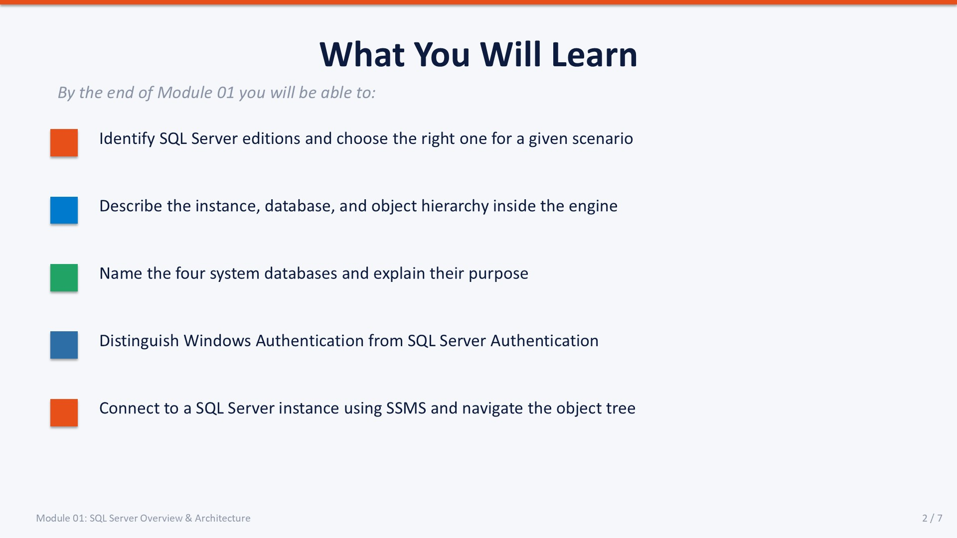
Slide 2 of 7

Learning Objectives
By the end of Module 01 you will be able to:
- Identify SQL Server editions — and choose the right one for a given scenario (Express for small/free, Standard for departmental workloads, Enterprise for mission-critical, Developer for learning/testing).
- Describe the instance, database, and object hierarchy — inside the SQL Server engine — and understand what connects at which level.
- Name the four system databases — (master, model, msdb, tempdb) and explain the specific DBA responsibility each one carries.
- Distinguish Windows Authentication from SQL Server Authentication — and apply the recommended best practice for each environment type.
- Connect to a SQL Server instance using SSMS — navigate the Object Explorer, run a T-SQL query, and check server properties.
These five objectives map directly to the five content slides in this module and to the five parts of Lab 01. Completing the lab validates each objective.

SLIDE 3 — SQL SERVER EDITIONS

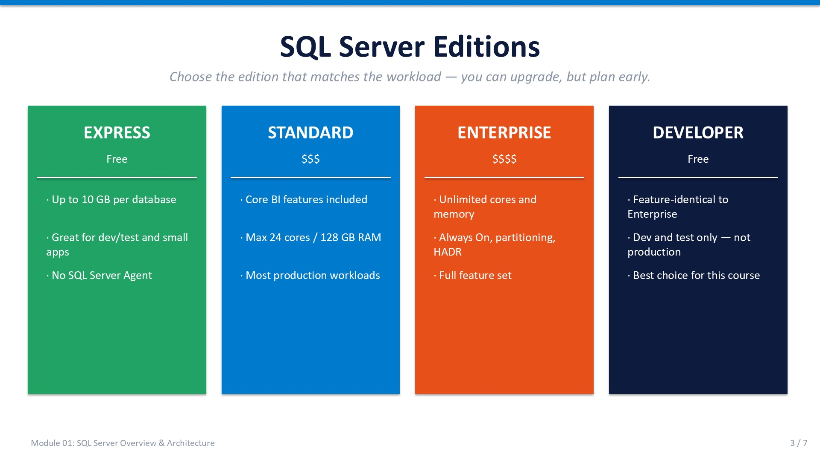
Slide 3 of 7

1.1 SQL Server Editions
SQL Server ships in several editions that differ in features, resource limits, and cost. Selecting the wrong edition at deployment time is difficult to correct later — you can upgrade an edition, but it requires re-installation in most scenarios. Use the table below to match the edition to the workload.
Edition | Target Use | Key Limits
Express | Small apps, learning, development | 10 GB per database · 1 GB RAM for the engine · 1 socket / 4 cores
Standard | Departmental workloads | 128 GB RAM · 24 cores
Enterprise | Mission-critical, large-scale | Unlimited memory and cores — all features enabled
Developer | Development and testing only | Feature-identical to Enterprise — not for production
Evaluation | 180-day full-feature trial | Expires — not for production use

ℹ | Lab Environment Note  The training VM uses Developer Edition. You will see "Developer" in the SSMS title bar and in the output of SELECT @@VERSION.

Feature Highlights by Edition
- Always On Availability Groups Enterprise only — multi-replica failover clustering.
- Table Partitioning Enterprise only — partition large tables across filegroups.
- Advanced SSIS Connectors Enterprise only — full ETL feature set.
- Basic Always On Standard — two nodes, single database failover.
- Transparent Data Encryption (TDE) Standard and Enterprise — encrypts data files at rest.
- SQL Server Agent All editions except Express — job scheduling and alerts.
- In-Memory OLTP Enterprise — memory-optimised tables for ultra-fast OLTP.

1.2 SQL Server Components
A full SQL Server installation can include several independent components. During setup you choose which components to install. In this course we focus exclusively on the **Database Engine** and **SQL Server Agent**.
Component | Purpose | Default?
Database Engine | Core relational engine — stores and queries data | Yes
SQL Server Agent | Scheduled jobs, alerts, and operator notifications | Yes (needs Engine)
SQL Server Browser | Resolves named instance addresses on the network | Optional
Integration Services (SSIS) | ETL — extract, transform, load data between systems | Optional
Reporting Services (SSRS) | Web-based report publishing | Optional
Analysis Services (SSAS) | OLAP cubes, tabular models, and data mining | Optional
Full-Text Search | Advanced linguistic text indexing and search predicates | Optional

All core administration tasks in this course (backup, security, maintenance, automation, monitoring, and import/export) require only the Database Engine and SQL Server Agent.

SLIDE 4 — INSTANCE, DATABASE & ENGINE ARCHITECTURE

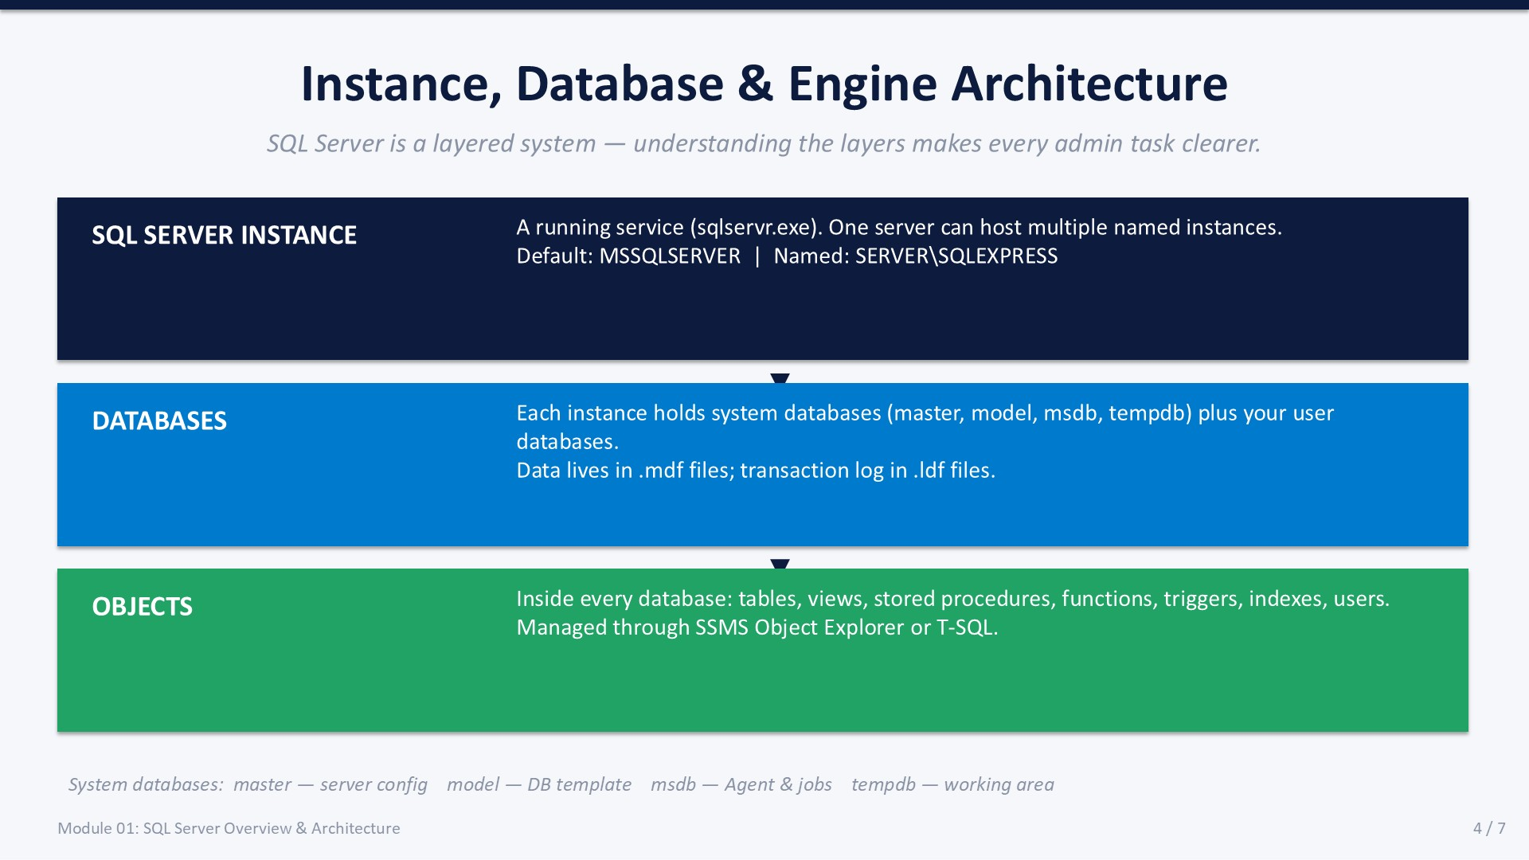
Slide 4 of 7

1.3 Instances
An instance is a complete, independent copy of the SQL Server Database Engine running on a server. Each instance has its own system databases, logins, memory allocation, SQL Server Agent, and TCP/IP port. A single physical (or virtual) server can run multiple instances simultaneously.

Default vs. Named Instance
 | Default Instance | Named Instance
Connect string | SERVERNAME or . | SERVERNAME\INSTANCENAME
TCP/IP port | 1433 (standard) | Dynamic or manually assigned
Windows service | MSSQLSERVER | MSSQL$INSTANCENAME
When to use | Single instance per server | Multiple instances on one server

The Three-Layer Hierarchy
- SQL Server Instance The running service (sqlservr.exe). Every database and object lives inside an instance. You connect to the instance first, then select a database context.
- Databases Each instance holds system databases (master, model, msdb, tempdb) plus user databases you create. Database data is stored in .mdf files; transaction logs in .ldf files.
- Objects Inside every database: tables, views, stored procedures, functions, triggers, indexes, users, and schemas. Objects are managed through SSMS Object Explorer or T-SQL statements.

Connecting in SSMS
- Open SSMS.
- In the Connect to Server dialog, set Server type to Database Engine.
- Enter the server name:
• Default instance: . or localhost
• Named instance: .\SQLEXPRESS or SERVER01\PROD2019
- Choose your Authentication type.
- Click Connect.
Expected: Object Explorer shows your server with a green connected icon.

1.4 System Databases
Every SQL Server instance includes four system databases that the engine uses internally. Never modify these directly unless directed by Microsoft support. A DBA must understand each one because they are all involved in routine operations.

master
Stores instance-level metadata: logins, linked servers, server configuration, endpoint definitions, and the locations of all user databases. If master is damaged and there is no backup, the instance cannot start. Back up master after adding logins, creating databases, or changing server configuration.

model
Template database. Every new user database is created by copying model. Any object or setting you add to model will appear in all subsequently created databases. Modifying AUTO_SHRINK in model, for example, propagates that setting to every new database.

msdb
Used by SQL Server Agent to store jobs, schedules, alerts, operators, and job history. Also stores backup/restore history and Database Mail configuration. Back up msdb regularly if you rely on SQL Server Agent.

tempdb
Shared scratch space for temporary tables (#temp), table variables, row versioning, and intermediate sort operations. Recreated from model every time the instance starts — never back up tempdb. Heavy tempdb contention is one of the most common SQL Server performance problems.
ℹ | Finding System Databases in SSMS  In Object Explorer, expand: SERVERNAME → Databases → System Databases  You will see all four listed there.

SLIDE 5 — AUTHENTICATION MODES

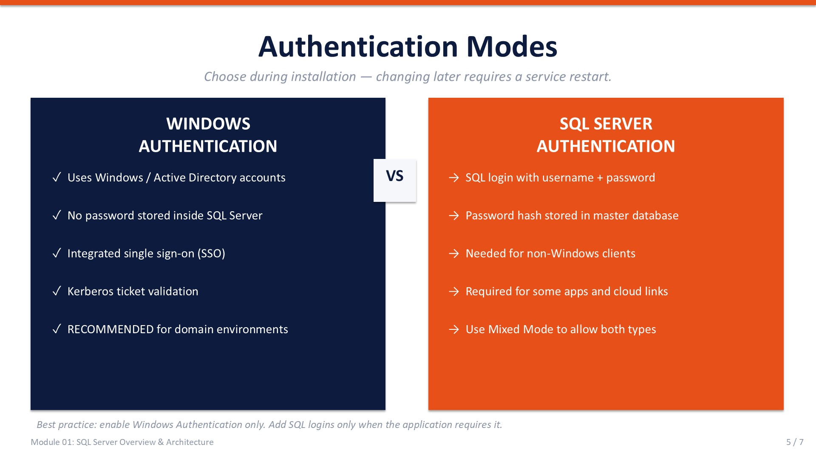
Slide 5 of 7

1.5 Authentication Modes
SQL Server supports two authentication modes, configured at the instance level. The mode is chosen during installation but can be changed afterward — however, changing the mode requires restarting the SQL Server service.

Windows Authentication
Uses the operating system's existing identity — an Active Directory domain account or a local Windows account. SQL Server trusts the Windows security token; no separate SQL password is stored inside the database. This is generally the more secure option because it leverages Kerberos / NTLM, Windows account lockout policies, and centrally managed Active Directory credentials.
Typical ADO.NET connection string with Windows Authentication:
Connection String
Server=SQLSERVER01;Database=NovaMart;Integrated Security=True;

- No password stored inside SQL Server — reduced credential exposure.
- Inherits Windows account lockout and expiration policies automatically.
- Single sign-on: the user's Windows session is reused — no extra prompt.
- Kerberos mutual authentication supported in domain environments.
- Recommended for all domain-joined application servers and admin workstations.

SQL Server Authentication (Mixed Mode)
SQL Server stores its own username and password (a "SQL login"). The password hash is stored in the master database. This mode is required when clients are on a different Windows domain, when applications connect from non-Windows platforms (Linux, macOS, mobile), or when a service account does not have an Active Directory identity. To enable SQL logins you must switch the instance to Mixed Mode.
Typical ADO.NET connection string with SQL Authentication:
Connection String
Server=SQLSERVER01;Database=NovaMart;User Id=AppUser;Password=Str0ng!Pass;

- SQL login credentials are independent of Windows — useful for cross-platform clients.
- Password policies can be enforced (CHECK_POLICY option on the login).
- The SA (System Administrator) login is a built-in SQL login — disable or rename it in production.
- Requires Mixed Mode — enabling it does not disable Windows Authentication.

Checking and Changing the Authentication Mode
- In Object Explorer, right-click the instance → Properties.
- Click the Security page.
Expected: The current Server authentication setting is displayed.
- To enable Mixed Mode: select SQL Server and Windows Authentication mode → OK.
- Restart the SQL Server service for the change to take effect.
You can also query the current mode via T-SQL:
T-SQL
-- Returns 1 = Windows Authentication only
-- Returns 0 = Mixed Mode (SQL Server + Windows)
SELECT SERVERPROPERTY('IsIntegratedSecurityOnly') AS WindowsAuthOnly;

⚠ | Best Practice  Use Windows Authentication wherever possible. Enable Mixed Mode only when an application requires SQL logins. Always set a strong password on the SA account, or disable it, in any environment that matters.

SLIDE 6 — SQL SERVER MANAGEMENT STUDIO

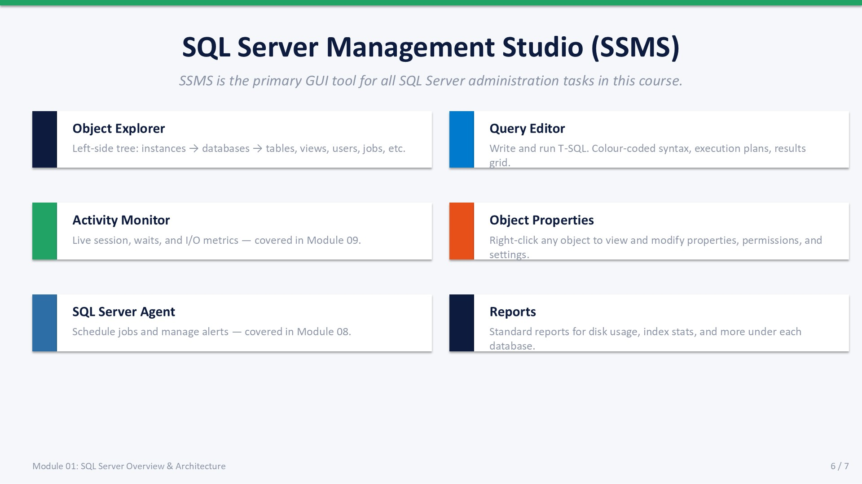
Slide 6 of 7

1.6 SQL Server Management Studio (SSMS)
SQL Server Management Studio is the primary graphical tool for administering SQL Server. It is free, downloadable from Microsoft, and runs on Windows. Every administration task in this course — connecting, querying, configuring, monitoring, and managing jobs — is performed in SSMS or in SSMS query windows.

Key Areas of SSMS
Area | Location | Purpose
Object Explorer | Left panel (dockable) | Navigate instances, databases, and every object type.
Query Editor | Centre pane (tabbed) | Write and execute T-SQL; view results in grid or text.
Results Pane | Below Query Editor | Query output: grid view, messages, and execution plan.
Activity Monitor | Right-click instance | Live view of processes, waits, and I/O — covered in M09.
Template Explorer | View menu | Pre-built T-SQL script templates for common tasks.
SQL Server Agent | Object Explorer node | View, create, and manage jobs and alerts — covered in M08.
Object Properties | Right-click any object | View/modify settings, permissions, and file paths.

Useful Keyboard Shortcuts
Shortcut | Action
F5 or Ctrl+E | Execute selected query (executes all if nothing is selected)
Ctrl+K, Ctrl+C | Comment out the selected lines
Ctrl+K, Ctrl+U | Uncomment the selected lines
Ctrl+L | Display estimated execution plan without running the query
Ctrl+M | Toggle capture of actual execution plan on the next run
Ctrl+R | Show / hide the Results pane
Ctrl+Shift+U | Convert selected text to uppercase
Alt+F1 | Run sp_help on the selected object name

ℹ | SSMS Version Note  This course uses SSMS 19 or later. The interface is consistent across versions, but some options (like Azure integration) are only visible in newer builds. Download the latest version free from: https://aka.ms/ssmsfullsetup

SLIDE 7 — LAB 01

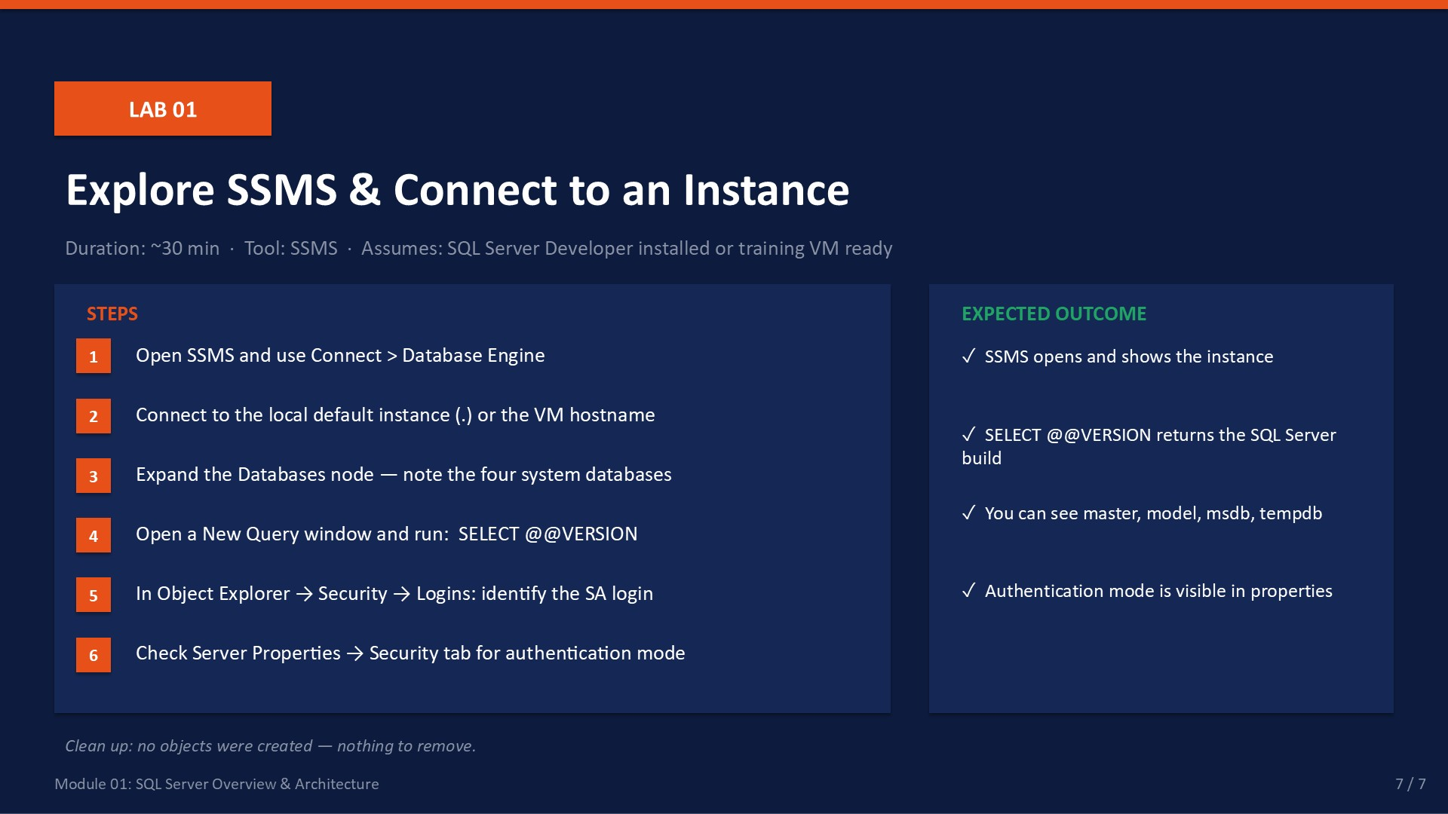
Slide 7 of 7

Lab 01: Explore SSMS & Connect to an Instance
Duration:  ~30 min | Tool:  SSMS | Role Required:  sysadmin | Cleanup:  None — read-only

🎯 | Mission Briefing — Lab 01: Your First Day at NovaMart  Budi (IT Manager) walks you through the server room. A Windows Server with SQL Server 2022 Developer Edition is already installed. Your job: open SSMS, connect to the instance, and report back with the SQL Server version and the list of system databases present.

Part A — Connect to the Instance
- Open SQL Server Management Studio from the Start menu.
- The Connect to Server dialog opens automatically. If it does not, click File → Connect Object Explorer.
- Set the following fields:
Server type: Database Engine
Server name: .\ (dot-backslash for a local default instance)
Authentication: Windows Authentication
- Click Connect.
Expected: Object Explorer shows your server name with a green connected icon.

Part B — Explore Object Explorer
- In Object Explorer, expand your server node. You should see: Databases, Security, Server Objects, Management, SQL Server Agent.
- Expand Databases → System Databases.
Expected: You see: master, model, msdb, tempdb.
- Right-click master → Properties. On the Files page, note the .mdf and .ldf file paths. Click Cancel.

Part C — Query the Instance Version
- Click New Query in the toolbar.
- Execute:
T-SQL
SELECT @@VERSION;

Expected: a single row containing the SQL Server version string, e.g. "Microsoft SQL Server 2022 ... Developer Edition (64-bit)."
- List all databases on the instance:
T-SQL
SELECT name, database_id, state_desc, recovery_model_desc
FROM sys.databases
ORDER BY database_id;

Expected: at least 4 rows (master, tempdb, model, msdb) all with state_desc = ONLINE.

Part D — Check Server Properties
- Right-click your server → Properties.
- General page: note the Product version, Operating system, Platform.
- Security page: observe the Server authentication mode.
- Memory page: note Maximum server memory (2,147,483,647 = unlimited default). Click Cancel.

Part E — Identify Authentication Mode via T-SQL
- Run:
T-SQL
-- Returns 1 = Windows Auth only, 0 = Mixed Mode
SELECT SERVERPROPERTY('IsIntegratedSecurityOnly') AS WindowsAuthOnly;

- List existing logins:
T-SQL
SELECT name, type_desc, is_disabled
FROM sys.server_principals
WHERE type IN ('S','U','G') -- SQL login, Windows user, Windows group
ORDER BY type_desc, name;

Expected: at least sa (SQL login, possibly disabled) and your Windows account.

Validation Checklist
☐ SSMS connects to the instance without error
☐ System Databases folder shows all four system DBs
☐ SELECT @@VERSION returns a SQL Server 2019 or 2022 result
☐ sys.databases query returns at least 4 rows, all ONLINE
☐ Server Properties → Security page shows the current auth mode

Troubleshooting
Symptom | Likely Cause | Fix
Cannot connect to .\ | SQL Server service not running | Open services.msc, start SQL Server (MSSQLSERVER)
Login failed for user | Account not mapped to a SQL login | Connect using a local Windows admin (auto-mapped to sysadmin)
Object Explorer shows only one database | SQL Server Browser service not running | Start SQL Server Browser in services.msc
SELECT @@VERSION returns error | Query editor window not connected | Check the connection indicator in the SSMS status bar
Server Properties page is greyed out | Insufficient permissions | Ensure the login has the sysadmin server role

✓ | Cleanup  No cleanup required — Lab 01 is entirely read-only. No databases, tables, or logins were created. Move directly to Module 02.

Knowledge Check
Answer these questions to test your understanding of Module 01. Answers appear below each question.
Q1. What is the maximum database size for SQL Server Express Edition?
Answer: 10 GB per database.
Q2. Which system database must be backed up whenever you create a new SQL Server login?
Answer: master — because master stores all logins and instance-level metadata.
Q3. Two application servers on a separate Windows domain need to connect to your SQL Server instance. Which authentication mode must you enable?
Answer: Mixed Mode (SQL Server and Windows Authentication).
Q4. What is the name of the Windows service for a default SQL Server instance?
Answer: MSSQLSERVER
Q5. What happens to data stored in tempdb when the SQL Server service restarts?
Answer: All data in tempdb is permanently lost. tempdb is recreated from model on every service start.

