SLIDE 1 — MODULE COVER

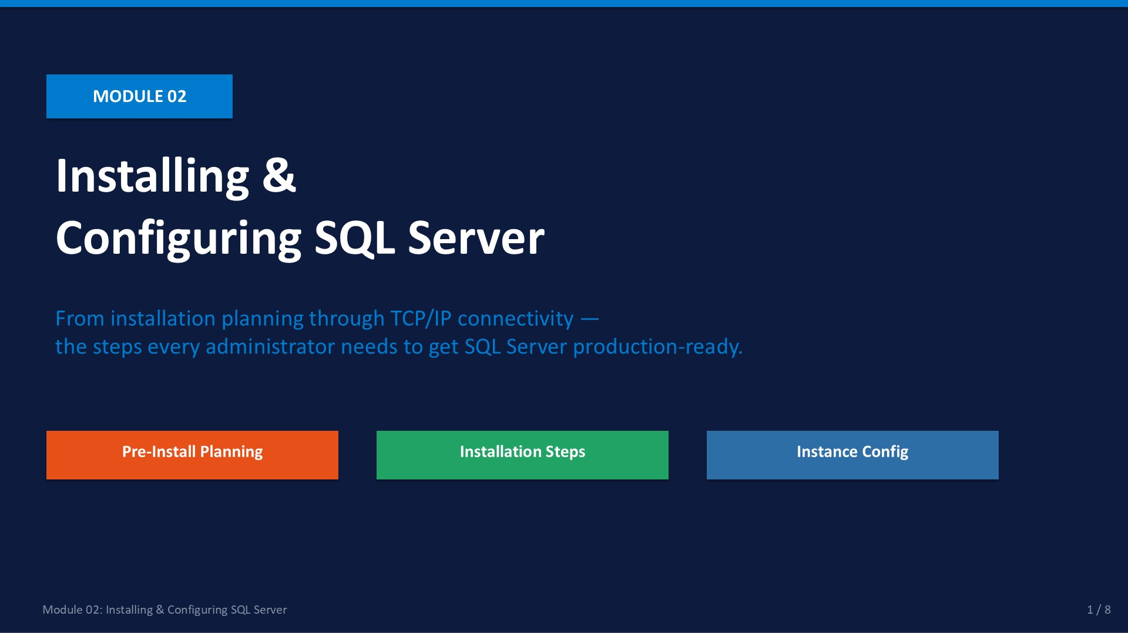
Slide 1 of 8

Module 02: Installing & Configuring SQL Server
Module | Day | Duration | Lab
02 | 1 — Morning | 120 minutes | Lab 02

Before you can administer a SQL Server environment, you need to know how to build one. This module walks through every decision and every step — from checking hardware requirements through enabling remote connectivity. The choices you make during installation (especially collation) are very difficult to reverse, so planning ahead is critical.
The lab uses a pre-installed Developer Edition VM, so you practise the configuration steps that are needed after installation rather than the setup wizard itself. Understanding the wizard flow remains important — it is examined in knowledge checks and expected in real-world interviews.
ℹ | Lab Environment  Lab 02 uses a VM with SQL Server 2022 Developer Edition already installed. The focus is on post-install configuration: SQL Server Configuration Manager, TCP/IP, Windows Firewall, and remote SSMS connectivity.

What This Module Covers
- Pre-Install Planning Hardware, storage layout, collation, feature selection, service accounts.
- Setup Wizard Walk-Through All 8 wizard pages in order — what to set and why.
- Instance Configuration Memory limits, MAXDOP, Cost Threshold, server name verification.
- Configuration Manager Services, startup types, TCP/IP, Named Pipes, port 1433.
- Remote Connectivity Firewall rules, remote SSMS connection test, troubleshooting checklist.

SLIDE 2 — LEARNING OBJECTIVES

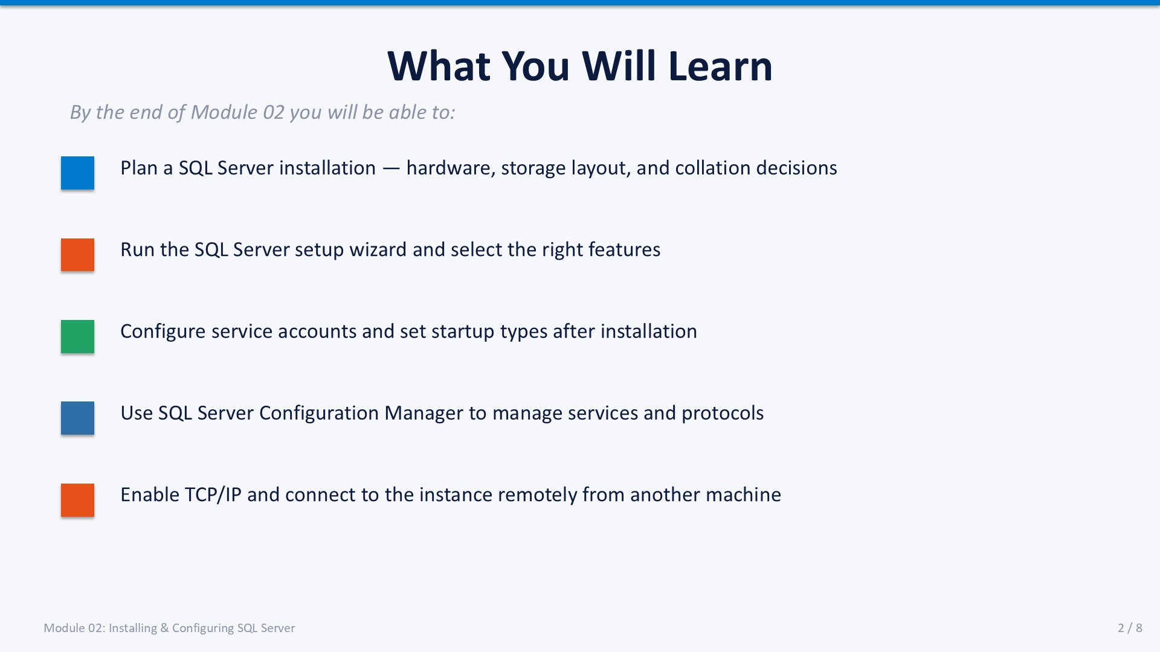
Slide 2 of 8

Learning Objectives
By the end of Module 02 you will be able to:
- Plan a SQL Server installation — — identify hardware requirements, choose an appropriate collation, and list the minimum features required for a production database engine.
- Run the SQL Server setup wizard — — navigate all 8 wizard pages and select the correct options at each step.
- Configure service accounts and startup types — — set appropriate Windows service accounts and ensure SQL Server Agent starts automatically.
- Use SQL Server Configuration Manager — — manage services, enable TCP/IP, set static port 1433, and restart affected services.
- Enable remote connectivity — — open the Windows Firewall for port 1433 and connect from a remote SSMS session.
These five objectives map to the five content slides in this module.

SLIDE 3 — PRE-INSTALLATION PLANNING

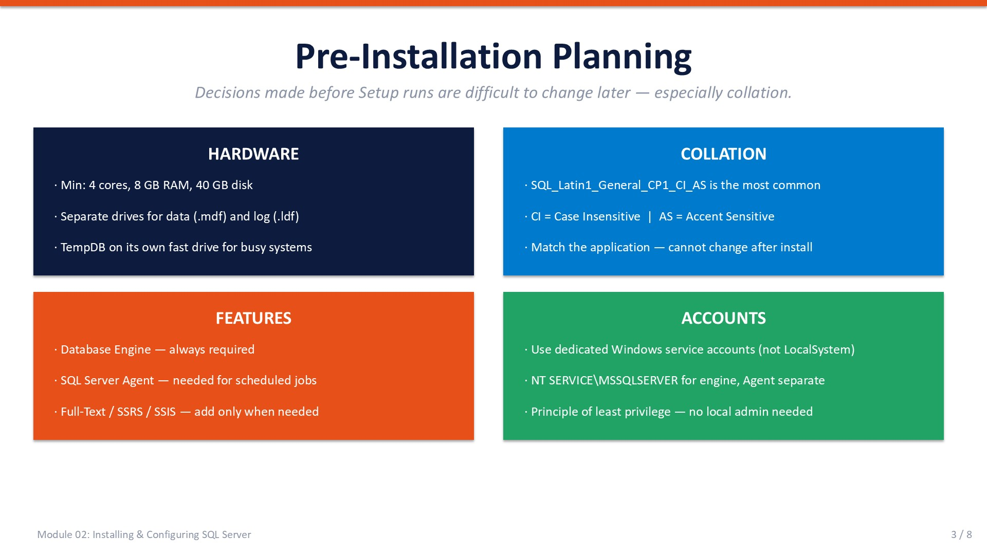
Slide 3 of 8

2.1 Pre-Installation Planning
Successful SQL Server installations start before setup.exe is ever run. Decisions made at installation time — particularly collation — are permanent without a full reinstall. The four areas below must be addressed in every installation plan.

Hardware Minimum Requirements
Component | Minimum | Recommended for Training
CPU | 1.4 GHz (64-bit) | 4 cores or more
RAM | 1 GB minimum | 8 GB or more
Disk | 6 GB for engine | Separate drives for data and log
OS | Windows Server 2016+ | Windows Server 2019/2022

Collation
Collation defines how SQL Server sorts and compares character data. It is set at the instance level and per-database. The most common choice for English-language environments is SQL_Latin1_General_CP1_CI_AS:
- CI Case Insensitive (WHERE Name = 'alice' matches 'Alice' and 'ALICE'.)
- AS Accent Sensitive (WHERE Name = 'résumé' does NOT match 'resume'.)
⚠ | Warning: Collation Cannot Change After Installation  Changing instance-level collation after installation requires rebuilding the system databases. Match the collation to the application vendor's requirements — check the application documentation before running Setup.

Feature Selection
Install only what you need. Extra features increase the attack surface and maintenance overhead.
Feature | Required? | When to Add
Database Engine Services | Always | The core — always install this.
SQL Server Agent | Yes | Needed for scheduled jobs (Module 08).
SQL Server Browser | Optional | Required for named instances on non-standard ports.
Integration Services (SSIS) | Optional | Add when ETL workloads are required.
Reporting Services (SSRS) | Optional | Add when web-based reports are required.
Full-Text Search | Optional | Add when text search predicates are needed.

Service Accounts
Each SQL Server service runs under a Windows account. Use dedicated accounts following the principle of least privilege. Never run production services as LocalSystem or a domain admin.
- NT SERVICE\MSSQLSERVER — Virtual service account; used by the Database Engine by default.
- NT SERVICE\SQLSERVERAGENT — Virtual service account for SQL Server Agent.
- Domain service account — Required when the service needs network access (e.g., linked servers, backups to UNC paths).

SLIDE 4 — SETUP WIZARD WALK-THROUGH

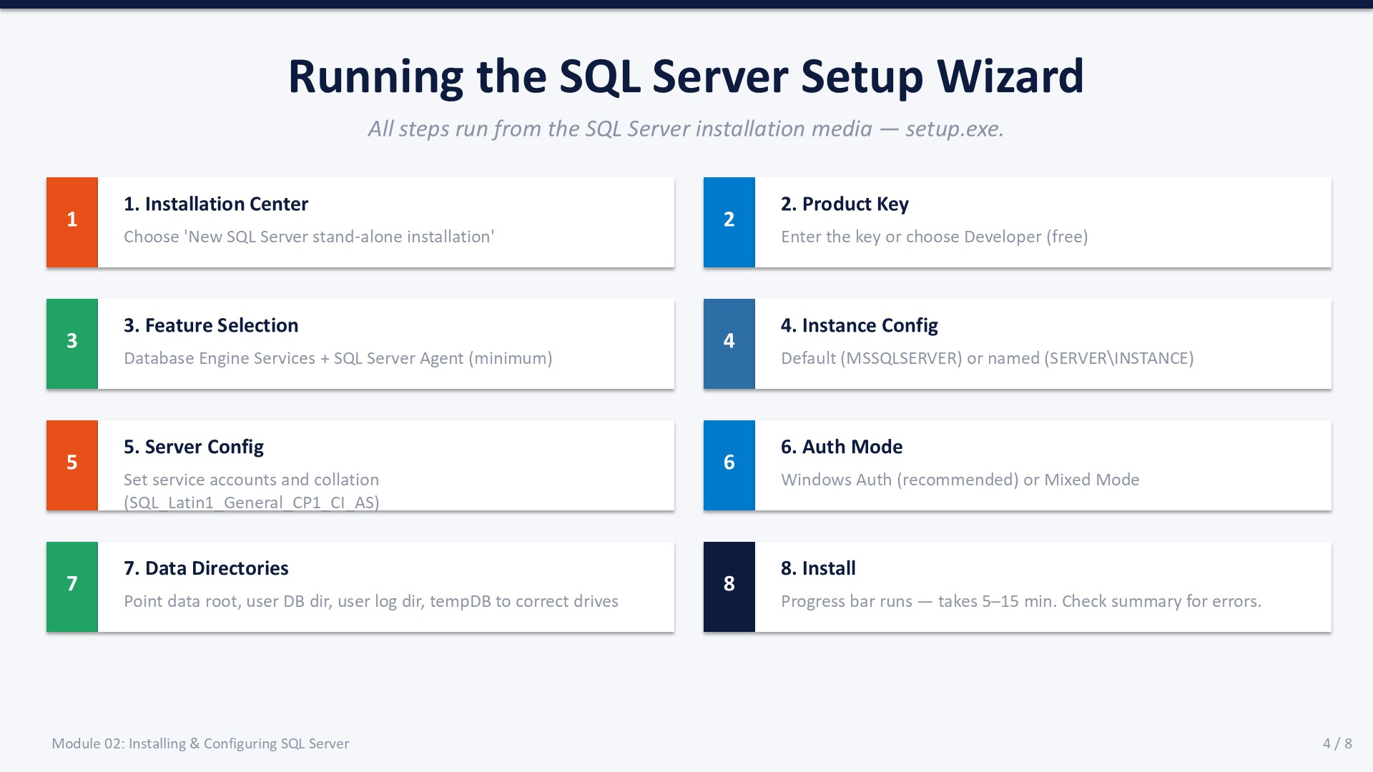
Slide 4 of 8

2.2 SQL Server Setup Wizard
The SQL Server setup wizard runs from setup.exe on the installation media. The pages appear in a fixed sequence. Each decision point below maps to a specific wizard page.
- Installation Center — Select "New SQL Server stand-alone installation or add features to an existing installation." This launches the actual setup wizard.
- Product Key — Enter a licence key, or select "Developer" for a free, full-featured development installation.
- Feature Selection — At minimum, check: Database Engine Services and SQL Server Agent. Uncheck SQL Server Replication and Machine Learning Services unless required.
- Instance Configuration — Choose "Default instance" (MSSQLSERVER) if this is the only instance on the server, or specify a named instance. Named instances use the format SERVER\INSTANCENAME.
- Server Configuration — Set service accounts (see 2.1 above) and collation. Set SQL Server Agent startup type to Automatic so jobs run without manual intervention.
Expected: Set both Database Engine and SQL Server Agent to Automatic startup.
- Database Engine Configuration — Authentication — Choose Windows Authentication Mode (recommended) or Mixed Mode. If Mixed Mode: set a strong password for the SA account immediately.
- Data Directories — Set: Data root, User database directory, User database log directory, tempDB directory. Place data and log on separate drives for production environments.
- Install — The progress bar runs for 5–15 minutes. When complete, review the summary — any component that shows "Failed" must be investigated before proceeding.
Expected: All features show "Succeeded" in the installation summary.
ℹ | Post-Install Verification  After Setup completes, open SSMS and connect to the instance. Run SELECT @@VERSION to confirm the installation. Check SQL Server Agent is running in Configuration Manager.

SLIDE 5 — INSTANCE CONFIGURATION

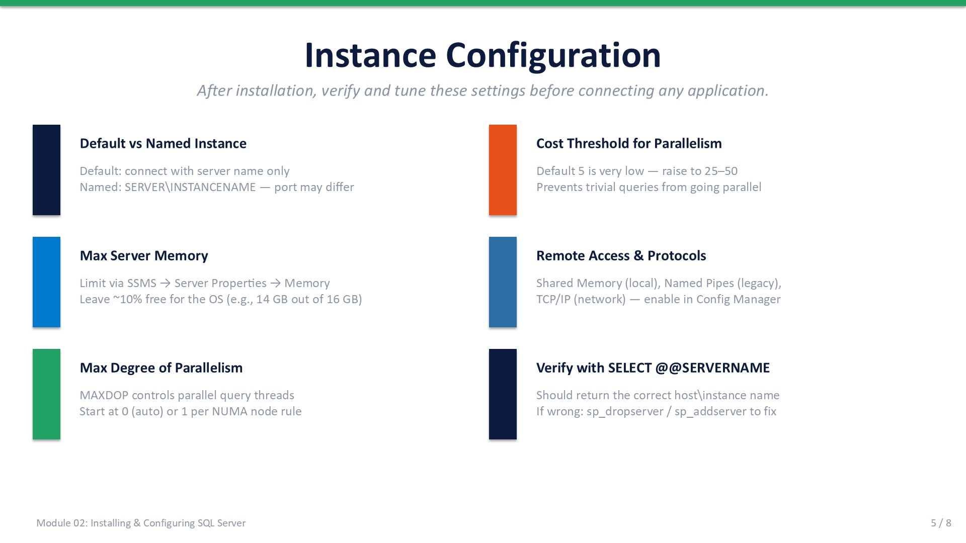
Slide 5 of 8

2.3 Instance Configuration
After installation, several instance-level settings should be reviewed and tuned before the server goes into use. These settings are changed via SSMS Server Properties or via sp_configure.

Max Server Memory
Limits the memory SQL Server can allocate for the buffer pool. The default (2 147 483 647 MB = unlimited) means SQL Server will consume all available RAM, starving the OS. Set this to approximately 90% of total physical RAM. Example: on a 16 GB server, set Max Server Memory to 14 336 MB.
How to change: SSMS → right-click instance → Properties → Memory

Max Degree of Parallelism (MAXDOP)
Controls the maximum number of CPU threads a single query can use. The default (0 = unlimited) can cause contention. Microsoft recommends MAXDOP = number of physical cores per NUMA node, up to 8.
How to change: SSMS → Properties → Advanced, or: EXEC sp_configure 'max degree of parallelism', 4; RECONFIGURE;

Cost Threshold for Parallelism
The query cost above which SQL Server considers a parallel plan. The default of 5 is very low — trivial queries go parallel unnecessarily. Raise to 25–50 in most environments.
How to change: EXEC sp_configure 'cost threshold for parallelism', 50; RECONFIGURE;

Server Name Verification
After installation, verify the registered server name is correct. Incorrect registration happens when the server was renamed or when using VMs.
How to change: SELECT @@SERVERNAME — should match the actual host/instance name.
T-SQL
-- View current sp_configure settings
EXEC sp_configure;
-- Set Max Server Memory (example: 14 GB)
EXEC sp_configure 'show advanced options', 1; RECONFIGURE;
EXEC sp_configure 'max server memory (MB)', 14336; RECONFIGURE;
-- Verify the registered server name
SELECT @@SERVERNAME AS RegisteredName,
SERVERPROPERTY('MachineName') AS ActualHost;

SLIDE 6 — SQL SERVER CONFIGURATION MANAGER

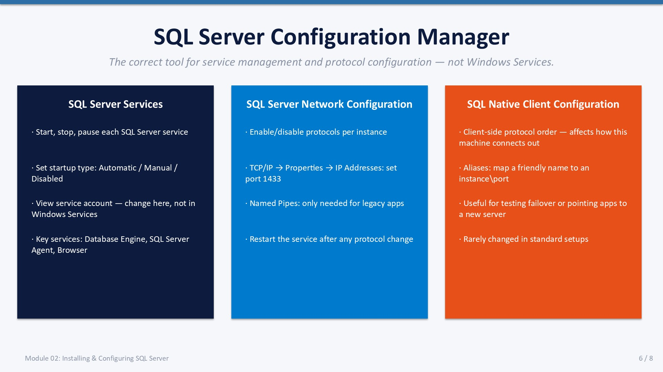
Slide 6 of 8

2.4 SQL Server Configuration Manager
SQL Server Configuration Manager (SSCM) is the correct tool for managing SQL Server services and network protocols. Do not use the Windows Services console (services.msc) or the registry to change SQL Server service accounts — SSCM updates all required registry keys and permission grants atomically.
ℹ | How to Open SSCM  Start menu → search for "SQL Server Configuration Manager"  Or: run SQLServerManager16.msc (SQL Server 2022) from Run / Command Prompt.

SQL Server Services Node
Lists all SQL Server services installed on this machine:
- SQL Server (MSSQLSERVER) — The Database Engine. Must be Running for any connection.
- SQL Server Agent (MSSQLSERVER) — Job scheduler. Set to Automatic startup.
- SQL Server Browser — Resolves named instance connections. Enable for named instances.
To change service account: right-click service → Properties → Log On tab. Use this path — never edit the registry directly.

SQL Server Network Configuration Node
Controls network protocols for each instance:
- Shared Memory — Local connections only. Always enabled, cannot be disabled.
- Named Pipes — Legacy protocol. Disable unless required by an older application.
- TCP/IP — Network connections. Must be enabled for remote SSMS access.

Enabling TCP/IP and Setting Port 1433
- Open SSCM.
- Expand SQL Server Network Configuration → Protocols for MSSQLSERVER.
- Right-click TCP/IP → Enable.
Expected: Status changes to Enabled.
- Right-click TCP/IP → Properties → IP Addresses tab.
- Scroll to IPAll at the bottom. Set TCP Port to 1433. Clear TCP Dynamic Ports.
- Click OK.
- Return to SQL Server Services → right-click SQL Server (MSSQLSERVER) → Restart.
Expected: Service restarts and the new port is applied.

Windows Firewall Rule
TCP/IP must also be open in the Windows Firewall:
PowerShell
# Run in an elevated PowerShell or Command Prompt
New-NetFirewallRule -DisplayName "SQL Server 1433" `
-Direction Inbound -Protocol TCP `
-LocalPort 1433 -Action Allow

Or via GUI: Windows Defender Firewall → Advanced Settings → Inbound Rules → New Rule → Port → TCP → 1433.

SLIDE 7 — LAB 02

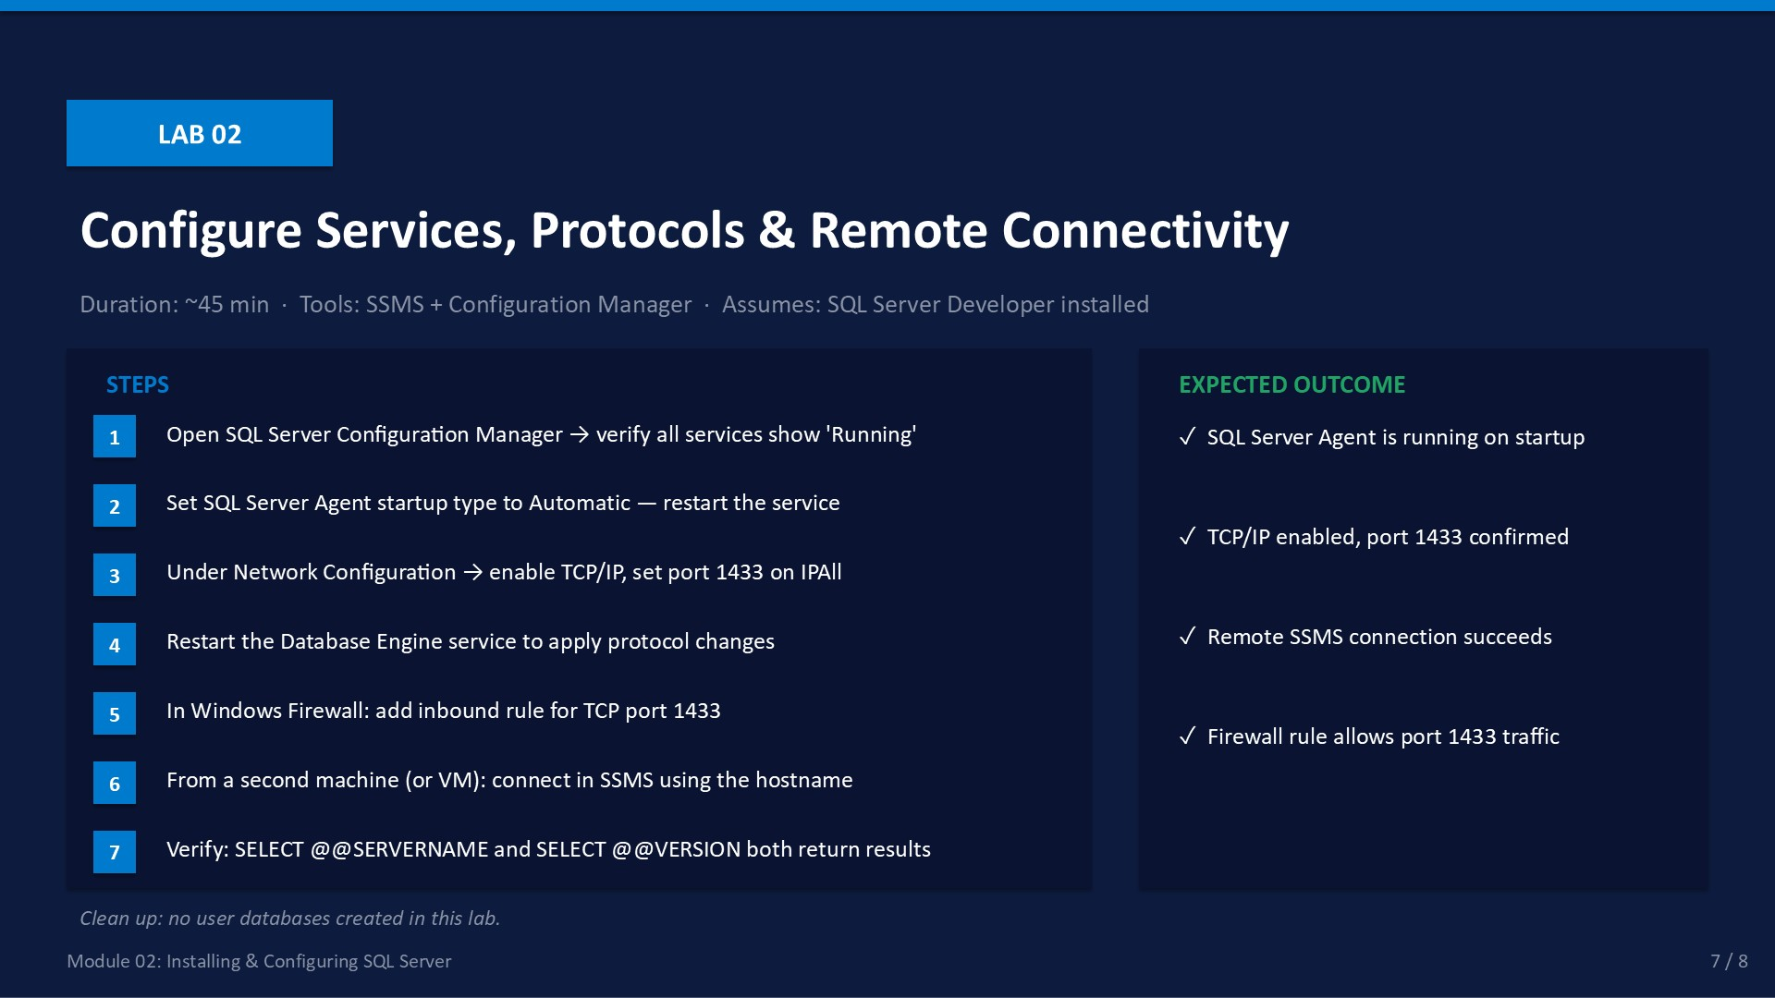
Slide 7 of 8

Lab 02: Configure Services, Protocols & Remote Connectivity
Duration:  ~45 min | Tools:  SSMS + SSCM | Role:  sysadmin | Cleanup:  None

🎯 | Mission Briefing — Lab 02  Budi tells you the server is installed but no one has verified the configuration. SQL Server Agent is set to Manual startup and remote connections are failing. Your job: fix the service startup, enable TCP/IP, open the firewall, and prove remote connectivity works.

Part A — Verify and Fix Service Startup
- Open SQL Server Configuration Manager.
- In SQL Server Services, check the state of all listed services.
- Right-click SQL Server Agent → Properties → Service tab → set Start Mode to Automatic.
- Click OK, then right-click SQL Server Agent → Start.
Expected: SQL Server Agent shows Running in the State column.

Part B — Enable TCP/IP and Set Port 1433
- Expand SQL Server Network Configuration → Protocols for MSSQLSERVER.
- Right-click TCP/IP → Enable.
Expected: TCP/IP status changes to Enabled.
- Right-click TCP/IP → Properties → IP Addresses tab.
- In the IPAll section: set TCP Port to 1433, clear TCP Dynamic Ports.
- Click OK.
- Restart the SQL Server service from the SQL Server Services node.
Expected: Service restarts without error.

Part C — Open the Firewall
- Open Windows Defender Firewall with Advanced Security from the Start menu.
- Click Inbound Rules → New Rule.
- Rule Type: Port → TCP → Specific local ports: 1433 → Allow the connection.
- Name the rule "SQL Server 1433" → Finish.
Expected: The rule appears in the Inbound Rules list.

Part D — Test Remote Connectivity
- From a second VM or machine on the same network, open SSMS.
- In Connect to Server: Server name = <IP or hostname> → Windows Authentication.
- Click Connect.
Expected: Object Explorer connects and shows the remote instance.
- Run: SELECT @@SERVERNAME, @@VERSION
Expected: Both return values from the remote instance.

Validation Checklist
☐ SQL Server Agent is Running and set to Automatic startup
☐ TCP/IP is Enabled in Network Configuration
☐ Port 1433 is set in IPAll, Dynamic Ports is empty
☐ Firewall inbound rule for TCP 1433 exists
☐ Remote SSMS connection succeeds
☐ SELECT @@SERVERNAME and @@VERSION return correct values remotely

Troubleshooting
Symptom | Likely Cause | Fix
Cannot connect remotely | TCP/IP disabled or port wrong | Re-check SSCM → TCP/IP → IPAll → port 1433
Connection timeout | Firewall blocking 1433 | Add/check inbound rule in Windows Firewall
Login failed | Auth mode mismatch | Use Windows Auth; or enable Mixed Mode if SQL login needed
Agent not starting | Missing permissions on service account | Check event log; run SSCM as administrator
Port in use | Another app or SQL instance on 1433 | Use a different port and update firewall rule accordingly

✓ | Cleanup  No user databases were created in this lab. The firewall rule and TCP/IP configuration persist — required for all remaining labs.

SLIDE 8 — MODULE SUMMARY

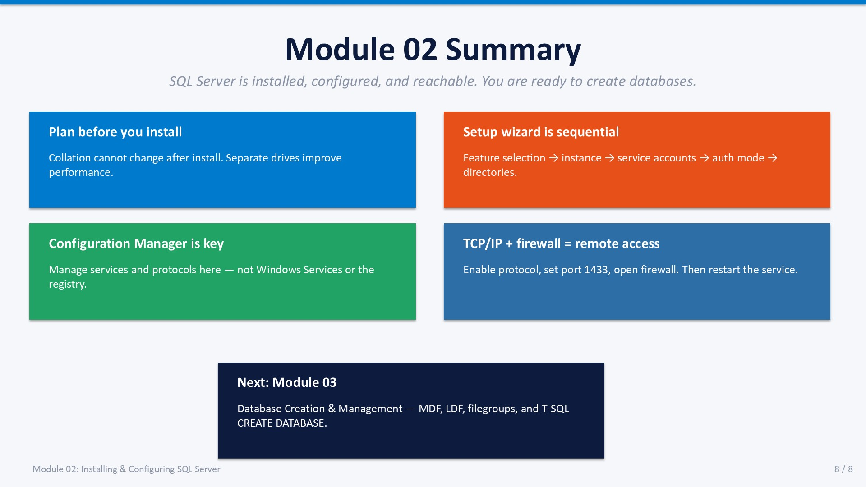
Slide 8 of 8

Module 02 Summary
SQL Server is now installed, configured, and reachable. The decisions made in this module underpin every subsequent operation in the course.

Key Takeaways
- Plan before you install Collation cannot change after installation. Separate data and log drives from the start.
- Setup wizard is sequential Feature selection → instance → service accounts → auth mode → directories.
- Configuration Manager is the service tool Manage services and protocols here — not Windows Services or the registry.
- TCP/IP + firewall = remote access Enable the protocol, set port 1433, open the firewall, restart the service.
- Next: Module 03 Database Creation & Management — MDF, LDF, filegroups, and T-SQL CREATE DATABASE.

Knowledge Check
Q1. What collation setting is most common for English-language SQL Server installations?
Answer: SQL_Latin1_General_CP1_CI_AS (Case Insensitive, Accent Sensitive).
Q2. Why should you not use the Windows Services console to change a SQL Server service account?
Answer: SSCM also updates required registry permissions atomically. Services.msc changes the account without updating permissions, which can break the service.
Q3. What two changes are required to enable remote connections to SQL Server?
Answer: Enable TCP/IP in Configuration Manager AND add a Windows Firewall inbound rule for port 1433.
Q4. What is the risk of leaving Max Server Memory at the default unlimited value?
Answer: SQL Server can consume all available RAM, starving the OS and other processes, potentially causing instability.

