SLIDE 1 — MODULE COVER

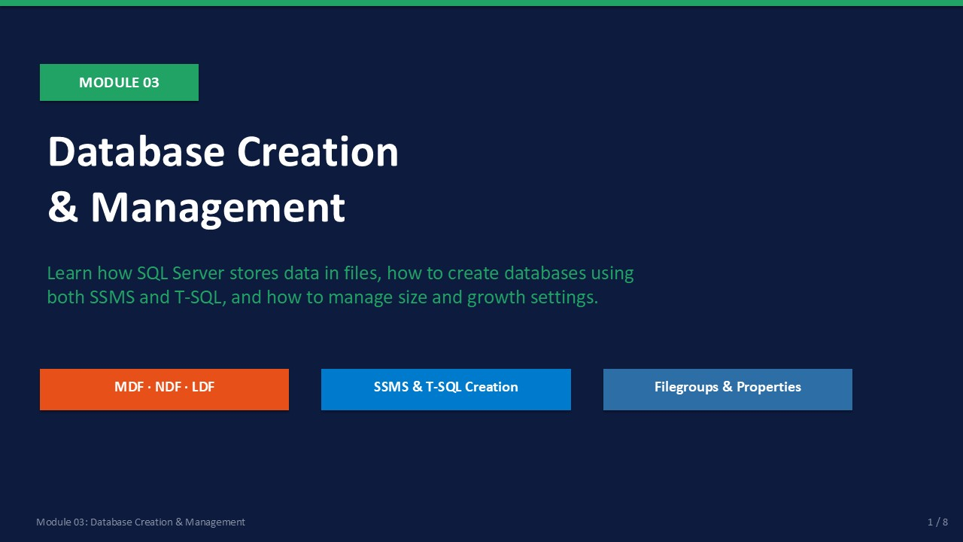
Slide 1 of 16

Module 03: Database Creation & Management
Module | Day | Duration | Lab
03 | 1 — Afternoon | 120 minutes | Lab 03

Databases are the fundamental unit of storage in SQL Server. Every application, every table, and every piece of data lives inside a database. This module explains how databases are physically stored, how to create them using both SSMS and T-SQL, and how to manage their key properties.
Understanding the file structure — primary data files, secondary data files, and log files — is essential for proper sizing, placement, and backup strategy. The T-SQL approach to creation gives you exact control and produces repeatable scripts suitable for deployment automation.
ℹ | Lab Environment Note  Lab 03 uses the SQL Server 2022 Developer Edition instance configured in Lab 02. TCP/IP and SSMS remote access should already be working before this lab.

What This Module Covers
- MDF, NDF, and LDF Files The three SQL Server file types and their roles.
- Create via SSMS GUI-based database creation with sensible defaults.
- Create via T-SQL Full control with CREATE DATABASE syntax.
- Filegroups How to organise data files into logical groups.
- Database Properties Recovery model, compatibility level, auto options.

SLIDE 2 — LEARNING OBJECTIVES

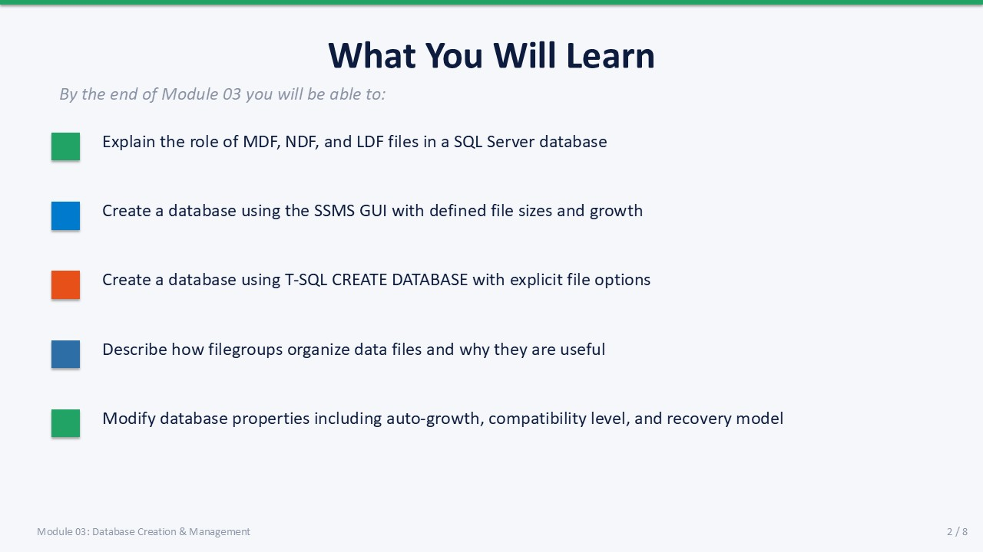
Slide 2 of 16

Learning Objectives
By the end of Module 03 you will be able to:
- Explain the roles of MDF, NDF, and LDF files — including which file holds the system catalog and why the log should never share a drive with data files.
- Create a database using the SSMS GUI — setting initial sizes and auto-growth values in MB rather than percent.
- Create a database using T-SQL — using a complete CREATE DATABASE statement with named file groups, sizes, and growth increments.
- Describe filegroups — and explain how assigning data files to user-defined filegroups improves manageability.
- Set key database properties — including recovery model, compatibility level, Auto Shrink, Auto Close, and Page Verify.

SLIDE 3 — FILE STRUCTURE

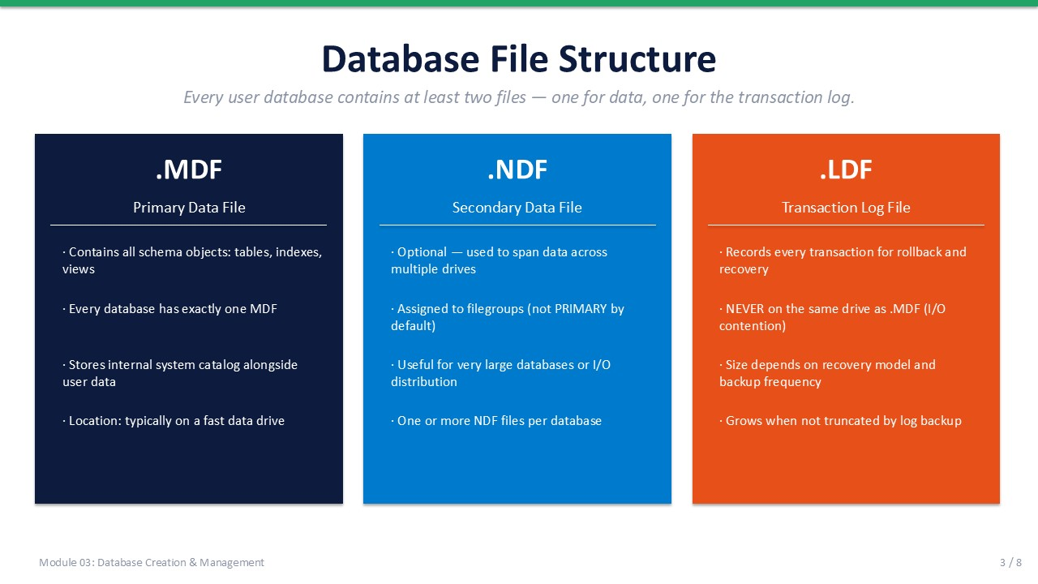
Slide 3 of 16

3.1 Database File Structure
A SQL Server database consists of at least two physical files: one data file and one log file. Understanding their roles helps you make correct decisions about sizing, placement, and backup configuration.
File Type | Extension | Role | Key Facts
Primary Data | .mdf | Stores all data and the system catalog | Exactly one per database. Contains page 1 (boot page).
Secondary Data | .ndf | Additional data storage | Zero or more. Used to span drives or isolate object groups.
Transaction Log | .ldf | Records all transactions | At least one per database. Should be on a separate drive from MDF.

Why Separate Data and Log Files?
The transaction log is written sequentially, while data files receive random I/O. Placing them on separate physical drives prevents contention and improves performance. In a production environment this is mandatory; in training VMs it is not enforced, but the good habit should be practised.
⚠ | Never Auto-Shrink the Log File  Auto Shrink (database property) frequently shrinks and re-grows files, causing severe fragmentation. Leave Auto Shrink = OFF on all databases. Manage file sizes explicitly.

SLIDE 4 — CREATE DATABASE VIA SSMS

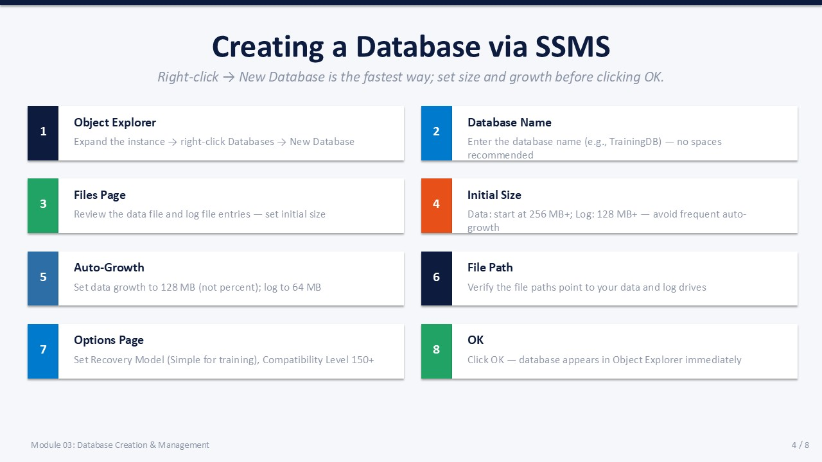
Slide 4 of 16

3.2 Creating a Database via SSMS
The SSMS New Database dialog is the fastest way to create a database during learning. It generates the underlying T-SQL and executes it for you. The eight steps below walk through every important setting.
- In Object Explorer, expand the instance, right-click Databases → New Database.
- In the Database name field, type LabDB_GUI.
- Switch to the Files page (already open by default).
- Set the initial size for the data file (LabDB_GUI) to 64 MB.
- Click the … button in the Autogrowth/Maxsize column for the data file. Set growth to 128 MB, Maximum File Size = Unlimited.
- Set the initial size for the log file (LabDB_GUI_log) to 32 MB. Set autogrowth to 64 MB, Maximum File Size = Unlimited.
- Click the Options page. Set Recovery Model to Simple. Confirm Compatibility Level is 150 or 160.
- Click OK.
Expected: LabDB_GUI appears under Databases in Object Explorer.
💡 | Growth in MB, not Percent  The default autogrowth value is "10 percent". This is dangerous for large databases — a 100 GB database grows by 10 GB at a time, causing long stalls. Always set autogrowth in MB (e.g., 128 MB for data, 64 MB for log).

SLIDE 5 — CREATE DATABASE VIA T-SQL

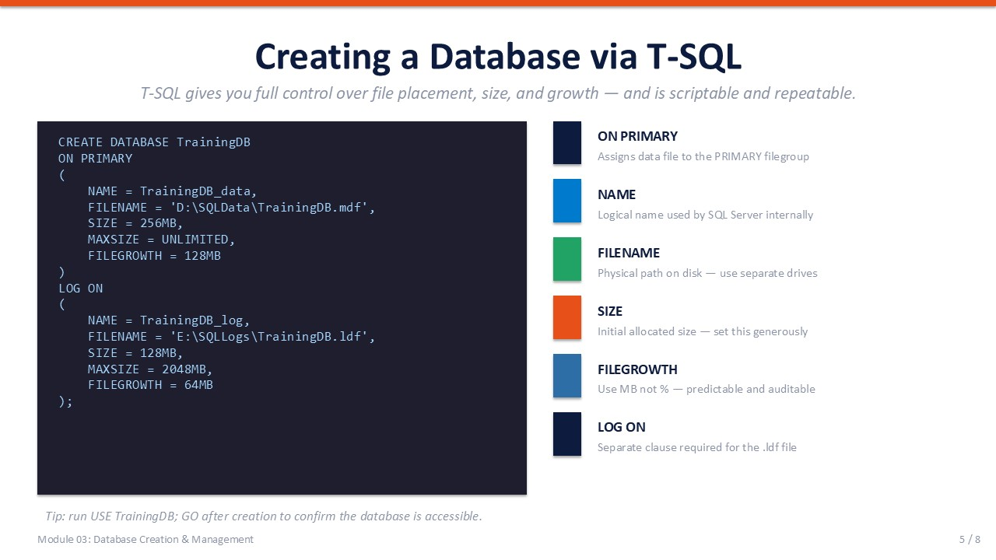
Slide 5 of 16

3.3 Creating a Database via T-SQL
The CREATE DATABASE statement gives complete control over every file attribute. It is the correct approach for any database that will be deployed more than once, automated through a pipeline, or documented in source control.
T-SQL
CREATE DATABASE LabDB_TSQL
ON PRIMARY
(
NAME = LabDB_TSQL,
FILENAME = N'C:\SQLData\LabDB_TSQL.mdf',
SIZE = 64MB,
MAXSIZE = UNLIMITED,
FILEGROWTH = 128MB
)
LOG ON
(
NAME = LabDB_TSQL_log,
FILENAME = N'C:\SQLLog\LabDB_TSQL_log.ldf',
SIZE = 32MB,
MAXSIZE = UNLIMITED,
FILEGROWTH = 64MB
);
GO
-- Set recovery model to Simple
ALTER DATABASE LabDB_TSQL SET RECOVERY SIMPLE;
GO

Syntax Annotations
Clause / Parameter | Meaning
ON PRIMARY | Declares the data file on the PRIMARY filegroup (default and required).
NAME | Logical name — used in T-SQL to reference the file.
FILENAME | Physical OS path — directory must already exist.
SIZE | Initial allocation. Be generous — undersizing causes frequent growth events.
MAXSIZE | UNLIMITED is acceptable when disk space is monitored. Set explicit limits in shared environments.
FILEGROWTH | Growth increment. Always specify in MB, not percent.
LOG ON | Introduces the log file definition — separate from the data clause.

Verifying the Database
T-SQL
-- Confirm the database exists and view its files
SELECT name, state_desc, recovery_model_desc
FROM sys.databases
WHERE name = 'LabDB_TSQL';
-- View file details
SELECT name, type_desc, physical_name,
size * 8 / 1024 AS size_MB,
growth * 8 / 1024 AS growth_MB
FROM sys.master_files
WHERE database_id = DB_ID('LabDB_TSQL');

SLIDE 6 — FILEGROUPS & DATABASE PROPERTIES

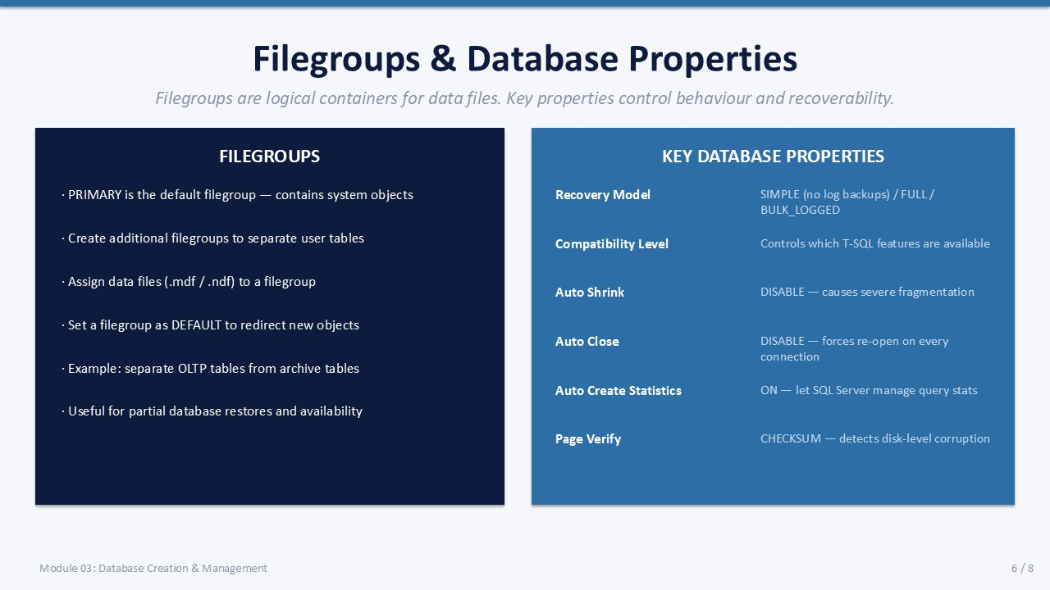
Slide 6 of 16

3.4 Filegroups & Database Properties

Filegroups
A filegroup is a named container that groups one or more data files. Every database has a PRIMARY filegroup created automatically. User-defined filegroups let you control where tables and indexes are stored, enabling performance isolation and partial restores.
- PRIMARY — Default filegroup. System tables always live here. The MDF is a member.
- User filegroups — Created with ALTER DATABASE ADD FILEGROUP <name>. Assign NDF files here.
- DEFAULT — The filegroup used when no filegroup is specified in CREATE TABLE. Can be changed.
- READONLY — A filegroup can be set read-only to protect historical data.
T-SQL
-- Add a user-defined filegroup
ALTER DATABASE LabDB_TSQL
ADD FILEGROUP HistoricalData;
-- Add an NDF file to the new filegroup
ALTER DATABASE LabDB_TSQL
ADD FILE
(
NAME = LabDB_TSQL_hist,
FILENAME = N'C:\SQLData\LabDB_TSQL_hist.ndf',
SIZE = 64MB,
FILEGROWTH = 128MB
)
TO FILEGROUP HistoricalData;
-- Make the new filegroup the DEFAULT
ALTER DATABASE LabDB_TSQL
MODIFY FILEGROUP HistoricalData DEFAULT;

Important Database Properties
Property | Recommended Value | Notes
Recovery Model | SIMPLE (training) | FULL in production — enables log backups.
Compatibility Level | 150 (SQL 2019)  160 (SQL 2022) | Controls T-SQL feature availability and optimizer behaviour.
Auto Shrink | OFF | ON causes fragmentation. Leave OFF always.
Auto Close | OFF | ON drops the plan cache on every close — bad for performance.
Auto Create Stats | ON | SQL Server creates statistics automatically — keep ON.
Page Verify | CHECKSUM | Detects I/O errors. Use CHECKSUM on all databases.

SLIDE 7 — LAB 03

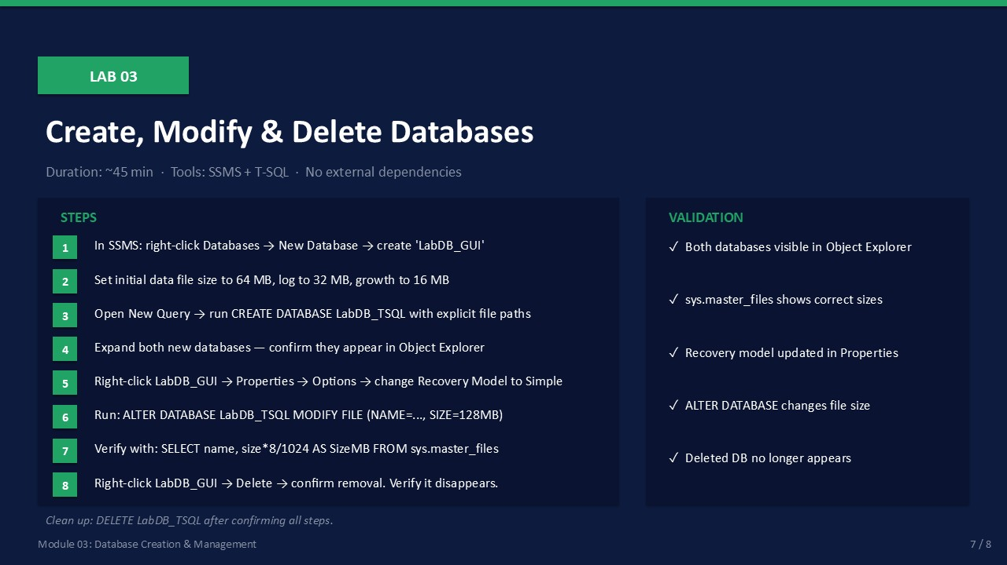
Slide 7 of 16

Lab 03: Create, Modify, and Delete Databases
Duration:  ~45 min | Tools:  SSMS + T-SQL | Role:  sysadmin | Cleanup:  Partial

🎯 | Mission Briefing — Lab 03  The development team needs two new databases. One will be created via SSMS to learn the interface, the other via T-SQL because the DBA team requires all production databases to be scripted. You also need to set properties, resize a file, and confirm using DMVs.

Part A — Create LabDB_GUI via SSMS
- In Object Explorer, right-click Databases → New Database.
- Set Database name to LabDB_GUI.
- On the Files page, set data file initial size to 64 MB.
- Set data file autogrowth to 128 MB, no maximum.
- Set log file initial size to 32 MB, autogrowth to 64 MB.
- Click Options page → set Recovery Model to Simple.
- Click OK.
Expected: LabDB_GUI appears under Databases.

Part B — Create LabDB_TSQL via T-SQL
Open a new query window connected to the instance (not to a specific database). Run:
T-SQL
CREATE DATABASE LabDB_TSQL
ON PRIMARY
(
NAME = LabDB_TSQL,
FILENAME = N'C:\SQLData\LabDB_TSQL.mdf',
SIZE = 64MB, MAXSIZE = UNLIMITED, FILEGROWTH = 128MB
)
LOG ON
(
NAME = LabDB_TSQL_log,
FILENAME = N'C:\SQLLog\LabDB_TSQL_log.ldf',
SIZE = 32MB, MAXSIZE = UNLIMITED, FILEGROWTH = 64MB
);
GO
ALTER DATABASE LabDB_TSQL SET RECOVERY SIMPLE;
GO

- Run the script above.
Expected: Command(s) completed successfully.
- Refresh Object Explorer — LabDB_TSQL appears.

Part C — Change Recovery Model and Modify File Size
T-SQL
-- Change recovery model
ALTER DATABASE LabDB_GUI SET RECOVERY FULL;
GO
-- Grow the data file
USE master;
GO
ALTER DATABASE LabDB_GUI
MODIFY FILE ( NAME = LabDB_GUI, SIZE = 128MB );
GO

- Run the script above.
Expected: Command(s) completed successfully.

Part D — Verify with sys.master_files
T-SQL
SELECT
d.name AS database_name,
mf.type_desc,
mf.name AS logical_name,
mf.physical_name,
mf.size * 8 / 1024 AS size_MB
FROM sys.databases d
JOIN sys.master_files mf ON d.database_id = mf.database_id
WHERE d.name IN ('LabDB_GUI', 'LabDB_TSQL')
ORDER BY d.name, mf.type_desc;

- Run the query and observe the output.
Expected: Both databases show with correct file types and sizes.

Part E — Delete LabDB_GUI
T-SQL
-- GUI method: right-click LabDB_GUI → Delete → check "Close existing connections" → OK
-- T-SQL method:
USE master;
GO
ALTER DATABASE LabDB_GUI SET SINGLE_USER WITH ROLLBACK IMMEDIATE;
GO
DROP DATABASE LabDB_GUI;
GO

- Delete LabDB_GUI using either method above.
Expected: LabDB_GUI no longer appears in Object Explorer.

Validation Checklist
☐ LabDB_GUI was created via SSMS with correct sizes
☐ LabDB_TSQL was created via T-SQL script
☐ Both databases appeared in Object Explorer
☐ Recovery model changed to FULL via ALTER DATABASE
☐ ALTER DATABASE MODIFY FILE increased the data file size
☐ sys.master_files shows correct file sizes
☐ LabDB_GUI was deleted and no longer appears in Object Explorer
☐ LabDB_TSQL still exists — used in Labs 04 and 05

Troubleshooting
Error | Likely Cause | Fix
Directory not found | C:\SQLData or C:\SQLLog does not exist | Create the folders first: mkdir C:\SQLData; mkdir C:\SQLLog
Cannot drop — in use | Another session is connected | Use SET SINGLE_USER before DROP DATABASE
Insufficient disk space | File system full | Check available space; reduce initial SIZE in CREATE DATABASE
ALTER DATABASE failed | New size smaller than current | SIZE in MODIFY FILE must be ≥ current file size

✓ | Cleanup  LabDB_GUI was deleted in Part E. LabDB_TSQL must remain — Lab 04 will create tables inside it.

SLIDE 8 — MODULE SUMMARY

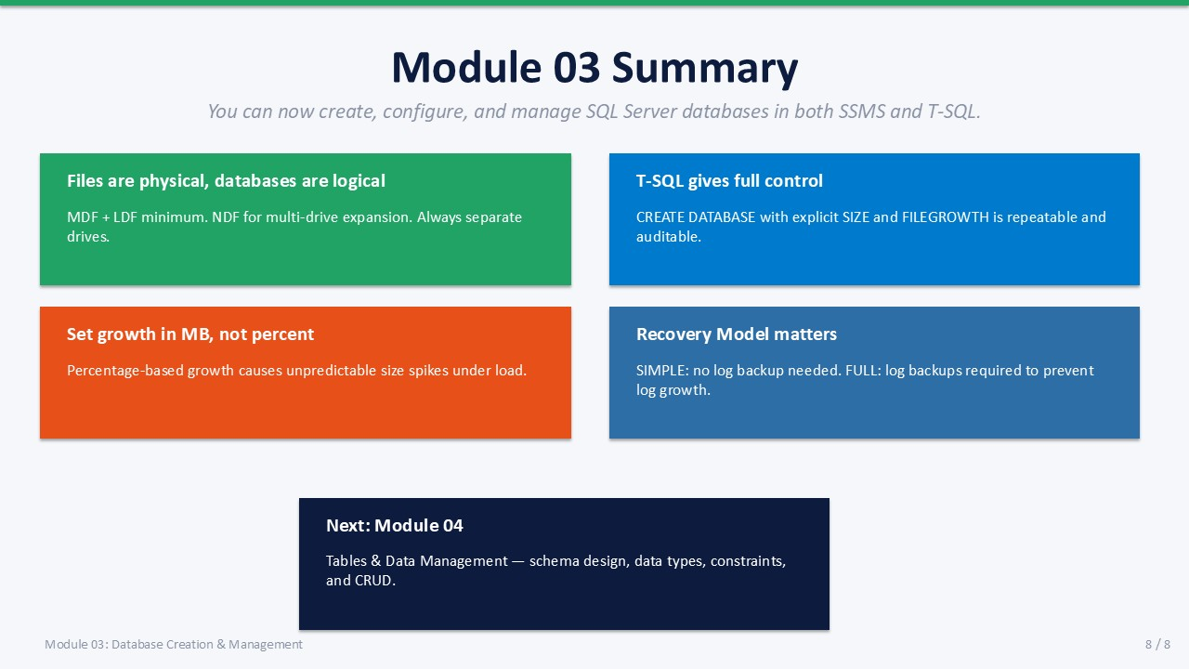
Slide 8 of 16

Module 03 Summary
You can now create, configure, and delete SQL Server databases using both the SSMS GUI and T-SQL. These skills form the foundation for every subsequent module.

Key Takeaways
- Files are physical; databases are logical The MDF, NDF, and LDF are OS files. The "database" is SQL Server's logical grouping of them.
- T-SQL gives full control CREATE DATABASE with explicit sizes and paths is the production-standard approach.
- Growth in MB, not percent Percent growth causes unpredictable stalls on large databases.
- Recovery Model matters SIMPLE truncates the log; FULL enables point-in-time recovery.
- Next: Module 04 Tables & Data Management — create tables, apply constraints, and run CRUD operations.

Knowledge Check
Q1. What file type holds the SQL Server system catalog for a database?
Answer: The primary data file (.mdf) — specifically its first page (the database boot page).
Q2. Why should you never set autogrowth to a percentage for large databases?
Answer: A percentage-based growth event on a large database (e.g., 10% of 100 GB = 10 GB) can take minutes, during which SQL Server stalls all operations on that file. Use fixed MB increments instead.
Q3. What T-SQL statement modifies the size of an existing database file?
Answer: ALTER DATABASE <name> MODIFY FILE ( NAME = <logical_name>, SIZE = <new_size>MB );
Q4. Which database property, if left ON, causes frequent fragmentation?
Answer: AUTO_SHRINK. It repeatedly shrinks and re-grows files, causing index fragmentation.

