SLIDE 1 — MODULE COVER

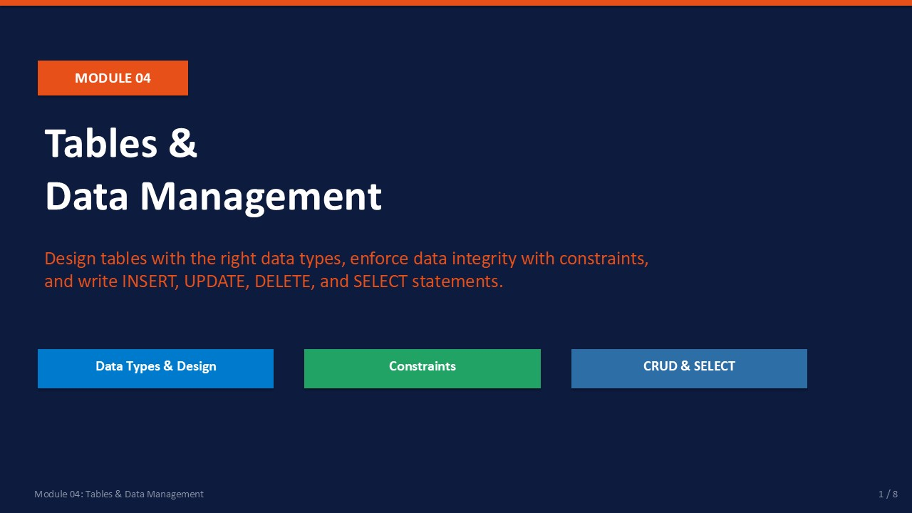
Slide 1 of 16

Module 04: Tables & Data Management
Module | Day | Duration | Lab
04 | 1 — Afternoon | 120 minutes | Lab 04

Databases store data in tables — rows and columns with enforced rules. This module covers everything needed to design, create, and populate tables in SQL Server: choosing the right data types, applying integrity constraints, and performing all four CRUD operations (Create, Read, Update, Delete).
The tables you build in Lab 04 persist into Lab 05, where you will test access control against them. Good table design is also the foundation for the backup, maintenance, and performance work in Day 2.
ℹ | Prerequisite  Lab 04 uses LabDB_TSQL created in Lab 03. Confirm that database exists and is accessible in SSMS before starting this lab.

What This Module Covers
- Data Types SQL Server numeric, string, date, and special data types.
- Constraints PRIMARY KEY, FOREIGN KEY, UNIQUE, NOT NULL, and CHECK.
- INSERT & UPDATE Adding and modifying rows safely.
- DELETE & SELECT Removing rows and querying data including JOINs.

SLIDE 2 — LEARNING OBJECTIVES

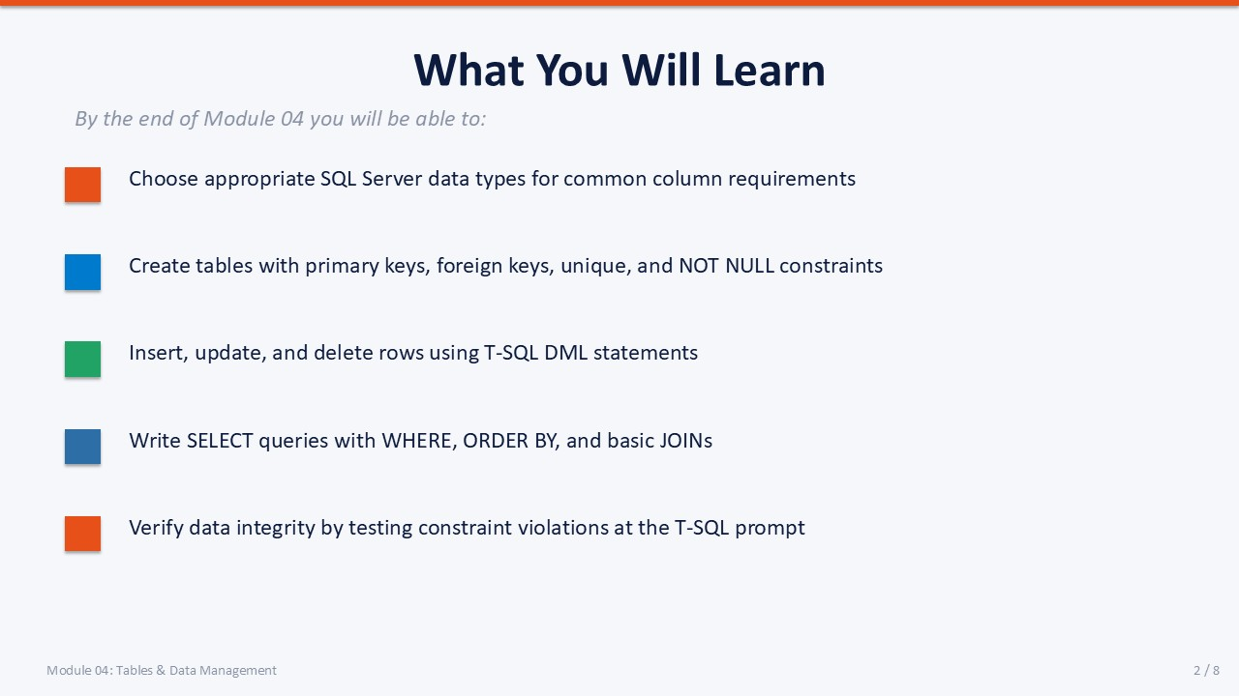
Slide 2 of 16

Learning Objectives
By the end of Module 04 you will be able to:
- Choose appropriate data types — selecting the correct type prevents data quality issues and wasted storage.
- Create tables with constraints — PRIMARY KEY, FOREIGN KEY, UNIQUE, NOT NULL, and CHECK in T-SQL.
- Perform INSERT and UPDATE — single-row, multi-row, and update-with-where-clause patterns.
- Perform DELETE and SELECT — safe deletion with WHERE and full SELECT including JOINs.
- Verify referential integrity — test that FOREIGN KEY constraints reject invalid data as expected.

SLIDE 3 — DATA TYPES

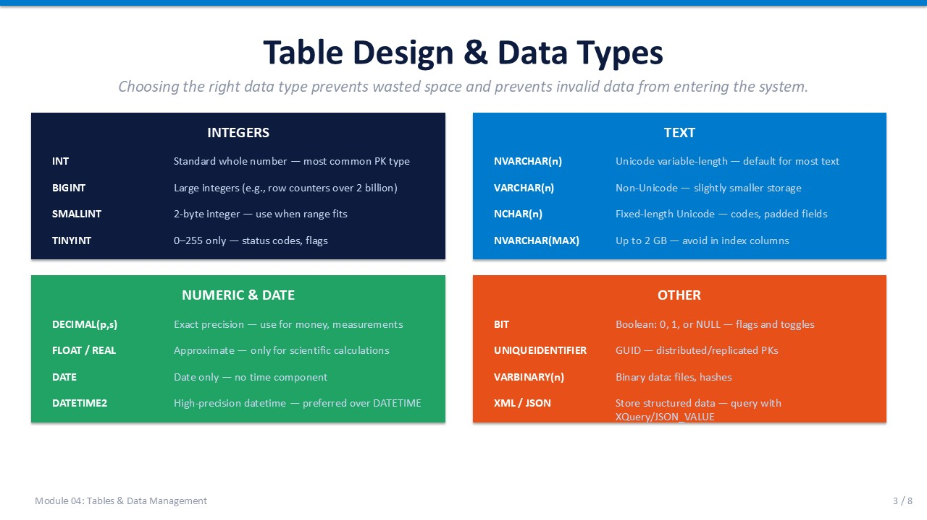
Slide 3 of 16

4.1 Choosing the Right Data Type
Data types define what values a column can hold. Choosing the correct type enforces data quality at the engine level and affects storage size, index efficiency, and query performance.
Category | Type | Storage | Use When
Integer | INT | 4 bytes | Whole numbers up to ~2.1 billion.
Integer | BIGINT | 8 bytes | Whole numbers up to ~9.2 × 10¹⁸.
Integer | SMALLINT | 2 bytes | Whole numbers –32,768 to 32,767.
Integer | TINYINT | 1 byte | Whole numbers 0 to 255.
Text | NVARCHAR(n) | 2n bytes | Variable-length Unicode text (international).
Text | VARCHAR(n) | n bytes | Variable-length ASCII text (English-only).
Text | NVARCHAR(MAX) | up to 2 GB | Large text blobs (avoid in indexed columns).
Numeric | DECIMAL(p,s) | variable | Exact fixed-point numbers (money, quantities).
Numeric | FLOAT | 4 or 8 bytes | Approximate floating-point (avoid for money).
Date/Time | DATE | 3 bytes | Date only: 0001-01-01 to 9999-12-31.
Date/Time | DATETIME2(n) | 6–8 bytes | High-precision date and time.
Special | BIT | 1 bit | Boolean (0/1/NULL).
Special | UNIQUEIDENTIFIER | 16 bytes | GUID — globally unique identifier.

💡 | NVARCHAR vs VARCHAR  Use NVARCHAR for any column that may contain non-English characters (names, addresses, descriptions). Use VARCHAR only when you are certain the data will always be ASCII. Mismatches cause implicit conversions that break index seeks.

SLIDE 4 — CONSTRAINTS

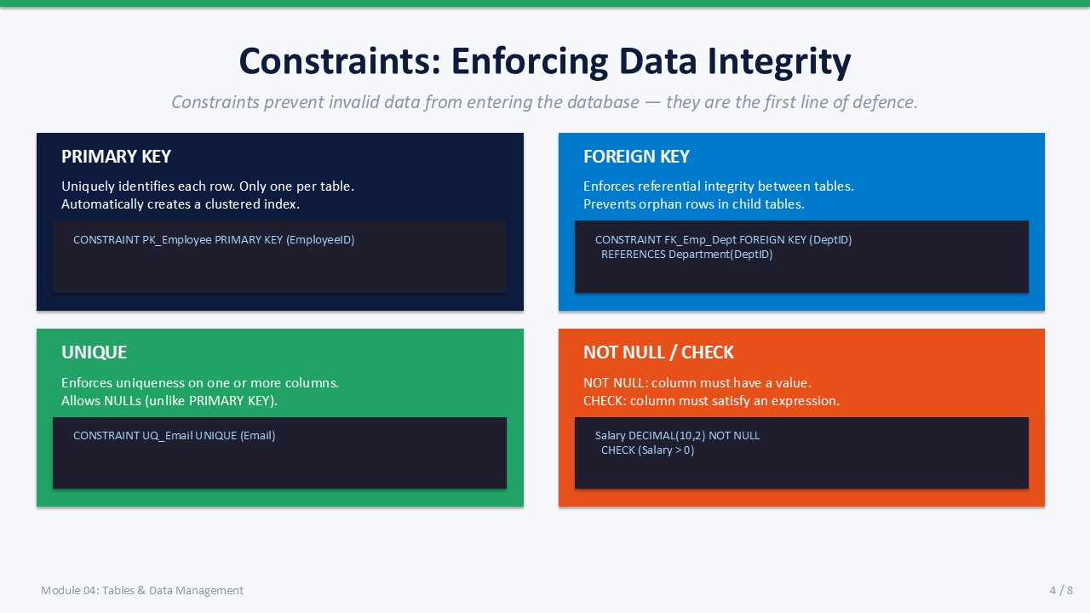
Slide 4 of 16

4.2 Table Constraints
Constraints are rules that SQL Server enforces at the engine level. They are the first and strongest line of data integrity defence — they fire before any application code can inspect the data.

PRIMARY KEY
Uniquely identifies each row in a table. Only one per table. SQL Server automatically creates a clustered index on the primary key unless specified otherwise.
T-SQL
CREATE TABLE Department
(
DeptID INT NOT NULL,
DeptName NVARCHAR(100) NOT NULL,
CONSTRAINT PK_Department PRIMARY KEY (DeptID)
);

FOREIGN KEY
Enforces referential integrity between two tables. A foreign key value must either be NULL or match an existing value in the referenced primary key. This prevents orphaned rows.
T-SQL
CREATE TABLE Employee
(
EmpID INT NOT NULL,
EmpName NVARCHAR(100) NOT NULL,
DeptID INT NULL,
Salary DECIMAL(10,2) NOT NULL,
CONSTRAINT PK_Employee PRIMARY KEY (EmpID),
CONSTRAINT FK_Emp_Dept FOREIGN KEY (DeptID)
REFERENCES Department(DeptID),
CONSTRAINT CK_Emp_Salary CHECK (Salary > 0)
);

UNIQUE
Ensures all values in a column (or combination of columns) are distinct. Unlike PRIMARY KEY, a UNIQUE column allows NULLs (up to one NULL per column).
T-SQL
-- Add UNIQUE on a column
ALTER TABLE Employee
ADD CONSTRAINT UQ_EmpName UNIQUE (EmpName);
-- Or inline at table creation
-- EmpEmail NVARCHAR(200) UNIQUE

NOT NULL and CHECK
NOT NULL prevents missing values. CHECK constrains the allowed range or pattern of values.
T-SQL
-- NOT NULL (declared inline with column)
-- EmpName NVARCHAR(100) NOT NULL
-- CHECK constraint
ALTER TABLE Employee
ADD CONSTRAINT CK_Salary_Positive CHECK (Salary > 0);
-- CHECK with pattern
ALTER TABLE Employee
ADD CONSTRAINT CK_Hire_Date CHECK (HireDate <= GETDATE());

SLIDE 5 — INSERT & UPDATE

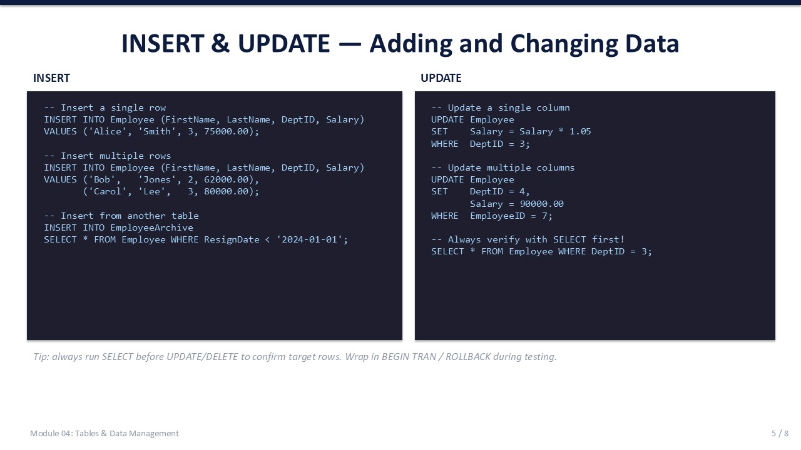
Slide 5 of 16

4.3 INSERT and UPDATE

INSERT
Three common INSERT patterns:
T-SQL
-- 1. Single-row insert with explicit column list (recommended)
INSERT INTO Department (DeptID, DeptName)
VALUES (1, N'Engineering');
-- 2. Multi-row insert
INSERT INTO Department (DeptID, DeptName)
VALUES
(2, N'Finance'),
(3, N'Human Resources');
-- 3. Insert from another table
INSERT INTO Department (DeptID, DeptName)
SELECT OldID, OldName
FROM OldDepartment
WHERE Active = 1;

💡 | Always Specify the Column List  INSERT INTO Table VALUES (...) without a column list depends on column order. If a column is ever added or reordered, the insert breaks. Always name the target columns explicitly.

UPDATE
T-SQL
-- Always SELECT first — verify what rows will be affected
SELECT EmpID, Salary
FROM Employee
WHERE DeptID = 1;
-- Single column update
UPDATE Employee
SET Salary = Salary * 1.10
WHERE DeptID = 1;
-- Multi-column update
UPDATE Employee
SET Salary = 75000,
DeptID = 2
WHERE EmpID = 3;

⚠ | UPDATE Without WHERE Updates All Rows  UPDATE Employee SET Salary = 0 — without a WHERE clause — zeroes every employee's salary. Always confirm the WHERE clause by running a SELECT first.

SLIDE 6 — DELETE & SELECT

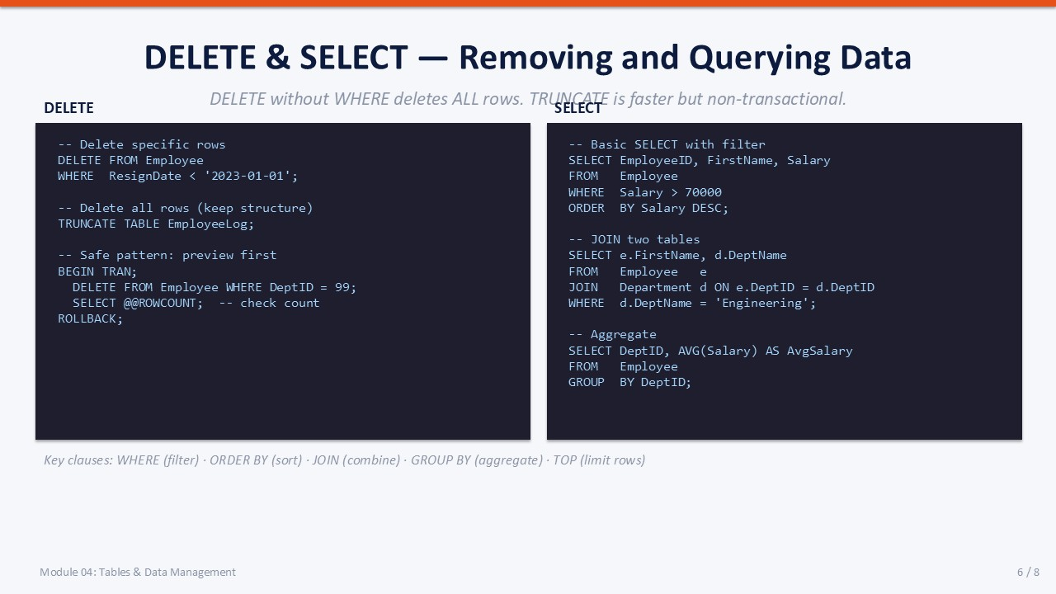
Slide 6 of 16

4.4 DELETE and SELECT

DELETE
Three approaches to removing rows:
T-SQL
-- DELETE with WHERE (targeted removal)
DELETE FROM Employee
WHERE EmpID = 5;
-- TRUNCATE (removes all rows, much faster than DELETE)
-- Cannot roll back if not inside an explicit transaction
-- Cannot be used on tables with foreign key references
TRUNCATE TABLE StagingData;
-- Safe pattern with explicit transaction
BEGIN TRAN;
DELETE FROM Employee
WHERE DeptID = 99;
-- Check row count: SELECT @@ROWCOUNT
ROLLBACK; -- Change to COMMIT when satisfied

SELECT
Common SELECT patterns used in this module:
T-SQL
-- All rows (use sparingly on large tables)
SELECT * FROM Employee;
-- Specific columns with filter and sort
SELECT EmpName, Salary
FROM Employee
WHERE Salary > 50000
ORDER BY Salary DESC;
-- INNER JOIN — match rows between tables
SELECT e.EmpName, d.DeptName, e.Salary
FROM Employee e
INNER JOIN Department d ON e.DeptID = d.DeptID
ORDER BY d.DeptName, e.EmpName;
-- GROUP BY with aggregate
SELECT d.DeptName,
COUNT(e.EmpID) AS HeadCount,
AVG(e.Salary) AS AvgSalary
FROM Employee e
INNER JOIN Department d ON e.DeptID = d.DeptID
GROUP BY d.DeptName
ORDER BY AvgSalary DESC;

SLIDE 7 — LAB 04

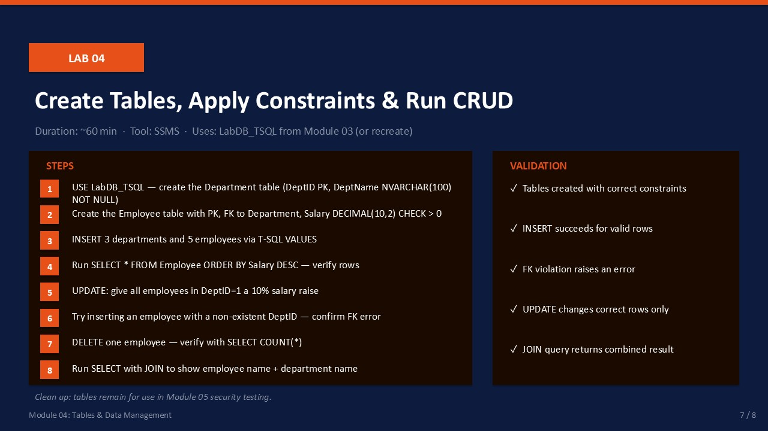
Slide 7 of 16

Lab 04: Tables, Constraints & CRUD Operations
Duration:  ~50 min | Database:  LabDB_TSQL | Role:  sysadmin | Cleanup:  Keep tables

🎯 | Mission Briefing — Lab 04  The company needs a new HR system. You have been asked to create the initial table structure for departments and employees in LabDB_TSQL, load test data, and verify that constraints work correctly. The tables must remain at the end — Module 05 tests security against them.

Part A — Create Tables
Open a new query window targeting LabDB_TSQL and run:
T-SQL
USE LabDB_TSQL;
GO
-- Department table
CREATE TABLE Department
(
DeptID INT NOT NULL,
DeptName NVARCHAR(100) NOT NULL,
CONSTRAINT PK_Department PRIMARY KEY (DeptID)
);
GO
-- Employee table with FK and CHECK
CREATE TABLE Employee
(
EmpID INT NOT NULL,
EmpName NVARCHAR(100) NOT NULL,
DeptID INT NULL,
Salary DECIMAL(10,2) NOT NULL,
HireDate DATE NOT NULL DEFAULT GETDATE(),
CONSTRAINT PK_Employee PRIMARY KEY (EmpID),
CONSTRAINT FK_Emp_Dept FOREIGN KEY (DeptID)
REFERENCES Department(DeptID),
CONSTRAINT CK_Salary CHECK (Salary > 0)
);
GO

- Run the script above.
Expected: Tables Department and Employee are created.
- Expand LabDB_TSQL → Tables in Object Explorer — both tables are visible.

Part B — Insert Data
T-SQL
-- Insert 3 departments
INSERT INTO Department (DeptID, DeptName) VALUES
(1, N'Engineering'),
(2, N'Finance'),
(3, N'Human Resources');
GO
-- Insert 5 employees
INSERT INTO Employee (EmpID, EmpName, DeptID, Salary) VALUES
(1, N'Ana Kovač', 1, 72000),
(2, N'Budi Santoso', 2, 68000),
(3, N'Claire Dupont', 1, 85000),
(4, N'Dawit Bekele', 3, 61000),
(5, N'Emre Yilmaz', 2, 74000);
GO

- Run the INSERT statements.
Expected: (3 rows affected) then (5 rows affected).

Part C — SELECT and UPDATE
T-SQL
-- View all employees
SELECT e.EmpID, e.EmpName, d.DeptName, e.Salary
FROM Employee e
INNER JOIN Department d ON e.DeptID = d.DeptID
ORDER BY e.EmpName;
GO
-- Give Engineering a 10% raise
UPDATE Employee
SET Salary = Salary * 1.10
WHERE DeptID = 1;
GO
-- Verify
SELECT EmpName, Salary FROM Employee WHERE DeptID = 1;

- Run the SELECT — confirm 5 rows with department names.
- Run the UPDATE.
Expected: (2 rows affected).
- Run the verification SELECT — Ana and Claire's salaries should be 10% higher.

Part D — Test the Foreign Key Constraint
T-SQL
-- This MUST fail — DeptID 99 does not exist
INSERT INTO Employee (EmpID, EmpName, DeptID, Salary)
VALUES (99, N'Ghost User', 99, 50000);

- Run the INSERT above.
Expected: Error: The INSERT statement conflicted with the FOREIGN KEY constraint "FK_Emp_Dept".

Part E — DELETE and COUNT
T-SQL
-- Delete one employee
DELETE FROM Employee WHERE EmpID = 5;
GO
-- Verify row count
SELECT COUNT(*) AS EmployeeCount FROM Employee;

- Run DELETE.
Expected: (1 row affected).
- Run COUNT — should return 4.

Validation Checklist
☐ Department and Employee tables exist in LabDB_TSQL
☐ 3 departments and 4 employees remain (after delete)
☐ JOIN query returns correct DeptName for each employee
☐ Engineering salaries are 10% higher after UPDATE
☐ FK violation INSERT failed with correct error message
☐ COUNT returns 4 after DELETE

Troubleshooting
Error | Likely Cause | Fix
Object already exists | Script run twice | DROP the table first or check IF NOT EXISTS
FK constraint violation | DeptID not in Department table | Insert matching Department row first
CHECK constraint failed | Salary value ≤ 0 | Use a positive Salary value in the INSERT
Cannot DROP table | FK reference from another table | DROP the referencing table first, or disable FK first

✓ | Tables Persist for Module 05  Do NOT drop Department or Employee tables. Module 05 Lab tests login access by querying these tables as a restricted user.

SLIDE 8 — MODULE SUMMARY

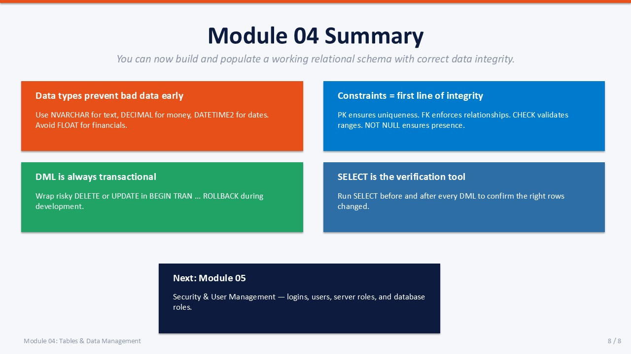
Slide 8 of 16

Module 04 Summary
The Department and Employee tables are now in place with proper constraints and data. The skills in this module are foundational to everything else in database administration.

Key Takeaways
- Data types prevent bad data Choosing the right type is the first constraint on data quality.
- Constraints are the first defence PK, FK, CHECK, and NOT NULL reject bad data before application code runs.
- DML is always transactional INSERT, UPDATE, DELETE can be wrapped in BEGIN TRAN for safety.
- SELECT is your verification tool Run SELECT before every UPDATE or DELETE to confirm the WHERE clause.
- Next: Module 05 Security & User Management — logins, users, and access control on these tables.

Knowledge Check
Q1. Which data type should you use for a name column that may contain non-English characters?
Answer: NVARCHAR(n) — it stores Unicode characters and supports international scripts.
Q2. What happens when you INSERT a row with a DeptID that does not exist in the Department table?
Answer: SQL Server raises an error: "The INSERT statement conflicted with the FOREIGN KEY constraint." The row is not inserted.
Q3. Why should you run SELECT before UPDATE?
Answer: To verify that the WHERE clause selects exactly the rows you intend to modify. An incorrect WHERE clause in an UPDATE can affect thousands of rows.
Q4. What is the difference between DELETE and TRUNCATE?
Answer: DELETE removes rows one at a time, logs each deletion, and fires triggers. TRUNCATE removes all rows as a single minimally-logged operation, resets identity, and cannot be used on tables with active FK references.

