SLIDE 1 — MODULE COVER

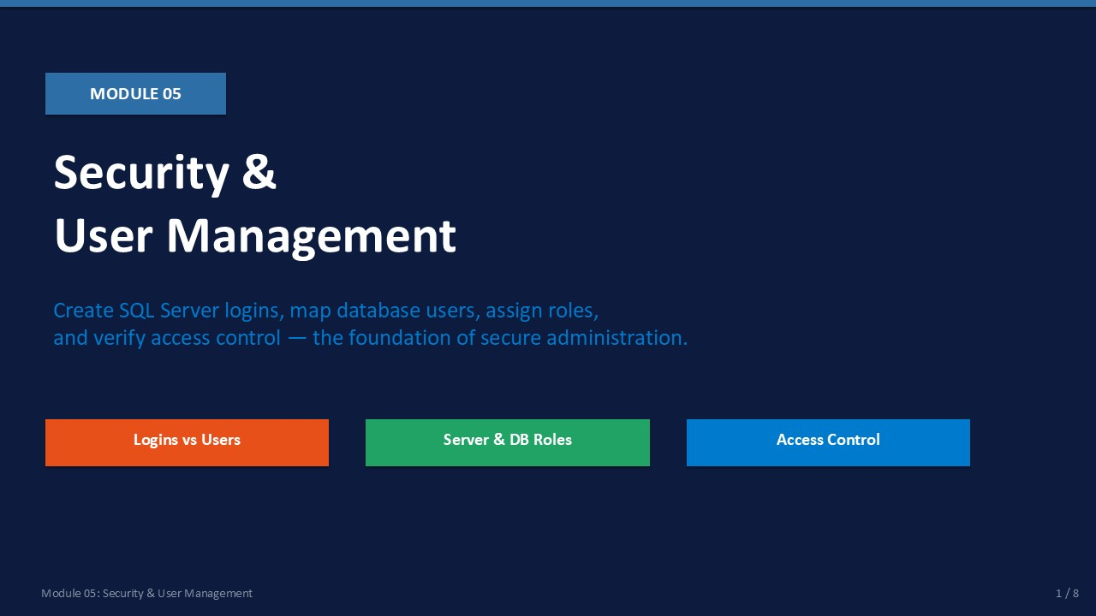
Slide 1 of 16

Module 05: SQL Server Security & User Management
Module | Day | Duration | Lab
05 | 1 — Afternoon | 90 minutes | Lab 05

Security is the most common source of both administrative headaches and serious incidents. SQL Server has a two-level security model: logins authenticate at the instance level, and database users authorise access at the database level. Confusing these two objects is the most frequent security mistake beginners make.
This module builds on the Employee and Department tables created in Lab 04. You will create a restricted login, map it to LabDB_TSQL, assign roles, test the access, then add more permissions and test again. The module closes Day 1 with a complete recap of all five modules.
ℹ | Security Principle: Least Privilege  Always grant the minimum permissions a user needs to do their job. Do not assign db_owner or sysadmin unless the role genuinely requires it. Start with db_datareader and add permissions only as proven necessary.

What This Module Covers
- Logins vs Database Users Two separate objects at two separate levels.
- Server Roles Instance-wide roles: sysadmin, securityadmin, dbcreator, and others.
- Database Roles Per-database roles: db_owner, db_datareader, db_datawriter, and others.
- T-SQL Security Commands CREATE LOGIN, CREATE USER, ALTER ROLE, GRANT, DENY, REVOKE.
- SSMS Security Workflow GUI path for creating logins and mapping users.

SLIDE 2 — LEARNING OBJECTIVES

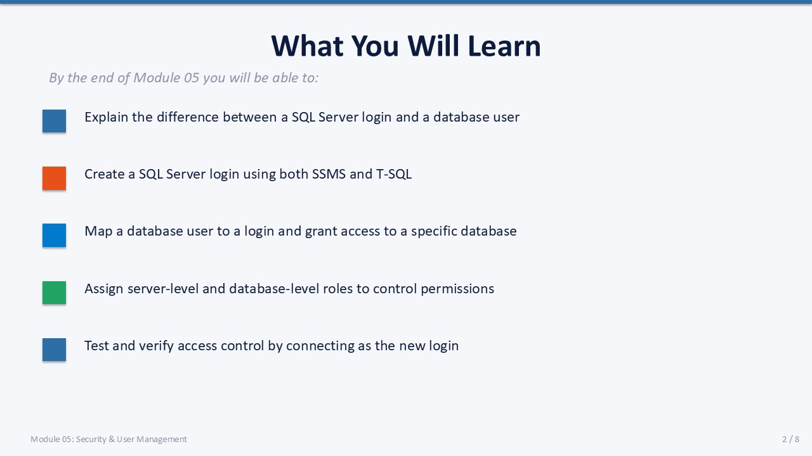
Slide 2 of 16

Learning Objectives
By the end of Module 05 you will be able to:
- Explain the difference between a login and a database user — a login authenticates; a user authorises. One login can map to users in many databases.
- Create a SQL Server login using SSMS and T-SQL — using CREATE LOGIN with CHECK_POLICY and DEFAULT_DATABASE.
- Map a database user to a login — using CREATE USER … FOR LOGIN inside the target database.
- Assign server and database roles — ALTER ROLE … ADD MEMBER for database roles; sp_addsrvrolemember for server roles.
- Test and verify access control — connect as the new login, run permitted and denied operations, confirm IS_MEMBER.

SLIDE 3 — LOGINS VS DATABASE USERS

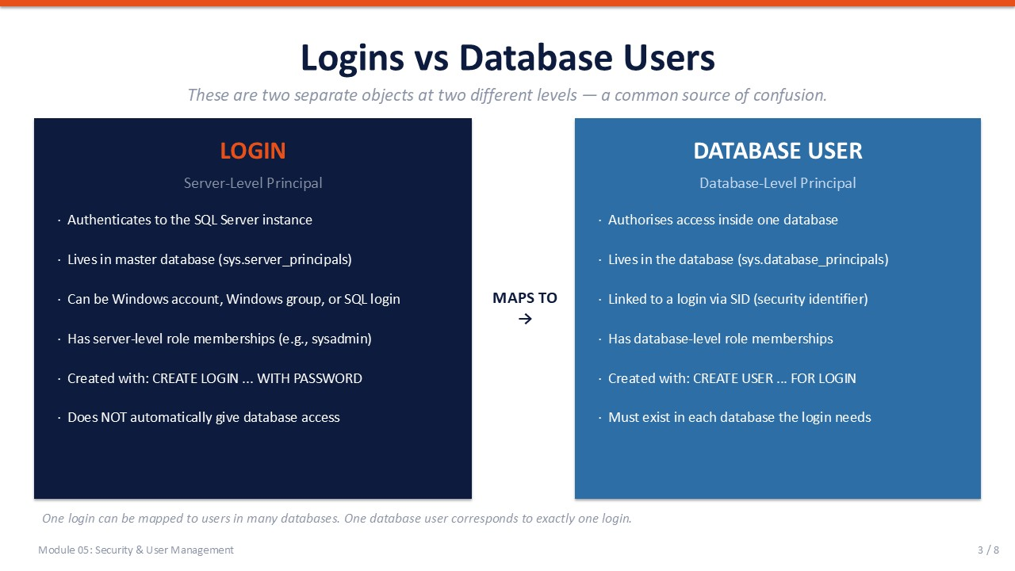
Slide 3 of 16

5.1 Logins vs Database Users
The single most important concept in SQL Server security is the distinction between a login and a database user. They are different objects, at different levels, stored in different system tables.
Attribute | LOGIN | DATABASE USER
Level | Instance (server-level) | Database-level
Stored in | master database | Each individual database
System view | sys.server_principals | sys.database_principals
Auth types | Windows account / SQL auth | Linked to login via SID
Roles | Server roles | Database roles
Created with | CREATE LOGIN … WITH PASSWORD | CREATE USER … FOR LOGIN
Key fact | Allows connection to the instance | Does NOT auto-grant DB access

💡 | Key Insight: Login ≠ Database Access  Creating a login does NOT automatically give access to any database. You must also create a database user in each database the login needs access to. This two-step requirement is a deliberate security design.

The Mapping
A login is linked to a database user via the Security Identifier (SID). When a login connects and attempts to access a database, SQL Server looks for a user in that database whose SID matches the login's SID. If none is found, the login is denied access (or mapped to the guest user if enabled — which it should not be).

SLIDE 4 — SERVER ROLES & DATABASE ROLES

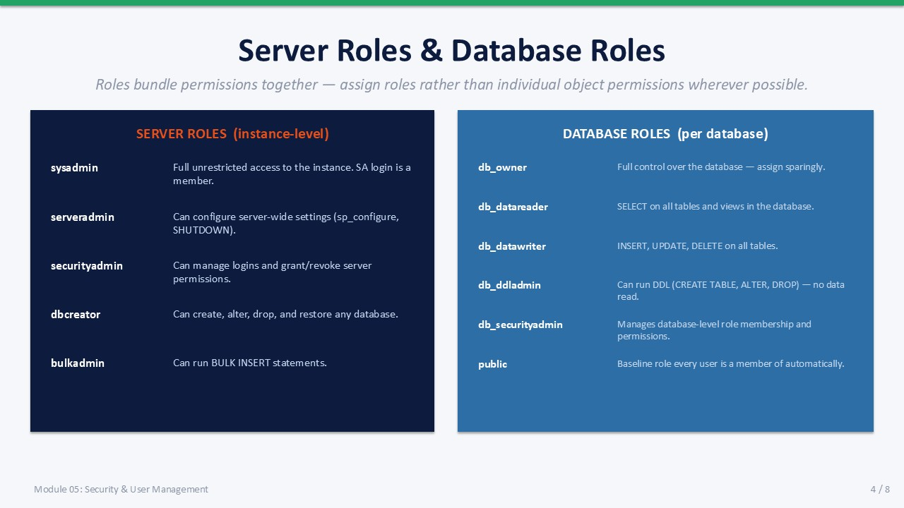
Slide 4 of 16

5.2 Server Roles and Database Roles
Roles are the recommended way to grant permissions. Assign roles rather than individual object permissions wherever possible — roles are easier to audit, revoke, and document.

Fixed Server Roles
Role | Grants
sysadmin | Full unrestricted control over the instance. The SA login is a member. Assign with extreme care.
serveradmin | Can configure server-wide settings and shut down the instance.
securityadmin | Can manage logins and grant/revoke server-level permissions.
dbcreator | Can create, alter, drop, and restore any database.
bulkadmin | Can run BULK INSERT statements — useful for ETL service accounts.
public | Every login is a member. Used for minimal default permissions.

Fixed Database Roles
Role | Grants
db_owner | Full control over the database — create, alter, drop objects, manage users.
db_datareader | SELECT on all tables and views in the database.
db_datawriter | INSERT, UPDATE, DELETE on all tables in the database.
db_ddladmin | Can run DDL (CREATE TABLE, ALTER, DROP) — cannot read or write data.
db_securityadmin | Manages database-level role membership and permissions.
public | Baseline role every database user is a member of automatically.

⚠ | Never Assign db_owner for Read-Only Access  db_owner gives the user permission to drop tables, change permissions, and delete the database. For read-only access, use db_datareader. For read+write, use db_datareader + db_datawriter. Only use db_owner for application service accounts that genuinely need full control.

SLIDE 5 — T-SQL FOR SECURITY

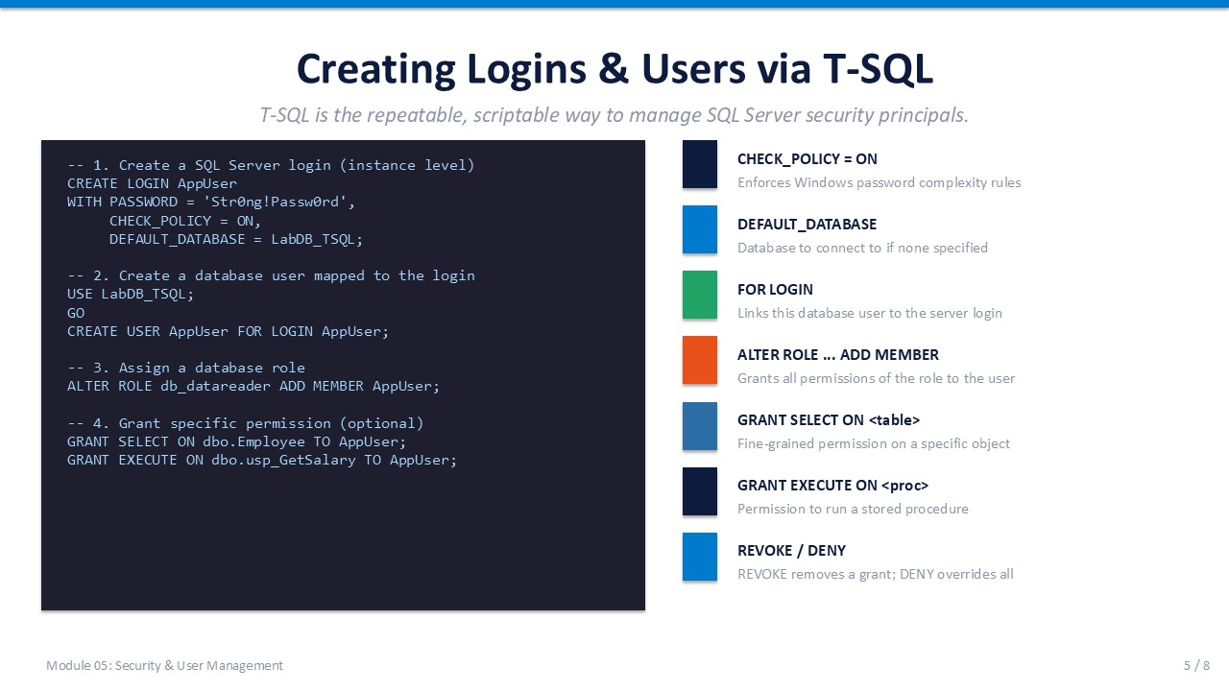
Slide 5 of 16

5.3 Creating Logins and Users via T-SQL
T-SQL is the authoritative, scriptable method for managing security principals. Production environments should have all security objects in source control as T-SQL scripts.
T-SQL
-- ── Step 1: Create a SQL Server login (run in master or any context) ──────
CREATE LOGIN AppUser
WITH PASSWORD = 'Str0ng!Passw0rd',
CHECK_POLICY = ON, -- Enforce Windows password policy
DEFAULT_DATABASE = LabDB_TSQL;
GO
-- ── Step 2: Create a database user mapped to the login ──────────────────
USE LabDB_TSQL;
GO
CREATE USER AppUser FOR LOGIN AppUser;
GO
-- ── Step 3: Assign a database role ──────────────────────────────────────
ALTER ROLE db_datareader ADD MEMBER AppUser;
GO
-- ── Step 4: Grant specific object permission (optional) ─────────────────
GRANT SELECT ON dbo.Employee TO AppUser;
GRANT EXECUTE ON dbo.usp_GetSalary TO AppUser;
GO
-- ── Revoke and Deny ─────────────────────────────────────────────────────
-- REVOKE removes a previously granted permission
REVOKE SELECT ON dbo.Employee FROM AppUser;
-- DENY overrides all grants — use to explicitly block an inherited permission
DENY SELECT ON dbo.Employee TO AppUser;

Command | Effect
CHECK_POLICY = ON | Enforces Windows password complexity rules (length, special chars).
DEFAULT_DATABASE | The database SQL Server connects to if none is specified.
CREATE USER … FOR LOGIN | Links the database user to the server login via SID.
ALTER ROLE … ADD MEMBER | Grants all permissions of the role to the specified user.
GRANT SELECT ON <table> | Grants SELECT permission on a specific table.
REVOKE | Removes a previously granted or denied permission.
DENY | Explicitly blocks a permission, overriding any role grants.

SLIDE 6 — MANAGING SECURITY VIA SSMS

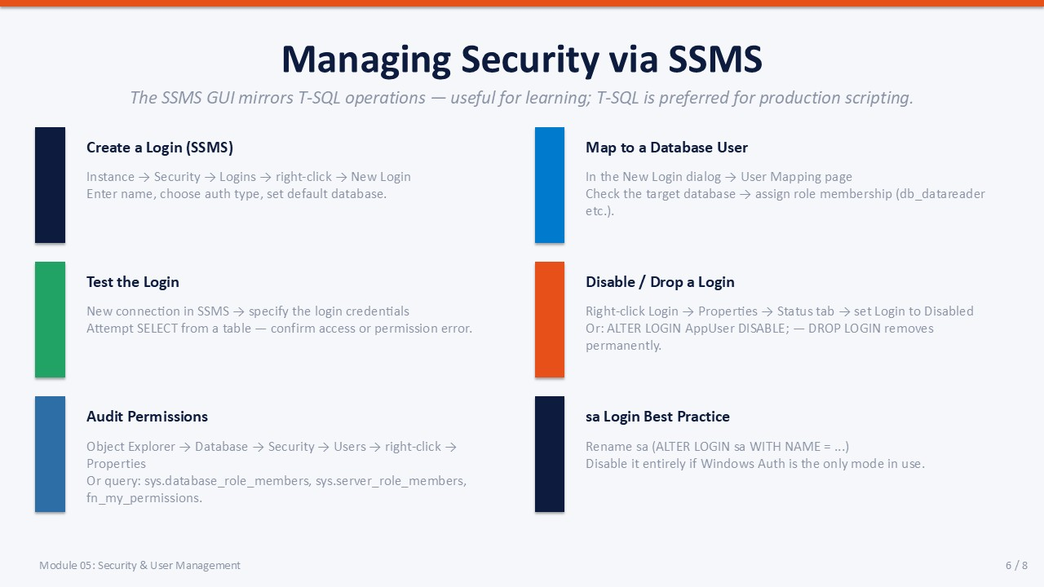
Slide 6 of 16

5.4 Managing Security via SSMS
The SSMS GUI provides the same operations as T-SQL. It is useful for learning and one-off tasks, but T-SQL scripts should be used for production changes to maintain an audit trail in source control.

Create a Login (SSMS)
In Object Explorer expand the instance → Security → Logins → right-click → New Login.
Enter the login name, choose SQL Server Authentication, set password, choose default database. User Mapping page: check target database and assign role.

Map to a Database User
In the New Login dialog → User Mapping page.
Check the checkbox next to the target database. In the Database Role Membership section, check db_datareader.

Test the Login
Open a new SSMS connection window. Click "Change Connection" or open a second SSMS instance.
Connect using the new login credentials. Run SELECT — confirm access. Try INSERT — confirm denial.

Disable / Drop a Login
Right-click Login → Properties → Status tab → set Login to Disabled.
Or via T-SQL: ALTER LOGIN AppUser DISABLE;
To remove permanently: DROP LOGIN AppUser; (run in master).

Audit Permissions
Object Explorer → Database → Security → Users → right-click → Properties.
Or query: SELECT * FROM sys.database_role_members; and sys.server_role_members.

SA Login Best Practice
The SA account is a well-known target. If using Mixed Mode: rename SA to something non-obvious, and set a strong password.
If using Windows Auth only: disable SA with ALTER LOGIN sa DISABLE;

SLIDE 7 — LAB 05

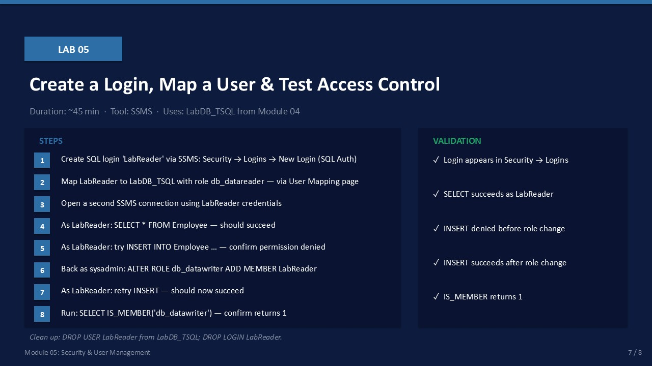
Slide 7 of 16

Lab 05: Create a Login, Map a User & Test Access Control
Duration:  ~45 min | Database:  LabDB_TSQL | Role:  sysadmin | Cleanup:  Yes

🎯 | Mission Briefing — Lab 05  A junior analyst named LabReader needs read-only access to the HR database (LabDB_TSQL). They should be able to SELECT from Employee, but not INSERT or UPDATE. Later, the team lead decides LabReader also needs write access. Your job: provision the login, test both access levels, then clean up.

Part A — Create the LabReader Login via SSMS
- In Object Explorer, expand the instance → Security → Logins → right-click → New Login.
- Login name: LabReader.
- Select SQL Server Authentication. Password: Lab@Reader2024. Uncheck "Enforce password expiration".
- Default database: LabDB_TSQL.
- Click User Mapping. Check LabDB_TSQL. In Database Role Membership, check db_datareader.
- Click OK.
Expected: LabReader appears under Security → Logins.

Part B — Test Read Access as LabReader
Open a new SSMS query window and change the connection to LabReader:
- File → New → Database Engine Query. Server: same instance. Auth: SQL Auth. Login: LabReader, Password: Lab@Reader2024.
- In the new window, run: SELECT * FROM LabDB_TSQL.dbo.Employee;
Expected: 4 rows returned — SELECT succeeds.
- Run: INSERT INTO LabDB_TSQL.dbo.Employee (EmpID, EmpName, DeptID, Salary) VALUES (99, N'Test', 1, 50000);
Expected: Error: INSERT permission was denied on the object 'Employee'.

Part C — Grant Write Access
Switch back to the sysadmin query window and run:
T-SQL
USE LabDB_TSQL;
GO
ALTER ROLE db_datawriter ADD MEMBER LabReader;
GO

- Run the script.
Expected: Command(s) completed successfully.
- Switch to the LabReader window. Retry the INSERT.
Expected: INSERT succeeds — (1 row affected).
- Run: SELECT IS_MEMBER('db_datawriter'); — in the LabReader connection.
Expected: Returns 1, confirming role membership.

Part D — Verify Role Membership
Back in the sysadmin window:
T-SQL
-- View all database users and their role memberships
SELECT dp.name AS principal_name,
dp.type_desc,
rp.name AS role_name
FROM sys.database_role_members rm
JOIN sys.database_principals dp ON rm.member_principal_id = dp.principal_id
JOIN sys.database_principals rp ON rm.role_principal_id = rp.principal_id
WHERE dp.name = 'LabReader'
ORDER BY rp.name;

- Run the query.
Expected: Two rows returned: db_datareader and db_datawriter.

Part E — Cleanup
T-SQL
-- 1. Clean up the test row inserted in Part C
USE LabDB_TSQL;
GO
DELETE FROM Employee WHERE EmpID = 99;
GO
-- 2. Drop the database user
DROP USER LabReader;
GO
-- 3. Drop the login
USE master;
GO
DROP LOGIN LabReader;
GO

- Run the cleanup script.
Expected: All three statements complete successfully.
- Verify: LabReader no longer appears under Security → Logins.

Validation Checklist
☐ LabReader login appears in Security → Logins
☐ SELECT * FROM Employee succeeds as LabReader
☐ INSERT denied before db_datawriter role is added
☐ INSERT succeeds after ALTER ROLE db_datawriter ADD MEMBER LabReader
☐ IS_MEMBER('db_datawriter') returns 1
☐ sys query shows LabReader in both db_datareader and db_datawriter
☐ Cleanup: test row deleted, user dropped, login dropped

Troubleshooting
Error | Likely Cause | Fix
Login failed for LabReader | Wrong password or login disabled | Check SSMS → Security → Logins → Properties → Status
Cannot connect to database | User mapping missing | Create User in LabDB_TSQL: CREATE USER LabReader FOR LOGIN LabReader
INSERT still denied after role add | Role not added to current context | Close and reopen LabReader connection to reload permissions
Cannot drop login | User still exists in a database | Run DROP USER LabReader in each database first, then DROP LOGIN

SLIDE 8 — DAY 1 WRAP-UP

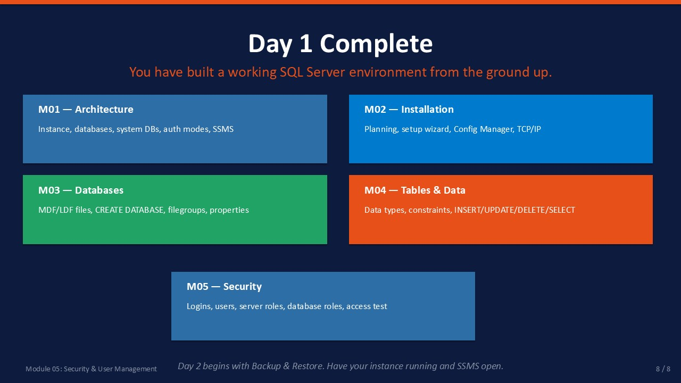
Slide 8 of 16

Day 1 Complete — Course Recap
You have built a complete SQL Server environment from scratch. Every skill from this day is a prerequisite for Day 2 — if any area is unclear, review the relevant module before Day 2 begins.
Module | Title | Core Skills Achieved
M01 | Architecture | SSMS navigation, system databases, auth modes, instance structure
M02 | Installation | Config Manager, TCP/IP, firewall, remote SSMS connection
M03 | Databases | CREATE DATABASE (GUI + T-SQL), filegroups, ALTER DATABASE, DMVs
M04 | Tables & Data | CREATE TABLE, constraints, INSERT/UPDATE/DELETE/SELECT, JOIN
M05 | Security | Logins, users, roles, GRANT/DENY/REVOKE, access verification

Day 2 Preview
- Module 06 — Backup & Restore Full, differential, log backups. Recovery models. Restore scenarios.
- Module 07 — Maintenance Index rebuild, update statistics, DBCC CHECKDB.
- Module 08 — SQL Server Agent Jobs, schedules, alerts, automated maintenance.
- Module 09 — Monitoring Activity Monitor, DMVs, blocking and deadlocks.
- Module 10 — Troubleshooting Error logs, login failures, performance bottlenecks.
- Module 11 — Import/Export Import/Export Wizard, CSV, Excel, basic ETL concepts.
ℹ | Preparation for Day 2  Ensure the following are in place before Day 2:  • SQL Server service running and SSMS accessible  • TCP/IP enabled and firewall rule for port 1433 in place  • LabDB_TSQL exists with Department and Employee tables  • sysadmin login available for backup and maintenance tasks

Knowledge Check
Q1. What is the key difference between a SQL Server login and a database user?
Answer: A login is a server-level principal that authenticates at the instance level (stored in master). A database user is a database-level principal that authorises access within one specific database. Creating a login does NOT automatically grant database access.
Q2. Which role gives SELECT access on all tables without giving write permission?
Answer: db_datareader. It grants SELECT on all user tables and views in the database.
Q3. How do you give a user write access after they already have db_datareader?
Answer: ALTER ROLE db_datawriter ADD MEMBER <username>; — run in the context of the target database.
Q4. What does DENY do differently from REVOKE?
Answer: REVOKE removes a previously granted permission. DENY explicitly blocks the permission, overriding any grants that come from role membership. A DENY takes precedence over a GRANT from any role.

