SLIDE 1 — MODULE COVER

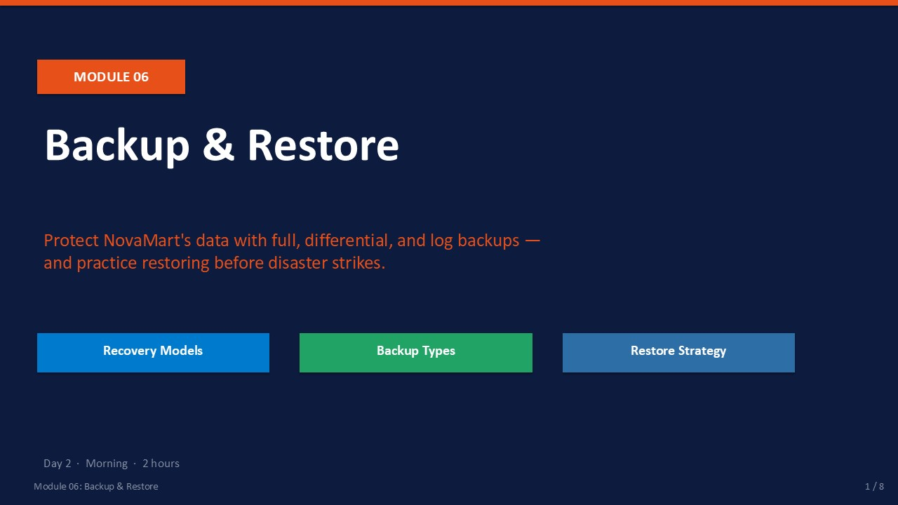
Slide 1 of 8

Module 06: Backup & Restore
Module | Day | Duration | Lab
06 | 2 — Morning | 2 hours | Lab 06

A backup is your last line of defence against data loss. Accidental table drops, hardware failure, ransomware, and human error are all resolved the same way: restore from a clean backup. This module teaches you how to choose the right recovery model, build a layered backup strategy, and practice restoring so that when disaster strikes you can act quickly and confidently.
NovaMart runs a production database. By the end of this module you will have performed a full backup, a differential backup, and a transaction log backup — then simulated a disaster and restored the complete database.
⚠ | Test Your Restores — Not Just Your Backups  An untested backup is not a backup — it is a hypothesis. Run a restore drill at least once per quarter on a test instance. Confirm that the database comes online, data is intact, and the restore completes in the expected time.

What This Module Covers
- Recovery Models Simple, Full, and Bulk-Logged — how each affects what you can restore.
- Backup Types Full, differential, and transaction log backups — when and why to use each.
- T-SQL Backup BACKUP DATABASE and BACKUP LOG commands with key options.
- Restore Sequence NORECOVERY vs RECOVERY, STOPAT for point-in-time, and REPLACE.
- Lab 06 Full disaster simulation: backup → drop table → restore → verify.

SLIDE 2 — LEARNING OBJECTIVES

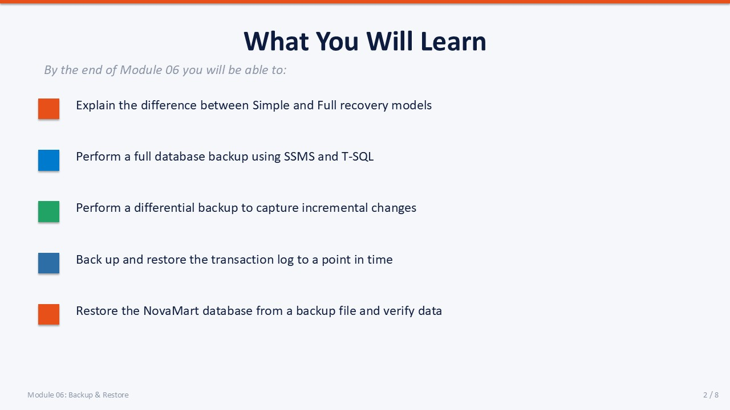
Slide 2 of 8

Learning Objectives
By the end of Module 06 you will be able to:
- Explain the difference between Simple and Full recovery models — and set the recovery model with ALTER DATABASE.
- Perform a full database backup using SSMS and T-SQL — BACKUP DATABASE ... TO DISK with FORMAT, INIT, COMPRESSION.
- Perform a differential backup to capture incremental changes — BACKUP DATABASE ... WITH DIFFERENTIAL.
- Back up and restore the transaction log to a point in time — BACKUP LOG; RESTORE LOG ... WITH STOPAT.
- Restore the NovaMart database from a backup chain and verify data — applying full → differential → log WITH NORECOVERY / RECOVERY in sequence.

SLIDE 3 — RECOVERY MODELS

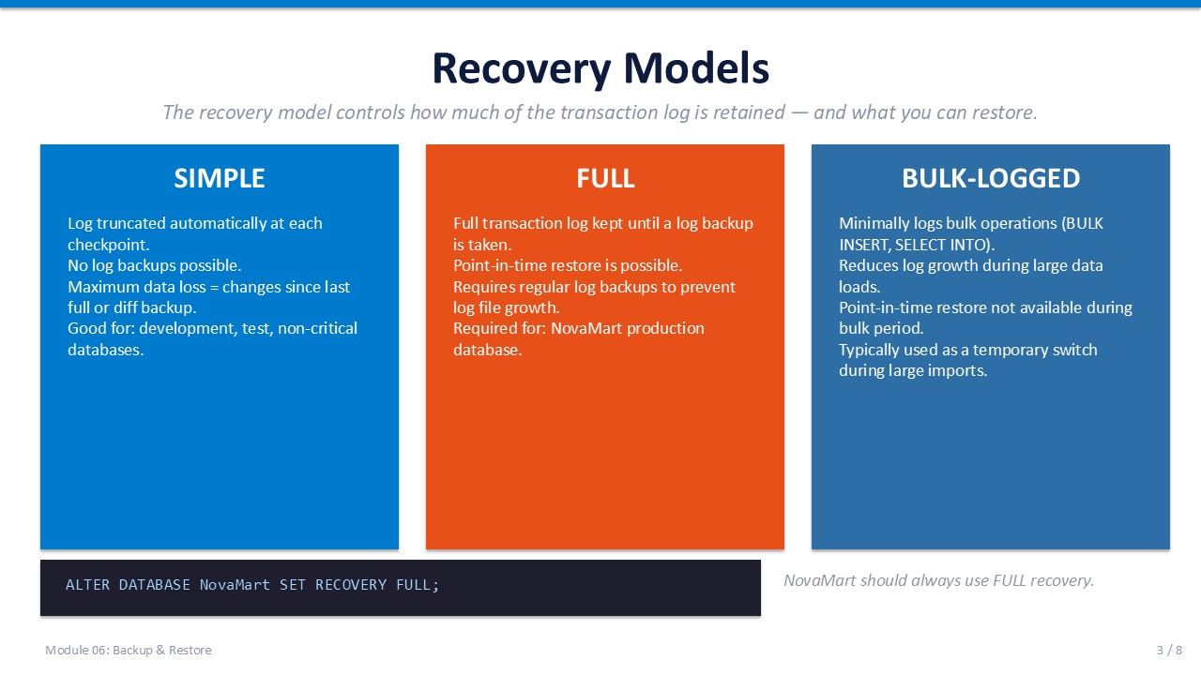
Slide 3 of 8

Recovery Models
The recovery model is a database-level setting that controls how much transaction log history SQL Server retains, which in turn determines what you can restore. Choose the wrong model and you may lose hours of data even when backups ran successfully.
Model | Log Truncation | Log Backups | Point-in-Time Restore | Best For
SIMPLE | Automatic (at checkpoint) | Not possible | No | Dev/test, read-only databases, low-criticality
FULL | Only via log backup | Required | Yes | Production databases where zero data loss matters
BULK-LOGGED | Only via log backup | Required | Limited | Temporary switch during large bulk operations to reduce log growth

ℹ | NovaMart Must Use FULL Recovery  NovaMart is a production database. Always set it to FULL recovery. SIMPLE recovery truncates the log automatically, making transaction log backups impossible and point-in-time restore unavailable.

T-SQL
-- Check the current recovery model
SELECT name, recovery_model_desc
FROM sys.databases
WHERE name = 'NovaMart';
-- Set to FULL recovery
ALTER DATABASE NovaMart SET RECOVERY FULL;
-- Verify the change
SELECT name, recovery_model_desc
FROM sys.databases
WHERE name = 'NovaMart';

Log File Growth Warning
Under FULL recovery the transaction log grows continuously until a log backup is taken. If you set FULL recovery but never schedule log backups, the log file will grow until the drive is full. Always pair FULL recovery with a log backup schedule.

SLIDE 4 — BACKUP TYPES

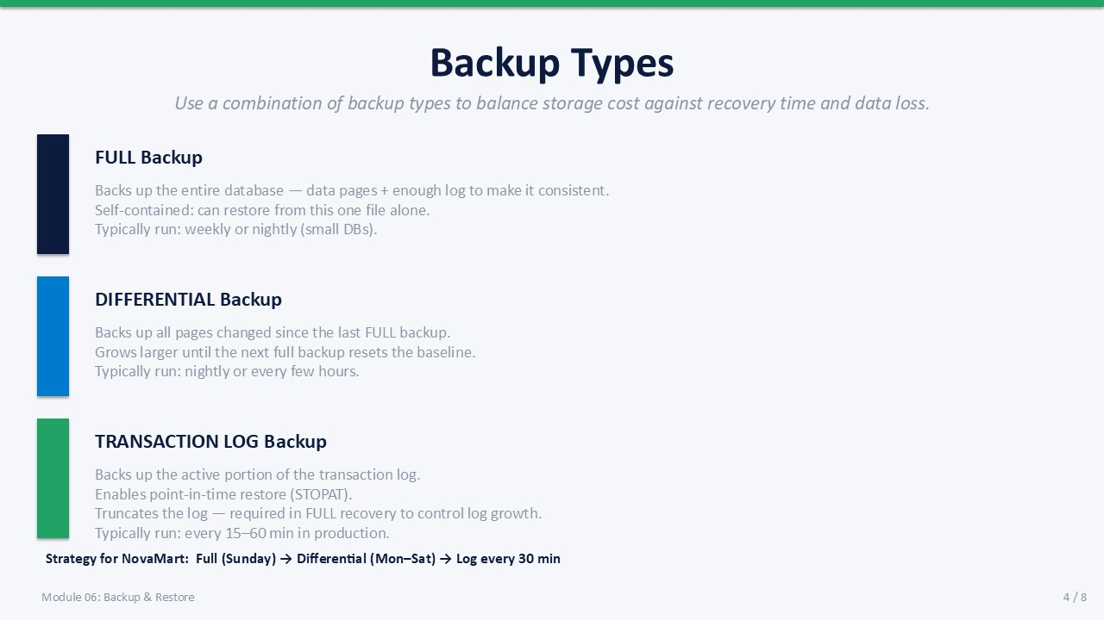
Slide 4 of 8

Backup Types
SQL Server provides three complementary backup types. Use them in combination to balance storage cost, backup window, and recovery time objective (RTO).
Type | What It Captures | Self-Contained | Typical Schedule
Full Backup | Entire database — all data pages plus enough log to ensure consistency | Yes — can restore from this file alone | Weekly (large DBs) or nightly (small DBs)
Differential Backup | All pages changed since the last full backup (grows until next full) | No — requires the last full backup | Nightly or every few hours
Transaction Log Backup | Active log since the last log backup; truncates log after backup | No — requires full + prior log chain | Every 15–60 minutes in production

NovaMart Recommended Strategy
Full backup every Sunday → Differential backup Monday through Saturday → Transaction log backup every 30 minutes around the clock.
- Full (Sun) Baseline — enables all restores for the week. Keep for 4 weeks.
- Diff (Mon–Sat) Reduces restore time vs log-only chain. Keep for 1 week.
- Log (every 30m) Point-in-time precision. Keep for 48 hours minimum.
ℹ | First Log Backup After Setting FULL Recovery  After switching from SIMPLE to FULL recovery, take a full backup immediately. Until the first full backup is taken after the model change, SQL Server keeps the database in "pseudo-SIMPLE" mode and log backups are not possible.

SLIDE 5 — PERFORMING BACKUPS VIA T-SQL

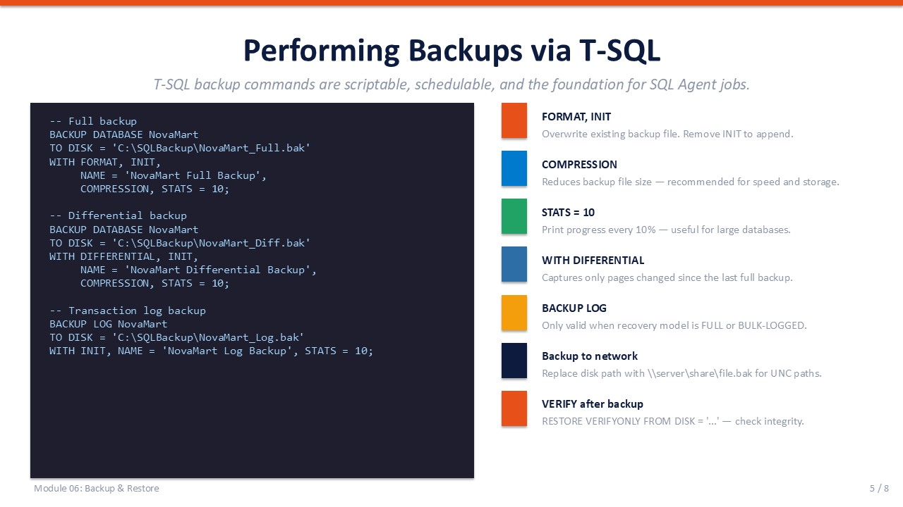
Slide 5 of 8

Performing Backups via T-SQL
T-SQL backup commands are the foundation for all automation. They are used directly in ad-hoc scripts, SQL Agent job steps, and maintenance plan tasks.
T-SQL
-- ── Full backup ──────────────────────────────────────────────────
BACKUP DATABASE NovaMart
TO DISK = 'C:\SQLBackup\NovaMart_Full.bak'
WITH FORMAT, -- overwrite file; create new backup set
INIT, -- overwrite existing backup sets in the file
NAME = 'NovaMart Full Backup',
COMPRESSION, -- smaller file, faster I/O
STATS = 10; -- print progress every 10 %
-- ── Differential backup ─────────────────────────────────────────
BACKUP DATABASE NovaMart
TO DISK = 'C:\SQLBackup\NovaMart_Diff.bak'
WITH DIFFERENTIAL,
INIT,
NAME = 'NovaMart Differential Backup',
COMPRESSION, STATS = 10;
-- ── Transaction log backup ───────────────────────────────────────
BACKUP LOG NovaMart
TO DISK = 'C:\SQLBackup\NovaMart_Log.bak'
WITH INIT,
NAME = 'NovaMart Log Backup',
STATS = 10;

Key Backup Options Reference
Option | Effect | When to Use
FORMAT | Creates a new media set — overwrites all existing backup sets on the file | First backup to a new file or when recycling a file
INIT | Overwrites existing backup sets in the media set (without new media header) | Nightly overwrites of yesterday's backup file
NOINIT | Appends to the existing backup sets in the file | Multiple backups in one file (audit trail)
COMPRESSION | Compresses the backup — reduces size 50–80 % | Always on unless restoring to pre-SQL 2008 R2
STATS = 10 | Prints completion percentage every 10 % in the Messages pane | Long-running backups; script visibility
COPY_ONLY | Ad-hoc backup that does not affect the differential baseline | Manual backup before a risky change without disrupting schedule
VERIFY ONLY | Checks backup integrity without restoring | RESTORE VERIFYONLY FROM DISK = '...' after every backup

SLIDE 6 — RESTORING A DATABASE

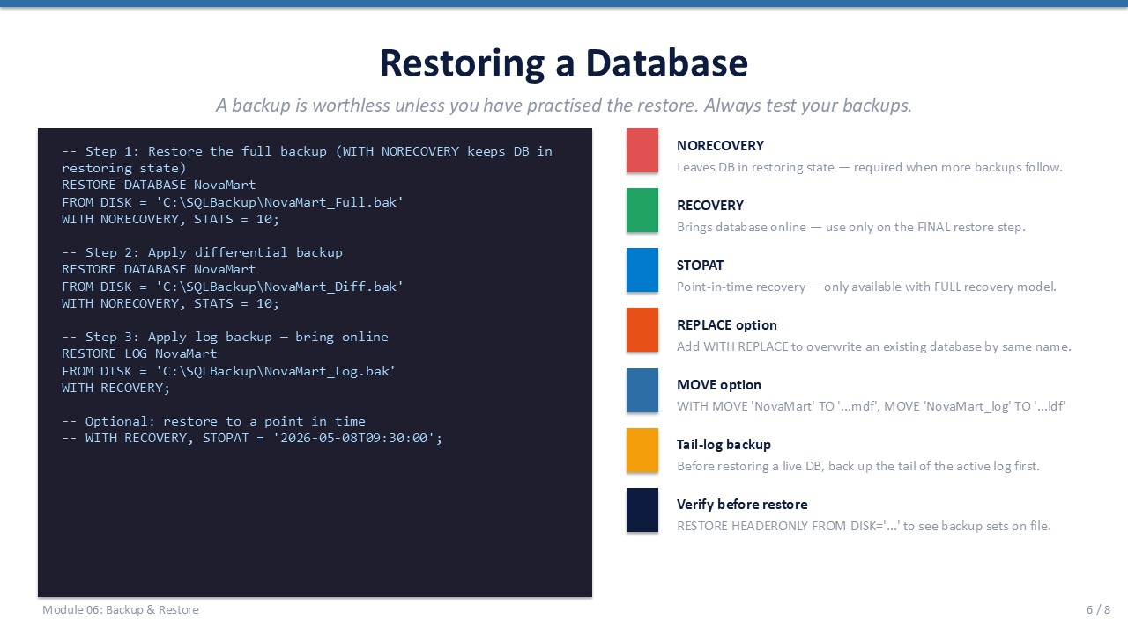
Slide 6 of 8

Restoring a Database
Restoring requires applying backups in the correct order: full first, then differential (if available), then log backups in sequence. Every step except the last uses WITH NORECOVERY to keep the database in a "Restoring" state that accepts further backups. The final step uses WITH RECOVERY to bring the database online.
T-SQL
-- ── Step 1: Restore the full backup ────────────────────────────
RESTORE DATABASE NovaMart
FROM DISK = 'C:\SQLBackup\NovaMart_Full.bak'
WITH NORECOVERY, -- keep DB in Restoring; more backups follow
STATS = 10;
-- ── Step 2: Apply differential backup ───────────────────────────
RESTORE DATABASE NovaMart
FROM DISK = 'C:\SQLBackup\NovaMart_Diff.bak'
WITH NORECOVERY,
STATS = 10;
-- ── Step 3: Apply log backup — bring database online ─────────────
RESTORE LOG NovaMart
FROM DISK = 'C:\SQLBackup\NovaMart_Log.bak'
WITH RECOVERY;
-- ── Optional: point-in-time recovery ────────────────────────────
-- Replace WITH RECOVERY above with:
-- WITH RECOVERY, STOPAT = '2026-05-15T09:30:00';

Restore Options Reference
Option | Effect
NORECOVERY | Database stays in Restoring state — required when more backups will be applied
RECOVERY | Brings database online — use only on the FINAL restore step
STOPAT | Point-in-time restore — requires FULL recovery model and a log backup that spans the target time
REPLACE | Overwrites an existing database of the same name — use with caution
MOVE ... TO | Relocates data and log files to different paths on the target server

⚠ | Take a Tail-Log Backup Before Restoring a Live Database  If you need to restore a live database without losing the most recent transactions, first run: BACKUP LOG NovaMart TO DISK = '...' WITH NO_TRUNCATE;  This captures the active log even if the database is damaged. Then apply it as the final step of the restore chain.

SLIDE 7 — LAB 06

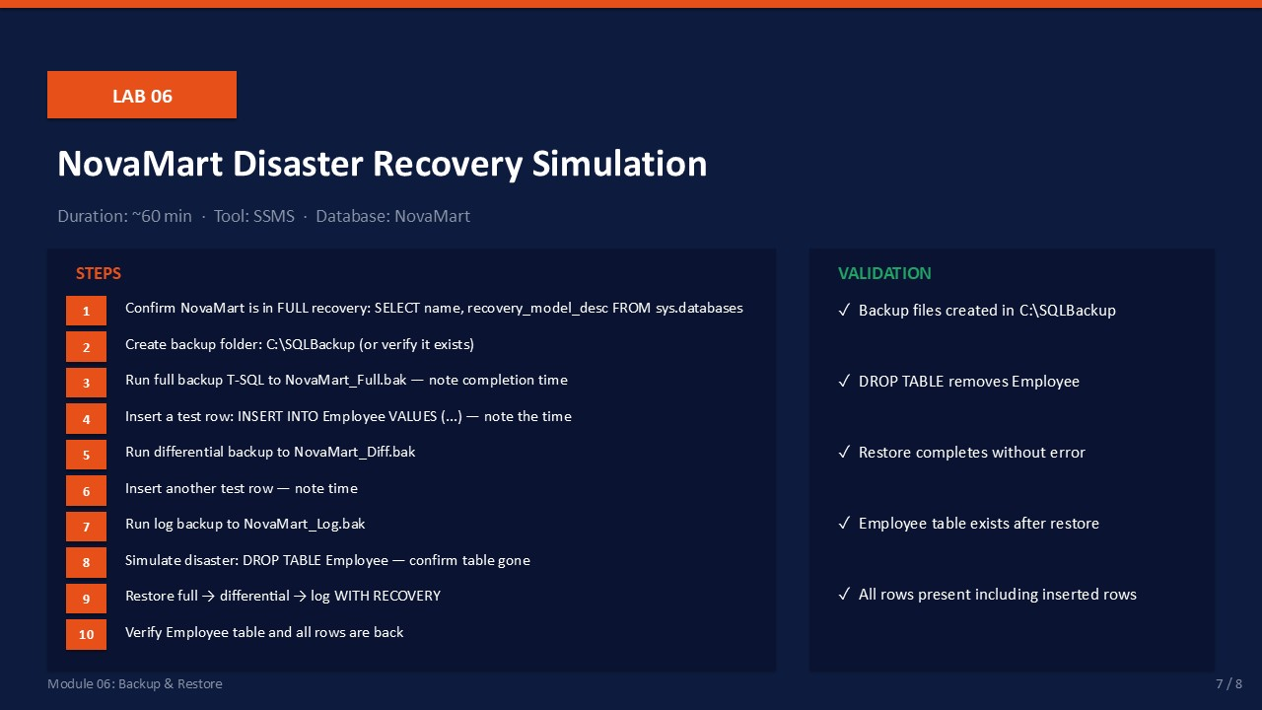
Slide 7 of 8

Lab 06: NovaMart Disaster Recovery Simulation
Goal | Duration | Tool | Database
Full backup chain, disaster simulation, and complete restore | ~60 min | SSMS | NovaMart

Prerequisites
- NovaMart database in FULL recovery model.
- C:\SQLBackup\ folder created on the server (or create it in step 2).
- Employee table exists with at least 3 rows (from Lab 04).

Part A: Set Up and Perform Backups
- Confirm FULL recovery model:
SELECT name, recovery_model_desc FROM sys.databases WHERE name = 'NovaMart';
Expected: recovery_model_desc shows FULL. If SIMPLE, run: ALTER DATABASE NovaMart SET RECOVERY FULL;
- Create the backup folder if it does not exist.
In PowerShell: New-Item -ItemType Directory -Path C:\SQLBackup -Force
Expected: C:\SQLBackup\ folder exists.
- Run a full backup:
BACKUP DATABASE NovaMart
TO DISK = 'C:\SQLBackup\NovaMart_Full.bak'
WITH FORMAT, INIT, NAME = 'NovaMart Full', COMPRESSION, STATS = 10;
Expected: Messages pane shows 100% and "BACKUP DATABASE successfully processed N pages."
- Note the current time. Insert a test row:
INSERT INTO dbo.Employee (FirstName, LastName, DeptID)
VALUES ('Disaster', 'TestRow', 1);
SELECT * FROM dbo.Employee;
Expected: New row visible. Note the time after the insert.
- Run a differential backup:
BACKUP DATABASE NovaMart
TO DISK = 'C:\SQLBackup\NovaMart_Diff.bak'
WITH DIFFERENTIAL, INIT, NAME = 'NovaMart Diff', COMPRESSION, STATS = 10;
Expected: Differential backup completes successfully.
- Insert a second test row:
INSERT INTO dbo.Employee (FirstName, LastName, DeptID)
VALUES ('Second', 'TestRow', 2);
Expected: Row inserted.
- Run a log backup:
BACKUP LOG NovaMart
TO DISK = 'C:\SQLBackup\NovaMart_Log.bak'
WITH INIT, NAME = 'NovaMart Log', STATS = 10;
Expected: Log backup completes. "Second TestRow" is now in the log backup.

Part B: Simulate Disaster
- Simulate accidental data loss:
DROP TABLE dbo.Employee;
SELECT * FROM dbo.Employee; -- should fail
Expected: Error: "Invalid object name 'dbo.Employee'." Table is gone.

Part C: Restore
- Restore the full backup (NORECOVERY — more backups follow):
RESTORE DATABASE NovaMart
FROM DISK = 'C:\SQLBackup\NovaMart_Full.bak'
WITH NORECOVERY, STATS = 10;
Expected: Database enters Restoring state. It is not yet accessible.
- Apply the differential backup:
RESTORE DATABASE NovaMart
FROM DISK = 'C:\SQLBackup\NovaMart_Diff.bak'
WITH NORECOVERY, STATS = 10;
Expected: Differential applied successfully.
- Apply the log backup and bring the database online:
RESTORE LOG NovaMart
FROM DISK = 'C:\SQLBackup\NovaMart_Log.bak'
WITH RECOVERY;
Expected: Database comes online. "RESTORE DATABASE successfully processed."
- Verify full recovery:
SELECT * FROM dbo.Employee;
Expected: Employee table exists with all original rows AND both TestRow rows inserted in steps 4 and 6.

Validation Checklist
☐ NovaMart_Full.bak, NovaMart_Diff.bak, NovaMart_Log.bak all exist in C:\SQLBackup\
☐ DROP TABLE confirmed the table was gone before restore
☐ Restore chain applied in correct order without errors
☐ Employee table accessible after restore with RECOVERY
☐ Both TestRow rows present — confirming differential and log were applied

Troubleshooting
Symptom | Likely Cause | Resolution
BACKUP LOG fails | Recovery model is SIMPLE | ALTER DATABASE NovaMart SET RECOVERY FULL; then take a full backup first
RESTORE fails: "exclusive access" | SSMS is connected to NovaMart | Set context to master before restoring: USE master; then RESTORE
Restore: "too new to be restored" | Log backup is older than diff backup | Apply backups in strict sequence: full → diff → log
Database stays in Restoring state | RECOVERY not applied on final step | Run: RESTORE DATABASE NovaMart WITH RECOVERY;

SLIDE 8 — DAY 2 PROGRESS CHECK

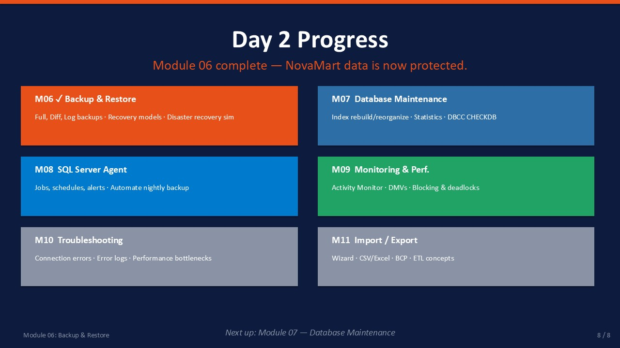
Slide 8 of 8

Day 2 Progress — Module 06 Complete
NovaMart data is now protected. You have built a complete backup strategy and proven it works with a full disaster simulation. The remaining Day 2 modules build on this foundation — automation, monitoring, and troubleshooting.
Module | Topic | Status
06 | Backup & Restore | ✓ Complete — full backup chain, disaster simulation, restore verified
07 | Database Maintenance | Next — index rebuild/reorganize, statistics, DBCC CHECKDB
08 | SQL Server Agent | Upcoming — automate the nightly backup job created today
09 | Monitoring & Performance | Upcoming — Activity Monitor, DMVs, blocking and deadlocks
10 | Basic Troubleshooting | Upcoming — connection errors, error log, performance first response
11 | Data Import & Export | Upcoming — Wizard, BULK INSERT, BCP, ETL concepts

ℹ | What Comes Next: Automate This in Module 08  In Module 08 (SQL Server Agent) you will turn today's manual backup commands into a scheduled SQL Agent job that runs every night at 02:00. Module 07 first covers database maintenance — keeping indexes and statistics healthy so queries remain fast after the data loads you performed in Module 04.

