SLIDE 1 — MODULE COVER

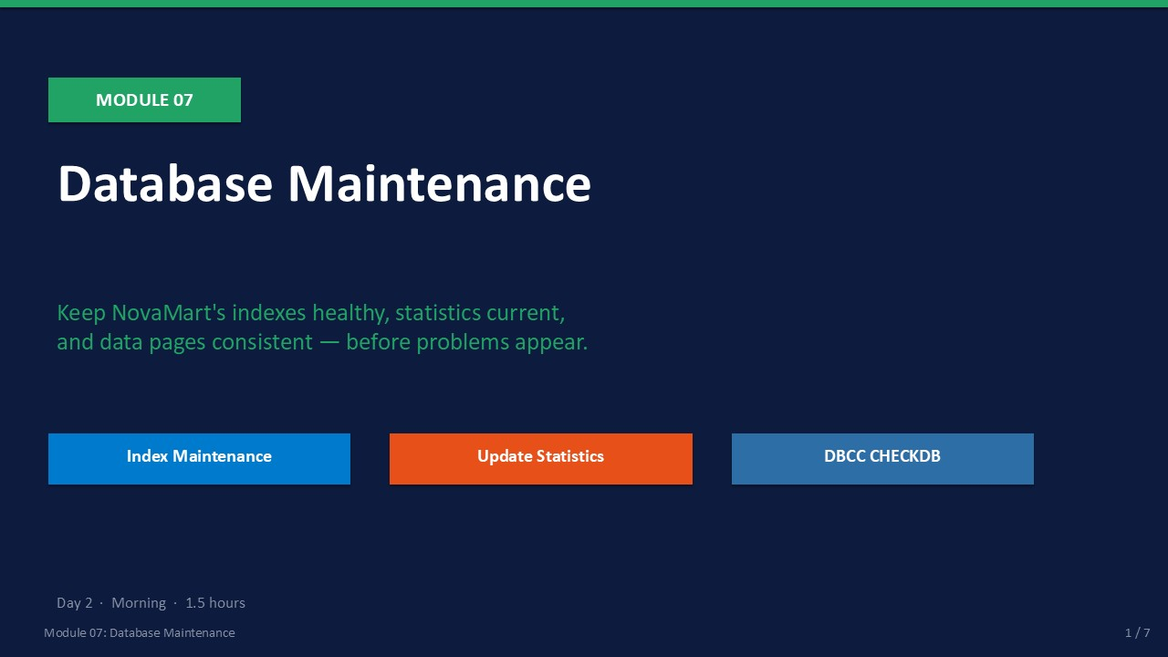
Slide 1 of 7

Module 07: Database Maintenance
Module | Day | Duration | Lab
07 | 2 — Morning | 90 minutes | Lab 07

Reactive maintenance is the most expensive kind. A database that has never had its indexes rebuilt or its statistics refreshed will quietly degrade over months until a sudden performance crisis appears. Module 07 teaches you how to keep NovaMart healthy through a predictable weekly routine that prevents problems before they reach the help desk.
You will learn the three core maintenance tasks every DBA must master: index maintenance (REORGANIZE and REBUILD), statistics updates, and DBCC CHECKDB for physical integrity verification. Each task has a clear rule for when to run it, a T-SQL command to execute it, and a measurable outcome to confirm it worked.
ℹ | The 5/30 Rule for Index Maintenance  Fragmentation 5–30 %: use REORGANIZE (online, no lock). Fragmentation > 30 %: use REBUILD (drops and recreates the index). Below 5 %: skip — the overhead of maintenance exceeds the benefit.

What This Module Covers
- Index Fragmentation What it is, how to detect it with sys.dm_db_index_physical_stats.
- REORGANIZE vs REBUILD When to use each, T-SQL syntax, impact on availability.
- Update Statistics sp_updatestats and UPDATE STATISTICS WITH FULLSCAN.
- DBCC CHECKDB Physical and logical consistency checking — how to read the output.
- Weekly Schedule A repeatable NovaMart maintenance routine combining all four tasks.

SLIDE 2 — LEARNING OBJECTIVES

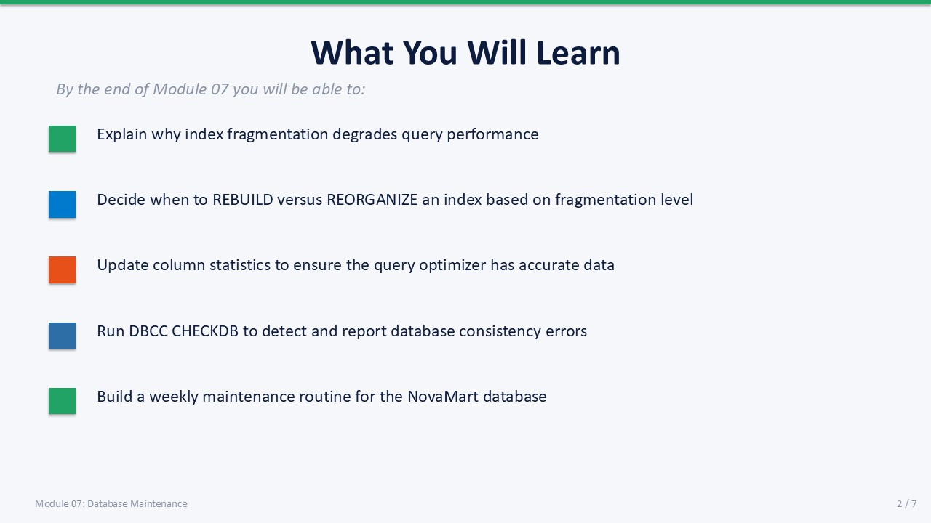
Slide 2 of 7

Learning Objectives
By the end of Module 07 you will be able to:
- Explain why index fragmentation degrades query performance — scattered pages force random I/O instead of sequential reads.
- Decide when to REBUILD versus REORGANIZE an index — based on the avg_fragmentation_in_percent value from dm_db_index_physical_stats.
- Update column statistics to help the query optimizer — using UPDATE STATISTICS WITH FULLSCAN and sp_updatestats.
- Run DBCC CHECKDB to detect database consistency errors — and interpret the "0 allocation errors, 0 consistency errors" confirmation.
- Build a weekly maintenance routine for the NovaMart database — combining backup, index, statistics, and CHECKDB tasks on a timed schedule.

SLIDE 3 — INDEX FRAGMENTATION

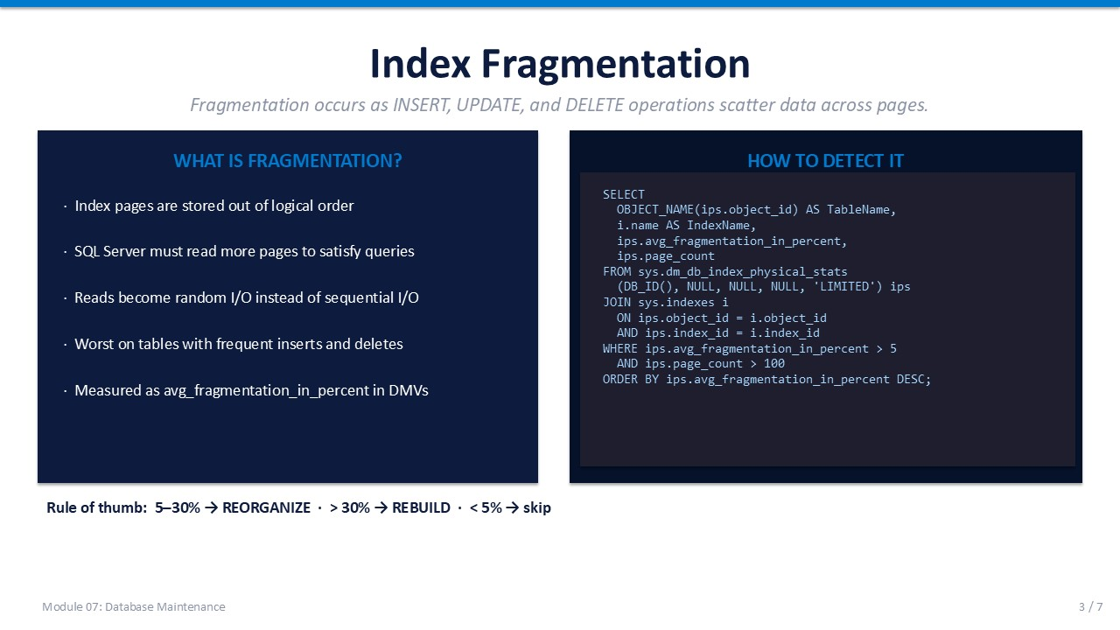
Slide 3 of 7

Index Fragmentation
Every INSERT, UPDATE, and DELETE that touches an indexed table can split index pages, leaving logical gaps between data pages. Over time this fragmentation forces SQL Server to read more pages to satisfy queries — turning fast sequential I/O into slow random I/O.

What Fragmentation Looks Like
- Page splits When a page is full and a new row must be inserted, SQL Server splits the page — creating two half-full pages.
- Out-of-order pages The logical order of index keys no longer matches the physical order of pages on disk.
- Wasted space Half-full pages consume storage and buffer pool memory without contributing data density.
- Random I/O impact Fragmented indexes force the storage subsystem to seek rather than scan — especially costly on spinning disks.

Detecting Fragmentation
The DMV sys.dm_db_index_physical_stats returns fragmentation metrics for every index in the database. Filter for indexes with more than 100 pages (small indexes are not worth maintaining) and fragmentation above 5 %.
T-SQL
SELECT
OBJECT_NAME(ips.object_id) AS TableName,
i.name AS IndexName,
ips.avg_fragmentation_in_percent,
ips.page_count
FROM sys.dm_db_index_physical_stats
(DB_ID(), NULL, NULL, NULL, 'LIMITED') ips
JOIN sys.indexes i
ON ips.object_id = i.object_id
AND ips.index_id = i.index_id
WHERE ips.avg_fragmentation_in_percent > 5
AND ips.page_count > 100
ORDER BY ips.avg_fragmentation_in_percent DESC;

⚠ | Performance Warning: LIMITED vs DETAILED  The LIMITED mode (used above) is fast — it samples pages. DETAILED mode scans every page and is accurate but slow on large tables. Use LIMITED for regular checks; DETAILED only when diagnosing a specific problem.

Fragmentation % | Recommended Action | Notes
< 5 % | No action needed | Overhead of maintenance exceeds benefit
5 – 30 % | REORGANIZE | Online, no table lock, leaf-level defrag only
> 30 % | REBUILD | Drops and recreates the index; offline by default

SLIDE 4 — REBUILD VS REORGANIZE

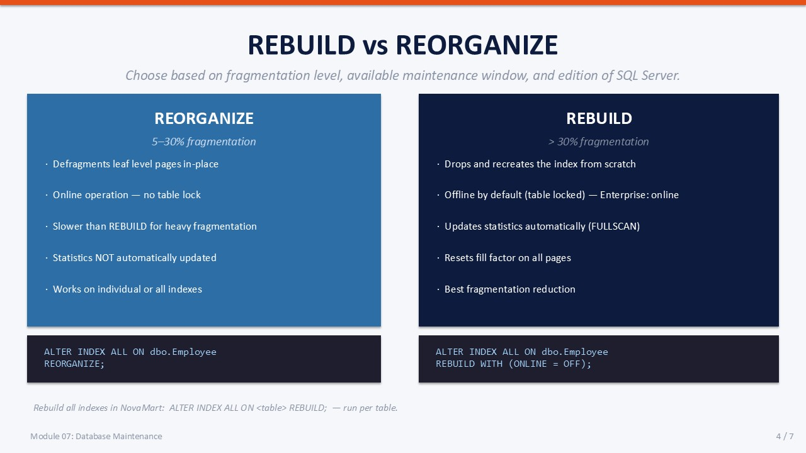
Slide 4 of 7

REBUILD vs REORGANIZE
Both commands reduce fragmentation, but they work differently and have different availability implications. Choose based on the fragmentation level, the maintenance window, and your SQL Server edition.

REORGANIZE
Best for: 5–30 % fragmentation. Works online — the table remains accessible.
- How it works Defragments the leaf level of the index in-place by physically reordering the leaf pages.
- Availability Online operation — no exclusive table lock. Users can read and write during reorganization.
- Statistics Does NOT automatically update statistics. Run UPDATE STATISTICS separately afterward.
- When to use Scheduled daily or nightly maintenance on moderately fragmented indexes.
T-SQL
-- Reorganize all indexes on one table
ALTER INDEX ALL ON dbo.Employee
REORGANIZE;
-- Reorganize a specific index
ALTER INDEX PK_Employee ON dbo.Employee
REORGANIZE;

REBUILD
Best for: > 30 % fragmentation. Drops and recreates the index structure completely.
- How it works Drops the entire index and rebuilds it from scratch with a fresh fill factor.
- Availability Offline by default (ONLINE = OFF) — acquires an exclusive lock. Enterprise edition supports ONLINE = ON.
- Statistics Automatically updates statistics with the equivalent of a FULLSCAN — no separate update needed.
- Fill factor Resets the fill factor on all pages, leaving room for future inserts and reducing page splits.
- When to use Weekly or monthly maintenance window on heavily fragmented indexes.
T-SQL
-- Rebuild all indexes on one table
ALTER INDEX ALL ON dbo.Employee
REBUILD WITH (ONLINE = OFF);
-- Rebuild a specific index
ALTER INDEX PK_Employee ON dbo.Employee
REBUILD WITH (ONLINE = OFF, FILLFACTOR = 80);

ℹ | Fill Factor Explained  Fill factor = the percentage of each index page to fill during a rebuild. A fill factor of 80 leaves 20 % free, reducing page splits on tables with frequent inserts. The default (0 or 100) fills pages completely — efficient for read-heavy tables.

SLIDE 5 — UPDATE STATISTICS & DBCC CHECKDB

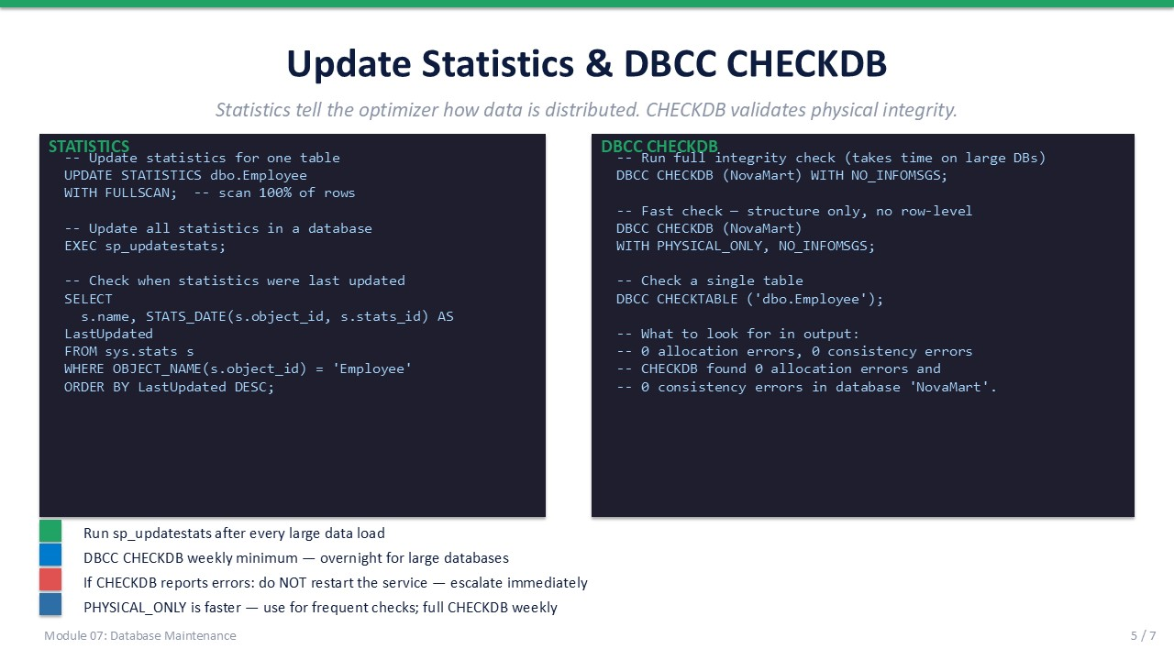
Slide 5 of 7

Update Statistics
SQL Server's query optimizer uses statistics — histograms of column data distribution — to estimate row counts and choose efficient query plans. Stale statistics lead to bad plan choices: the optimizer may choose a table scan when an index seek would be faster, or underestimate rows and choose a nested loop join that performs poorly on large data sets.
- Auto-update statistics SQL Server auto-updates statistics when 20 % of rows change (SQL 2016+ uses a dynamic threshold for large tables). Auto-update is asynchronous — it may not fire before your query runs.
- WITH FULLSCAN Scans 100 % of rows to build the most accurate histogram. Slower but more reliable on skewed data distributions.
- sp_updatestats Updates statistics for all user tables in the current database that have changed since the last update. Fast and safe to run daily.
T-SQL
-- Update statistics for one table (full scan)
UPDATE STATISTICS dbo.Employee
WITH FULLSCAN;
-- Update all statistics in the current database
EXEC sp_updatestats;
-- Check when statistics were last updated
SELECT
s.name,
STATS_DATE(s.object_id, s.stats_id) AS LastUpdated
FROM sys.stats s
WHERE OBJECT_NAME(s.object_id) = 'Employee'
ORDER BY LastUpdated DESC;

DBCC CHECKDB
DBCC CHECKDB validates the physical and logical integrity of every object in the database. It checks allocation pages, data pages, index pages, and referential constraints. A clean CHECKDB result — "0 allocation errors and 0 consistency errors" — is the baseline confirmation that the database is sound.
T-SQL
-- Full integrity check (may take minutes on large databases)
DBCC CHECKDB (NovaMart)
WITH NO_INFOMSGS;
-- Fast structural check only (no row-level validation)
DBCC CHECKDB (NovaMart)
WITH PHYSICAL_ONLY, NO_INFOMSGS;
-- Check a single table
DBCC CHECKTABLE ('dbo.Employee');
-- Expected clean output:
-- CHECKDB found 0 allocation errors and
-- 0 consistency errors in database 'NovaMart'.

⚠ | If CHECKDB Reports Errors  Do NOT restart the SQL Server service or run DBCC CHECKDB WITH REPAIR_ALLOW_DATA_LOSS without first consulting a senior DBA. CHECKDB errors can indicate physical storage problems. Take a backup immediately and escalate. Repairs may involve data loss.

SLIDE 6 — WEEKLY MAINTENANCE SCHEDULE

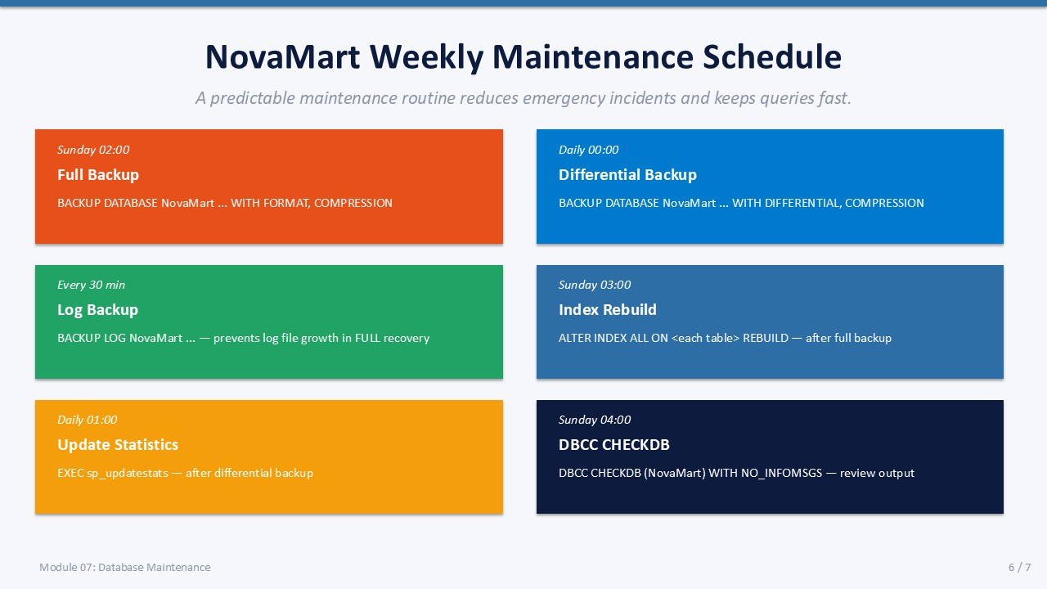
Slide 6 of 7

NovaMart Weekly Maintenance Schedule
A predictable maintenance routine prevents emergency incidents. The schedule below combines backup, index, statistics, and integrity tasks into a repeatable Sunday/daily cadence. In Module 08 you will automate this schedule using SQL Server Agent jobs.
Time | Task | Command / Tool | Priority
Sunday 02:00 | Full Backup | BACKUP DATABASE NovaMart … WITH FORMAT, COMPRESSION | Critical
Daily 00:00 | Differential Backup | BACKUP DATABASE NovaMart … WITH DIFFERENTIAL, COMPRESSION | Critical
Every 30 min | Log Backup | BACKUP LOG NovaMart … (Full recovery model) | Critical
Sunday 03:00 | Index Rebuild | ALTER INDEX ALL ON <table> REBUILD — per table | High
Daily 01:00 | Update Statistics | EXEC sp_updatestats | High
Sunday 04:00 | DBCC CHECKDB | DBCC CHECKDB (NovaMart) WITH NO_INFOMSGS | High

Implementation Notes
- Order matters Run backups before index rebuilds — a rebuild changes the database; the backup captures the clean pre-rebuild state.
- PHYSICAL_ONLY weekdays On busy days, use DBCC CHECKDB WITH PHYSICAL_ONLY — it is much faster and still catches I/O corruption.
- Monitor job history After automating these tasks in SQL Server Agent, check job history every morning for any failures.
- Large table strategy On very large tables, rebuild indexes for the most fragmented tables first and skip low-page-count indexes entirely.
✅ | Maintenance Best Practice  Schedule all maintenance tasks during off-peak hours. Index REBUILDs hold exclusive locks (in Standard edition) — running them while users are active will cause blocking and timeouts.

SLIDE 7 — LAB 07

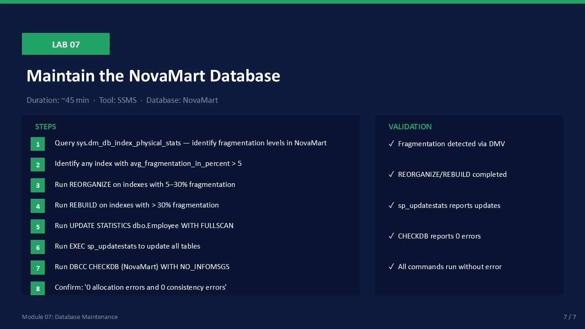
Slide 7 of 7

Lab 07: Maintain the NovaMart Database
Goal | Duration | Tool | Database
Run index maintenance, update statistics, and verify CHECKDB on NovaMart | ~45 min | SSMS | NovaMart

Prerequisites
- NovaMart database exists with Department and Employee tables (created in Lab 04).
- SQL Server instance is running and accessible via SSMS.

Lab Steps
- Open SSMS. Connect to your SQL Server instance. Open a new query window targeting NovaMart.
Expected: Query window opens with NovaMart shown in the database dropdown.
- Query sys.dm_db_index_physical_stats to find fragmented indexes in NovaMart:
SELECT OBJECT_NAME(ips.object_id) AS TableName, i.name AS IndexName,
ips.avg_fragmentation_in_percent, ips.page_count
FROM sys.dm_db_index_physical_stats(DB_ID(), NULL, NULL, NULL, 'LIMITED') ips
JOIN sys.indexes i ON ips.object_id = i.object_id AND ips.index_id = i.index_id
WHERE ips.page_count > 1
ORDER BY ips.avg_fragmentation_in_percent DESC;
Expected: A result set appears showing indexes, fragmentation %, and page count.
- For any index showing 5–30 % fragmentation, run REORGANIZE:
ALTER INDEX ALL ON dbo.Employee REORGANIZE;
ALTER INDEX ALL ON dbo.Department REORGANIZE;
Expected: Command completes without error.
- For any index showing > 30 % fragmentation, run REBUILD:
ALTER INDEX ALL ON dbo.Employee REBUILD WITH (ONLINE = OFF);
ALTER INDEX ALL ON dbo.Department REBUILD WITH (ONLINE = OFF);
Expected: Command completes; verify by re-running the DMV query — fragmentation should drop near 0.
- Update statistics for the Employee table with a full scan:
UPDATE STATISTICS dbo.Employee WITH FULLSCAN;
Expected: Command completes: "Statistics updated."
- Update all statistics in NovaMart:
EXEC sp_updatestats;
Expected: Output shows: "Updating [dbo].[Employee]" and other tables. "Statistics for all tables have been updated."
- Run DBCC CHECKDB on NovaMart:
DBCC CHECKDB (NovaMart) WITH NO_INFOMSGS;
Expected: Output ends with: "CHECKDB found 0 allocation errors and 0 consistency errors in database 'NovaMart'."
- Re-run the fragmentation DMV query to confirm fragmentation has been reduced.
Expected: avg_fragmentation_in_percent values are significantly lower or near 0.

Validation Checklist
☐ Fragmentation detected and reported via DMV
☐ REORGANIZE or REBUILD completed without error
☐ sp_updatestats reports updated tables
☐ DBCC CHECKDB reports 0 allocation errors and 0 consistency errors
☐ Post-maintenance DMV query confirms reduced fragmentation

Troubleshooting
Symptom | Likely Cause | Resolution
DMV returns no rows | NovaMart tables are very small (< 1 page) | Normal for a training database — run INSERT to add more rows first
ALTER INDEX fails — lock timeout | Active connections holding locks | Wait for activity to finish or test during off-peak hours
CHECKDB reports errors | Physical or logical corruption detected | Take a backup immediately and notify your DBA lead
sp_updatestats returns no output | Statistics already up to date (no row changes) | Normal — stats were already current; try INSERT/UPDATE first

