SLIDE 1 — MODULE COVER

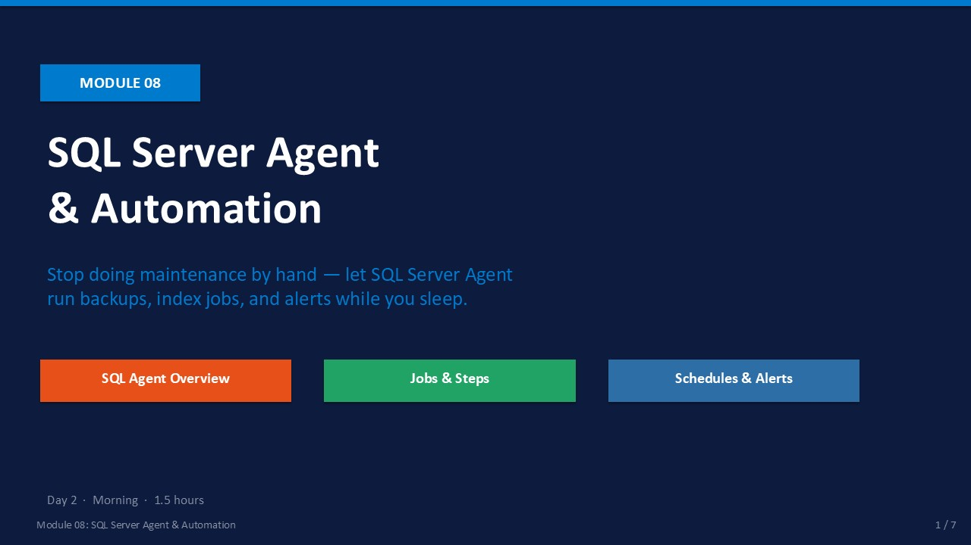
Slide 1 of 7

Module 08: SQL Server Agent & Automation
Module | Day | Duration | Lab
08 | 2 — Morning | 90 minutes | Lab 08

Manually running backup scripts and maintenance commands every night is not administration — it is a liability. A missed step, a late night, or a single distraction can mean a day without a backup. SQL Server Agent eliminates that risk by running jobs on a schedule, retrying failed steps, and sending email alerts when something goes wrong.
In this module you will learn the full SQL Server Agent architecture: jobs, steps, schedules, alerts, and operators. You will build a multi-step nightly backup job in SSMS and then script the same job using T-SQL so it can be version-controlled and deployed to other instances.
ℹ | Prerequisite: SQL Server Agent Service  SQL Server Agent is a separate Windows service. Before doing anything in this module, open SQL Server Configuration Manager and confirm that the SQL Server Agent service is Running and set to Automatic start. If it is stopped, right-click and start it.

What This Module Covers
- Agent Architecture Jobs, job steps, schedules, alerts, and operators — and how they relate.
- Creating Jobs in SSMS GUI walkthrough: New Job → Steps → Schedules → Notifications.
- Schedules & History Recurring schedules, viewing job history, and diagnosing failed steps.
- T-SQL Job Scripting sp_add_job, sp_add_jobstep, sp_add_schedule, sp_attach_schedule.

SLIDE 2 — LEARNING OBJECTIVES

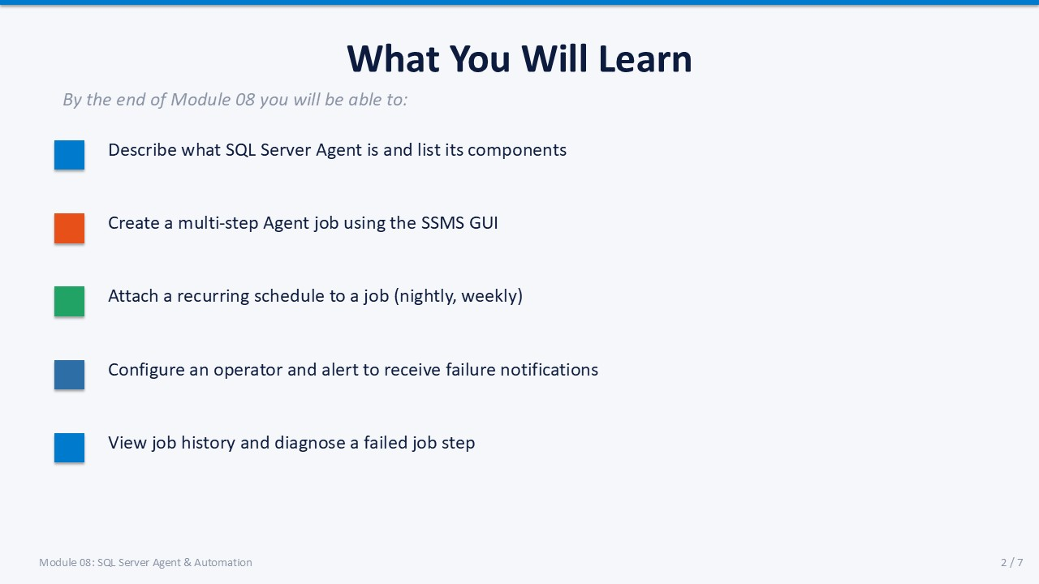
Slide 2 of 7

Learning Objectives
By the end of Module 08 you will be able to:
- Describe SQL Server Agent and list its components — job, job step, schedule, alert, and operator.
- Create a multi-step Agent job using the SSMS GUI — including a Full Backup step, a Log Backup step, and a statistics update step.
- Attach a recurring schedule to a job — daily at 02:00, with a meaningful schedule name for reuse across jobs.
- Configure an operator and alert to receive failure notifications — using Database Mail if available, or understanding the prerequisite steps.
- View job history and diagnose a failed job step — in the SSMS Log File Viewer and via msdb.dbo.sysjobhistory.

SLIDE 3 — SQL SERVER AGENT ARCHITECTURE

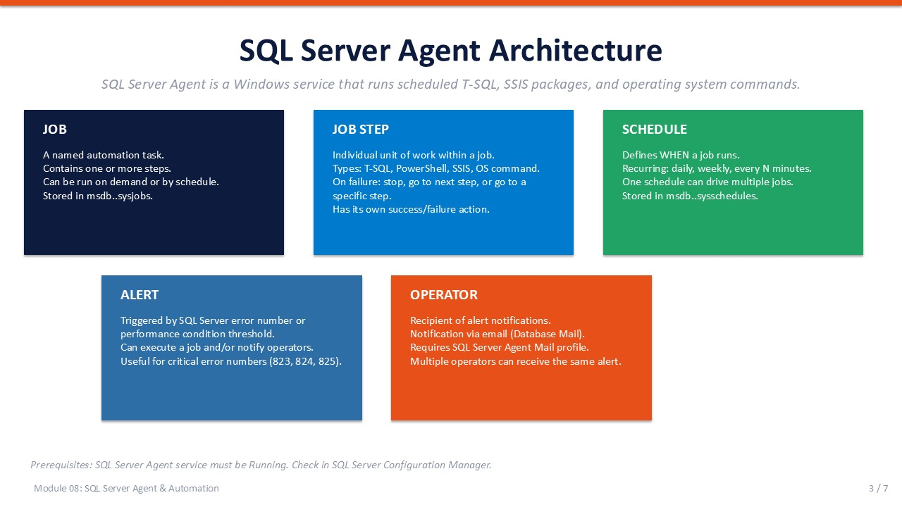
Slide 3 of 7

SQL Server Agent Architecture
SQL Server Agent is a Windows service (SQLSERVERAGENT) that reads job definitions stored in the msdb system database and executes them according to their schedules. It runs independently of the SQL Server Database Engine — if the Engine restarts, Agent continues tracking schedules.
Component | Description | Stored in msdb table
Job | A named automation task containing one or more steps. Can be run on demand or by schedule. | sysjobs
Job Step | An individual unit of work within a job. Types: T-SQL, PowerShell, SSIS package, OS command. | sysjobsteps
Schedule | Defines when a job runs. One schedule can drive multiple jobs. Supports recurring and one-time. | sysschedules
Alert | Triggers on a SQL Server error number or performance condition. Executes a job or notifies operators. | sysalerts
Operator | A person or team to notify. Receives alerts via email (requires Database Mail). | sysoperators

Job Step Types
- T-SQL Runs a T-SQL batch against a specified database. Most common type for backups and maintenance.
- PowerShell Runs a PowerShell script in a SQL Server PowerShell host session.
- SSIS Package Executes an Integration Services package (.dtsx) from the SSIS catalog or file system.
- CmdExec Runs a Windows command or executable. Requires appropriate permissions and is a security risk if misconfigured.

Step Success and Failure Actions
Each job step has an On Success Action and an On Failure Action. Options include: Go to the next step, Quit with success, Quit with failure, or Go to step N. This lets you build conditional workflows — for example, a log backup step that only runs if the full backup step succeeded.
ℹ | msdb Is the Agent's Database  All job definitions, schedules, history, operators, and alerts are stored in the msdb system database. Always include msdb in your backup plan. If msdb is lost, all Agent jobs and their history are lost too.

SLIDE 4 — CREATING A JOB IN SSMS

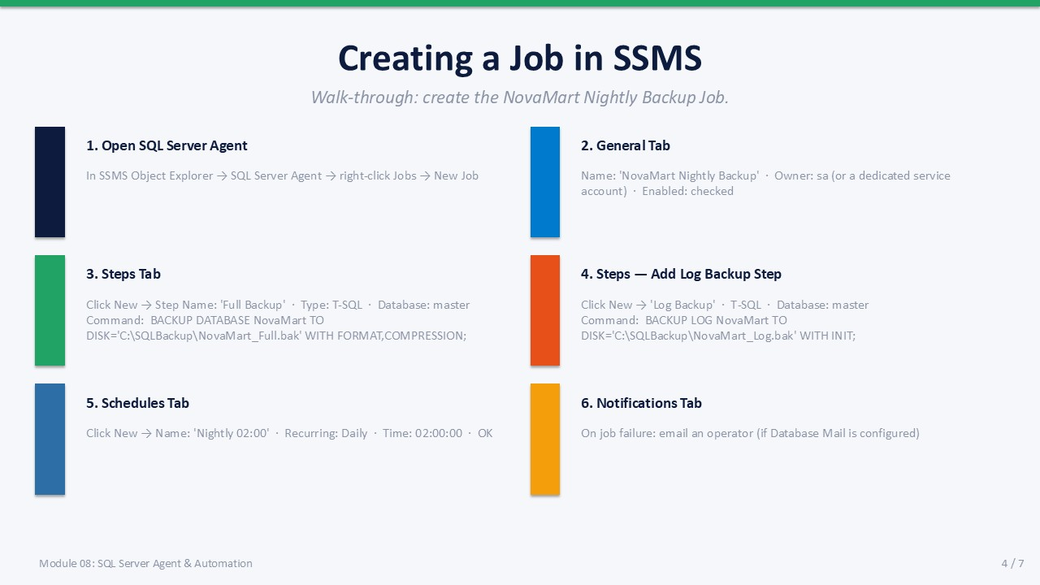
Slide 4 of 7

Creating a Job in SSMS
The SSMS GUI provides a guided interface for creating jobs. The walk-through below creates the "NovaMart Nightly Backup" job with three steps: a full backup, a statistics update, and a transaction log backup.

Step-by-Step: New Job GUI
- 1. Open SQL Server Agent In SSMS Object Explorer, expand the instance → expand SQL Server Agent → right-click Jobs → New Job.
- 2. General tab Name: NovaMart Nightly Backup. Owner: sa (or a dedicated service account). Enabled: checked.
- 3. Steps tab — Step 1 Click New. Step Name: Full Backup. Type: Transact-SQL. Database: master. Command: BACKUP DATABASE NovaMart TO DISK='C:\SQLBackup\NovaMart_Full.bak' WITH FORMAT, COMPRESSION, STATS=10;
- 4. Steps tab — Step 2 Click New. Step Name: Update Stats. Type: Transact-SQL. Database: NovaMart. Command: EXEC sp_updatestats;
- 5. Steps tab — Step 3 Click New. Step Name: Log Backup. Type: Transact-SQL. Database: master. Command: BACKUP LOG NovaMart TO DISK='C:\SQLBackup\NovaMart_Log.bak' WITH INIT, COMPRESSION;
- 6. Schedules tab Click New. Name: Nightly 02:00. Frequency: Daily. Time: 02:00:00. Click OK.
- 7. Notifications tab On job failure: email an operator (if Database Mail is configured). Click OK to save the job.
✅ | Test Before You Trust the Schedule  After creating the job, right-click it in Object Explorer → Start Job at Step → Step 1. Watch the progress and confirm all three steps show a green checkmark in the job history. A job that has never been manually tested should not be relied upon for nightly backups.

Backup Folder Prerequisite
Create the backup folder before the job runs. The SQL Server service account needs write permission to it.
T-SQL / PowerShell
-- Create backup folder (run in PowerShell or Command Prompt as admin)
-- New-Item -ItemType Directory -Path 'C:\SQLBackup'
-- Or verify the folder exists and SQL Server can write to it:
EXEC xp_cmdshell 'dir C:\SQLBackup'; -- requires xp_cmdshell enabled

SLIDE 5 — SCHEDULES, ALERTS & JOB HISTORY

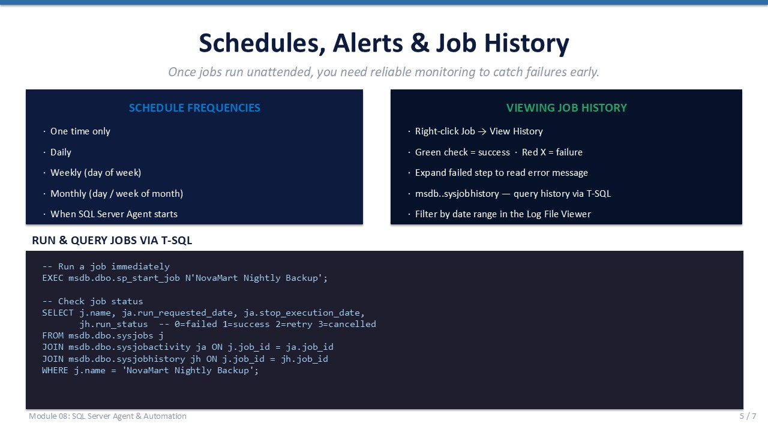
Slide 5 of 7

Schedules, Alerts & Job History
Once jobs run unattended you need reliable monitoring. SQL Server Agent gives you three tools: reusable schedules, condition-based alerts, and a built-in history log that records every execution.

Schedule Frequency Options
Frequency Type | Use Case Example
One time only | One-off data migration job
Daily | Nightly backup at 02:00
Weekly (select days) | Full index rebuild every Sunday
Monthly (day or week of month) | End-of-month reporting job
When SQL Server Agent starts | Startup cleanup or initialisation task
When CPU is idle | Low-priority statistics rebuild during off-peak

Viewing Job History
- SSMS GUI Right-click the job → View History. The Log File Viewer opens showing each execution.
- Green check Step succeeded. Click the row to see duration and step output.
- Red X Step failed. Expand the row to read the error message and step number.
- Filter by date Use the filter button in Log File Viewer to narrow history to a specific date range.

Query Job History via T-SQL
T-SQL
-- Run a job immediately
EXEC msdb.dbo.sp_start_job N'NovaMart Nightly Backup';
-- View recent job execution history
SELECT
j.name AS JobName,
h.step_name,
h.run_date,
h.run_time,
h.run_duration,
CASE h.run_status
WHEN 0 THEN 'Failed'
WHEN 1 THEN 'Succeeded'
WHEN 2 THEN 'Retry'
WHEN 3 THEN 'Cancelled'
END AS Status,
h.message
FROM msdb.dbo.sysjobs j
JOIN msdb.dbo.sysjobhistory h ON j.job_id = h.job_id
WHERE j.name = 'NovaMart Nightly Backup'
ORDER BY h.run_date DESC, h.run_time DESC;

SLIDE 6 — CREATING A JOB VIA T-SQL

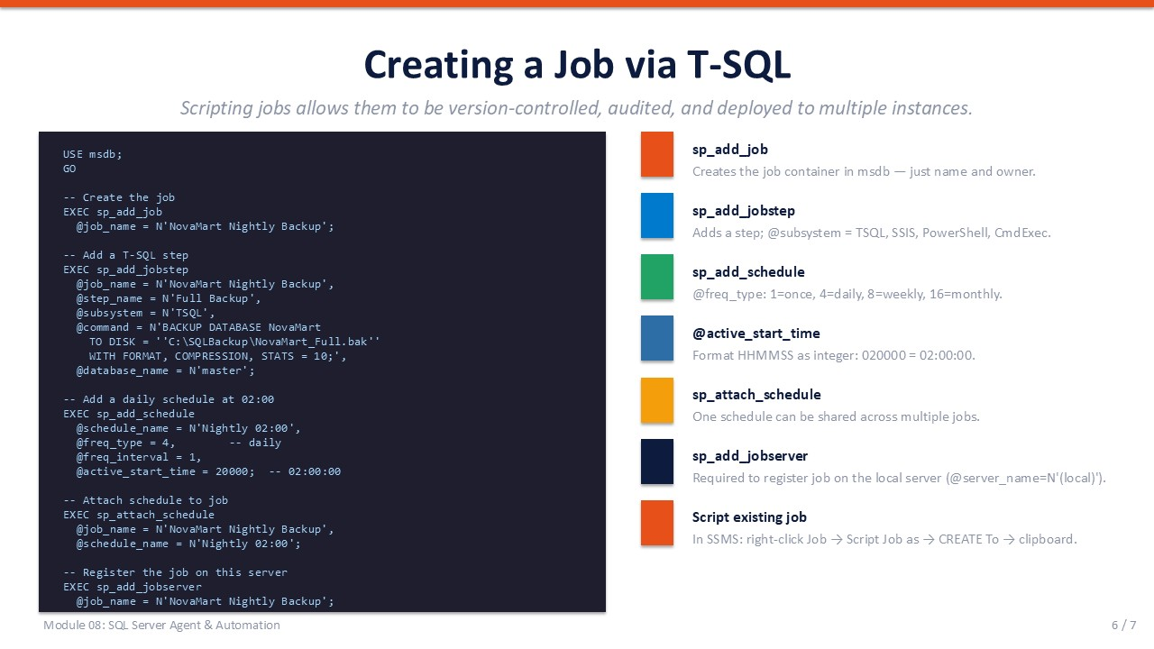
Slide 6 of 7

Creating a Job via T-SQL
Scripting jobs in T-SQL has two major advantages over the GUI: the scripts can be stored in source control and deployed identically to multiple instances. The stored procedures are all in the msdb database under the dbo schema.
T-SQL
USE msdb;
GO
-- 1. Create the job container
EXEC sp_add_job
@job_name = N'NovaMart Nightly Backup';
-- 2. Add Step 1: Full Backup
EXEC sp_add_jobstep
@job_name = N'NovaMart Nightly Backup',
@step_name = N'Full Backup',
@subsystem = N'TSQL',
@command = N'BACKUP DATABASE NovaMart
TO DISK = ''C:\SQLBackup\NovaMart_Full.bak''
WITH FORMAT, COMPRESSION, STATS = 10;',
@database_name = N'master';
-- 3. Add a daily schedule at 02:00
EXEC sp_add_schedule
@schedule_name = N'Nightly 02:00',
@freq_type = 4, -- 4 = daily
@freq_interval = 1,
@active_start_time = 20000; -- 02:00:00 as HHMMSS integer
-- 4. Link schedule to job
EXEC sp_attach_schedule
@job_name = N'NovaMart Nightly Backup',
@schedule_name = N'Nightly 02:00';
-- 5. Register the job on this server
EXEC sp_add_jobserver
@job_name = N'NovaMart Nightly Backup';

Key Procedure Reference
Procedure | Purpose | Key Parameter
sp_add_job | Creates the job container | @job_name
sp_add_jobstep | Adds a step; @subsystem = TSQL/PowerShell/SSIS | @command
sp_add_schedule | @freq_type: 1=once, 4=daily, 8=weekly, 16=monthly | @active_start_time (HHMMSS)
sp_attach_schedule | Links a schedule to a job (many-to-many) | @schedule_name
sp_add_jobserver | Registers job on the local server | @server_name = N'(local)'
sp_start_job | Runs a job immediately | @job_name
sp_delete_job | Removes a job and its history | @job_name

ℹ | Script an Existing Job  In SSMS, right-click any job → Script Job as → CREATE To → New Query Editor Window. This generates the full sp_add_job / sp_add_jobstep T-SQL you can save and redeploy.

SLIDE 7 — LAB 08

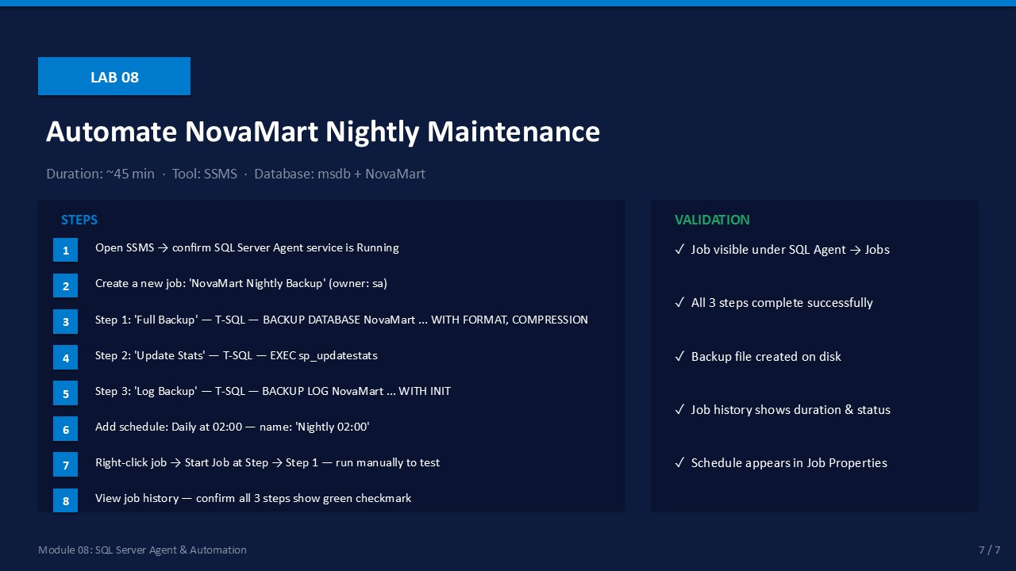
Slide 7 of 7

Lab 08: Automate NovaMart Nightly Maintenance
Goal | Duration | Tool | Database
Create and test a multi-step nightly maintenance job in SQL Server Agent | ~45 min | SSMS | msdb + NovaMart

Prerequisites
- SQL Server Agent service is Running (verify in SQL Server Configuration Manager).
- NovaMart database exists with data (from previous labs).
- C:\SQLBackup folder exists and SQL Server service account has write permission.

Lab Steps
- In SSMS Object Explorer, expand the instance. Verify SQL Server Agent shows a green arrow (Running).
Expected: SQL Server Agent is visible and shows Running status.
- Right-click Jobs under SQL Server Agent → New Job.
General tab: Name = NovaMart Nightly Backup. Owner = sa. Enabled = checked.
Expected: New Job dialog opens.
- Steps tab → New.
Step Name: Full Backup. Type: Transact-SQL. Database: master.
Command: BACKUP DATABASE NovaMart TO DISK='C:\SQLBackup\NovaMart_Full.bak' WITH FORMAT, COMPRESSION, STATS=10;
Expected: Step 1 appears in the Steps list.
- Steps tab → New (again).
Step Name: Update Stats. Type: Transact-SQL. Database: NovaMart.
Command: EXEC sp_updatestats;
Expected: Step 2 appears in the Steps list.
- Steps tab → New (again).
Step Name: Log Backup. Type: Transact-SQL. Database: master.
Command: BACKUP LOG NovaMart TO DISK='C:\SQLBackup\NovaMart_Log.bak' WITH INIT, COMPRESSION;
Expected: Step 3 appears in the Steps list.
- Schedules tab → New.
Name: Nightly 02:00. Recurring: Daily. Time: 02:00:00. Click OK twice.
Expected: Job saved successfully; visible under SQL Server Agent → Jobs.
- Right-click the job → Start Job at Step → select Step 1 (Full Backup) → Start.
Expected: Job execution dialog appears and shows progress.
- Right-click the job → View History. Expand the most recent execution.
Expected: All 3 steps show green checkmarks. No error messages.
- Verify backup files were created:
In SSMS: EXEC xp_cmdshell 'dir C:\SQLBackup';
Expected: NovaMart_Full.bak and NovaMart_Log.bak appear in the directory listing.

Validation Checklist
☐ Job visible under SQL Server Agent → Jobs
☐ All 3 steps complete successfully (green checkmarks in history)
☐ Backup .bak file created on disk in C:\SQLBackup
☐ Job history shows execution time and duration for each step
☐ Schedule "Nightly 02:00" appears in Job Properties → Schedules

Troubleshooting
Symptom | Likely Cause | Resolution
SQL Server Agent not visible | Service is stopped | Open SQL Server Configuration Manager → start SQL Server Agent
Step 1 fails — backup path error | C:\SQLBackup folder does not exist | Create the folder; grant write permission to the SQL Server service account
Step 3 (Log Backup) fails | NovaMart is in Simple recovery model | Change to Full: ALTER DATABASE NovaMart SET RECOVERY FULL; take a full backup first
Job runs but no history visible | History retention set too short | Right-click SQL Server Agent → Properties → History → increase row limit

