SLIDE 1 — MODULE COVER

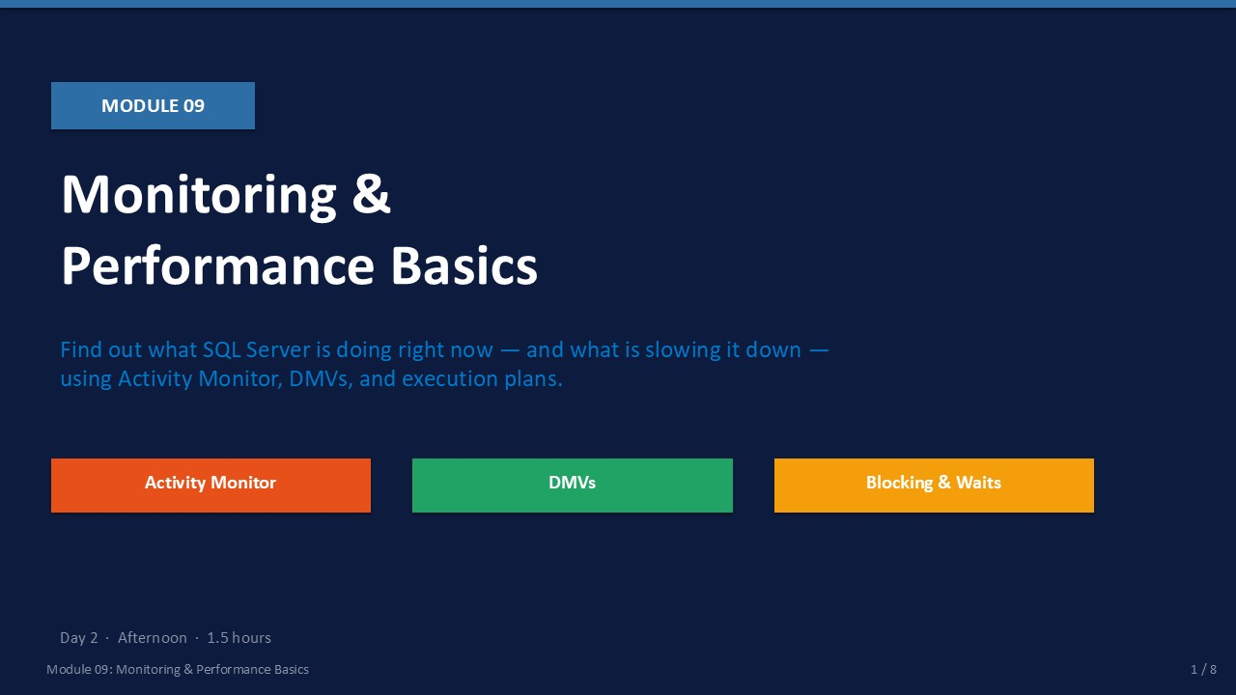
Slide 1 of 8

Module 09: Monitoring & Performance Basics
Module | Day | Duration | Lab
09 | 2 — Afternoon | 90 minutes | Lab 09

When a user reports that "SQL Server is slow," you need a structured method to isolate the problem — not guesswork. This module teaches you the three diagnostic layers every DBA must master: Activity Monitor for a fast visual overview, Dynamic Management Views for precise T-SQL-based investigation, and execution plans to find exactly where a query spends its time.
You will also learn how to identify blocking chains — a very common cause of performance complaints — and how to read wait statistics to understand whether the bottleneck is CPU, I/O, locks, memory, or network. Module 09 ends with a first-response checklist you can apply on the job every time someone says "something is wrong with the database."
ℹ | Read Before Touching  When investigating a live performance problem, always observe first. Run read-only DMV queries and check Activity Monitor before making any changes. Killing sessions or restarting services without diagnosis often makes things worse.

What This Module Covers
- Activity Monitor CPU, batch requests, waiting tasks, recent expensive queries — all in one GUI.
- Key DMVs sys.dm_exec_requests, dm_os_wait_stats, dm_exec_sql_text, and others.
- Blocking & Deadlocks Finding the head blocker, understanding deadlock victims, using KILL judiciously.
- Wait Statistics Common wait types and what each one tells you about the bottleneck layer.
- Execution Plans Reading plans right-to-left, identifying table scans, key lookups, and operator cost.
- Performance Checklist Eight-step first-response workflow for unknown performance incidents.

SLIDE 2 — LEARNING OBJECTIVES

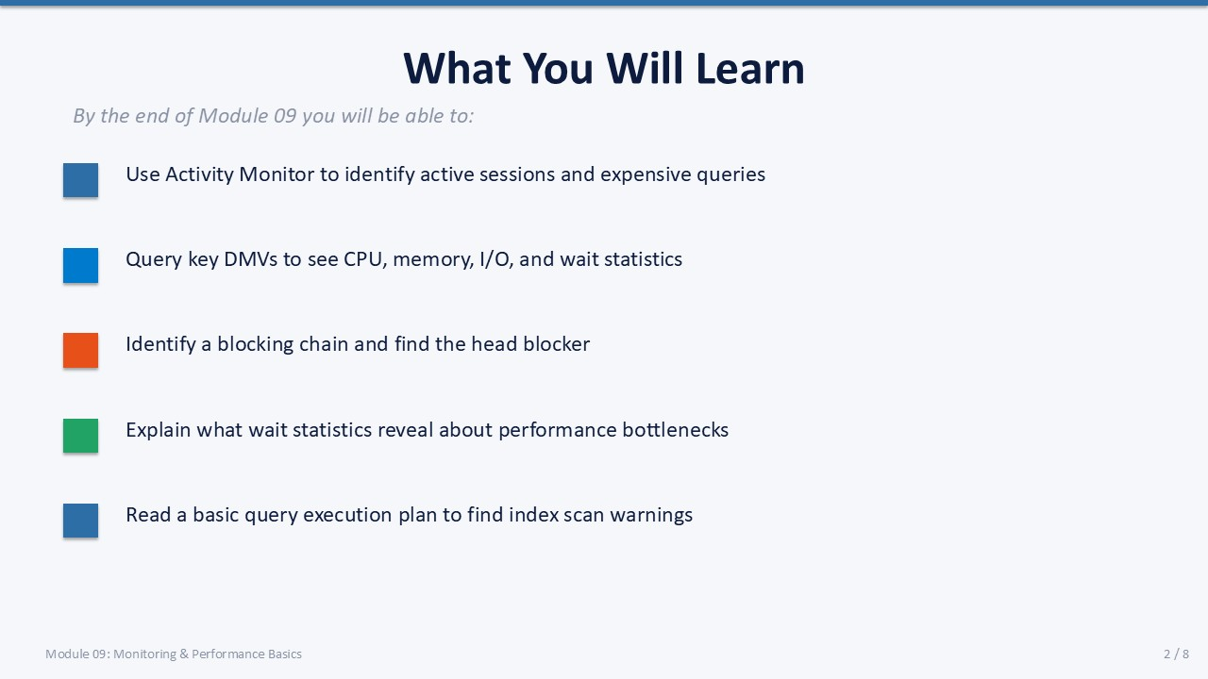
Slide 2 of 8

Learning Objectives
By the end of Module 09 you will be able to:
- Use Activity Monitor to identify active sessions and expensive queries — open Activity Monitor, expand the five panels, and find the session consuming the most CPU.
- Query key DMVs to see CPU, memory, I/O, and wait statistics — using dm_exec_requests, dm_os_wait_stats, and dm_exec_query_stats.
- Identify a blocking chain and find the head blocker — using the blocking_session_id column in dm_exec_requests.
- Explain what wait statistics reveal about performance bottlenecks — mapping common wait types (PAGEIOLATCH, LCK_M_X, CXPACKET) to their root causes.
- Read a basic query execution plan to find index scan warnings — enabling Include Actual Execution Plan, reading right-to-left, spotting Table Scan and Key Lookup.

SLIDE 3 — ACTIVITY MONITOR

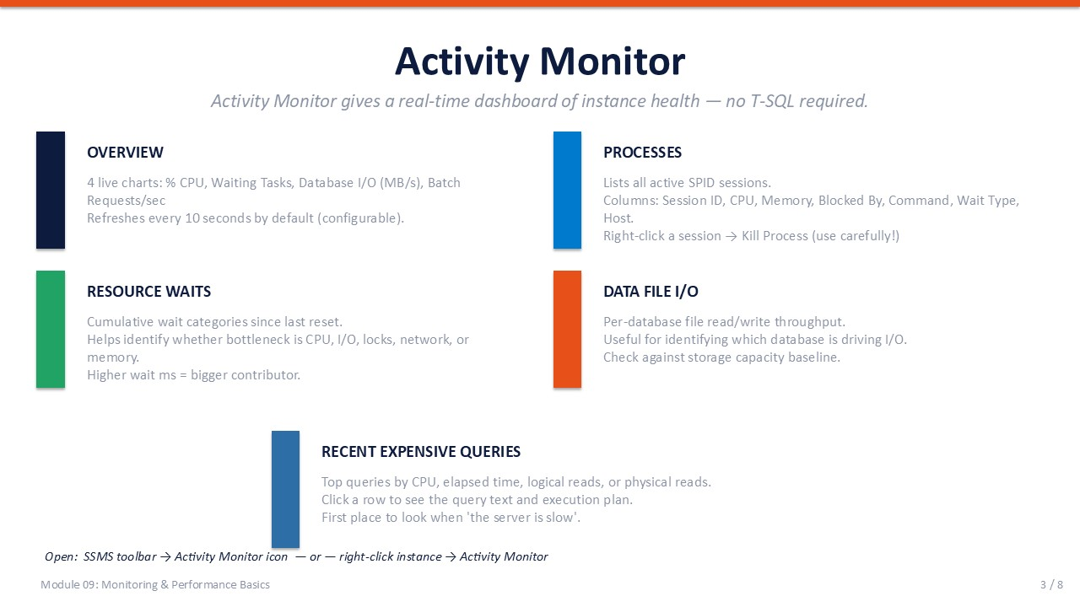
Slide 3 of 8

Activity Monitor
Activity Monitor is the fastest way to see what SQL Server is doing right now. It requires no T-SQL and provides a real-time dashboard that auto-refreshes every 10 seconds. Open it from the SSMS toolbar (the bar chart icon) or by right-clicking the instance and selecting Activity Monitor.

The Five Panels
Panel | What It Shows | What to Look For
Overview | 4 live charts: CPU %, Waiting Tasks, Database I/O (MB/s), Batch Requests/sec | Sudden CPU spike, sustained waiting tasks > 5
Processes | All active SPID sessions with CPU, memory, blocked-by, and wait type columns | Sessions with a non-zero Blocked By value
Resource Waits | Cumulative wait category totals since last reset | Top wait category drives the next investigation step
Data File I/O | Per-database file read/write throughput in MB/s | One database dominating I/O bandwidth
Recent Expensive Queries | Top queries by CPU, elapsed time, logical reads, or physical reads | Click a row to view query text and execution plan

Killing a Session (Last Resort)
In the Processes panel you can right-click any session and select Kill Process. Use this only when the session is blocking others and cannot be resolved by waiting. A KILL command causes an immediate rollback of the active transaction — this can take a long time for large transactions.
⚠ | Activity Monitor Has Overhead  Activity Monitor runs queries against the instance every 10 seconds. On a heavily loaded server this can add noticeable overhead. Close Activity Monitor when not actively investigating.

SLIDE 4 — ESSENTIAL DMVs

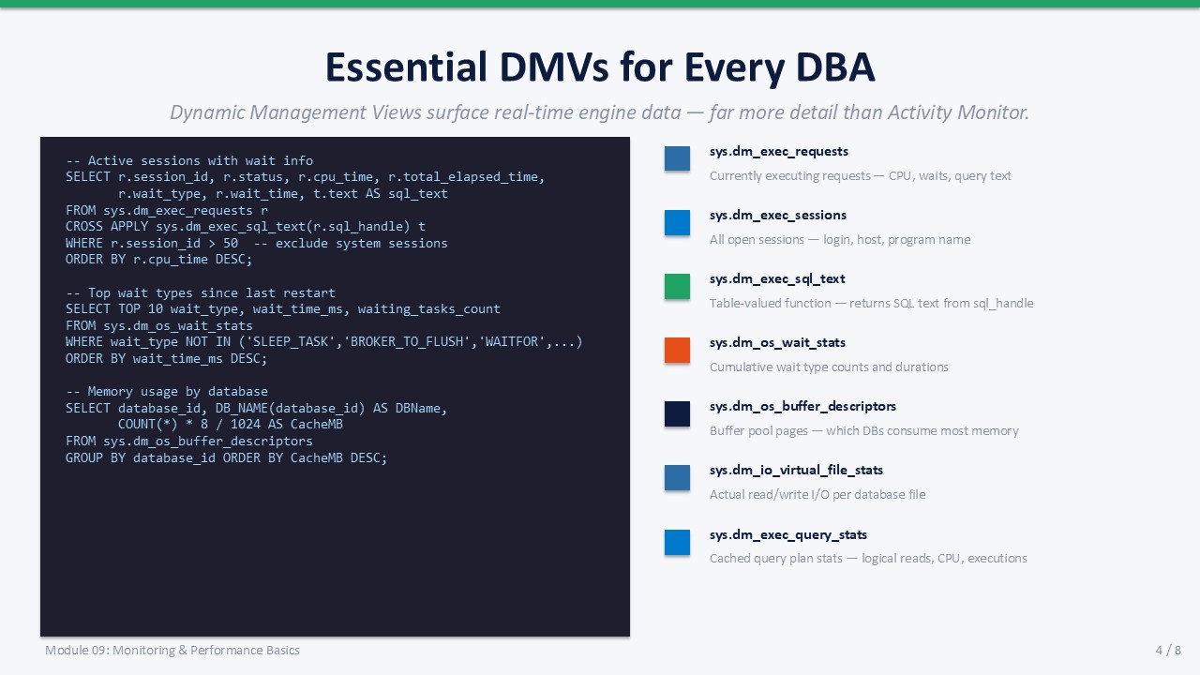
Slide 4 of 8

Essential DMVs for Every DBA
Dynamic Management Views (DMVs) are system views that surface real-time engine state. They provide far more detail than Activity Monitor and are queryable with T-SQL so results can be filtered, joined, and saved.
DMV | What It Returns
sys.dm_exec_requests | Currently executing requests — CPU time, wait type, blocking session, query handle
sys.dm_exec_sessions | All open sessions — login name, host, application, last request time
sys.dm_exec_sql_text() | Table-valued function — returns SQL text from a sql_handle or plan_handle
sys.dm_os_wait_stats | Cumulative wait type counts and total wait durations since last restart
sys.dm_os_buffer_descriptors | Buffer pool pages — which databases consume the most memory
sys.dm_io_virtual_file_stats() | Read and write I/O counters per database data and log file
sys.dm_exec_query_stats | Aggregated plan cache stats — total CPU, logical reads, execution count

Active Sessions with Wait Info
T-SQL
-- Show active requests with their current wait type and SQL text
SELECT
r.session_id,
r.status,
r.cpu_time,
r.total_elapsed_time,
r.wait_type,
r.wait_time,
t.text AS sql_text
FROM sys.dm_exec_requests r
CROSS APPLY sys.dm_exec_sql_text(r.sql_handle) t
WHERE r.session_id > 50 -- exclude system sessions
ORDER BY r.cpu_time DESC;

Top Wait Types
T-SQL
-- Find top 10 wait types since last SQL Server restart
SELECT TOP 10
wait_type,
wait_time_ms,
waiting_tasks_count,
wait_time_ms / NULLIF(waiting_tasks_count, 0) AS avg_wait_ms
FROM sys.dm_os_wait_stats
WHERE wait_type NOT IN (
'SLEEP_TASK', 'BROKER_TO_FLUSH', 'WAITFOR',
'DISPATCHER_QUEUE_SEMAPHORE', 'CLR_AUTO_EVENT'
)
ORDER BY wait_time_ms DESC;

SLIDE 5 — BLOCKING & DEADLOCKS

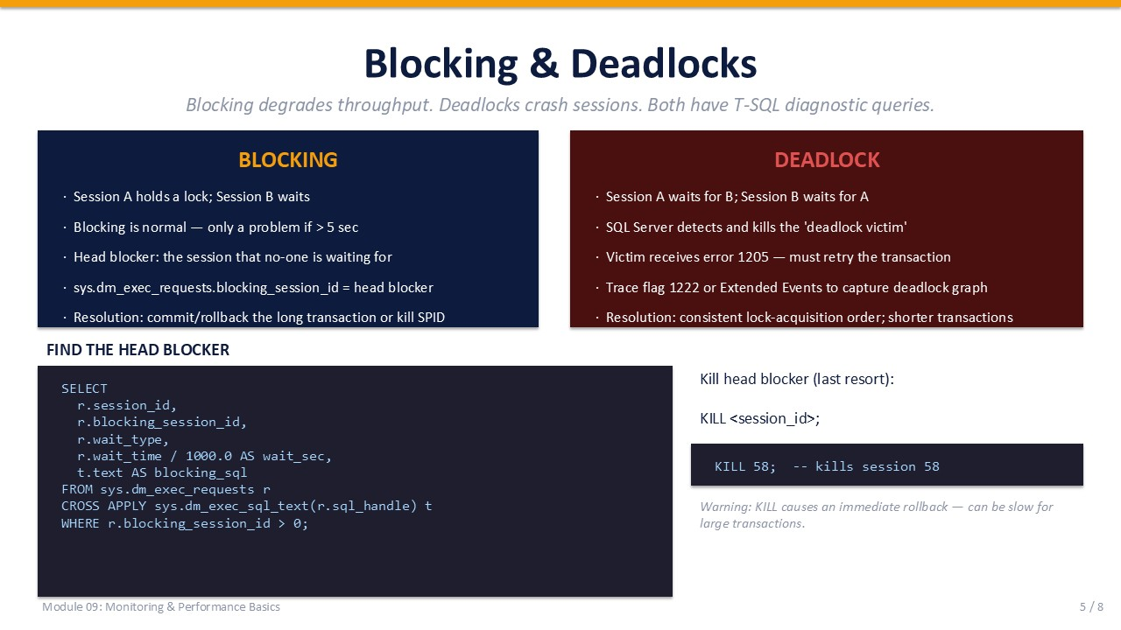
Slide 5 of 8

Blocking & Deadlocks
Blocking and deadlocks are the two most common lock-related performance problems in SQL Server. They look similar but have different causes and require different responses.

Blocking
Blocking occurs when Session A holds a lock on a resource and Session B is waiting for that same resource. Blocking is normal and expected in a transactional database. It only becomes a problem when the wait time exceeds a few seconds or when a chain of blocked sessions grows.
- Head blocker The session that no other session is waiting for. Identify it by finding sessions with blocking_session_id = 0 that other sessions are blocked by.
- Blocking threshold The default is 0 seconds (all blocking is recorded). Alert when blocking exceeds 5 seconds.
- Resolution Find the head blocker's query, determine why the transaction is open, commit or roll back the transaction. Use KILL only as a last resort.
T-SQL
-- Find all blocked sessions and their head blocker
SELECT
r.session_id,
r.blocking_session_id,
r.wait_type,
r.wait_time / 1000.0 AS wait_sec,
t.text AS blocked_sql
FROM sys.dm_exec_requests r
CROSS APPLY sys.dm_exec_sql_text(r.sql_handle) t
WHERE r.blocking_session_id > 0;

Deadlocks
A deadlock occurs when Session A is waiting for Session B, AND Session B is simultaneously waiting for Session A — a circular wait with no exit. SQL Server automatically detects this, selects a "deadlock victim" (the cheaper transaction to roll back), and terminates it with error 1205.
- Error 1205 The application receives "Transaction was deadlocked on lock resources with another process and has been chosen as the deadlock victim."
- Deadlock victim SQL Server chooses based on SET DEADLOCK_PRIORITY or the transaction with the least rollback cost.
- Prevention strategy Access tables in a consistent order across all transactions; keep transactions short; avoid user interaction inside a transaction.
- Capture deadlocks Enable trace flag 1222 or use Extended Events with the xml_deadlock_report event to capture deadlock graphs.
⚠ | KILL Is a Blunt Instrument  KILL <session_id> causes an immediate rollback of the active transaction. For long-running transactions this rollback can take minutes. Always identify the blocking SQL first and try to resolve it gracefully before using KILL.

SLIDE 6 — WAIT STATISTICS & EXECUTION PLANS

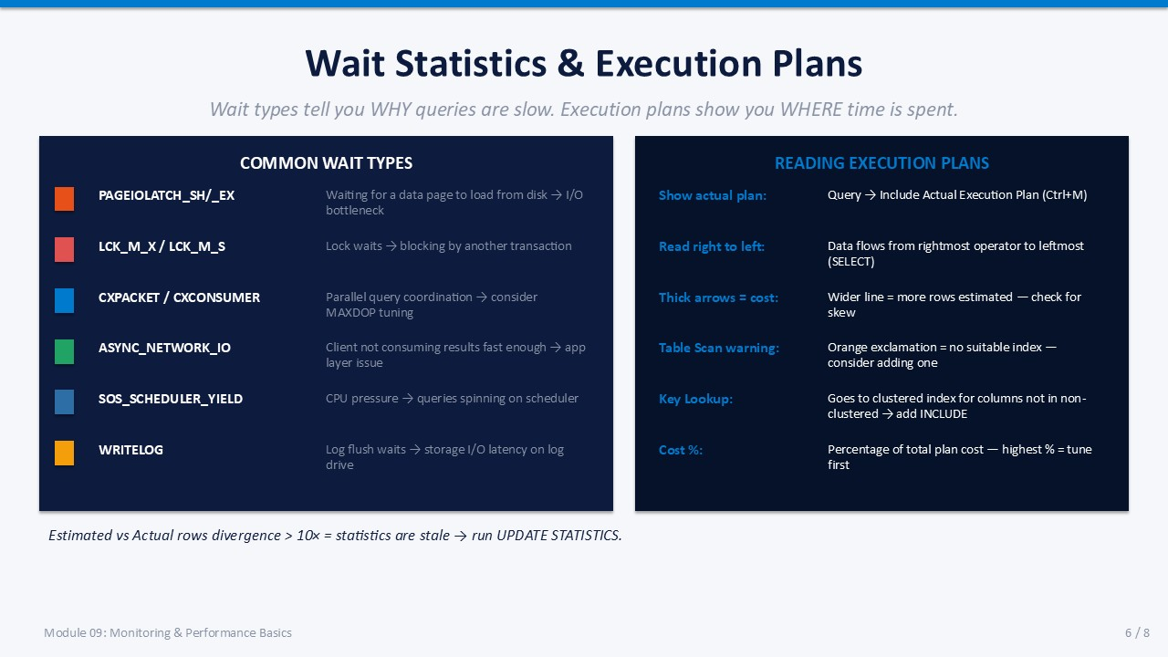
Slide 6 of 8

Wait Statistics & Execution Plans
Wait statistics tell you WHY a query is slow. Execution plans tell you WHERE inside the query the time is spent. Together they guide you to the root cause without guesswork.

Common Wait Types Reference
Wait Type | What It Means | Typical Root Cause
PAGEIOLATCH_SH / _EX | Waiting for a data page to load from disk | I/O bottleneck — slow storage or missing index causing large scans
LCK_M_X / LCK_M_S | Lock waits — exclusive or shared | Blocking by another long-running transaction
CXPACKET / CXCONSUMER | Parallel query thread coordination | Consider reducing MAXDOP; one thread lagging behind others
ASYNC_NETWORK_IO | Client is not consuming result rows fast enough | Application-layer issue; large result sets; slow network
SOS_SCHEDULER_YIELD | CPU spinning — waiting for scheduler time | CPU pressure; too many concurrent queries or expensive queries
WRITELOG | Waiting for transaction log flush to complete | Log drive I/O latency; log file on slow storage

When estimated rows diverge from actual rows by more than 10×, statistics are stale. Run UPDATE STATISTICS on the relevant table.

Reading Execution Plans
- Enable actual plan In SSMS: Query menu → Include Actual Execution Plan (Ctrl+M). Run the query.
- Read right to left Data flows from the rightmost operator (data source) to the leftmost (SELECT). Start your analysis at the right.
- Thick arrows = rows The width of connecting arrows represents the estimated number of rows. Unexpectedly wide arrows indicate cardinality issues.
- Table Scan warning A yellow exclamation mark on a Table Scan operator means no suitable index was found. Consider adding one.
- Key Lookup SQL Server goes back to the clustered index to fetch columns not in the non-clustered index. Add those columns as INCLUDE columns.
- Operator cost % Each operator shows its percentage of total plan cost. Tune the highest-cost operator first.

SLIDE 7 — LAB 09

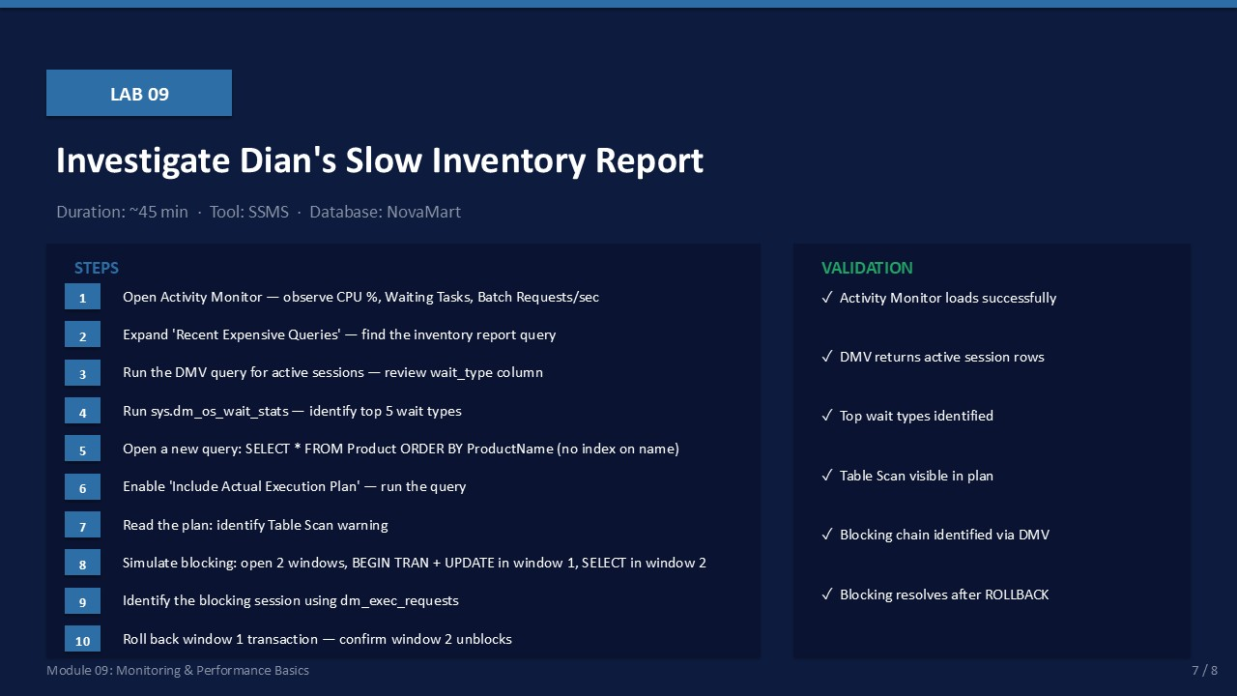
Slide 7 of 8

Lab 09: Investigate a Slow Inventory Report
Goal | Duration | Tool | Database
Use Activity Monitor, DMVs, execution plans, and blocking simulation to diagnose performance | ~45 min | SSMS | NovaMart

Prerequisites
- NovaMart database with Employee and Department tables (from Lab 04).
- SSMS connected to the SQL Server instance.

Lab Steps
- Open Activity Monitor (right-click the instance → Activity Monitor). Observe the Overview charts.
Expected: Four live charts appear: CPU %, Waiting Tasks, Database I/O, Batch Requests/sec.
- Expand the Processes panel. Note the columns: Session ID, CPU, Blocked By, Wait Type, Host Name.
Expected: Current sessions are listed. Most should show no wait type or be in background status.
- Expand Recent Expensive Queries. Click a row to view the query text in the panel at the bottom.
Expected: Query text and execution plan button appear in the lower panel.
- Open a new query window. Run the active sessions DMV:
SELECT r.session_id, r.status, r.cpu_time, r.wait_type, t.text
FROM sys.dm_exec_requests r
CROSS APPLY sys.dm_exec_sql_text(r.sql_handle) t
WHERE r.session_id > 50
ORDER BY r.cpu_time DESC;
Expected: Returns rows for active sessions with wait types visible.
- Run the top wait types query:
SELECT TOP 10 wait_type, wait_time_ms, waiting_tasks_count
FROM sys.dm_os_wait_stats
ORDER BY wait_time_ms DESC;
Expected: Returns a list of wait types ordered by total wait time. Note the top 3 wait types.
- Enable Include Actual Execution Plan (Ctrl+M).
Run: SELECT * FROM dbo.Employee ORDER BY FirstName;
(Assumes there is no index on FirstName.)
Expected: Execution plan appears in a new Execution Plan tab.
- In the execution plan, look for a Table Scan or Clustered Index Scan operator with a yellow warning icon.
Expected: A warning appears indicating a missing index recommendation.
- Simulate blocking:
Window 1: BEGIN TRAN; UPDATE dbo.Employee SET DeptID = 1 WHERE EmpID = 1;
(Do NOT commit yet — leave the transaction open.)
Expected: Transaction is open; row is locked.
- Window 2: SELECT * FROM dbo.Employee WHERE EmpID = 1;
(This should hang — it is blocked by Window 1.)
Expected: Query in Window 2 does not return — it is waiting.
- Window 3: Run the blocking query:
SELECT r.session_id, r.blocking_session_id, r.wait_type, t.text
FROM sys.dm_exec_requests r
CROSS APPLY sys.dm_exec_sql_text(r.sql_handle) t
WHERE r.blocking_session_id > 0;
Expected: Blocked session and head blocker session ID are visible.
- Window 1: ROLLBACK;
Observe that Window 2's query now completes.
Expected: Window 2 returns the result row. Blocking resolved.

Validation Checklist
☐ Activity Monitor loads and shows all 5 panels
☐ DMV query returns active session rows with wait type information
☐ Top 5 wait types identified from dm_os_wait_stats
☐ Table Scan visible in the execution plan for the Employee SELECT
☐ Blocking chain identified in dm_exec_requests (blocking_session_id > 0)
☐ Blocking resolves after ROLLBACK in Window 1

Troubleshooting
Symptom | Likely Cause | Resolution
Activity Monitor shows error | Insufficient permissions | Must be sysadmin or have VIEW SERVER STATE permission
DMV returns no rows | No active queries above session 50 | Normal in a quiet training environment — run a slow query first
Execution plan tab not showing | Ctrl+M not enabled before running | Enable Include Actual Execution Plan before executing the query
Window 2 does not block | Read committed snapshot isolation on | Check: SELECT is_read_committed_snapshot_on FROM sys.databases WHERE name='NovaMart'

SLIDE 8 — PERFORMANCE FIRST-RESPONSE CHECKLIST

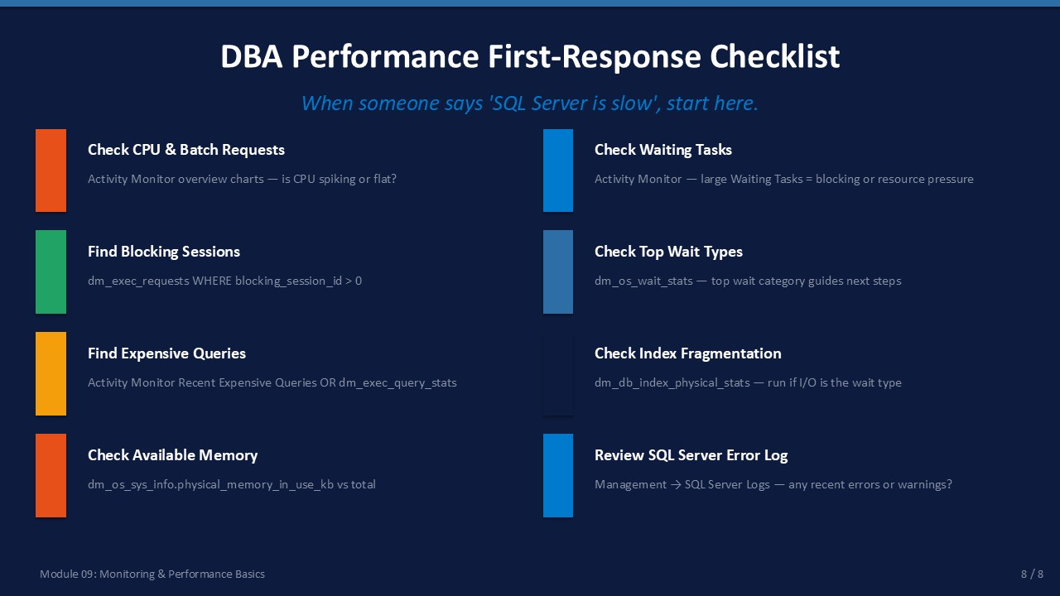
Slide 8 of 8

DBA Performance First-Response Checklist
When someone reports "SQL Server is slow," apply this eight-step first-response workflow before making any changes. Each step narrows the problem to the correct layer.
Step | Action | Tool / Query
1 | Check CPU & Batch Requests | Activity Monitor overview — is CPU spiking or sustained flat?
2 | Check Waiting Tasks | Activity Monitor — high Waiting Tasks = blocking or resource pressure
3 | Find Blocking Sessions | SELECT from dm_exec_requests WHERE blocking_session_id > 0
4 | Check Top Wait Types | SELECT from dm_os_wait_stats ORDER BY wait_time_ms DESC
5 | Find Expensive Queries | Activity Monitor Recent Expensive Queries OR dm_exec_query_stats
6 | Check Index Fragmentation | dm_db_index_physical_stats — run if PAGEIOLATCH is the top wait
7 | Check Available Memory | dm_os_sys_info — physical_memory_in_use_kb vs total_physical_memory_kb
8 | Review SQL Server Error Log | Management → SQL Server Logs — recent errors, stack dumps, I/O warnings

ℹ | Document What You Find  Even if you resolve the problem, write down: what time the issue started, which session or query was the root cause, what you did to resolve it, and the outcome. This log becomes invaluable for pattern recognition in future incidents.

