SLIDE 1 — MODULE COVER

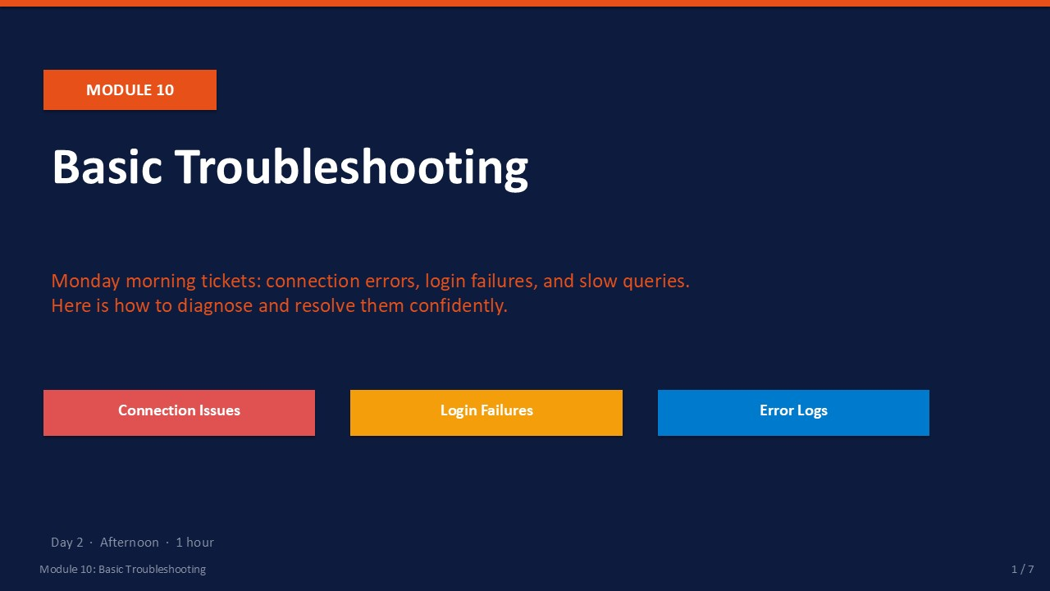
Slide 1 of 7

Module 10: Basic Troubleshooting
Module | Day | Duration | Lab
10 | 2 — Afternoon | 60 minutes | Lab 10

Monday morning support tickets follow predictable patterns: "I can't connect to SQL Server," "My login isn't working," or "the report is incredibly slow today." This module gives you a structured response to each of these common scenarios so you can diagnose the root cause quickly and resolve it with confidence.
You will learn to read the SQL Server Error Log — the most authoritative source of truth about what the engine has experienced — and to apply a disciplined first-response workflow to connection failures, authentication errors, and performance bottlenecks. The lab simulates three realistic support tickets.
ℹ | Troubleshooting Is a Process, Not a Guess  Every troubleshooting session should follow the same pattern: (1) Reproduce the problem. (2) Identify the error message and its code. (3) Read the Error Log for details. (4) Isolate the layer (network, service, authentication, query). (5) Fix the root cause — not just the symptom.

What This Module Covers
- Connection Errors Error 53, 17, 4060, 10060 — causes, diagnostics, and fixes.
- Login Failures Error 18456 state codes — what each state means and how to resolve it.
- SQL Server Error Log Reading the log in SSMS and via sp_readerrorlog.
- Performance Bottlenecks Six bottleneck categories and their first-response diagnostic queries.

SLIDE 2 — LEARNING OBJECTIVES

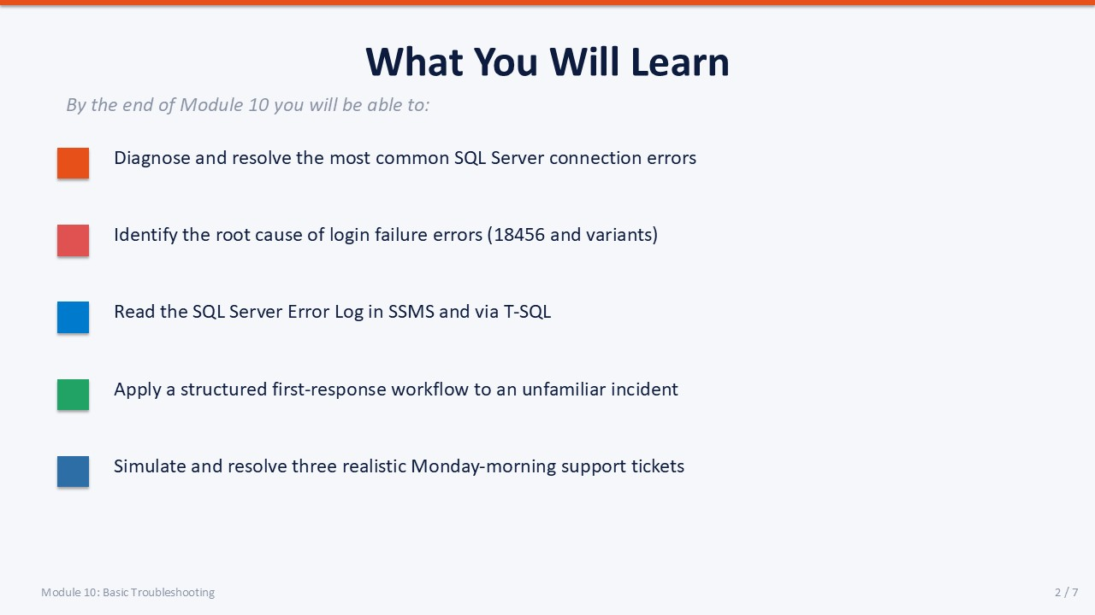
Slide 2 of 7

Learning Objectives
By the end of Module 10 you will be able to:
- Diagnose and resolve the most common SQL Server connection errors — error 53, 17, 4060, and 10060 with a structured check sequence.
- Identify the root cause of login failure error 18456 — using the state code from the SQL Server Error Log, not the generic client message.
- Read the SQL Server Error Log in SSMS and via T-SQL — using sp_readerrorlog with keyword filters.
- Apply a structured first-response workflow to performance incidents — CPU, memory, I/O, lock, network, and query design bottlenecks.
- Simulate and resolve three realistic Monday-morning support tickets — connection failure, login failure, and slow query.

SLIDE 3 — COMMON CONNECTION ERRORS

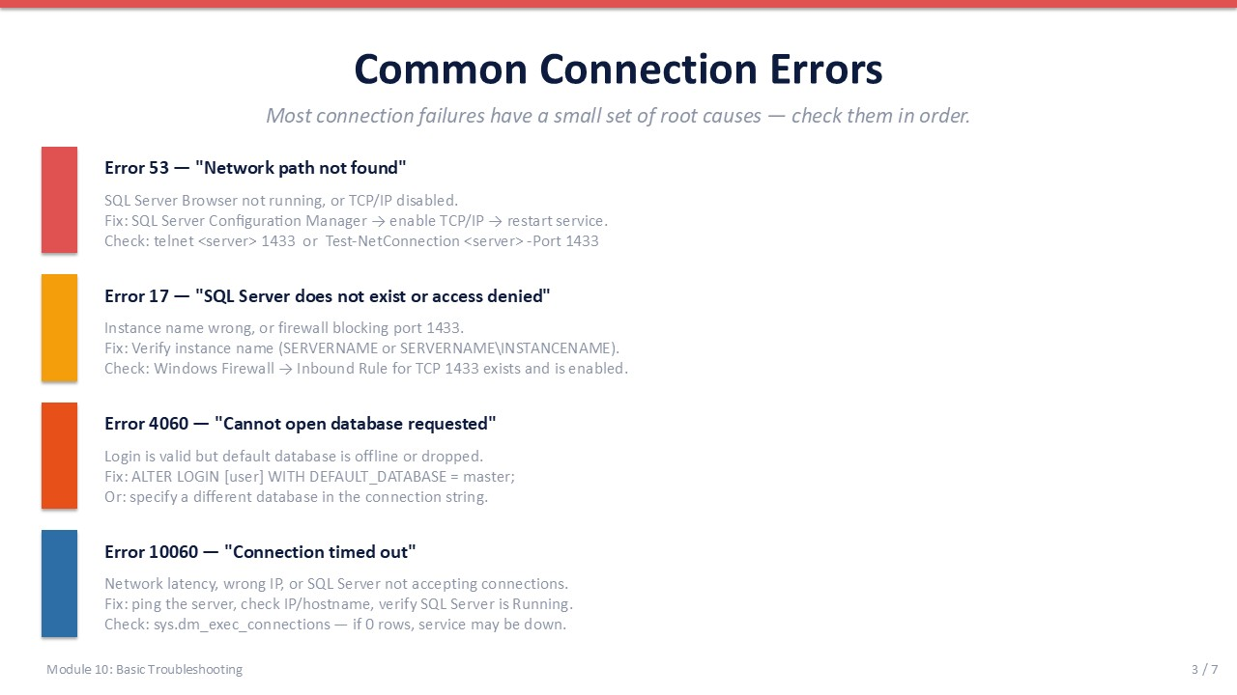
Slide 3 of 7

Common Connection Errors
Most connection failures trace back to a small set of root causes. Always check them in order: service status first, then network, then configuration, then authentication.
Error | Message (abbreviated) | Root Cause | First Fix
53 | "Network path not found" | SQL Server Browser stopped, or TCP/IP disabled | Config Manager → enable TCP/IP → restart service
17 | "SQL Server does not exist or access denied" | Wrong instance name, or firewall blocking port 1433 | Verify instance name; check Windows Firewall inbound rule for TCP 1433
4060 | "Cannot open database requested" | Login is valid but default database is offline or dropped | ALTER LOGIN [user] WITH DEFAULT_DATABASE = master;
10060 | "Connection timed out" | Wrong IP/hostname, or SQL Server not accepting connections | Ping the server; verify SQL Server service is Running

Quick Connectivity Test
Before changing any SQL Server configuration, verify basic network connectivity:
PowerShell / Checklist
-- PowerShell: test TCP port 1433 from the client machine
Test-NetConnection -ComputerName SQLSERVER01 -Port 1433
-- Should return: TcpTestSucceeded : True
-- If False: firewall or SQL Server not listening on 1433
-- SQL Server Configuration Manager checklist:
-- 1. SQL Server (MSSQLSERVER) service = Running
-- 2. SQL Server Browser service = Running (for named instances)
-- 3. TCP/IP protocol = Enabled
-- 4. TCP Port under IP All = 1433

ℹ | Named vs Default Instance  A default instance connects as SERVERNAME. A named instance connects as SERVERNAME\INSTANCENAME and requires SQL Server Browser. If Browser is stopped, named instance connections fail with error 53 even if the engine is running.

SLIDE 4 — LOGIN FAILURES (ERROR 18456)

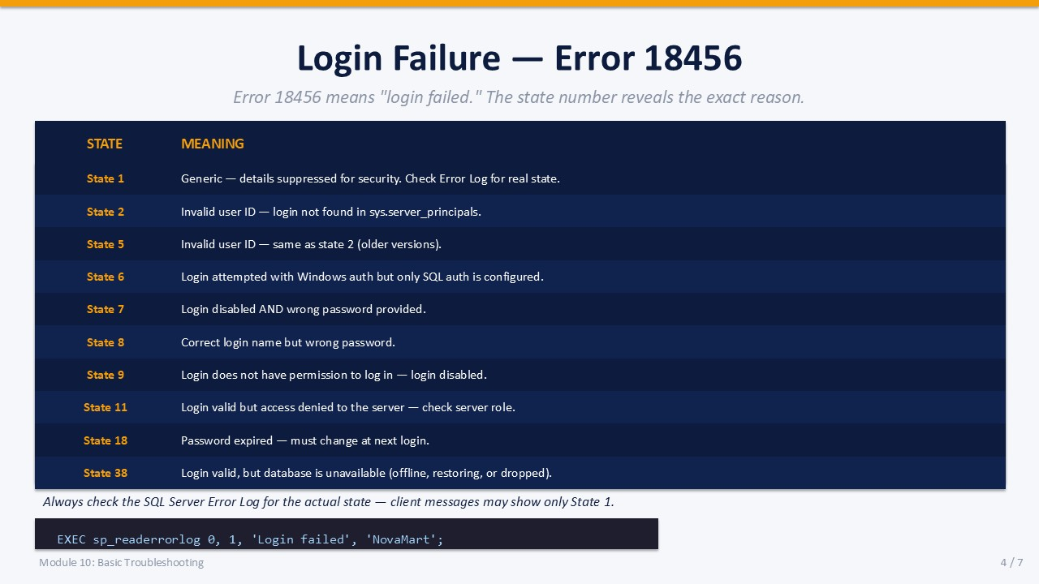
Slide 4 of 7

Login Failure — Error 18456
Error 18456 means "login failed." The client always receives State 1 (generic, for security). The actual state code is written to the SQL Server Error Log. Always read the Error Log to find the real state before troubleshooting.
State | Meaning | Resolution
2 | Login name not found in sys.server_principals | Create the login: CREATE LOGIN [name] WITH PASSWORD='...';
5 | Same as State 2 (older SQL versions) | Create the login
6 | Windows auth attempted but only SQL auth configured | Enable Windows auth: Server Properties → Security → Mixed Mode
7 | Login disabled AND wrong password | ALTER LOGIN [name] ENABLE; reset password
8 | Wrong password (login exists and is enabled) | Reset: ALTER LOGIN [name] WITH PASSWORD='newpass';
9 | Login is valid but disabled | ALTER LOGIN [name] ENABLE;
11 | Login valid but not authorized to log in to server | Grant CONNECT permission or add to a server role
18 | Password expired — must change at next login | ALTER LOGIN [name] WITH PASSWORD='...' MUST_CHANGE = OFF;
38 | Login valid but database unavailable (offline/restoring) | ALTER LOGIN [name] WITH DEFAULT_DATABASE = master;

Finding the Real State in the Error Log
T-SQL
-- Search the current error log for login failures
EXEC sp_readerrorlog 0, 1, 'Login failed';
-- Search for a specific login
EXEC sp_readerrorlog 0, 1, 'Login failed', 'LabSari';
-- The log shows: Login failed for user 'LabSari'. Reason: ... [State 9]
-- State 9 = login disabled → ALTER LOGIN LabSari ENABLE;

⚠ | Client Error vs Server Log  The client application always sees: "Login failed for user 'X'. (Microsoft SQL Server, Error: 18456)" with State 1. The real diagnostic state is only in the SQL Server Error Log. Never try to resolve 18456 based on the client message alone.

SLIDE 5 — READING THE SQL SERVER ERROR LOG

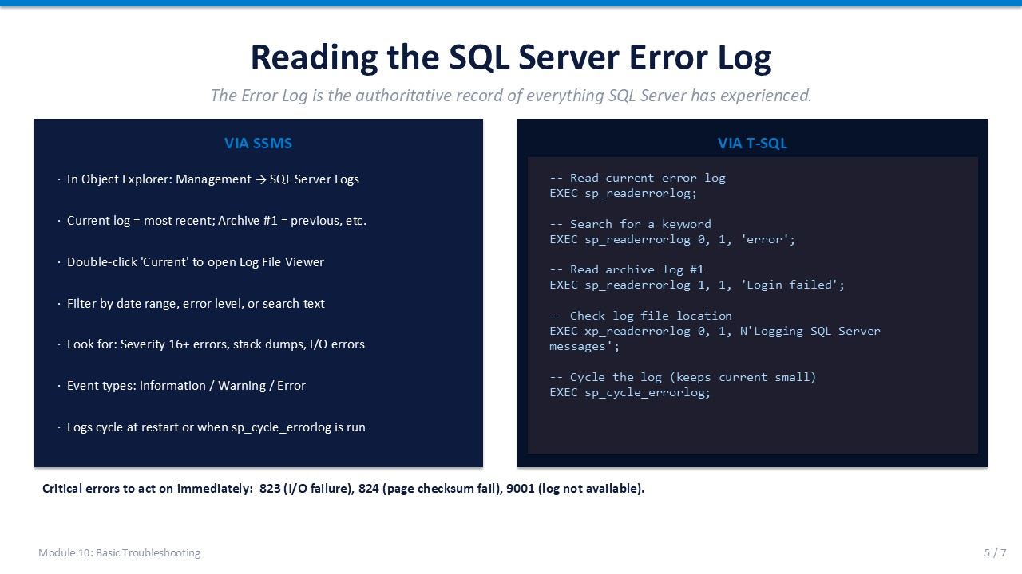
Slide 5 of 7

Reading the SQL Server Error Log
The SQL Server Error Log is the authoritative record of everything the engine has experienced: startups, shutdowns, authentication failures, backup events, I/O errors, and stack dumps. It is always the first place to look during any incident.

Reading the Log in SSMS
- Navigate Object Explorer → Management → SQL Server Logs. "Current" is the active log. "Archive #1" is the previous.
- Open Double-click "Current" to open the Log File Viewer.
- Filter Use the Filter button to narrow by date range, message type, or search keyword.
- Severity levels Informational (normal), Warning (attention needed), Error (action required, Severity 16+).
- Cycle log Right-click SQL Server Logs → Configure → or run EXEC sp_cycle_errorlog to start a new log file.

Reading the Log via T-SQL
T-SQL
-- Read the current (active) error log
EXEC sp_readerrorlog;
-- Search for the keyword 'error' in the current log
EXEC sp_readerrorlog 0, 1, 'error';
-- Search archive log #1 for login failures
EXEC sp_readerrorlog 1, 1, 'Login failed';
-- Cycle the error log (keeps current log small)
EXEC sp_cycle_errorlog;
-- Check the log file path
EXEC xp_readerrorlog 0, 1, N'Logging SQL Server messages';

Critical Error Numbers to Act On Immediately
Error Number | Description | Action
823 | I/O error reading from disk — hardware failure suspected | Take a backup immediately. Check storage hardware. Run DBCC CHECKDB.
824 | SQL Server detected logical consistency-based I/O error | Take a backup immediately. Run DBCC CHECKDB. Escalate to storage team.
9001 | Log file for database is unavailable | The database may be in suspect state. Check disk space and log drive health.
1205 | Deadlock victim | Application-level — see Module 09. Capture deadlock graph if recurring.
17803 | Insufficient memory to run server | Check max server memory setting and available RAM on the server.

SLIDE 6 — PERFORMANCE BOTTLENECK FIRST RESPONSE

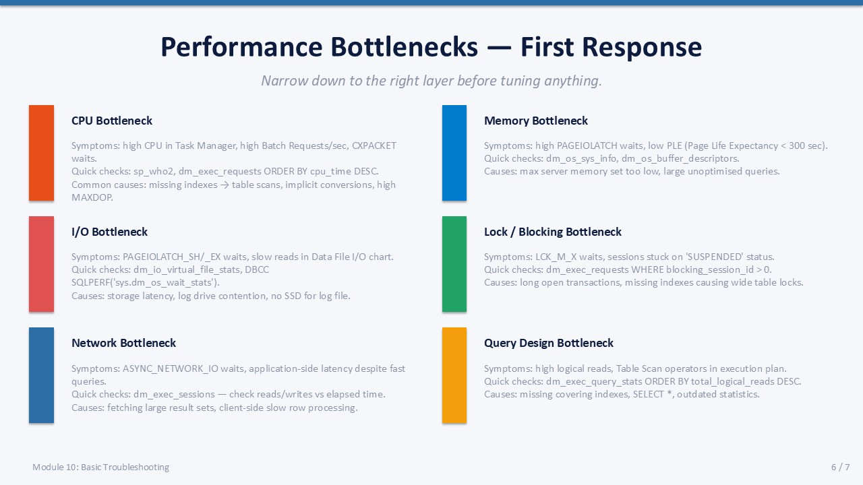
Slide 6 of 7

Performance Bottlenecks — First Response
Narrow down to the correct layer before tuning anything. Each bottleneck type has characteristic symptoms, quick diagnostic queries, and common root causes.
Bottleneck | Symptoms | Quick Diagnostic | Common Cause
CPU | High CPU in Task Manager; CXPACKET waits; high Batch Requests/sec | sp_who2; dm_exec_requests ORDER BY cpu_time DESC | Missing indexes → table scans; implicit type conversions; high MAXDOP
Memory | PAGEIOLATCH waits; low Page Life Expectancy (PLE < 300 sec) | dm_os_sys_info; dm_os_buffer_descriptors | max server memory set too low; large unoptimised queries
I/O | PAGEIOLATCH_SH/_EX waits; slow reads in Data File I/O chart | dm_io_virtual_file_stats; Activity Monitor Data File I/O | Storage latency; log and data files on same drive; no SSD for log
Locks | LCK_M_X waits; sessions stuck on SUSPENDED status | dm_exec_requests WHERE blocking_session_id > 0 | Long open transactions; missing indexes causing wide table locks
Network | ASYNC_NETWORK_IO waits; fast queries but slow application response | dm_exec_sessions — reads/writes vs elapsed time | Fetching large result sets; client-side slow row processing
Query Design | High logical reads; Table Scan in execution plan | dm_exec_query_stats ORDER BY total_logical_reads DESC | Missing covering indexes; SELECT *; outdated statistics

ℹ | PLE (Page Life Expectancy)  PLE measures how long (in seconds) a data page stays in the buffer pool before being evicted. PLE < 300 seconds historically indicated memory pressure. On modern servers with large RAM, PLE should be much higher (thousands of seconds). Monitor the trend over time rather than using a fixed threshold.

SLIDE 7 — LAB 10

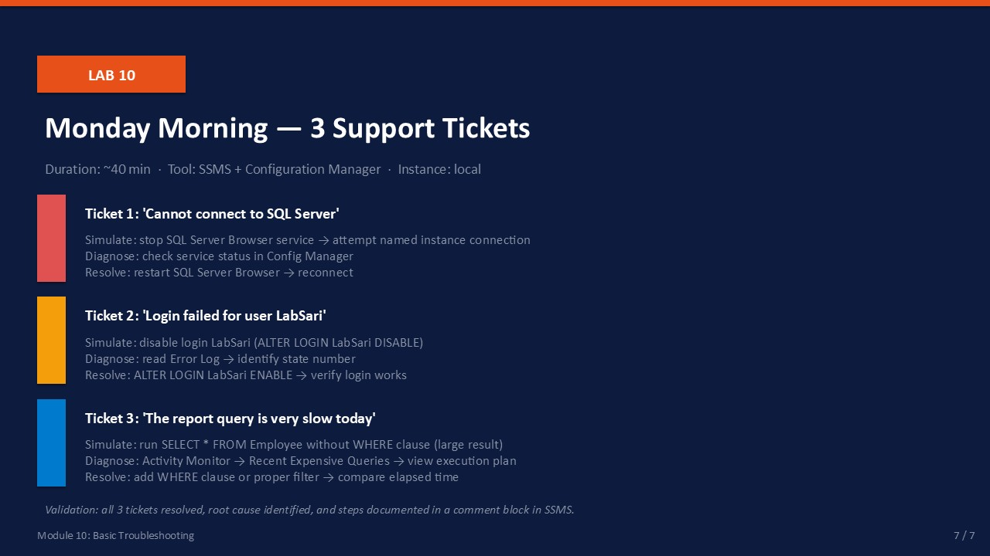
Slide 7 of 7

Lab 10: Monday Morning — 3 Support Tickets
Goal | Duration | Tool | Instance
Simulate and resolve three realistic connection, login, and query support tickets | ~40 min | SSMS + Config Manager | Local SQL Server

Prerequisites
- SQL Server instance running with NovaMart database.
- Login LabSari exists (created in Lab 05) or create it: CREATE LOGIN LabSari WITH PASSWORD='P@ssw0rd';

Ticket 1: "I cannot connect to SQL Server"
Simulate: Open SQL Server Configuration Manager. Stop the SQL Server Browser service.
- In SQL Server Configuration Manager → SQL Server Services → right-click SQL Server Browser → Stop.
Expected: SQL Server Browser shows Stopped.
- In SSMS, try to connect to the named instance (SERVERNAME\SQLEXPRESS or similar) using the full instance name.
Expected: Connection fails with error 53 or "network path not found".
- Diagnose: In Config Manager, confirm SQL Server Browser is Stopped. This is the root cause for named instance discovery.
Expected: Root cause identified: SQL Server Browser stopped.
- Resolve: Right-click SQL Server Browser → Start. Retry the connection in SSMS.
Expected: Connection succeeds.

Ticket 2: "Login failed for user LabSari"
Simulate: Disable login LabSari.
- In SSMS, run: ALTER LOGIN LabSari DISABLE;
Expected: Command succeeds.
- Try to connect to SSMS using LabSari credentials (SQL Server Authentication). Note the error message.
Expected: Error 18456 — Login failed for user 'LabSari'.
- Read the Error Log to find the real state:
EXEC sp_readerrorlog 0, 1, 'Login failed', 'LabSari';
Expected: Log entry shows: State 9 (login disabled).
- Resolve: ALTER LOGIN LabSari ENABLE;
Expected: Login succeeds when retried with LabSari credentials.

Ticket 3: "The report query is very slow today"
Simulate: Run a query without a useful WHERE clause.
- Enable Include Actual Execution Plan (Ctrl+M). Run:
SELECT * FROM dbo.Employee ORDER BY FirstName;
Expected: Query completes; execution plan appears in the Execution Plan tab.
- In the execution plan, identify the most expensive operator (Table Scan or Clustered Index Scan). Note the cost %.
Expected: Table Scan or similar full-scan operator with highest cost % is visible.
- Check Activity Monitor → Recent Expensive Queries to see if the query appears.
Expected: The full-scan query appears in the expensive queries list.
- Resolve by adding a WHERE clause: SELECT * FROM dbo.Employee WHERE DeptID = 1;
Compare execution time.
Expected: Fewer rows returned; elapsed time reduced. Execution plan shows index seek (if index exists on DeptID).

Validation Checklist
☐ Ticket 1: connection failure simulated, SQL Server Browser identified as root cause, connection restored
☐ Ticket 2: login failure simulated, Error Log reveals State 9, login re-enabled and access confirmed
☐ Ticket 3: slow query identified in execution plan, WHERE clause applied, performance improved
☐ All three root causes documented (simulated incident notes)

Troubleshooting the Lab
Symptom | Likely Cause | Resolution
Connection still fails after Browser start | Default instance — Browser not needed | Default instances connect without Browser; use SERVERNAME (no backslash)
LabSari login does not exist | Login was not created in Lab 05 | CREATE LOGIN LabSari WITH PASSWORD='P@ssw0rd', DEFAULT_DATABASE=master;
State 9 not visible in Error Log | Log has been cycled | Try Archive log #1: EXEC sp_readerrorlog 1, 1, 'Login failed', 'LabSari';

