SLIDE 1 — MODULE COVER

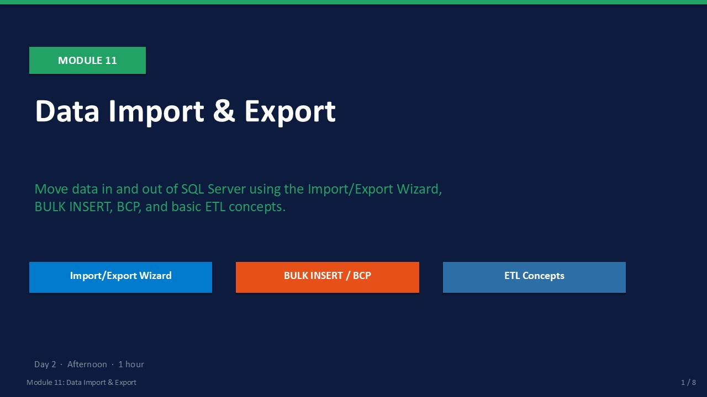
Slide 1 of 8

Module 11: Data Import & Export
Module | Day | Duration | Lab
11 | 2 — Afternoon | 60 minutes | Lab 11

Moving data between systems is one of the most frequent tasks a DBA performs: importing a CSV from a finance team, loading a legacy product catalog, extracting a table for a vendor, or migrating data from an old application. SQL Server provides three tools for this: the Import/Export Wizard for one-off GUI-driven tasks, BULK INSERT for high-speed flat-file loading with T-SQL, and BCP for command-line bulk copy operations.
This module also introduces ETL (Extract, Transform, Load) concepts and the MERGE statement — the T-SQL operator for synchronising source and target tables in a single pass. Module 11 closes the two-day course with a wrap-up slide reviewing all ten modules' key outcomes.
ℹ | Tools Covered in This Module  Import/Export Wizard: best for ad-hoc one-off data moves via GUI.  BULK INSERT: best for repeated server-side flat-file loads.  BCP: best for command-line scripting and scheduled file exports.

What This Module Covers
- Import/Export Wizard Six-step GUI wizard to move data between sources and destinations.
- BULK INSERT T-SQL command for fast flat-file imports with format options.
- BCP Utility Command-line bulk copy for exports, imports, and scripted transfers.
- ETL Concepts Extract, Transform, Load — and the MERGE statement for incremental sync.
- Lab 11 Migrate NovaMart's legacy product catalog: CSV → Wizard → BULK INSERT → BCP → MERGE.
- Course Wrap-Up All ten module outcomes summarised; next steps and learning resources.

SLIDE 2 — LEARNING OBJECTIVES

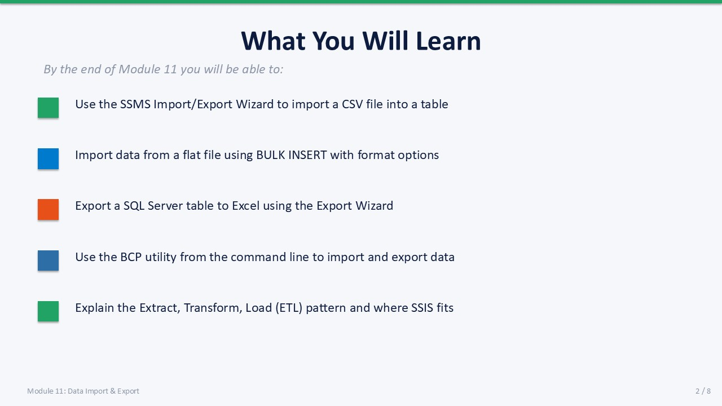
Slide 2 of 8

Learning Objectives
By the end of Module 11 you will be able to:
- Use the Import/Export Wizard to move data between a CSV file and a SQL Server table — launch from SSMS, select source, destination, column mapping, and run.
- Write a BULK INSERT statement to load a flat file into a table — using FIRSTROW, FIELDTERMINATOR, ROWTERMINATOR, and TABLOCK options.
- Use the BCP utility to export and import data from the command line — bcp out, bcp in, and bcp queryout with -S, -T, -c, and -t switches.
- Explain the ETL process and when to use it — Extract from source, Transform (clean/enrich), Load into destination.
- Use the MERGE statement to synchronise a source and target table — WHEN MATCHED THEN UPDATE, WHEN NOT MATCHED THEN INSERT, WHEN NOT MATCHED BY SOURCE THEN DELETE.

SLIDE 3 — IMPORT/EXPORT WIZARD

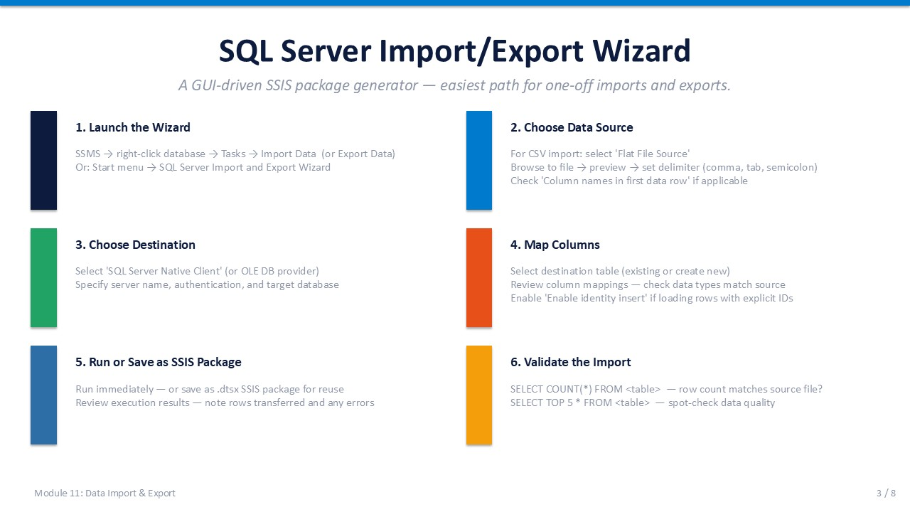
Slide 3 of 8

SQL Server Import and Export Wizard
The SQL Server Import and Export Wizard is the fastest way to move data between heterogeneous sources and destinations without writing code. It supports flat files (CSV, TXT), Excel, Access, SQL Server, OLE DB providers, and ODBC sources.

Six-Step Walkthrough
Step | Screen | What to Do
1 | Launch | In SSMS: right-click the database → Tasks → Import Data (or Export Data).
2 | Choose Data Source | Select the source type (e.g., Flat File Source for CSV). Set the file path and preview columns.
3 | Choose Destination | Select SQL Server Native Client. Set Server Name, authentication, and destination database.
4 | Map Columns | Review the column mapping screen. Ensure data types are compatible. Rename destination columns if needed.
5 | Run or Save as SSIS Package | Run Immediately = one-time execution. Save as SSIS Package = reusable scheduled package.
6 | Validate | The wizard reports rows transferred. Verify in SSMS: SELECT COUNT(*) FROM dbo.TargetTable;

ℹ | First Row = Column Headers  When importing a CSV, check "Column names in the first data row" on the Flat File Connection Manager screen. If skipped, the header row is imported as a data row and you will see column names as values in your table.

Supported Source and Destination Types
Type | Use Case
Flat File (CSV/TXT) | Import finance exports, legacy system dumps, third-party data feeds
Microsoft Excel | Import spreadsheets directly (requires ACE driver; 64-bit limitations apply)
SQL Server (another DB) | Copy tables between databases or instances
OLE DB / ODBC | Connect to Oracle, MySQL, Access, or any ODBC-compliant source

SLIDE 4 — BULK INSERT

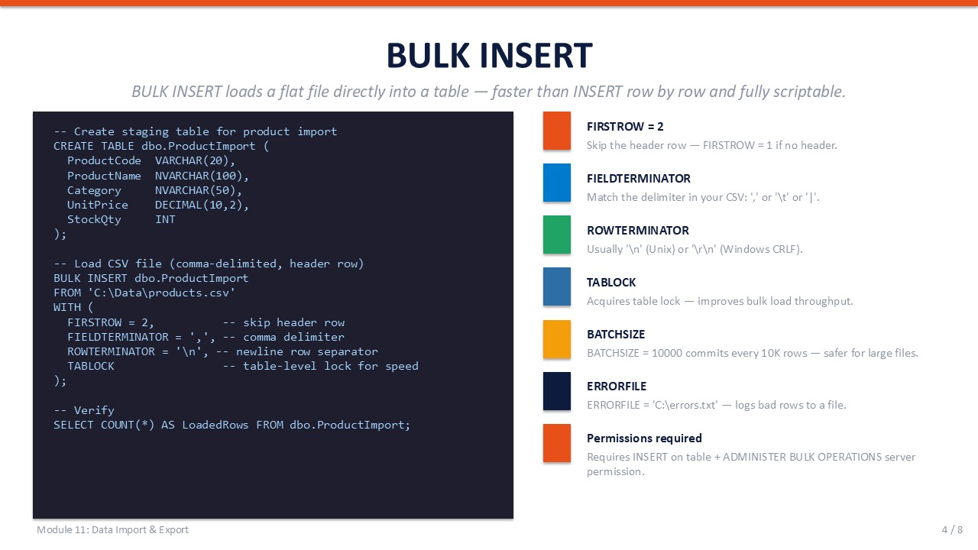
Slide 4 of 8

BULK INSERT
BULK INSERT is a T-SQL command that reads a flat file directly into a table without any wizard steps. It is the fastest way to load data in a repeatable, scriptable way and is typically 10–100× faster than row-by-row INSERT statements.

Creating the Target Table and Loading Data
T-SQL
-- Step 1: Create the staging table
USE NovaMart;
GO
CREATE TABLE dbo.ProductImport (
ProductID INT,
ProductName NVARCHAR(100),
Category NVARCHAR(50),
Price DECIMAL(10, 2),
StockQty INT
);
GO
-- Step 2: Bulk load the CSV
BULK INSERT dbo.ProductImport
FROM 'C:\LabFiles\products.csv'
WITH (
FIRSTROW = 2, -- skip header row
FIELDTERMINATOR = ',', -- comma-separated
ROWTERMINATOR = '\n', -- newline at end of each row
TABLOCK -- table-level lock for speed
);
-- Step 3: Verify
SELECT COUNT(*) AS RowsLoaded FROM dbo.ProductImport;

Key BULK INSERT Options
Option | Description | Example
FIRSTROW | Skip header rows; row number to start reading from | FIRSTROW = 2
FIELDTERMINATOR | Character separating columns | FIELDTERMINATOR = ','
ROWTERMINATOR | Character ending each row | ROWTERMINATOR = '\n'
TABLOCK | Acquire table-level lock — fastest for large loads | TABLOCK
BATCHSIZE | Commit in chunks; allows partial load recovery | BATCHSIZE = 10000
MAXERRORS | Stop after N errors; useful for dirty data | MAXERRORS = 5
FORMATFILE | Path to a format file that describes column layout | FORMATFILE = 'C:\fmt.xml'

⚠ | File Must Be on the Server  BULK INSERT reads the file from a path relative to the SQL Server service account. The file must be accessible from the server — not just the client machine. Use a UNC path (\\server\share\file.csv) or copy the file to the server first.

SLIDE 5 — BCP UTILITY

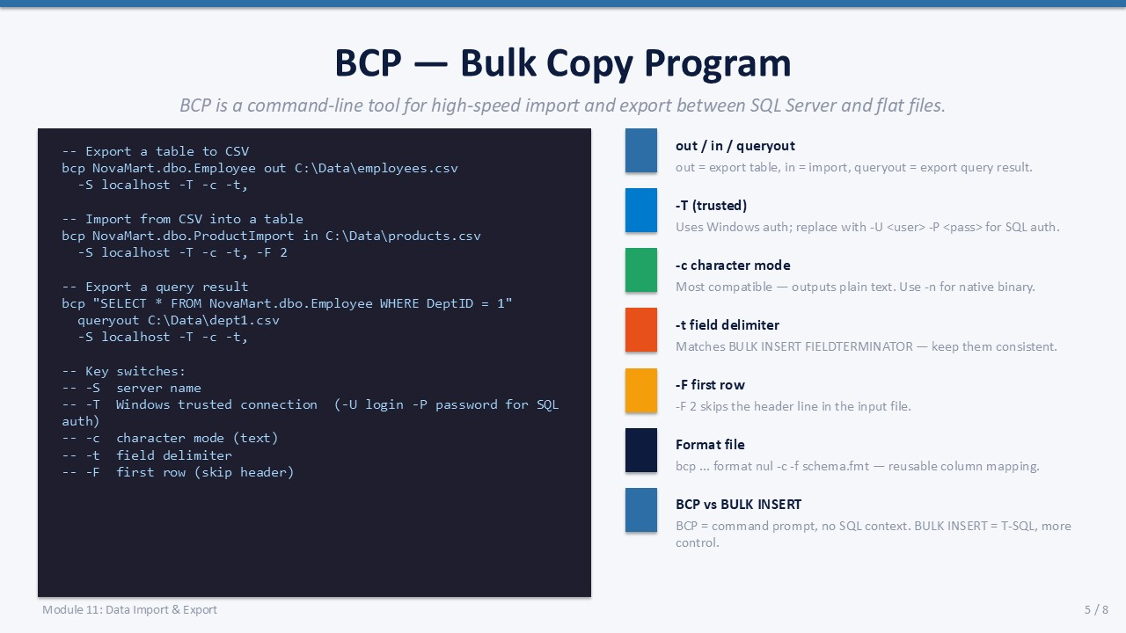
Slide 5 of 8

BCP (Bulk Copy Program) Utility
BCP is a command-line tool included with SQL Server that copies data between SQL Server and flat files. It is ideal for scheduled exports, migrations, and scripted data transfers — tasks where the wizard is too manual.

BCP Syntax Reference
Command Prompt (BCP)
-- Export an entire table to a flat file
bcp NovaMart.dbo.Employee out C:\LabFiles\employees.dat -S SQLSERVER01 -T -c
-- Import a flat file into a table
bcp NovaMart.dbo.EmployeeImport in C:\LabFiles\employees.dat -S SQLSERVER01 -T -c
-- Export the result of a query to a CSV
bcp "SELECT EmpID, FirstName, LastName FROM NovaMart.dbo.Employee" queryout \
C:\LabFiles\emp_export.csv -S SQLSERVER01 -T -c -t ","

Key BCP Switches
Switch | Meaning | Notes
-S server | SQL Server instance name | Use SERVERNAME or SERVERNAME\INSTANCENAME
-T | Use Windows trusted (integrated) authentication | Omit -T and use -U/-P for SQL auth
-U user | SQL login username | Combine with -P for SQL Server auth
-P password | SQL login password | Avoid in scripts — use -T or stored credentials
-c | Character mode — data as text, tab-delimited | Most compatible; readable in Notepad
-t delim | Field terminator override | -t "," for CSV
-F n | First row to import (skip n-1 rows) | -F 2 to skip header
-e errfile | Error file path for rows that failed to load | Helps troubleshoot import issues

ℹ | BCP vs BULK INSERT  BULK INSERT runs inside SQL Server and reads files from the server filesystem. BCP runs as a client-side command-line program and can read or write files on the client machine. Use BULK INSERT for server-side scripts and SQL Agent jobs; use BCP for client-side or cross-machine transfers.

SLIDE 6 — ETL CONCEPTS

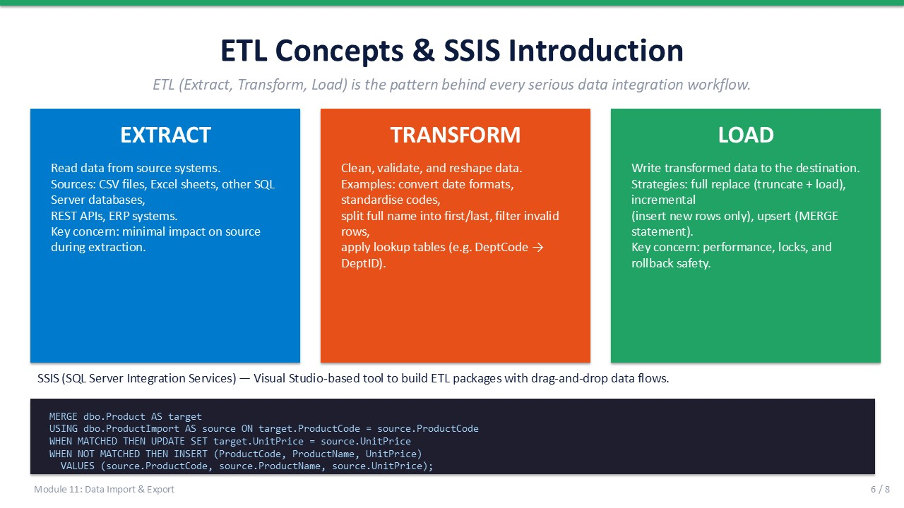
Slide 6 of 8

ETL Concepts
ETL — Extract, Transform, Load — is the standard pattern for moving data from a source system into a destination (data warehouse, staging table, or application database) with cleaning and enrichment steps in between.

The Three Stages
Stage | Description | SQL Server Tool
EXTRACT | Read source data — CSV, another database, API, Excel, or legacy system | BULK INSERT, BCP, Linked Servers, Import/Export Wizard
TRANSFORM | Clean, validate, deduplicate, enrich, and reformat data | T-SQL: TRIM, CAST, CASE, JOIN, ISNULL, UPDATE on staging table
LOAD | Write cleaned data into the destination table | INSERT INTO ... SELECT, MERGE, or bcp in

The MERGE Statement
MERGE is the T-SQL operator for incremental synchronisation. It compares a source dataset to a target table in a single pass and applies INSERT, UPDATE, or DELETE depending on whether each row is matched.
T-SQL
-- Synchronise dbo.Product from dbo.ProductImport (staging)
MERGE dbo.Product AS target
USING dbo.ProductImport AS source
ON target.ProductID = source.ProductID
WHEN MATCHED THEN
UPDATE SET
target.ProductName = source.ProductName,
target.Price = source.Price,
target.StockQty = source.StockQty
WHEN NOT MATCHED BY TARGET THEN
INSERT (ProductID, ProductName, Category, Price, StockQty)
VALUES (source.ProductID, source.ProductName, source.Category,
source.Price, source.StockQty)
WHEN NOT MATCHED BY SOURCE THEN
DELETE;
-- OUTPUT clause (optional) — capture affected rows
-- OUTPUT $action, inserted.ProductID INTO dbo.MergeLog;

- WHEN MATCHED Row exists in both source and target — UPDATE target with source values.
- WHEN NOT MATCHED BY TARGET Row is in source but not in target — INSERT it.
- WHEN NOT MATCHED BY SOURCE Row is in target but not in source — DELETE it (use with caution).
- OUTPUT clause Optionally capture inserted/updated/deleted rows into a log table for auditing.

SLIDE 7 — LAB 11

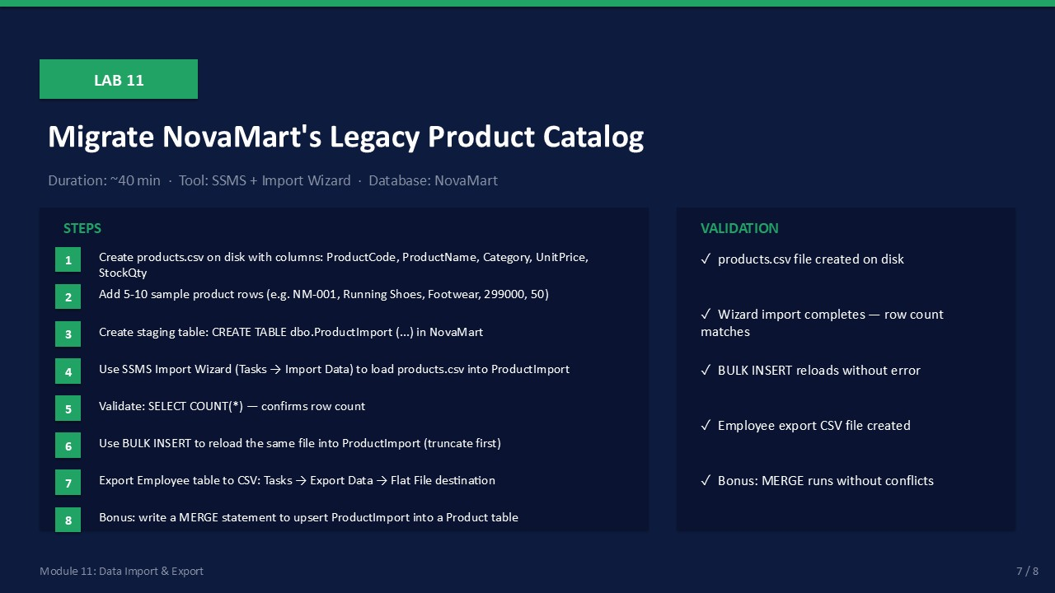
Slide 7 of 8

Lab 11: Migrate NovaMart's Legacy Product Catalog
Goal | Duration | Tool | Database
Import a product CSV using three methods and synchronise with MERGE | ~45 min | SSMS + BCP + File Explorer | NovaMart

Prerequisites
- NovaMart database exists.
- C:\LabFiles\ folder exists on the server (create it if not present).
- BCP command-line tool available (installed with SQL Server).

Part A: Create the CSV File
- Create C:\LabFiles\products.csv with the following content:
ProductID,ProductName,Category,Price,StockQty
1,Wireless Mouse,Peripherals,25.99,150
2,USB Keyboard,Peripherals,45.00,80
3,Monitor 24",Displays,199.99,40
4,HDMI Cable,Accessories,9.99,300
5,Laptop Stand,Accessories,35.00,120
Expected: File saved with 5 data rows and 1 header row.

Part B: Import Using the Wizard
- In SSMS, right-click NovaMart → Tasks → Import Data. Click Next on the Welcome screen.
Expected: SQL Server Import and Export Wizard opens.
- Data Source: "Flat File Source". File path: C:\LabFiles\products.csv. Check "Column names in the first data row." Click Next.
Expected: Columns detected: ProductID, ProductName, Category, Price, StockQty.
- Destination: "SQL Server Native Client". Server: localhost (or your instance name). Database: NovaMart. Click Next.
Expected: Destination connection established.
- On the "Select Source Tables and Views" screen, rename the destination table to dbo.ProductWizard. Click Next.
Expected: Mapping screen shows all 5 columns mapped.
- Click Finish → Run. Note the number of rows transferred.
Expected: 5 rows transferred successfully.
- Verify: SELECT * FROM dbo.ProductWizard;
Expected: 5 product rows returned.

Part C: Import Using BULK INSERT
- Run the following T-SQL to create a staging table and load the CSV:
T-SQL
CREATE TABLE dbo.ProductImport (
ProductID INT,
ProductName NVARCHAR(100),
Category NVARCHAR(50),
Price DECIMAL(10,2),
StockQty INT
);
BULK INSERT dbo.ProductImport
FROM 'C:\LabFiles\products.csv'
WITH (
FIRSTROW = 2,
FIELDTERMINATOR = ',',
ROWTERMINATOR = '\n',
TABLOCK
);
SELECT COUNT(*) AS RowsLoaded FROM dbo.ProductImport;

Expected: 5 rows loaded into dbo.ProductImport.

Part D: Export Using BCP
- Open a Command Prompt (or PowerShell). Export the Employee table to a CSV:
bcp NovaMart.dbo.Employee out C:\LabFiles\employees_export.csv -S localhost -T -c -t ","
Expected: BCP reports rows copied. File appears in C:\LabFiles\.
- Verify the file contents: open employees_export.csv in Notepad.
Expected: Employee rows visible in CSV format, comma-separated.

Part E (Bonus): MERGE Sync
- Create a target Product table and run MERGE from the staging table:
SELECT * INTO dbo.Product FROM dbo.ProductImport WHERE 1=0; -- create empty target
Then insert 3 rows manually into dbo.Product (ProductID 1, 2, 3).
Modify ProductID 1's name in dbo.ProductImport. Then run the MERGE statement from Section 6.
Expected: MERGE inserts rows 4 and 5, updates row 1 with the new name, leaves rows 2 and 3 unchanged.

Validation Checklist
☐ dbo.ProductWizard contains 5 rows imported via Wizard
☐ dbo.ProductImport contains 5 rows loaded via BULK INSERT
☐ employees_export.csv created in C:\LabFiles\ with all Employee rows
☐ MERGE result: new rows inserted, changed row updated, no orphan rows in target
☐ All three import methods executed without errors

Troubleshooting
Symptom | Likely Cause | Resolution
BULK INSERT error: "cannot open file" | File path is relative to server, not client | Copy products.csv to the server; use UNC path if on a network share
Wizard cannot see CSV columns | "First row = headers" checkbox not checked | Go back to Flat File Source screen and tick the checkbox
BCP error: "login failed" | -T uses Windows auth; service account needs access | Use -U sa -P password or verify the service account has SQL login
MERGE inserts all rows (no matches) | ON clause key mismatch | Verify ProductID data types match between source and target tables

SLIDE 8 — COURSE WRAP-UP

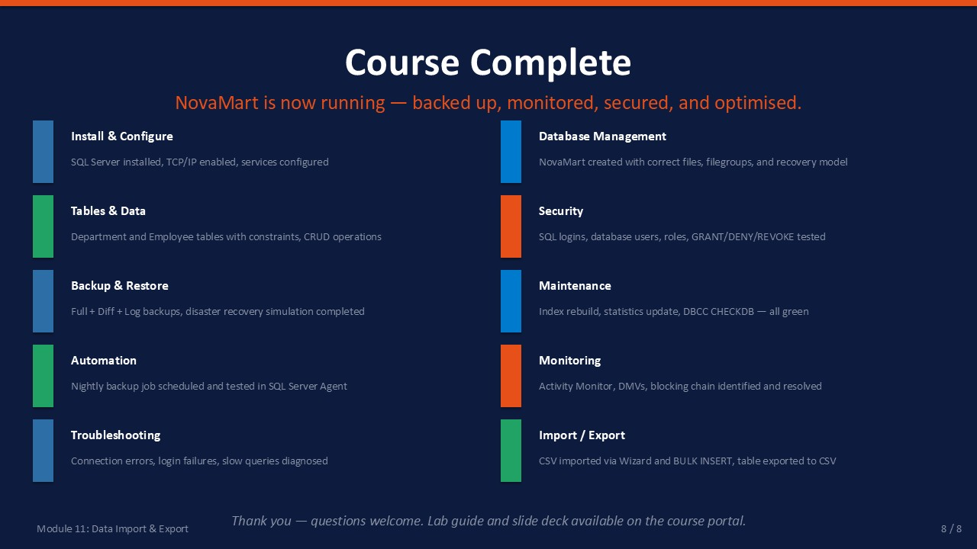
Slide 8 of 8

Course Wrap-Up
Congratulations on completing the two-day SQL Server Administration course. You have covered the full operational lifecycle of SQL Server — from installation through database design, security, backup, maintenance, performance, troubleshooting, and data integration.

All Course Outcomes
Module | Topic | Key Outcome
01 | SQL Server Overview & Architecture | Identify editions, components, authentication modes, and system databases
02 | Installing & Configuring SQL Server | Install SQL Server, configure services, enable TCP/IP, connect remotely
03 | Database Creation & Management | Create databases in SSMS and T-SQL; manage file growth and filegroups
04 | Tables & Data Management | Design tables, apply constraints, and perform CRUD operations
05 | SQL Server Security & User Management | Create logins and users, assign server and database roles, test access
06 | Backup & Restore | Perform full, differential, and log backups; restore a database
07 | Database Maintenance | Rebuild/reorganise indexes, update statistics, run DBCC CHECKDB
08 | SQL Server Agent & Automation | Create scheduled jobs, configure alerts, monitor execution history
09 | Monitoring & Performance Basics | Use Activity Monitor, DMVs, execution plans, and identify blocking
10 | Basic Troubleshooting | Diagnose connection errors, resolve error 18456, read the Error Log
11 | Data Import & Export | Import CSV data with Wizard and BULK INSERT; export with BCP; use MERGE

🎓 | Next Steps  Practice: Run all labs on your own training instance without the step-by-step guide.  Study: Review Microsoft Learn paths for SQL Server — search "SQL Server administration fundamentals".  Certify: Consider DP-300 (Administering Relational Databases on Microsoft Azure) for cloud-extended skills.  Explore: SQL Server Agent automation, Always On Availability Groups, and Query Store for deeper expertise.

Thank you for attending this SQL Server Administration course.
Good luck in your work as a SQL Server DBA.

