Environment Deployment Doc

CI Part

* Build Jenkins
  + docker run -itd -p 8081:8080 jenkins/jenkins
* Config Jenkins
  + install plugins (recommended by default)
  + environment variables
    - JAVA_HOME (/opt/java/openjdk)
    - SCANTIST_IMPORT_URL (<https://api.scantist.io/ci-scan/>)
    - SCANTIST TOKEN (23994440-2d14-48df-a1c0-c7a27b38fa67)
* Build Jenkins Pipeline (flask_demo)
  + SCM: Git

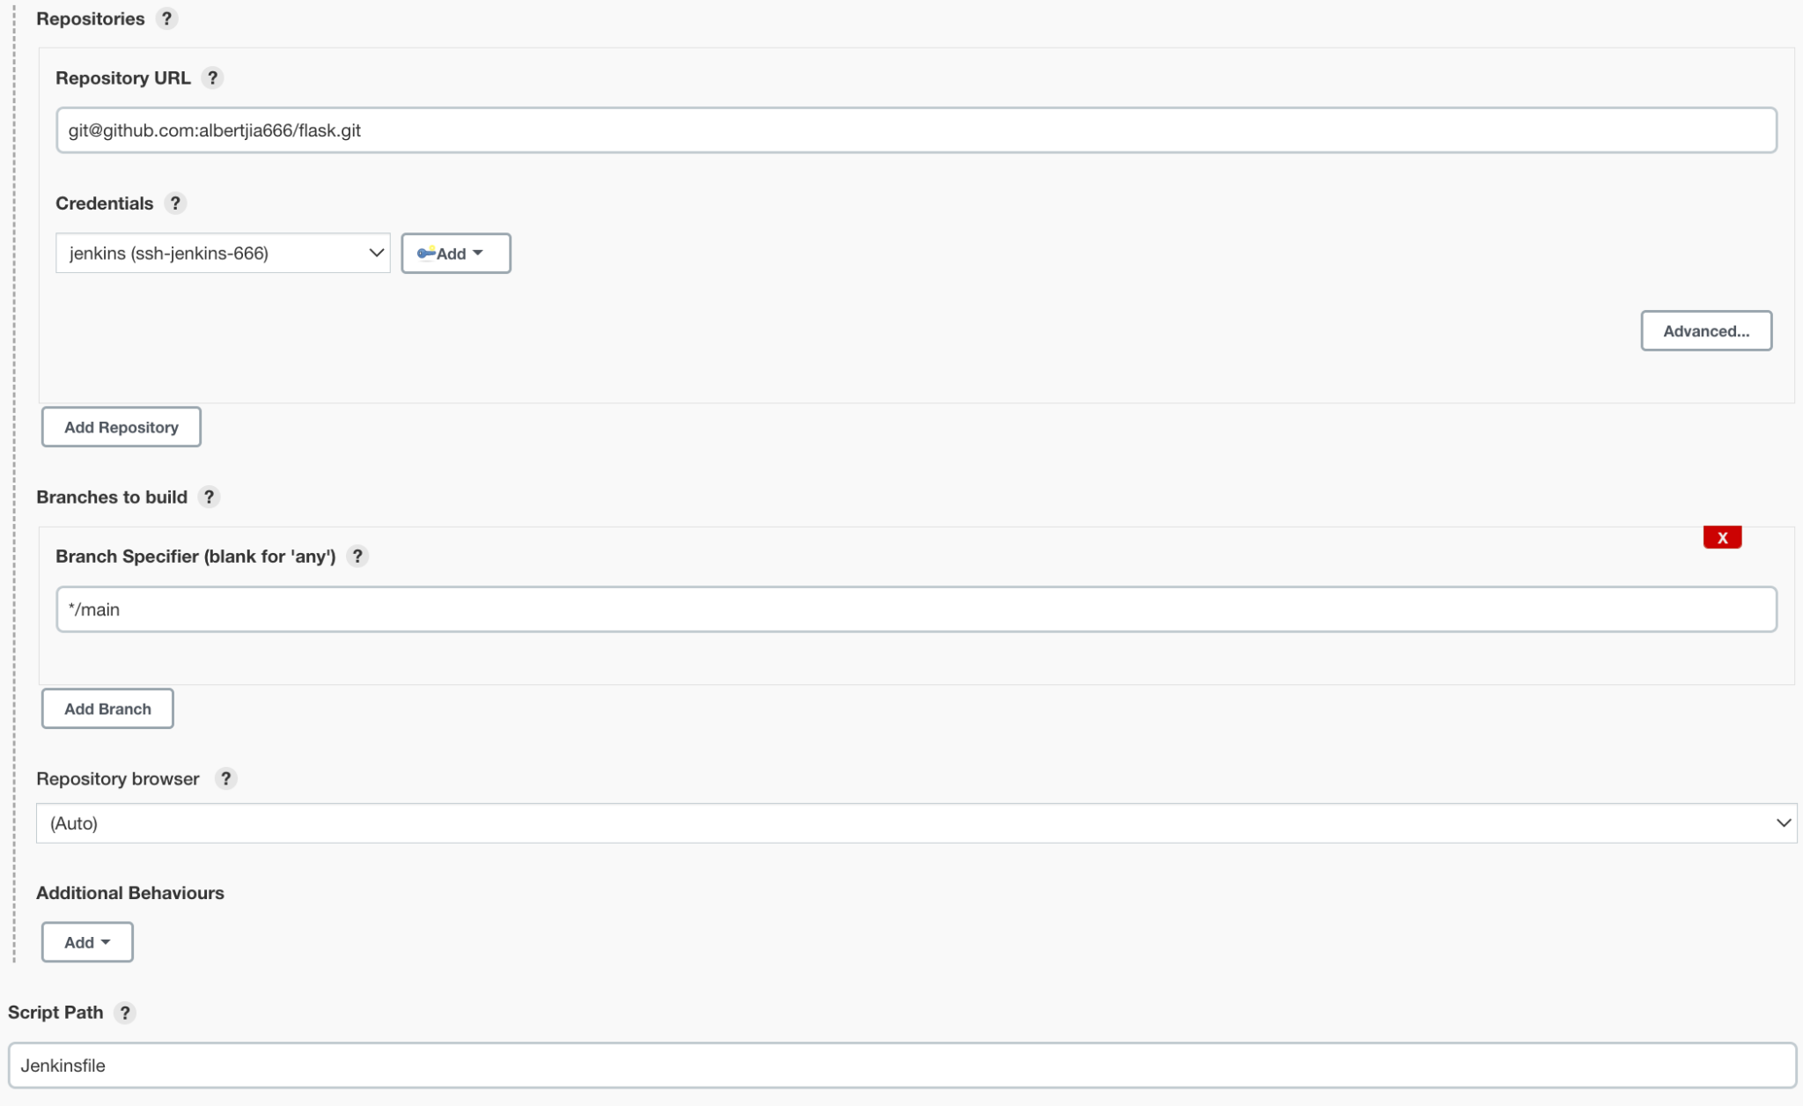

* Jenkins Credentials
  + github ssh credentials for repo (jenkins (ssh-jenkins-666))
  + github credentials for webhook (github-webhook)
* Jenkins URL
  + <http://5b0d-208-36-133-200.ngrok.io> for example (use ngrok for public ip)
* Jenkins Github Config

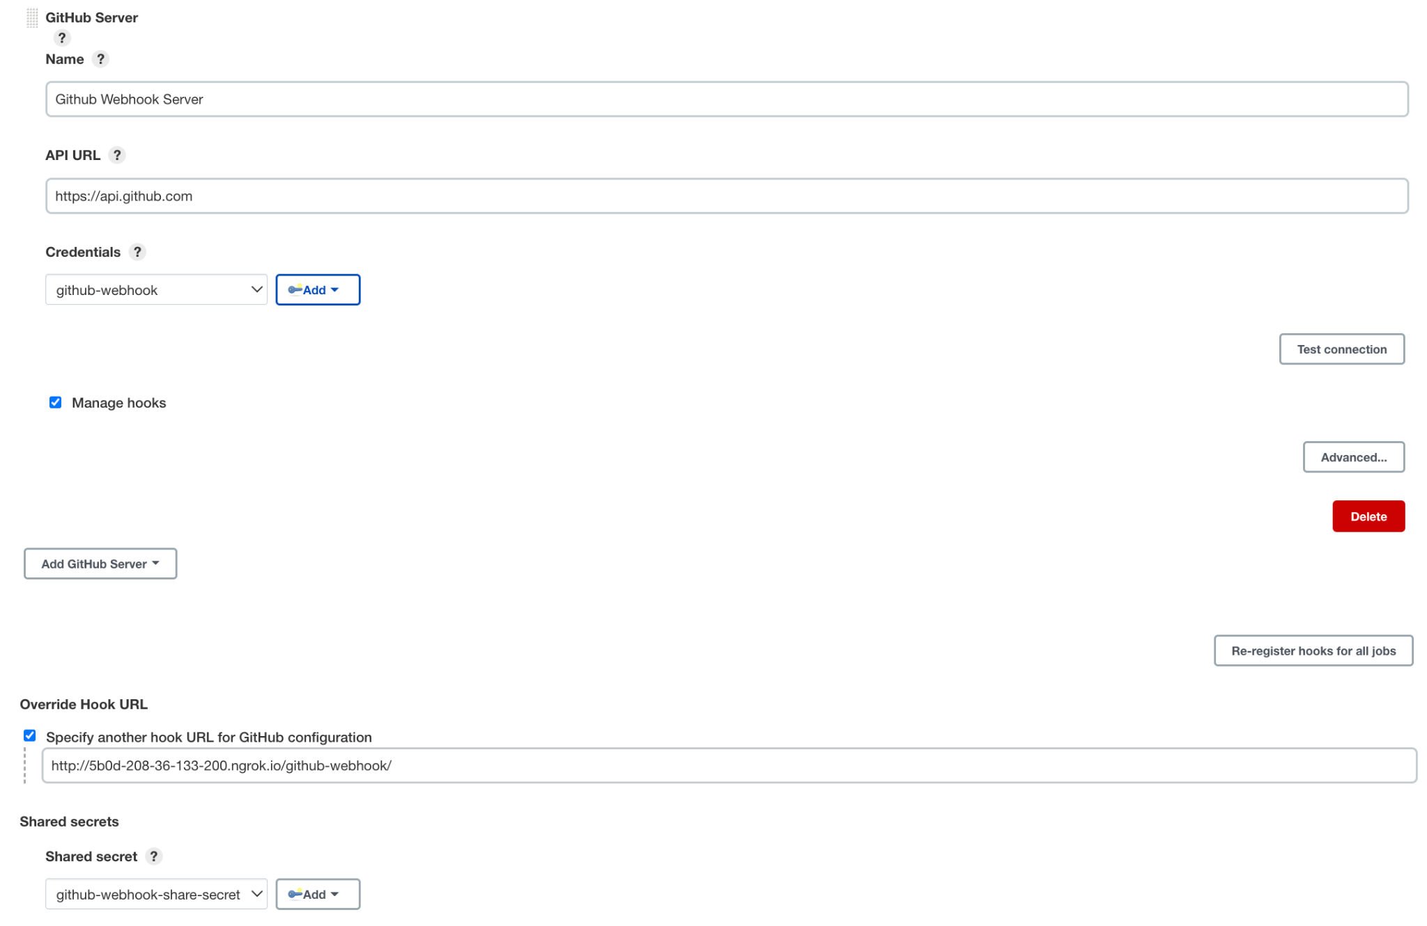

* Jenkinsfile
  + See detail in repo Jenkinsfile
* CI Build

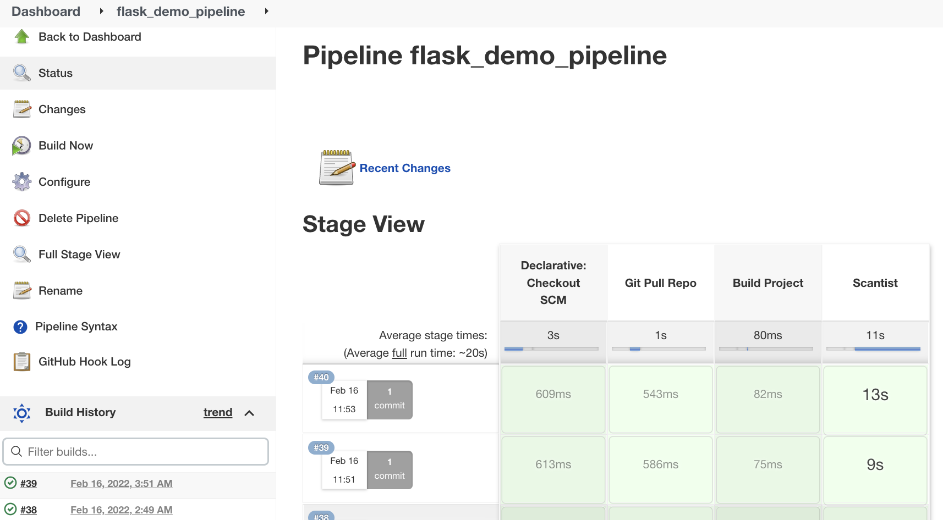

CD Part

* Build GoCD Environment
  + docker run -d -p8153:8153 -e GOCD_PLUGIN_INSTALL_docker-registry-artifact-plugin=https://github.com/gocd/docker-registry-artifact-plugin/releases/download/v1.3.0-138-exp/docker-registry-artifact-plugin-1.3.0-138.jar hezhong0711/gocd-server-jdk8
  + docker run -d -p 5000:5000 -e GO_SERVER_URL=http://$(docker inspect --format='{{(index (index .NetworkSettings.IPAddress))}}' charming_yalow):8153/go gocd/gocd-agent-ubuntu-18.04:v21.4.0
* Enable GoCD Agent
* Build Pipeline-01

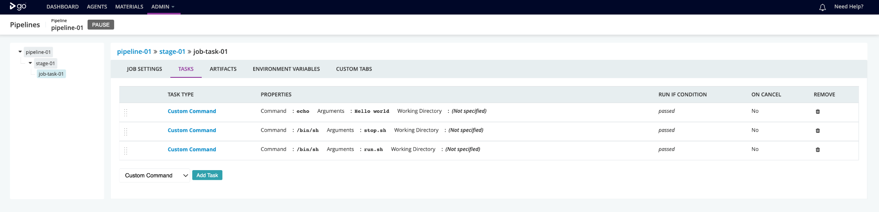

* Build Environment

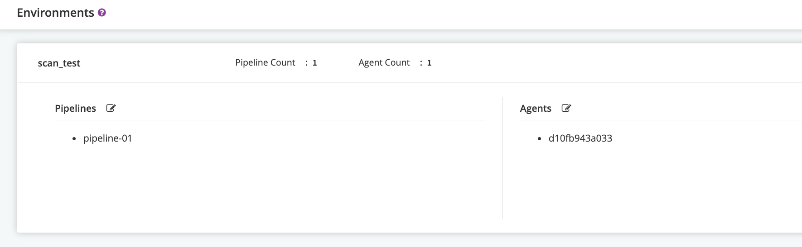

* CD Triggered When Repo Update
* 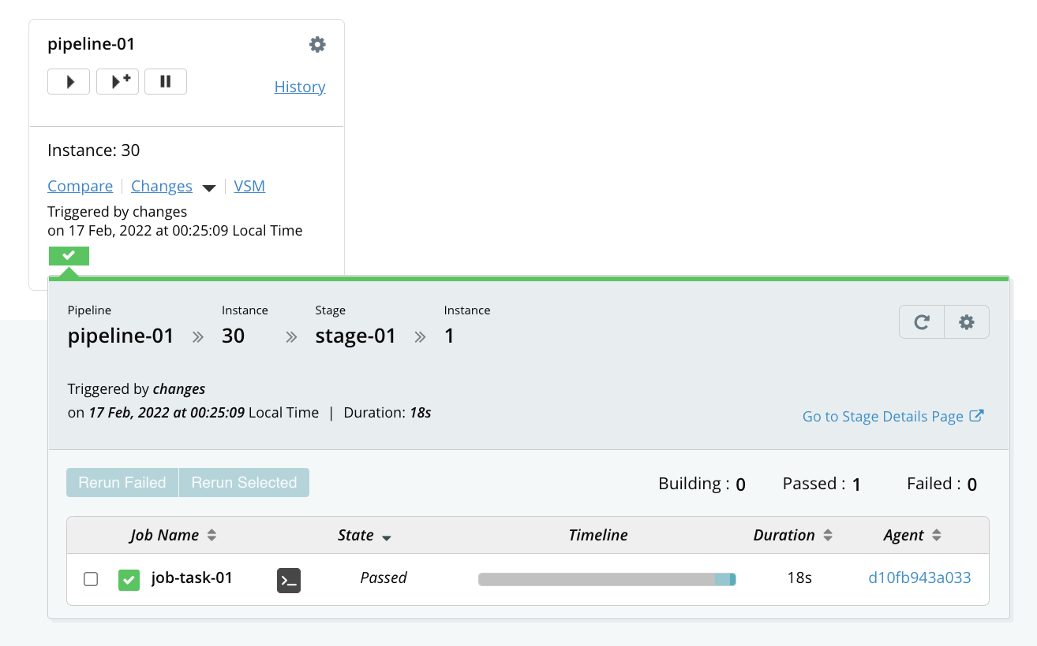

SCA Jenkins CI Integrate Part

