Guided Project: Analyzing CIA Factbook Data Using SQL

1. Jupyter

Dataquest, we strongly advocate project-based learning. For this reason, we've created guided projects. As you work on guided projects, you have two options:
- Work directly in our interface using Jupyter Notebook
- Work locally by installing Jupyter Notebook on your own computer.
Jupyter Notebook — often called Jupyter — is a popular tool that data professionals use for the following:
- Typing and executing code (or query) in many languages (including SQL)
- Viewing the results of their code.
- Adding accompanying text to their code and results.
This combination of code and narrative text is a key element in almost any data science workflow. Jupyter makes it easy to combine these elements. It is a must-have tool for any data scientist.
The Jupyter interface on the right of the screen features a few sections, including the following:
- A menu
- A toolbar
- A code cell
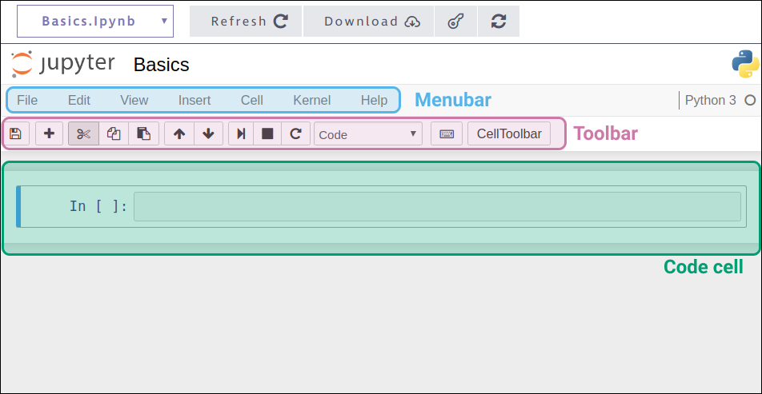
To type and run code, follow these steps:
- Click on the code cell.
- Type the code you want to run.
- Click the run cell, select below button on the toolbar (or use the Shift + Enter keyboard shortcut).
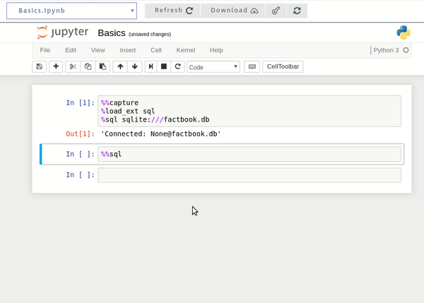
To work on this project locally, you should install Jupyter. To do this, we recommend you install Anaconda.
The default Anaconda installation includes Jupyter and several other useful tools. To install it, follow the instructions for your operating system here.
You'll also need ipython-sql which you can install by starting Jupyter and running the following in a code cell:
!conda install -yc conda-forge ipython-sql
You'll only have to do this once.
Guided projects don't have answer-checking like you see in our missions. You shouldn't feel bound to follow our instructions. In fact, we highly encourage you to explore. We're just providing some guidance!
2. Introduction

In this project, we'll work with data from the CIA World Factbook, a compendium of statistics about all of the countries on Earth. The Factbook contains demographic information like the following:
- population — the global population.
- population_growth — the annual population growth rate, as a percentage.
- area — the total land and water area.
In this guided project, we'll use SQL in Jupyter Notebook to analyze data from this database. If you want to work on this project locally, you can download the SQLite factbook.db database by clicking the Download button on the right.
We'll use the following code to connect our Jupyter Notebook to our database file:
%%capture
%load_ext sql
%sql sqlite:///factbook.db
You should add this code block as the first cell in your notebook.
You can find the solutions notebook for this guided project here or by clicking the key button on the right:
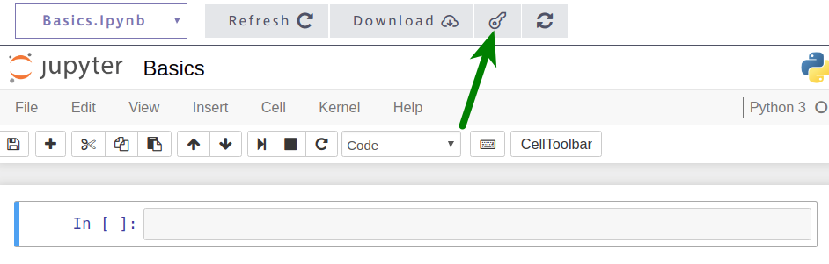
Let's get started!
Instructions

- Copy the text above into a code cell in the Jupyter Notebook on the right.
- Using the menu bar or keyboard shortcut, run the cell.
You should see the output: 'Connected: None@factbook.db'

3. Overview of the Data

Throughout this course, we introduced the name of the table and what the table looked like in the jobs.db database. We can actually query the database to get this information directly:
SELECT *
FROM sqlite_master
WHERE type='table';
This will return the following output:
 | type | name | tbl_name | rootpage | sql
0 | table | facts | facts | 2 | CREATE TABLE "facts" ("id" INTEGER PRIMARY KEY...
1 | table | sqlite_sequence | sqlite_sequence | 3 | CREATE TABLE sqlite_sequence(name,seq)
To run SQL queries in this project, we add %%sql on its own line to the start of our query. So to execute the query above, we'll use the following code:
%%sql
SELECT *
FROM sqlite_master
WHERE type='table';
Let's get started writing queries!
Instructions

- Write a query to return information on the tables in the database.
- In a different code cell, write and run another query that returns the first five rows of the facts table in the database.

4. Summary Statistics

Executing our previous query, we see the first few rows of our facts table look like this:
id | code | name | area | area_land | area_water | population | population_growth | birth_rate | death_rate | migration_rate
1 | af | Afghanistan | 652230 | 652230 | 0 | 32564342 | 2.32 | 38.57 | 13.89 | 1.51
2 | al | Albania | 28748 | 27398 | 1350 | 3029278 | 0.3 | 12.92 | 6.58 | 3.3
3 | ag | Algeria | 2381741 | 2381741 | 0 | 39542166 | 1.84 | 23.67 | 4.31 | 0.92
4 | an | Andorra | 468 | 468 | 0 | 85580 | 0.12 | 8.13 | 6.96 | 0.0
5 | ao | Angola | 1246700 | 1246700 | 0 | 19625353 | 2.78 | 38.78 | 11.49 | 0.46
Here are the descriptions for some of the columns:
- name — the name of the country.
- area— the country's total area (both land and water).
- area_land — the country's land area in square kilometers.
- area_water — the country's waterarea in square kilometers.
- population — the country's population.
- population_growth— the country's population growth as a percentage.
- birth_rate — the country's birth rate, or the number of births per year per 1,000 people.
- death_rate — the country's death rate, or the number of death per year per 1,000 people.
Let's start by calculating some summary statistics and look for any outlier countries.
Instructions

- Write a single query that returns the following:
  - Minimum population
  - Maximum population
  - Minimum population growth
  - Maximum population growth

5. Exploring Outliers
We see a few interesting things in the summary statistics on the previous screen:
- There's a country with a population of 0
- There's a country with a population of 7256490011 (or more than 7.2 billion people)
Let's use subqueries to zoom in on just these countries without using the specific values.
Instructions

- Write a query that returns the countries with the minimum population.
- Write a query that returns the countries with the maximum population.
6. Exploring Average Population and Area

It seems like the table contains a row for the whole world, which explains the population of over 7.2 billion. It also seems like the table contains a row for Antarctica, which explains the population of 0. This seems to match the CIA Factbook page for Antarctica:
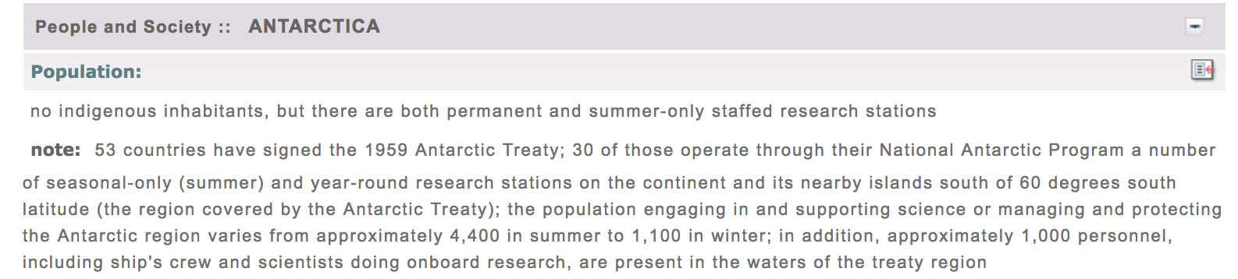
Now that we know this, we should recalculate the summary statistics we calculated earlier — this time excluding the row for the whole world.
Instruction
- Recompute the summary statistics you found earlier while excluding the row for the whole world. Include the following:
  - Minimum population
  - Maximum population
  - Minimum population growth
  - Maximum population growth
- In a different code cell, calculate the average value for the following columns:
  - population
  - area
7. Finding Densely Populated Countries

To finish, we'll build on the query we wrote for the previous screen to find countries that are densely populated. We'll identify countries that have the following:
- Above-average values for population.
- Below-average values for area.
It's possible to write this query by copying the values you calculated on the previous screen, but try to find a way to do this without hard-coding them!
Instructions
- Write a query that finds all countries meeting both of the following criteria:
  - The population is above average.
  - The area is below average.

8. Next Steps

That's it for the guided steps. Here are some next steps to explore on your own:
- Which country has the most people? Which country has the highest growth rate?
- Which countries have the highest ratios of water to land? Which countries have more water than land?
- Which countries will add the most people to their populations next year?
- Which countries have a higher death rate than birth rate?
- Which countries have the highest population/area ratio, and how does it compare to list we found in the previous screen?
Curious to see what other students have done on this project? Head over to our Community to check them out.
And of course, we welcome you to share your own project and show off your hard work. Head over to our Community to share your finished Guided Project!

