

ASSIGNMENT ON STRING FUNCTION

PROGRAMMING IN C



SUBMITTED BY : ALBERT JOSEPH SUBMITTED TO:LINU MISS

DEPARTMENT:CS(BCA 1ST YEAR)

ROLL NO: 5

**STRING**

In C programming, the one-dimensional array of characters are called strings, which is terminated by a null character '\0'The character array or the string is used to manipulate text such as word or sentences. Each character in the array occupies one byte of memory.Header file used is STRING.H

***STRING HANDLING FUNCTIONS***

Some of the most commonly used String functions are:

1. ***Strcat():***

*It is used to concatenate two strings*

*Eg: program to combine two strings*

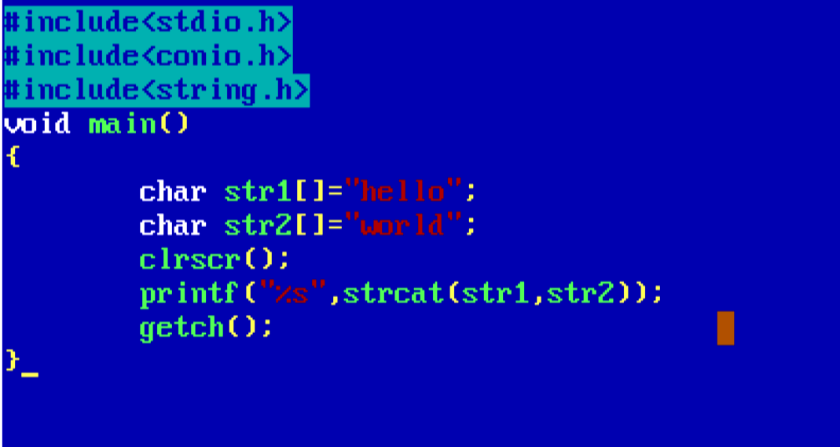

*Output:*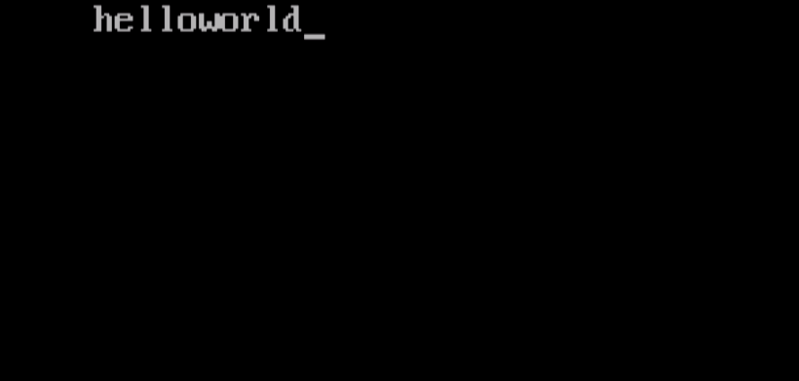

*2.****strlen():***

*Used to find the length of the string.*

*Eg:program to find the length of string*

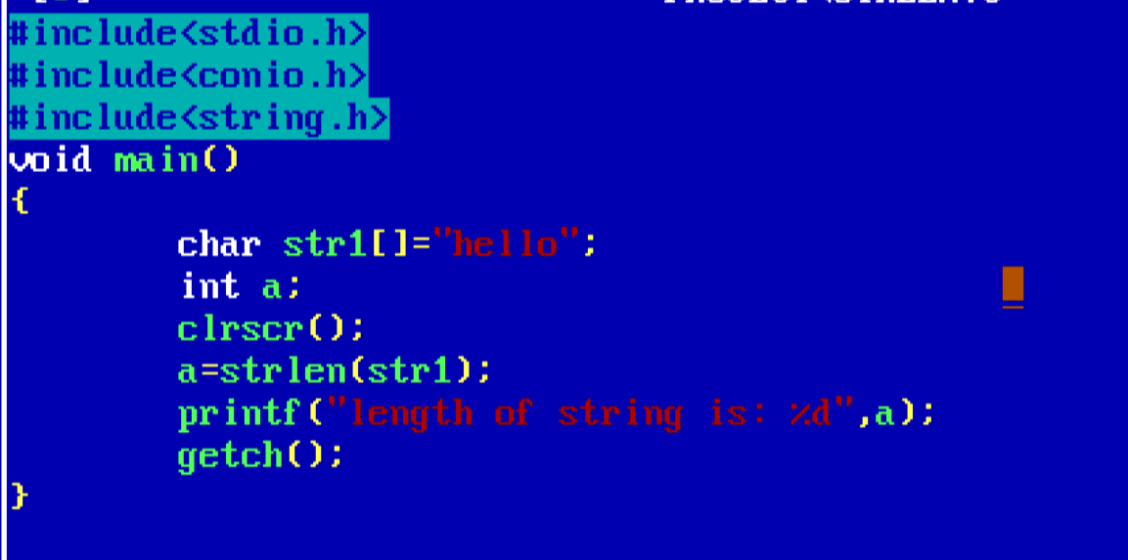

*OUTPUT: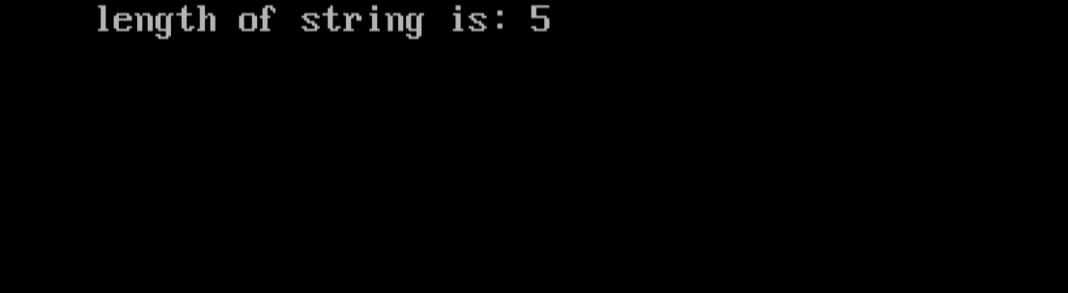*

*3.****strrev():***

*Used to reverse the order of string*

*Eg : program to print a string in reverse order*

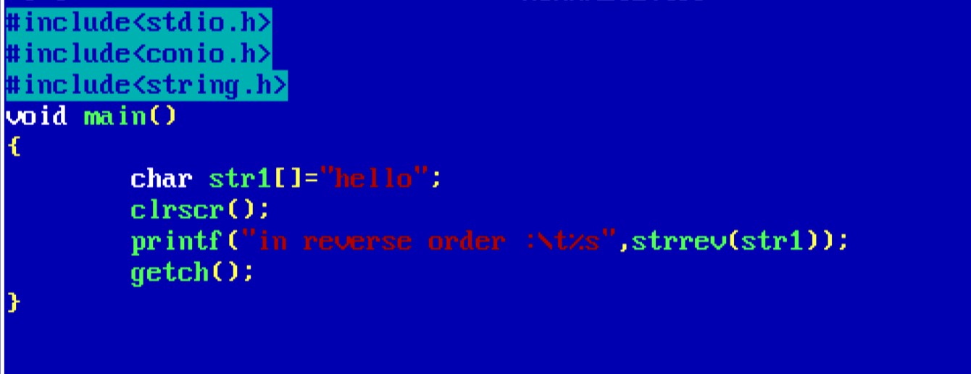

*Output:*

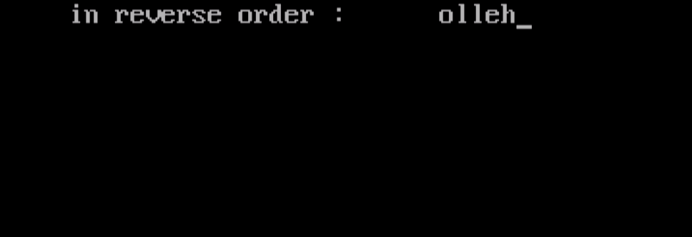

***4.strcpy():***

*Used to copy one string to another*

*Eg : program to copy one string to another and print it*

*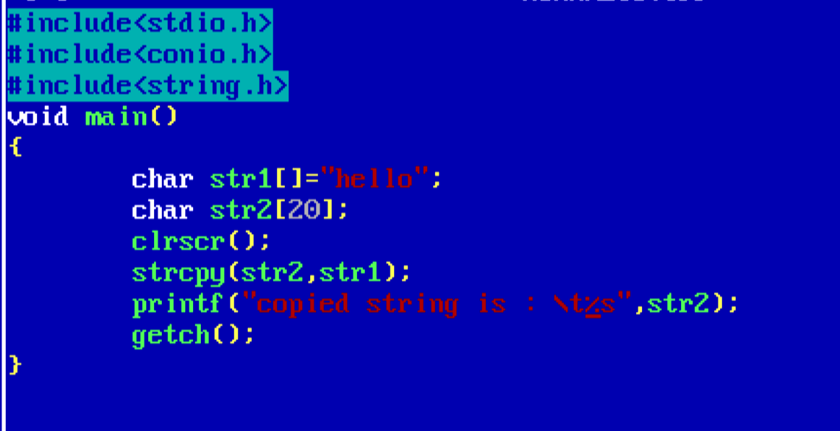Output: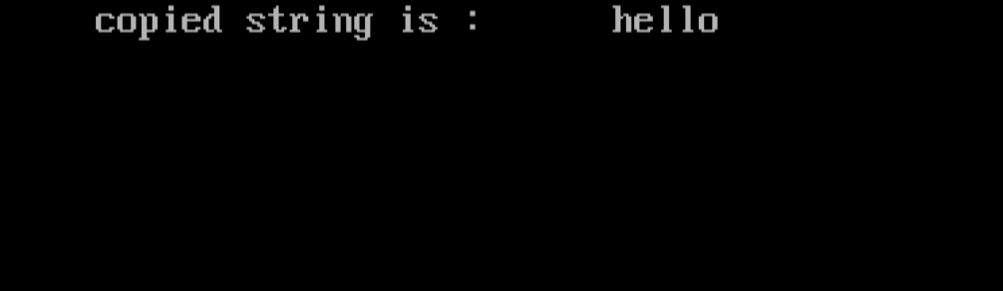*

***5.strcmp():***

*Used to compare two strings*

*Eg: program to compare two strings*

*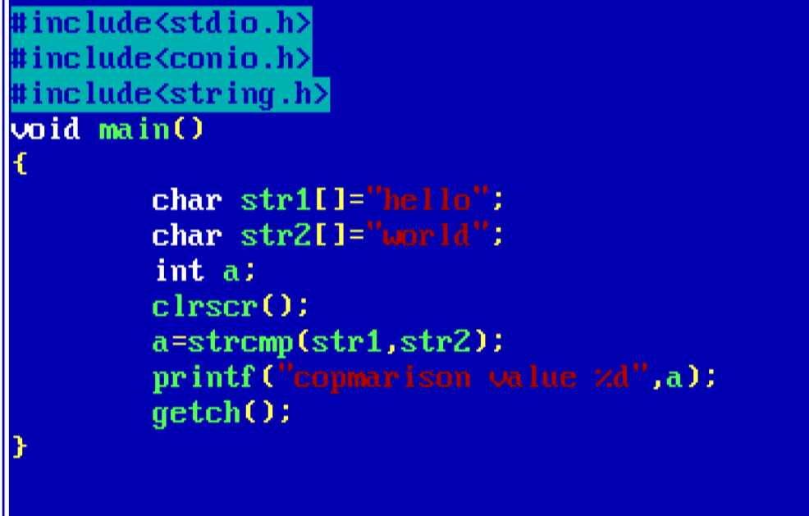Output:*

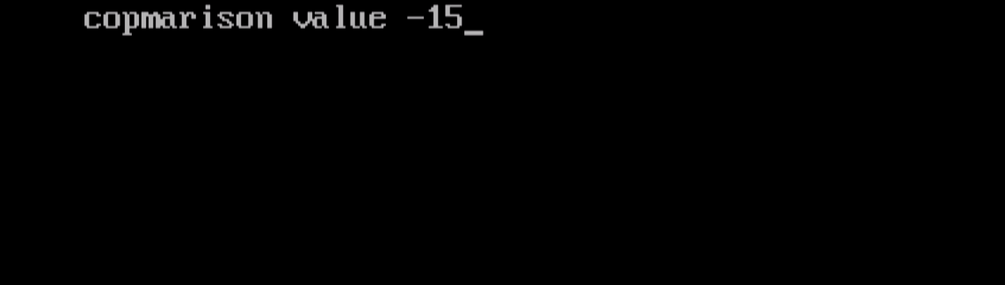

*6.****strlwr():***

*Used to convert the string into lower case.*

*Eg: program to convert the string to lower case*

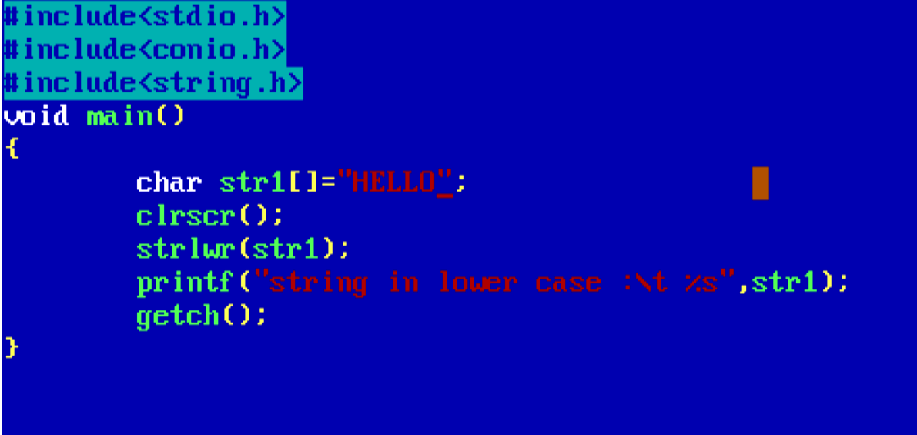

*Output:*

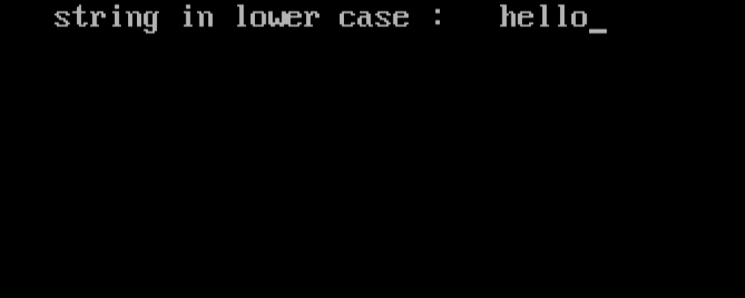

*7.****strupr():***

*Used to convert the string into upper case letters*

*Eg: program to convert the string to uppercase*

*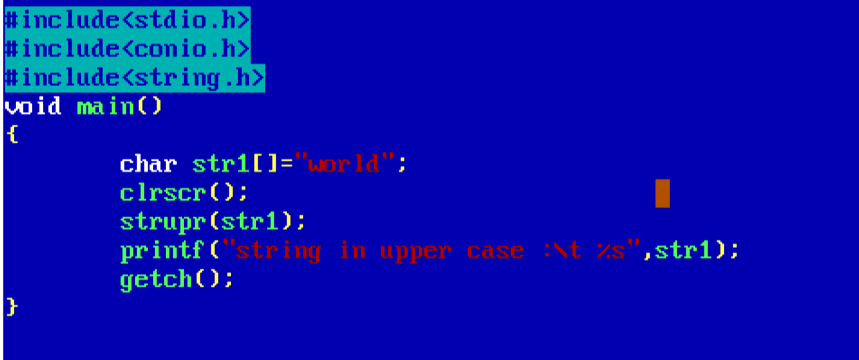 Output:*

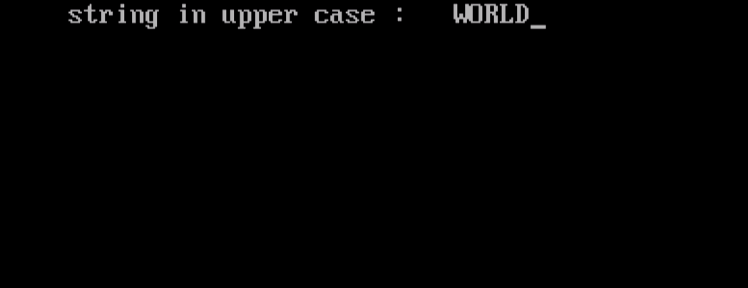

***8.strncat();***

*Used to concatenate n characters of second string to first string*

*Eg: program to concatenate n characters of string to another string*

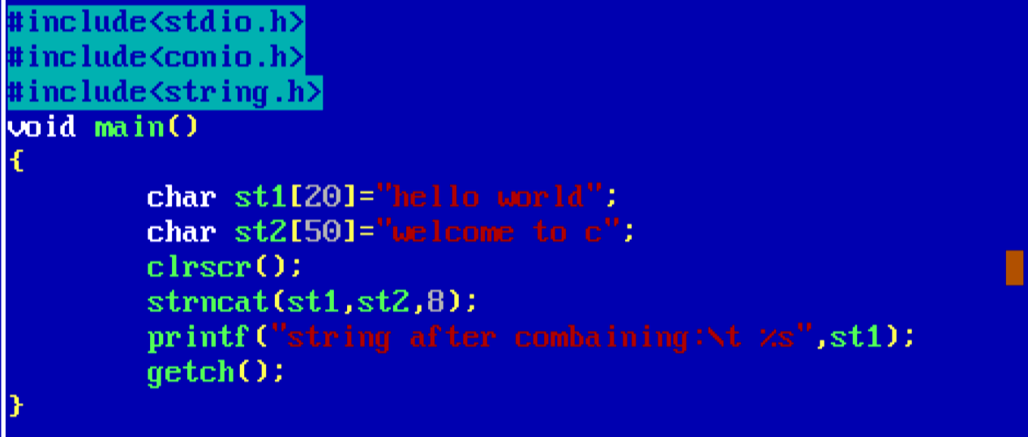

*Output:*

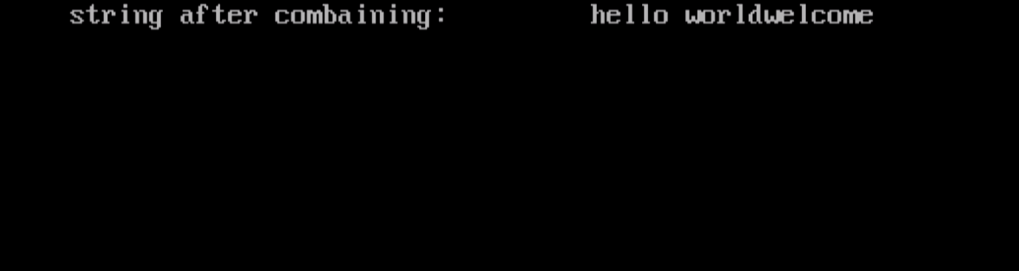

*9****.strncpy();***

*Copies up to n characters from a string to another.*

*Eg: program to copy n characters form a string to another*

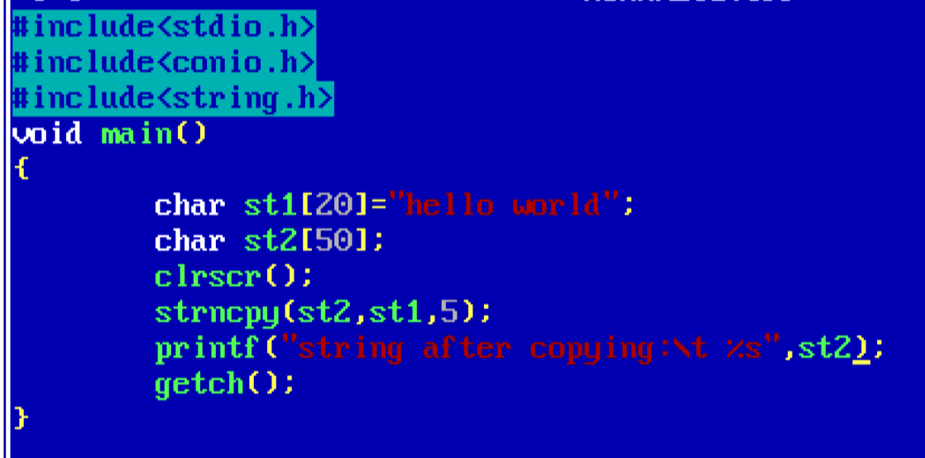

*Output:*

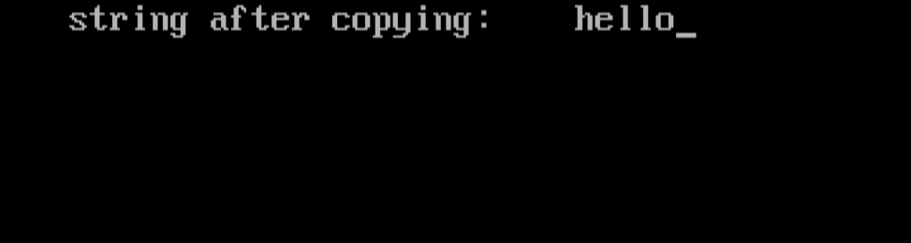

*10****.strstr():***

*It returns the first occurance of str2 in str1*

*.the syntax is strstr(str1,str2)*

*Eg: 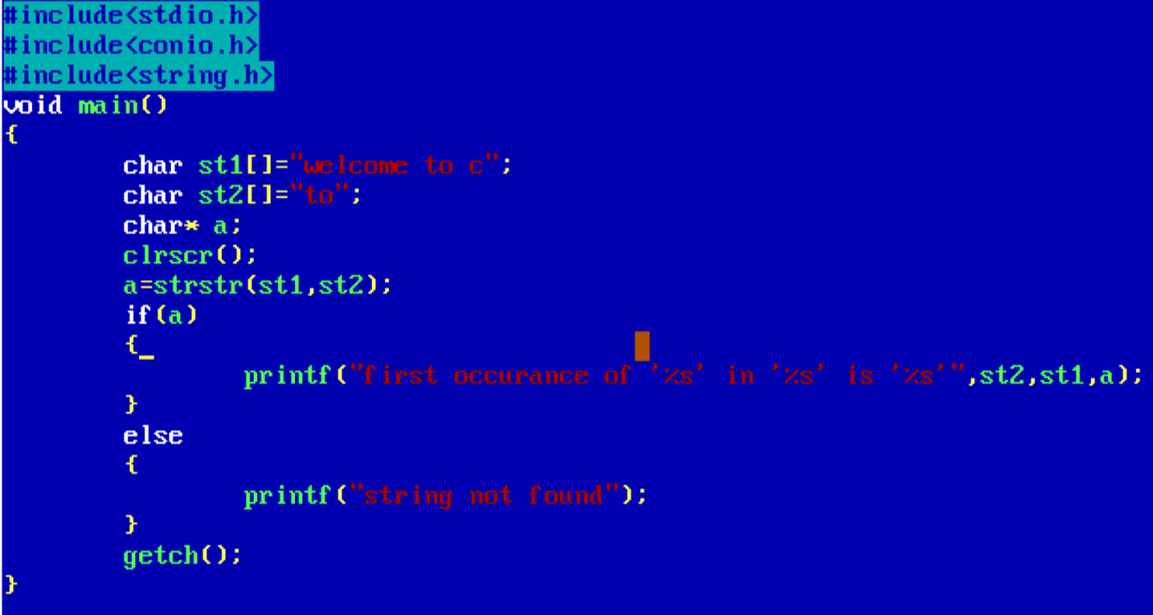*

*Output:*

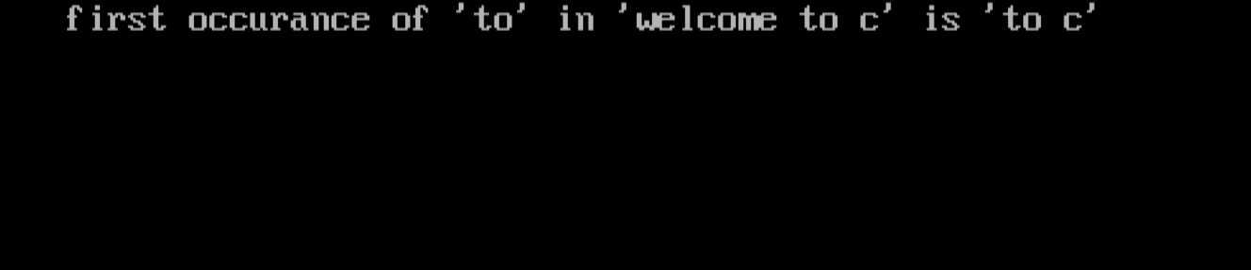

*-------------------------END------------------------------------*