# Arena

The goal of the game is to survive as many waves as possible. Do this by avoiding both enemy attacks and the enemies themselves. As you kill enemies, you gain experience points, which help you grow stronger. When your experience bar fills, you increase in level, which replenishes your health and mana, and also increases your character’s stats. If you decide to play the Mage character, you start with lower stats than the Warrior, but gain a powerful special attack. Using this attack depletes your mana. When your mana pool runs dry, you will no longer be able to use your special attack. Taking damage from an enemy or an enemy’s attack will cause your player to take damage. When the player’s health reaches zero, he will lose a life. When the player loses all of his lives, it’s game over.

Player

* HP: The player’s current health. When this drops to zero, the player loses a life.
* MP: The player’s current mana. When this drops to zero, the player can no longer use special attacks.
* XP: The player’s experience points. Gain enough, and you level up!
* Strength: The damage the player causes to enemies. Increases when you level up.
* Speed: The player’s speed. Dictates how fast the player moves on the screen.

Main Menu

When you first run Arena, you are brought to the Main Menu. From here, you can select the player’s class (1) (2), play a single player game (3), or play a multiplayer game (4). For multiplayer mode, you must input the IP address of the server (5).

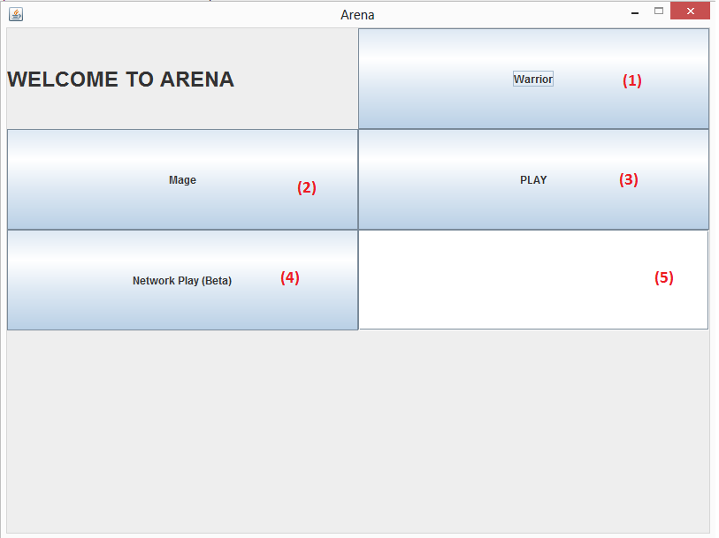

Game Screen

The game screen is where the action takes place. The player’s HP, MP, and XP bars are displayed in the top left corner, and his lives and level are displayed to the right of the bars. The enemy’s health bar hovers above its head, following it as it moves about the screen. The player, enemy, and all attacks fired are also displayed on the screen.  
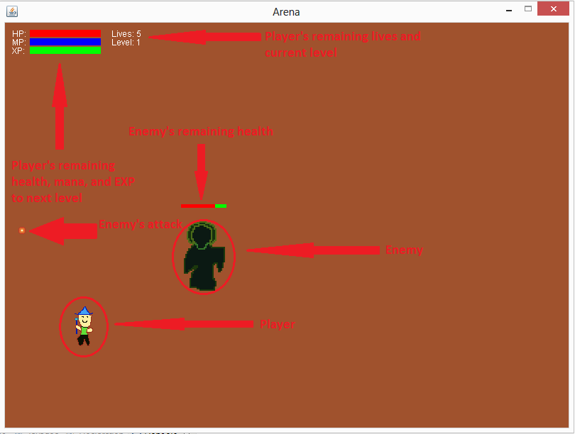

Controls

Arena currently supports keyboard and mouse input only. Gamepad support may be included in future implementations of the game.

* W: Moves the player upward
* A: Moves the player left
* S: Moves the player down
* D: Moves the player right
* Spacebar: Activates player’s special attack
* Mouse Pointer: Dictates direction of the player’s attack
* Mouse Click: Left or Right click fires an attack toward the mouse pointer

Connecting Multiplayer Games

To create a multiplayer game, the server must first be run. Users must run the Server java program. On a mac, or other unix based, command line environment the following commands can be used to start the server:

>> cd <Path to folder containing server>

>> javac Server.java

>> java Server

The server class will wait idely for users to connect using the Arena client program.

Next users should connect to the server. Invoke the Arena application and type the IP address of the server hosting the game into box (5). After entering the IP address, be sure to press the Return key so that the interface accepts the Input. Then the Network Play button can be used to start an online game.

*Caution:*

If you plan to host the server and run a local game on the same machine, be sure to connect to the server using the IP Address of the port via which other users would seek to connect remotely. If you connect to your own server by the loopback interface, remote users will not be able to join the game.

*Troubleshooting:*

If the game is unable to connect to the server, ensure that the remote host can ping the servers IP address. If this test fails, there is likely a conectivity issue with network. If this test passes, and the game is still unable to connect, users should ensure that the firewall settings on their computer are configured to allow access via port 47681. Finally, the server administrator should ensure that the server socket is not bound to the server’s loopback interface.