Trade Participation and Emissions Efficiency
of Indonesian Manufacturing Firms
Deasy D.P. Pane, Natanael W.G. Massie, Riandy Laksono,
Schalke Anindya, Albert Ludi A. & Ariel T.W. Massie

1. Introduction
The relationship between international trade and environmental outcomes has been a central concern in economics for more than three decades. The theoretical foundations laid by Grossman and Krueger (1991, 1995), Copeland and Taylor (1994, 2004), and Antweiler, Copeland, and Taylor (2001) established that trade affects pollution through three channels: a scale effect, whereby trade expansion raises output and potentially pollution; a composition effect, whereby trade shifts the industrial mix toward cleaner or dirtier sectors depending on comparative advantage; and a technique effect, whereby trade-induced income growth and competition raise demand for and adoption of cleaner production technologies. The empirical evidence from cross-country studies has generally concluded that the technique effect dominates, so that freer trade tends to be associated with lower pollution concentrations (Antweiler et al., 2001). Yet these aggregate findings leave open a question that is increasingly important for policy: through which firm-level mechanisms does trade participation affect emissions, and does the evidence hold for developing-country manufacturers operating in carbon-intensive energy environments?
This paper addresses that question using firm-level data from Indonesia’s manufacturing sector. We examine whether entry into international markets, through exporting, importing intermediate inputs, or receiving foreign direct investment, improves the emissions efficiency of Indonesian manufacturers. We investigate two aspects of energy and emissions efficiency, namely the value added produced per unit of energy consumed (VA/GJ) and per unit of CO₂ emitted (VA/CO₂). These intensity-based measures capture whether firms produce more economic value with less environmental cost, which is the relevant margin for assessing whether trade participation generates a technique effect at the firm level.
The question matters for several reasons. First, Indonesia is among the world’s top ten CO₂ emitters, with approximately 812 million tonnes of emissions in 2024 (Global Carbon Budget, 2025). Manufacturing plays a dual role in this profile. It is central to Indonesia’s economic development strategy, contributing to employment, productivity, and export growth, but it is also a major consumer of energy and a significant source of industrial emissions. The tension between these two roles makes manufacturing the critical arena for any green transition strategy. If trade participation can improve the energy and emissions efficiency of manufacturing firms, then trade-facilitating policies may deliver a form of double dividend outcomes, namely improving economic competitiveness alongside reducing emissions intensity.
Second, the global trade-climate landscape has changed in ways that make embedded emissions increasingly relevant to export competitiveness. Since the adoption of the Paris Agreement in 2015, climate policy has moved from a largely environmental agenda into the core of trade, investment, and industrial policy. The European Union’s Carbon Border Adjustment Mechanism (CBAM), which entered its definitive phase in January 2026 after a transitional reporting period, places a carbon price on embedded emissions in selected imports, including iron and steel, aluminium, cement, fertilisers, hydrogen, and electricity. For Indonesian exporters in these sectors, the carbon intensity of production is no longer only a domestic environmental issue. It now directly affects price competitiveness and market access in one of the world’s largest import markets.
Beyond formal carbon pricing, multinational lead firms are also tightening climate-related requirements across their supply chains. Apple’s Supplier Clean Energy Program, for example, requires participating suppliers to use 100 per cent clean energy for Apple production by 2030. Similar pressures are emerging from other global companies through supplier decarbonisation targets, low-carbon material sourcing, and Scope 3 emissions commitments. Volkswagen, for instance, has set decarbonisation targets across its production system and supply chain, while Unilever has worked with major retailers to reduce Scope 3 emissions across its value chain. These private-sector requirements operate as a form of de facto carbon regulation, transmitting new cost and compliance pressures to upstream producers in countries such as Indonesia.
Consumer demand is also moving in the same direction, although unevenly. Survey and market evidence suggests that many consumers, especially in advanced economies, are willing to pay more for sustainably produced or sourced goods, while sustainability-marketed products have continued to gain market share in several consumer markets.
Third, the evidence base on trade and emissions at the firm level remains thin for developing countries. The existing literature draws primarily on advanced-economy samples. Holladay (2016) documents that US exporters emit 9 to 13 per cent less pollution than non-exporters after controlling for output. Forslid, Okubo, and Ulltveit-Moe (2018), using Swedish firm-level data, find that exporters are 11 to 27 per cent less emissions-intensive for CO₂, NOx, and SO₂, and provide a theoretical mechanism through the fixed-cost nature of abatement investment. Cherniwchan (2017) shows that NAFTA reduced US manufacturing emissions by approximately 8 per cent, concentrated in the within-plant technique effect. Shapiro and Walker (2018) decompose the 60 per cent decline in US manufacturing emissions between 1990 and 2008 and find that environmental regulation, rather than trade per se, accounts for the bulk of the reduction. From developing countries, Rodrigue, Sheng, and Tan (2024) study Chinese manufacturers following WTO accession and find that exporters are significantly less emissions-intensive, with productivity-driven technique effects playing a role alongside abatement investment. He, Yin, and Zheng (2023) provide the most directly relevant evidence on the import channel, showing that both importing and exporting reduce firm-level emission intensities in China.
Indonesia offers a particularly informative setting for studying these questions for three reasons. First, its manufacturing sector is large and highly heterogeneous, with substantial variation across firms in energy intensity, trade participation, technology use, and ownership structure. This heterogeneity makes it possible to examine whether exposure to international markets is associated with improvements in energy and emissions efficiency, rather than only differences across sectors. Second, Indonesia’s electricity system remains heavily dependent on coal, which accounted for around 69 per cent of power generation in 2023 according to IEA data. This creates a structural constraint that distinguishes Indonesia from the Swedish and US settings that dominate much of the existing firm-level literature. Even when firms improve their energy efficiency, the resulting emissions gains may be partly dampened by the high carbon intensity of the electricity grid, especially for firms that rely heavily on purchased electricity. Third, Indonesia’s trade policy environment has become more interventionist, with the growing use of non-tariff measures, local content requirements, and import restrictions that may limit firms’ access to imported intermediate inputs. Existing studies show that internationalisation can improve firm productivity and export performance. However, less is known about whether these benefits also extend to the environmental dimension. This paper therefore asks whether export, import, and FDI participation help Indonesian manufacturing firms produce more value with less energy use and lower emissions intensity.
Our empirical strategy uses staggered difference-in-differences to estimate the causal effect of trade entry on emissions efficiency. The staggered design exploits the fact that firms enter international markets in different years, allowing us to compare changes in efficiency for firms that just entered with changes for similar firms that have not yet entered or never enter. We use four complementary estimators. The Borusyak, Jaravel, and Spiess (2024) imputation estimator is used as the primary specification. The Callaway and Sant’Anna (2021) group-time average treatment effect estimator provide an additional robustness check by allowing treatment effects to vary across cohorts and over time. The de Chaisemartin and D’Haultfœuille (2020) dynamic estimator is used for validation and pre-trend diagnostics, while standard two-way fixed effects are reported as a benchmark for comparability with the earlier literature. We also introduce a sustained-entry timing rule that requires trade participation to persist for at least two consecutive years, reducing attenuation from transient trade spells.
The emissions data are constructed from the ground up using the Annual Manufacturing Survey for 2000–2014 from the Statistic Office of Indonesia (BPS). We convert physical fuel consumption into Scope 1 emissions using net calorific values from Indonesia’s energy balance and IPCC 2006 emission factors. Scope 2 emissions are estimated by multiplying purchased electricity by a grid emission factor that we construct year by year from national electricity generation data. This bottom-up approach, using physical energy quantities rather than monetary expenditure, provides a more reliable basis for estimating firm-level emissions because it avoids distortions from energy subsidies, price variation, and accounting inconsistencies.
Our main findings are as follows. First, sustained entry into export is associated with efficiency gains of approximately 8 per cent on VA/GJ and 6.5 per cent on VA/CO₂, under the preferred BJS specification. consistent with the scale-and-abatement mechanism documented in the advanced-economy literature. Second, the import channel produces larger effects sustained import entry raises energy efficiency by 11.3 per cent and emission efficiency by 9.9 per cent, under BJS approach, consistent with the hypothesis that imported inputs embody technologies that improve energy and emissions performance. Third, FDI entry does not produce a statistically significant effect, possibly reflecting the weak environmental regulatory environment during the sample period. Fifth, the effect on energy efficiency (VA/GJ) consistently exceeds the effect on emissions efficiency (VA/CO₂), pointing to a structural constraint imposed by Indonesia’s coal-heavy grid. Even if a firm uses less energy per unit of value added, the emissions gain will be smaller if the energy it still uses comes from carbon-intensive sources.
The paper makes three contributions. First, it provides the first staggered difference-in-differences estimates of trade’s effect on emissions efficiency in a major developing-country manufacturing sector, with export and import channels identified separately. Second, it constructs firm-level emissions indicators from physical energy data for the full universe of medium and large Indonesian manufacturers over a 15-year panel, a dataset that has not previously been used for environmental analysis in this form. Third, it documents a new empirical regularity, that is the gap between energy efficiency and emissions efficiency effects as a function of grid carbon intensity, which has implications for the complementarity between trade policy and energy policy in the green transition.
The remainder of the paper is organised as follows. Section 2 reviews the theoretical and empirical literature on trade and the environment at the country, industry, and firm levels. Section 3 describes the data and the construction of emissions variables. Section 4 presents the identification strategy. Section 5 reports the main results and robustness checks. Section 6 discusses the findings in the context of the existing literature and their policy implications. Section 7 concludes.

2. Literature Review

2.1. Trade and the environment: the aggregate evidence
The theoretical framework for analysing trade’s environmental effects was established by Grossman and Krueger (1991, 1995) and formalised by Copeland and Taylor (1994, 2004). Their models decompose the environmental impact of trade into three effects. The scale effect captures the increase in pollution associated with higher output when trade raises the overall level of economic activity. The composition effect reflects changes in the industrial mix: if trade shifts a country’s production toward sectors in which it has a comparative advantage, and if those sectors happen to be more (or less) pollution-intensive, the composition of output changes accordingly. The technique effect captures the adoption of cleaner production methods, driven by higher incomes, stricter environmental regulation, or competitive pressure from international markets.
Antweiler, Copeland, and Taylor (2001) operationalised this framework empirically using data on sulphur dioxide concentrations across countries. Their central finding is that the technique effect dominates: freer trade appears to reduce pollution concentrations, because the income gains from trade induce both stronger environmental regulation and cleaner production technologies. This result is qualified by the composition effect, which depends on factor endowments and comparative advantage, but the net effect is negative (i.e. trade reduces pollution). Copeland and Taylor (2004) provide a comprehensive survey of this literature and emphasise that the aggregate outcome is the product of these three forces, so the environmental consequences of trade are theoretically ambiguous and must be resolved empirically.
The pollution haven hypothesis, which predicts that trade liberalisation causes pollution-intensive production to relocate to countries with weaker environmental regulation, has received mixed empirical support. Levinson and Taylor (2008) find some evidence that higher abatement costs in the United States are associated with increased imports from Mexico, consistent with pollution-haven effects. However, the magnitude is modest relative to the technique effect. More recently, Shapiro (2021) provides a clean test using a gravity framework and finds that environmental policy differences do influence the pattern of trade, but the implied emissions leakage is small.

2.2. From aggregate to firm-level analysis
While the aggregate evidence is informative, it cannot identify the mechanisms through which trade affects emissions at the level of the firm. This matters because aggregate industry-level changes in emissions can arise from multiple margins: individual firms may become cleaner (the intensity effect), market shares may shift toward cleaner firms (the reallocation effect), or dirtier firms may exit (the selection effect).
Cherniwchan, Copeland, and Taylor (2017) provide a systematic decomposition of these margins and argue that firm-level evidence is necessary to identify which mechanisms are at work. At the firm level, the study provides the first clean causal evidence on trade liberalisation and plant-level emissions. Exploiting NAFTA as a quasi-natural experiment, she finds that trade liberalisation reduced total emissions from US manufacturing by approximately 8 per cent, with the reduction concentrated in the within-plant technique effect rather than compositional shifts. This is an important finding because it confirms that trade can make individual plants cleaner, not merely shift production toward cleaner sectors or force dirty plants to exit.
Shapiro and Walker (2018), in a comprehensive decomposition of the 60 per cent decline in US manufacturing emissions between 1990 and 2008, find that within-product changes in emissions intensity, rather than shifts in output composition, drive the aggregate decline. They attribute roughly three-quarters of the reduction to environmental regulation, specifically the implicit pollution tax faced by US manufacturers, which approximately doubled over the period. Their framework is important for the present study because it clarifies the relative roles of regulation and trade in driving firm-level emissions reductions. In the US context, regulation dominated. In a country like Indonesia, where formal environmental regulation during the sample period was relatively weak, the question is whether trade participation can serve as a substitute mechanism for inducing firm-level efficiency gains.

2.3. Exporting and emissions efficiency
The firm-level evidence on the export-emissions relationship draws on two theoretical channels. The first is the productivity-sorting channel, which follows from Melitz (2003): more productive firms self-select into exporting, and if productivity and emissions efficiency are correlated, exporters will appear cleaner even without a causal effect of exporting itself. The second is the scale-and-abatement channel, formalised by Forslid, Okubo, and Ulltveit-Moe (2018): exporting raises production volumes, which allows firms to spread the fixed costs of abatement investment over more units, thereby lowering emissions intensity. Their model predicts that emissions intensity is negatively related to both firm productivity and export status, and that trade liberalisation can reduce global emissions even in the presence of pollution-haven effects.
Empirically, Holladay (2016) documents that US exporters emit 9 to 13 per cent less pollution than non-exporters after controlling for output, industry, state, and year effects. Cui, Lapan, and Moschini (2016) confirm this pattern for multiple pollutants using direct plant-level productivity measures. Forslid, Okubo, and Ulltveit-Moe (2018), using Swedish firm-level data with precise export sales tracking, find a strong negative relationship between exporting and emission intensity for CO₂, NOx, and SO₂, with exporters being 11 to 27 per cent less emissions-intensive than comparable non-exporters.
From developing countries, the evidence is more recent and thinner. Rodrigue, Sheng, and Tan (2024), examine Chinese manufacturers following WTO accession. They document that exporters are significantly less emissions-intensive than non-exporters for SO₂ and industrial dust emissions, and that this gap widened over the accession period. Importantly, they show that the lower emissions intensity of exporters cannot be fully explained by differential rates of abatement investment, suggesting that productivity-driven technique effects also play a role. This finding is relevant for the present study because it indicates that the benefits of exporting for environmental performance are not confined to advanced economies with strong environmental regulation.
Gao, Yu, Jiang, and Pei (2024), using Chinese firm-level data matched with input-output tables, find that firms positioned further downstream in global value chains have lower pollutant emission intensity, and attribute this to production factor structure effects, knowledge absorption, and abatement investment. Their work suggests that the position of a firm in international production networks, not merely its export status, matters for environmental outcomes.

2.4. Importing and emissions efficiency
The import channel has received less attention in the trade-environment literature than the export channel, but it is potentially important because imported intermediate inputs can directly alter the production technology frontier. The theoretical case rests on the insight that imported inputs may embody technologies, materials, or process innovations that improve energy and emissions efficiency per unit of output. This channel is distinct from the export channel, which operates more indirectly through learning, scale, and buyer-induced upgrading.
He, Yin, and Zheng (2023), develop a theoretical framework showing that firms have a greater incentive to invest in abatement when they become importers, exporters, or both. Using Chinese firm-level data, they confirm that both importing and exporting contribute to significant reductions in emission intensities. Their finding that the import channel operates through access to cleaner or more efficient intermediate inputs is directly relevant to the present study. The framework also predicts that firms investing in imported inputs have stronger incentives to adopt complementary abatement technologies, creating a reinforcing dynamic between trade participation and environmental performance.
The broader literature on imported inputs and firm performance supports this channel. Amiti and Konings (2007) show that input tariff reductions raise firm productivity more than output tariff reductions, using Indonesian data. Goldberg, Khandelwal, Pavcnik, and Topalova (2010) find that imported inputs expand the product scope of Indian firms through access to new input varieties. Pane and Patunru (2023), using Indonesian data show that imported inputs raise firm productivity and export performance, with the variety margin (access to broader alternatives of inputs) being more important than the volume margin.
The most directly related paper for Indonesia is Imbruno and Ketterer (2018). They study whether importing intermediate inputs improves firm-level environmental performance in Indonesian manufacturing. Using firm-level data and a combined propensity score matching and difference-in-differences approach, they find energy efficiency gains from importing, particularly through access to new imported input varieties. Their evidence strongly supports the argument that the import channel can improve environmental performance in a developing economy. The present paper differs by using a longer manufacturing panel, constructing Scope 1 and Scope 2 emissions from physical energy data, examining value added per unit of energy and per unit of CO2, separating export, import, and FDI entry, and applying modern staggered difference-in-differences estimators.

2.5. Foreign direct investment and environmental performance
The relationship between FDI and environmental performance has been studied through two competing hypotheses. The pollution haven hypothesis predicts that FDI flows to countries with weaker environmental regulation, implying that foreign-owned plants may be dirtier than domestic firms. The pollution halo hypothesis predicts the opposite: foreign investors bring cleaner technologies, better management practices, and stronger environmental standards, so foreign-owned plants should be cleaner.
Brucal, Javorcik, and Love (2019) provide the most relevant evidence. Using establishment-level data from Indonesia and 60 other countries, they find that foreign-acquired plants improve their energy intensity, but that the magnitude depends on the regulatory stringency of the acquirer’s home country. The effect is stronger when the acquiring firm comes from a country with more stringent environmental standards, consistent with the transfer of cleaner technologies and management practices. This finding is important because it suggests that the environmental benefit of FDI is not automatic; it depends on the institutional and regulatory context.
Eskeland and Harrison (2003), in an earlier study, find little evidence that foreign firms are attracted to developing countries because of laxer environmental regulation. Instead, they find that foreign plants tend to be more energy-efficient than their domestic counterparts. Cole, Elliott, and Strobl (2008) confirm this using plant-level data from Ghana, finding that foreign-owned plants are less energy-intensive. The evidence is thus more consistent with the pollution halo hypothesis, but the magnitude and significance of the FDI-environment link appear to depend on the regulatory gap between the source and host countries.

2.6. Methodological advances: staggered difference-in-differences
A growing literature has demonstrated that the conventional two-way fixed effects (TWFE) estimator can produce biased estimates of average treatment effects under staggered treatment adoption with heterogeneous treatment effects. Goodman-Bacon (2021), provides the canonical decomposition showing that the TWFE estimator is a weighted average of all possible two-by-two difference-in-differences comparisons, some of which use already-treated units as controls, potentially introducing negative weights and bias.
There have been several solutions proposed to tackled the problem. Callaway and Sant’Anna (2021) develop a group-time average treatment effect estimator that avoids problematic comparisons. Sun and Abraham (2021) propose an interaction-weighted estimator. Borusyak, Jaravel, and Spiess (2024), develop an imputation estimator that first estimates a model on untreated observations to impute counterfactual outcomes for treated units, then computes treatment effects as the difference between observed and imputed outcomes. De Chaisemartin and D’Haultfœuille (2020) develop a dynamic estimator that separately reports placebo coefficients at pre-treatment leads, providing explicit identification diagnostics.
The present paper uses the BJS imputation estimator as the primary specification, complemented by the dCDH dynamic estimator for validation and pre-trend testing, and TWFE as a benchmark. This triangulation strategy is motivated by the staggered nature of trade entry across Indonesian manufacturing firms over the 15-year panel: firms enter export, import, and FDI markets in different years, which is precisely the setting where TWFE can produce misleading results. The use of multiple modern DID estimators provides a more credible basis for causal inference than any single estimator alone.

3. Data and Stylized Facts

3.1. Data source and sample
We use data from the Annual Manufacturing Survey (Survei Industri, SI) conducted by Statistics Indonesia (BPS). The SI is a census of all manufacturing establishments in Indonesia with 20 or more employees, covering the universe of medium and large manufacturing firms. The survey collects detailed information on output, inputs, employment, investment, energy use, ownership, and trade status. We use the panel for the period 2000 to 2014, which gives us 15 years of annual firm-level observations. To identify firms that enter exporting for the first time, we also use earlier panel data from the 1990s to verify that firms classified as new exporters during our sample period were not already exporting before 2000.
The SI reports physical quantities of fuel consumption for each establishment, alongside electricity purchases in kilowatt-hours. This is a key advantage of the dataset for our purposes. While it also reports monetary expenditure of energy, we use the physical quantities as they are not distorted by energy subsidies, regional price differences, or firm-level procurement arrangements. Because emissions are a physical process determined by the quantity and type of fuel burned, physical consumption data provide a more reliable basis for estimating firm-level emissions than expenditure data. After cleaning for duplicate identifiers, missing key variables, and implausible values, and after restricting to the balanced estimation sample with non-missing energy and trade data, the working sample contains approximately 314,500 firm-year observations from around 43,000 unique establishments.

3.2. Construction of emissions variables
We construct two categories of firm-level emissions: Scope 1 emissions from direct fuel combustion, and Scope 2 emissions from purchased electricity. The construction follows the methodology of the Intergovernmental Panel on Climate Change (IPCC, 2006) and uses emission factors and net calorific values (NCVs) from the BPS Neraca Energi Indonesia (Indonesian Energy Balance) and the IPCC 2006 Guidelines for National Greenhouse Gas Inventories.
Scope 1: Direct fuel combustion. For each fuel type f reported by firm i in year t, we convert physical consumption into energy units using the net calorific value, and then multiply by the IPCC emission factor to obtain CO₂ emissions:
Emissionsᵢₜ = Σ_f [ Physical Quantity_f × NCV_f × EF_f ] / 1000
where Physical Quantity is the reported consumption in physical units (e.g. litres, kilograms, or cubic metres), NCV is the net calorific value in GJ per physical unit from the BPS Neraca Energi, and EF is the IPCC 2006 default emission factor in kg CO₂ per GJ (IPCC 2006, Table 2.3). The division by 1,000 converts kilograms to tonnes of CO₂.
The fuels available in the SI can be grouped into three categories based on their availability across the panel. The core panel fuels, available continuously or near-continuously from 2000 to 2014, include diesel (solar), gasoline (bensin/premium), kerosene (minyak tanah), liquefied petroleum gas (LPG), natural gas (gas alam), coal (batu bara/briket), and coke. These fuels account for the large majority of industrial energy use. A second group of fuels was introduced from 2006 as the survey expanded its fuel coverage, including certain biomass fuels and alternative energy sources. A third group is sparse, appearing only in selected survey rounds due to changes in questionnaire design. We use the core panel fuels for the primary analysis and conduct robustness checks with the extended fuel set where available.
Scope 2: Purchased electricity. Scope 2 emissions are estimated by multiplying each firm's purchased electricity in kilowatt-hours by a grid emission factor that we construct year by year from PLN's (the state electricity company) generation data:
Scope 2ᵢₜ = kWhᵢₜ × Grid EFₜ
The grid emission factor (Grid EF) for each year is constructed as the ratio of total CO₂ emissions from PLN's fossil fuel consumption to total electricity generated by PLN in that year. PLN's fuel consumption data are taken from the Neraca Energi Indonesia, and the emissions from each fuel are computed using the same IPCC emission factors used for Scope 1. This approach captures the year-to-year variation in the carbon intensity of Indonesia's electricity grid, which has changed over time as the share of coal in the generation mix has increased.
We use Scope 1 and Scope 2 emissions both separately and in combination (total CO₂ = Scope 1 + Scope 2). The primary outcome variables for the regression analysis are log value added per GJ of total energy consumed (log VA/GJ), which captures energy efficiency, and log value added per tonne of CO₂ emitted (log VA/CO₂), which captures emissions efficiency. Higher values of both measures indicate greater efficiency.

3.3. Treatment variables
We define three treatment margins corresponding to the three channels through which firms engage with international markets.
Export entry. A firm is classified as entering the export market if it transitions from non-exporting to exporting status. The SI records whether a firm exports any share of its output. We use this binary indicator, combined with earlier panel data, to identify firms that begin exporting for the first time during the sample period. Following Imbruno and Ketterer (2018), we require that the firm was not exporting in the two years prior to the observed transition. This produces an Imbruno-style entry definition based on a (0, 0, 1, 1) spell. Our preferred specification uses sustained export entry, which assigns treatment at the second year of the spell (i.e. the second consecutive year of exporting), to reduce noise from one-off or experimental trade participation.
Import entry. A firm is classified as entering the import market if it transitions from not using imported raw materials or intermediate inputs to using them. The SI records the value of imported raw materials, which we convert into a binary indicator. The same (0, 0, 1, 1) spell logic and sustained-entry timing are applied as for export entry.
FDI entry. A firm is classified as receiving FDI if its foreign ownership share crosses the 10 per cent threshold, which is the conventional definition of direct investment. The SI records the percentage of foreign ownership. We construct a binary indicator and apply the same entry timing rules.
Table 1 reports the descriptive statistics for the main variables. The sample contains approximately 314,500 firm-year observations. About 17 per cent of firm-years involve exporting, 18 per cent involve importing, and about 8 per cent involve FDI participation. The majority of firms are never-exporters (65 per cent), never-importers (63 per cent), and never-FDI recipients (88 per cent), which provides the never-treated control group for the difference-in-differences strategy.
Table 1. Descriptive Statistics
Variable | Obs | Mean | Std. dev. | Min | Max
Ln CO2 Scope 1 | 314,576 | 3.086 | 2.346 | 0 | 15.699
Ln CO2 Scope 2 | 314,576 | 3.054 | 2.481 | 0 | 15.364
Ln CO2 Total | 314,576 | 4.177 | 2.363 | 0 | 15.813
FDI | 314,576 | 0.079 | 0.270 | 0 | 1
Never_fdi | 314,576 | 0.880 | 0.325 | 0 | 1
Import | 314,551 | 0.183 | 0.387 | 0 | 1
Never_import | 314,576 | 0.634 | 0.482 | 0 | 1
Export | 308,416 | 0.170 | 0.376 | 0 | 1
Never_export | 314,576 | 0.652 | 0.476 | 0 | 1

3.4. Stylized facts
Before turning to the econometric analysis, we document several stylized facts about the relationship between energy use, emissions, and trade participation in Indonesian manufacturing.
First, energy use and emissions vary substantially across and within industries (Figure 1). There is also substantial within-industry variation, with energy intensity varying by more than an order of magnitude across firms within the same two-digit sector. This suggests that emissions are shaped not only by broad industry characteristics but also by firm-level choices about technology, fuel mix, and production scale.
Figure 1. Energy used by sector
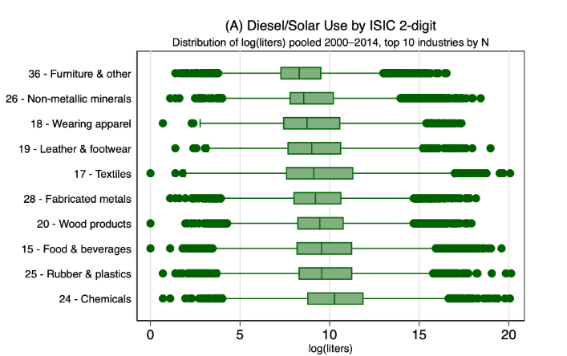 | 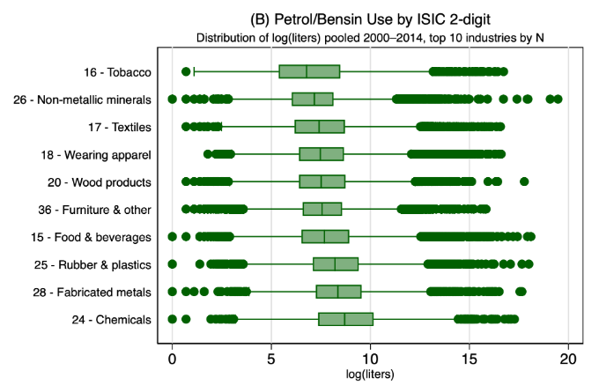
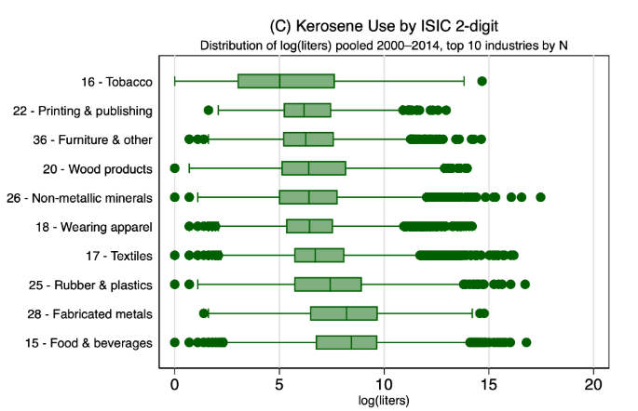 | 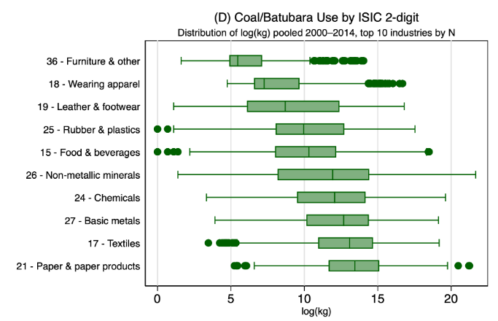
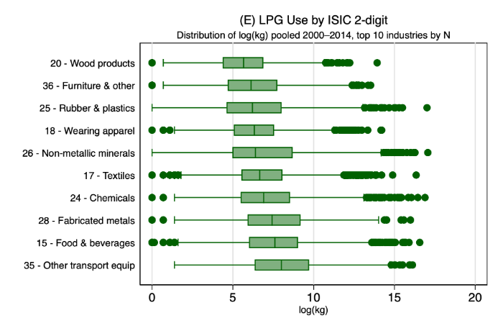 | 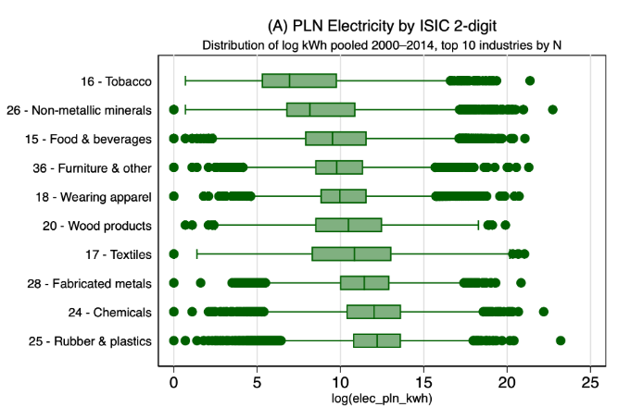

Second, the Scope 1 energy mix has shifted toward coal over time. Between 2000 and 2014, the share of coal in direct fuel consumption by manufacturing firms increased, while the shares of diesel and kerosene declined (Figure 2a). This compositional shift has raised the average carbon intensity of Scope 1 energy use. At the same time, firms have become more reliant on purchased electricity, so that Scope 2 emissions have grown relative to Scope 1 (Figure 2b). Both trends make the carbon intensity of the electricity grid increasingly important for aggregate manufacturing emissions.

Figure 2. Scope 1 and scope 2 emissions
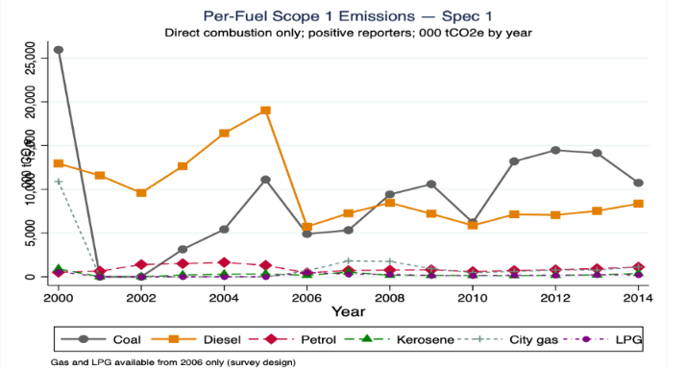
- Scope 1 energy mixed
- Scope 1 and 2 mix

Third, emissions are geographically and sectorally concentrated. Java dominates manufacturing activity and contributes the highest share of industrial CO₂ emissions. Within Java, West Java emits more than East Java, despite both provinces having large manufacturing bases (Figure 3a). This likely reflects differences in sectoral composition, firm size distribution, and fuel mix. Figure 3b shows that the highest-emitting sectors are ISIC 26 (non-metallic mineral products) and ISIC 17 (textiles). The top 20 sector-province emission pairs account for a disproportionate share of total manufacturing emissions, reinforcing the concentration pattern (Figure 3c).
Figure 3. Emission by sector and province
- Emissions and number of firms by province
- Emissions by sector
- Top 20 sector-province emissions

Fourth, emissions are strongly correlated with firm size and value added (Figure 4). Larger firms emit more in absolute terms, consistent with the scale effect. This is precisely why we use efficiency-based outcomes (VA/GJ and VA/CO₂) rather than total emissions as the dependent variables. Efficiency measures capture whether firms produce more value with less environmental cost, controlling for the fact that larger firms naturally consume more energy.
Figure 4. Emissions by firm size and value added
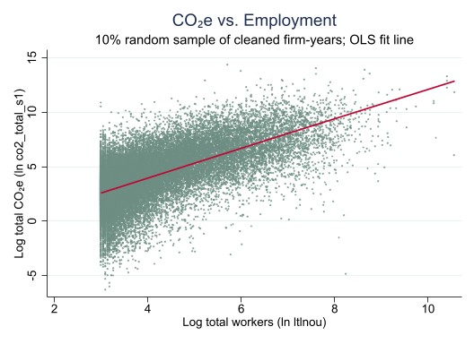 | 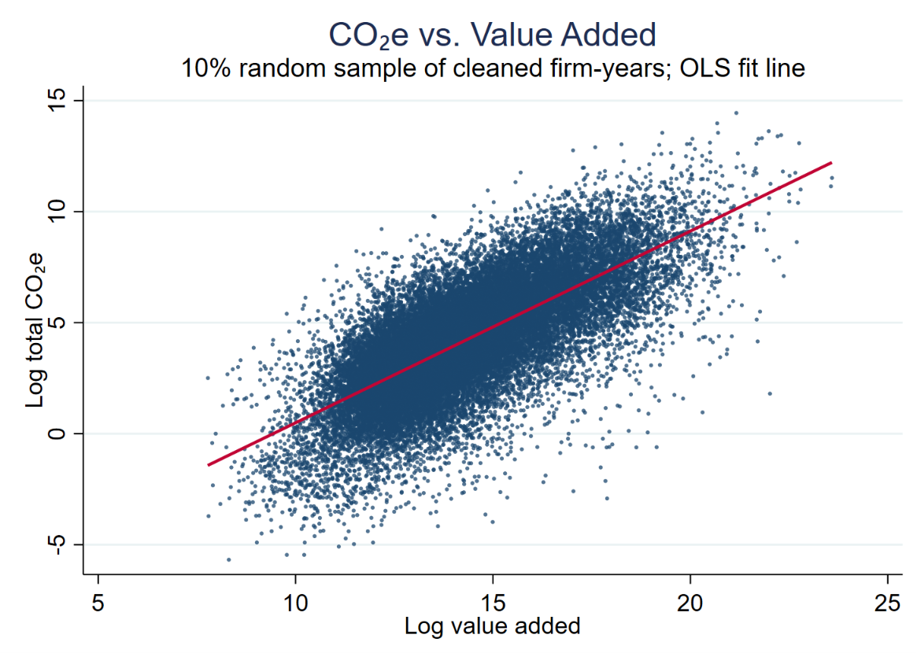
- Emissions and firm size | - Emissions and value added
- Correlation between emissions and value added and size

Table 2. Emissions and internationalization
 | (1) | (2) | (3) | (4) | (5) | (6)
VARIABLES | ln_co2_total | ln_co2_total | ln_co2_total | ln_co2_total | ln_co2_total | ln_co2_total
Starting to export | 1.985*** | -0.127***
 | (0.0138) | (0.0296)
Starting to import |  |  | 1.854*** | -0.0938**
 |  |  | (0.0158) | (0.0409)
Starting to FDI |  |  |  |  | 2.415*** | -0.0317
 |  |  |  |  | (0.0138) | (0.0555)
Observations | 306,517 | 306,517 | 306,517 | 306,517 | 306,517 | 306,517
Number of psid |  | 43,487 |  | 43,487 |  | 43,487
Fixed effects | No | Yes | No | Yes | No | Yes

Fifth, exporters and importers appear more emissions-efficient than non-traders, but this difference may reflect selection. Simple regressions without firm fixed effects show that firms entering export or import markets have substantially higher total emissions (approximately 190 and 185 per cent higher, respectively), but this entirely reflects the fact that trading firms are larger. Once firm fixed effects are included, the signs reverse: starting to export is associated with approximately 12.7 per cent lower emissions, and starting to import with approximately 9.4 per cent lower emissions. FDI entry shows no statistically significant association. These conditional correlations motivate the staggered DID analysis, which provides a more credible basis for causal inference by controlling for time-invariant firm heterogeneity and exploiting the timing of entry.

References
Amiti, M. and Konings, J. (2007). Trade liberalization, intermediate inputs, and productivity: Evidence from Indonesia. American Economic Review, 97(5), 1611–1638. https://doi.org/10.1257/aer.97.5.1611
Antweiler, W., Copeland, B. R., and Taylor, M. S. (2001). Is free trade good for the environment? American Economic Review, 91(4), 877–908. https://doi.org/10.1257/aer.91.4.877
Borusyak, K., Jaravel, X., and Spiess, J. (2024). Revisiting event-study designs: Robust and efficient estimation. Review of Economic Studies, 91(6), 3253–3285. https://doi.org/10.1093/restud/rdae007
Brucal, A., Javorcik, B., and Love, I. (2019). Good for the environment, good for business: Foreign acquisitions and energy intensity. Journal of International Economics, 121, 103247. https://doi.org/10.1016/j.jinteco.2019.07.002
Callaway, B. and Sant’Anna, P. H. C. (2021). Difference-in-differences with multiple time periods. Journal of Econometrics, 225(2), 200–230. https://doi.org/10.1016/j.jeconom.2020.12.001
Cherniwchan, J. (2017). Trade liberalization and the environment: Evidence from NAFTA and US manufacturing. Review of Economics and Statistics, 99(1), 141–155. https://doi.org/10.1016/j.jinteco.2017.01.005
Cherniwchan, J., Copeland, B. R., and Taylor, M. S. (2017). Trade and the environment: New methods, measurements, and results. Annual Review of Economics, 9, 59–85. https://doi.org/10.1146/annurev-economics-063016-103756
Cole, M. A., Elliott, R. J. R., and Strobl, E. (2008). The environmental performance of firms: The role of foreign ownership, training, and experience. Ecological Economics, 65(3), 538–546. https://doi.org/10.1016/j.ecolecon.2007.07.025
Copeland, B. R. and Taylor, M. S. (1994). North-South trade and the environment. Quarterly Journal of Economics, 109(3), 755–787. https://doi.org/10.2307/2118421
Copeland, B. R. and Taylor, M. S. (2004). Trade, growth, and the environment. Journal of Economic Literature, 42(1), 7–71. https://doi.org/10.1257/002205104773558047
Cui, J., Lapan, H., and Moschini, G. (2016). Productivity, export, and environmental performance: Air pollutants in the United States. American Journal of Agricultural Economics, 98(2), 447–467. https://doi.org/10.1093/ajae/aav066
de Chaisemartin, C. and D’Haultfœuille, X. (2020). Two-way fixed effects estimators with heterogeneous treatment effects. American Economic Review, 110(9), 2964–2996. https://doi.org/10.1257/aer.20181169
Eskeland, G. S. and Harrison, A. E. (2003). Moving to greener pastures? Multinationals and the pollution haven hypothesis. Journal of Development Economics, 70(1), 1–23. https://doi.org/10.1016/S0304-3878(02)00084-6
Forslid, R., Okubo, T., and Ulltveit-Moe, K. H. (2018). Why are firms that export cleaner? International trade, abatement and environmental emissions. Journal of Environmental Economics and Management, 91, 166–183. https://doi.org/10.1016/j.jeem.2018.07.006
Gao, Y., Yu, A., Jiang, J., and Pei, J. (2024). Will global value chain participation reduce environmental emissions? Evidence from Chinese firm-level data. Structural Change and Economic Dynamics, 69, 512–526. https://doi.org/10.1016/j.strueco.2024.01.006
Goldberg, P. K., Khandelwal, A. K., Pavcnik, N., and Topalova, P. (2010). Imported intermediate inputs and domestic product growth: Evidence from India. Quarterly Journal of Economics, 125(4), 1727–1767. https://doi.org/10.1162/qjec.2010.125.4.1727
Goodman-Bacon, A. (2021). Difference-in-differences with variation in treatment timing. Journal of Econometrics, 225(2), 254–277. https://doi.org/10.1016/j.jeconom.2021.03.014
Grossman, G. M. and Krueger, A. B. (1991). Environmental impacts of a North American Free Trade Agreement. NBER Working Paper No. 3914. https://doi.org/10.3386/w3914
Grossman, G. M. and Krueger, A. B. (1995). Economic growth and the environment. Quarterly Journal of Economics, 110(2), 353–377. https://doi.org/10.2307/2118443
He, C., Yin, X., and Zheng, F. (2023). Global firms and emissions: Investigating the dual channels of emissions abatement. Journal of Environmental Economics and Management, 117, 102758. https://doi.org/10.1016/j.jeem.2022.102772
Holladay, J. S. (2016). Exporters and the environment. Canadian Journal of Economics, 49(1), 147–172. https://doi.org/10.1111/caje.12193
Imbruno, M. and Ketterer, T. D. (2018). Energy efficiency gains from importing intermediate inputs: Firm-level evidence from Indonesia. Journal of Development Economics, 135, 117–141. https://doi.org/10.1016/j.jdeveco.2018.06.014
IPCC (2006). 2006 IPCC Guidelines for National Greenhouse Gas Inventories. Volume 2: Energy, Table 2.3. Intergovernmental Panel on Climate Change. https://www.ipcc-nggip.iges.or.jp/public/2006gl/vol2.html
Levinson, A. and Taylor, M. S. (2008). Unmasking the pollution haven effect. International Economic Review, 49(1), 223–254. https://doi.org/10.1111/j.1468-2354.2008.00478.x
Melitz, M. J. (2003). The impact of trade on intra-industry reallocations and aggregate industry productivity. Econometrica, 71(6), 1695–1725. https://doi.org/10.1111/1468-0262.00467
Pane, D. D. and Patunru, A. A. (2023). The role of imported inputs in firms’ productivity and exports: Evidence from Indonesia. Review of World Economics, 159, 629–672. https://doi.org/10.1007/s10290-022-00476-z
Rodrigue, J., Sheng, D., and Tan, Y. (2024). Exporting, abatement, and firm-level emissions: Evidence from China’s accession to the WTO. Review of Economics and Statistics, 106(4), 1064–1082. https://doi.org/10.1162/rest_a_01194
Shapiro, J. S. (2021). The environmental bias of trade policy. Quarterly Journal of Economics, 136(2), 831–886. https://doi.org/10.1093/qje/qjaa042
Shapiro, J. S. and Walker, R. (2018). Why is pollution from US manufacturing declining? The roles of environmental regulation, productivity, and trade. American Economic Review, 108(12), 3814–3854. https://doi.org/10.1257/aer.20151272
Sun, L. and Abraham, S. (2021). Estimating dynamic treatment effects in event studies with heterogeneous treatment effects. Journal of Econometrics, 225(2), 175–199. https://doi.org/10.1016/j.jeconom.2020.09.006

