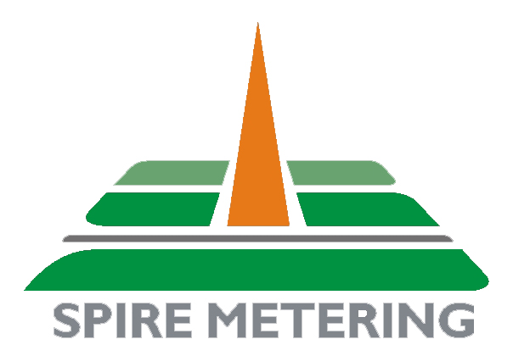
249 Cedar Hill St
Marlborough, MA 01752, USA
Tel： 978-263-7100
Fax ：978-418-9170
support@spiremt.com

Ultrasonic Flowmeter Calibration Certificate

The reference flowmeter is a high-accuracy electromagnetic flowmeter, MAG888. It has been calibrated to an accuracy of ±0.25% in National Institute of Science and Technology, USA.

Technician: _________________
Calibration Standard: NIST
Std. Last Verified: April 1, 2014
Std. Next Verify Due: April 1, 2016
Verification Officer: _______________ __
Calibration Date: _________________

