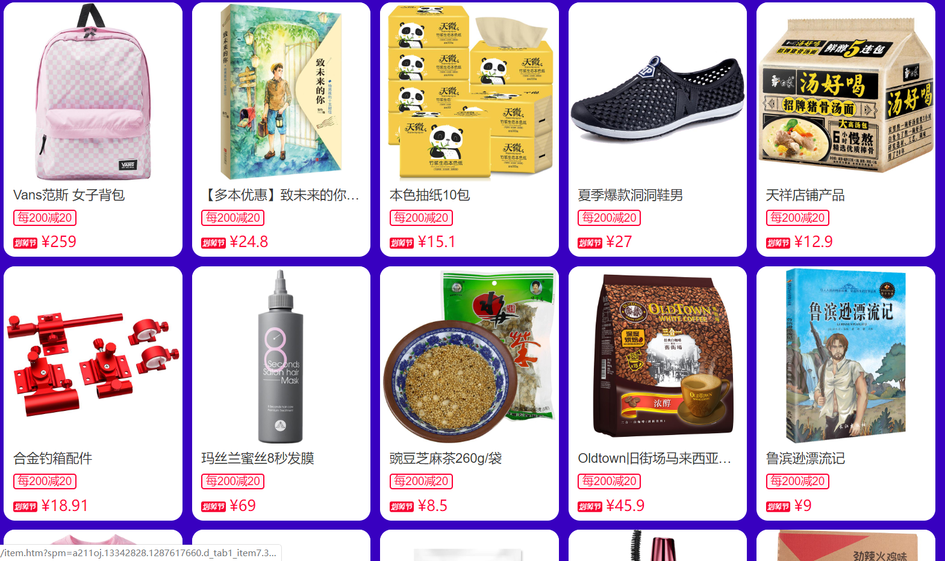

硅谷外卖

<https://github.com/W-Qing/Vue-MintShop>