**DevLab Eclipse Setup**



Auteur: Marco Kortooms  
Versie: 0.1  
Documentdatum: 24 December 2013

network  
to final results

Inhoud

1 Introduction 3

2 Development environment 4

3 Watershare Web Application 5

3.1 Application layout 5

Appendix A – Pom.xml 7

Appendix B – spring-servlet.xml 9

Appendix C – Web.xml 11

e for residual signing for cleaner water

# Introduction

This document contains an explanation of how to set up your development environment to be able to contribute to the DevLab development project. The set up will consist of the next items:

* Installation of Eclipse (Kepler)
* Installation of JBoss Tools (Kepler)
* Installation of Spring Tools Suite
* Configuration of Git/GitHub
* Import DevLab projects in your workspace
* Set up a Tomcat server

# Development environment

## Installation of Eclipse

To develop the DevLab applications Eclipse Kepler is used. This version of eclipse is available at the next location:

<http://www.eclipse.org/downloads/packages/eclipse-standard-431/keplersr1>

Download the Eclipse Archive file and extract the content to a directory. After installation start Eclipse. Standard GIT support is included in Eclipse Kepler. Additional plugins are not needed.

It is recommended to import the code style and compiler preferences stored in the EclipsePreferences.epf file included the root folder of GitHub. This to make sure every contributor is using the same code style conventions in the applications.

## Installation of JBoss Tools

Maven integration is available by installing the next plug-ins using the Eclipse Marketplace:

* JBoss Tools (Kepler) 4.1.1.Final

Open the Eclipse Marketplace (Menu Help -> Marketplace) and search for ‘JBoss’. Select ‘JBoss Tools (Kepler) 4.1.1.Final’ and install the package.

## Installation of Spring Tools

To support the development of Spring applications the next plug-in is necessary to install from the Eclipse Marketplace:

* Spring Tool Suite (STS) for Eclipse Kepler (4.3) 3.4.0 Release

Open the Eclipse Marketplace (Menu Help -> Marketplace) and search for ‘Spring Tools’. Select ‘Spring Tool Suite (STS) for Eclipse Kepler (4.3) 3.4.0 Release’ and install the package.

after installation and restart of Eclipse the Spring Tool Suite Dashboard will automatically open.

Click the Extensions tab (buttom of the dashboard screen).

Mark the checkbox indicating ‘Grails’ (current production release)

Click install button to install Groovy/Grail.

## Installation of Spring Tools

To check out the DebLab project it is necessary to connect to the DevLab GitHub repository. This can be done by cloning the GitHub DevLab repository locally using Eclipse.

In Eclipse open the ‘Git Repository Exploring’ perspective

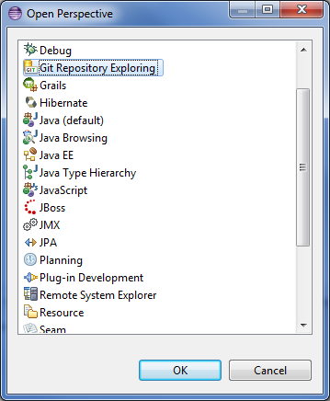

Click on ‘Clone Git Repository’ in Git Repositories tab:

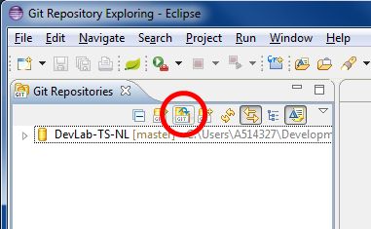

Enter URI:

https://github.com/albertmon/DevLab-TS-NL.git

Select ‘master’ branch

Click Finish. The Remote GitHub repository is cloned to your computer.

## Import DevLab projects in your workspace

Open ‘Git Repository Explorer’ perspective

Open ‘DevLab-TS-NL’ repository

Open Working Directory

Click with right mouse button on preferred project and click ‘Import Projects…’

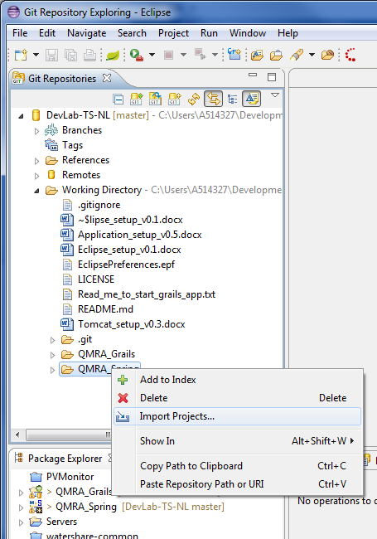

## Set up a Tomcat server

Create a new server by right click, and select ‘New ->’.

Click on ‘Other…’

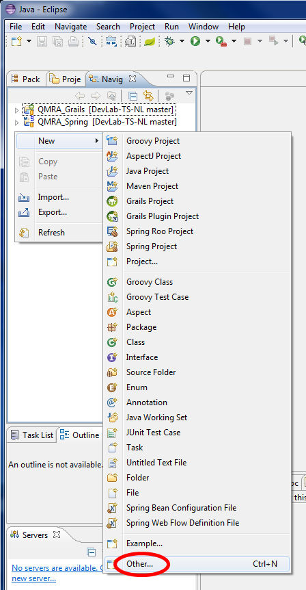

Select a new server

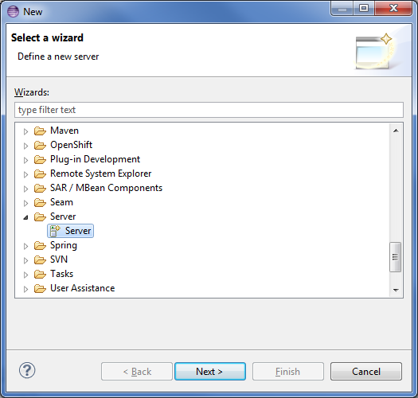

Click ‘Next’

Select ‘Apache Tomcat v7.0 Server

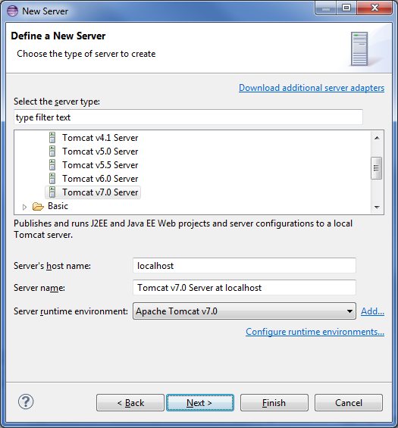

Click ‘Add’ to add a new Server Runtime environment. How to install and set up a Tomcat Server see: Setup_Tomcat_vx.x.doc

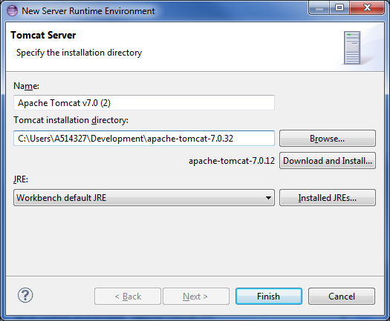

Select the Tomcat Installation directory and click ‘Finish’ to add the Server runtime environment

Click ‘Next’

Add the imported Projects to the Tomcat server

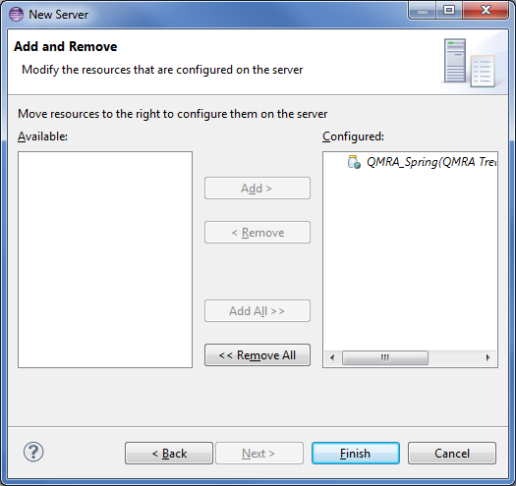

Click ‘Finish’ to install the Server to Eclipse

Start the server and see if the QMRA Application works by clicking:

<http://localhost:8080/qmratreatmentcalculator/start.do?external-session-id=xxxxxxxxxxxxxxxxxxxxxxxx&user-id=xxxxxxxx&country-id=xx>