**Tomcat setup**

**Watershare tools**



Auteur: Marco Kortooms  
Versie: 0.3  
Documentdatum: 23 December 2013

A ten-s  
water

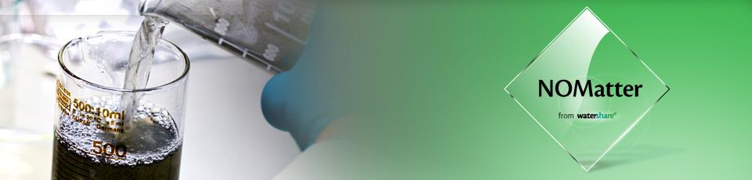

optimizing colour  
and natural organic  
material removal

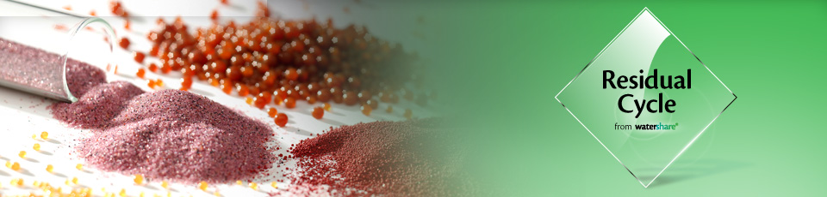

Valorising water  
treatment residuals



Enhanced network  
performance and reduced  
maintenance cost

from groundwater  
monitoring network  
to final results

Inhoud

1 Introduction 3

2 Install Tomcat Server 4

3 Set up environment 5

e for residual signing for cleaner water

# Introduction

This document contains an brief explanation of the settings used to setup the Tomcat Server.

# Install Tomcat Server

The standard installation of Tomcat 7.0.32 can be found at the next location:

<http://tomcat.apache.org/download-70.cgi#7.0.47>

Extract the zip-file to a folder.

Increase the perGen settings for the Catalina process by modifying the catalina.bat/catalina.sh in the bin folder and add the next line as first line in the batch:

Windows:

set CATALINA_OPTS=-Djava.awt.headless=true -Dfile.encoding=UTF-8 -server -Xms64m -Xmx512m -XX:PermSize=128m -XX:MaxPermSize=512m -XX:+CMSClassUnloadingEnabled -XX:+CMSPermGenSweepingEnabled

Linux:

export CATALINA_OPTS="-Djava.awt.headless=true -Dfile.encoding=UTF-8 -server -Xms64m -Xmx512m -XX:PermSize=128m -XX:MaxPermSize=512m -XX:+CMSClassUnloadingEnabled -XX:+CMSPermGenSweepingEnabled"