“Instructions to Prepare the Abstract for WaterSpain 2017”

First A. Author,† Second B. Author‡ and Third C. Author§

† Deparament de Fisica Fonamemtal, Universitat de Barcelona, Diagonal 645,
E-08028 Barcelona, Spain
‡ Departament de Fisica i Enginyeria nuclear, Universitat Politècnica de Catalunya, Campus Nord UPC, 08034 Barcelona, Spain
§Institut de Ciència de Materials de Barcelona ICMAB-CSIC, Campus de la UAB,
E-08193 Bellaterra, Spain

Contributions should be submitted as short abstracts on one page A4 size paper, including title, author(s), affiliation(s), and corresponding author contact information (New Roman, 12 pts, Bold, Left aligned); follow by main text in a single column (Times New Roman, 12 pts, justified, single spacing), including illustrations (figures and tables) and citations, if necessary. All margins should be of 1 inch.

The Abstract must contain the full name and full address of the author/s. In the case of joint authorships, the name of the author who will actually present the contribution should be indicated.

. 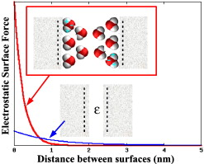

Fig. 1: Sketch of typical electrostatic force between two soft surfaces (for example, surfactant layers) calculated using MD simulations with explicit solvent or replacing water by a dielectric constant.

[1] G. Franzese, V. Bianco, S. Iskrov, Food Biophysics 6 ,186 (2011).
[2] V. Bianco, S. Iskrov, G. Franzese, J Biol Phys 38, 27 (2012).

