Cover Letter of Transmittal

From: QORVO_RADIO2 Team

Date: November 30, 2025

To: Russ Kegley, Jed Sander, Daisy Vazquez, Nathan Whitt
Qorvo
7628 Thorndike Rd, Greensboro, NC 27409

Greetings Qorvo,

This document describes the progress of the QORVO_RADIO2 project for Senior Design. The objective for this project is to create a radio controlled IoT using Qorvo’s QPG6200L that can be controlled through a main interface.

The main tasks in this project are building the PCB’s for each device, creating the network to connect the devices, and creating enclosures to house the devices. The team will work closely with Qorvo to bring about these desired outcomes.

In the coming semester, the team will have acquired all the necessary parts for the project and begin construction. This includes PCB assembly, programming of the SOC and gateway, and the assembly of enclosures.

Our team has enjoyed working with Qorvo in creating this IoT. We look forward to fabricating our design in Senior Design 2.

Sincerely,
Ethan Hartman, Alberto Hernandez, Luke Matthews, Abdul Bah, Kenneth Le

Design Report Changes
The project plan was updated with dates for PCB Assembly and SOC Programming tasks adjusted to fit order delivery times. The BOM was updated to reflect parts ordered and received since the latest revision.

Division of Duties Summary Table
The team was provided a list of tasks of what they should accomplish towards the project’s completion, displayed in the table below. The percentage shows how much each member contributed towards each task.

Tasks | Ethan Hartman | Alberto Hernandez | Luke Matthews | Abdul Bah | Kenneth Le | Total
SOW, Progress Reports, CDR, PDR, EXPO | 40% | 15% | 15% | 15% | 15% | 100%
BOM | 5% | 80% | 5% | 5% | 5% | 100%
PCB Design | 5% | 0% | 60% | 35% | 0% | 100%
Mesh Network | 0% | 0% | 0% | 0% | 100% | 100%
QPG Programming | 0% | 100% | 0% | 0% | 0% | 100%
Component Selection | 5% | 10% | 50% | 25% | 10% | 100%
Mechanical Design | 95% | 0% | 5% | 0% | 0% | 100%

QORVO_RADIO2 Project – Final Design Package – Senior Design I

Date | Revision | Author | Comments
2025-11-30 | Initial Draft | All Members
2026-01-15 | SD2 revisions | Luke M. | Updated Project plan to reflect current assembly and programming dates.

Table of Contents
1 Overview of this Document 2
2 Project Overview/ Statement of Work Summary 3
3 Specifications 3
4 Design Narrative 5
5 Adherence to Engineering Standards and Codes 16
6 Impact 18
7 Bill of Materials (BOM) 18
8 Budget 23
9 Project Plan for Senior Design 2 28
10 Conclusions 29
11 References 29
12 Appendices 30

Overview of this Document
This document describes the design of the QORVO_RADIO2 project and of its end-product. It begins with a project overview and a summary of the Statement of Work, describing the objective and scope of the project, approach on solving the problem proposed by Qorvo, and expected deliverables. It then moves onto the design specifications, which contains all the general requirements, stretch goals, and performance specifications and verification that are needed to meet the project’s objectives. The design narrative section includes decisions behind the design process, component selection, and implementation strategies. It then moves onto the Engineering Standards and Codes that are required by this project. The impact section provides an explanation of how this project will affect Qorvo, UNCC, the general public, and the environment. The Bill of Materials (BOM) is the list of components for all assemblies and subassemblies, which includes the costs, quantity, and sources of each item, while the budget section includes what items are planning to be bought, what items are submitted in the purchase requisition (PR), and as well as the project balance. The project plan for Senior Design 2 describes all the activities and objectives that will be completed during the next semester, including a developed test plan and verification process. Lastly, the conclusion summarizes the project, processes, and results. The references are formatted in Chicago style and include all notable sources. The appendix section lists where to find the files mentioned throughout the report.

Ethan Hartman, the designated Project Lead, is responsible for maintaining and updating this document.

Project Overview/ Statement of Work Summary [C]
Qorvo has tasked the team with developing an improved radio-based IoT control system as a follow-up to a previous senior design project. The problem was the need for a more capable, multi-device radio platform that could reliably transmit and receive data across different protocols while remaining portable and user-friendly.
The proposed solution was to design and build a set of battery-powered remote modules using the Qorvo QPG6200L SoC. These modules would support multiple peripherals, use bi-directional communication with a web interface, and demonstrate practical IoT control capabilities. The primary project deliverable was a fully functional multi-device IoT system ready for demonstration at the senior design expo.

Specifications [C]
The radio-based IoT control system developed for this project must meet the objectives established by Qorvo. These specifications define the performance, functionality, and reliability requirements necessary to validate the system’s success. The design emphasizes modularity, portability, and multi-protocol communication between the remote devices to operate seamlessly across various peripherals and interfaces. Meeting these specifications ensures that the system is ready to be demonstrated, suitable for future expansion, and educational use.

3.1 General Requirements
Requirements for this project include:
REQ1 : | Fully functional module that communicates with QORVO_RADIO and remote devices.

REQ2: | Mechanical enclosure to secure electronic hardware.

REQ3: | PCB design and fabrication.

REQ4: | Software for protocol implementation and SDR control.

REQ5: | Provide a bill of materials for off the shelf components and materials needed for fabrication.

REQ6: | The final cost must be within the specified project budget.

REQ7: | Module must be able to transmit and receive within the specified frequency range.

REQ8: | Project must be organized in a way that allows for future incorporations (schematics/ assembly notes).

REQ9: | Final design must be portable.

REQ10: | Feature an interactive display for users.

REQ11: | The devkit portion of the project should be battery powered

REQ12: | Devkit must use 3 different peripherals.

REQ13: | Remote devices must have battery life of > 1 week

REQ14: | Remote devices must occupy a space less than 3"x3"x3"

REQ15: | Remote devices must weigh less than 0.5 lb

Stretch Goal Requirements:
SREQ1: | SDR system must fit inside the existing case.

SREQ2: | SDR should operate as a minimal gateway

3.2 Performance Specifications
The performance specifications of the QORVO_RADIO2 project includes:
PS1: | Capability of transmitting and receiving within the 2.4GHz – 2.5GHz ISM band
PS2: | Support for multiple protocols (e.g., 802.11 and Zigbee) to control multiple remote devices.
PS3: | Battery capable of supplying remote devices for more than a week of operation.
PS4: | Remote devices must occupy a space smaller than 3”x3”x3”
PS5: | Remote devices must weigh less than 0.5 lbs

3.3 Performance Verification
V1: A spectrum analyzer will be used to verify the operating frequency range of the front end module.
V2: Demonstrate commands from each protocol on remote devices. (e.g., LED Toggle via WI-FI, sensor read via Zigbee)
V3: A multimeter will be used to ensure devices consume the same current within a reasonable tolerance as the theoretical calculations for power consumption and battery life.
V4: Remote devices will be measured using an accurate tool such as a tape measure, ruler, etc…
V5: Remote devices will be weighed using a standardized and accurate scale.

Design Narrative
The design narrative is an overview of the process the team followed in developing the QORVO_RADIO2 project. This process includes but is not limited to the decisions made regarding design methodology, component selection, and implementation strategies.

DN1: Board logic and KiCad schematic Design
The design of the PCB was established with a clear understanding of the project requirements laid out by the industry sponsors. The PCB design must be replicated across multiple boards that can communicate with each other over the 2.4-2.5GHz ISM band. The boards will incorporate Qorvo’s QPG6200L, and must be able to demonstrate at least 3 of the unique peripherals. These requirements gave rise to significant challenges in the design, such as power consumption, component sizing, track routing, and RF layout. The goal was to create a PCB design that could be replicated across multiple devices, with each device maintaining the ability to demonstrate the various peripherals functionalities.

The block diagram for the Replicated PCB design can be seen in Figure 1, visualising each device's peripheral and pin connection to the QPG6200L.

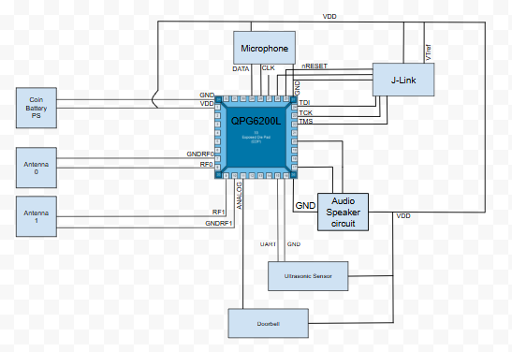
Figure 1: PCB Logic Design [D]

The QPG6200L will be powered by two 3V coin cell batteries. This power supply option was chosen as it allows the replicated devices to operate wirelessly. These coin cell batteries are mounted inside the TE Connectivity 1775485-1 vertical low profile CR2032 Battery Holder, allowing users to replace dead coin cells with ease. The two coin cell batteries are routed in series providing a maximum of 6V for each PCB. For component safety, the C&K OS102011MS2QN1 Slide Switch was mounted after the coin cell batteries, allowing the users to turn all power off to the board. A diode was placed after a 1 ohm resistor ensuring that current would not flow back into the positive terminals of the coin cell batteries. This circuit layout from the KiCad schematic can be seen below in Figure 2.

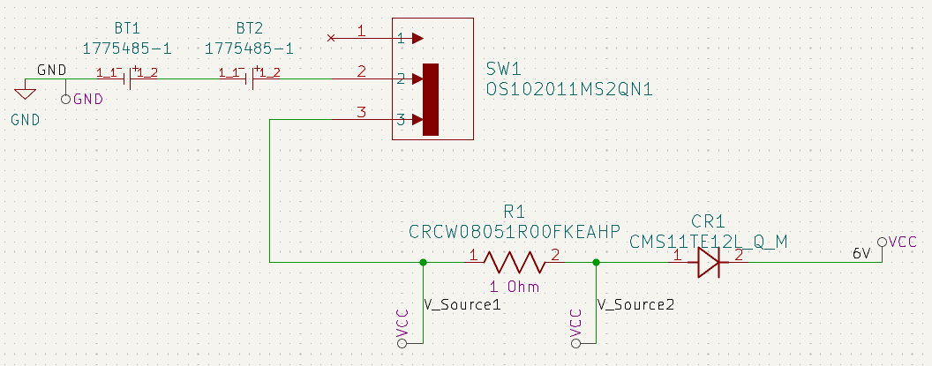
Figure 2: Input Power circuit [F]

The coin cell battery circuit is fed into two low dropout (LDO) voltage regulators that each provide a stable 3.3V and 5V supply respectively. These LDO’s were chosen for their limited reliance on passive components and standardized package size. The LDO circuit layout from the KiCad schematic can be seen below in Figure 3.

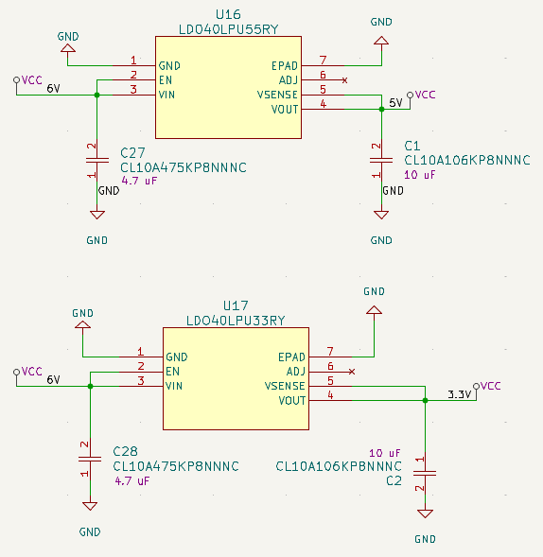
Figure 3: LDO circuits [F]

The QPG6200L was selected by Qorvo’s industry sponsors as the SoC for the project. The QPG6200L allows users to communicate over protocols that function within the 2.4-2.5GHz ISM band such as Bluetooth, and Zigbee. The QPG6200L has a vast assortment of peripherals such as analog, UART, and PDM across dozens of general purpose input output (GPIO) pins. The QPG6200L requires an external crystal oscillator for its clock to function. TXC Corporation’s 8Q-32.000MEEV-T 32 MHz crystal oscillator was chosen for its availability, standardized package, and frequency range. The QPG6200L’s circuit layout from the KiCad schematic can be seen below in Figure 4.

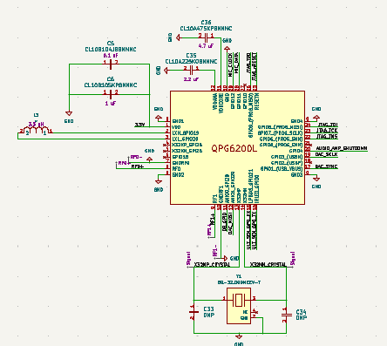
Figure 4: QPG6200L layout and pin connections [F]

To communicate to the QPG6200L the RF0 and RF1 pins were utilized. An F-Inverted antenna was designed to the 2.4-2.5GHz specifications in KiCads footprint editor. This antenna alleviates the need for a physical antenna to protrude from the board simplifying the mechanical design of the enclosure. The F-Inverted antenna was mounted at the edge of the board with keepouts surrounding the antenna to mitigate interference from the top layers GND plane and other various components. A second antenna connection was made to a vertical male SMA connector. This connector was added as backup for troubleshooting the designed F-Inverted Antenna during prototyping. Each antenna was connected to the QPG6200L utilizing KiCad’s Coplanar waveguide calculator to determine spacing, and width requirements for the 50 Ohm transmission line. Shield vias were placed along the edges of the transmission lines to mitigate interference. The filter from the QPG6200L’s datasheet was used on each transmission line. The F-Inverted antenna and circuit filtering layout from the KiCad schematic can be seen below in Figures 5 and 6 respectively.

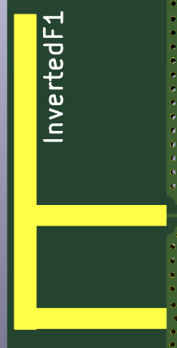
Figure 5: F-Inverted Antenna [F]

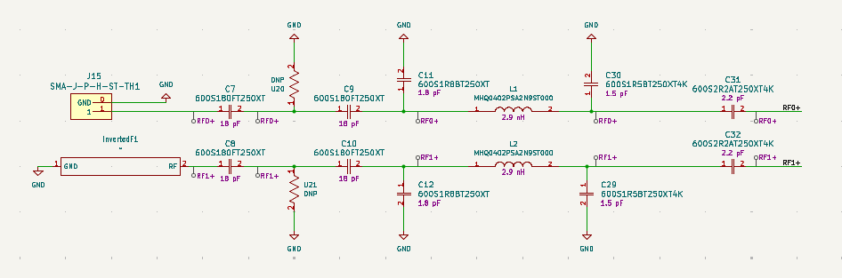
Figure 6: Antenna filtering circuit [F]

The QPG6200L will be programmed with the SEGGER J-Link EDU mini debugger. The JTAG peripheral will be used to communicate to the QPG6200L via a 10 pin header. This will allow users to easily program the QPG6200L after installation into the enclosure. The EDU mini variation was chosen for its affordability while offering similar functionality compared to the standard J-Link device. The J-Link 10 pin header circuit connection from the KiCad schematic can be seen below in Figure 7.

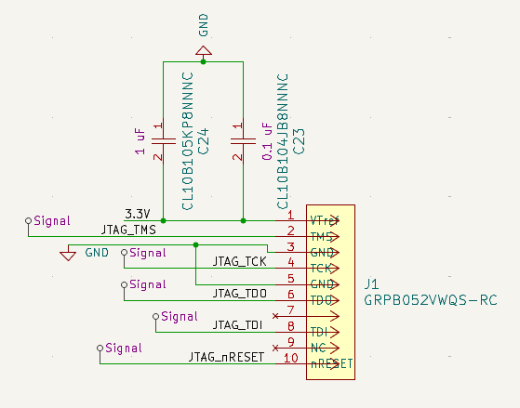
Figure 7: J-Link 10 pin header circuit [F]

For the first interactive device a simple analog doorbell was chosen. This device consists of a push button switch from E-switch. This push button switch was chosen for its simplicity, size, affordability, and availability. The switch’s two terminals are connected to a 3.3V source, and one of the QPG6200L’s dedicated configurable GPIO pins. The user can program the device to communicate with other devices when it senses the 3.3V from the switch connection, such as a speaker or light. The analog doorbell will be connected to the enclosure externally from the board via a 2 pin header. The doorbell 2 pin header circuit connection from the KiCad schematic can be seen below in Figure 8.

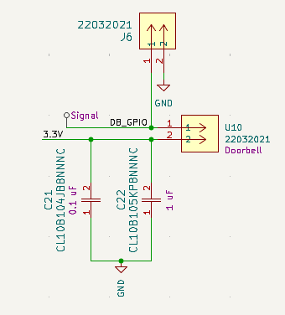
Figure 8: Doorbell 2 pin header circuit [F]

An ultrasonic sensor was selected for its interactive abilities, unique peripheral connection, and ease of implementation. The MaxBotix Inc. MB1000-000 was chosen over alternative options due to its increased range, and availability compared to similar devices. The MB1000-000 can detect people up to 10 feet, a vast difference compared to alternatives that had ranges spanning between 5-8 feet. The Ultrasonic sensor will be mounted externally from the board, onto the enclosure itself. The device will be connected via a 4 pin header. The ultrasonic sensor 2 pin header circuit connection from the KiCad schematic can be seen below in Figure 9.

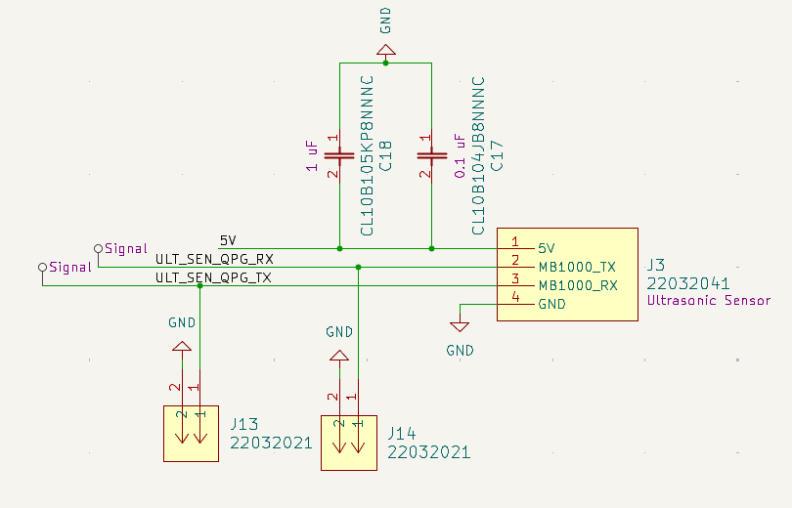
Figure 9: Ultrasonic sensor 4 pin header circuit [F]

The QPG6200L offers microphone functionality through its PDM peripheral connection. The Syntiant SPG08P4HM4H-1 was selected for its standardized package, top mounted microphone, and common use in small wireless devices such as smartphones. The SPG08P4HM4H-1 contains an integrated regulator and analog to digital converter (ADC) reducing its reliance on passive components. The SPG08P4HM4H-1 is mounted on the board as shown below in Figure 10.

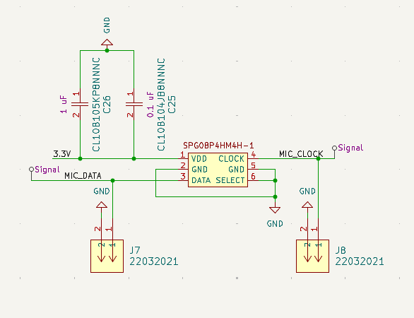
Figure 10: MEMS PDM microphone circuit [F]

The speaker connection is one of the most complex circuits on the board. It consists of a digital to analog converter (DAC), coupling capacitors, an audio amplifier, footprints for external filtering, and a 2 pin header for the external speaker. The speaker function was selected for its interactivity with the user and other device functions. The Texas Instruments DAC6551AQDGKRQ1 was selected for its low power consumption, input voltage range, and standard package size. The DAC connects to the QPG6200L through the SPI peripheral. Fulfilling the 3rd unique peripheral requirement. The DAC outputs a single analog signal that is connected via coupling capacitors to the Texas Instruments TPA2034D1YZFT audio amplifier. The TPA2034D1YZFT was selected due to its superior functionality. Offering various models to match a range of speaker impedances, while allowing for differential and single input connection. The TPA2034D1YZFT was designed for small wireless devices such as headphones, making the device ideal for our implementation. From the output of the audio amplifier to the input of the 2 pin speaker header footprints were laid out for filtering if needed during prototyping. The speaker will be external connected from the board onto the top of the enclosure. The Same Sky CSS-66668N was selected for its frequency response range, cost, and availability. The circuits for the DAC, and audio amplifier to filter to 2 pin header connection can be seen below in Figures 11 and 12.

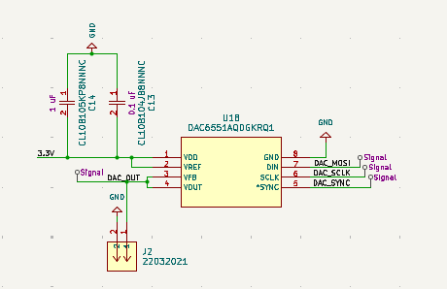
Figure 11: DAC circuit [F]

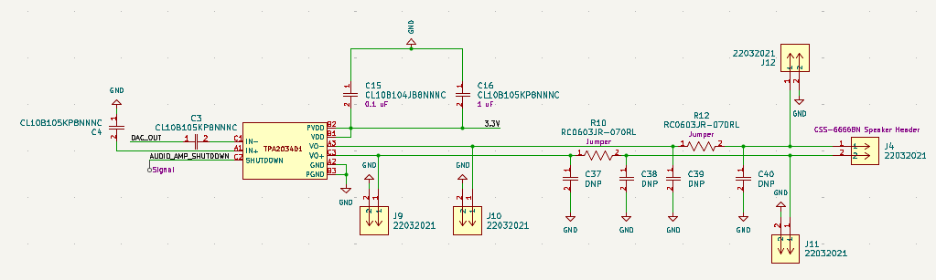
Figure 12: Audio amplifier, filtering, and 2 pin header circuit [F]

Test points were added across the board for debugging during the prototyping phase. A 4 pin header was added to measure the input voltage from the coin cell batteries, the 3.3V LDO, the 5V LDO, and the total current from the coin cell batteries. Other 2 pin headers were added across the entire board near various signal lines. The 2 pin header was selected with 1 pin designated for the desired signal, and the other pin connected to GND. This allows ease of measurement with an oscilloscope lead which requires a GND connection.

Two filtering capacitors were added at the input voltage pin of all devices to mitigate noise within the circuit. The capacitor values were chosen based on the switching frequencies, with one capacitor sized at a smaller value than the other.

A variety of custom symbols were made for the schematic as well as imported manufacture symbols for various IC’s, and KiCad standard symbols for passive components such as resistors and capacitors. Custom symbols were made to match functionally and aesthetically with manufacture and KiCad symbols to ensure readability from a new user's perspective.

DN2: KiCad PCBDesign
The PCB was designed as a 6 layer board following JLC PCB stackup and design rules. JLC PCB was selected as the manufacturer for the PCB for their ability to mount small devices such as the selected audio amplifier, the cost of manufacturing, ability to assemble the board with components, and the lead time required to manufacture and ship orders. JLC PCB offered standardized stackups for 6 layer board designs, as well as a list of design rules which eased the process of designing the board in Ki Cad. For parts assembly, JLC PCB offers a marketplace where users can select parts such as passive components and integrated circuits (IC’s) to be mounted on the board when shipped. This service reduces time spent preparing boards for programming and prototyping.

After finalizing the PCB layout best practices were followed by revising the design. Revisions such as island removal, and GND vias in “dead spaces” were made.

Footprints and 3D models were imported from the manufacturer and compared to datasheets to ensure accuracy. Footprints from KiCad were used for components such as capacitors that did not have manufacturer footprints. These footprints were compared to datasheets as well to ensure accuracy. This process was critical to ensure that all parts selected could be mounted and function on the designed PCB. The 3D models are shown below mounted to the final PCB design in Figure 13.

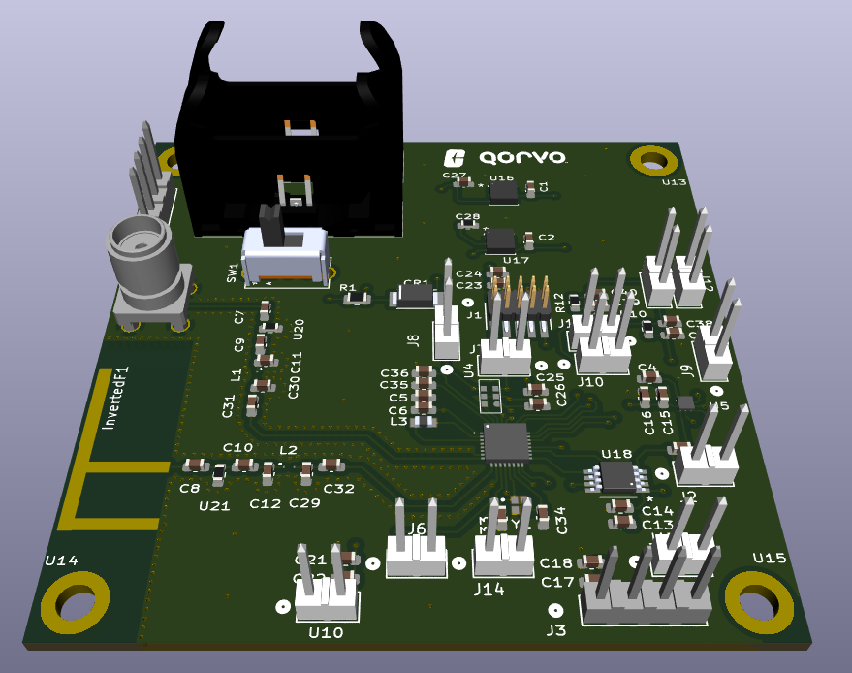
Figure 13: Final PCB design with 3D models [E]

DN3: Mechanical Enclosure Design
The mechanical enclosure is meant to hold the PCB as well as the devices the PCB will control. Those devices are the speaker, push button, and sonic sensor. The enclosures needed to be less than 0.5lb and around 3”x3”x3”.

The final design is made out of 3D printed PLA and held together with M3 bolts. Each enclosure is made out of around 3.25oz of PLA which is roughly $2.50 of material.. Each enclosure takes around 4-4.5 hours of print time. They are themed to generally look like a castle as it fits the entryway/ home security design.
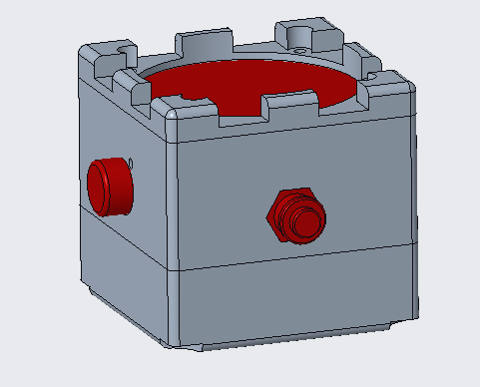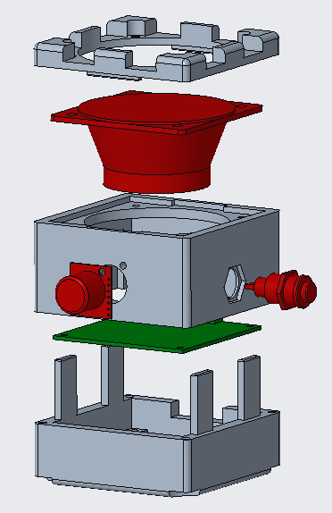
Figure 14: 3D-Printed Enclosure Design [I]

The enclosures were designed in creo parametric but can be opened in solidworks. The CAD files and STL files can be found in the mechanical research section of the comprehensive submission.

DN4: Computer Design for QPG6200L Programming
The computer design subsystem focuses on the firmware development and protocol implementations for the QPG6200L SoC, which serves as the core processing unit for the remote IoT devices. This subsystem enables bi-directional communication across multiple protocols (BLE and Zigbee), mesh networking, and interaction with the gateway and user interface. The design intent was to create a scalable, low-power software architecture that supports real-time control of peripherals (e.g., ultrasonic sensor via UART, microphone via PDM, speaker via SPI, and doorbell via analog) while adhering to IEEE 802.15.1, IEEE 802.15.4, and Matter protocol standards for interoperability and security. Rationale for choices included prioritizing open source tools for cost efficiency and ease of debugging, ensuring compatibility with Qorvo’s hardware. And optimizing battery life through low power modes.

The overall system architecture is a hierarchical flow: The user interacts with a web-based interface (ThingsBoard on a Lenovo Tab M11 tablet) to send commands via Wi-Fi (IEEE 802.11) to the EW840E5N gateway. The gateway interprets the command, determines the target device and protocol (e.g., BLE for speaker/microphone or Zigbee for movement detector), and routes it to the appropriate remote device. The QPG6200L on each remote PCB processes the command, and activates the peripheral, and sends status updates back through the mesh network to the gateway, which relays them to the user interface for visualization (e.g., dashboards showing motion data or audio output confirmation). Figure 15 provides an illustration of this process. [G]

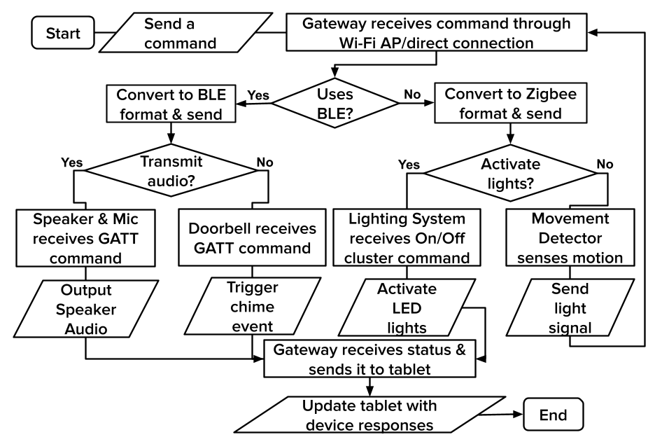
Figure 15: IoT Block Diagram

Hardware connection diagrams for the remote devices illustrate the QPG6200L’s peripheral mapping: UART for the MaxBotix ultrasonic sensor, PDM for the Syntiant MEMS microphone, SPI for the TI 12-bit DAC (speaker system), and analog input for the E-switch pushbutton (doorbell) [H]. These connections were rationalized based on peripheral requirements and SoC capabilities, minimizing pin usage while supporting multi-protocol operations.

For software development, the QPG6200L is programmed using Qorvo’s SDK which provides libraries for RF communication, protocol stacks, and peripheral drivers. The software was tested on the QPG6200LDK-01 (development kit). The process involves:
- Setting up a Docker container for the development environment to ensure cross-platform consistency and avoid native installation issues.
- Connecting the QPG6200L Development kit to our laptop via USB and flashing the firmware using J-Link Commander V8.10h.
- Using PuTTY for serial communication to monitor logs and interact with the SoC during testing.
- Initial validation through simple LED flashing scripts to confirm successful code deployment and functionality. [K]
- Movement detection firmware was implemented and tested. [J]
This approach aligns with the project plan outlined in the SOW, where computer engineering scope emphasized firmware for hardware-software integration. Revisions from initial planning included shifting from a custom UI to ThingsBoard after CDR feedback highlighted time constraints, and incorporating Matter over Thread/Zigbee for enhanced security, which required minor firmware adjustments but improved interoperability without impacting the timeline. Development accorded with the PDR by completing conceptual firmware workflows, with full implementation scheduled for SD2 assembly (January 2026).

Adherence to Engineering Standards and Codes
The WORVO_RADIO2 project incorporates several engineering standards and codes identified in the Statement of Work (SOW) and Performance Specifications to ensure reliability, interoperability, safety, and regulatory compliance. These standards guide the design of the custom PCB, wireless communication protocols, and overall system integration. Below, we detail each applicable standard, the steps taken to ensure compliance, and the aspects of the project impacted. Compliance was verified through iterative design reviews, simulations, and testing plans aligned with the Conceptual Design Review (CDR) and Preliminary Design Review (PDR) milestones. Tools such as KiCad for PCB design, VS Code for firmware development, and SolidWorks for CAD modeling were used to implement and document adherence.
- IPC-2221 (PCB Design Standard): This standard governs the design, layout, and fabrication of (PCBs) to ensure manufacturability, electrical integrity, and reliability. In our project, it impacted the 6-layer, 2.5” x 2.5” PCB design for the remote devices, including trace widths, clearances, layer stacking, and component placement. Steps for compliance included: calculating minimum trace widths using PCB trace width calculator, oversized to account for current loads and manufacturing tolerances; adhering to JLC PCB design rules for capabilities like minimum trace width/spacing and via sizes during KiCad layout; conducting design rules checks (DRC) in KiCad to verify clearances, impedance matching, and thermal management; and simulating signal integrity to confirm no violations in RF paths. This ensured the PCB supports multi-protocol operation without interference, reducing risks of signal degradation or failure in the 2.4-2.5 GHz ISM band.
- IEEE 802.4 (Ethernet Standard for Wired LAN Communication): This standard defines protocols for wired local area network (LAN) communications, impacting the gateway’s ethernet interface for stable data transfer between the EW840E5N gateway and the user interface. Compliance steps involved: selecting compatible hardware like the Trendnet AC2600 Dual Band Wireless Router and Cat8 Ethernet cables; configuring the gateway's Ethernet port in firmware to support bi-directional communication; and testing packet transmission in a simulated network environment using VS Code and PuTTY for serial debugging. This standard influenced the system's reliability for real-time IoT control, ensuring low-latency updates for device status in the interactive entryway demonstration.
- IEEE 802.11 (Wi-Fi Standard Operating in the 2.4 GHz ISM Band): Governing Wi-Fi connectivity, this standard affected the gateway's wireless interface for bi-directional communication with the Lenovo Tab M11 user display and remote devices. To ensure compliance: the EW840E5N gateway was configured to operate within the 2.4 GHz band; power levels and channel allocations were limited to unlicensed ISM band specifications. It impacted the mesh network topology, enabling scalable control of peripherals.
- IEEE 802.15.1 (Bluetooth/BLE Standard for Short-Range Wireless Communication): This standard supports low-energy, short-range transmission and was applied to devices such as the doorbell and speaker/microphone system. Compliance measures included: programming the QPG6200L SoC via J-Link debugger to implement BLE profiles for bi-directional data exchange; conducting range tests (<10 ft for peripherals like the ultrasonic sensor) to meet short-range requirements.
- IEEE 802.15.4 (Zigbee and Thread Protocol Foundation for Low-Power Mesh Networking): This forms the basis for Zigbee/Thread protocols used in mesh topology for devices like the movement detector and lighting system. Steps for adherence: firmware development in VS Code to enable mesh networking on the QPG6200L, supporting at least two protocols; simulating network scalability with multiple nodes; and verifying low-power modes to align with energy efficiency specs. This standard impacted the system's ability to handle multi-device control.
- Matter Protocol Specification (Application Layer Standard for Secure, Interoperable Smart Devices): As an application layer over Zigbee/Thread, Matter ensures secure device interoperability. Compliance involved: integrating Matter-compatible firmware on the QPG6200L using Qorvo's SDK; (2) implementing rule-based automation in ThingsBoard for secure commands (e.g., LED toggle via Zigbee); and (3) planning encryption tests for data transmission. It affected security features, promoting safe RF operations in demonstrations.
- FCC Title 47 CFR Part 2 (Frequency Allocations and Equipment Authorization): This regulates frequency use and authorization for RF-transmitting devices. To comply: (1) the design was restricted to the 2.4-2.5 GHz ISM band; It impacted antenna design to avoid unauthorized emissions.
- FCC Title 47 CFR Part 15 (Regulations for Unlicensed RF Devices): Covering unlicensed operations for Wi-Fi, Bluetooth, and Zigbee, compliance steps included: limiting transmit emissions in firmware; conducting interference simulations; and ensuring no harmful interference in the ISM band. This influenced the overall RF front-end design, prioritizing low-power modes.
- FCC Title 47 CFR Part 18 (Regulations for ISM Equipment): This applies to industrial, scientific, and medical devices in the ISM band. Adherence was achieved by: designing for non-interfering operations; frequency stability with the 32 MHz crystal oscillator; and planning emissions tests. It impacted the project's focus on educational RF tools without regulatory risks.
No additional standards were deemed necessary, as the identified ones comprehensively cover PCB fabrication, wireless protocols, RF regulations, and mechanical aspects. Non-compliance risks were mitigated through simulations, ensuring design aligns with Qorvo and UNC Charlotte’s goals.

Impact
Some of the primary objectives of this project are to promote radio frequency research at UNC Charlotte as well as advance and highlight Qorvo’s RF investments, innovations, and applications.This project will present the broad functionality of low power electronics in security, healthcare, communication, and many more applications. Through this project, there will be a demonstration of the transformative and real world impacts of radio frequency.

Bill of Materials (BOM) [B]
Below is a table listing the vendor, quantity, cost, and order status of each part for the project. The bill of materials can also be found in the comprehensive submission. Most of the bill of materials is focused on electrical components for the PCB boards and computer components.

So far, 5 purchase requisition forms have been submitted and received with the remaining forms to be turned in before the end of the semester.

Parts List
Status | Part | Description | Quantity | Supplier | Unit Cost | Total Cost | Lead Time | Notes | Link
Computer Parts
Received | EW840E5N | Open Source BLE 5.2/Thread/Zigbee to Ethernet, WiFi gateway | 1 | Fanstel | $95.52 | $107.52 | 1 week | Size: Individual | Fanstel
Received | 485-3571 | J-Link debugger | 2 | Mouser | $74.94 | $149.88 | 5 weeks | Low in stock | Mouser
 | B0CQMPSWMJ | Lenovo Tab M11 | 1 | Amazon | $153.52 | $153.52 | 1 week | In stock | Amazon
Received | 2312-QPG6200LDK-01-ND | Development Kit | 1 | Digikey | $348.75 | $355.74 | 19 Weeks | Low in stock | Digikey
Received | 1914-PK-LEW840X-ND | EVAL BOARD FOR LEW840X | 1 | Digikey | $26.64 | $29.30 | 12 Weeks | Low in stock | Digikey
Received | 3922-TEW-827DRU-ND | Trendnet AC2600 Dual Band Wireless Router | 1 | Digikey | $74.00 | $74.00 | 1 week | Low in stock | Digikey
Received | B018TQRUWW | Cat8 Ethernet Cable, | 1 | Amazon | $11.04 | $11.04 | 1 week | In stock | Amazon
Electrical Parts
Received | LR431U-7.2X7IR3 | 5V LED Light Strip with USB A connection | 3 | The Home Depot | $6.48 | $19.44 | 1 week | Due to the 5V voltage requirement, and data/Power connection the LED light strip can only be found from a non approved vendor. | Home Depot
Received | 1863-1001-ND | Ultrasonic Sensor | 10 | Digikey | $19.95 | $199.50 | 2 weeks | Low in stock | Digikey
Received | 102-3861-ND | SPEAKER 8OHM 3W | 7 | Digikey | $4.18 | $29.26 | 15 weeks | Low in stock | Digikey
Received | 595-TPA2034D1YZFT | Audio Amplifiers 2.75W Mon Fully Diff Class-D Aud Amp A 595-TPA2034D1YZFR | 10 | Mouser | $1.24 | $12.40 | 6 weeks | Low in stock | Mouser
Received | EG1930-ND | Pushbutton Switch SPST-NO Standard Panel Mount, Front | 10 | Digikey | $1.98 | $19.80 | 17 weeks | In stock | Digikey
 | A107796-ND | 2032 coin cell battery holder | 20 | Digikey | $1.25 | $25.00 | 5 weeks | In stock | Digikey
 | 6017-SPG08P4HM4H-1CT-ND | 30 Hz ~ 10 kHz Digital, PDM Microphone MEMS | 10 | Digikey | $1.83 | $18.30 | 14 weeks | In stock | Digikey
 | 1675 | 10-pin 2x5 Socket-Socket 1.27mm IDC (SWD) Cable - 150mm long | 1 | Adafruit | $2.95 | $2.95 | 1 Week | In stock | Adafruit
 | 1175-1627-ND | Connector Header Surface Mount 10 position 0.050" (1.27mm) | 10 | Digikey | $0.75 | $7.50 | 20 weeks | High in stock | Digikey
 | 900-2177971022-ND | 2 Position Cable Assembly Rectangular Socket to Individual Wire Leads 0.984' | 20 | Digikey | $1.56 | $31.20 | 21 weeks | In stock | Digikey
 | WM4000-ND | Connector Header Through Hole 2 position 0.100" (2.54mm) | 20 | Digikey | $0.22 | $4.40 | 15 weeks | High in Stock | Digikey
 | 1276-1192-1-ND | 10 µF ±10% 10V Ceramic Capacitor X5R 0603 (1608 Metric) | 20 | Digikey | $0.02 | $0.44 | 31 weeks | High in stock | Digikey
 | 1276-1033-1-ND | 0.1 µF ±5% 50V Ceramic Capacitor X7R 0603 (1608 Metric) | 90 | Digikey | $0.01 | $0.54 | 31 weeks | High in stock | Digikey
 | CMS11QCT-ND | Diode 40 V 2A Surface Mount M-FLAT (2.4x3.8) | 20 | Digikey | $0.24 | $4.76 | 16 weeks | High in stock | Digikey
 | 311-0.0GRCT-ND | 0 Ohms Jumper Chip Resistor 0603 (1608 Metric) | 40 | Digikey | $0.01 | $0.40 | 18 weeks | High in stock | Digikey
 | WM4002-ND | Connector Header Through Hole 4 position 0.100" (2.54mm) | 20 | Digikey | $0.29 | $5.80 | 15 weeks | High in stock | Digikey
 | 900-2177971042-ND | 4 Position Cable Assembly Rectangular Socket to Individual Wire Leads 0.984' (300.00mm, 11.81") | 20 | Digikey | $2.66 | $53.12 | 21 weeks | In stock | Digikey
 | 296-45314-1-ND | 12 Bit Digital to Analog Converter 1 8-VSSOP | 10 | Digikey | $3.36 | $33.64 | N/A | High in stock | Digikey
 | 887-1849-1-ND | 32 MHz ±10ppm Crystal 8pF 80 Ohms 4-SMD, No Lead | 10 | Digikey | $0.77 | $7.73 | 17 weeks | High in stock | Digikey
 | 490-18646-ND | Coin, 20.0mm Lithium Manganese Dioxide 3 V Battery Non-Rechargeable (Primary) | 50 | Digikey | $0.24 | $12.05 | 18 weeks | High in stock | Digikey
 | CKN9565-ND | Slide Switch SPDT Through Hole | 10 | Digikey | $0.61 | $6.08 | 12 weeks | High in stock | Digikey
 | 490-12783-1-ND | 3.3 µH Shielded Multilayer Inductor 700 mA 438mOhm Max 0603 (1608 Metric) | 10 | Digikey | $0.14 | $1.36 | 10 weeks | High in stock | Digikey
 | 1276-1946-1-ND | 1 µF ±10% 10V Ceramic Capacitor X7R 0603 (1608 Metric) | 100 | Digikey | $0.01 | $0.50 | 31 weeks | High in stock | Digikey
 | 1276-1040-1-ND | 2.2 µF ±10% 16V Ceramic Capacitor X5R 0603 (1608 Metric) | 10 | Digikey | $0.01 | $0.09 | 32 weeks | High in stock | Digikey
 | 1276-1044-1-ND | 4.7 µF ±10% 10V Ceramic Capacitor X5R 0603 (1608 Metric) | 30 | Digikey | $0.01 | $0.18 | 31 weeks | High in stock | Digikey
 | 541-1.00TCT-ND | 1 Ohms ±1% 0.5W, 1/2W Chip Resistor 0805 (2012 Metric) Automotive AEC-Q200, Pulse Withstanding Thick Film | 10 | Digikey | $0.13 | $1.26 | 14 weeks | High in stock | Digikey
 | 497-18288-1-ND | Linear Voltage Regulator IC Positive Fixed 1 Output 400mA 6-DFN (3x3) | 10 | Digikey | $1.26 | $12.56 | 24 weeks | In stock | Digikey
 | 311-10.0KHRCT-ND | 10 kOhms ±1% 0.1W, 1/10W Chip Resistor 0603 (1608 Metric) Moisture Resistant Thick Film | 40 | Digikey | $0.01 | $0.24 | 18 weeks | High in stock/ HOLD OFF ON ORDER | Digikey
 | 772-QPG6200LTR13 | Qorvo SOC 10DBM 4X4QFN32 | 10 | Mouser | $4.68 | $46.80 | 22 weeks | In stock | Mouser
 |  | JCL PCB 6 layer estimate | 5 | JLC PCB | N/A | $133.86 | N/A | N/A | JLC PCB
 | 497-LDO40LPU50RYCT-ND | Linear Voltage Regulator IC Positive Fixed 1 Output 400mA 6-DFN (3x3) | 10 | Digikey | $1.26 | $12.56 | 24 weeks | In stock | Digikey
 | 296-38372-1-ND | Audio Amplifier 2 Circuit Rail-to-Rail 8-SON (3x3) | 10 | Digikey | $6.57 | $65.73 | 12 weeks | Low in stock/ HOLD OFF ON ORDER | Digikey
 | 478-600S2R2AT250XT4KCT-ND | 2.2 pF ±0.05pF 250V Ceramic Capacitor C0G, NP0 0603 (1608 Metric) | 20 | Digikey | $1.11 | $22.20 | 12 weeks | In stock | Digikey
 | 1284-600S1R5BT250XT4KCT-ND | 1.5 pF ±0.1pF 250V Ceramic Capacitor C0G, NP0 0603 (1608 Metric) | 20 | Digikey | $0.72 | $14.30 | 12 weeks | High in stock | Digikey
 | 478-600S1R8BT250XT4KCT-ND | 1.8 pF ±0.1pF 250V Ceramic Capacitor C0G, NP0 0603 (1608 Metric) | 20 | Digikey | $0.91 | $18.14 | 12 weeks | High in stock | Digikey
 | 478-600S180FT250XT4KCT-ND | 18 pF ±1% 250V Ceramic Capacitor C0G, NP0 0603 (1608 Metric) | 40 | Digikey | $1.55 | $61.92 | 12 weeks | In stock | Digikey
 | 445-MHQ0402PSA2N9ST000CT-ND | 2.9 nH Shielded Multilayer Inductor 250 mA 600mOhm Max 01005 (0402 Metric) | 20 | Digikey | $0.03 | $0.60 | 12 weeks | High in stock | Digikey
 | SAM8971-ND | SMA Connector Jack, Female Socket 50 Ohms Through Hole Solder | 10 | Digikey | $2.27 | $22.66 | 4 weeks | High in stock | Digikey
Mechanical Parts
Received | B0C8HWQYXF | Elegoo 1 kg 3d printer filament (marble) | 2 | Amazon | $21.99 | $43.98 | 1 week | In stock | Amazon
Received | B0D3X5CT2J | M3 Bolt Set | 1 | Amazon | $7.99 | $7.99 | 1 week | In stock | Amazon
 | B079KTVRC9 | Apache 3800 carrying case | 1 | Amazon | $49.00 | $49.00 | 1 week | In stock | Amazon
 |  |  |  | Mechanical Total |  | $100.97
 |  |  |  | Electrical Total |  | $909.27
 |  |  |  | Computer Total |  | $881.00
 |  |  |  | Budget Remaining |  | $1,358.76
 |  |  |  | Total Spent: |  | $1,891.24
 |  |  |  | Cost Per Device |  | $74.44
 |  |  |  | Total Budget |  | $3,250
Figure 16: Bill of Materials (BOM)

Budget [B]
The only addition to the previous bill of materials is the labor cost for the PCB construction, which is around $130.

Parts List
Status | Part | Description | Quantity | Supplier | Unit Cost | Total Cost | Lead Time | Notes | Link
Computer Parts
Received | EW840E5N | Open Source BLE 5.2/Thread/Zigbee to Ethernet, WiFi gateway | 1 | Fanstel | $95.52 | $107.52 | 1 week | Size: Individual | Fanstel
Received | 485-3571 | J-Link debugger | 2 | Mouser | $74.94 | $149.88 | 5 weeks | Low in stock | Mouser
 | B0CQMPSWMJ | Lenovo Tab M11 | 1 | Amazon | $153.52 | $153.52 | 1 week | In stock | Amazon
Received | 2312-QPG6200LDK-01-ND | Development Kit | 1 | Digikey | $348.75 | $355.74 | 19 Weeks | Low in stock | Digikey
Received | 1914-PK-LEW840X-ND | EVAL BOARD FOR LEW840X | 1 | Digikey | $26.64 | $29.30 | 12 Weeks | Low in stock | Digikey
Received | 3922-TEW-827DRU-ND | Trendnet AC2600 Dual Band Wireless Router | 1 | Digikey | $74.00 | $74.00 | 1 week | Low in stock | Digikey
Received | B018TQRUWW | Cat8 Ethernet Cable | 1 | Amazon | $11.04 | $11.04 | 1 week | In stock | Amazon
Electrical Parts
Received | LR431U-7.2X7IR3 | 5V LED Light Strip with USB A connection | 3 | The Home Depot | $6.48 | $19.44 | 1 week | Due to the 5V voltage requirement, and data/Power connection the LED light strip can only be found from a non approved vendor. | Home Depot
Received | 1863-1001-ND | Ultrasonic Sensor | 10 | Digikey | $19.95 | $199.50 | 2 weeks | Low in stock | Digikey
Received | 102-3861-ND | SPEAKER 8OHM 3W | 7 | Digikey | $4.18 | $29.26 | 15 weeks | Low in stock | Digikey
Received | 595-TPA2034D1YZFT | Audio Amplifiers 2.75W Mon Fully Diff Class-D Aud Amp A 595-TPA2034D1YZFR | 10 | Mouser | $1.24 | $12.40 | 6 weeks | Low in stock | Mouser
Received | EG1930-ND | Pushbutton Switch SPST-NO Standard Panel Mount, Front | 10 | Digikey | $1.98 | $19.80 | 17 weeks | In stock | Digikey
 | A107796-ND | 2032 coin cell battery holder | 20 | Digikey | $1.25 | $25.00 | 5 weeks | In stock | Digikey
 | 6017-SPG08P4HM4H-1CT-ND | 30 Hz ~ 10 kHz Digital, PDM Microphone MEMS | 10 | Digikey | $1.83 | $18.30 | 14 weeks | In stock | Digikey
 | 1675 | 10-pin 2x5 Socket-Socket 1.27mm IDC (SWD) Cable - 150mm long | 1 | Adafruit | $2.95 | $2.95 | 1 Week | In stock | Adafruit
 | 1175-1627-ND | Connector Header Surface Mount 10 position 0.050" (1.27mm) | 10 | Digikey | $0.75 | $7.50 | 20 weeks | High in stock | Digikey
 | 900-2177971022-ND | 2 Position Cable Assembly Rectangular Socket to Individual Wire Leads 0.984' | 20 | Digikey | $1.56 | $31.20 | 21 weeks | In stock | Digikey
 | WM4000-ND | Connector Header Through Hole 2 position 0.100" (2.54mm) | 20 | Digikey | $0.22 | $4.40 | 15 weeks | High in Stock | Digikey
 | 1276-1192-1-ND | 10 µF ±10% 10V Ceramic Capacitor X5R 0603 (1608 Metric) | 20 | Digikey | $0.02 | $0.44 | 31 weeks | High in stock | Digikey
 | 1276-1033-1-ND | 0.1 µF ±5% 50V Ceramic Capacitor X7R 0603 (1608 Metric) | 90 | Digikey | $0.01 | $0.54 | 31 weeks | High in stock | Digikey
 | CMS11QCT-ND | Diode 40 V 2A Surface Mount M-FLAT (2.4x3.8) | 20 | Digikey | $0.24 | $4.76 | 16 weeks | High in stock | Digikey
 | 311-0.0GRCT-ND | 0 Ohms Jumper Chip Resistor 0603 (1608 Metric) | 40 | Digikey | $0.01 | $0.40 | 18 weeks | High in stock | Digikey
 | WM4002-ND | Connector Header Through Hole 4 position 0.100" (2.54mm) | 20 | Digikey | $0.29 | $5.80 | 15 weeks | High in stock | Digikey
 | 900-2177971042-ND | 4 Position Cable Assembly Rectangular Socket to Individual Wire Leads 0.984' (300.00mm, 11.81") | 20 | Digikey | $2.66 | $53.12 | 21 weeks | In stock | Digikey
 | 296-45314-1-ND | 12 Bit Digital to Analog Converter 1 8-VSSOP | 10 | Digikey | $3.36 | $33.64 | N/A | High in stock | Digikey
 | 887-1849-1-ND | 32 MHz ±10ppm Crystal 8pF 80 Ohms 4-SMD, No Lead | 10 | Digikey | $0.77 | $7.73 | 17 weeks | High in stock | Digikey
 | 490-18646-ND | Coin, 20.0mm Lithium Manganese Dioxide 3 V Battery Non-Rechargeable (Primary) | 50 | Digikey | $0.24 | $12.05 | 18 weeks | High in stock | Digikey
 | CKN9565-ND | Slide Switch SPDT Through Hole | 10 | Digikey | $0.61 | $6.08 | 12 weeks | High in stock | Digikey
 | 490-12783-1-ND | 3.3 µH Shielded Multilayer Inductor 700 mA 438mOhm Max 0603 (1608 Metric) | 10 | Digikey | $0.14 | $1.36 | 10 weeks | High in stock | Digikey
 | 1276-1946-1-ND | 1 µF ±10% 10V Ceramic Capacitor X7R 0603 (1608 Metric) | 100 | Digikey | $0.01 | $0.50 | 31 weeks | High in stock | Digikey
 | 1276-1040-1-ND | 2.2 µF ±10% 16V Ceramic Capacitor X5R 0603 (1608 Metric) | 10 | Digikey | $0.01 | $0.09 | 32 weeks | High in stock | Digikey
 | 1276-1044-1-ND | 4.7 µF ±10% 10V Ceramic Capacitor X5R 0603 (1608 Metric) | 30 | Digikey | $0.01 | $0.18 | 31 weeks | High in stock | Digikey
 | 541-1.00TCT-ND | 1 Ohms ±1% 0.5W, 1/2W Chip Resistor 0805 (2012 Metric) Automotive AEC-Q200, Pulse Withstanding Thick Film | 10 | Digikey | $0.13 | $1.26 | 14 weeks | High in stock | Digikey
 | 497-18288-1-ND | Linear Voltage Regulator IC Positive Fixed 1 Output 400mA 6-DFN (3x3) | 10 | Digikey | $1.26 | $12.56 | 24 weeks | In stock | Digikey
 | 311-10.0KHRCT-ND | 10 kOhms ±1% 0.1W, 1/10W Chip Resistor 0603 (1608 Metric) Moisture Resistant Thick Film | 40 | Digikey | $0.01 | $0.24 | 18 weeks | High in stock/ HOLD OFF ON ORDER | Digikey
 | 772-QPG6200LTR13 | Qorvo SOC 10DBM 4X4QFN32 | 10 | Mouser | $4.68 | $46.80 | 22 weeks | In stock | Mouser
 |  | JCL PCB 6 layer estimate | 5 | JLC PCB | N/A | $133.86 | N/A | N/A | JLC PCB
 | 497-LDO40LPU50RYCT-ND | Linear Voltage Regulator IC Positive Fixed 1 Output 400mA 6-DFN (3x3) | 10 | Digikey | $1.26 | $12.56 | 24 weeks | In stock | Digikey
 | 296-38372-1-ND | Audio Amplifier 2 Circuit Rail-to-Rail 8-SON (3x3) | 10 | Digikey | $6.57 | $65.73 | 12 weeks | Low in stock/ HOLD OFF ON ORDER | Digikey
 | 478-600S2R2AT250XT4KCT-ND | 2.2 pF ±0.05pF 250V Ceramic Capacitor C0G, NP0 0603 (1608 Metric) | 20 | Digikey | $1.11 | $22.20 | 12 weeks | In stock | Digikey
 | 1284-600S1R5BT250XT4KCT-ND | 1.5 pF ±0.1pF 250V Ceramic Capacitor C0G, NP0 0603 (1608 Metric) | 20 | Digikey | $0.72 | $14.30 | 12 weeks | High in stock | Digikey
 | 478-600S1R8BT250XT4KCT-ND | 1.8 pF ±0.1pF 250V Ceramic Capacitor C0G, NP0 0603 (1608 Metric) | 20 | Digikey | $0.91 | $18.14 | 12 weeks | High in stock | Digikey
 | 478-600S180FT250XT4KCT-ND | 18 pF ±1% 250V Ceramic Capacitor C0G, NP0 0603 (1608 Metric) | 40 | Digikey | $1.55 | $61.92 | 12 weeks | In stock | Digikey
 | 445-MHQ0402PSA2N9ST000CT-ND | 2.9 nH Shielded Multilayer Inductor 250 mA 600mOhm Max 01005 (0402 Metric) | 20 | Digikey | $0.03 | $0.60 | 12 weeks | High in stock | Digikey
 | SAM8971-ND | SMA Connector Jack, Female Socket 50 Ohms Through Hole Solder | 10 | Digikey | $2.27 | $22.66 | 4 weeks | High in stock | Digikey
 |  | JLC PCB construction cost |  |  |  | $130.00
Mechanical Parts
Received | B0C8HWQYXF | Elegoo 1 kg 3d printer filament (marble) | 2 | Amazon | $21.99 | $43.98 | 1 week | In stock | Amazon
Received | B0D3X5CT2J | M3 Bolt Set | 1 | Amazon | $7.99 | $7.99 | 1 week | In stock | Amazon
 | B079KTVRC9 | Apache 3800 carrying case | 1 | Amazon | $49.00 | $49.00 | 1 week | In stock | Amazon
 |  |  |  | Mechanical Total |  | $100.97
 |  |  |  | Electrical Total |  | $909.27
 |  |  |  | Computer Total |  | $881.00
 |  |  |  | Budget Remaining |  | $1,228.76
 |  |  |  | Total Spent: |  | $2,021.24
 |  |  |  | Cost Per Device |  | $74.44
 |  |  |  | Total Budget |  | $3,250
Figure 17: Bill of Materials (BOM)

Project Plan for Senior Design 2
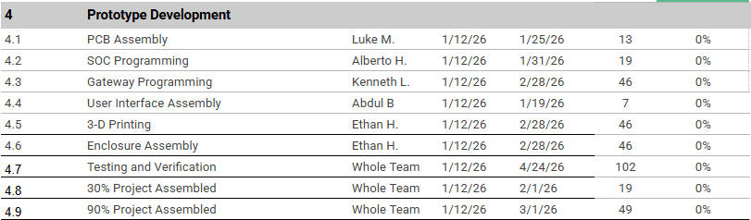
Figure 18: Project Plan/Gantt Chart for SD2

For the electrical work Luke M. and Abdul B. will begin assembling the PCB as well as working on the interface at the start of the semester and should finish the completion of the PCB board by the end of February (2/25/2026). There will be revisions that will most likely be needed and that are accounted for in the timeline.

On the computer side of the project, Alberto H.will begin the programming for the SOC while Kenneth L. works on programming the gateway at the beginning of the semester. Kenneth L. works should be completed around the end of February (1/31/2026), while Alberto H. should be completed with his work around the mid to late March (3/20/2026).

The mechanical work will be completed by Ethan H. where he will begin at the start of the semester and should be finished at the end of February (2/28/2026). This work will include 3-D printing and the enclosure assembly.

The testing and verification of the project itself should be completed close to late April to allow time before the design expo. The entire team will be working on this part of the project together to reach the finalization of the project. This process will throughout the entire semester starting from 1/12/2026 to 4/24/2026, which will leave about 1 to 2 weeks before the project is presented at the expo, at the beginning of May (5/1/2026), allowing for the project to be reviewed as well as checked beforehand. The full verification and test plan to be executed in Senior Design 2 is attached as Appendix [A].

Conclusions
Our senior design project, assigned and guided by Qorvo, demonstrates significant strides in developing an interactive replicable RF device that will promote future research and interest in RF technology at UNC Charlotte as well as Qorvo’s QPG26200L SoC. During the first semester, we were successfully able to design a device that can communicate over a mesh network through 2 unique protocols. The device can be replicated and houses various interactive components utilizing 3 unique peripherals from the QPG6200L. All designs were completed following engineering standards and best practices. The finalized design fell within the allotted budget, physical dimension, and technological constraints determined by our industry sponsors.

This project demonstrated our team's ability to overcome complex design challenges such as implementing an F-Inverted antenna onto the PCB, and selecting comparable components for the speaker circuit.

Upon completion of this project in the upcoming semester, a complex network of functional devices will be presented that communicate to each other and offer users with an interactive environment to explore the unique subject of radio frequency. With our team on track to begin the next phase of our project, we are confident in our ability to deliver functional replicated devices that meet Qorvo’s standards.

References
- “QPG6200L - Qorvo,” Qorvo - Low-Power Multi-standard Wireless SoC. https://www.qorvo.com/products/p/QPG6200L
- “EW840E5N, Open Source BLE 5.2/Thread/Zigbee to Ethernet, WiFi gateway — Fanstel,” Fanstel. https://www.fanstel.com/buy/ew840e5p
- Thingsboard, “ThingsBoard — open-source IoT (Internet of things) platform,” ThingsBoard. https://thingsboard.io/
- “QPG6200LDK-01 - Qorvo, IoT Dev Kit for QPG6200L. https://www.qorvo.com/products/p/QPG6200LDK-01
- IEEE Standards Association. (2005). IEEE 802.15.1-2005: Wireless Medium Access Control (MAC) and Physical Layer (PHY) Specifications for Wireless Personal Area Networks (WPANs). Retrieved October 16, 2025, from https://ieeexplore.ieee.org/document/1490827
- IEEE Standards Association. (2020). IEEE 802.15.4-2020: Low-Rate Wireless Networks. Retrieved October 16, 2025, from https://standards.ieee.org/ieee/802.15.4/7029/.
- Connectivity Standards Alliance. (2024). Matter Specification Version 1.4. Retrieved October 16, 2025, from https://csa-iot.org/wp-content/uploads/2024/11/24-27349-006_Matter-1.4-Core-Specification.pdf.

Appendices
[A]
TITLE: QORVO_RADIO2_Plan_Rev_A .xlsx
AUTHOR: Luke Matthews
FILE LOCATION: SD1_QORVO_RADIO2_F25/REPORTS/DOCUMENTS

[B]
TITLE: Parts List
AUTHOR: Alberto Hernandez
FILE LOCATION: SD1_QORVO_RADIO2_F25/Bill of Materials and Budget

[C]
TITLE: QORVO_RADIO2_PerformanceSpec_and_SOW.docx
AUTHOR: QORVO_RADIO2 Team
FILE LOCATION: SD1_QORVO_RADIO2_F25/REPORTS/DOCUMENTS

[D]
TITLE: Main PCB Logic Design
AUTHOR: Luke Matthews
FILE LOCATION: SD1_QORVO_RADIO2_F25/Research/Electrical

[E]
TITLE: QORVO_RADIO2_pcb
AUTHOR: Luke Matthews
FILE LOCATION: QORVO_RADIO2/electrical/hardware/schematics

[F]
TITLE: QORVO_RADIO2_sch
AUTHOR: Luke Matthews
FILE LOCATION: QORVO_RADIO2/electrical/hardware/schematics

[G]
TITLE: IoT Protocol Logic Diagram
AUTHOR: Kenneth Le
FILE LOCATION: SD1_QORVO_RADIO2_F25/Drawings

[H]
TITLE: HardwareDiagrams
AUTHOR: Alberto Hernandez
FILE LOCATION: SD1_QORVO_RADIO2_F25/Drawings

[I]
TITLE: 3D-Printed Enclosure Design
AUTHOR: Ethan Hartman
FILE LOCATION: QORVO_RADIO2/Mechanical

[J]
TITLE: MovementDetector
AUTHOR: Alberto Hernandez
FILE LOCATION: QORVO_RADIO2/Computer/Software/Firmware

[K]
TITLE: LED_Blink
AUTHOR: Alberto Hernandez
FILE LOCATION: QORVO_RADIO2/Computer/Software/Firmware

