SD1_QORVO_RADIO2_F25/S26
Project – Progress Report 2

Date | Revision | Author | Comments
2025-10-13 | Initial | QORVO_RADIO2 - Full Team | Initial Draft
2025-10-17 | Final | QORVO_RADIO2 - Full Team | Final

Table of Contents

1 Objective [B] 1
2 Work Completed 1
3 Issues that Need Immediate Assistance 3
4 Plans for the Remainder of Semester [A] [B] 4
5 Budget and Purchasing 5
6 Communication with Faculty Mentor and Supporter 5
7 References 5
8 Appendices 5

Objective [B]

The objective for the project is to design and construct a multi protocol radio frequency device for Qorvo Inc. The device will be designed with a Qorvo devkit, and it will be able to control several devices remotely through transmitting and receiving signals in a frequency range of 2.4GHz-2.5GHz [4]. Once completed, the project will be demonstrated at the senior design expo, and after it will be used by both UNC Charlotte to promote radio frequency (RF) education and Qorvo to use as marketing for their radio devices.

Work Completed
This section details the design progression, divided into mechanical, electrical, computer, and overall project milestones.
Mechanical Aspects Completed:
- Developed conceptual mechanical designs for device enclosures (2.5”x2.5” PCBs housed in 3D-printed PLA plastic, varying per device: Doorbell, Movement Sensor, Lighting System, Microphone) and a display base (plastic case with 3D-printed inserts, dimensions 15.5”x17.875”x7.375”). Created a case layout diagram to ensure portability (devices <3"x3"x3" and <0.5 lbs) (See Figure 1 for the case layout diagram).
Electrical Aspects Completed:
- Performed research and designed the components, symbols, and footprints for the QPG6200L [1].
- The components that were made were split into parts and calculations as well as size and arrangements on where each symbol would be placed were done during this process.
- The circuit design was split into 2 parts, Luke M. worked on the microphone, power supply, J-link, and the audio speaker. Abdul B. was tasked with the chip antennas, doorbell button, ultrasonic sensor, and LED lighting system connections.
- Research was done by both team members to best decide which components would be best to use. This research was then implemented into the design to figure out which components would be best for both the budget and device configuration.
- Both team members completed the circuit design Wednesday, 10/08/2025, and will complete the footprints for the PCB by 10/17/2025.
- The finished design for the PCB will be done by 10/29/2025.
Computer Aspects Completed:
- Conducted initial planning focusing on the software requirements for the network of remote devices
- Evaluated and selected the user interface: ThingsBoard, an open-source IoT platform with customizable dashboards for device management, data visualization, and rule based automation [3].
- Evaluated and selected the gateway: EW840E5N, supporting multi-protocol bi-directional communication and mesh topology for Bluetooth, Zigbee, and Thread [2].
- Analyzed the standards including IEEE 802.15.1 for Bluetooth, IEEE 802.15.4 for Zigbee/Thread, and Matter Protocol for secure, interoperable smart devices [5] [6] (See Table 1 for analyzed standards).
- Developed decision matrices for user interface Chosen UI (ThingsBoard) for minimal development effort, scalability, and IoT protocol integration.
- Ongoing planning for firmware development and web-based control of peripherals
Overall Project Milestones Completed:
- Conducted research on topics provided by Qorvo sponsors as well as other materials at team members’ discretion. This additional research was used to finish and submit the final Statement of Work (SOW) on September 12th, as well as to document additional standards that the project needed to follow. This research was completed by September 12th.
- After research was concluded and a final SOW was submitted and approved, the team began the conceptual design phase for all electrical, mechanical and computer work. Work on the IoT Application Demonstration was prioritized. The conceptual design work was completed by September 26th. During this same time frame the team developed concepts for various demonstrations that could be performed at the expo to showcase the SoC’s capabilities. The chosen demonstration is an interactive entryway system, enabling user interaction via push buttons, motion sensors, and audio devices for bi directional communication.
- From September 15th-18th the team met and constructed a decision matrix to assist in determining our technical approach that was showcased at the Conceptual Design Review (CDR). A bill of materials was prepared from September 18th-26th. From September 22nd-26th the team met, prepared, and practiced for the CDR. All CDR material was submitted by September 26th. The team lead communicated with the project’s mentors and sponsors to coordinate a CDR presentation time.

Table 1: Engineering Standards
Standard | Description | Application in Project
IEEE 802.15.1 | Bluetooth/BLE for short-range wireless communication | Enables low-energy transmission in remote modules.
IEEE 802.15.4 | Foundation for Zigbee/Thread low-power mesh networking | Supports mesh topology and bi-directional communication.
Matter Protocol | Application layer for secure, interoperable smart devices | Ensures secure control via web interface on top of Thread/Zigbee.
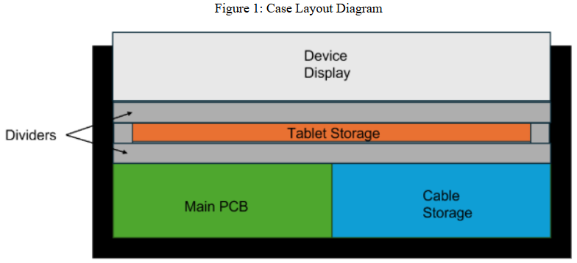

3 | Project Design
3.1 | PCB Design | Luke M. | 9/29/25 | 10/29/25 | 30 | 80%
3.2 | Enclosure Design | Ethan H. | 9/29/25 | 10/29/25 | 30 | 20%
3.2.1 | IoT Protocol Logic | Kenneth L. | 9/29/25 | 10/29/25 | 30 | 0%
3.2.2 | UI Flow | Alberto H. | 9/29/25 | 10/29/25 | 30 | 0%
3.3 | Prepare and practice CDR presentation | Whole Team | 10/29/25 | 11/7/25 | 8 | 0%
3.3.1 | PDR | Whole Team | 11/7/25 | 11/7/25 | 0 | 0%
3.4 | Parts Order | Ethan H. | 11/7/25 | 12/4/25 | 27 | 0%
4 | Prototype Development
4.1 | PCB Assembly | Luke M. | 1/12/26 | 2/28/26 | 46 | 0%
4.2 | SOC Programming | Alberto H. | 1/12/26 | 3/20/26 | 68 | 0%
4.3 | Gateway Programming | Kenneth L. | 1/12/26 | 2/28/26 | 46 | 0%
4.4 | User Interface Assembly | Abdul B | 1/12/26 | 1/19/26 | 7 | 0%
4.5 | 3-D Printing | Ethan H. | 1/12/26 | 2/28/26 | 46 | 0%
4.6 | Enclosure Assembly | Ethan H. | 1/12/26 | 2/28/26 | 46 | 0%
4.7 | Testing and Verification | Whole Team | 1/12/26 | 4/24/26 | 102 | 0%
4.8 | 30% Project Assembled | Whole Team | 1/12/26 | 2/1/26 | 19 | 0%
4.9 | 90% Project Assembled | Whole Team | 1/12/26 | 3/1/26 | 49 | 0%

Issues that Need Immediate Assistance

This section highlights any problems or areas where support from faculty mentors, sponsors, or course instructors is required. It also notes approved engineering changes. These items go beyond normal project development tasks and represent areas where external assistance is needed.
- Plans & Use for the SDR
  - More information about the issues & revisions that need to be made from the previous semester SDR design will be obtained from Qorvo member, Jed Sander

Plans for the Remainder of Semester [A] [B]
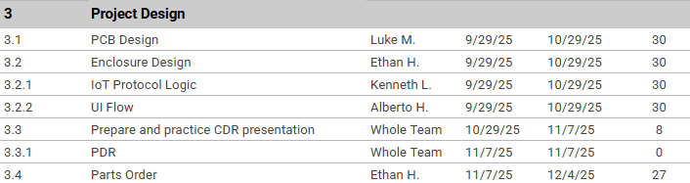

For the electrical scope of work Luke M. and Abdul B. will complete the footprint design of their individual subcircuits by 10/17/2025. The footprints and symbols of the subcircuits will be compiled together and a completed multilayer PCB design will be completed by 10/29/2025.
Luke M. and Abdul B. will work closely with Ethan H. to determine all electrical components that will be mounted to the printed enclosure. Proper documentation with component dimensions will be handed over to Ethan H. as well as any additional specifications needed to fulfill the mechanical scope of work. The CAD enclosure design will be completed by 10/29/2025.
For the computer scope of work, Kenneth L. and Alberto H. will learn to use the gateway UI software and understand the programming workflow for the QPG6200L by 10/24/2025. This includes activating and configuring the necessary peripherals, setting up RF communication, and exploring mesh topology implementation. They will also learn to code and test the supported wireless protocols to ensure proper device communication.
All developed code, configuration files, and documentation will be compiled and shared with the electrical and mechanical teams to ensure full integration with the PCB and enclosure design.
From 10/29/2025 - 11/07/2025, the team will meet and construct a presentation of our final design that will be showcased at the PDR (Preliminary Design Review). A revised bill of materials will be prepared from 10/29/2025 - 11/07/2025. During this time period the team will meet, prepare, and practice for the PDR. All PDR material will be submitted by 11/07/2025. The team lead will communicate with the project's mentor and sponsors to coordinate a PDR presentation time.

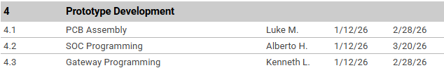

From 01/12/2025 - 02/28/2025 Luke M. and Abdul B. will assemble the PCB. Components will be soldered on in the ISL lab.
From 01/12/2025 - 02/28/2025 Alberto H. will lead the development of SOC programming. During this same time period Kenneth L. will lead the development of Gateway programming.

Budget and Purchasing

Category | Item | Quantity | Unit Price | Subtotal | Notes
Mechanical | Plastic Case | 1 | 72.00 | 72.00 | Enclosures for remote devices
Mechanical | PLA Filament | 1 | 24.00 | 24.00 | For 3D printing custom parts
Mechanical | M3 Inserts | 1 | 18.00 | 18.00 | Threaded inserts for assembly
Mechanical | M3 Bolts | 1 | 24.00 | 24.00 | Fasteners for enclosures
Mechanical Subtotal |  |  |  | 138.00
Electrical | Doorbell | 6 | 3.00 | 18.00 | For remote sensing use case
Electrical | Ultrasonic Sensor | 6 | 36.00 | 216.00 | Distance/proximity sensors
Electrical | LED Strip | 1 | 53.00 | 53.00 | For lighting control demo
Electrical | Microphone | 6 | 0.50 | 3.00 | For remote microphone use case
Electrical | Speaker | 2 | 28.00 | 56.00 | Audio output peripherals
Electrical | DAC | 6 | 4.25 | 25.50 | Digital-to-analog converters
Electrical | Audio Amplifier | 6 | 0.60 | 3.60 | For speaker amplification
Electrical | J-Link | 1 | 960.00 | 960.00 | Debugging tool for QPG6200L )
Electrical | J-Link Adapter | 1 | 50.00 | 50.00 | Adapter for J-Link
Electrical | Batteries | 20 | 0.82 | 16.40 | Coin cell for remote devices
Electrical | Battery Holder | 20 | 1.63 | 32.60 | Holders for batteries
Electrical | Door Lock | 1 | 203.99 | 203.99 | For smart lock demo
Electrical | PCB | 1 | 365.00 | 365.00 | Custom PCB for 6 assemblies
Electrical | Antenna | 12 | 13.30 | 159.60 | For RF connectivity
Electrical | QPG6200L | 10 | 4.68 | 46.80 | For RF connectivity
Electrical Subtotal |  |  |  | 2,209.49
Computer | EW840E5N Gateway | 1 | 114.62 | 114.62 | Multi-protocol (BLE/Thread/Zigbee) to WiFi/Ethernet
Computer | PK-LEW840X Programmer | 1 | 36.00 | 36.00 | Required for gateway programming
Computer | Lenovo Tab M10 Plus 3rd Gen | 1 | 228.00 | 228.00 | Display the user sees
Computer Subtotal |  |  |  | 378.62
Grand Total (With 20% Safety Factor) |  |  |  | 2,726.11 | Covers all hardware for IoT demos, enclosures, and control

Communication with Faculty Mentor and Supporter

Microsoft Teams meetings with the industry supporters have been conducted weekly on either Wednesday or Friday and the weekly emails with the industry supporters have been sent out on Fridays detailing weekly events. These weekly meetings will continue throughout the remainder of the project to ensure proper communication for progression.
Meetings with the team mentor(s) have also been conducted weekly, both in person or online Zoom meetings. These weekly mentor meetings will also continue throughout the remainder of the project to ensure that the mentors are up-to-date.
These meetings and email correspondence will continue to be maintained throughout the duration of the project. See Appendix [C] for samples.

References

- “QPG6200L - Qorvo,” Qorvo - Low-Power Multi-standard Wireless SoC. https://www.qorvo.com/products/p/QPG6200L
- “EW840E5N, Open Source BLE 5.2/Thread/Zigbee to Ethernet, WiFi gateway — Fanstel,” Fanstel. https://www.fanstel.com/buy/ew840e5p
- Thingsboard, “ThingsBoard — open-source IoT (Internet of things) platform,” ThingsBoard. https://thingsboard.io/
- “QPG6200LDK-01 - Qorvo, IoT Dev Kit for QPG6200L. https://www.qorvo.com/products/p/QPG6200LDK-01
- IEEE Standards Association. (2005). IEEE 802.15.1-2005: Wireless Medium Access Control (MAC) and Physical Layer (PHY) Specifications for Wireless Personal Area Networks (WPANs). Retrieved October 16, 2025, from https://ieeexplore.ieee.org/document/1490827
- IEEE Standards Association. (2020). IEEE 802.15.4-2020: Low-Rate Wireless Networks. Retrieved October 16, 2025, from https://standards.ieee.org/ieee/802.15.4/7029/.
- Connectivity Standards Alliance. (2024). Matter Specification Version 1.4. Retrieved October 16, 2025, from https://csa-iot.org/wp-content/uploads/2024/11/24-27349-006_Matter-1.4-Core-Specification.pdf.

Appendices

[A]
TITLE: ProjectPlan .xlsx
AUTHOR: Luke Matthews
FILE LOCATION: SD1_QORVO_RADIO2_F25/REPORTS/DOCUMENTS

[B]
TITLE: QORVO_RADIO2_PerformanceSpec_and_SOW
AUTHOR: Luke Matthews
FILE LOCATION: SD1_QORVO_RADIO2_F25/REPORTS/DOCUMENTS

[C]
TITLE: Email Correspondence
AUTHOR: Ethan Hartman
FILE LOCATION: SD1_QORVO_RADIO2_F25/Email Correspondance

[D]
TITLE: QORVO_RADIO2_CDR.pptx
AUTHOR: QORVO_RADIO2 Team
FILE LOCATION: SD1_QORVO_RADIO2_F25/Presentations

