SD2_QORVO_RADIO2_F25/S26
Project – Progress Report

Date | Revision | Author | Comments
2026-03-26 | Initial | QORVO_RADIO2 - Full Team | Original Document
2026-04-02 | REV A | QORVO_RADIO2 - Full Team | Revisions

Table of Contents

1 Objective 1
2 Work Completed 2
Electrical Work Completed 2
Antenna Filter Circuit Tuning 2
Trace Width Calculations 5
Audio Amplifier Redesign 6
J-Tag Connection Revision 8
Power Supply Redesign 10
Testing/Verification and Assembly Documentation [G] [H] 10
Computer Work Completed 11
Firmware Development 12
IoT Gateway Stack [A] 13
Node-RED Dashboard [B] 14
Mechanical Work Completed 14
3 Issues that Need Immediate Assistance 15
4 Future Plans [I] 15
5 Budget and Purchasing [J] 17
6 Communication with Faculty Mentor and Supporter 18
7 References 18
8 Appendices 19

Objective

The objective for the project is to design and construct a multi protocol radio frequency device for Qorvo Inc. The device will be designed with a Qorvo devkit, and it will be able to control several devices remotely through transmitting and receiving signals in a frequency range of 2.4GHz-2.5GHz. Once completed, the project will be demonstrated at the senior design expo, and after it will be used by both UNC Charlotte to promote radio frequency (RF) education and Qorvo to use as marketing for their radio devices.

Work Completed

Electrical Work Completed
The electrical hardware design is currently preparing for and awaiting the arrival of the 3rd rendition of boards, QORVO_RADIO2_REV2. The current boards on hand, QORVO_RADIO2_REV1, are 90% assembled with limited functionality. The 3rd rendition of boards include revisions and redesigns to the antenna circuit, power supply, audio amplifier, and J-Tag circuit. Intense testing was performed across all sub circuits to ensure functionality for the 3rd rendition of boards. All testing was documented utilizing a custom made assembly and testing verification document.

Antenna Filter Circuit Tuning
The fabricated antenna filter circuit was tested utilizing the NanoVNA, allowing data such as smith chart plots, impedance, reflection, and return loss to be pulled from the existing circuit. The initial filter topology was designed and fabricated with values acquired from the QPG6200L’s datasheet.
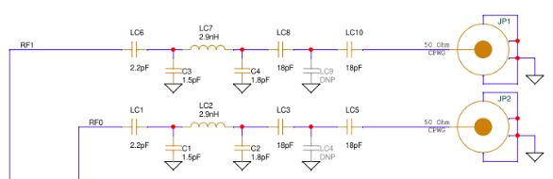
Figure 1: QPG6200L Filter Design

This filter was recreated in KiCad and utilized for the first renditions of the PCB design. The NanoVNA was utilized to test the S11 Impedance, Return Loss, VSWR, and other variables at the 2.4 GHz to 2.5 GHz frequency band. The following figures display this data.

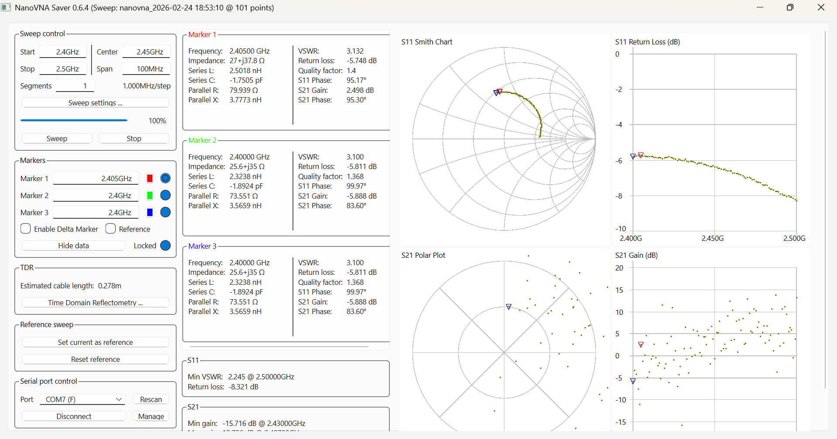
Figure 2: NanoVNA Table 1

Figure 3: NanoVNA Table 2


Figure 4: NanoVNA Return Loss Plot

Figure 5: NanoVNA Smith Chart Plot

The Circuit was then reconstructed in ADS to tune the Impedance and return loss to the desired specifications.
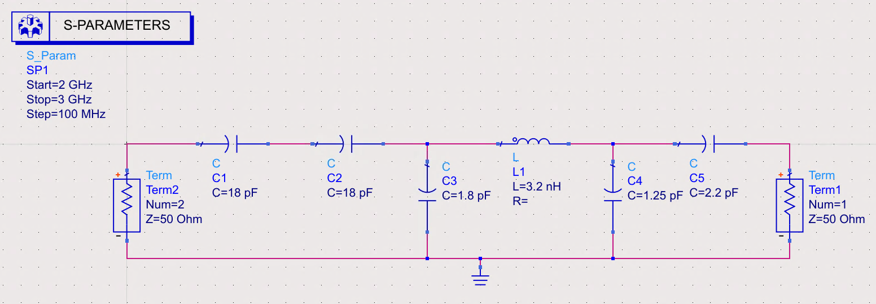
Figure 6: ADS Filter redesign

The following circuit was then simulated and the following Impedance and Return loss were obtained.

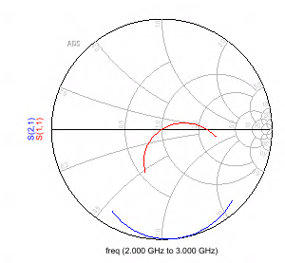
Figure 7: ADS Impedance Plot

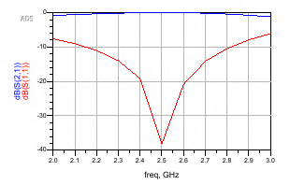
Figure 8: ADS Return Loss Plot

The L1 inductor and C4 capacitor were altered to achieve the near 50 Ohm S11 impedance and -38 dB Return loss at 2.5 GHz.

Trace Width Calculations
The trace widths for the antenna circuit were initially calculated to meet JLC PCB manufacturing specifications. After the last minute switch to OSH Park the recalculation of trace widths was missed for the first 2 board orders. The trace widths were recalculated using the KiCad trace width calculator tool.

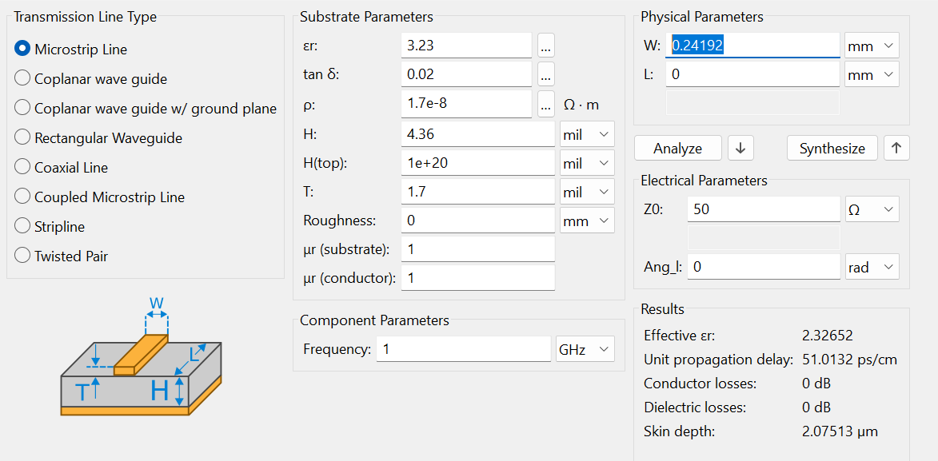
Figure 9: KiCadTrace Width Calculator

Audio Amplifier Redesign
The designed audio amplifier circuit utilized the 595-TPA2034D1YZFT from TI. This IC utilized a WCSP with WCSP balls for pad connection. The pads required for these balls are smaller than the team's chosen manufacturer (OSH Park) can manufacture. Therefore a new audio amplifier was found that meets OSH Parks manufacturing specifications as well as the circuit requirements.
The LM48511 was selected for its power output, output impedance, package type, and package size. The following circuit was recreated in KiCad schematic editor matching the manufactures datasheet recommendations.
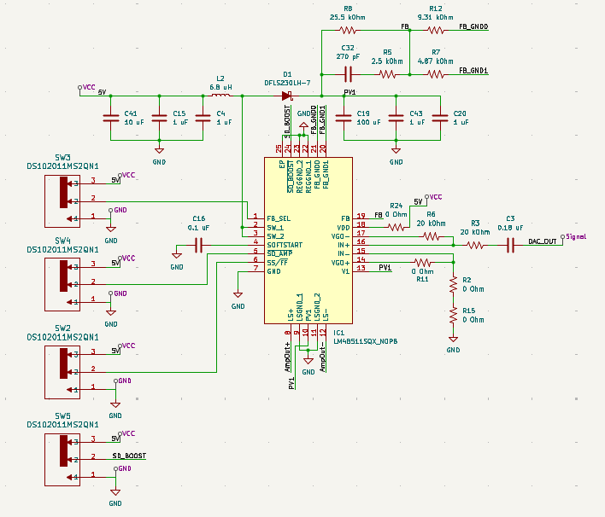
Figure 10: Audio Amplifier Redesign

The LM48511 features 2 independent shutdown controls, SD_AMP for the Class D amplifiers, and SD_BOOST for the regulator. These inputs can be driven low to disable the corresponding parts of the IC. These pinouts do not require pulldown/pullup resistors.
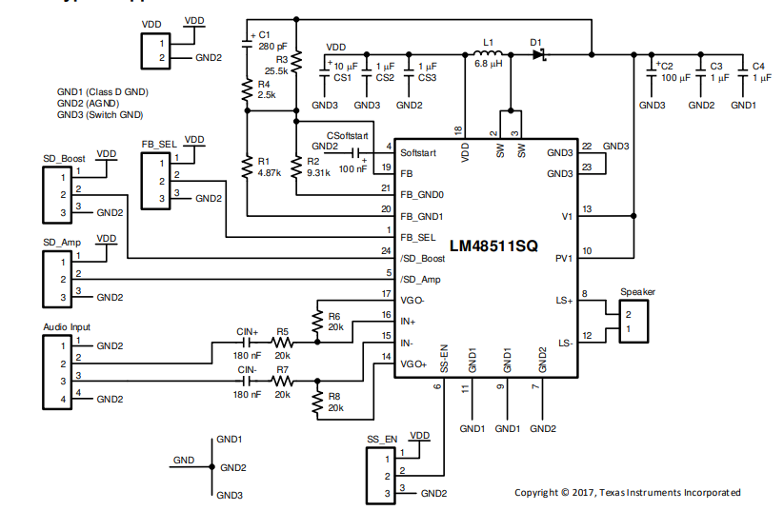
Figure 11: Manufacturer Circuit Layout

J-Tag Connection Revision
The initial board design (QORVO_RADIO2_REV0) utilized the following footprint layout for the 10 position header.
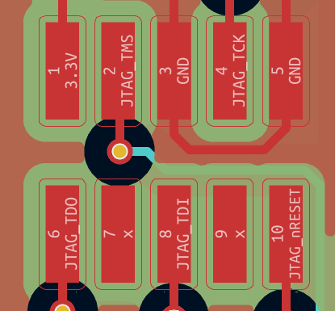
Figure 12: QORVO_RADIO2_REV0 J-Link Connector Header Footprint

This footprint layout did not match the pinout for the J-Link EDU mini as referenced in the figure below.
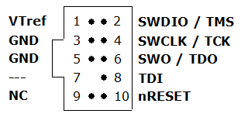
Figure 13: Segger J-Link EDU Mini Connector Pinout

This footprint was revised in QORVO_RADIO2_REV1 as shown below.
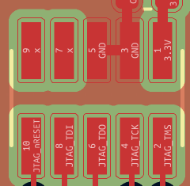
Figure 14: QORVO_RADIO2_REV1 J-Link Connector Header Footprint

After ordering QORVO_RADIO2_REV1, an issue with the QPG6200L pinout for programming was found. The GPIO5/PROG_ENn pin, utilized to put the QPG6200L into program mode, was left unconnected “floating” state. This pin must be in a low state to enable “programming mode”.
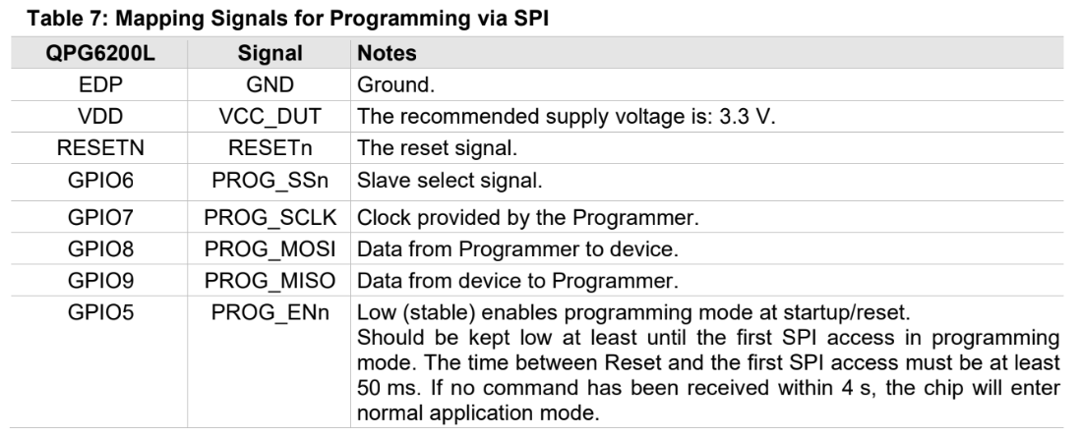
Figure #: QPG6200L datasheet Table 7

A 330Ω resistor was connected in series between GND and the switch for a low GND connection for state 1. A 1kΩ resistor was connected between 3.3V and the switch for a high connection for state 2. A pad for a 0603 component was placed in parallel with the switch and resistor in case the circuit needs bypassing.

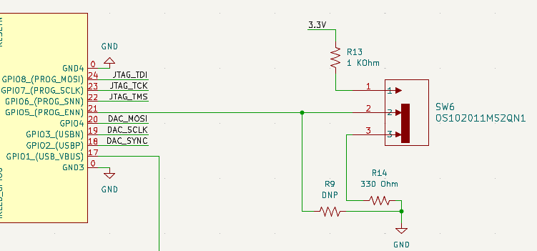
Figure #: PROG_ENn Connection to QPG6200L

Power Supply Redesign
The chosen power supply CR2032 from Murata Electronics supports the voltage and mAh specifications when connected in series but does not support the constant amp draw specification. An alternative power supply was sourced and implemented to ensure remote device functionality.
The UBBP-01 was selected as a solution for its size, maximum continuous current draw, mAh, and voltage specifications. Like the coin cell batteries, two UBBP-01 cells will need to be connected in series to achieve the desired voltage of 6V or more.

Testing/Verification and Assembly Documentation [G] [H]
For testing and assembly, documentation was conducted on both versions of the board. These testing methods and assembly steps will be performed again for the second revision of the boards. Within the testing and assembly documentation, the steps taken for the respective processes were put in order. These steps can be observed through the excel sheets for both the testing and verification, as well as assembly procedures.

PCB Assembly[G]
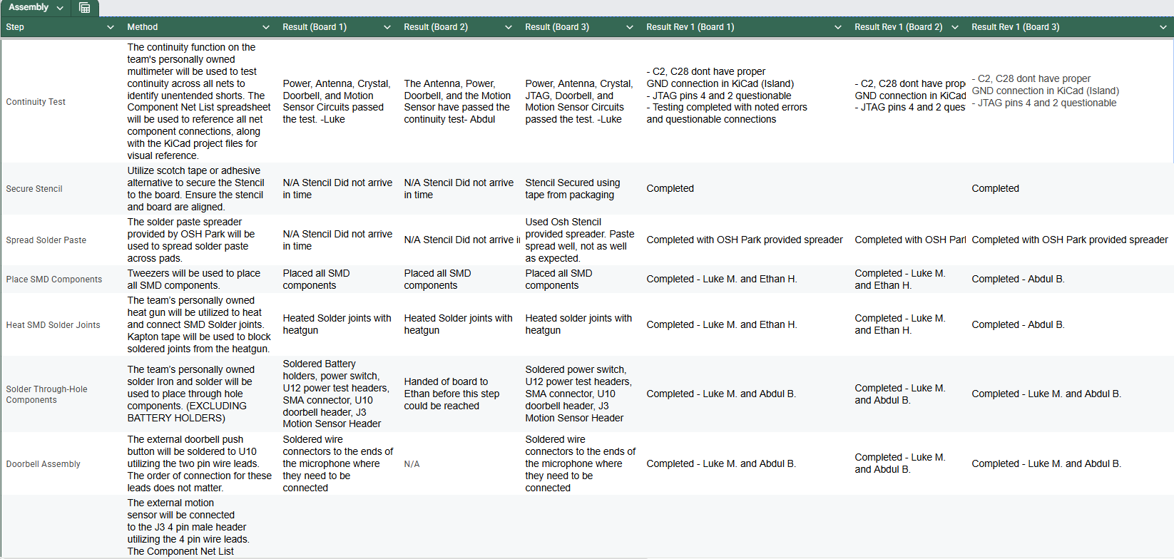
PCB Testing[H]
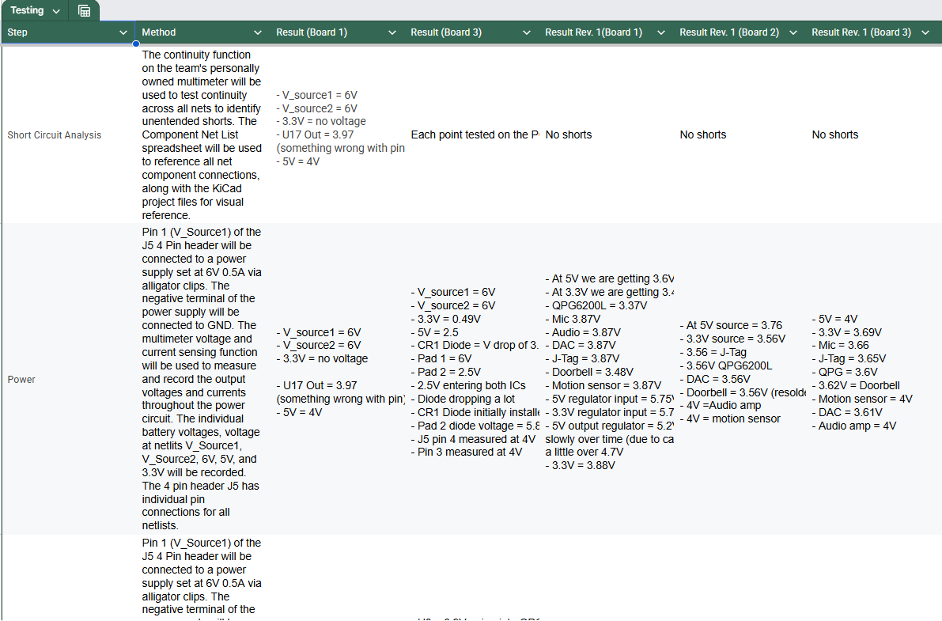

Computer Work Completed
The computer and software development for this project spans three primary areas: firmware development for the Qorvo QPG6200L System-on-Chip (SoC), Internet of Things (IoT) gateway stack configuration on the Raspberry Pi 4, and the Node-RED Dashboard 2.0 user interface. All firmware is written using the Qorvo qpg6200-iot-sdk inside a Visual Studio Code development container running Docker.

Firmware Development
Two complete firmware applications have been developed and verified on the QPG6200L Development Kit (QPG6200LDK-01). Both applications combine Bluetooth Low Energy (BLE) for initial device commissioning with OpenThread for mesh network communication, running concurrently on a single QPG6200L chip.
The first application, ThreadBleDoorbell_DK, implements a doorbell using the development kit's built-in PB2 push button on GPIO 5. The button is configured as active-low with an internal pull-up resistor. The firmware polls the button state every 50 milliseconds and applies a 3-sample debounce filter, requiring 150 ms of consistent readings before registering a state change. On a valid button press, the firmware transmits a 4-byte User Datagram Protocol (UDP) multicast packet to the mesh-local multicast address ff03::1 on port 5683. The payload structure consists of a message type byte (0x02 for doorbell), a ring state byte, and a 2-byte big-endian ring count representing the total number of presses since boot. [D]
The second application, ThreadBleMotionDetector_MaxSonar, interfaces with an LV-MaxSonar EZ series ultrasonic distance sensor via Universal Asynchronous Receiver-Transmitter 1 (UART1) at 9600 baud, 8N1. The sensor's TX pin connects to GPIO 8 (UART1 RX) and its RX pin connects to GPIO 9 (UART1 TX). The sensor outputs ASCII serial frames in the format R###\r, where ### represents the distance in inches. The firmware converts this to centimeters and declares motion when an object is detected within 200 cm. To reduce unnecessary network traffic, UDP multicast packets are only transmitted on state changes when motion is first detected or when motion clears rather than on every sensor reading. The motion event payload uses message type 0x01 with a motion state byte and a 2-byte big-endian distance value in centimeters. [E]
Both firmware applications support BLE commissioning, where a smartphone running nRF Connect or Qorvo Connect connects to the device over BLE and provisions Thread network credentials through a custom Generic Attribute Profile (GATT) service. The configurable credentials include the Thread Network Name (up to 16 bytes UTF-8), a 16-byte Network Key, the channel number (11–26), and the Personal Area Network Identifier (PAN ID, 2 bytes little-endian). Once written, a Join characteristic is set to 0x01 to initiate the Thread network join process. All credentials are stored in Non-Volatile Memory (NVM) so the device automatically rejoins the Thread network on subsequent power cycles without requiring BLE commissioning again. A factory reset is available by holding the PB1 button for 5 seconds or longer, which clears stored credentials and reboots the device.
Each firmware application is built inside the development container using the command make -f Makefile.[ProjectName]_qpg6200 all, which produces a signed .hex firmware image merged with the bootloader. Flashing is performed using the SEGGER J-Link Commander over the Serial Wire Debug (SWD) interface with the following sequence: device QPG6200, si SWD, speed 4000, connect, erase, loadfile [path].hex, r, g, exit. To enter SWD Debug Mode, the PROG_ENn pin (GPIO 5) is held LOW for approximately 1 second after reset and then released HIGH.

IoT Gateway Stack [A]
The IoT gateway was built on a Raspberry Pi 4 Model B to bridge the Thread mesh network to a local area network (LAN) and serve the monitoring dashboard. A TRENDnet TEW-827DRU AC2600 dual-band wireless router was configured to provide a private LAN on the 192.168.10.x subnet. This private network was necessary because the university WiFi enforces client isolation, which prevents device-to-device communication required for the gateway to receive Thread mesh traffic. The Raspberry Pi's MAC address (88:a2:9e:84:96:c1) was reserved at a static IP of 192.168.10.102.
The Raspberry Pi requires an external IEEE 802.15.4 radio to communicate with the Thread mesh network. A Nordic Semiconductor nRF52840 USB dongle was flashed with OpenThread Radio Co-Processor (RCP) firmware to serve this role. The RCP architecture means the dongle handles only low-level radio transmit and receive operations while the Raspberry Pi runs the full Thread networking stack, providing maximum flexibility. The RCP firmware was built on a Dell Latitude 7280 laptop running Ubuntu Linux by cloning the OpenThread nRF528xx repository, cross-compiling with the ARM GNU toolchain (gcc-arm-none-eabi), converting the output binary to Intel HEX format using arm-none-eabi-objcopy, packaging it as a Device Firmware Update (DFU) file with nrfutil, and flashing it to the dongle via USB DFU bootloader. Once flashed, the dongle was connected to the Raspberry Pi where it is detected as /dev/ttyACM0 and communicates using the Spinel binary protocol over USB serial.
OpenThread Border Router (OTBR) was installed on the Raspberry Pi by cloning the ot-br-posix repository from GitHub and executing the bootstrap and setup scripts with INFRA_IF_NAME=eth0 and WEB_GUI=1 to enable the web management interface. After installation, a Thread network was formed using ot-ctl commands to generate and commit an active dataset with the network credentials. The border router bridges IPv6 traffic between the Thread mesh interface (wpan0) and the Ethernet interface (eth0), allowing applications on the LAN to receive UDP multicast packets originating from the QPG6200L devices. The OTBR web interface was configured to listen on all network interfaces (0.0.0.0) rather than the default localhost binding, making it accessible from other devices on the LAN. [C]
Mosquitto, an open-source Message Queuing Telemetry Transport (MQTT) broker from the Eclipse Foundation, was installed on the Raspberry Pi and configured to listen on port 1883 across all network interfaces with anonymous access enabled. MQTT operates on a publish/subscribe model where devices publish messages to named topics and applications subscribe to those topics to receive updates. This decouples the sensor devices from the dashboard, allowing either side to be modified independently. [C]
The team originally planned to use a Fanstel EW840E5N gateway, but this was abandoned after discovering that the documentation and implementation was too complex for the time remaining to integrate the gateway. The Raspberry Pi with the nRF52840 dongle approach provided full control over the gateway stack. [K]

Node-RED Dashboard [B]
Node-RED 4.1.7, a visual flow-based programming tool originally developed by IBM, was installed on the Raspberry Pi using the official Linux installer script. The @flowfuse/node-red-dashboard v1.30.2 extension was installed through the Node-RED palette manager to provide Dashboard 2.0 functionality with real-time web-based user interface widgets. Node-RED is configured to start automatically on boot as a system service. [F]
The Node-RED flows receive incoming UDP multicast packets from the Thread mesh on port 5683, parse the 4-byte binary payload based on message type, convert the parsed data into MQTT messages, and display the results on the dashboard. Separate function nodes handle doorbell events (message type 0x02, extracting ring state and ring count) and motion detection events (message type 0x01, extracting motion state and distance in centimeters). The dashboard is accessible at http://192.168.10.102:1880/dashboard/page1 and is displayed on a laptop for the final demonstration at the senior design expo.
The full end-to-end data path has been verified with live data: QPG6200L devices are commissioned over BLE, join the Thread mesh network, transmit UDP multicast sensor events, which are received by the border router, forwarded to Node-RED, published to MQTT topics, and displayed on the dashboard in real time.

Mechanical Work Completed
The mechanical aspect of the project covers the enclosure and housing for electronics and devices. The enclosures are all made from 3D-printed PLA and held together by M3 bolts.
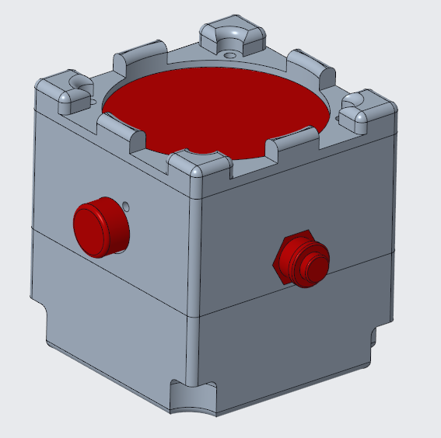
Figure 15: Mechanical Enclosure CAD Model

At this point all devices have been 3D-printed and the external devices have been mounted. These devices include the speaker, doorbell, and sonic sensor. The enclosures are awaiting the final rendition of the PCB boards to be fully complete.

The last redesign of the enclosures included the addition of a battery slot for the lithium-ion batteries. This was changed right before the PRP from coin cell batteries which were previously mounted directly to the board.

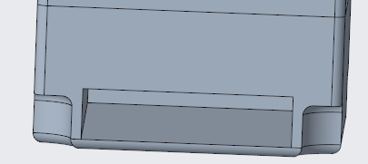
Figure 16: Enclosure Battery Slot

Issues that Need Immediate Assistance
With the delay of desired functionality from the PCB’s and inability to program existing boards key subcircuits have been identified that will require special consideration for the remainder of the semester. These subcircuits are the power, J-Tag, SOC, and antenna circuits. Each of these circuits are critical to board functionality, as a failure in one circuit will cause a board wide failure.
Contingencies have been made for the PROG-ENn SOC connection, such as a high state connection, and direct ground connection.
Boards assembly can be performed professionally at Qorvo’s site in Greensboro, this can be utilized if issues continue with SOC functionality and programming. Due to the current lab setup, chip package, and on campus resources, testing and securing the SOC is currently unideal. This has been identified as a possible failure point if the next revision is unfunctional.
Due to the power supply redesign, real world testing values have not been completed yet for the revised power supply circuit, if the new battery cells are nonfunctional an external power supply such as the ones from the lab may need to be used at expo. Acquiring one of these from the University should be investigated as a fall back due to unexpected failure.
A SMA connected antenna circuit was designed as a fallback for the F-Inverted antenna. From our current testing and results, this contingency works as intended.

Future Plans [I]

The next steps in the project are to 1, wait for the PCBs to arrive, and while that process is going on, brainstorming for the video will be conducted. Once video ideas have been discussed there will be more work put into that in order to make sure everything goes smoothly with that portion of the project. While that is going on, the computers will work on making sure all the bugs are worked out of the program and find ways to properly integrate everything together. Once the PCBs arrive, all members of the team will get together and assemble a board, one for each team member, and then once all assembly and testing is conducted and completed, the boards will be given to the computers to work on integration. Any alteration to the housing system for the PCBs will be handled by the mechanical member of the team. The team is in the final phase of the project, in this phase, tasks will be divided amongst each member, such as the project video and poster for the design expo. For the project video, 2 members will be spearheading front while working on their portions of the physical device. Once all the parts and components are received, the electrical members (Luke M. and Abdul B.) will begin assembling the PCBs. After assembly, testing, and verification is complete, the PCBs will be handed over to the computer members (Alberto H. and Kenneth L.) of the team where they will begin the integration process of everything. While all of this is happening, the mechanical team member (Ethan H.) will focus on the housing design and making sure it can meet the requirements of the PCB. This process is scheduled to be fully completed around mid to late April and will be presented on May 1st at the senior design expo.

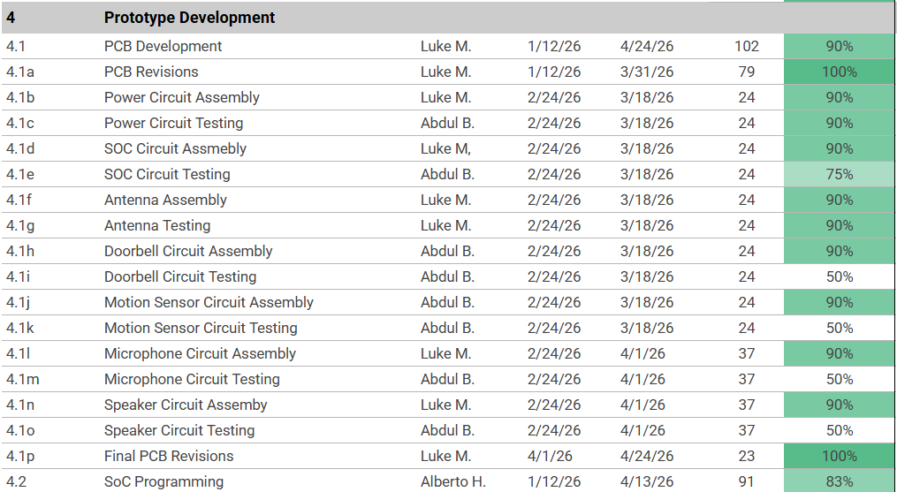
Figure 17: Project Plan [I]
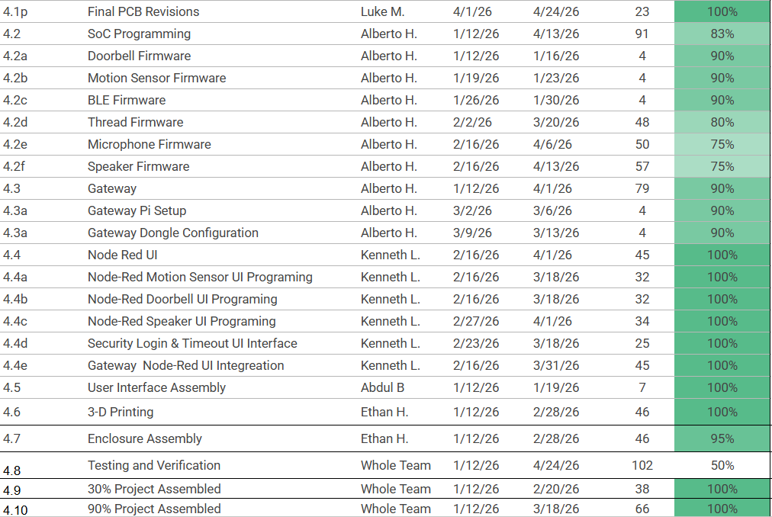
Figure 18: Project Plan [I]

Budget and Purchasing [J]

The starting budget for the project was $3,250. As of now all parts have been ordered totalling to $2,926.90 with $323.10 remaining. The remainder of the project will be used if any additional material needs to be purchased due to malfunctions or other errors. There is no concern about going over budget.

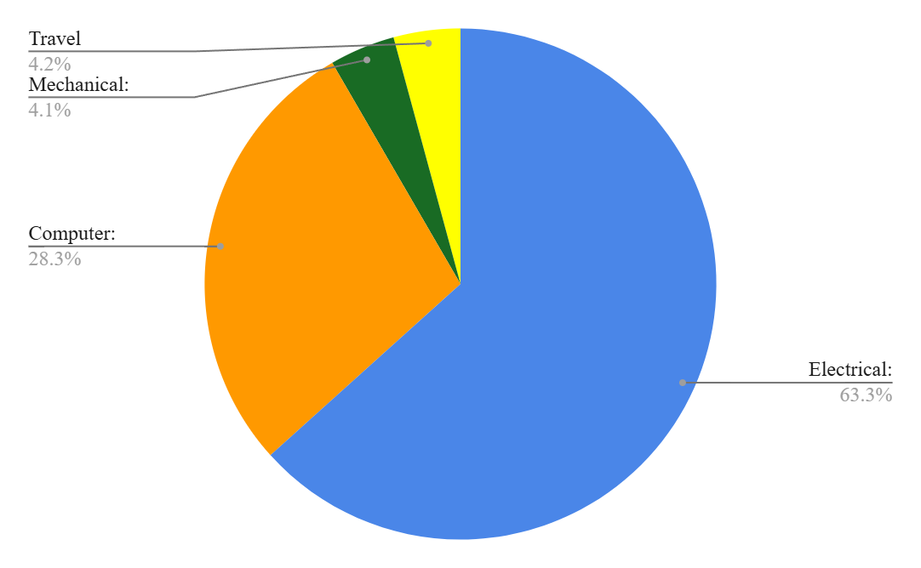
Figure 19: Budget Breakdown

At this point the only orders not received are a digikey order of components and the final round of PCB’s. These orders are expected to arrive within the next 1-2 weeks leaving plenty of time for assembly and testing.

The full budget breakdown is shown in Appendix J. The BOM is a rough estimate of each part as the ISL purchasing office gets discounts from their preferred vendors and does not provide price breakdowns for each order. The $2.926.90 is the true amount spent.

Communication with Faculty Mentor and Supporter

Weekly Microsoft Teams meetings with industry sponsors have been consistently conducted every Friday, accompanied by follow-up emails summarizing key discussions, progress updates, and action items. These meetings have proven to be highly effective in maintaining clear communication, aligning expectations, and gathering valuable feedback. As a result, this structured communication approach will be continued throughout the remainder of the project to support ongoing progress and iterative improvement.
In addition, the team has held regular weekly meetings with faculty mentors, primarily via Zoom. These sessions have served as an important platform for receiving guidance and reviewing deliverables, such as presentations and reports. Moving forward, these mentor meetings will continue to ensure that the project remains aligned with academic expectations and benefits from continuous expert feedback.
Furthermore, the team had the opportunity to conduct an in-person meeting at the sponsor’s workplace, Qorvo. During this visit, the team presented current project progress, engaged in technical discussions, and received direct feedback from industry professionals. The visit also included a facility tour, providing valuable insight into real-world applications and industry practices relevant to the project.

References
- "QPG6200L - Qorvo," Qorvo - Low-Power Multi-standard Wireless SoC. https://www.qorvo.com/products/p/QPG6200L
- "EW840E5N, Open Source BLE 5.2/Thread/Zigbee to Ethernet, WiFi gateway — Fanstel," Fanstel. https://www.fanstel.com/buy/ew840e5p
- "QPG6200LDK-01 - Qorvo," IoT Dev Kit for QPG6200L. https://www.qorvo.com/products/p/QPG6200LDK-01
- IEEE Standards Association. (2005). IEEE 802.15.1-2005: Wireless Medium Access Control (MAC) and Physical Layer (PHY) Specifications for Wireless Personal Area Networks (WPANs). Retrieved October 16, 2025, from https://ieeexplore.ieee.org/document/1490827
- IEEE Standards Association. (2020). IEEE 802.15.4-2020: Low-Rate Wireless Networks. Retrieved October 16, 2025, from https://standards.ieee.org/ieee/802.15.4/7029/
- Connectivity Standards Alliance. (2024). Matter Specification Version 1.4. Retrieved October 16, 2025, from https://csa-iot.org/wp-content/uploads/2024/11/24-27349-006_Matter-1.4-Core-Specification.pdf
- "OpenThread Border Router," OpenThread, Google. https://openthread.io/guides/border-router
- "Mosquitto — An Open Source MQTT Broker," Eclipse Foundation. https://mosquitto.org/
- "Node-RED — Low-code Programming for Event-driven Applications," OpenJS Foundation. https://nodered.org/
- "FlowFuse Node-RED Dashboard 2.0," FlowFuse. https://dashboard.flowfuse.com/
- "nRF52840 Dongle — PCA10059," Nordic Semiconductor. https://www.nordicsemi.com/Products/Development-hardware/nRF52840-Dongle
- "Raspberry Pi 4 Model B Specifications," Raspberry Pi Foundation. https://www.raspberrypi.com/products/raspberry-pi-4-model-b/
- "LV-MaxSonar-EZ Datasheet," MaxBotix Inc. https://maxbotix.com/pages/lv-maxsonar-ez-datasheet
- "TRENDnet TEW-827DRU AC2600 StreamBoost MU-MIMO WiFi Router," TRENDnet. https://www.trendnet.com/products/wifi/AC2600-StreamBoost-MU-MIMO-WiFi-Router-TEW-827DRU
- "SEGGER J-Link Debug Probes," SEGGER Microcontroller. https://www.segger.com/products/debug-probes/j-link/

Appendices
[A]
TITLE: IoT_Gateway_Stack_Complete_Documentation.pdf
AUTHOR: Alberto Hernandez
FILE LOCATION: QORVO_RADIO2/docs/IoT_Gateway_Stack_Complete_Documentation.pdf at main · alberto-hdz/QORVO_RADIO2
[B]
TITLE: NodeRED_Documentation.docx
AUTHOR: Alberto Hernandez
FILE LOCATION: QORVO_RADIO2/docs/NodeRED_Documentation.docx.md at main · alberto-hdz/QORVO_RADIO2
[C]
TITLE: IoT_Gateway_Documentation.docx
AUTHOR: Alberto Hernandez
FILE LOCATION: QORVO_RADIO2/docs/IoT_Gateway_Documentation.docx.md at main · alberto-hdz/QORVO_RADIO2
[D]
TITLE: ThreadBleDoorbell_DK
AUTHOR: Alberto Hernandez
FILE LOCATION: QORVO_RADIO2/Computer/Software/Firmware/ThreadBleDoorbell_DK at main · alberto-hdz/QORVO_RADIO2
[E]
TITLE: ThreadBleMotionDetector_MaxSonar
AUTHOR: Alberto Hernandez
FILE LOCATION: QORVO_RADIO2/Computer/Software/Firmware/ThreadBleMotionDetector_MaxSonar at main · alberto-hdz/QORVO_RADIO2
[F]
TITLE: flows.json
AUTHOR: Alberto Hernandez
FILE LOCATION: QORVO_RADIO2/Computer/NodeRedDashboardUI/flows.json at main · alberto-hdz/QORVO_RADIO2
[G]
TITLE: PCB Assembly
AUTHOR: Abdul Bah
FILE LOCATION: SD2_QORVO_RADIO2_S26/Reports/Documents/PCB Assembly, Test, and Operation/PCB Testing
[H]
TITLE: PCB Testing
AUTHOR: Abdul Bah
FILE LOCATION: SD2_QORVO_RADIO2_S26/Reports/Documents/PCB Assembly, Test, and Operation/PCB Testing
[I]
TITLE: ProjectPlan .xlsx
AUTHOR: QORVO_RADIO2 Team
FILE LOCATION: SD2_QORVO_RADIO2_S26/Reports/Documents/ ProjectPlan .xlsx
[J]
TITLE: PRP BOM
AUTHOR: Ethan Hartman
FILE LOCATION: SD2_QORVO_RADIO2_S26/Bill of Materials and Budget/PRP BOM
[K]
TITLE: EW840E5N Gateway Documentation
AUTHOR: Kenneth Le
FILE LOCATION: SD2_QORVO_RADIO2_S26/Reports/Documents/Gateway Setup/EW840E5N Gateway Documentation

