Step 4 ML Denoising Techniques

4.1 Covariance Denoising

The issue with covariance matrices is they contain noise. This effect typically amplifies if number of assets > number of observations. This leads to unstable eigenvalues -> poor portfolio optimization. Since Kelly optimization depends on eigenvalues this can derail the optimization. To solve this problem we turn to random matrix theory which helps identify the noisy eigenvalues and replace them.

Random Matrix Theory:
The basic concept here is that eigenvalues of pure noise matrices can have a resemblance. As in, they can follow a distribution. It was found out that they follow Marchenko–Pastur distribution under certain conditions which causes the eigenvalues to be bounded in an interval
  - $λ_{max/min} = σ² (1 ± 1/√q)², where q = T/N$

This gives an idea that if we have a matrix which has both signal and noise - we can potentially remove some part of the noise by removing the eigenvalues in the noise interval and replacing them by mean values. Eigenvalues inside $[λ_{min}, λ_{max}]$ are noise, outside ones are signal

Steps to denoise a covariance matrix:
The same idea is applied by converting the covariance matrix into correlation matrix. Then finding its eigenvalues of correlation matrix in the noise bands, replacing them and reconstructing the covariance matrix.
The benefits of this approach are more stable weights and reduced overfitting.
4.2 Hierarchical Risk Parity
Key points:
- Matrix inversion has its own set of issues
- Bypass it - use hierarchical clustering of assets
- Similar assets wrt correlation - distance low and viceversa
  - $d_{ij} = \sqrt{((1 - ρ_{ij})/2)}$
- Build single linkage hierarchical clustering - dendogram
- Recursive bisection - till we reach single asset
Benefits:
- Bypasses matrix inversion
- Diversifies across risk clusters not just assets
- Lower concentration risk
4.3 Covariance Detoning
Even after denoising, the market dominant factor (eigenvalue) remains in the covariance matrix. The first eigenvector itself can explain 30-40% variance which reduces diversification options. This method removes that first eigenvector.
Steps:
- Compute eigenvalue decomposition
- Remove the eigenvector corresponding to the highest eigenvalue
- $C_{detoned} = C - λ_{market} v vᵀ$
- Renormalize the diagonal and recreate covariance matrix

Step 5: Application of ML Improvements to the Kelly Portfolio
We apply the three techniques to our 12 asset universe with the training period from January 1, 2024 to September 30, 2025.
We create 5 portfolios from it:
- Baseline (constrained kelly)
- Denoised kelly
- Detoned kelly
- Denoised + Detoned kelly
- Hierarchical Risk Parity
Denoised kelly
=== Denoising ===
MP noise band : [0.6960, 1.3589]
Noisy eigenvalues : 4 / 12
Denoised covariance matrix computed.
Detoned kelly
=== Detoning ===
Market eigenvalue : 3.5170 (29.3% of trace)
Denoised + Detoned kelly
=== Denoised → Detoned (stacked) ===
Market eigenvalue : 3.5243 (29.4% of trace)

Hierarchical risk parity
=== HRP Weights ===
Ticker
AAPL 0.0468
AMZN 0.0294
BRK-B 0.0604
GLD 0.1566
JNJ 0.0939
JPM 0.0298
MSFT 0.0547
NEE 0.0368
PG 0.1022
TLT 0.2082
VNQ 0.0940
XOM 0.0871

Sum: 0.9999

Ticker | Baseline | Denoised | Detoned | Denoised + Detoned | HRP
AAPL | 0 | 0 | 0.0076 | 0.016 | 0.0468
AMZN | 0.2 | 0.2 | 0.2 | 0.2 | 0.0294
BRK-B | 0.2 | 0.2 | 0.2 | 0.2 | 0.0604
GLD | 0.2 | 0.2 | 0.2 | 0.2 | 0.1566
JNJ | 0 | 0 | 0 | 0 | 0.0939
JPM | 0.2 | 0.2 | 0.2 | 0.2 | 0.0298
MSFT | 0.2 | 0.2 | 0.1925 | 0.184 | 0.0547
NEE | 0 | 0 | 0 | 0 | 0.0368
PG | 0 | 0 | 0 | 0 | 0.1022
TLT | 0 | 0 | 0 | 0 | 0.2082
VNQ | 0 | 0 | 0 | 0 | 0.094
XOM | 0 | 0 | 0 | 0 | 0.0871
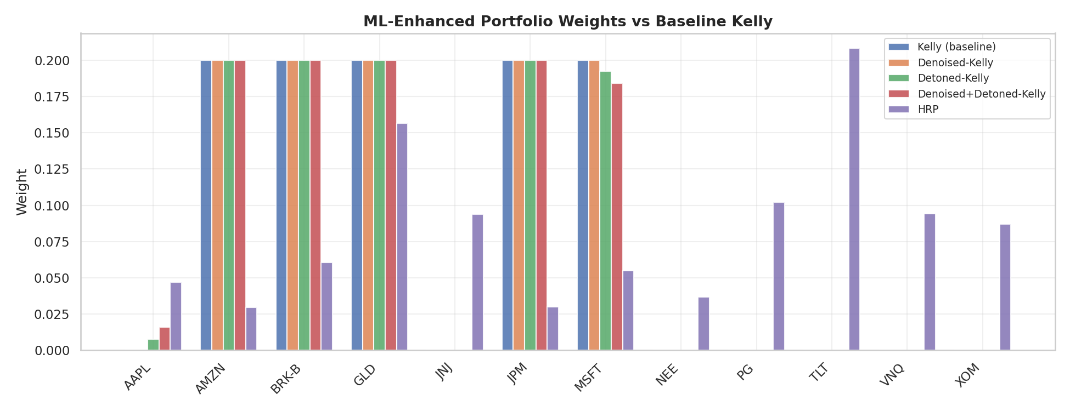
Step 6: Do the ML models outperform?
We compare the seven strategies on the OOS window (oct 1 - dec 31, 2025)
- Cumulative Return (%)
- Annualised Sharpe Ratio
- Sortino Ratio
- Maximum Drawdown (%)
- 95%-CVaR
These are the results:

Strategy | Cum Return (%) | Sharpe | Sortino | Max_Drawdown | CVaR%
Kelly (baseline) | 2.3877 | 0.3995 | 0.3948 | -5.5364 | -1.4394
Double-Kelly | 4.8324 | 0.5872 | 0.5858 | -10.7663 | -2.8787
Half-Kelly | 1.1868 | 0.0243 | 0.0239 | -2.8076 | -0.7197
Denoised-Kelly | 2.3877 | 0.3995 | 0.3948 | -5.5364 | -1.4394
Detoned-Kelly | 2.4907 | 0.4331 | 0.4287 | -5.5098 | -1.4341
Denoised+Detoned-Kelly | 2.6064 | 0.4708 | 0.4668 | -5.4797 | -1.4281
HRP | 2.8175 | 0.9033 | 0.8875 | -2.5599 | -0.7931

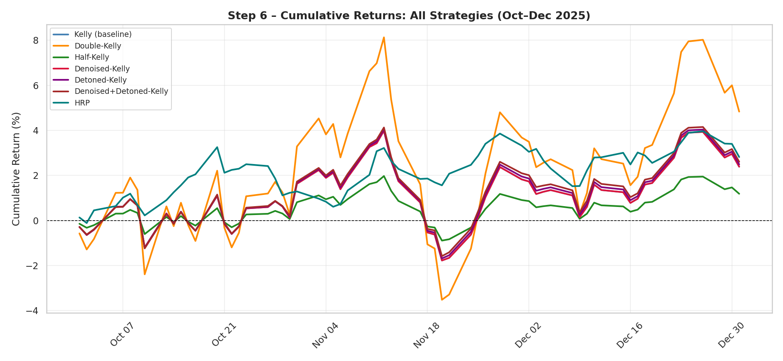
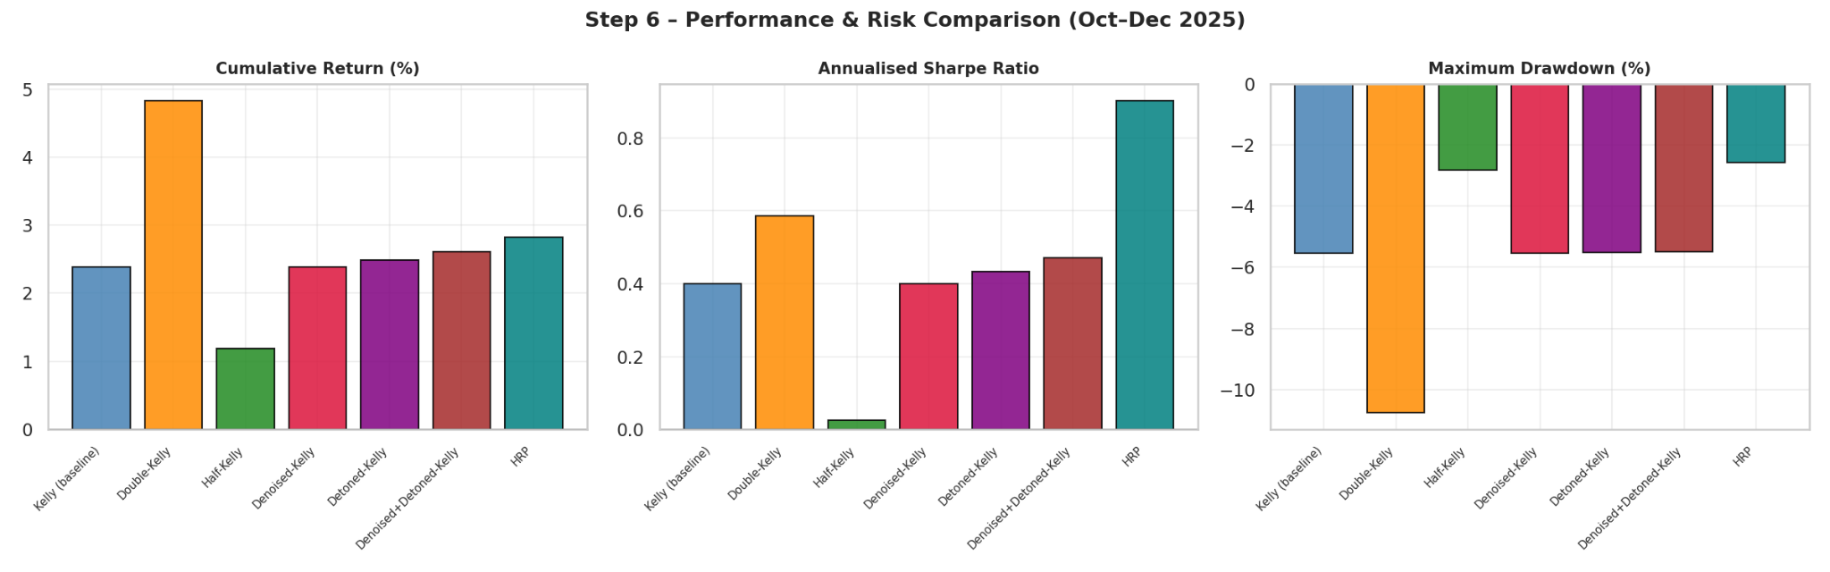
As we can see here:
Results:
- HRP is best performing
  - Sharpe: 0.903, Sortino: 0.888
  - Lowest risk: Drawdown -2.56%, CVaR -0.79%
- Denoised + Detoned-Kelly is best within Kelly family
  - Sharpe: 0.471, Sortino: 0.467
  - Shows ML improvements can work
- Detoned-Kelly and Denoised Kelly dont move the needle much from baseline
- Half-Kelly performs worst
  - Sharpe: 0.024
  - Lower risk but almost no return
- Key insight
  - Denoising + detoning are complementary and using together can be helpful

Recommended Sequence of Improvements
- Remove eigenvalue noise from covariance matrix - denoising
- Correct market factor using detoning
- Solve constrained Kelly optimization using the new cleaned covariance matrix
- Benchmark with HRP and baseline

